**Sudha Amarnath ID: 013709956**

**HW 3 Salesforce Assignment**

**Platform Development Basics**

Get started with the Salesforce Platfrom – 15 minutes

* Created a trailhead developer account.

<https://trailhead.salesforce.com/en/me/0052J000008BIf3QAG>

* Launched a trailhead playground and installed successfully "DreamHouse App”.
* Earned 500 points in the challenge.

Develop without code – 15 minutes

* Successful completion of this unit. Understood the benefits of metadatadriven development model and examples of no-code and low-code development approaches.
* Earned 50 points in the challenge.

Code with Salesforce Languages – 20 minutes

* Successfully completed this unit. Learnt about three core programmatic technologies and their use in the DreamHouse app:
  + Lightning component framework : a UI development framework similar to Angular JS. The IDE uses a XML markup containing both lightning specific and static HTML tags.
  + Apex : Salesforce’s proprietary programming language with java like syntax.
  + Visualforce : A markup language that lets us create Custom salesforce pages with code similar to HTML and also can use combination of Apex and Javascript.
* Earned 100 points in this challenge.

Extend the Salesforce Platfrom – 15 minutes

* Succesfully completed this unit .
  + Understood the use of different Salesforce API’s.
  + Relation of HerokuConnect with Salesforce – A development platform built on AWS that unifies Salesforce to Heroku Postgres that helps moving information across platforms.
  + Learnt the ways Salesforce interacts with IoT and bots and their use in the mobile apps and navigation of data.
* Earned 100 points in the challenge.

**Lightning Components Basics**

* Before you start – 10 minutes
  + Creating custom objects and configuring org for lightning component.
* Get started with lightning components – 15 minutes
  + Uses of lightning components framework and to customize Salesforce using it.
* Create and edit Lightning components – 25 minutes
  + Creating and editing Lightning component bundle in developer console
* Attributes and Expressions – 25 minutes
  + Creating multiple instances of a component
* Handle actions with controller – 45 minutes
  + Creating a client-side controller to handle user actions using Javascript
* Input data using forms – 35 minutes
  + Creating a form to read values of user input and refactor code from controller to helper
* Connect to Salesforce with Server-side Controllers – 35 minutes
  + Creating apex methods that can be called from component code
* Connect components with Events – 45 minutes
  + Defining custom events to apps, fire events to controller, refactoring big components to smaller.
* Discover Next steps – 5 minutes

**Quick Start: Lightning Components**

* Create a server-side Apex controller class – 5 minutes
* Create a Lightning component – 5 minutes
* Retrieve a contact list – 5 minutes
* Render and Preview the Contact list – 5 minutes

**Screenshots**

* Trail head account summary

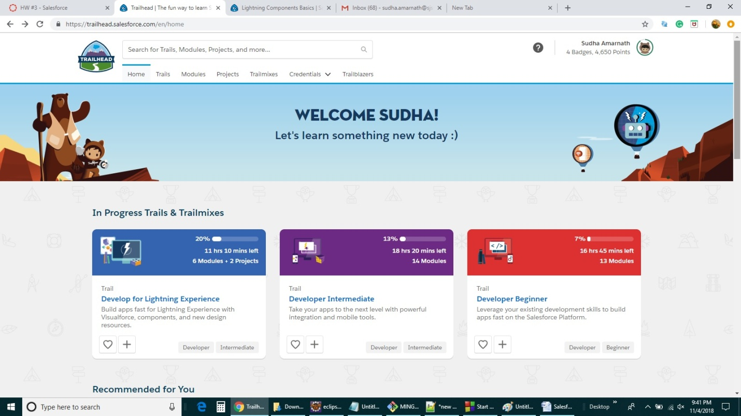

* Completion of all Platform Development Basic trailhead units.

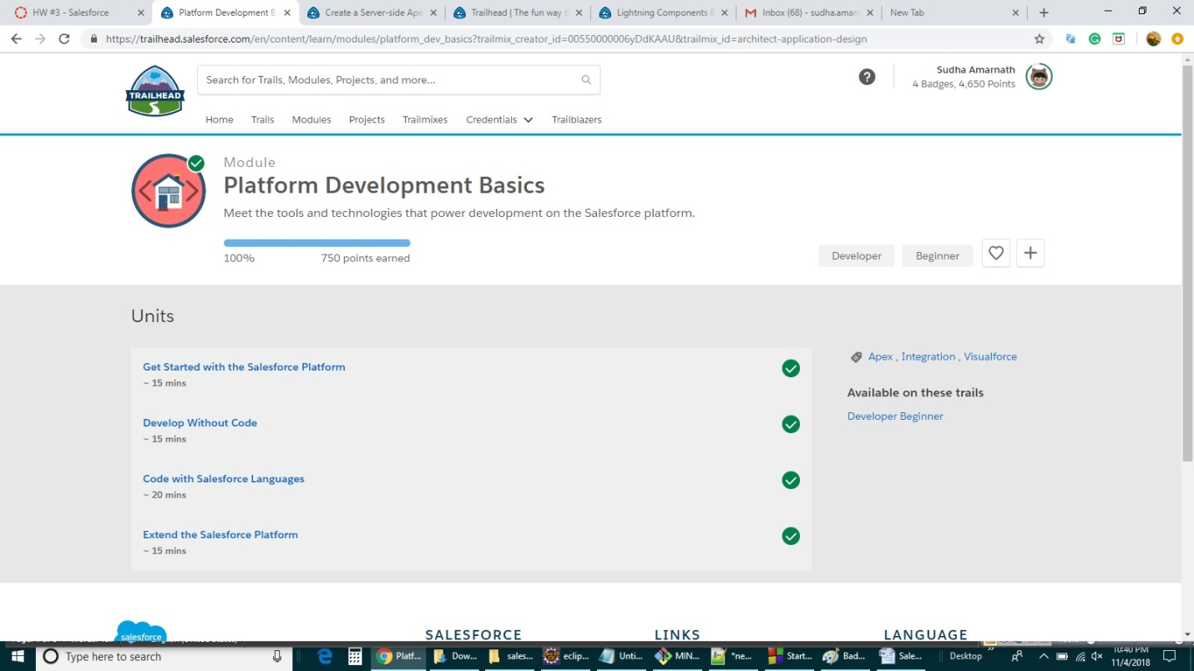

* DreamHouse App

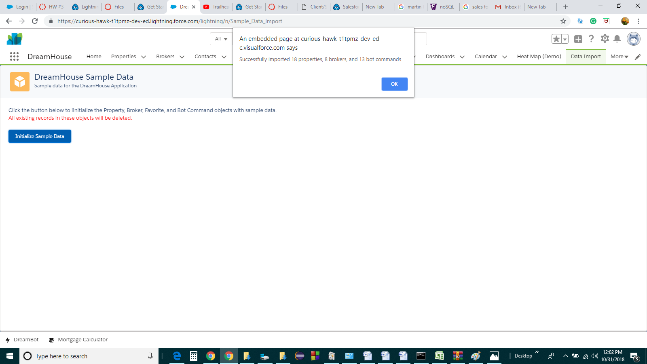

* Completion of Lightning components basics module

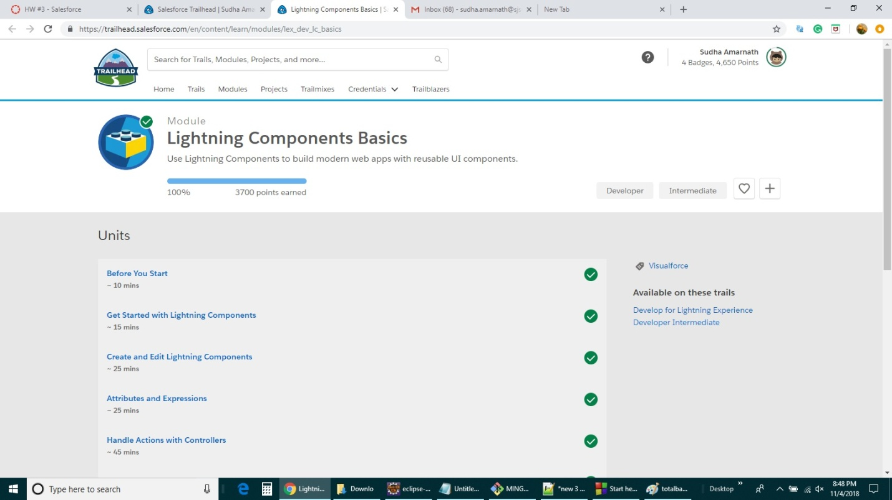

* Completion of Quick Start: lightning components module

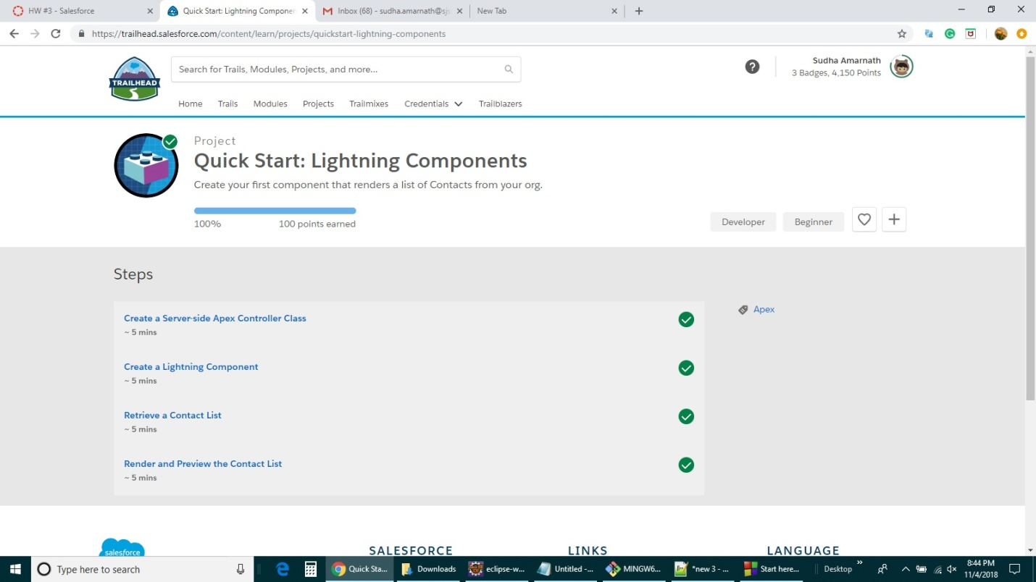

* Total badges and points earned in completing all the above modules in the trailhead playground.

