Deals data manager web app

Contents

High level design 2

Upload deals data MVC block diagram 2

Upload deals data sequence diagrams 2

Layered architecture 3

Some features of the application 3

Setup instructions 5

# High level design

## Upload deals data MVC block diagram

## Upload deals data sequence diagrams

ICSVReader is replaced with Generic Reader Interface. The required reader implementation will be selected based on the file type such as csv, excel etc.

MEF (Managed extensibility framework) is used to support extending the (deal data) file reading capability of different file types.

## Layered architecture

It is a three-layered application which consists of

* Presentation layer (React UI and controller)
* Business logic layer (Deal Service)
* DB layer (DB Service.cs/ InmemoryDBSerice)

# Some features of the application

1. Multiple csv file upload: multiple files can be uploaded at a time.

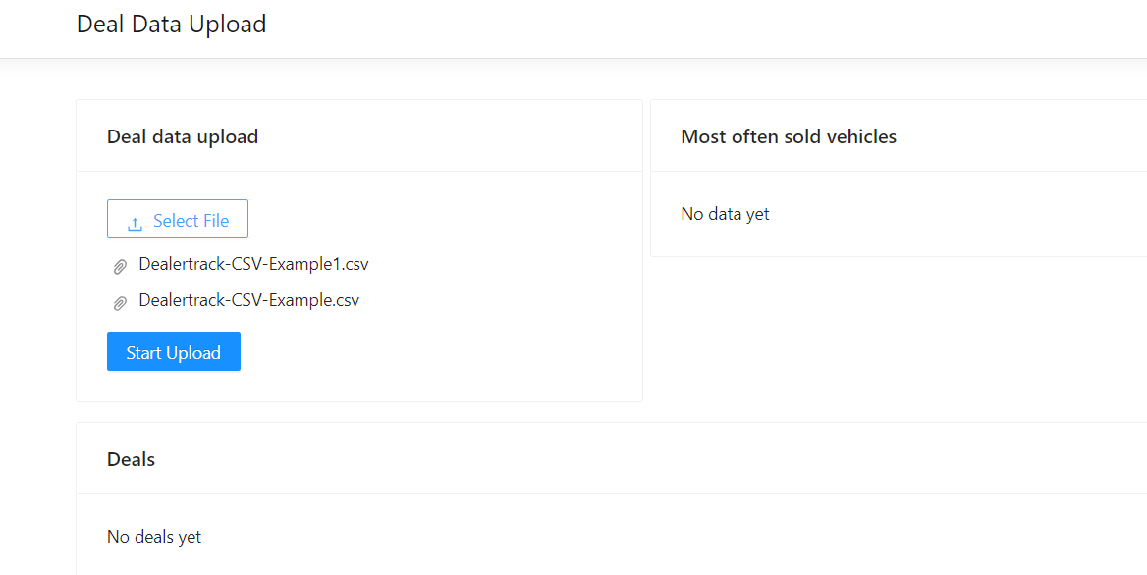

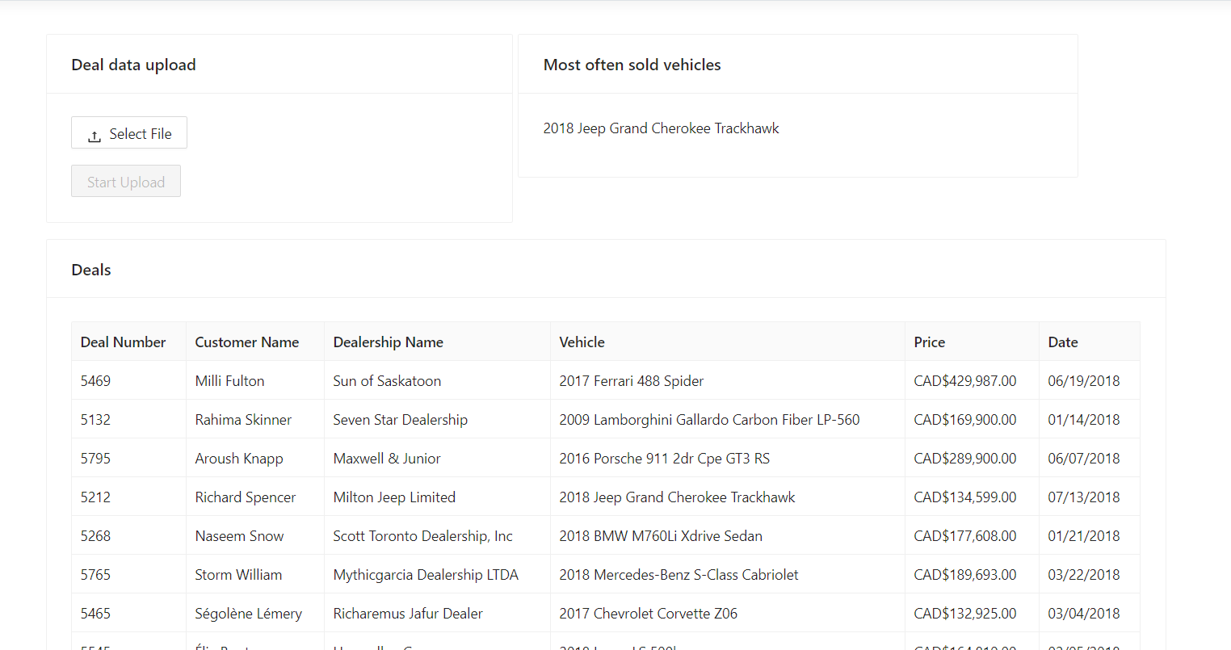

2.In memory DB service acts as a DB and the previously uploaded data will be retained.

3. User friendly error messages: If the data type of any field is incorrect then a user-friendly error message will be displayed to the end user.

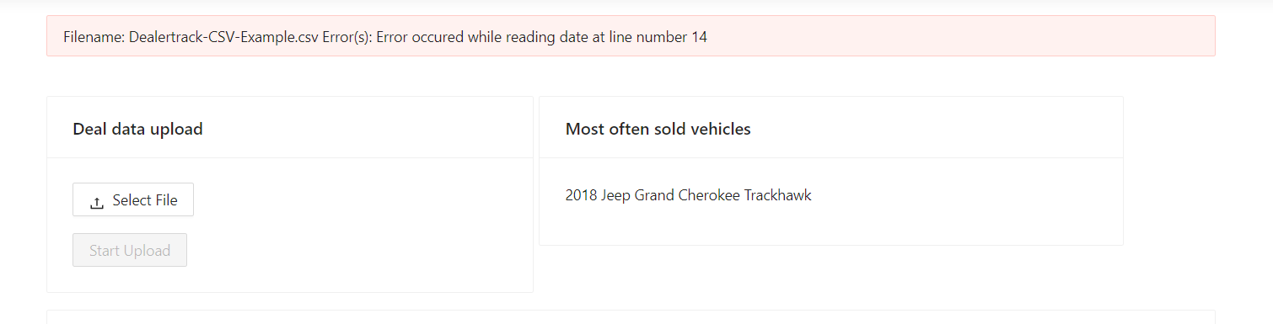

1. Customizable order of the columns in the excel: The CSVReader is programmed to process the csv file(s) with any order of the columns.

Example: In the following screenshot, Deal Number appears at the last.

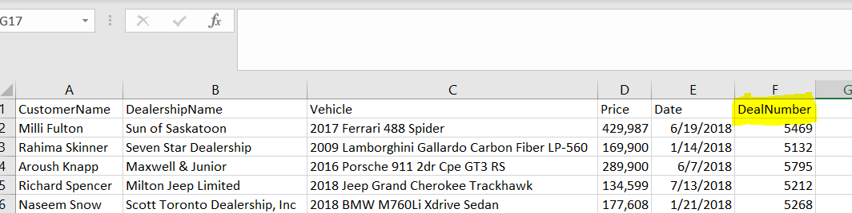

# Setup instructions

1. Node js and visual studio 2019 is required to run the application

Node js download link: <https://nodejs.org/en/download/>

1. Download the application from the following location

<https://github.com/SudhaBogaTech/DataUpload>

1. Open the visual studio solution file “DataUpload.sln”
2. Once the solution is opened then build and run the application.

This application is configured to automatic execution of command “npm install” when the application is opened in visual studio 2019.

Note*:

Deal Number in the csv file should be unique and the new record will not be add in the system if the deal number already exists.

**Troubleshooting steps for a common issue.**

If a below issue is encountered when running the application, then please follow the steps mentioned below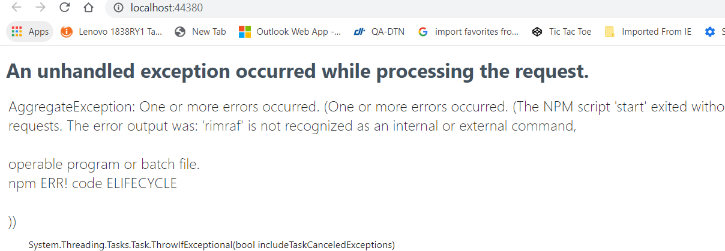

1. Navigate to the folder “\DataUpload\ClientApp” in windows explorer and remove/replace the node_modules folder as shown in the screenshot below.

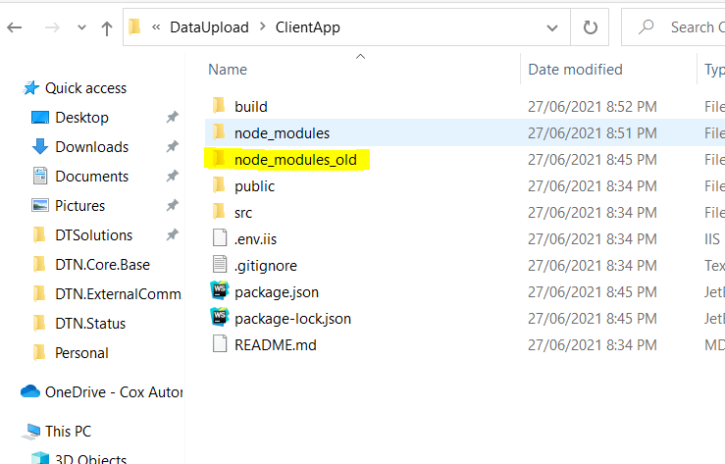

1. Open CMD and navigate to the clientapp folder and execute npm install command. This step will ensure all the required packages are installed. Refer the screenshot.

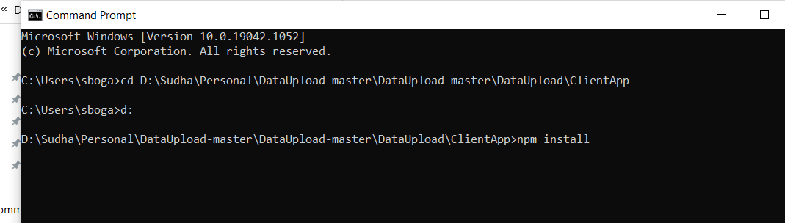

1. Go solution -> properties and set the multiple projects at startup as per below screenshot.

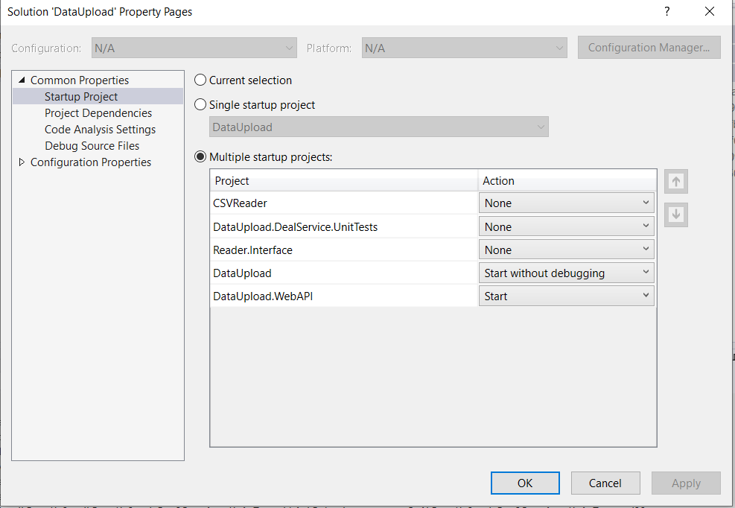

1. Press F5 to start the application.