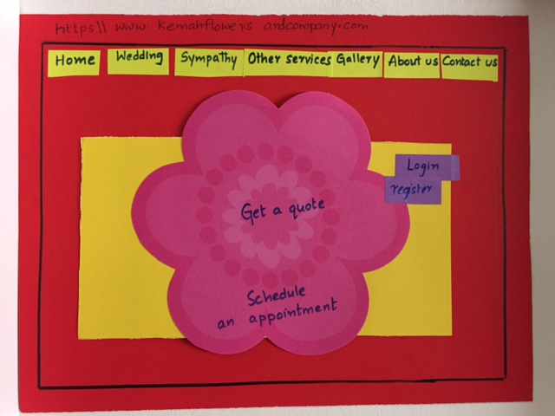

Fig 1 Kemah Flowers and Company Homepage

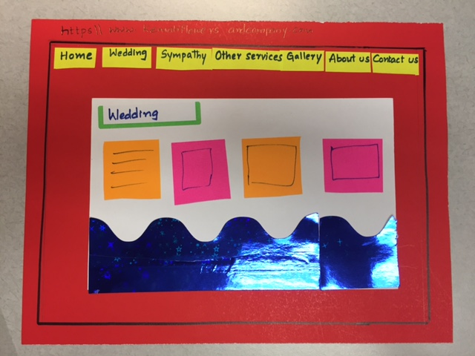

Fig 1.1 Wedding page

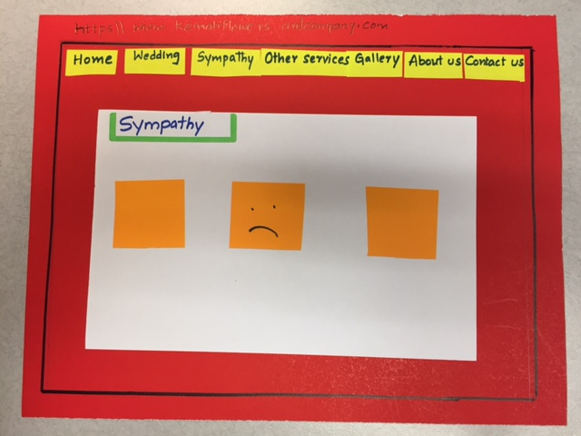

Fig 1.2 Sympathy page

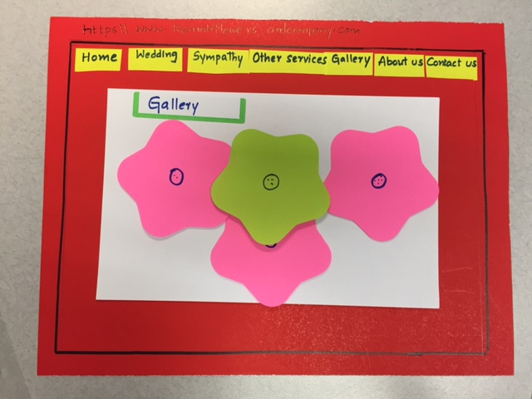

Fig 1.3 Gallery page

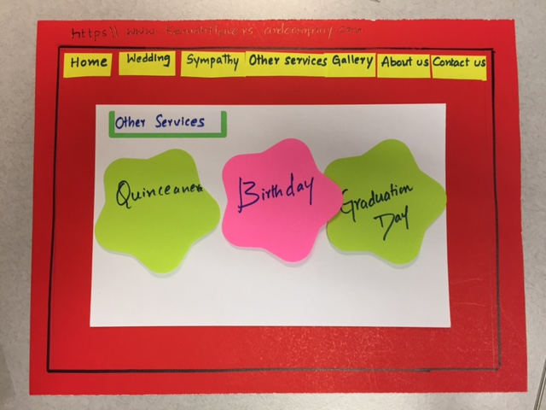

Fig 1.4 Other Services

**Creative Extra:**



Fig 2 Kemah Flowers and Company Homepage

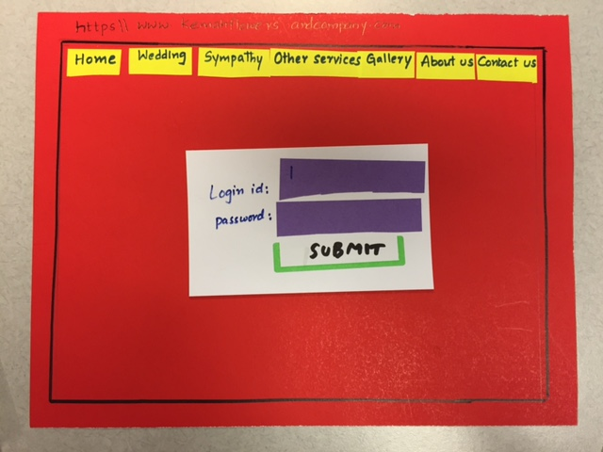

Fig 2.1 Customer login into the website to book an appointment

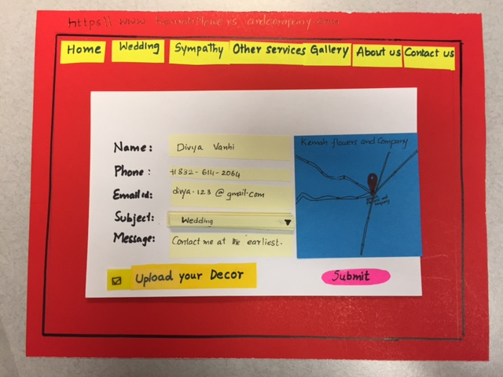

Fig 2.2 Customer enters the details to make an appointment with the manager

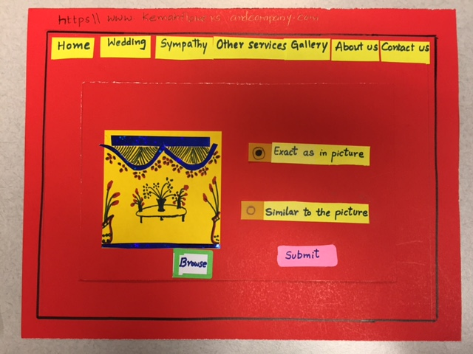

Fig 2.3 Customer uploads image of the event

Scenario: Scheduling appointment using Google Calendar



Fig 3 Kemah Flowers and Company Homepage



Fig 3.1 Manager login to the website

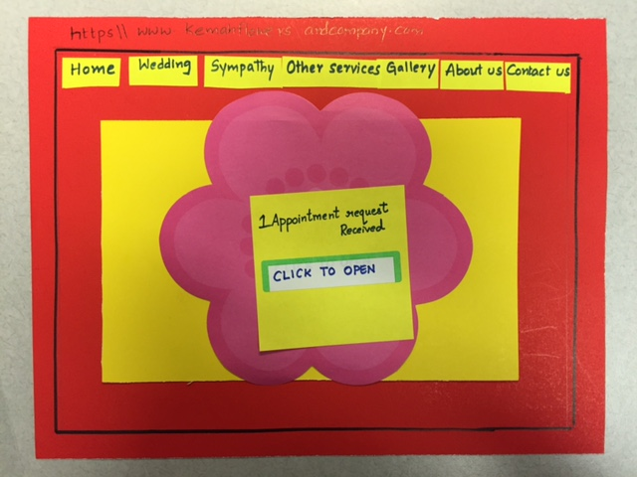

Fig 3.2 One Appointment request received from the customer

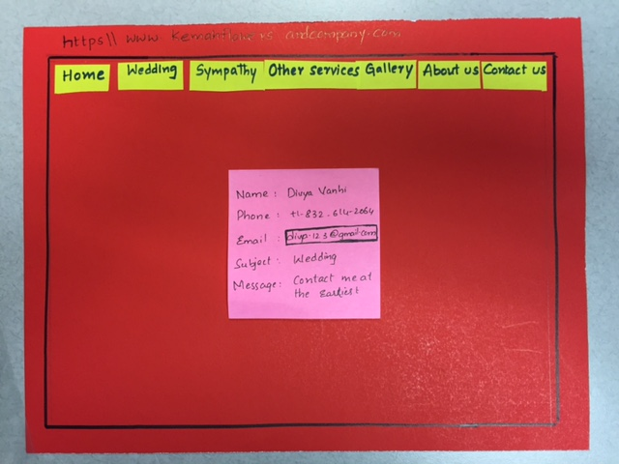

Fig 3.3 Manager checks the details of the customer

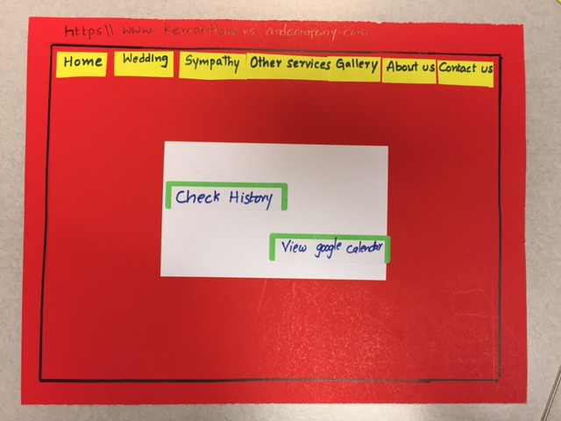

Fig 3.4 Manager views his Google Calendar for available slots

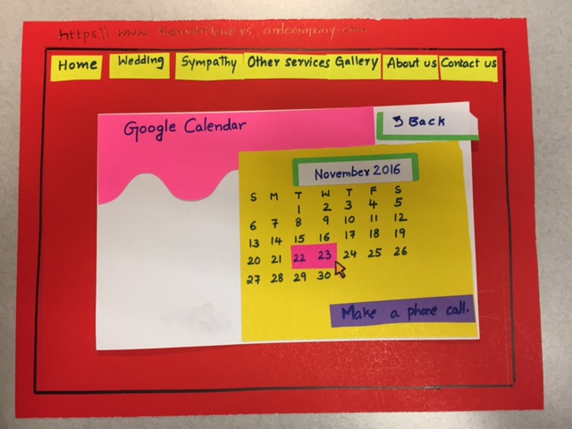

Fig 3.5 Manager selects his available slots in Google Calendar

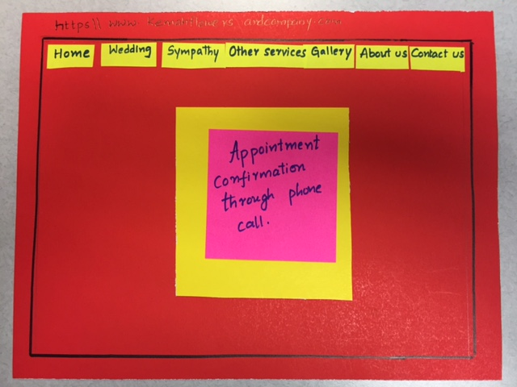

Fig 3.6 Manger confirms appointment to the customer through phone call

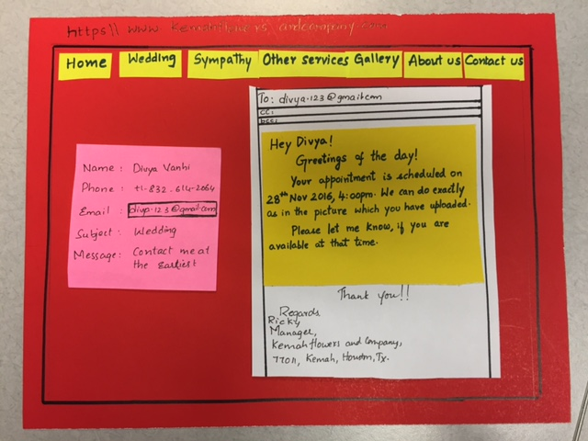

Fig 3.7 Manger confirms appointment to the customer via Email

Scenario: Like and feedback using Facebook

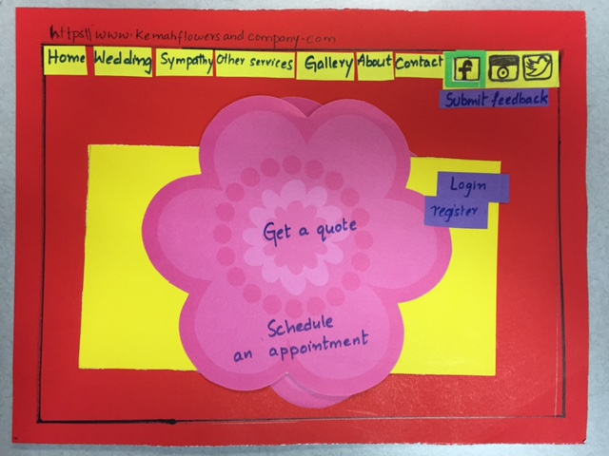

Fig 4 Kemah Flowers and Company Homepage]

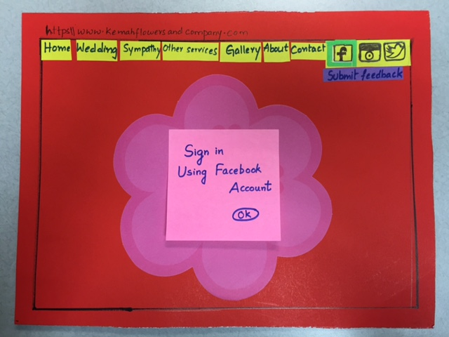

Fig 4.1 Customer Sign in using Facebook account

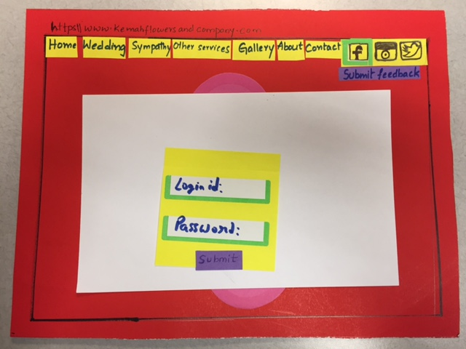

Fig 4.2 Customer enters his credentials

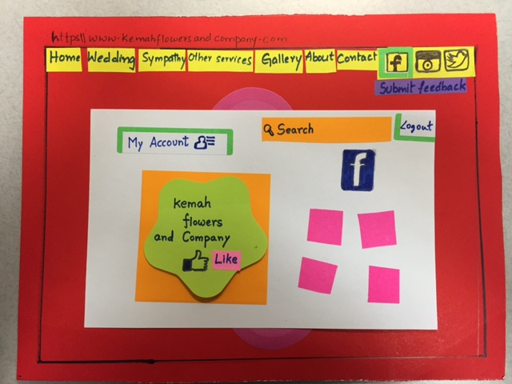

Fig 4.3 Customer likes Kemah Flowers and Company using Facebook

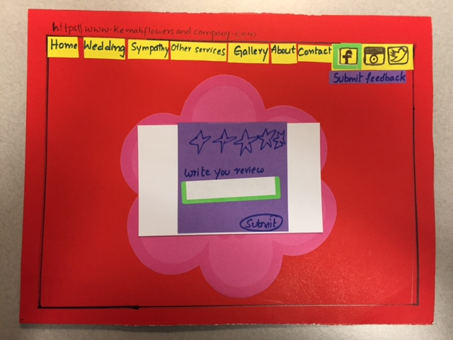

Fig 4.4 Customers can provide feedback to the website