**Planned value (PV)** The portion of the approved total cost estimate planned to be spent on an activity during a given period

**Actual cost (AC)** The total of direct and indirect costs incurred in accomplishing work on an activity during a given period

**Earned value (EV)** An estimate of the value of the physical work actually completed (PV X %Complete)

**Cost variance (CV)** The earned value minus the actual cost

**Schedule variance (SV)** The earned value minus the planned value

**Cost performance index (CPI)** The ratio of earned value to actual cost; can be used to estimate the projected cost to complete the project

**Schedule performance index (SPI)** The ratio of earned value to planned value; can be used to estimate the projected time to complete a project

**Budget at completion (BAC)** The original total budget for a project

**Estimate at completion (EAC)** An estimate of what it will cost to complete the project based on performance to date

**Rate of performance (RP)** The ratio of actual work completed to the percentage of work planned to have been completed at any given time during the life of the project or activity

**Formulas**

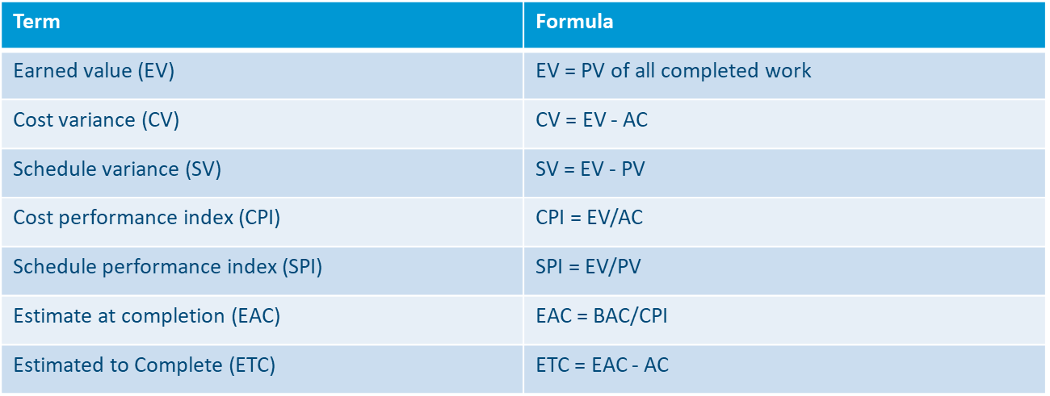

Given the following information for a one-year project, answer the following questions. Recall that PV is the planned value, EV is the earned value, AC is the actual cost, and BAC is the budget at completion.

PV=$23,000

EV=$20,000

AC=$25,000

BAC=$120,000

a. What is the cost variance, schedule variance, cost performance index (CPI), and schedule performance index (SPI) for the project?

b. How is the project doing? Is it ahead of schedule or behind schedule? Is it under budget or over budget?

c. Use the CPI to calculate the estimate at completion (EAC) for this project. Is the project performing better or worse than planned?

d. Use the SPI to estimate how long it will take to finish this project.

**Solution:**

* Cost variance = EV-AC=$20,000 - $25,000 = -$5,000
* Schedule variance = EV-PV=$20,000-$23,000=-$3,000
* CPI=EV/AC=$20,000/$25,000 =80% or .8
* SPI=EV/PV=$20,000/$23,000=87% or .87

b. The project is over budget and behind schedule.

c. EAC=BAC/CPI=$120,000/.8=$150,000

The project is performing worse than planned since the new estimate to complete it is $30,000 more than planned.

d. The estimated time to complete the project =12months/.87=13.8 months. The project is projected to take 1.8 months longer than planned.

2. You have been hired to do maintenance work on 4 servers. Each server is scheduled to take one day to complete at a cost of $600 per server. At the end of day 2, you have spent $1100 and 1.5 servers are complete. Fill in the following table with the appropriate earned value amounts, assuming that current sending will continue.

|  |  |
| --- | --- |
| **Earned Value** | **Amounts** |
| Planned Value | $1200 |
| Earned Value | $900 |
| Actual Cost | $1100 |
| Cost Variance | -$200 |
| Schedule Variance | -$300 |
| Cost performance Index | 0.82 |
| Schedule performance Index | 0.75 |
| Estimate at Completion (EAC) | $2927 |
| Estimate to completion (ETC) | $1827 |
| Variance at completion | -$527 |