**Ticketing System**

This is an app to maintain the CSR related tickets developed using NodeJs, MongoDB and Angular js.

NodeJs and MongoDB : For Rest API creation

Angular JS : For UI screens.

Demonstration of the POC:

1. After cloning with the git repository from Heroku toolbelt, run Heroku local

Git repository: <https://github.com/SudhaWarad/TicketingSystem>

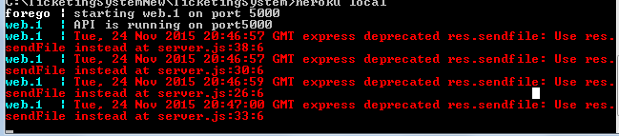

1. Open the web browser to see the application running

URL: <http://localhost:5000>

Initially when application loads, login screen will appear, enter the credentials and click on button “Login” to proceed.

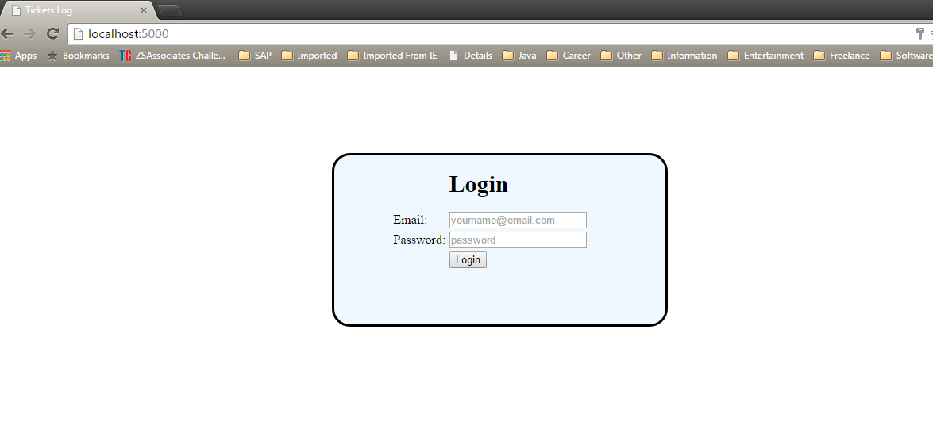

1. Once it is logged in, the tickets log page will open up, which has 2 parts
2. Master Page: It contains the list of logs with the ticket name, area of the log and the status. On click of which corresponding detail page opens up
3. Detail Page: This page contains the detailed information about the log

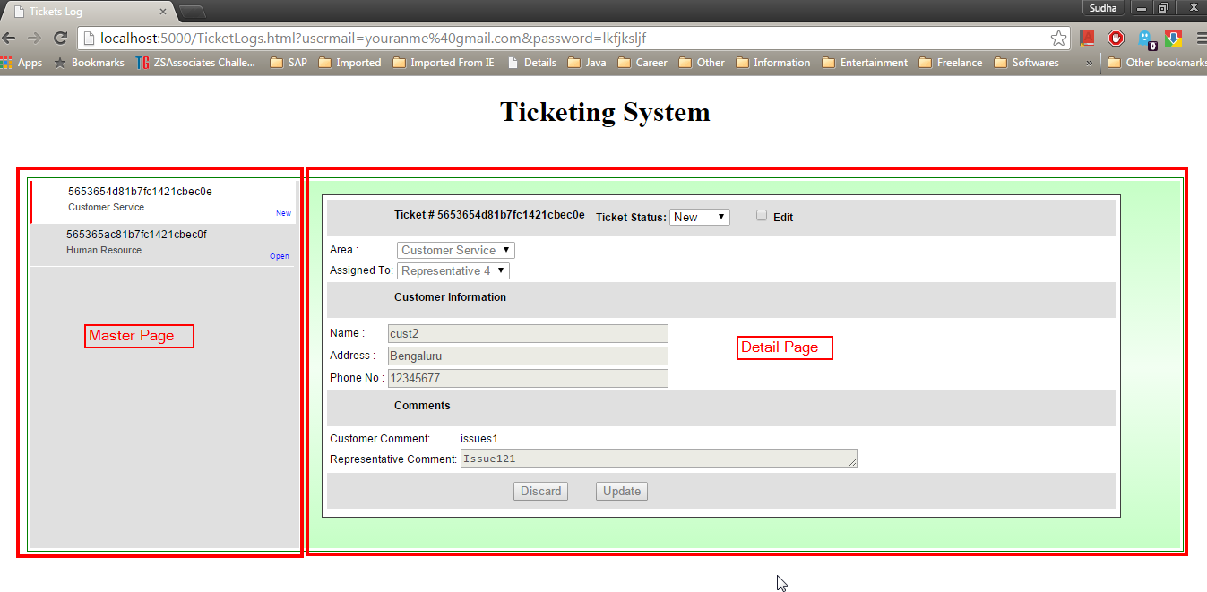

1. Click on any of the logs from master page and check the “Edit” to modify the log.

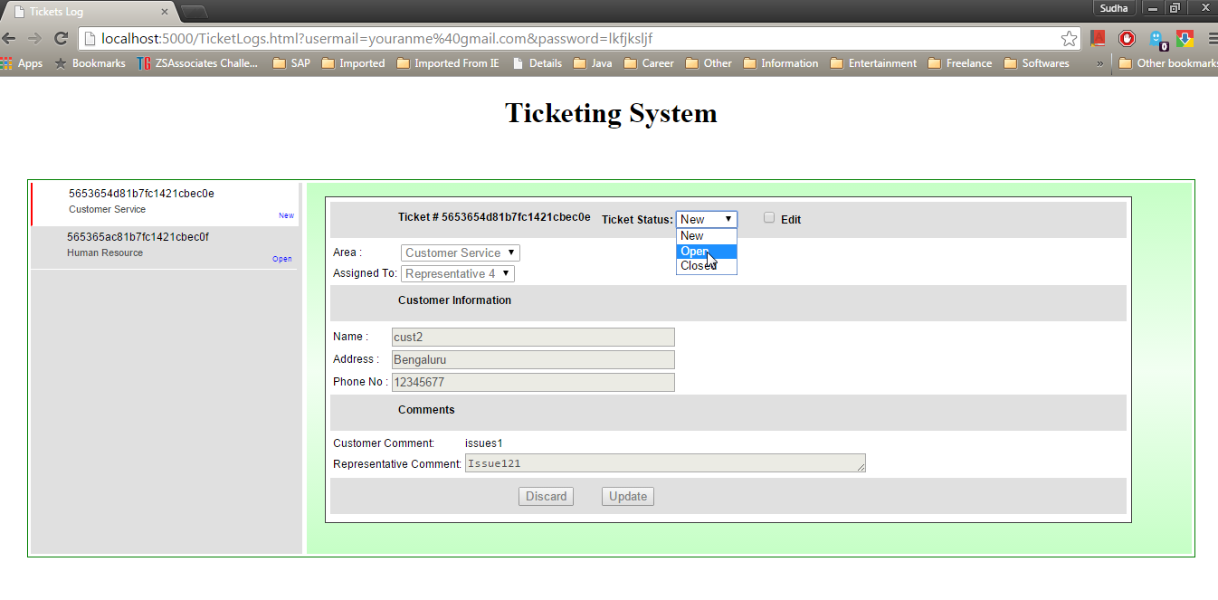

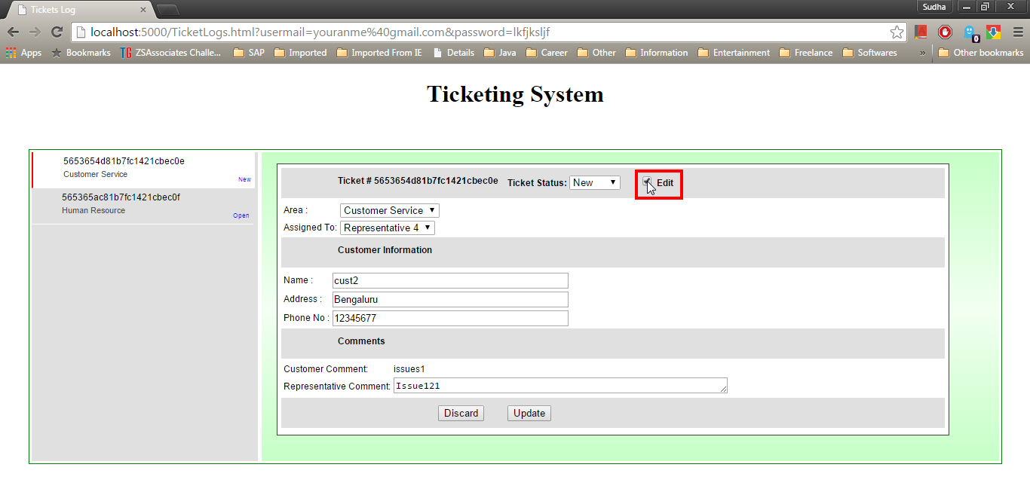

1. Select the areas of the issues from the dropdown box.

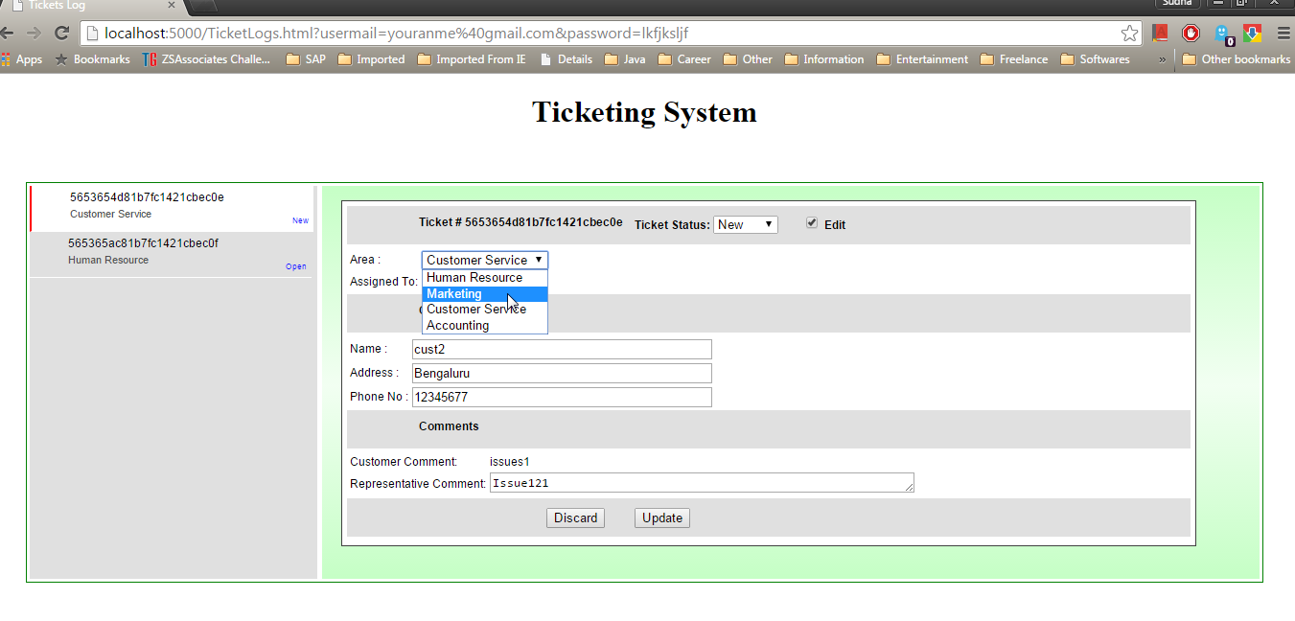

1. Assign the ticket to the Customer representative.

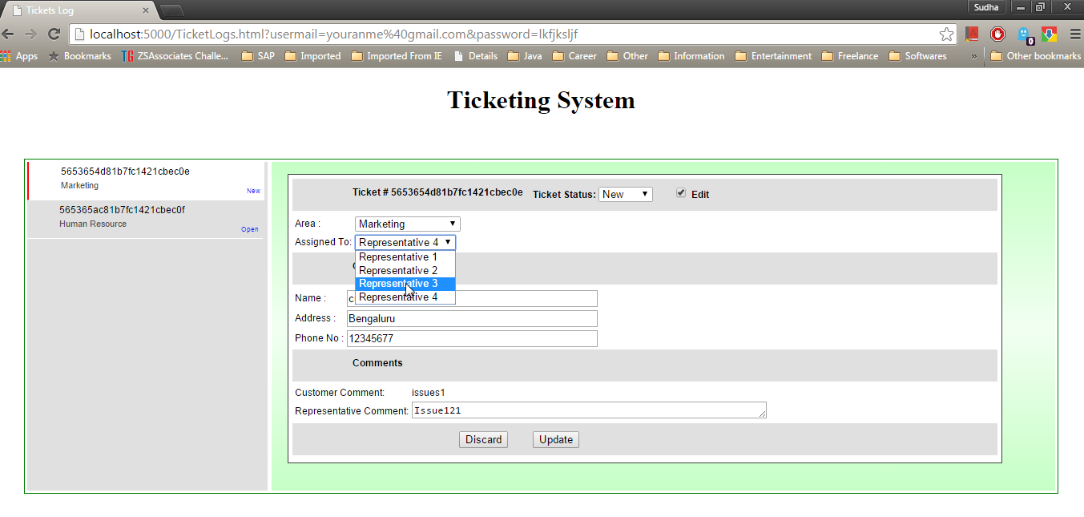

1. After modifying the data click on update button to save the changes.

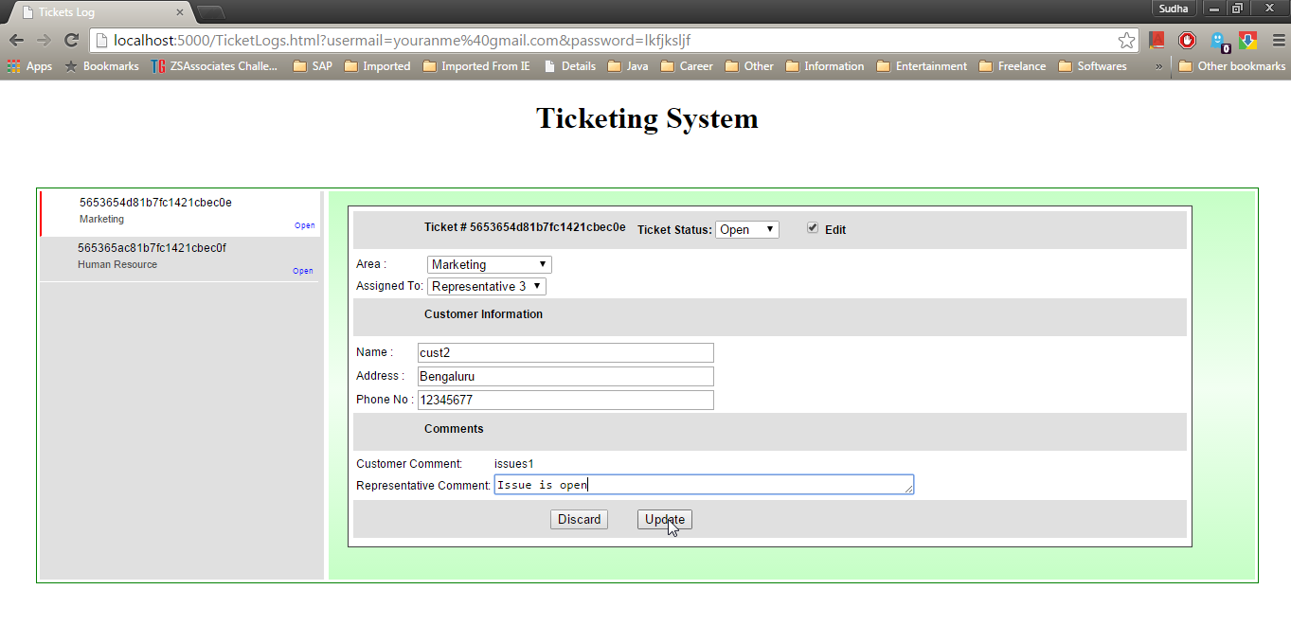

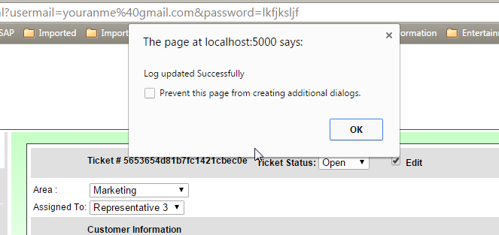

1. Once ticket is closed then the form cannot be edited.(Edit button will be disabled based on the status value)

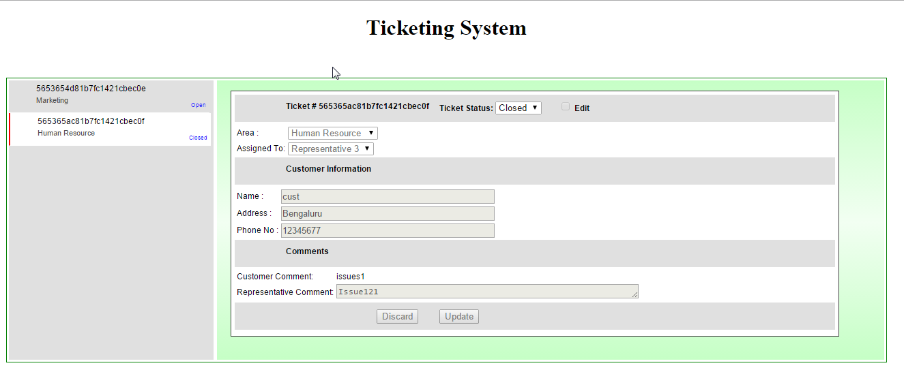

1. Open the “Postman” to add ticket logs to this application.

URL: <http://localhost:5000/api/tickets>

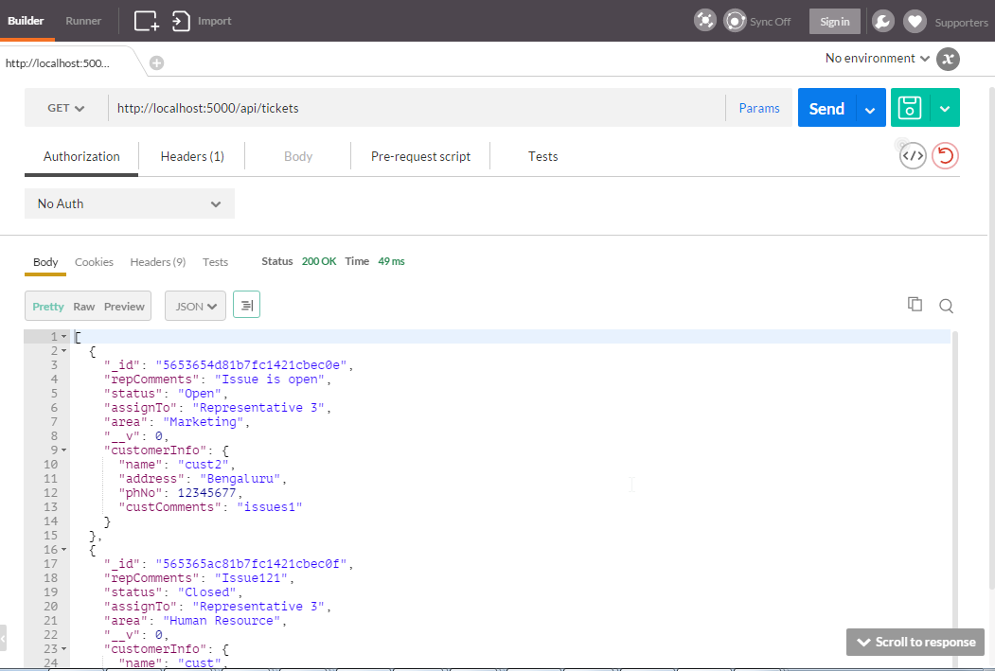

1. Adding the record to the logs.

Set the header and send the json data in with body

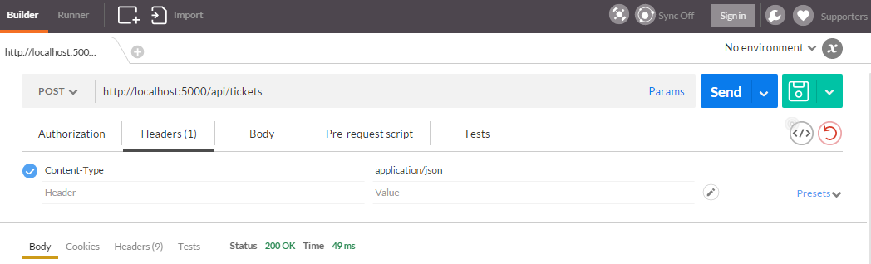

Body:

{

"repComments": "related to marketing",

"status": "New",

"assignTo": "Representative 2",

"area": "Customer Service",

"customerInfo": {

"name": "Mr. Roy",

"address": "Bengaluru",

"phNo": 998033540,

"custComments": "faulty product"

}

}

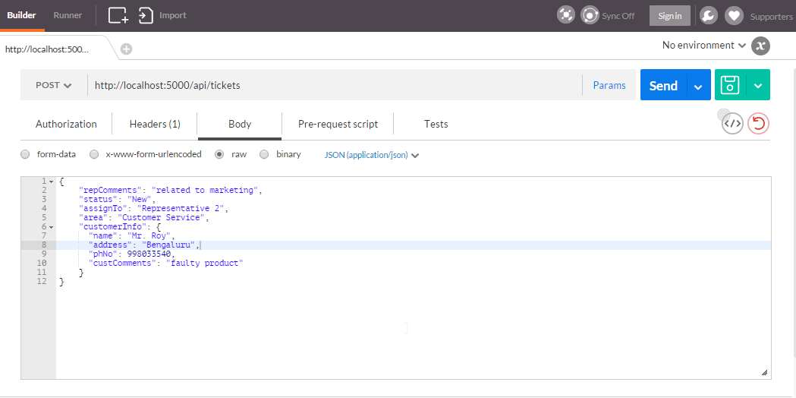

1. Goto app to see the new logs.

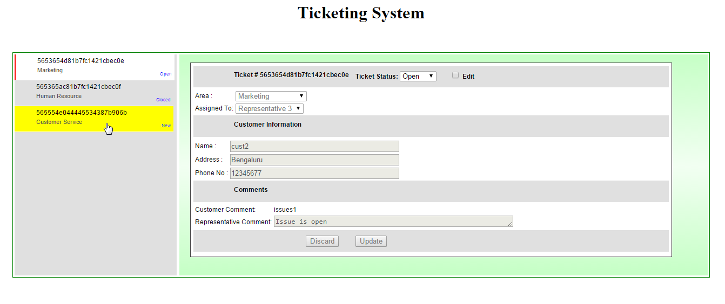

1. Deleting the log from Postman

Pass the “_id” value to the url to delete the log.

Example: http://localhost:3000/api/tickets/5653654d81b7fc1421cbec0e