OmniMart Pvt Ltd


Omnichannel Retail Behaviour and Performance Analytics Dashboard

Business Requirements Document (BRD)

Document Change Log:
Date | Author | Version | Description
14-Jul-2025 | Sudhagar | v0.1 | Initial draft with report page structure
18-Jul-2025 | Sudhagar | v0.2 | Added appendix questions A.1 to A.5
20-Jul-2025 | Sudhagar | v0.3 | Incorporated stakeholder feedback
22-Jul-2025 | Sudhagar | v1.0 | Finalized version for project approval

Prepared by:
Sudhagar Lakshmanan
Business Intelligence Engineer
Contents
1. Executive Summary 4
1.1 Scope of Work 4
2. Business Objective 5
2.1 Business Goals 5
2.2 Project Objective 5
2.3 Success Criteria 5
3. Current Business Environment 6
3.1 Current Process 6
3.2 Challenges and Issues 6
3.3 Current State Process Flow 6
4. Proposed Solution 7
4.1 Description of the Solution 7
4.2 KPIs & Metrics of Report Pages 7
4.3 Functional Requirements 9
4.4 Non-Functional Requirements 9
4.5 Role-Based Access Matrix 9
4.6 Wireframes and Visual References 10
4.7 Epics, User Stories and Stakeholder Access Permissions 11
4.8 Use Case Overview 11
4.9 Future State Process Flow 12
4.10 Gap Analysis Overview 12
5. Stakeholders 14
5.1 List of Stakeholders and Responsibilities 14
6. Constraints 15
6.1 Budgetary Constraints 15
6.2 Timeline Constraints 15
6.3 Regulatory Constraints 15
7. Assumptions 16
7.1 List of Assumptions 16
8. Risks 17
8.1 List of Risks 17
8.2 Risk Mitigation Strategies 17
9. Dependencies 18
9.1 List of Dependencies 18
10. Approval 19
10.1 Sign-Off 19
Appendix A.1 - Business Case Questions and Insights 20
A.1.1 Revenue Business Case Questions 20
A.1.2 Product Business Case Questions 21
A.1.3 Customer Business Case Questions 22
A.1.4 Campaign Business Case Questions 23
A.1.5 Support Business Case Questions 24
Appendix B.1 - Dashboard Wireframes 25
B.1.1 Summary Page Wireframe 25
B.1.2 Overview Page Wireframe 26
B.1.3 Revenue Page Wireframe 27
B.1.4 Products Page Wireframe 28
B.1.5 Customers Page Wireframe 29
B.1.6 Campaigns Page Wireframe 30
B.1.7 Support Tickets Page Wireframe 31
Appendix B.2 - Process Flow Diagrams 32
B.2.1 Current State Process Flow Diagram 32
B.2.2 Future State Process Flow Diagram 33
Appendix C.1 - Epic and User Story Tables 34
C.1.1 Epic List 34
C.1.2 User Stories with Acceptance Criteria 35
C.1.3 Stakeholder Access and Functional Use Mapping. 41
Appendix D.1 - Use Case Mapping 42
D.1.1 Use Case Details 42
D.1.2 Actor-Use Case Matrix 44

1. Executive Summary
OmniMart Pvt Ltd is embarking on the implementation of a centralized Power BI dashboard solution titled “Omnichannel Retail Behaviour and Performance Analytics”. The goal is to unify fragmented, static reporting into a dynamic, role-sensitive platform that provides timely, actionable insights across the organization.
This initiative is being led by Deepa Menon, Sales Director at OmniMart Pvt Ltd, who serves as the strategic approver. Her oversight ensures the solution supports comprehensive, enterprise-wide visibility into sales performance, marketing effectiveness, customer engagement, and support operations.
The dashboard will span seven report pages - Summary, Overview, Revenue, Products, Customers, Campaigns and Support providing visibility into omnichannel operations and performance trends.
Key Highlights:
- Integrated multi-channel insights from sales, marketing, customer engagement, and support systems
- Dynamic filtering via slicers for category, region, time period, and channel
- Comparative KPI tracking (Year-over-Year and Month-over-Month performance)
- Role-based views tailored to executives, analysts, and support teams
- Drillthrough functionality to explore granular data (products, customers, campaigns, tickets)

1.1 Scope of Work
In Scope:
- Development of seven interactive report pages
- Integration of structured data from internal sources (sales, CRM, support)
- Role-based access control for defined user groups
Out of Scope:
- Mobile responsiveness and optimization
- Embedding dashboards in third-party tools or portals
- Advanced analytics or predictive modelling

2. Business Objective

2.1 Business Goals
Accelerate decision-making by delivering timely, intuitive insights across key domains. Unify data visibility across offline and online channels for holistic performance analysis. Improve customer engagement and retention using churn, campaign and SLA metrics. Foster accountability through role-based dashboards tailored to stakeholder responsibilities.

2.2 Project Objective
To design, build and deploy a scalable Power BI dashboard that delivers actionable insights across business domains using curated SQL and Excel datasets, enabling faster decision-making, improved stakeholder engagement and streamlined performance tracking.
Objectives Include:
- Build seven structured report pages tailored to business needs
- Implement slicers and tooltips for personalized visual interactivity
- Establish drillthrough navigation to detailed records
- Apply SQL and DAX logic for data validation and KPI calculations
- Ensure secure data access through row-level security (RLS)
- Support dashboard documentation via BRD, process flows, use cases and testing artifacts

2.3 Success Criteria
- All KPIs and metrics align with stakeholder expectations
- Dashboard passes UAT across all user roles
- Reports are published and refresh successfully in Power BI Service
- Stakeholder feedback results in no more than 2 major iterations post-UAT

3. Current Business Environment

3.1 Current Process
Static spreadsheets are manually generated to report sales and campaign performance. Support metrics are reported via ticketing systems but lack visual consolidation. No central dashboard exists for omnichannel visibility.

3.2 Challenges and Issues
- Lack of drilldown capability
- Manual reporting is error-prone and time-consuming
- Disconnected views across departments
- No role-based data segregation

3.3 Current State Process Flow
The current state process involves multiple manual steps across departments using static spreadsheets and disconnected systems. The flow below illustrates how different teams operate in silos, leading to inefficiencies in tracking KPIs, campaign performance and support metrics.
🔗 Refer to Appendix B.2.1 - Current State Process Flow Diagram for visual representation of the existing workflow.

4. Proposed Solution

4.1 Description of the Solution
A centralized Power BI dashboard will unify datasets from transactions, customer records, campaign logs and support tickets. It will present high-level metrics with drillthrough capabilities, dynamic slicers for analysis and role-based views for controlled access. SQL validations and visual tooltips will ensure usability and trust.

4.2 KPIs & Metrics of Report Pages
This section maps essential KPIs to each dashboard page - Summary, Overview, Revenue, Products, Customers, Campaigns and Support. The selected metrics represent strategic priorities across business functions, guiding performance tracking and decision-making. Each subsection is aligned with business case questions detailed in Appendix A.1.1 to A.1.5 for traceability, relevance and stakeholder validation.

4.2.1 Summary
- Overall Revenue and Conversion Metrics
- Performance Alerts or Threshold Highlights
- Top KPIs across all business functions

4.2.2 Overview
- Combined YoY and MoM Trends
- Business health indicators across verticals
- Executive-level dashboard summary

4.2.3 Revenue
- Gross Revenue, Net Revenue, Discounts
- Month-over-Month and Year-over-Year Comparisons
- Product Category and State wise revenue analysis
🔗 Refer to Appendix A.1.1 - Revenue Business Questions for supporting metrics related to financial performance, discount impact and regional trends.

4.2.4 Products
- Quantity Sold, Product Rating
- First time buyer insights
- Product Category and State wise quantity analysis
🔗 Refer to Appendix A.1.2 - Product Business Questions for rationale behind category analysis, rating metrics and quantity sold indicators.

4.2.5 Customers
- Churn Count and Churn Rate
- Age Group Distribution
- Regional Segmentation
🔗 Refer to Appendix A.1.3 - Customer Business Questions for segmentation logic, churn risk evaluation and demographic performance insights.

4.2.6 Campaigns
- Impressions, Clicks, Conversions, CTR, ROI
- Budget vs Performance comparison
- Cost per Click, Conversion Rate calculations
🔗 Refer to Appendix A.1.4 - Campaign Business Questions for KPIs tied to impressions, conversions, ROI and channel engagement.

4.2.7 Support
- Resolution Time
- SLA Compliance Rate
- Satisfaction Score (1 to 5 scale)
- Ticket Volume by Issue Category
🔗 Refer to Appendix A.1.5 - Support Business Questions for justification of resolution time metrics, SLA benchmarks and ticket volume tracking.

4.3 Functional Requirements
- Dashboard pages: Summary, Overview, Revenue, Products, Customers, Campaigns, Support
- Responsive tooltips and dynamic cards based on slicers
- Metrics: Net Revenue, ROI, Churn Rate, SLA Compliance
- Slicers: Year, Quarter, Month, Category, State, Channel
- Drillthrough features for campaigns, customers & products and tickets
- Role-based views for Executives, Regional Leads and Support Analysts
- Exportable pages for executive decks

4.4 Non-Functional Requirements
- Dashboard refreshes daily with staging data
- Power BI Service deployment with licensed access
- Responsive layout optimized for desktop resolutions
- Performance optimized via imported mode, lean visuals, and streamlined DAX
- Structured version control with documented change logs and stakeholder-approved iterations

4.5 Role-Based Access Matrix
High-level matrix showing access permissions by user role in terms of Power BI report visibility and data access scope.
🔗 Refer to Appendix C.1.3 - Stakeholder Access and Functional Use Mapping for detailed alignment of individual stakeholders to their report usage context.
Role | Access Scope
Priya Ramanathan - Director | Summary and Overview page
Deepa Menon - Sales Director, OmniMart Pvt Ltd | Summary and Overview page
Sales Manager | Overview, Revenue, Products pages with region-wise filters
Marketing Analyst | Campaigns page, campaign performance KPIs only
Support Manager | Support Tickets and Customers pages with SLA and churn insights
Business Intelligence Engineer | Full access to all pages, used for QA, UAT coordination, KPI validation
Data Engineer / DBA | Backend access only - data model, refresh schedules, schema validation

4.6 Wireframes and Visual References
Wireframe mock-ups for the proposed dashboard pages have been prepared to visualize layout, slicers and interactivity elements. These are intended to align stakeholder expectations with actual design prior to development.
The wireframes were created using Balsamiq to represent the expected layout and user experience of the Power BI dashboard. These visual guides are intended to help align design expectations between stakeholders and the development team.
(Note: Wireframes are indicative only and subject to iterative refinement based on stakeholder feedback during the UAT phase)
🔗 Refer to Appendix B.1.1 Summary Page Wireframe
🔗 Refer to Appendix B.1.2 Overview Page Wireframe
🔗 Refer to Appendix B.1.3 Revenue Page Wireframe
🔗 Refer to Appendix B.1.4 Products Page Wireframe
🔗 Refer to Appendix B.1.5 Customers Page Wireframe
🔗 Refer to Appendix B.1.6 Campaigns Page Wireframe
🔗 Refer to Appendix B.1.7 Support Tickets Page Wireframe

4.7 Epics, User Stories and Stakeholder Access Permissions
This section consolidates key artifacts that bridge business requirements with user-centred functionality. It includes:
- A high-level Epic list representing major functional themes of the dashboard
- Detailed User Stories with Acceptance Criteria, defining what each user needs and how success is measured
- A Stakeholder Access Matrix outlining which roles can access specific pages and features, ensuring role-based experience and data security
Together, these components ensure traceability between requirements, user actions and stakeholder responsibilities. They serve as foundational inputs for development, testing and stakeholder validation during UAT.
🔗 Refer to Appendix C.1.1 Epic List
🔗 Refer to Appendix C.1.2 User Stories with Acceptance Criteria
🔗 Refer to Appendix C.1.3 Stakeholder Access and Functional Use Mapping.

4.8 Use Case Overview
This section outlines the core use cases associated with the dashboard solution, mapped to business actors, dashboard sections and corresponding user stories. Each use case represents a distinct user interaction or functionality that supports decision-making or operational efficiency.
The table below lists the use case ID, Title, Primary actor, Brief Description, User Story IDs, Dashboard section and expected outcome. These use cases serve as a bridge between business needs (user stories) and functional design.
🔗 Refer to Appendix D.1.1 Use Case Details for detailed descriptions for each use case, including actors, dashboard sections and mapped user stories
🔗 Refer to Appendix D.1.2 Actor-Use Case Matrix for a consolidated view of how different stakeholder roles align with specific use cases

4.9 Future State Process Flow
The proposed solution introduces a centralized BI dashboard, with automated data refreshes, unified KPIs and role-based access. The future state flow below demonstrates streamlined data pipelines, user interactions and reporting automation.
🔗 Refer to Appendix B.2.2 - Future State Process Flow Diagram for a visual overview of the intended solution workflow.

4.10 Gap Analysis Overview
To evaluate the transformation potential and identify system inefficiencies, a process-based gap analysis was conducted using current-state and future-state workflow diagrams. These visuals, detailed in Appendix B.2, formed the basis for understanding operational shortcomings and proposing strategic improvements.
The gap analysis highlights the following:
- Current-State Review
The existing workflow involves manual interventions, delayed insights, and fragmented data access. These result in operational inefficiencies and inconsistent stakeholder experiences.
- Future-State Vision
The proposed solution introduces automated data integration, role-based dashboard access, and real-time reporting capabilities. This enables streamlined decision-making and enhanced usability.
Identified Gaps and Implications:
Area | Current State | Future State | Gap Identified | Change Description
Data Entry | Manual input via spreadsheets | Automated sync from source systems | Time-consuming and error-prone | Introduce automated data pipelines
Stakeholder Views | Generic reporting | Role-based views via Power BI | Limited relevance and sensitivity | Implement dynamic access controls
Report Timeliness | Weekly updates | Near real-time dashboards | Decision delays | Enable scheduled refreshes and alerts

🔗 Refer to Appendix B.2.1 - Current State Process Flow Diagram for visual representation of the existing workflow.
🔗 Refer to Appendix B.2.2 - Future State Process Flow Diagram for a visual overview of the intended solution workflow.

5. Stakeholders

5.1 List of Stakeholders and Responsibilities
Role | Department | Name / Title | Responsibility
Project Sponsor | Sales | Priya Ramanathan (Director) | Ensures alignment of dashboard with strategic sales goals
 |  | Deepa Menon (Director, OmniMart Pvt Ltd) | Validates strategic KPIs and insights across Summary and Overview pages for final dashboard sign-off
Sales Manager | Sales | Regional Sales Leads | Monitors revenue performance and top-selling products across regions
Marketing Analyst | Marketing | Campaign Strategists | Reviews campaign ROI, audience targeting, and customer engagement
Support Manager | Customer Experience | CX Team Leads | Tracks support tickets, SLA performance, churn trends, and top customers
Business Intelligence Engineer | Data/Analytics | Sudhagar | Leads requirements gathering, UAT coordination, KPI validation
Data Engineer / DBA | IT | Internal Data Team | Prepares data sources, manages SQL models, maintains data integrity and refreshes

6. Constraints

6.1 Budgetary Constraints
Must utilize existing Power BI licenses and internal data sources. No external software tools or vendors approved at this time.

6.2 Timeline Constraints
Project must be completed by August 28, 2025, ahead of Q3 performance review.

6.3 Regulatory Constraints
Data presented must exclude personally identifiable information (PII). All reporting must comply with internal data access policies and regional privacy regulations.

7. Assumptions

7.1 List of Assumptions
- Initial dashboard development will use sample data; live SQL integration is expected in the staging phase
- Stakeholders will attend the scheduled workshop for KPI finalization
- Report refresh expected daily; scheduling to be finalized with IT
- Acceptance criteria based on stakeholder approval and successful UAT walkthroughs
- Campaign ROI and SLA targets are provided externally
- Power BI service will host the report with licensing in place
- Custom visuals or extensions are permitted only after IT validation
- Row-level security roles will be approved ahead of UAT phase

8. Risks

8.1 List of Risks
- Delay in data availability from source systems
- Ambiguity in KPI definitions during review
- Low stakeholder engagement during UAT

8.2 Risk Mitigation Strategies
- Schedule buffer built into timeline for data readiness
- Follow-up checklist post workshop for finalizing KPIs
- Stakeholder reminders with walkthroughs prior to UAT kick-off

9. Dependencies

9.1 List of Dependencies
- Access to SQL databases and benchmark spreadsheets
- Approval of role definitions for RLS
- Finalization of KPI definitions by business leads
- IT provisioning of Power BI workspace

10. Approval

10.1 Sign-Off
Name | Role | Signature | Date | Status
Priya Ramanathan | Project Sponsor
Deepa Menon | Strategic Approver
Sudhagar | Business Intelligence Engineer
BI Developer Lead | Report Developer
Data Engineering | SQL/Data Provision

Appendix A.1 - Business Case Questions and Insights
This appendix outlines the key business questions that guided the design of KPIs across the dashboard. It is structured by functional areas - Revenue, Product, Customer, Campaign and Support to ensure traceability between stakeholder needs and the report pages.

A.1.1 Revenue Business Case Questions
🔗 This table is mapped to Section 4.2.3 - Revenue KPIs.
Question No. | Business Question | Metric / Focus Area | Purpose / Insight
Q1 | Revenue Summary Metrics | Gross Revenue, Net Revenue, Discounts | Assess true earning impact before and after discounts
Q2 | Year-over-Year Revenue Growth | Monthly Revenue Trends | Identify seasonal momentum and long-term growth
Q3 | Revenue by Product Categories | Category-Level Revenue | Prioritize high-performing categories for inventory & marketing
Q4 | Top 10 Revenue-Generating Products | Product-Level Revenue | Spotlight best-selling SKUs driving commercial performance
Q5 | Revenue by Payment Method | Payment Choices | Understand revenue influence based on payment behaviour
Q6 | State-Wise Revenue Performance | Regional Revenue Comparison | Evaluate geographic strengths and opportunity zones

A.1.2 Product Business Case Questions
🔗 This table is mapped to Section 4.2.4 - Product KPIs.
Question No. | Business Question | Metric / Focus Area | Purpose / Insight
Q7 | Average Product Ratings | Customer Ratings | Measure perceived product quality from user feedback
Q8 | Top 10 Products by Quantity Sold | Units Sold | Identify high-demand products for stocking and promotion
Q9 | Best-Selling Categories by Quantity Sold | Category Sales Volume | Guide inventory planning across product verticals
Q10 | First-Time Buyers Count by Product Category | First Purchase Behaviour | Highlight categories successful in onboarding new customers

A.1.3 Customer Business Case Questions
🔗 This table is mapped to Section 4.2.5 - Customer KPIs.
Question No. | Business Question | Metric / Focus Area | Purpose / Insight
Q11 | Repeat Customers Count by Preferred Channel | Loyalty by Communication Channel | Determine which channels drive higher customer retention
Q12 | Top Spend by Age & Gender | Demographic Spending Patterns | Identify high-value customer segments
Q13 | Top 10 Customers by Revenue | Individual Customer Revenue | Spotlight key accounts for retention and upsell strategies
Q14 | Customer Distribution by Region | Geographic Spend Mapping | Analyse regional reach and concentration
Q15 | High-Risk Churn Segments | Churn by Age & Channel | Identify vulnerable segments for proactive engagement

A.1.4 Campaign Business Case Questions
🔗 This table is mapped to Section 4.2.6 - Campaign KPIs
Question No. | Business Question | Metric / Focus Area | Purpose / Insight
Q16 | Campaign Metrics by Type | ROI, Budget, Conversions | Compare marketing effectiveness across campaign types
Q17 | Peak Purchase Hours | Time-Based Purchase Activity | Optimize campaign timing for maximum impact
Q18 | ROI Efficiency by Target Segment | Segment ROI Performance | Focus on most profitable customer audiences
Q19 | Session Duration by Channel | Engagement Depth | Evaluate which channels maintain user interest longest
Q20 | User Interaction Volume by Channel | Clicks, Cart Additions, Session Engagement | Measure which campaign channels encourage initial engagement and actions
Q21 | Which channels contribute most to purchases or add to cart actions? | Purchase Count, Add-to-Cart Rate, Conversion Funnel | Evaluate which channels actually lead to completed conversions or cart behaviour

A.1.5 Support Business Case Questions
🔗 This table is mapped to Section 4.2.7 - Support KPIs
Question No. | Business Question | Metric / Focus Area | Purpose / Insight
Q22 | Resolution Time Distribution Buckets | Ticket Resolution Speed | Understand support performance across time bands
Q23 | Monthly Support Performance Trends | Volume, Resolution, Satisfaction | Monitor CSAT and efficiency over time
Q24 | Ticket Metrics by Issue Category | Resolution Time, Ticket Volume | Identify recurring service pain points
Q25 | Priority-Wise Ticket Metrics | Ticket Priority, Resolution Outcomes | Adjust workload based on urgency levels
Q26 | Resolution Status Breakdown | Ticket Status | Track resolution rates and unresolved ticket backlog

Appendix B.1 - Dashboard Wireframes
These wireframes are not final UI designs but serve as structural blueprints for layout, slicers, cards, charts and navigation.

B.1.1 Summary Page Wireframe
🔗 This image is mapped to section 4.6 Wireframes and Visual References.
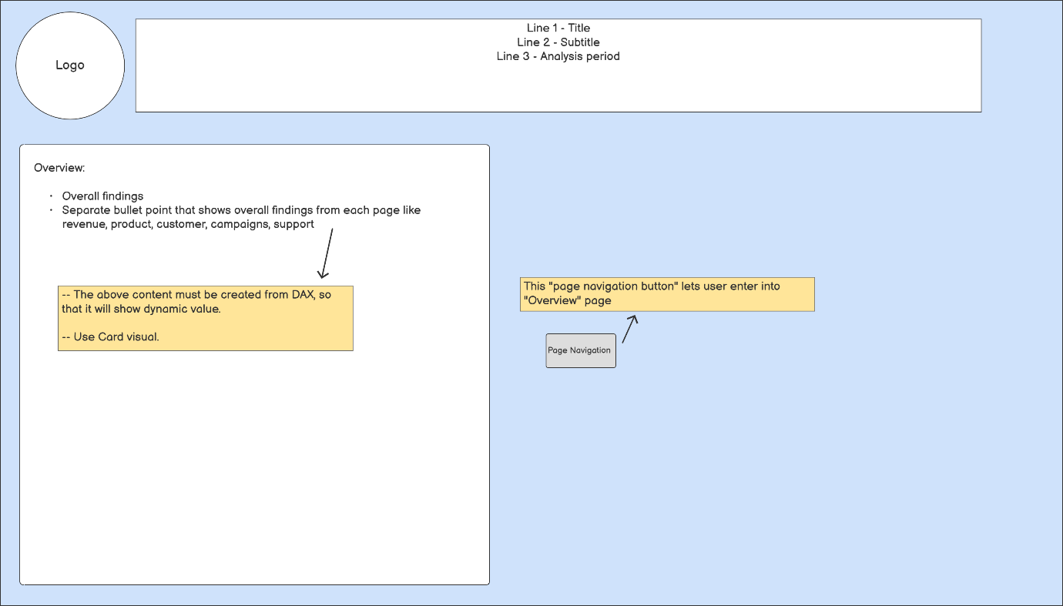

B.1.2 Overview Page Wireframe
🔗 This image is mapped to section 4.6 Wireframes and Visual References.
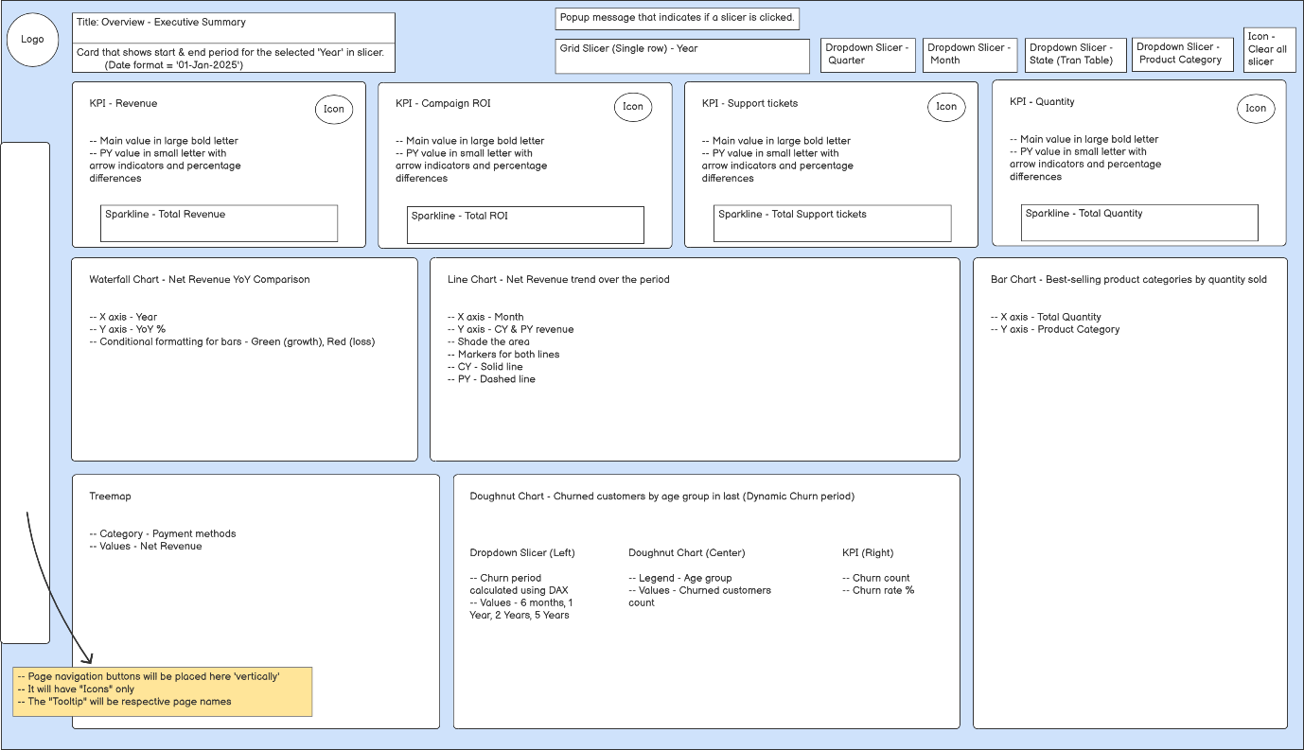

B.1.3 Revenue Page Wireframe
🔗 This image is mapped to section 4.6 Wireframes and Visual References.
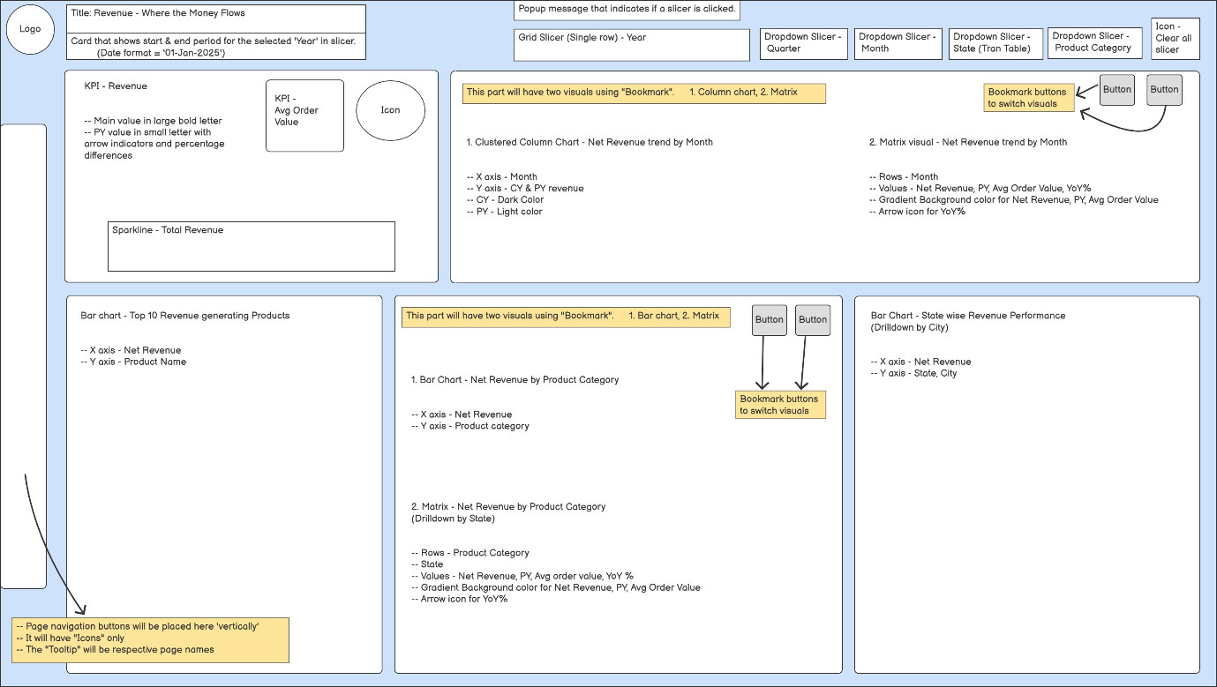

B.1.4 Products Page Wireframe
🔗 This image is mapped to section 4.6 Wireframes and Visual References.
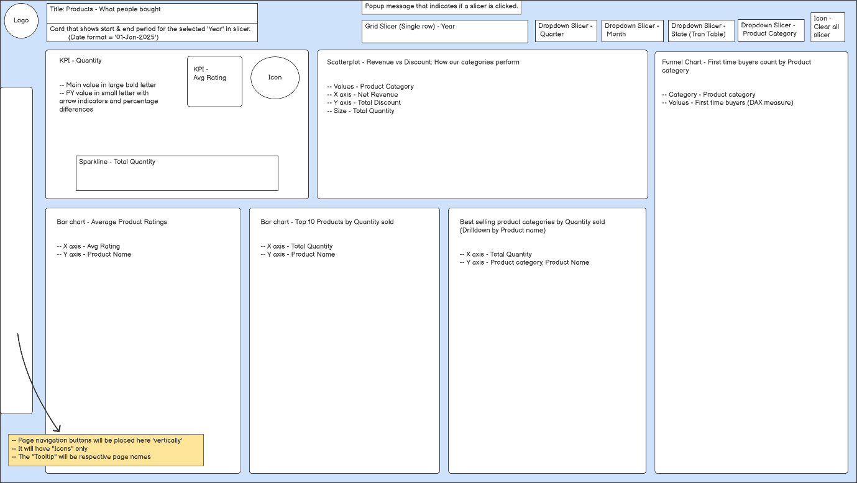

B.1.5 Customers Page Wireframe
🔗 This image is mapped to section 4.6 Wireframes and Visual References.
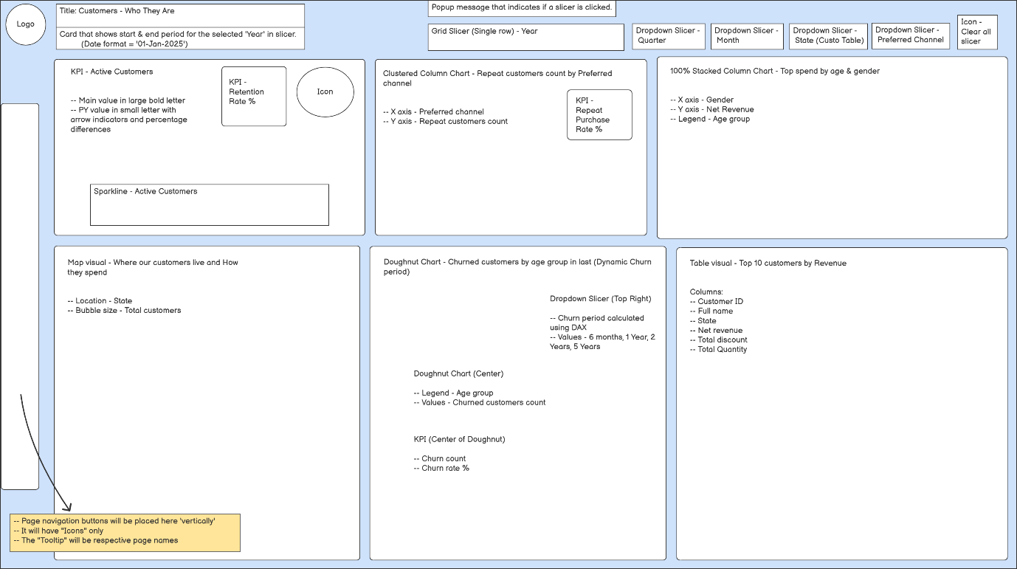

B.1.6 Campaigns Page Wireframe
🔗 This image is mapped to section 4.6 Wireframes and Visual References.
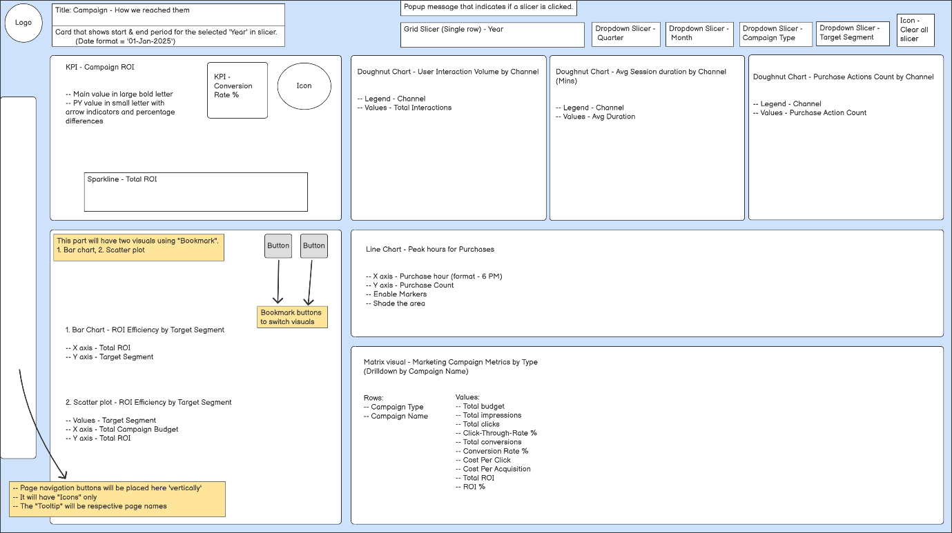

B.1.7 Support Tickets Page Wireframe
🔗 This image is mapped to section 4.6 Wireframes and Visual References.
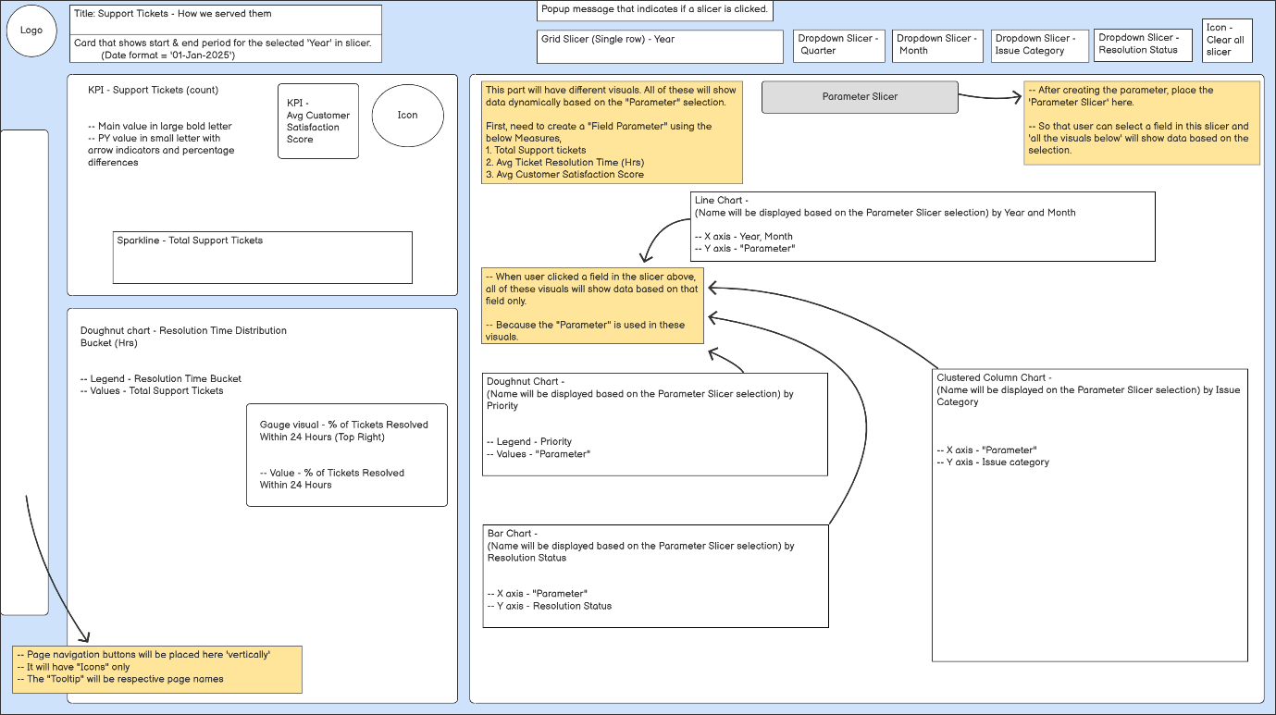

Appendix B.2 - Process Flow Diagrams

B.2.1 Current State Process Flow Diagram
This diagram outlines the fragmented manual reporting processes currently followed by Sales, Marketing and Support teams. It highlights system disconnects, lack of automation and absence of consolidated dashboards.
This image is referenced in:
🔗 Section - 3.3 Current State Process Flow
🔗 Section - 4.10 Gap Analysis Overview
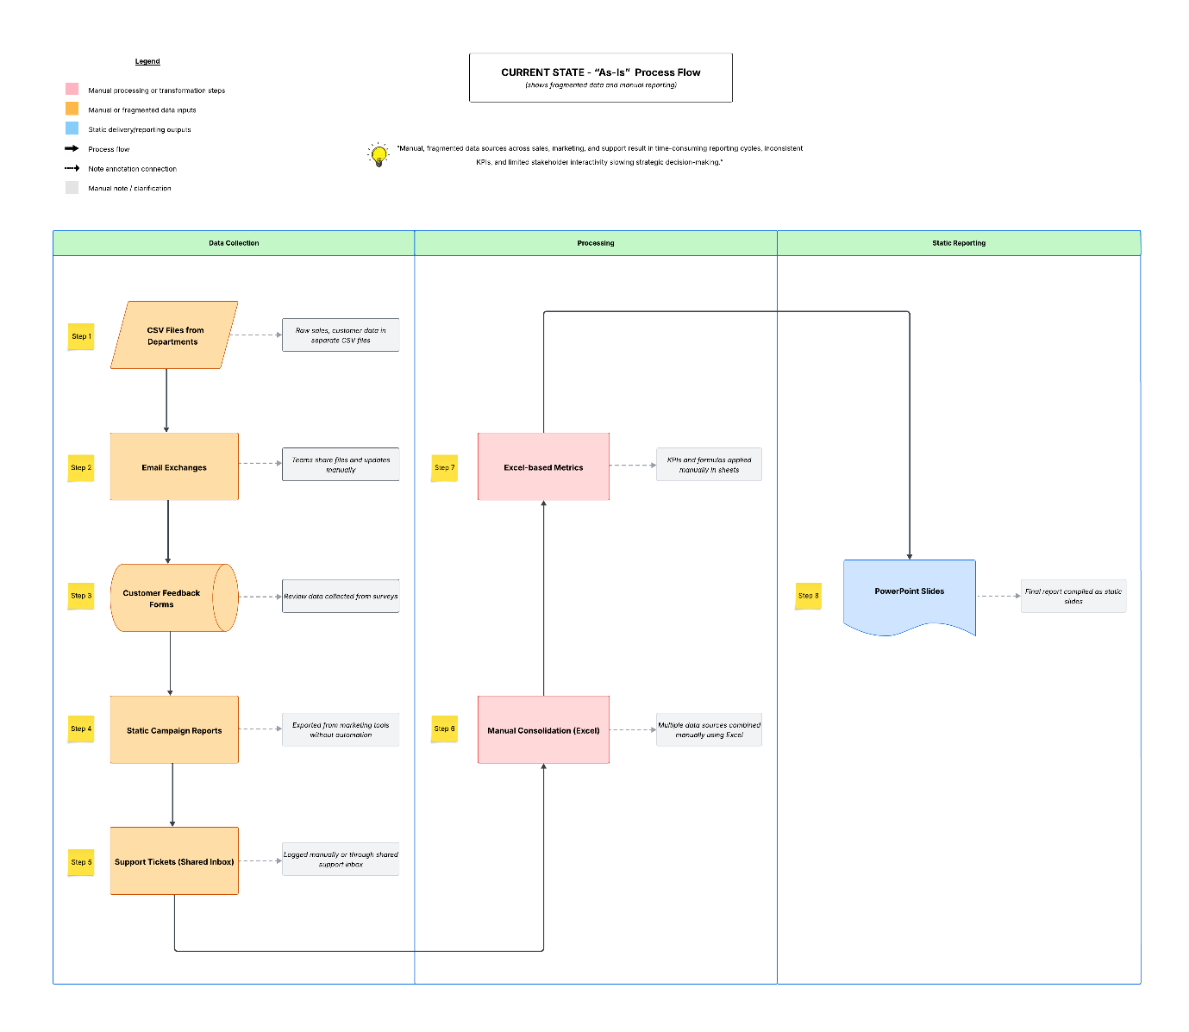

B.2.2 Future State Process Flow Diagram
This diagram illustrates the optimized, centralized reporting process using the Power BI solution. It shows automated data flows, stakeholder-specific access and integrated insights across departments.
This image is referenced in:
🔗 Section - 4.9 Future State Process Flow
🔗 Section - 4.10 Gap Analysis Overview
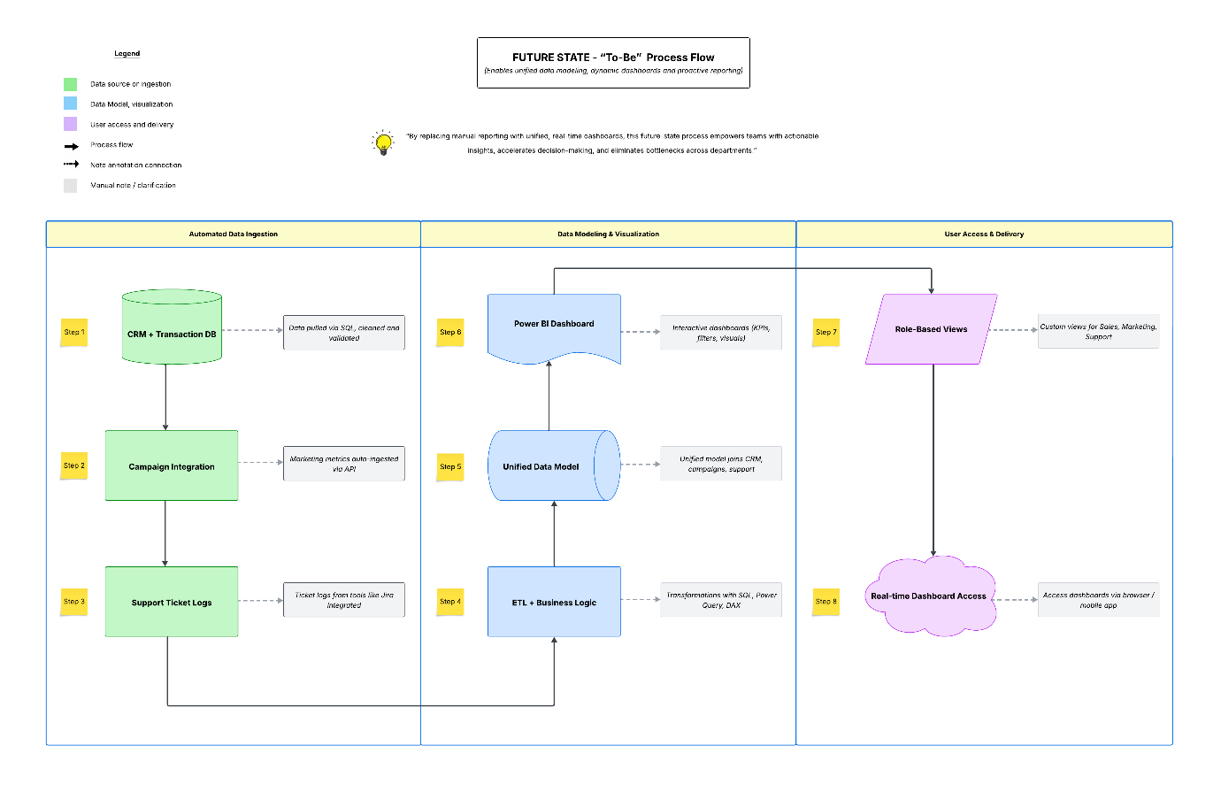

Appendix C.1 - Epic and User Story Tables
This appendix contains supporting tables referenced in Section 4.7, including epics, user stories with acceptance criteria and stakeholder access mapping. These artifacts provide clear traceability from business goals to functional roles and dashboard access.

C.1.1 Epic List
🔗 This table is mapped to section 4.7 Epics, User Stories and Stakeholder Access Permissions
Epic ID | Epic Name | Description
EP-01 | Executive Overview & KPIs | Track top-level business performance through KPIs and trends.
EP-02 | Sales & Regional Performance | Analyse revenue by region and product for sales optimization.
EP-03 | Marketing Campaign Insights | Evaluate campaign ROI and marketing performance across channels.
EP-04 | Customer & Support Operations | Monitor ticket volumes, SLAs, customer insights and high value customers to improve CX.
EP-05 | Dashboard Governance & Usability | Ensure data usability, consistency and maintainability of dashboards.
EP-06 | Data Infrastructure & Refresh | Provide clean, secure and updated datasets for reliable dashboards.

C.1.2 User Stories with Acceptance Criteria
🔗 This table is mapped to section 4.7 Epics, User Stories and Stakeholder Access Permissions
(Note: Click an Epic ID below to view ‘Epic List’ table)
Epic ID | User Story ID | User Story | Acceptance Criteria
EP-01  🔗 | US-01 | As a Project Sponsor,  I want to view key KPIs (total revenue, active customers, ROI) on the Overview page  so that I can evaluate business performance at a glance. | Given I access the Overview page,  When the page loads,  Then I should see KPI cards for Total Revenue, Active Customers and ROI.
EP-01  🔗 | US-02 | As a Project Sponsor,  I want to filter data by year, quarter, or month  so that I can compare performance trends across different time periods. | Given the Overview page is open,  When I select a filter option (Year, Quarter, or Month),  Then the data on all visuals updates accordingly.
EP-01  🔗 | US-03 | As a Project Sponsor,  I want to monitor churn rate in different age groups  so that I can analyse customer churn. | Given I view the Overview page,  When I look at the customer KPIs,  Then I should see related charts and tooltip insights for churn count.
EP-01  🔗 | US-04 | As Deepa Menon,  I want to access the Summary and Overview page with key visuals on revenue, campaign and churn  so that I can validate strategic performance outcomes prior to final approval. | Given I open the Summary and Overview page,  When I view all relevant visuals and KPIs,  Then I can assess alignment with strategic goals for final approval.
EP-02  🔗 | US-05 | As a Sales Manager,  I want to view revenue trends by product category over time  so that I can identify top-performing categories and adjust stock or promotions. | Given the category revenue visual is loaded,  When I select a time range,  Then I see revenue by category with dynamic sorting and tooltip metrics.
EP-02  🔗 | US-06 | As a Sales Manager,  I want to compare regional performance for top products  so that I can optimize marketing spend and resource distribution. | Given the regional comparison visual is loaded,  When I filter by region or product,  Then the visual ranks products by revenue and highlights top-performing regions.
EP-02  🔗 | US-07 | As a Sales Manager,  I want to view Year-over-Year revenue growth by month  so that I can detect seasonal patterns and measure business momentum. | Given the YoY Revenue visual is loaded,  When I select a year or month,  Then I see current and previous year's revenue and % change.
EP-02  🔗 | US-08 | As a Sales Manager,  I want to identify top revenue-generating products  so that I can spotlight high-performing items. | Given I open the Top Products chart,  When the report loads,  Then I see product names and net revenue, ranked by top 10.
EP-02  🔗 | US-09 | As a Sales Manager,  I want to track average product ratings  so that I can correlate customer satisfaction with revenue performance. | Given the ratings chart is available,  When I sort products,  Then I see product names with corresponding average rating.
EP-03  🔗 | US-10 | As a Marketing Analyst,  I want to monitor campaign ROI and conversion rate  so that I can evaluate campaign effectiveness. | Given I view the Campaign page,  When I access campaign visuals,  Then ROI and conversion rate are shown in tables or charts.
EP-03  🔗 | US-11 | As a Marketing Analyst,  I want to drill down into campaign performance by type and name  so that I can optimize future marketing spend. | Given I select a campaign type or name,  When I drill through the visual,  Then detailed breakdowns should be shown by that category.
EP-03  🔗 | US-12 | As a Marketing Analyst,  I want to compare user interaction, session duration and purchase actions across channels  so that I can identify high-performing touchpoints. | Given I open the channel performance visual,  When I compare metrics,  Then I should see session duration, bounce rate and purchases by channel.
EP-03  🔗 | US-13 | As a Marketing Analyst,  I want to track peak purchase hours so that I can schedule campaigns effectively. | Given I view the hourly sales chart,  When I analyse peak hours,  Then hourly trends should clearly highlight peak purchase times.
EP-03  🔗 | US-14 | As a Marketing Analyst,  I want to analyse ROI efficiency by target segment using bar and scatter plots  so that I can optimize targeting. | Given I apply segment filters,  When I view the ROI visuals,  Then ROI is displayed per segment using scatter/bar charts.
EP-04  🔗 | US-15 | As a Support Manager,  I want to monitor total support ticket volume and trends over time  so that I can manage staffing needs. | Given I view the Support page,  When the trend chart loads,  Then it displays ticket volume over time with comparison periods.
EP-04  🔗 | US-16 | As a Support Manager,  I want to analyse ticket resolution time buckets  so that I can identify SLA breaches. | Given ticket resolution data is loaded,  When I view the chart,  Then tickets are segmented into time buckets (e.g. 0-24h, 24-48h).
EP-04  🔗 | US-17 | As a Support Manager,  I want to compare average ticket resolution time, satisfaction scores and volume across parameters  so that I can identify service improvement areas. | Given the multi-metric visual loads,  When I compare agents or teams,  Then I see grouped averages by parameter.
EP-04  🔗 | US-18 | As a Support Manager,  I want to break down ticket data by priority, resolution status and issue category  so that I can manage performance at a detailed level. | Given support data is loaded,  When I interact with filters,  Then visuals update by issue category, resolution and priority.
EP-04  🔗 | US-19 | As a Support Manager,  I want to analyse repeat purchase behaviour by preferred channel  so that I can identify which touchpoints drive customer retention. | Given I access the Customers page,  When I view the Repeat Purchase visual,  Then I see repeat customer counts and rates by preferred channel.
EP-04  🔗 | US-20 | As a Support Manager,  I want to identify high-value customers  so that I can prioritize them for service and retention efforts. | Given the high-spend data is available,  When I view the Top Customers visual,  Then I see names and revenue totals for the top 10 spenders.
EP-04  🔗 | US-21 | As a Support Manager,  I want to detect high-risk churn segments by age and channel  so that I can initiate proactive retention measures. | Given churn data is based on last purchase dates,  When I view the segment breakdown visual,  Then I see churn rates by age group and preferred channel.
EP-05  🔗 | US-22 | As a Business Intelligence Engineer,  I want to define KPIs and dimensions for each dashboard page  so that reporting aligns with stakeholder needs. | Given I am drafting report specs,  When I define page-level metrics,  Then documentation reflects stakeholder-aligned KPIs.
EP-05  🔗 | US-23 | As a Business Intelligence Engineer,  I want to validate filters, slicers and drilldowns  so that I ensure dashboard usability and flexibility. | Given dashboard elements are built,  When I run a QA checklist,  Then all slicers, filters and drilldowns must work as expected.
EP-05  🔗 | US-24 | As a Business Intelligence Engineer,  I want to document all visuals and calculations  so that they can be easily maintained and scaled. | Given visuals and DAX are finalized,  When I create metadata,  Then it should cover all calculated fields and chart types.
EP-06  🔗 | US-25 | As a Data Engineer,  I want to provide clean, joined SQL datasets and schema views  so that dashboards load efficiently. | Given Power BI model is built,  When data is refreshed,  Then it uses cleaned and joined staging tables for performance.
EP-06  🔗 | US-26 | As a Data Engineer,  I want to schedule data refreshes regularly  so that stakeholders always see up-to-date information. | Given the report is deployed,  When a new day/hour begins,  Then data should be auto-refreshed and logged successfully.
EP-06  🔗 | US-27 | As a Data Engineer,  I want to apply role-level security if needed  so that users see only relevant data. | Given user roles are mapped,  When I set RLS rules,  Then access is restricted as per user role in Power BI.

C.1.3 Stakeholder Access and Functional Use Mapping.
🔗 This appendix complements section 4.5 Role-Based Access Matrix by aligning individual stakeholders with the specific report pages they access and the business objectives they fulfil. It enhances traceability between user needs and dashboard design decisions.
🔗 This table is cross-referenced with section 4.7 Epics, User Stories and Stakeholder Access Permissions.
Stakeholder | Page Accessed | Purpose / Use Case
Project Sponsor  (Priya Ramanathan - Director, Sales) | Summary, Overview | Track high-level KPIs like Revenue, Churn, ROI across time
Strategic Validator  (Deepa Menon – Director, Sales) | Summary, Overview | Review revenue, campaign and churn insights to validate strategic outcomes for final approval
Sales Manager  (Regional Leads) | Overview, Revenue, Products | Monitor revenue by region and top-selling products
Marketing Analyst (Campaign Strategist) | Campaigns | Measure campaign performance, ROI and targeting efficiency
Support Manager  (CX Leads) | Support Tickets, Customers | Analyse ticket volume, SLA trends, churn and customer retention metrics
Business Intelligence Engineer (Sudhagar) | All Pages | Define and validate KPIs, filters and layout for all users
Data Engineer / DBA | (Back-end Only) | Provide SQL data model, schedule refresh and manage schema

Appendix D.1 - Use Case Mapping
This appendix outlines the detailed use case mappings that describe how various stakeholders interact with the reporting system. Each use case supports a specific business goal and aligns with related user stories, dashboard sections and role-based access.

D.1.1 Use Case Details
🔗 This table is mapped to section 4.8 Use Case Overview
Use Case ID | Title | Primary Actor | Brief Description | User Story ID | Dashboard Section | Pre-Condition | Post-Condition
UC-01 | View Summary Page Insights | Project Sponsor | View key takeaways from all pages including revenue, customer, and campaigns | US-01, US-04 | Summary | User has report access and valid credentials. | Summary page opens with narrative insights across business metrics.
UC-02 | Validate Summary Page Metrics | Business Intelligence Engineer | Verify if DAX-driven bullet insights match defined KPIs and stakeholder needs | US-22, US-24 | Summary | Summary cards and narrative visuals are built | Validated definitions and layouts meet business expectations.
UC-03 | Filter Overview KPIs by Time | Project Sponsor | Use date slicers to compare performance across years or quarters | US-02 | Overview | Slicers available and data model supports time | KPI visuals dynamically update per date selection.
UC-04 | Monitor Churn by Age group | Project Sponsor | Analyse churn count data by Age group using churn period slicer | US-03 | Overview | Customer churn count data exists | Related visuals show churn count by age group
UC-05 | Review Revenue by Region & Category | Sales Manager | Analyse revenue split by region and product category | US-05, US-06 | Revenue | Sales and product data loaded | Visuals display YoY growth and regional revenue trends.
UC-06 | View Top Products and Ratings | Sales Manager | Identify top 10 products and their average ratings | US-08, US-09 | Products | Product and rating data available | Visuals show sorted product revenue and customer satisfaction ratings.
UC-07 | Evaluate Campaign ROI & Conversions | Marketing Analyst | Monitor campaign ROI and drill into types or channels | US-10, US-11, US-14 | Campaigns | Campaign-level data populated | Charts show conversion, ROI, and channel-based insights.
UC-08 | Compare Ticket Trends & SLA | Support Manager | Review total ticket volume, resolution times, and SLA breaches | US-15, US-16, US-17 | Support Tickets | Tickets and timestamps present | Trendlines and charts reflect ticket handling performance.
UC-09 | Segment Customer Retention Insights | Support Manager | Analyse repeat purchase behaviour and churn by demographics and channel | US-18, US-19, US-20, US-21 | Customers | Customer and transaction data joined | Visuals show repeat customers, churn % by age group/channel, and top customers.
UC-10 | QA Filters and Slicers Functionality | Business Intelligence Engineer | Validate that all filters, slicers and drilldowns work correctly | US-23 | All Pages | Test cases and QA checklist available | Slicers and interactions behave as expected on all relevant pages.
UC-11 | Schedule Data Refresh Jobs | Data Engineer | Automate daily/hourly data refresh in Power BI | US-26 | Back-end (not visual) | Data pipeline and schedule are set | Dashboards reflect up-to-date metrics after scheduled loads.
UC-12 | Apply Role-Level Security (RLS) | Data Engineer | Restrict data access based on user roles | US-27 | All Pages | RLS mapping and logic defined | Users see only authorized data as per their roles.

D.1.2 Actor-Use Case Matrix
The following matrix provides a high-level view of which stakeholder roles are associated with specific use cases.
🔗 This table is mapped to section 4.8 Use Case Overview
(Note: “Project Sponsor” in UC-01 includes validation role fulfilled by Deepa Menon, Sales Director, as per US-04)
Actor | Relevant Use Cases
Project Sponsor | UC-01, UC-03, UC-04
Sales Manager | UC-05, UC-06
Marketing Analyst | UC-07
Support Manager | UC-08, UC-09
Business Intelligence Engineer | UC-02, UC-10
Data Engineer | UC-11, UC-12

