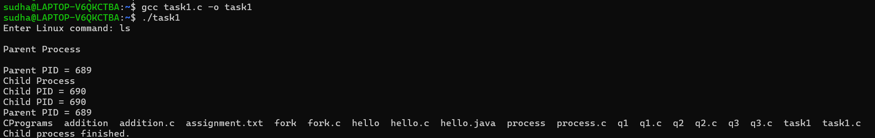
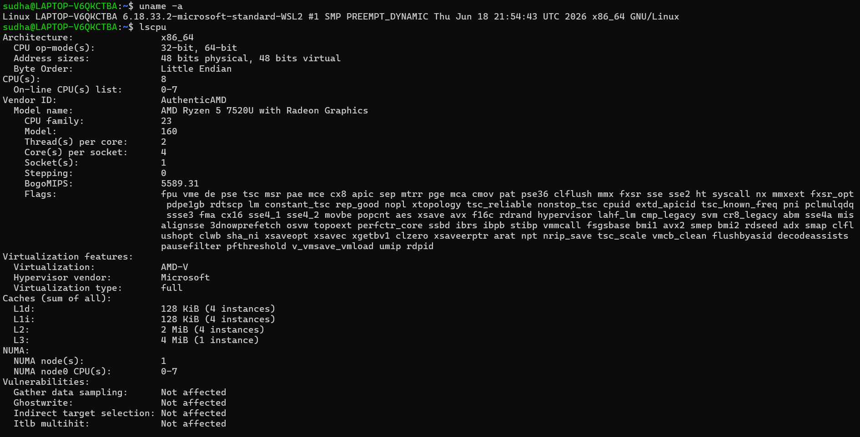
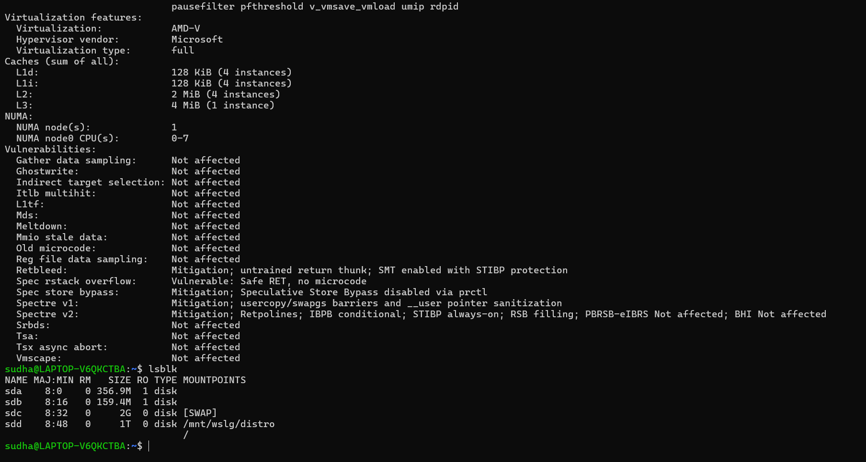
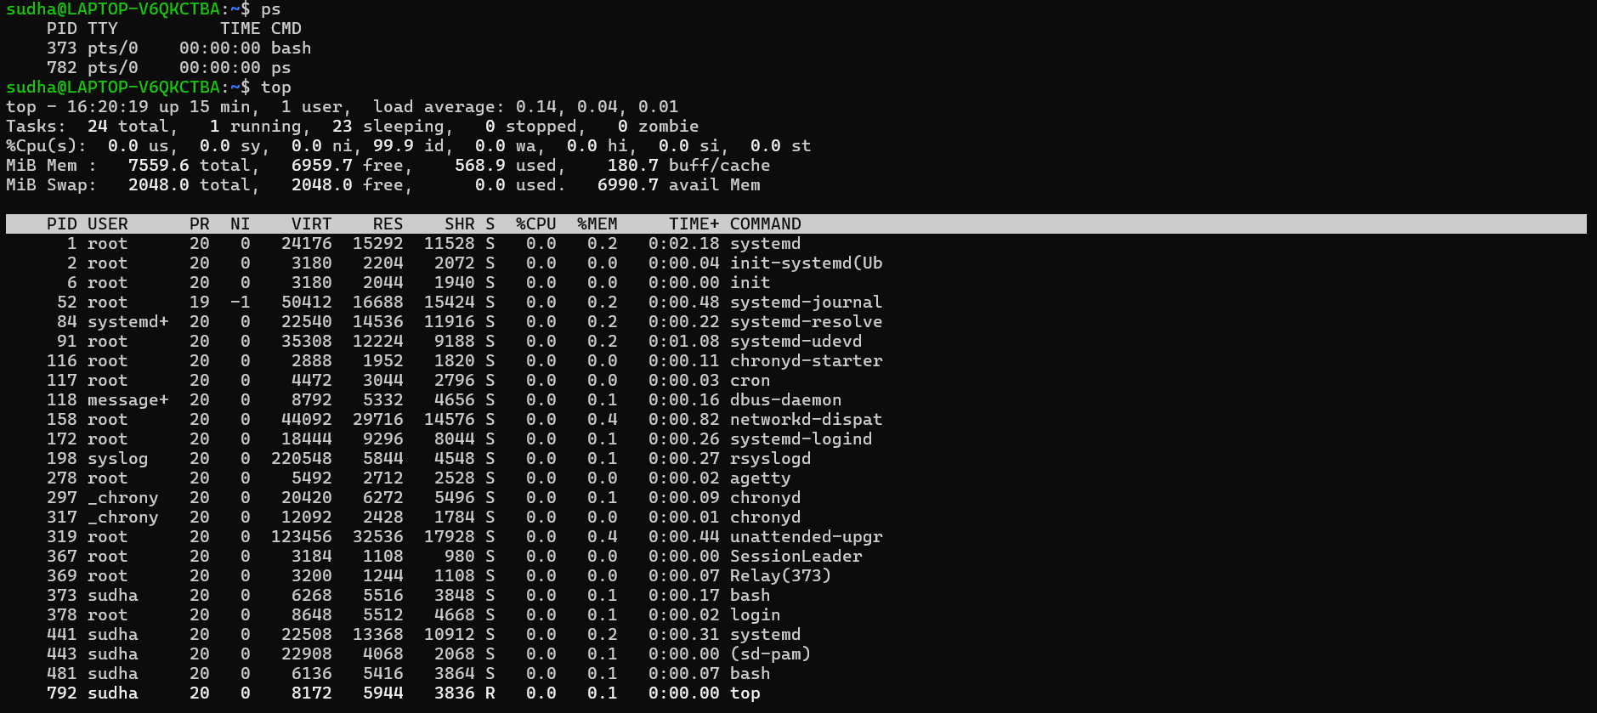
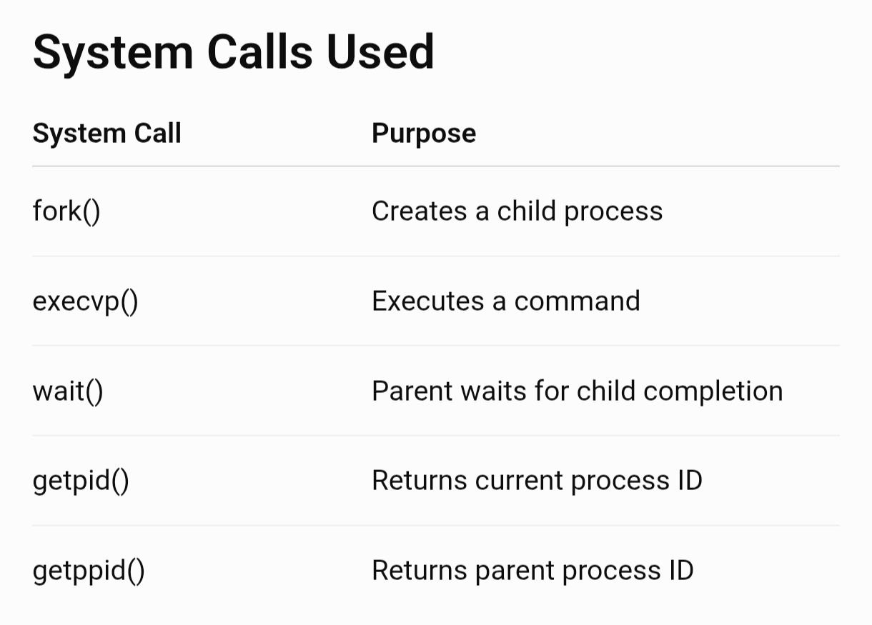

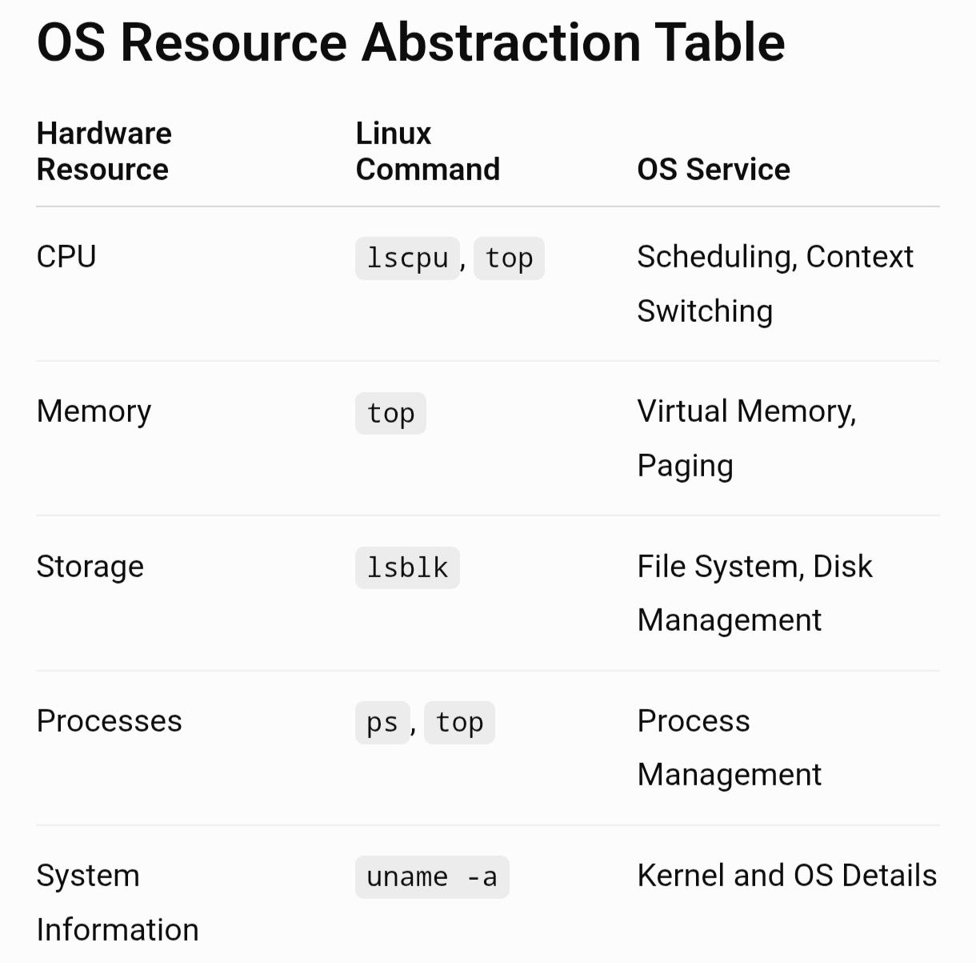

Report
- CPU: lscpu displays processor details such as cores, threads and architecture. The OS abstracts CPU resources through processes and scheduling.
- Memory: The OS manages RAM and provides each process with its own virtual address space.
- Storage: lsblk shows storage devices and partitions. The OS provides files and directories instead of requiring programs to directly control disks.
- I/O Devices: The OS uses device drivers to communicate with hardware and provides standard interfaces to applications.
- Processes: ps and top show running processes, CPU usage and memory usage.
- Overall abstraction: The OS hides hardware complexity and provides applications with simple interfaces such as files, processes, virtual memory and system calls.

