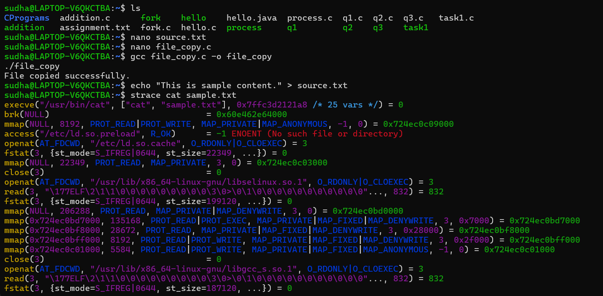
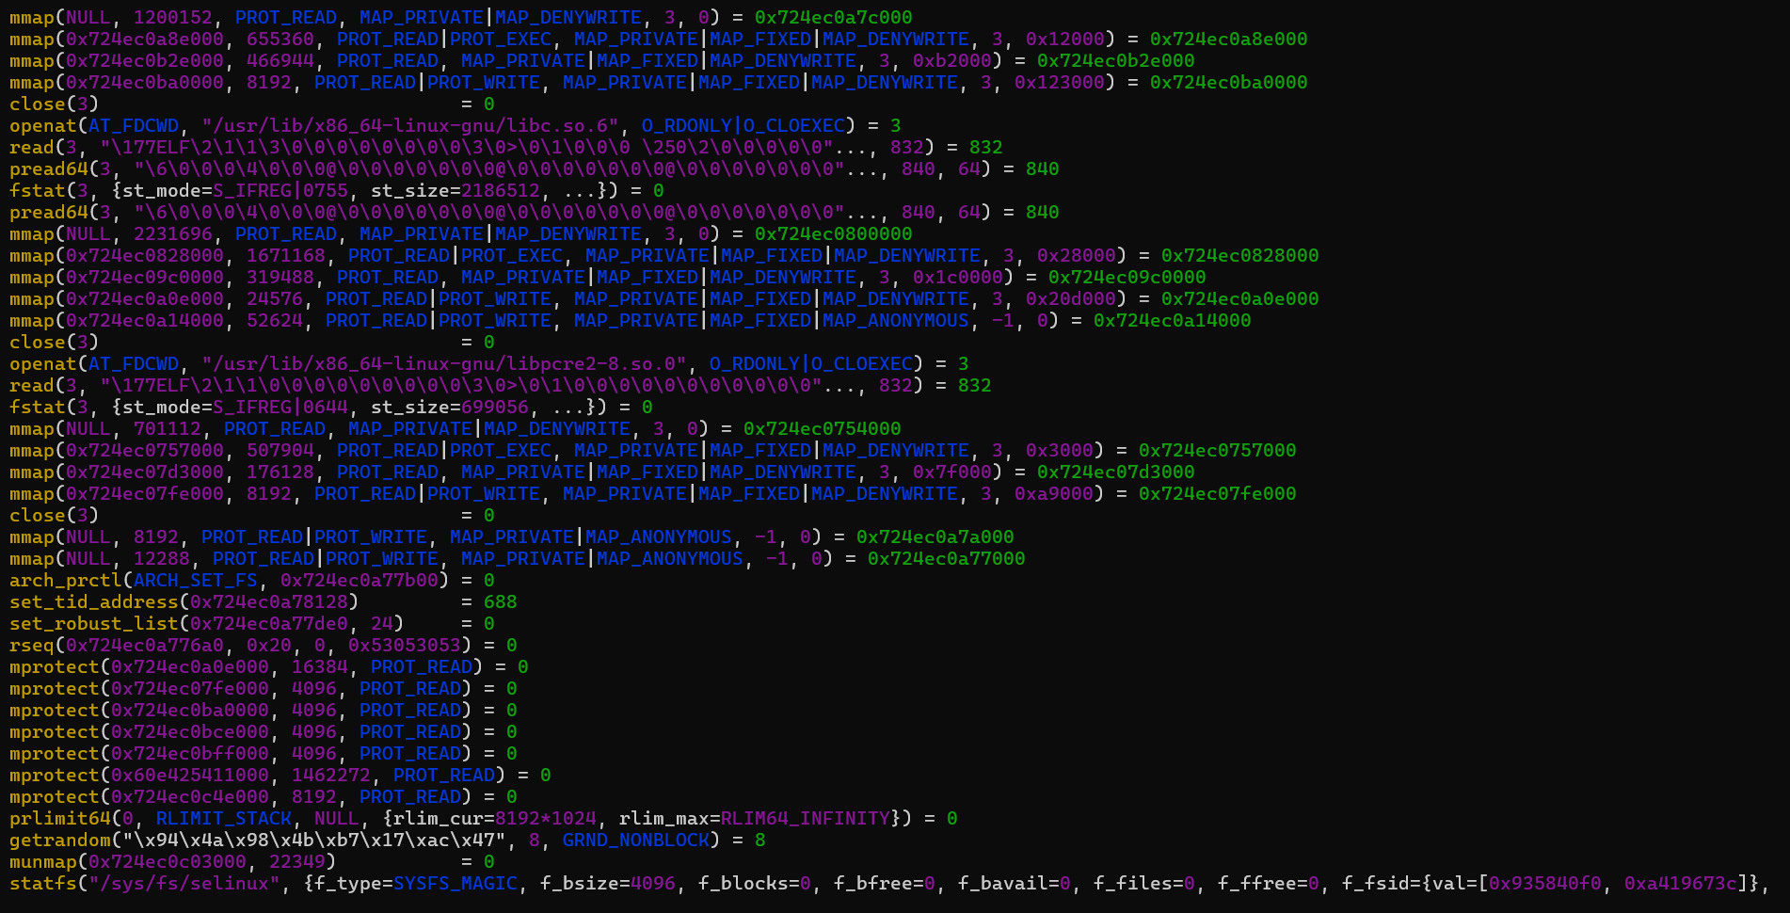
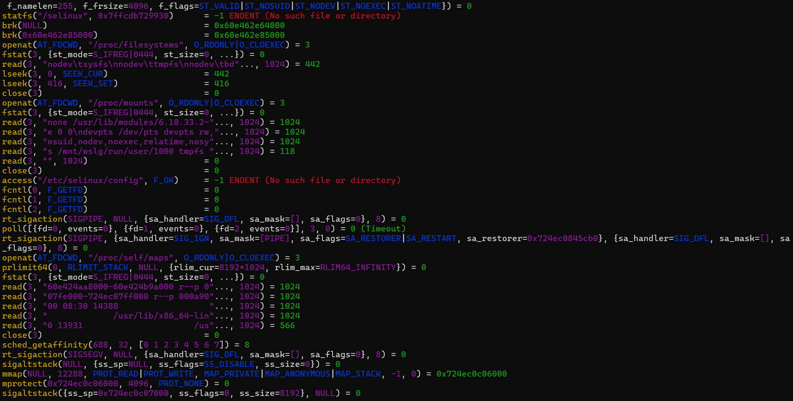
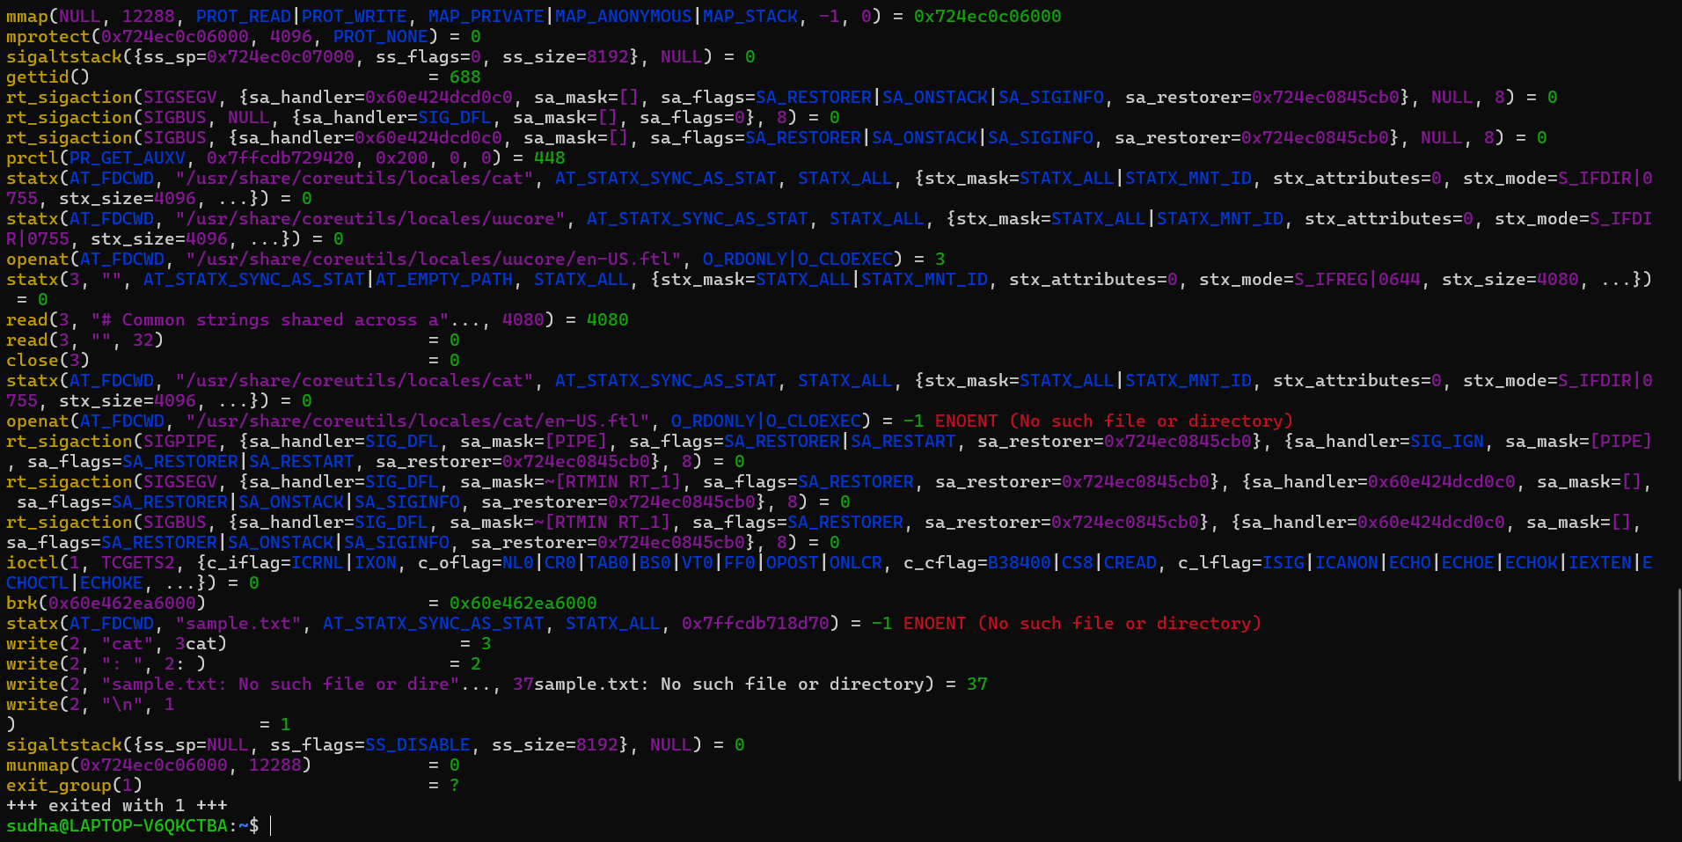

Analysis
- execve() starts the cat program.
- openat() requests the kernel to open sample.txt.
- read() transfers file data from kernel space to user space.
- write() sends the data to the terminal.
- close() releases the file descriptor.
- strace records the interaction between the user program and kernel.
- System calls provide the controlled transition from user space → kernel space → user space.

User space and kernel space
- The C program runs in user space.
- When open(), read(), write(), or close() is called, control enters kernel space.
- The kernel performs the requested operation using file-system and device services.
- The result is returned to the program in user space.

