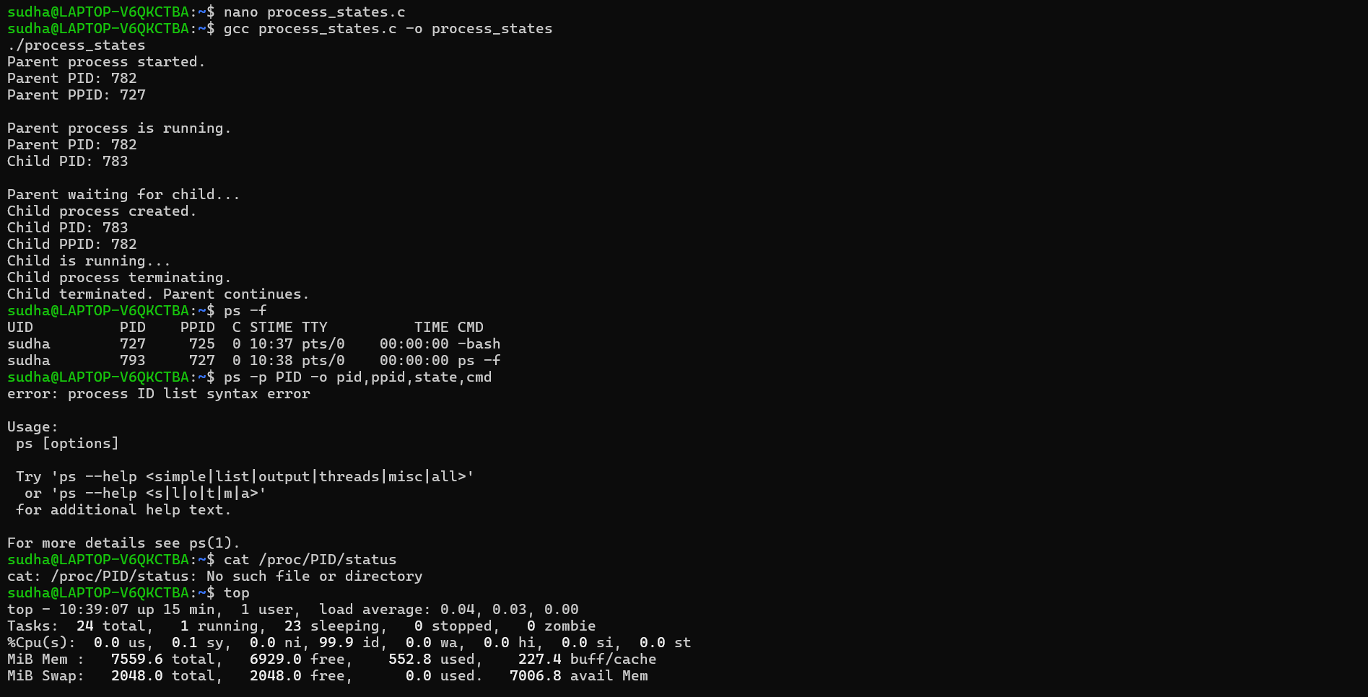
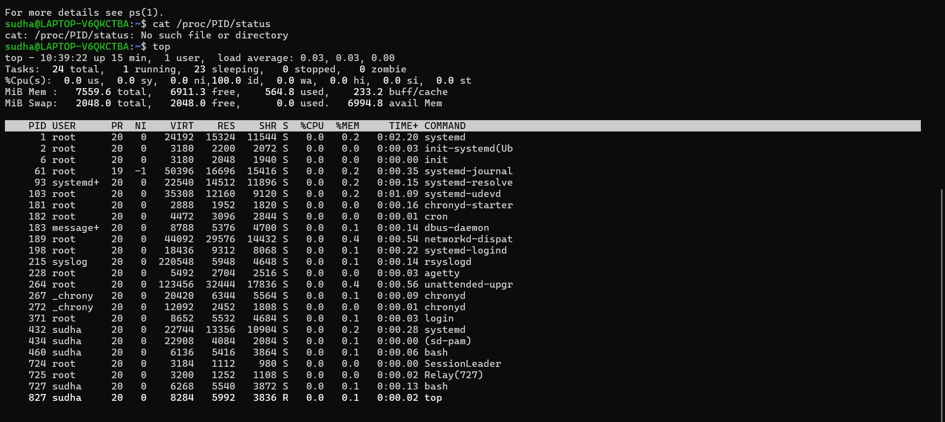
Process state experiment
State | Observation
Ready | Process is created and waiting for CPU scheduling.
Running | Process is executing instructions.
Waiting | Process waits for an event or operation such as sleep() or wait().
Terminated | Process finishes execution and exits.

