
(An Autonomous Institution, Affiliated to Anna University, Chennai)
MINI PROJECT
ONLINE FOOD DELIVERY ORDERS ANALYSIS AND VISUALIZATION USING PYTHON, POWER BI, AND TABLEAU
Framework for Data Visual Analytics
SUDHAKAR M
241501220

ABSTRACT
This mini project, carried out for the subject Framework of Data Visualization and Analytics (FDVA), analyses an Online Food Delivery Orders dataset using Python, Microsoft Power BI and Tableau. The dataset is stored in a file named foodOrders.csv and contains 200 order records with 18 columns, such as city, restaurant, cuisine, payment mode, order value, discount, delivery fee, distance, delivery time, customer rating and order date. The raw data had inconsistent text entries, mixed date formats, numeric values stored as text and missing values in three columns. Python with Pandas was used to correct these problems, create new columns such as Final_Amount and Discount_Percentage, and save a cleaned file with 200 rows and 23 columns. Matplotlib and Seaborn were then used to create eight charts, including restaurant-wise orders, payment mode share, a monthly trend and a correlation heatmap. Interactive dashboards were also developed in Power BI and Tableau, with slicers for city, cuisine and payment mode, KPI cards and charts by city. The analysis showed that Mumbai had the most orders, UPI was the most used payment mode, delivery time increased steadily with distance, and the total order value after discounts was about ₹54,412 for all 200 orders. The project shows how preprocessing, charts and dashboards turn raw order records into clear information that can support business decisions.

1. Data Preprocessing
The dataset (foodOrders.csv) has 200 rows and 18 columns. It was cleaned in Python using Pandas, as shown below.

1.1 Loading and inspecting the data
df = pd.read_csv("foodOrders.csv")
df.shape # (200, 18)
df.info()
Order value, discount, delivery time and order date were stored as text and had to be converted.

1.2 Missing values and duplicates
print(df.isnull().sum())
print("Duplicate rows:", df.duplicated().sum())
Customer_Age (10), Delivery_Time_Min (14) and Customer_Rating (30) had missing values. No duplicate rows were found (0).

1.3 Fixing data types and filling missing values
df["Delivery_Time_Min"] = pd.to_numeric(
df["Delivery_Time_Min"].astype(str).str.replace(
r"\s*mins?\s*$", "", regex=True, case=False),
errors="coerce")
df["Delivery_Time_Min"] = df["Delivery_Time_Min"].fillna(
df["Delivery_Time_Min"].median())
# same steps for Customer_Age and Customer_Rating
Units such as “min” and “mins” were removed, the columns were converted to numbers, and the missing values were filled with the median. After this, every column had 0 missing values.

1.4 Standardising text values
df["Customer_Gender"] = df["Customer_Gender"].astype(str).str.strip().str.upper()
df["Customer_Gender"] = df["Customer_Gender"].replace({"M": "MALE", "F": "FEMALE"})
df["Coupon_Used"] = df["Coupon_Used"].replace(
{"Y": "YES", "N": "NO", "1": "YES", "0": "NO"})
df["Payment_Mode"] = df["Payment_Mode"].astype(str).str.strip().str.upper()
The same answer was written in many ways (for example M, male, MALE). These were converted to one form for Customer_Gender, City, Payment_Mode and the Yes/No columns. Order_Value_INR and Discount_INR contained symbols such as “Rs.” and “₹”; these were removed with a regular expression and the columns were converted to numbers.

1.5 Converting the order date
df["Order_Date"] = pd.to_datetime(
df_original["Order_Date"].astype(str).str.strip(),
format="mixed", dayfirst=True, errors="coerce")
df["Order_Month"] = df["Order_Date"].dt.month
df["Order_Month_Name"] = df["Order_Date"].dt.month_name()
The first attempt with a single date format left 143 dates missing, so the original column was parsed again with format='mixed'. After this, no date was missing (0).

1.6 New columns and export
df["Final_Amount"] = (df["Order_Value_INR"] - df["Discount_INR"]
+ df["Delivery_Fee_INR"])
df["Discount_Percentage"] = df["Discount_INR"] / df["Order_Value_INR"] * 100
df.to_csv("Cleaned_Food_Orders.csv", index=False) # shape (200, 23)
Five columns were added (Order_Month, Order_Month_Name, Order_Quarter, Final_Amount, Discount_Percentage). The cleaned dataset with 200 rows and 23 columns was saved and used for the visualizations and dashboards.

2. Data Visualization Using Python
Eight charts were created from the cleaned data using Pandas, Matplotlib and Seaborn (sns.set_theme(style="whitegrid")). Each chart is explained briefly below.
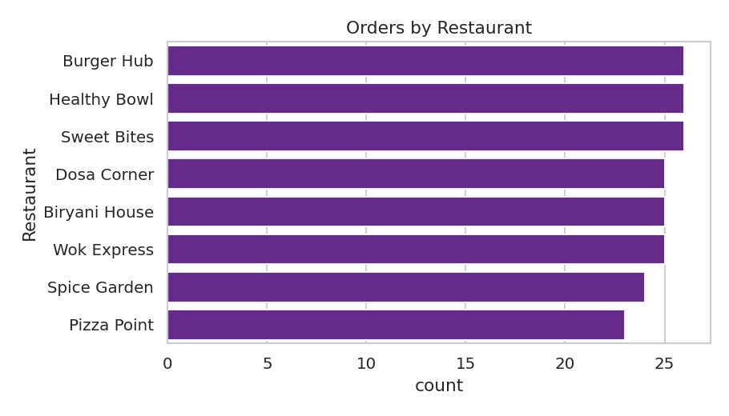
Figure 2.1: Restaurant-wise orders (sns.countplot)
Result: Burger Hub, Healthy Bowl and Sweet Bites have the most orders (26 each); Pizza Point has the fewest (23).
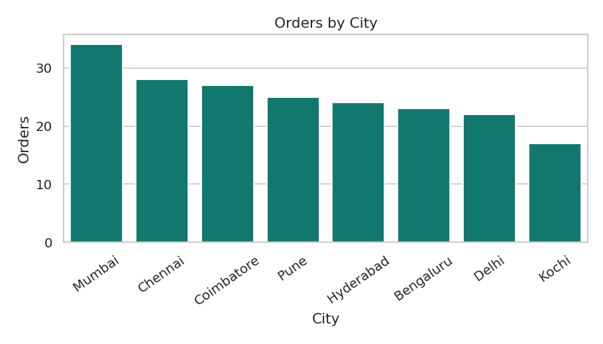
Figure 2.2: Orders by city (bar chart)
Result: Mumbai leads with 34 orders; Kochi has the fewest with 17.
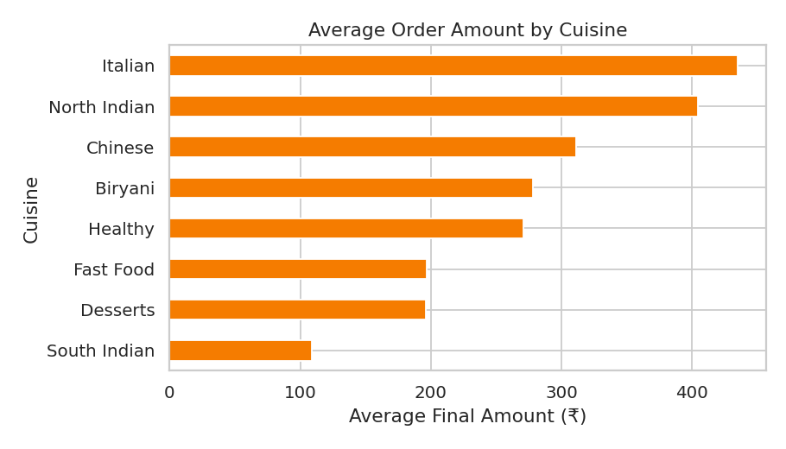
Figure 2.3: Average final amount by cuisine
Result: Italian is highest (about ₹435); South Indian is lowest (about ₹109).
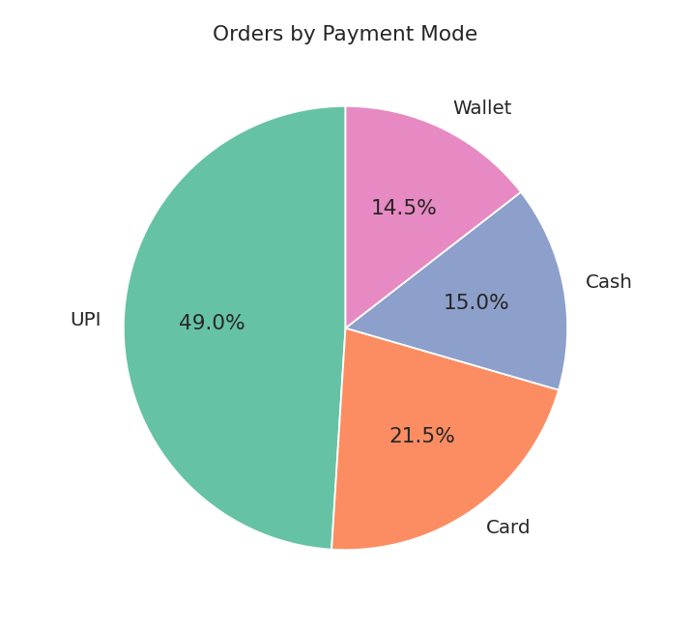
Figure 2.4: Orders by payment mode (pie chart)
Result: UPI 49%, Card 21.5%, Cash 15%, Wallet 14.5%.
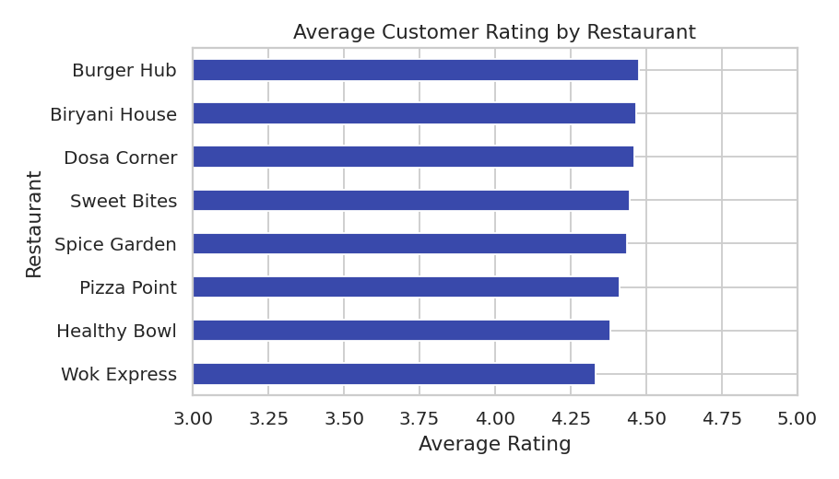
Figure 2.5: Average customer rating by restaurant
Result: Burger Hub is highest (4.48) and Wok Express lowest (4.33); all restaurants are close.
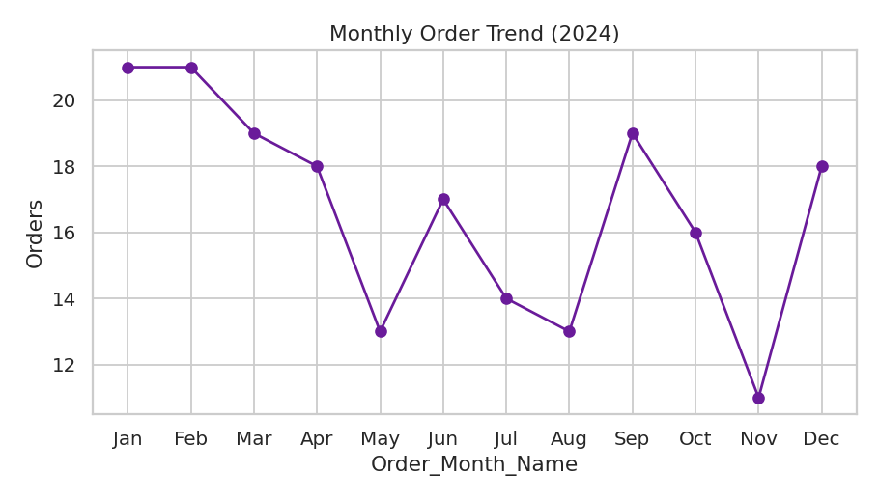
Figure 2.6: Monthly order trend (line chart)
Result: Orders vary between 11 and 21 per month, with the highest in January and February and the lowest in November.
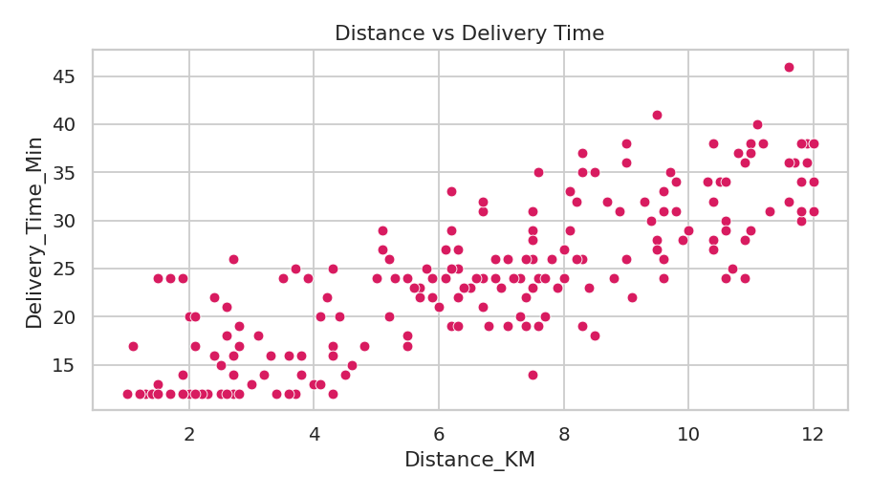
Figure 2.7: Distance vs delivery time (scatter plot)
Result: Delivery time rises steadily with distance (correlation 0.82); very short trips take about 12 to 15 minutes.
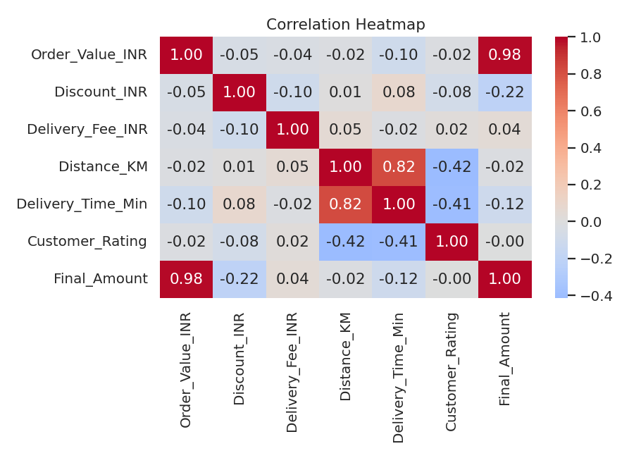
Figure 2.8: Correlation heatmap
Result: Order_Value_INR and Final_Amount are strongly related (0.98) and Distance_KM and Delivery_Time_Min are strongly related (0.82). Customer_Rating falls slightly as distance and delivery time increase (about -0.4); other pairs are weak.
Overall, orders are spread fairly evenly across restaurants and cities, UPI is the preferred way to pay, and longer delivery distance means longer waiting time and slightly lower customer ratings.

3. Power BI Dashboard
Power BI was used to build a one-page interactive dashboard from the cleaned food orders data (Cleaned_Food_Orders.csv).
[ Insert Power BI dashboard screenshot here ]
Figure 3.1: Food Orders Dashboard in Power BI
- Slicers: City, Cuisine, Payment_Mode and Restaurant filter the whole page; a Order_Month slicer is placed at the top.
- KPI cards: Total Final Amount ₹54.4K, Orders 200, Total Discount ₹5.4K and Avg. Rating 4.43.
- Charts: a donut chart of orders by payment mode, final amount by restaurant, final amount by city, a map of cities, and orders by month name.
- Insights: Mumbai leads in sales (about ₹11.2K), followed by Chennai (₹8K) and Coimbatore (₹7.5K); Pizza Point (₹10K) and Spice Garden (₹9.7K) lead among restaurants.
- Note: the month chart should be sorted by month number and not by value, so that it appears in calendar order.

4. Tableau Dashboard
Tableau was used to build the “Food Delivery Performance & Business Insights Dashboard” from the same cleaned data.
[ Insert Tableau dashboard screenshot here ]
Figure 4.1: Food Orders Dashboard in Tableau
- Filters: City, Restaurant, Cuisine and Payment Mode check lists, and an Order Month slider (January–December).
- KPIs: Total Sales ₹54,412, Orders 200, Average Order Value ₹272 and Average Delivery Time 24.2 minutes.
- Charts: monthly sales trend, sales by cuisine (pie), orders by order type (donut), India map of cities, and sales by city (bar).
- Insights: Mumbai has the highest sales and Delhi the lowest; Italian (₹10K) and North Indian (₹9.7K) are the largest cuisines; delivery orders (144) are far more than takeaway orders (56).

5. Steps to Build the Dashboards (Reference)
The following steps can be followed to create the two dashboards and capture the screenshots for Figures 3.1 and 4.1. This page may be removed from the final submission.

5.1 Power BI
- Open Power BI Desktop → Get Data → Text/CSV → select Cleaned_Food_Orders.csv → Load.
- Check that Order_Date is Date type and Final_Amount is Decimal number in the Data view.
- Insert four Card visuals: Sum of Final_Amount, Count of Order_ID, Sum of Discount_INR, Average of Customer_Rating.
- Insert a Donut chart (Legend = Payment_Mode, Values = Count of Order_ID), and Clustered bar charts for Restaurant and City (Values = Sum of Final_Amount).
- Insert a Map visual with City as Location and Final_Amount as Size.
- Insert a Column chart with Order_Month_Name on the axis; use Sort axis → Order_Month for calendar order.
- Add Slicers for City, Cuisine, Payment_Mode and Restaurant, then take a screenshot of the full page.

5.2 Tableau
- Open Tableau → Connect → Text file → select Cleaned_Food_Orders.csv.
- Create sheets: Monthly Sales (Order_Date by month on Columns, Final_Amount on Rows), Sales by Cuisine (pie), Order Type (donut), City Map (double-click City), Sales by City (bar).
- Create KPI sheets using Final_Amount, Order_ID count, average Order_Value_INR and average Delivery_Time_Min.
- Add filters for City, Restaurant, Cuisine and Payment Mode → Show Filter, and apply them to all worksheets.
- Create a new Dashboard, drag the sheets in, add the title and take a screenshot.

