Question 1:
mysql> SELECT o.orderNumber,p.productName,c.customerName,pm.amount,pm.checkNumber
-> FROM orders o
-> JOIN orderdetails od
-> ON o.orderNumber = od.orderNumber
-> JOIN products p
-> ON od.productCode = p.productCode
-> JOIN customers c
-> ON o.customerNumber = c.customerNumber
-> JOIN payments pm
-> ON pm.customerNumber = c.customerNumber
-> WHERE o.orderNumber=10100;

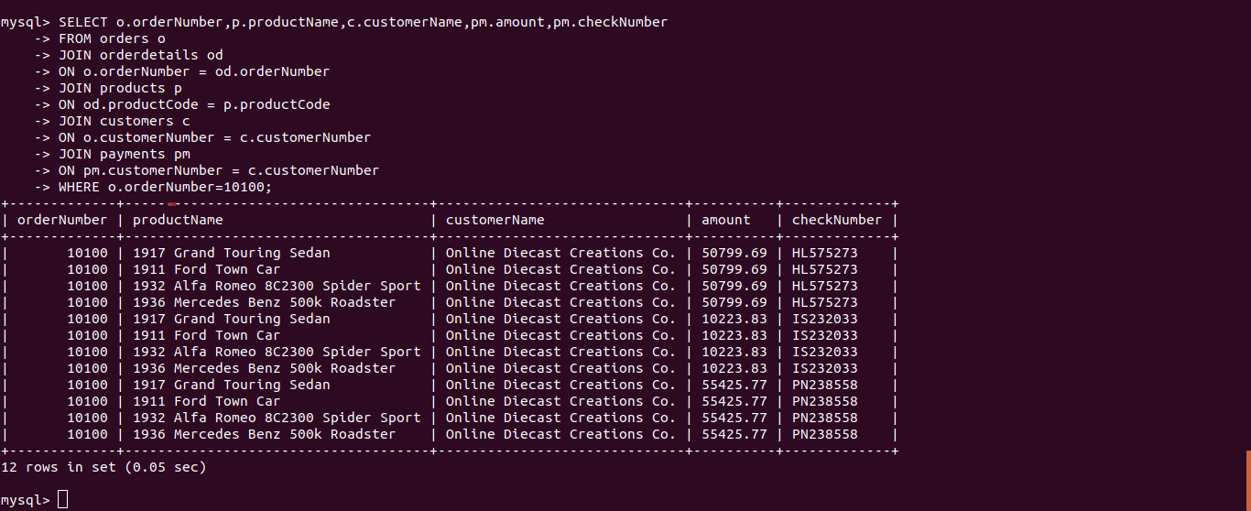

Question 2:

mysql> SELECT o.orderNumber,SUM(pm.amount) AS total_paid_amount_for_the_order_10110
-> FROM orders o
-> JOIN orderdetails od
-> ON o.orderNumber = od.orderNumber
-> JOIN products p
-> ON od.productCode = p.productCode
-> JOIN customers c
-> ON o.customerNumber = c.customerNumber
-> JOIN payments pm
-> ON pm.customerNumber = c.customerNumber
-> WHERE o.orderNumber=10100;
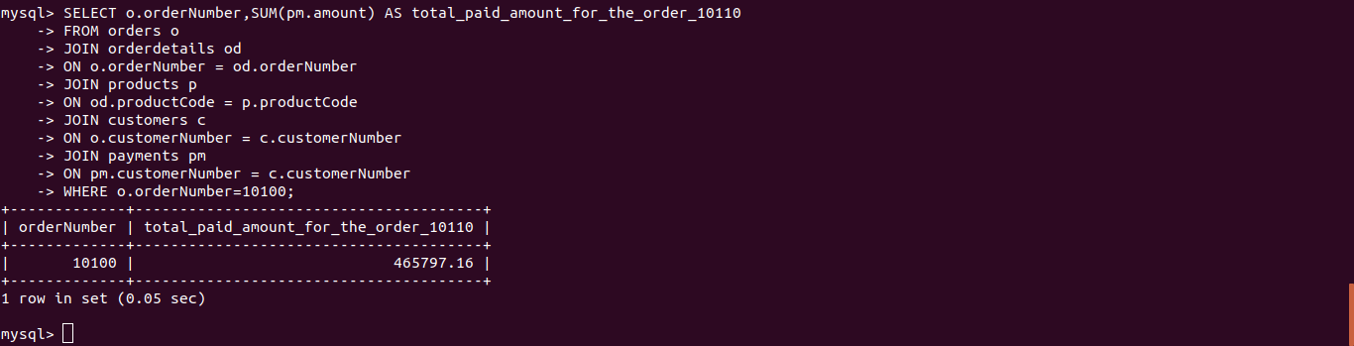

Question 3:
mysql> SELECT DISTINCT o.orderNumber,pm.checkNumber
-> FROM orders o
-> JOIN orderdetails od
-> ON o.orderNumber = od.orderNumber
-> JOIN products p
-> ON od.productCode = p.productCode
-> JOIN customers c
-> ON o.customerNumber = c.customerNumber
-> JOIN payments pm
-> ON pm.customerNumber = c.customerNumber
-> WHERE o.orderNumber=10100;
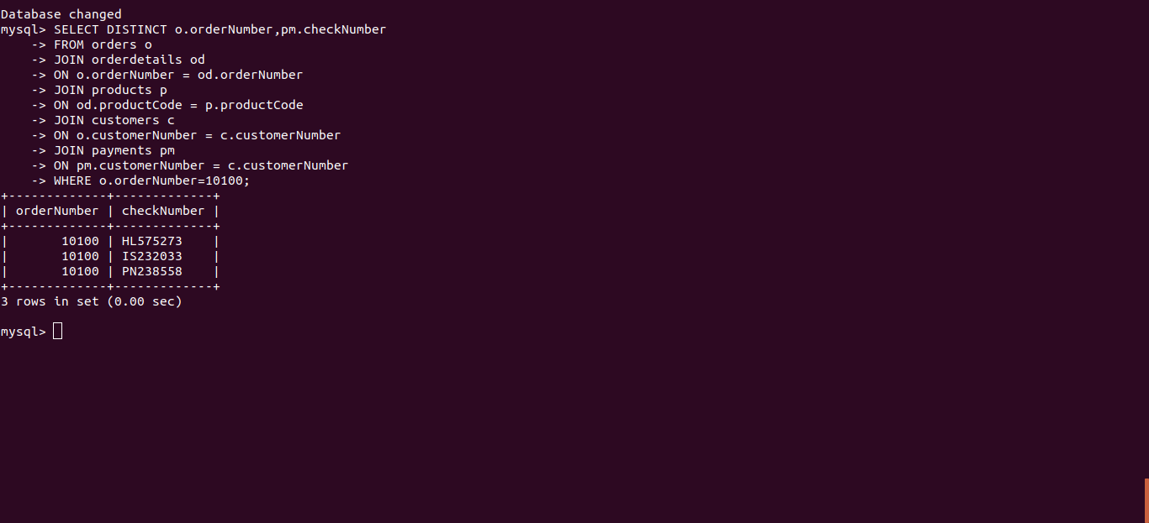

Question 4:

mysql> SELECT MIN(quantityInStock) AS min_value_in_quantityInStock,
-> MAX(quantityInStock) AS max_value_in_quantityInStock
-> FROM products;
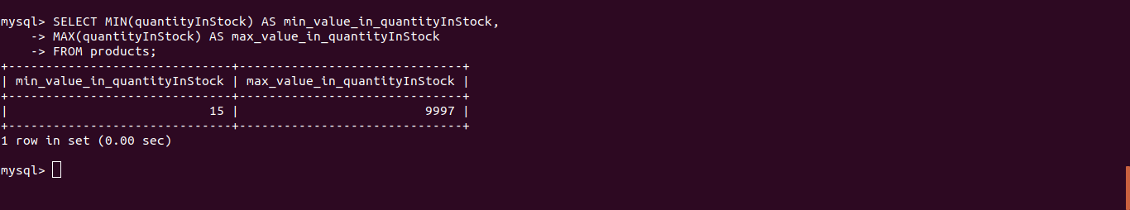

Question 5:
mysql> SELECT p.productCode,p.productLine,pl.htmlDescription
-> FROM products p
-> JOIN productlines pl
-> ON p.productLine = pl.productLine
-> WHERE
-> p.productLine = (SELECT productLine FROM productlines WHERE productLine='Classic Cars')
-> AND
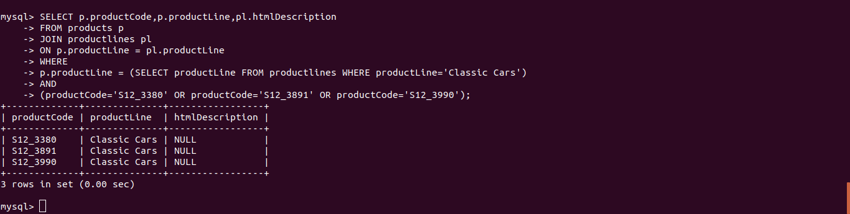
-> (productCode='S12_3380' OR productCode='S12_3891' OR productCode='S12_3990');

Question 6:
mysql> SELECT COUNT(*)
-> FROM productlines
-> WHERE htmlDescription IS NULL;
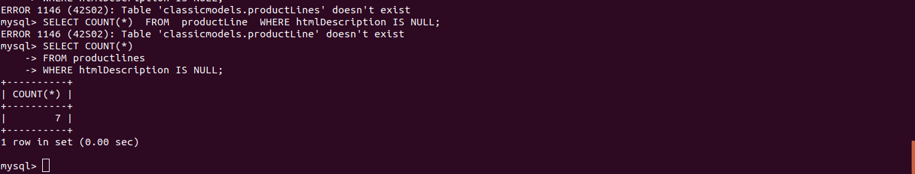

Question 7:

mysql> SELECT DATE_FORMAT('2019-07-18 12:49:24','%d-%b-%a') AS output;
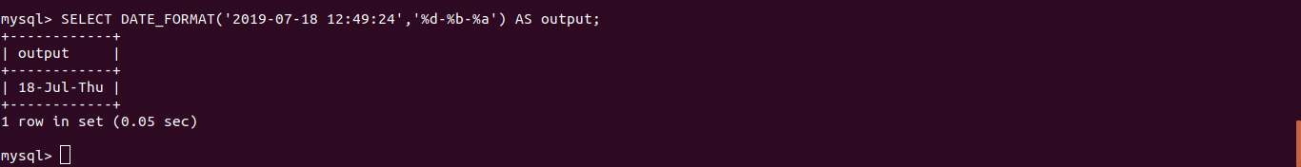

Question 8:
mysql> SELECT amount FROM payments ORDER BY amount DESC LIMIT 2,1;

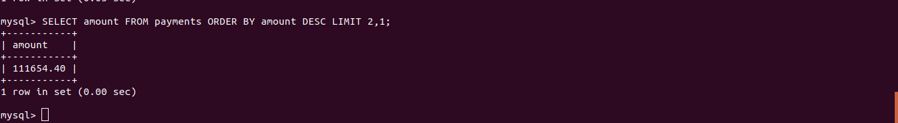

Question 9:

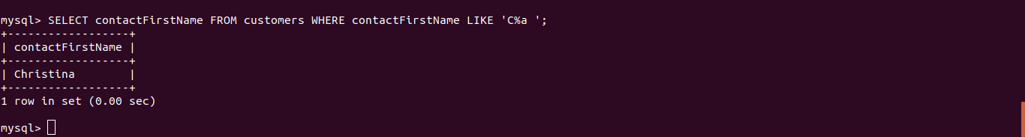
mysql> SELECT amount FROM payments ORDER BY amount DESC LIMIT 2,1;

Question 10:

mysql> SELECT pl.productLine,pl.textDescription,pl.htmlDescription,pl.image
-> FROM productlines pl
-> JOIN
-> products p
-> ON p.productLine = pl.productLine
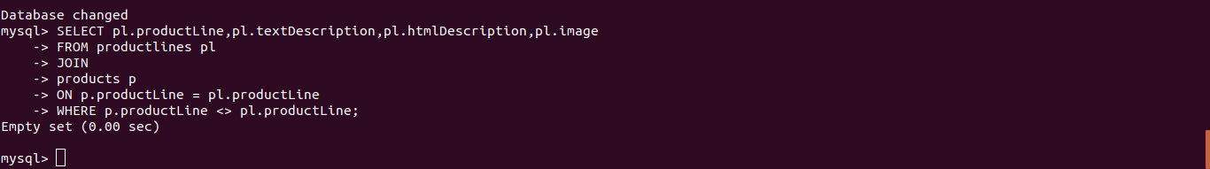
-> WHERE p.productLine <> pl.productLine;

