DevOps

https://www.youtube.com/watch?v=a9_oMNSgX2g
*DevOps is a software development strategy, which bridges the gap between the dev and the ops side of the company.

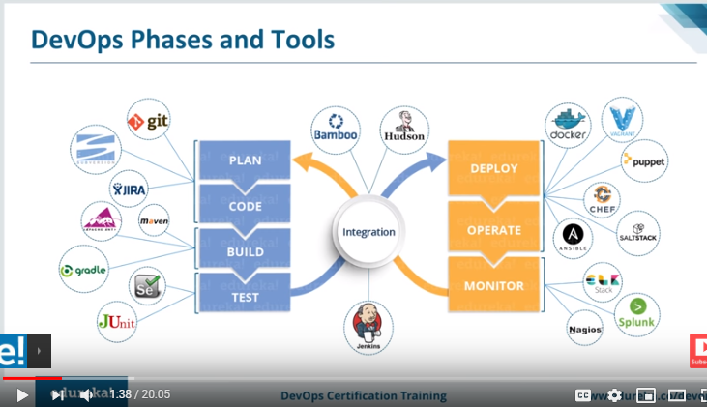

AWS

https://www.youtube.com/watch?v=IT1X42D1KeA
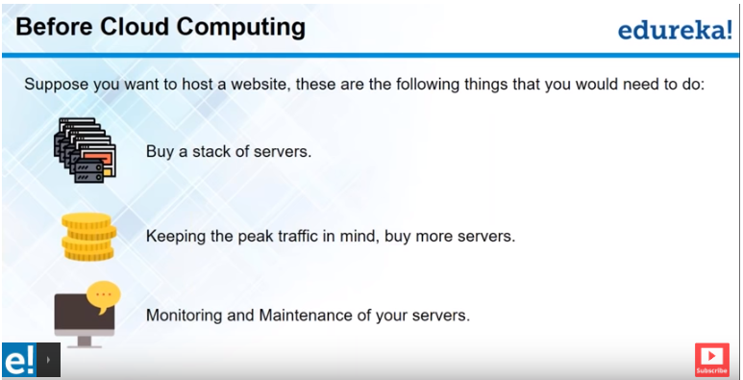

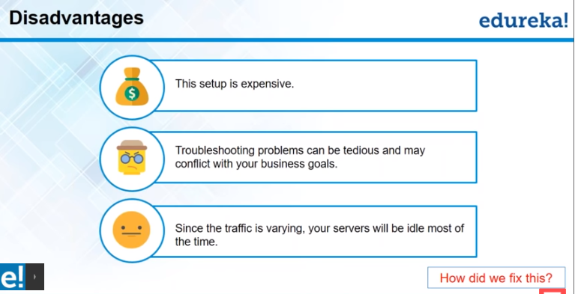

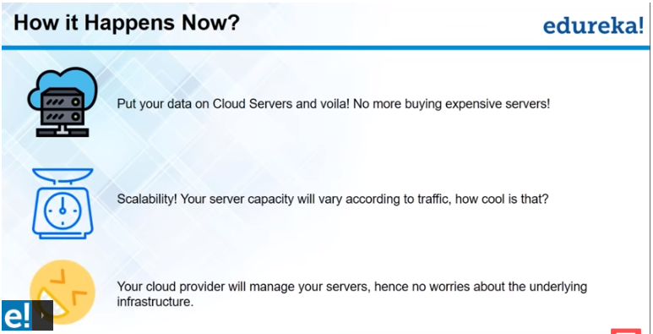
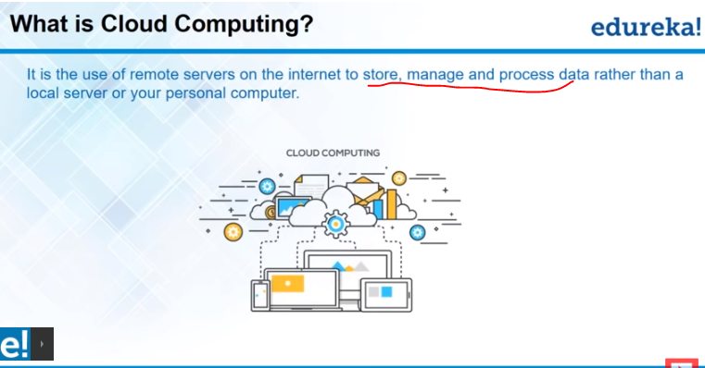

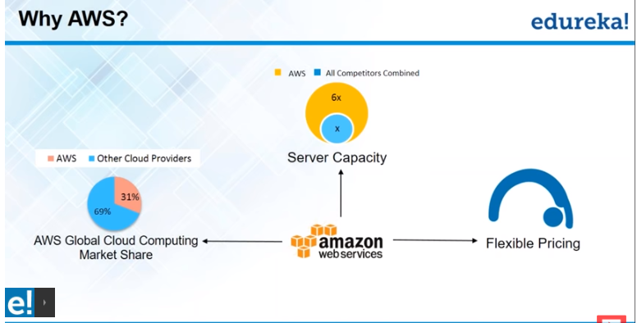

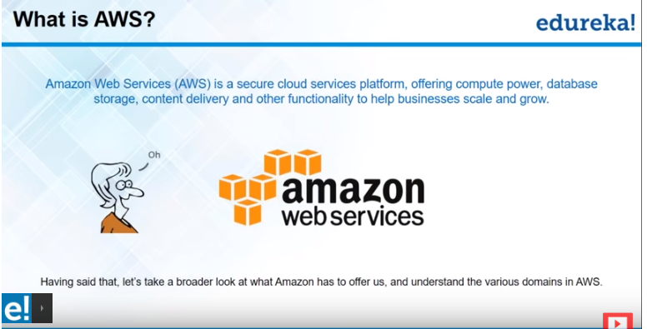

Domains:
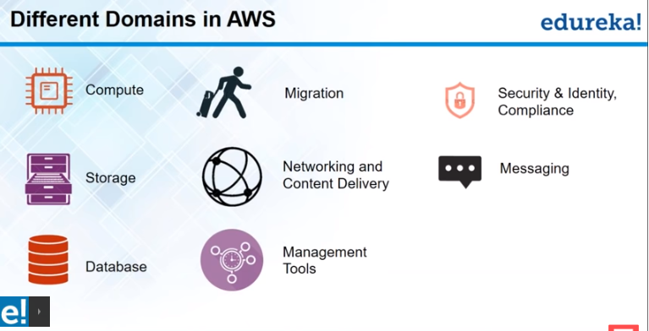

- Compute : provide like fresh new PC to run the applications
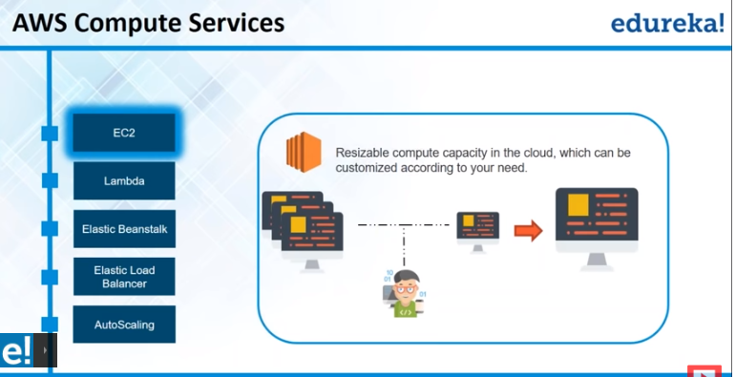
EC2: Amazon Elastic Compute Cloud (Amazon EC2) is a web-based service that allows businesses to run application programs in the Amazon Web Services (AWS) public cloud.
- If Elastic Beanstalk not hosting your environment, then go with EC2.
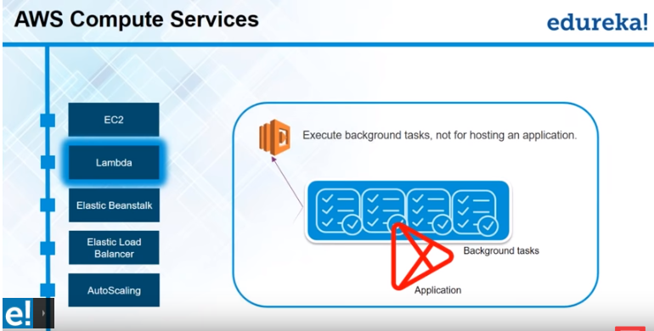
Lambda cannot be use to host an application, it is used to execute only backend ground task.

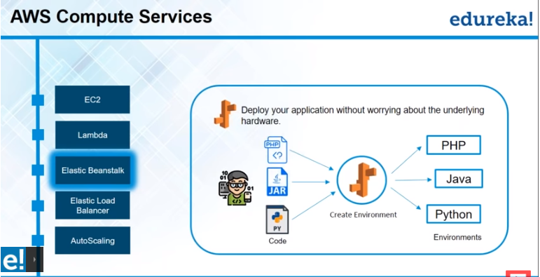
AWS Elastic Beanstalk: its holds the limited number environments, so first create an environment, launch the environment and deploy the application. … no need to manage firewall.
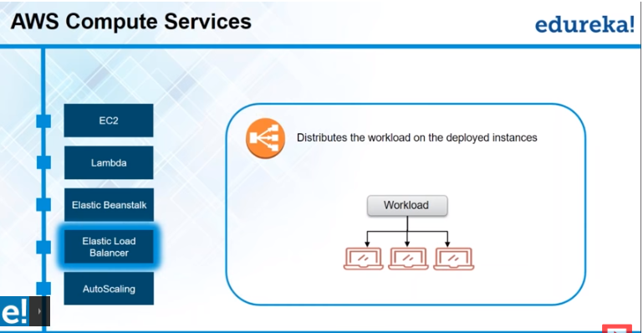
Distributes the workload equally among the instances.
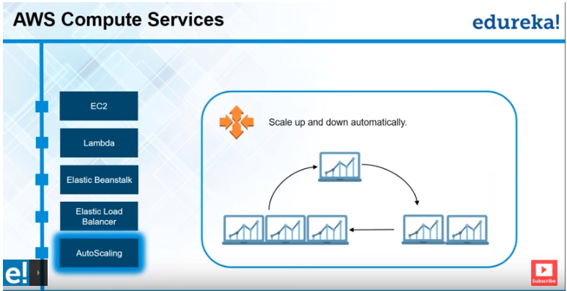
Scale up and down automatically without manual interaction.

- Migration : Transfer data to AWS/ transfer back data from AWS
- Security & identity compliance :
- Storage: object base file system (example image file..)
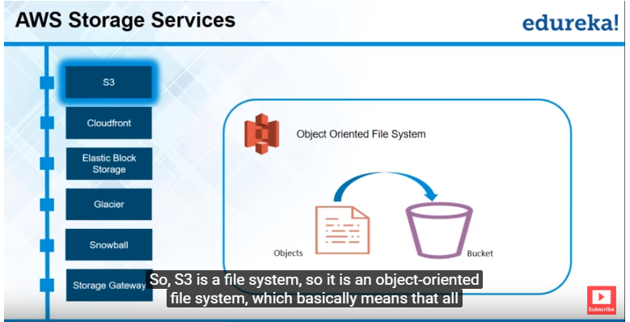
Consider bucket to be folder.
We cannot directly store the file into s3, first we need to create a bucket.
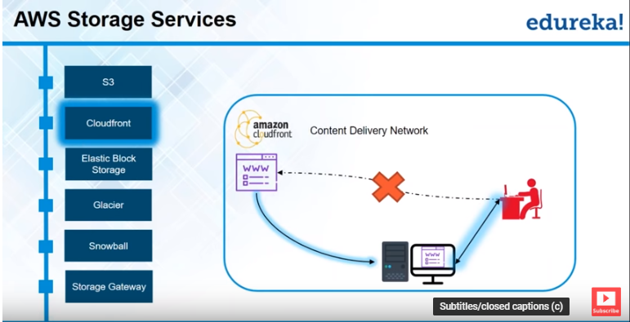

Create EC2 :
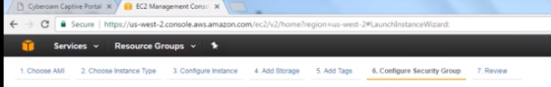
- Networking and content delivery :
- Messaging: .. acs
- Database: RDS
- Management tool :

