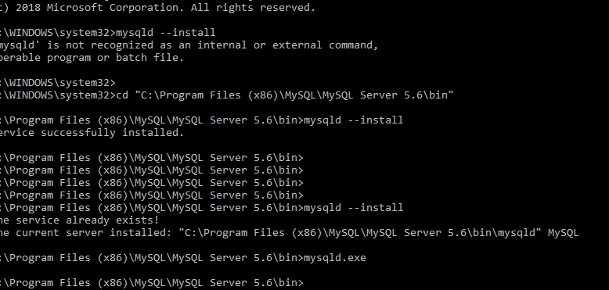

Then start the MYSQL service from services.msc

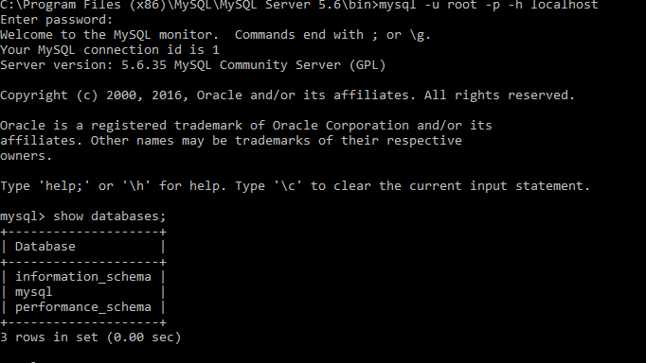

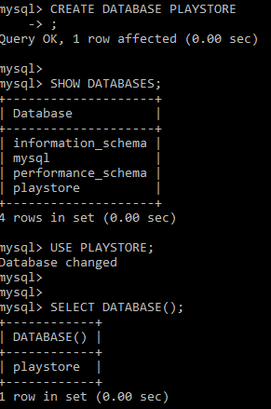

If exit from MQSQL console -> exit;

Or > quit;

If shout down MYSQL data base -> mysqladmin -u root shutdown

**Update root password :**

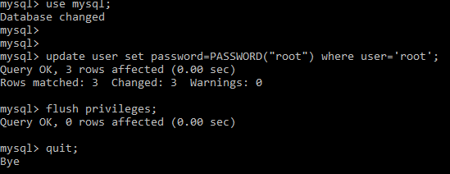

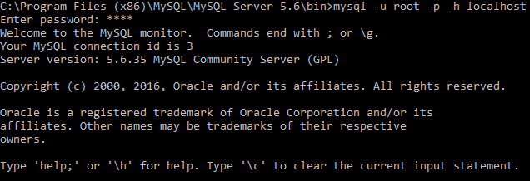

<https://www.digitalocean.com/community/tutorials/how-to-create-a-new-user-and-grant-permissions-in-mysql>

http://www.ntu.edu.sg/home/ehchua/programming/sql/mysql_beginner.html