HOW TO RESET THE NICEmail PASSWORD

1. Open urlhttps://mail.gov.in/
2. Login page will open as below:

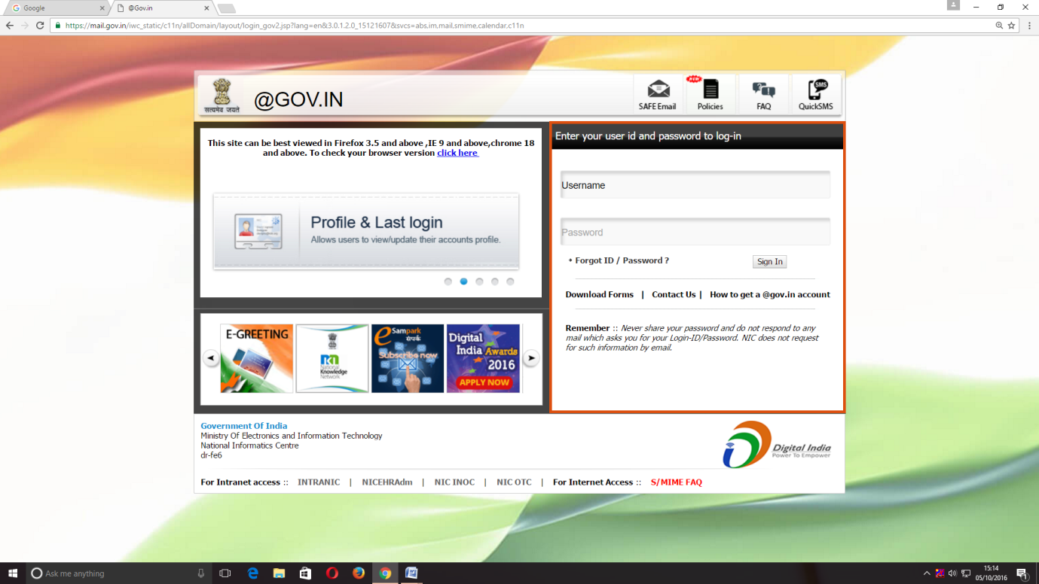
Click here

3.Click over "Forgot ID / Password ?" in the login page and a new window will open as below:

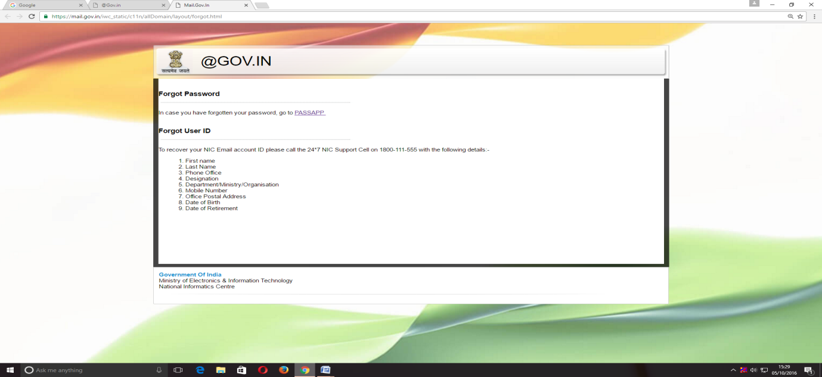
Click here

4.In this window click the a link for resetting the password with a title "PASSAPP ".
5.On clicking the PASSAPP link, following window shall open:
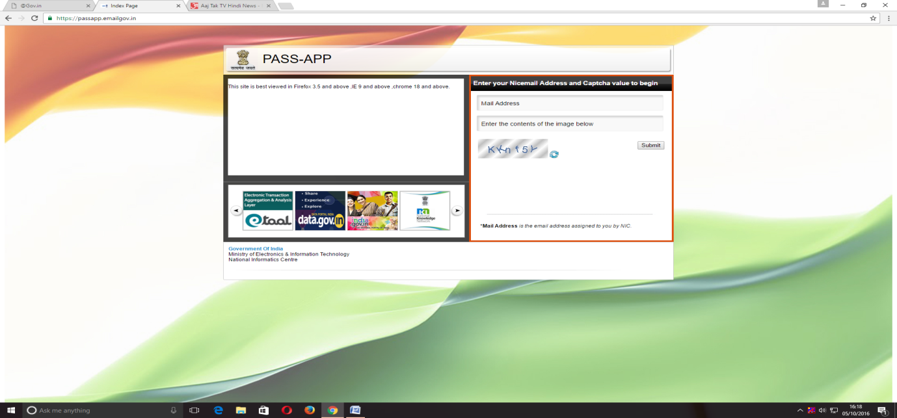

6.The user has to give email id for which password has to be reset and then he has to enter the captcha (alphabet/numerals given in image shown below).
7.The password will be generated and will be sent to the registered mobile no. of the user.
8.The user can log on through the password received in sms in https://mail.gov.in/ .

