Step by step guide for “Officer Reported Upon”.

- Open the url https://sparrow-irs.eoffice.gov.in/ in Mozilla browser. The software runs smoothly on Mozilla browser and thus it is recommended to install Mozilla browser.

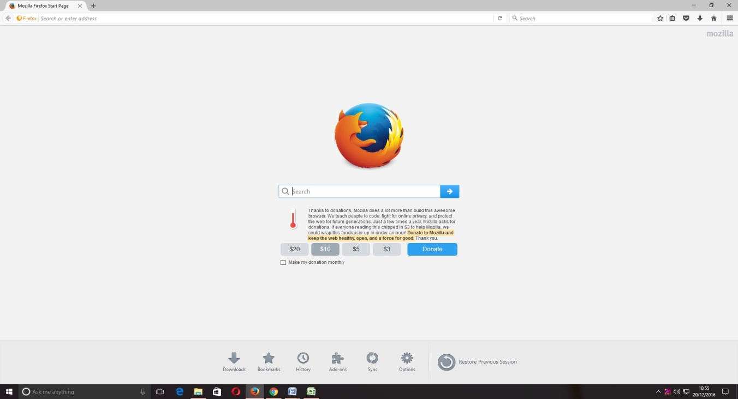

Then the "SPARROW - Read Me" window (given below) will open which shows the information about the e-signing facility in the SPARROW.

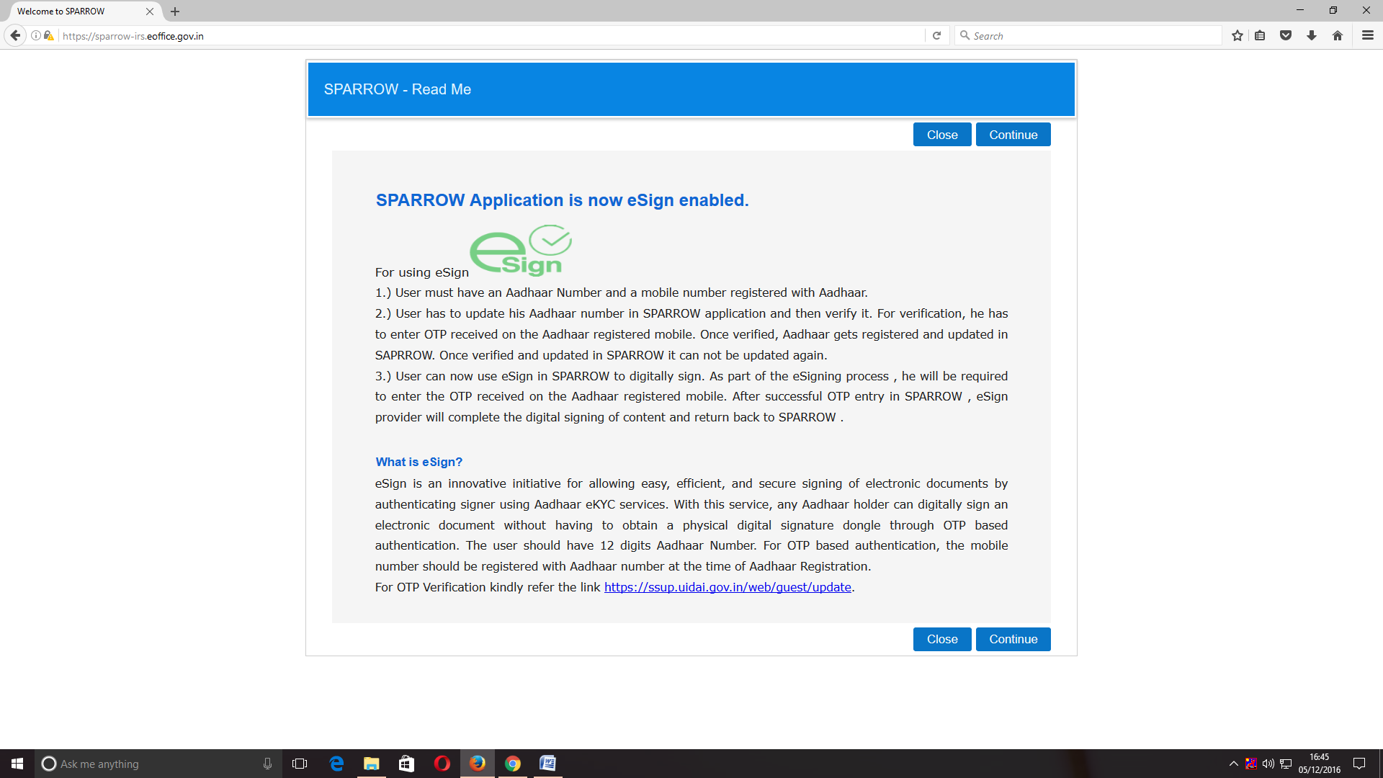
2. The read me window will have two buttons namely Close and Continue marked in blue, you can click any of the two buttons they will be doing the same function. On clicking any of the above two buttons, the user will be directed to the login screen of the SPARROW.
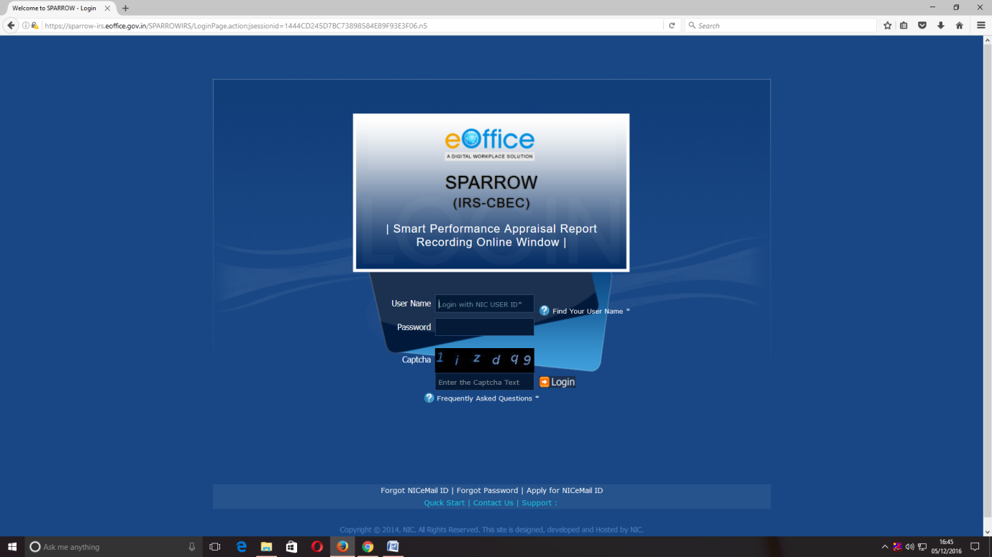

3. The "Smart Performance Appraisal Report Recording Online Window" screen will open up which is essentially a login screen for SPARROW. The screen will have three fields "Username", "Password" and "Captcha".
The username will be the NIC email id and only the name before "@" should be entered. For example if your NIC email is anish.upadhay@nic.in or anish.upadhay@gov.in, then, the user id will be anish.upadhyay.
The password for the application will be same as your NIC email ID password. However for practice environment, till software is launched, the default password for logging into the system is kept as "sparrow_irs" for all the users.
The Captcha as given in the box should be entered then click the "Login" button. It would open a POP UP Window to verify and update the Adhaar number.

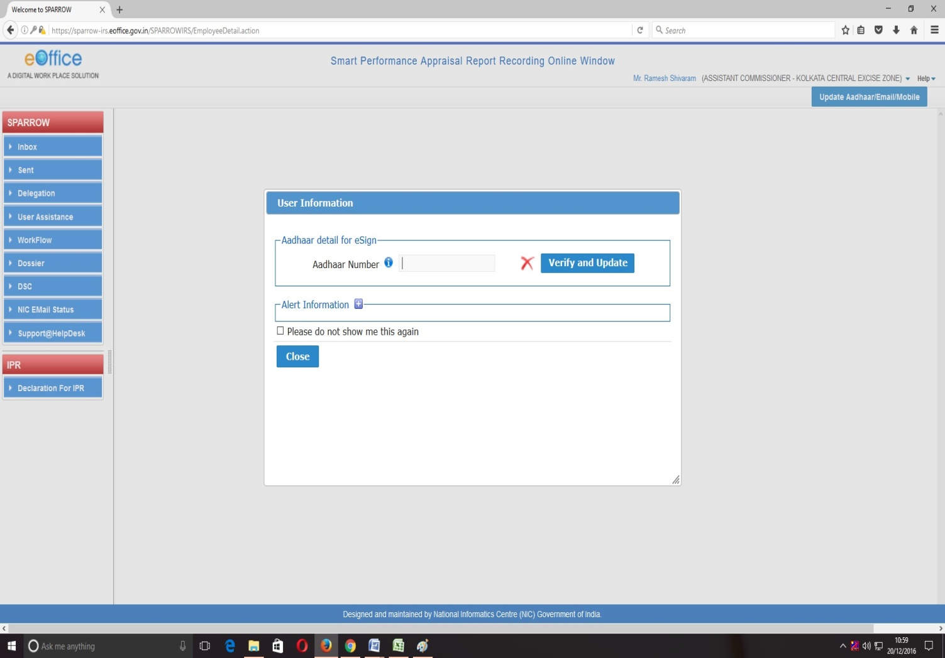

After verifying the Adhaar, the software would automatically move to next screen. By default, the SPARROW window will open up as shown in the next page.

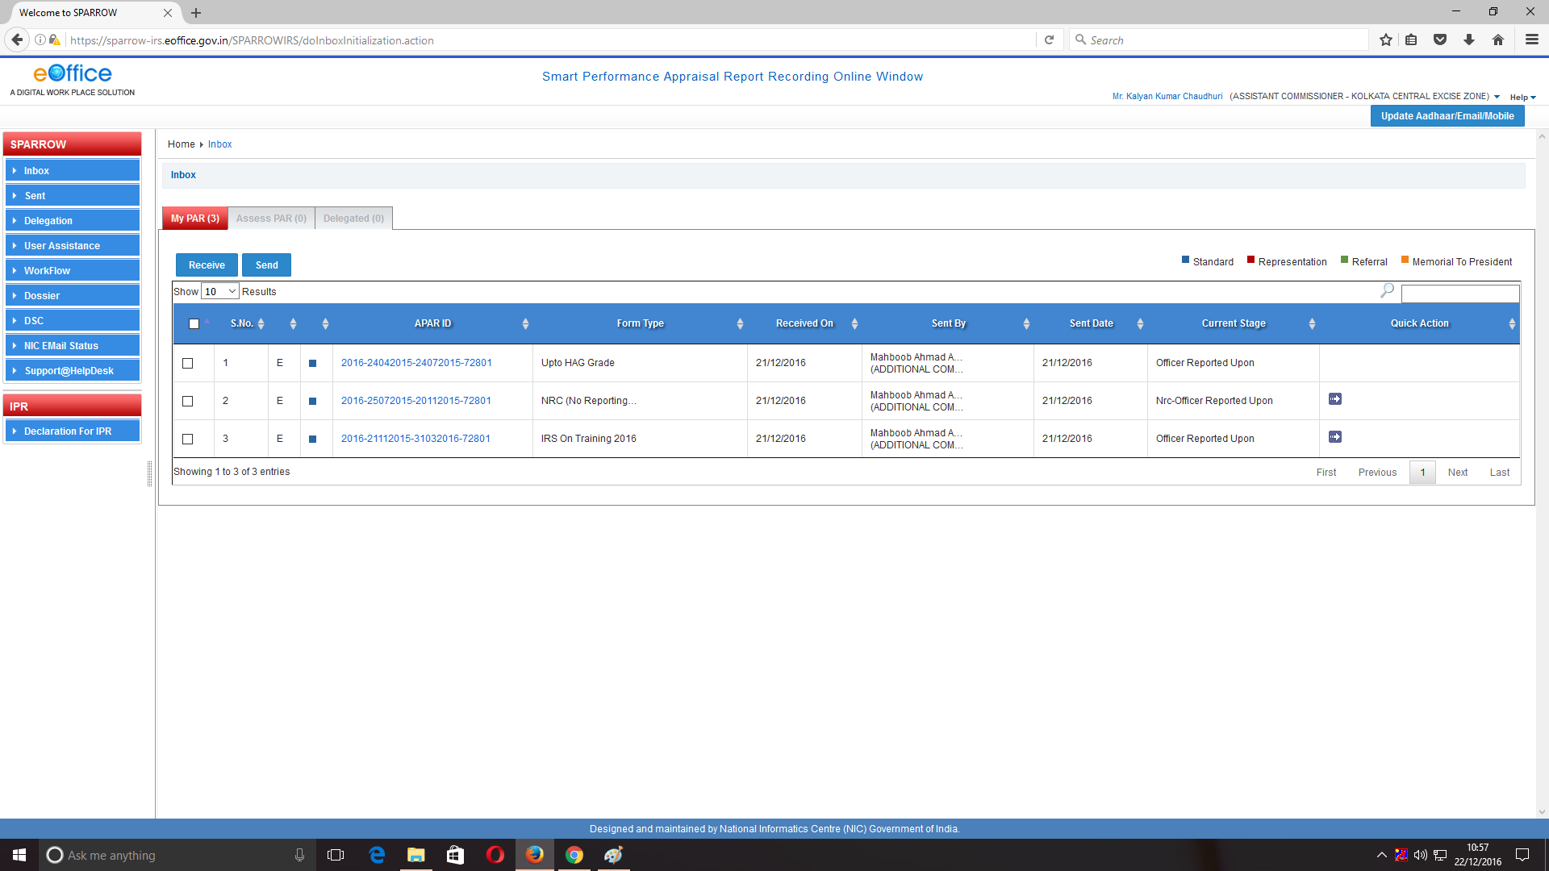
4. After successful login, the above window will open up. This page will have some tabs in the left side depending upon the role assigned to the officer. These roles are allocated centrally by DGHRD / NIC and on logging in, different window will open up depending upon the role assigned to that user ID.
Above page is for the Officer Reported Upon. In the inbox, on clicking the My Par Tab, all the 3 PARs generated by the Custodian shall be listed with their corresponding APAR-IDs (shown in blue colour) which are for the following work durations:
S.No. | From | To | Form Type
1. | 16/04/2015 | 24/07/2015 | Up to HAG grade
2. | 25/07/2015 | 20/11/2015 | NRC
3. | 21/11/2015 | 31/03/2016 | Foreign Assignment

5. Now, the officer Reported upon will select the first PAR for the period 16/04/2015 to 24/07/2015 by clicking the APAR-ID for the relevant period. This would open section-I of the APAR as filled and generated by the Custodian (shown in the screen shotbelow).

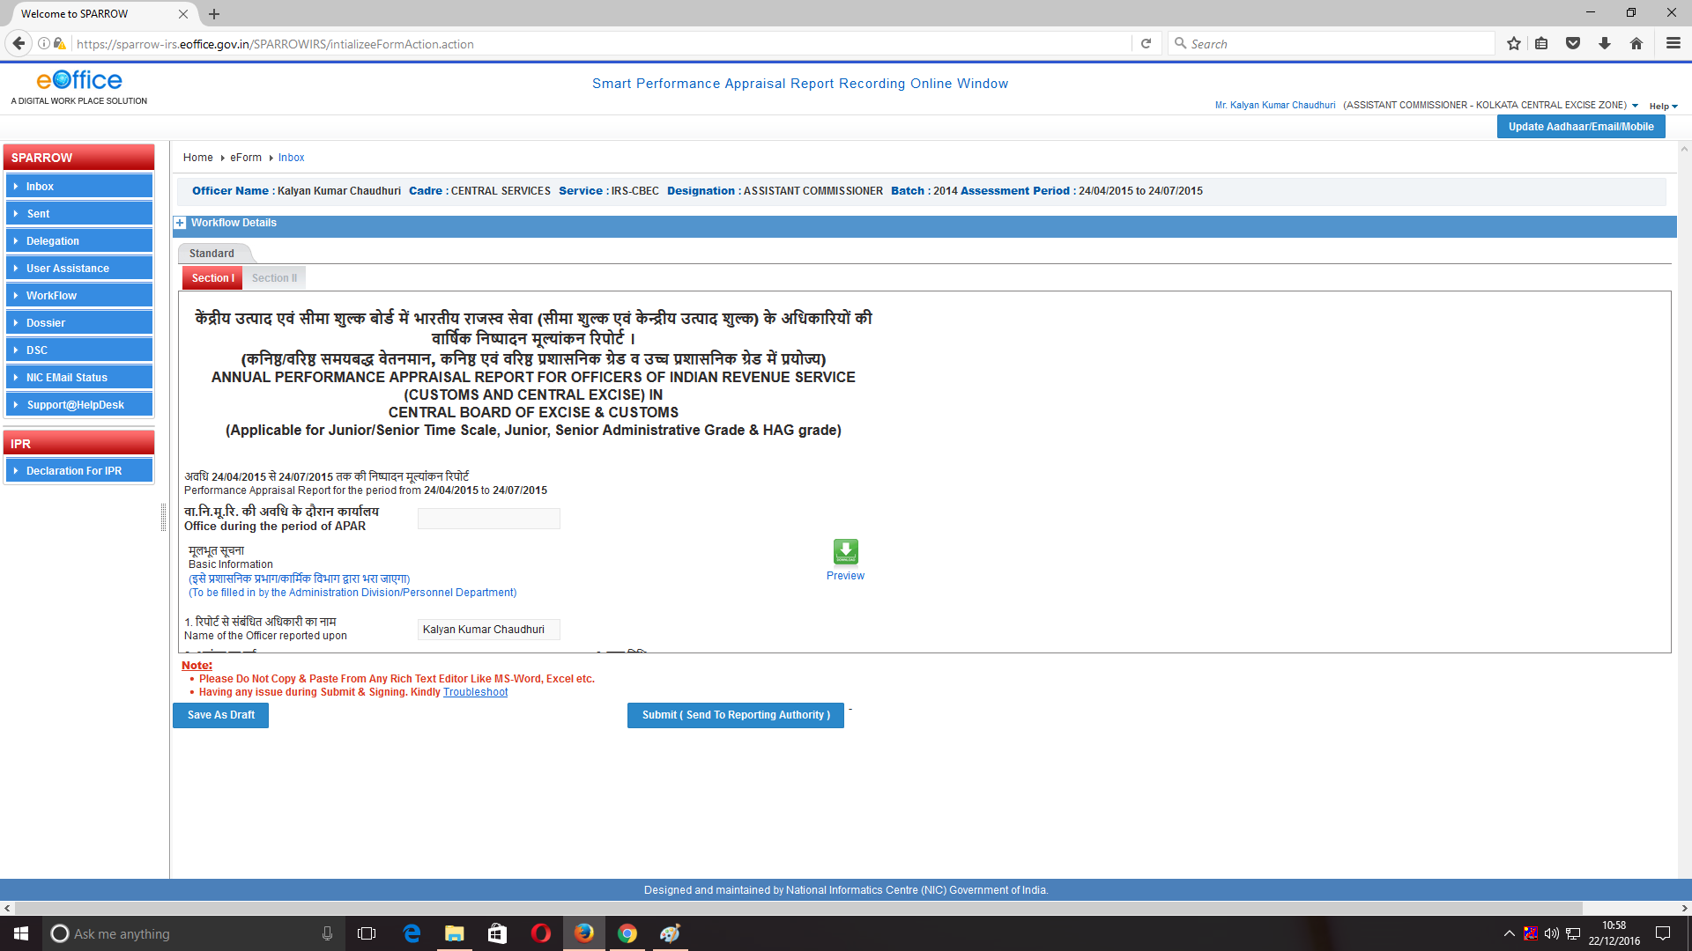

5. The Officer Reported Upon can check all his details filled in the Section-I which is name, Year of Allotment, Employee code, Date of Birth, work duration under Reporting and Reviewing Authority etc.
6. Further the officer has to check his leave details and trainings attended. These details would also be auto populated as they have been filled by Custodian.
7. Also the dates of filling the immovable property returns for year ending December, date of medical examination etc would be auto populated as they have been filled by Custodian.

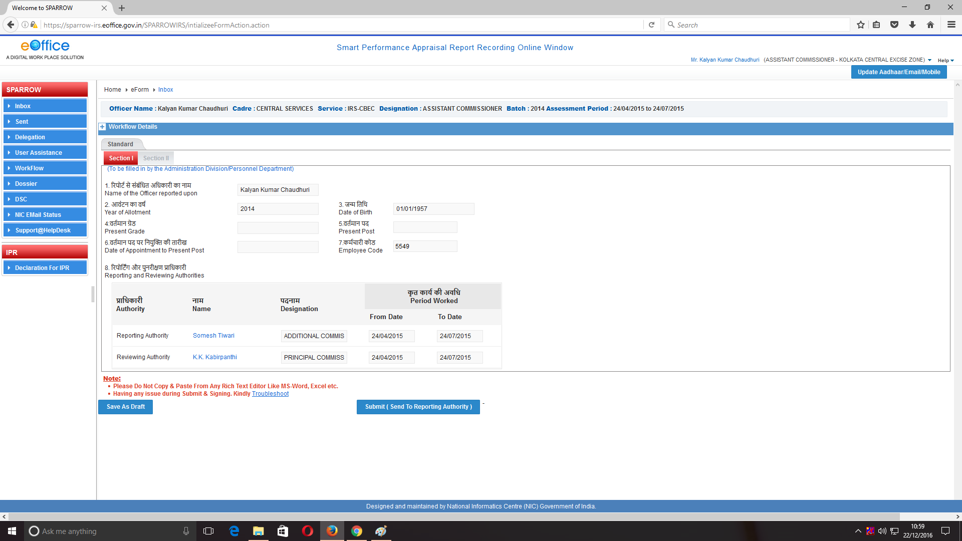
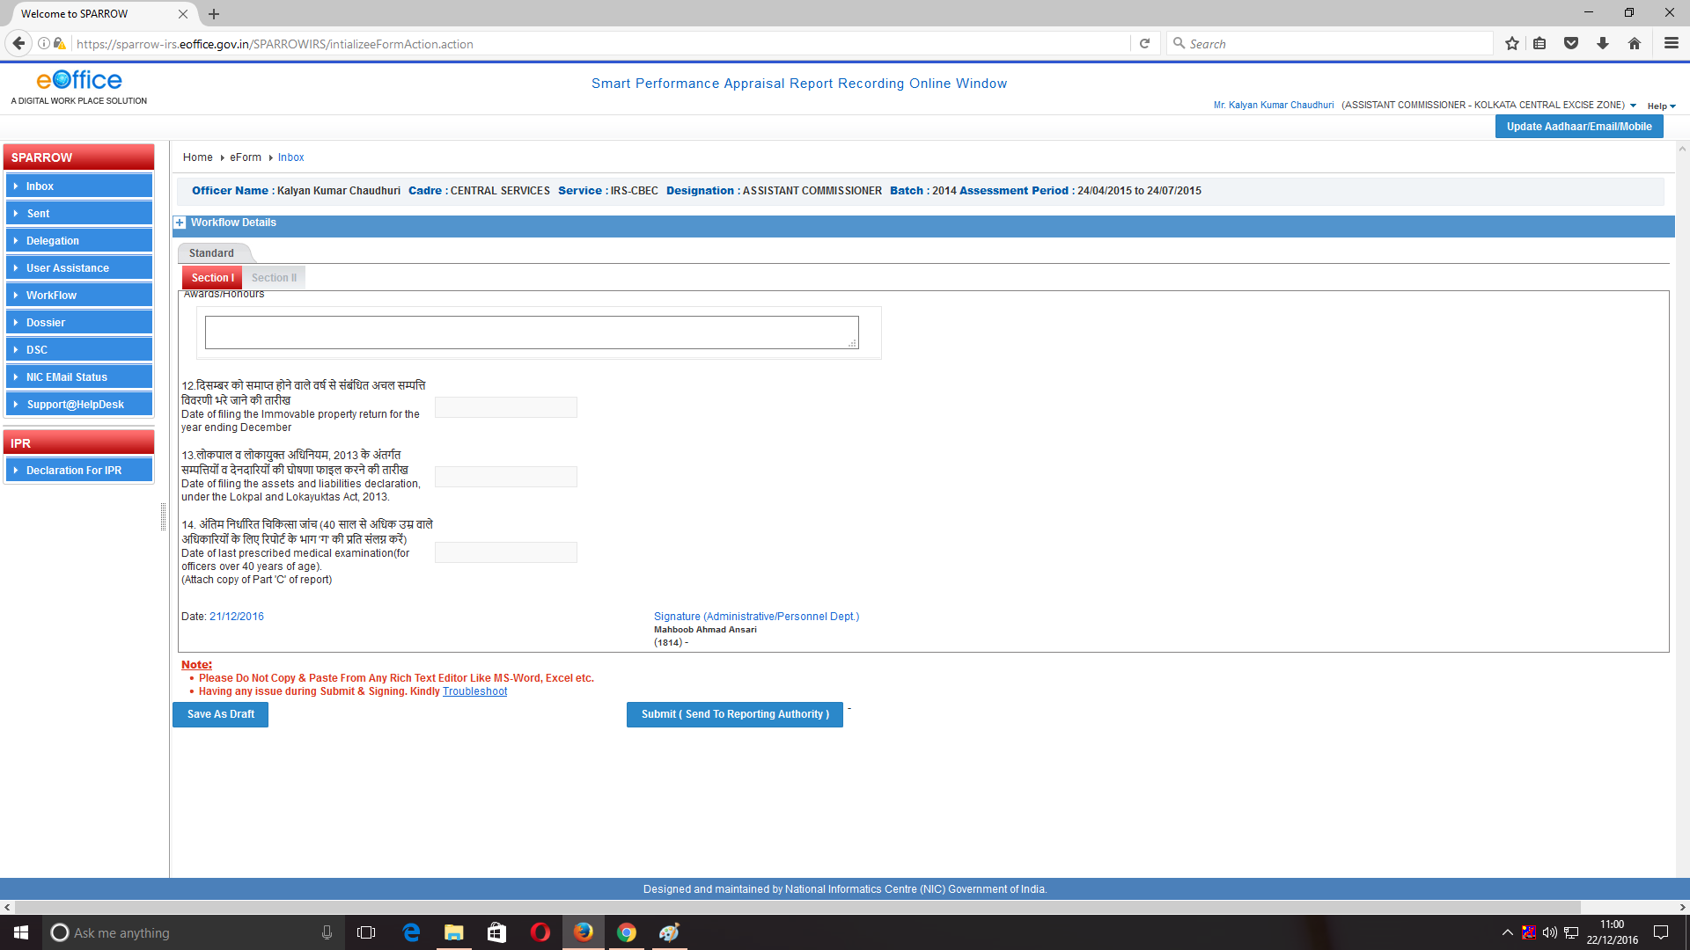
8. If any information is found to be incorrect then he can submit error report to Custodian by clicking Submit Error Report tab. If all the information filled in is correct, the officer can click Section-II of APAR and fill Section-II of APAR.
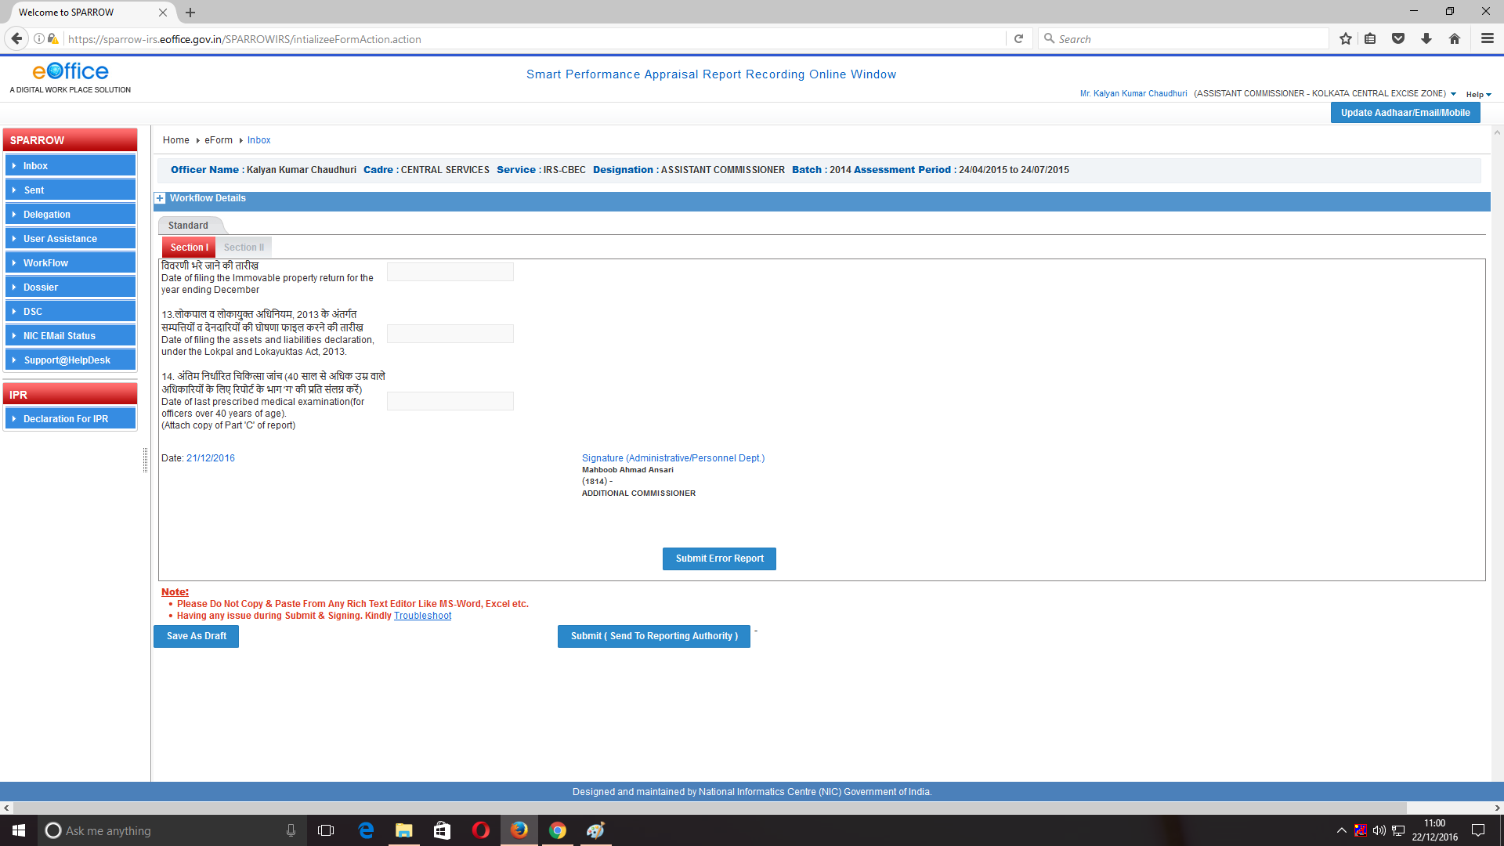
Click here to submit error to Custodian in Section I of APAR

9. If he clicks Submit Error Report option following screen will open up which will have a text box. The officer can give the nature of errors / details which are to be corrected in the text box and click Submit button. This will send Section-I of the PAR to Custodian and thus allow Custodian to make requisite corrections to Section-I of the APAR.
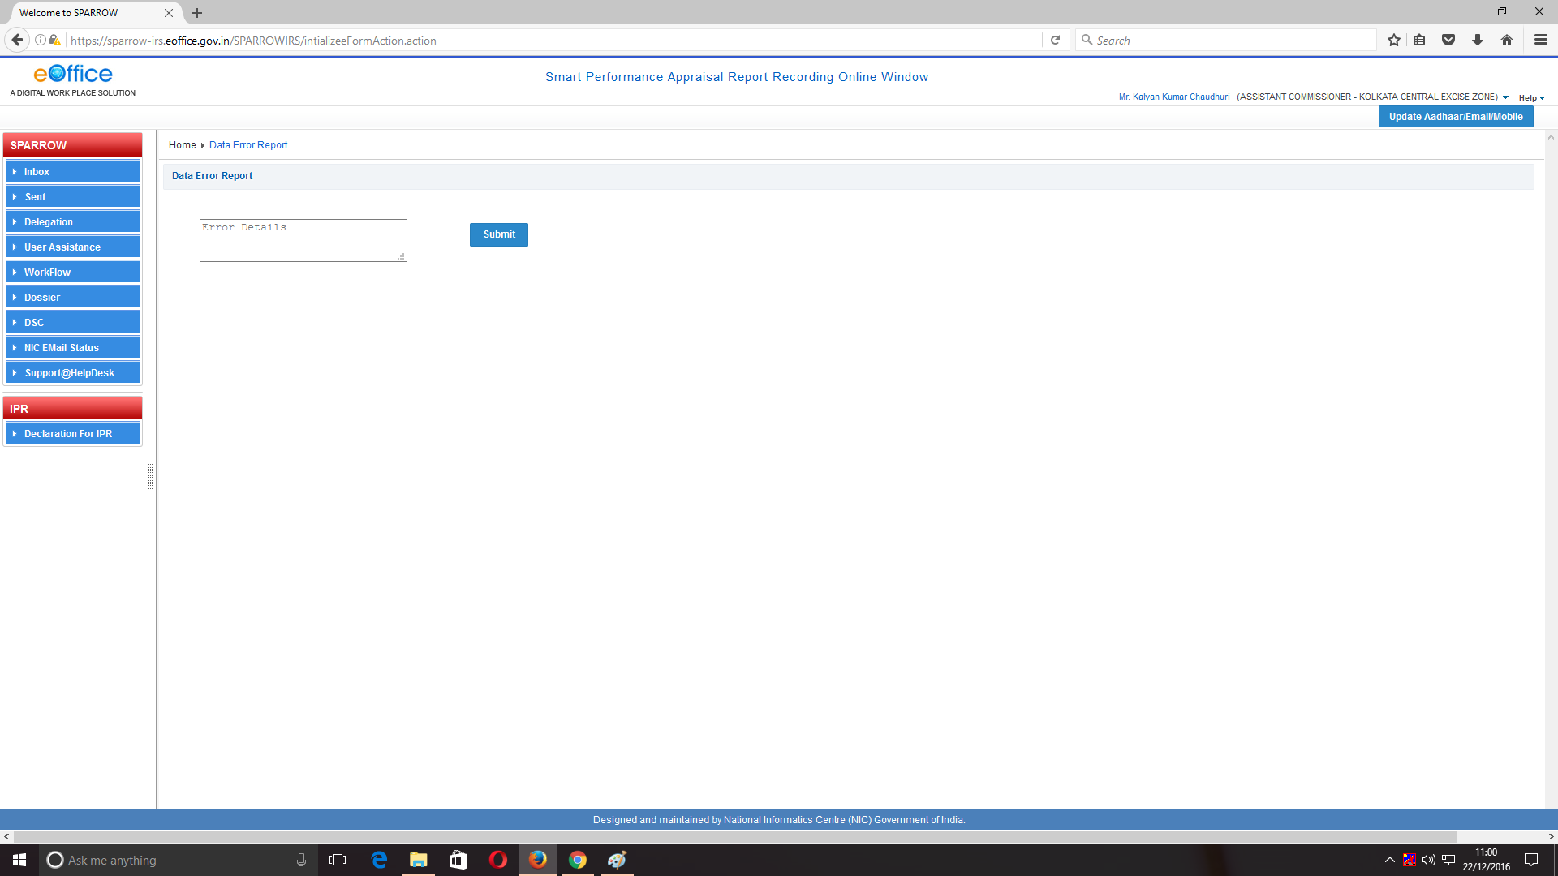

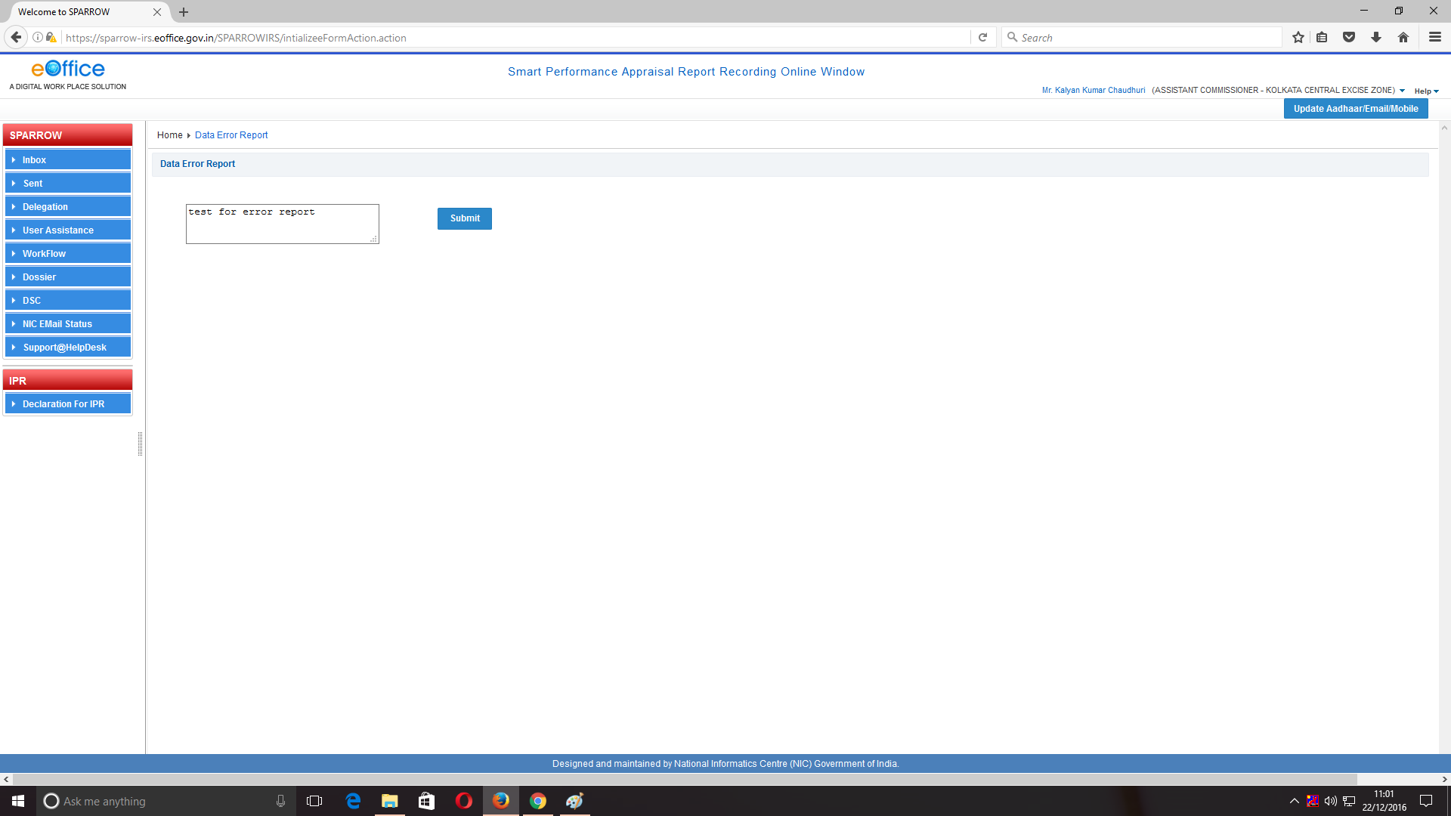

10. After clicking Submit a message would appear with text “Data Error Message is Reported Successfully” which means that the report has been sent to Custodian to make relevant changes.

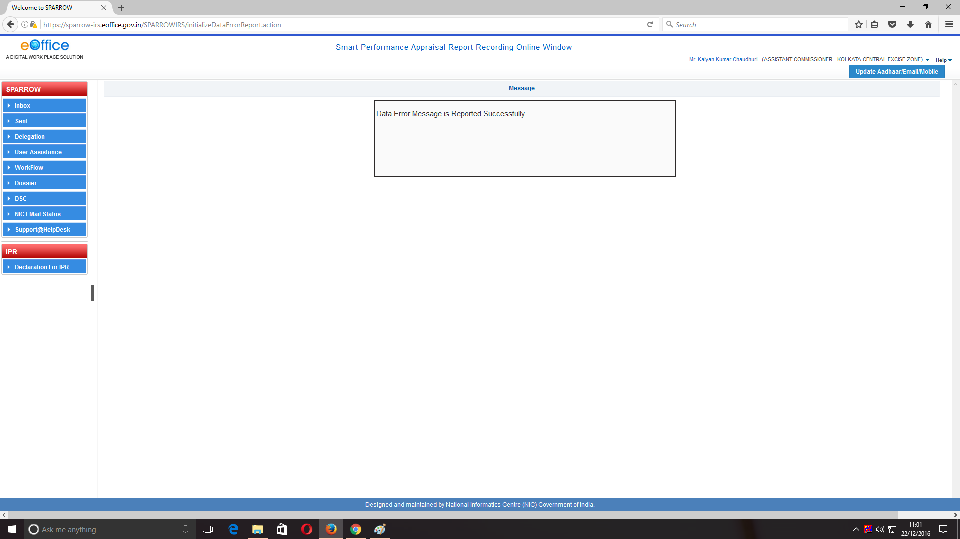

11. After sending the error report, the officer should go to Section-II of PAR and fill all his particulars for performance appraisal. The screenshots presented below shows the details of fields for Section-II which is same as that for the manual format of APAR.
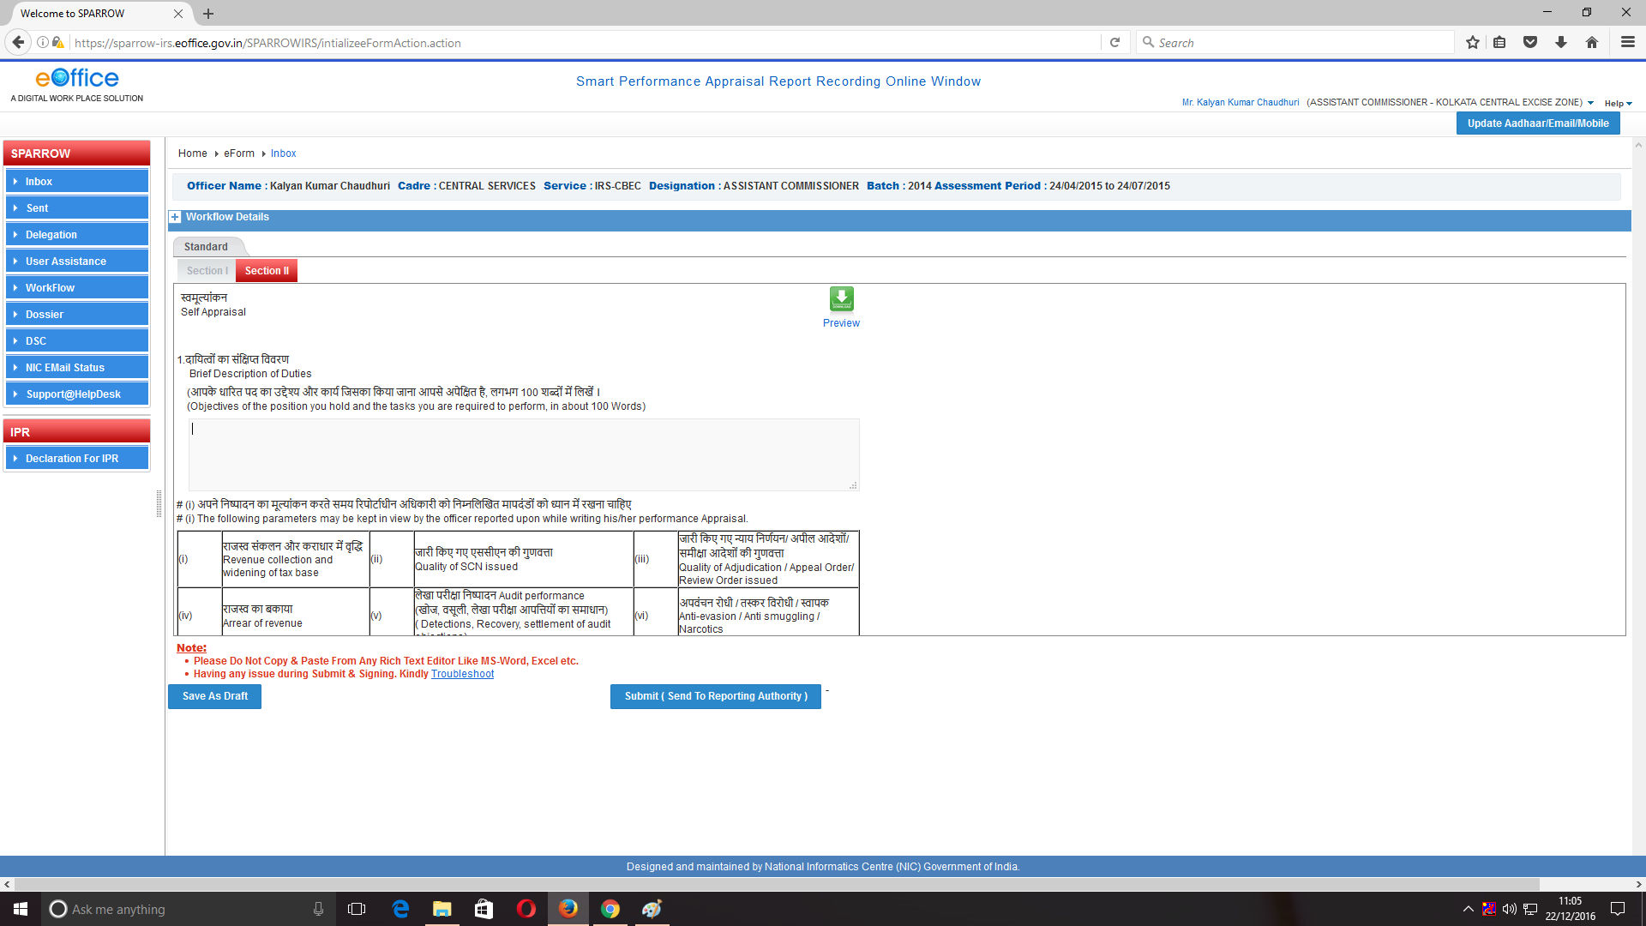

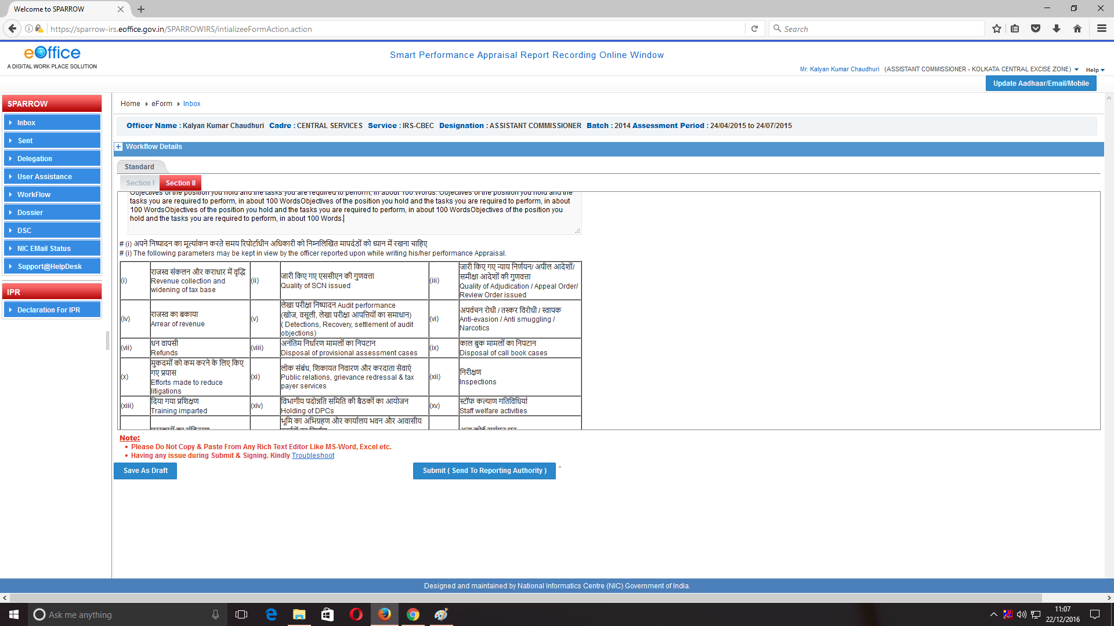
12. The officer would fill the Tasks to be performed for the Initial, Mid Year and Actual Achievement. The screenshot below represents the “Deliverables” window for task to be performed.
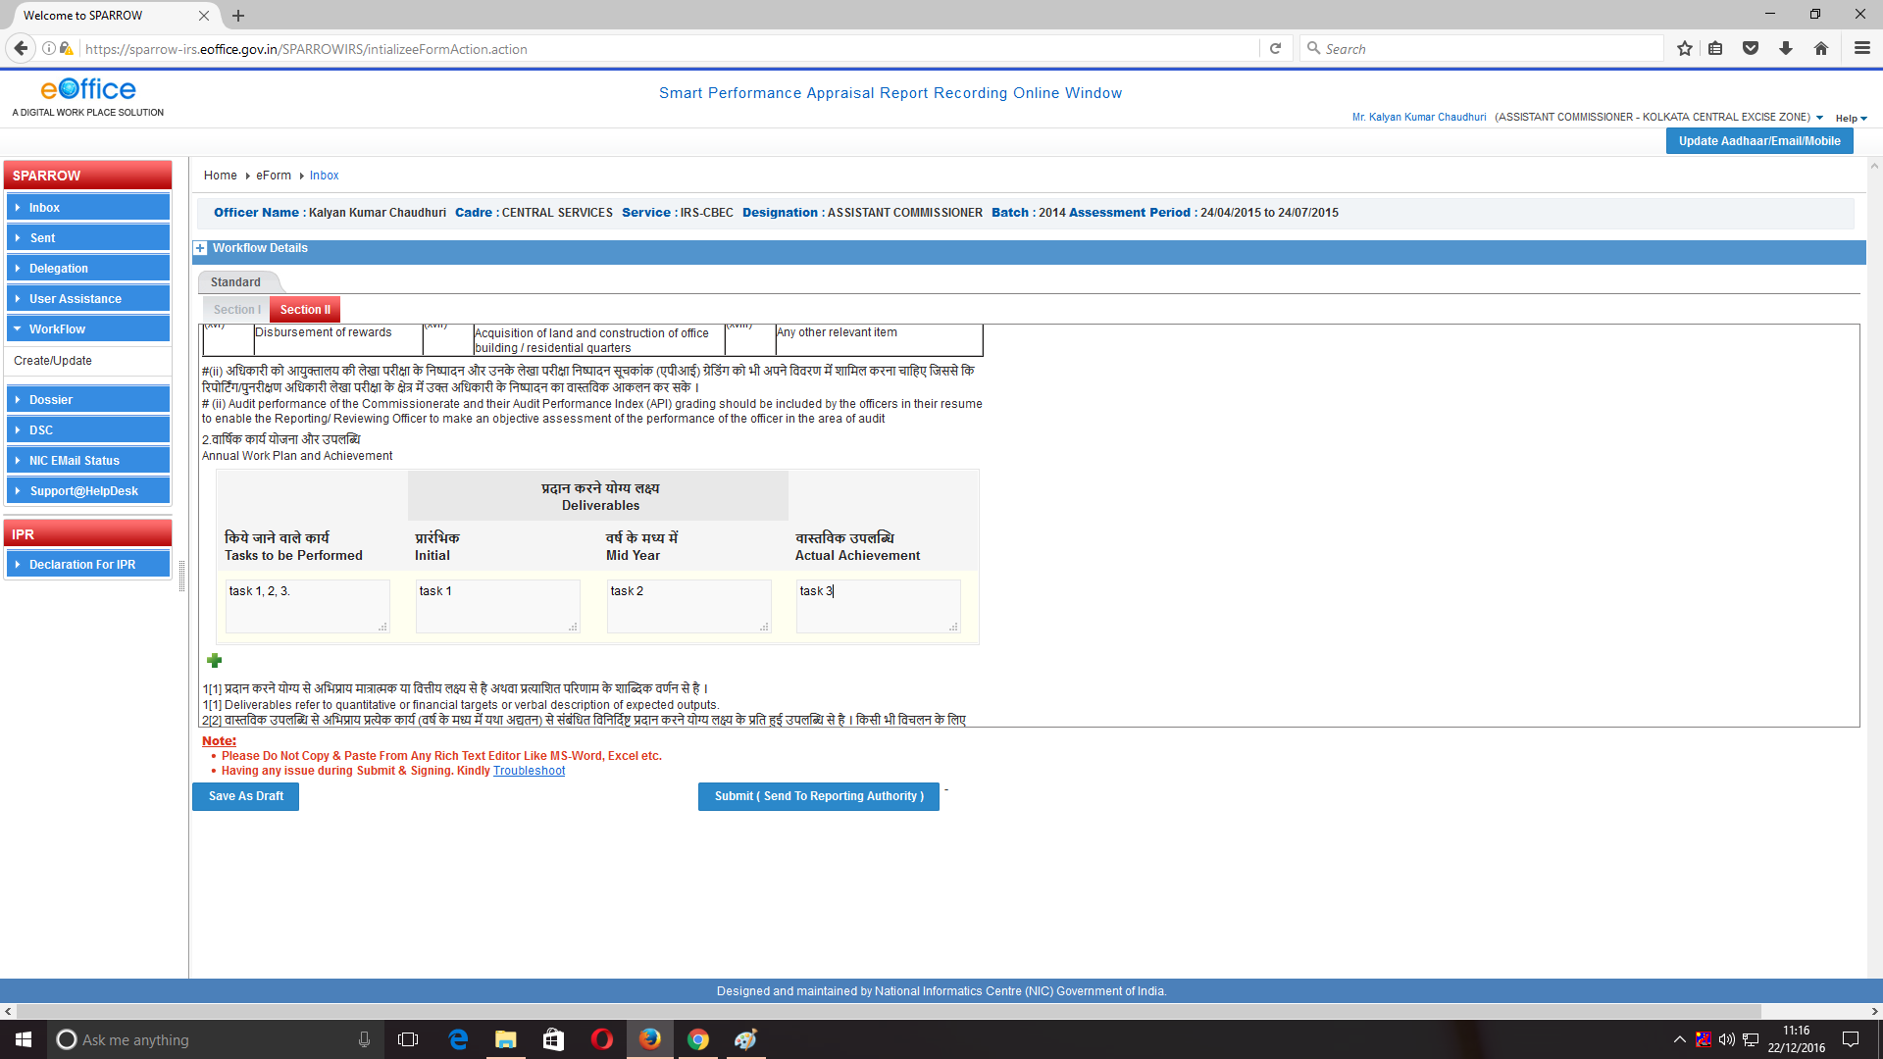
13. After this, the officer would fill the exceptional contribution made by him to the organisation. The word limit of 100 words should be adhered to. Also the officer would fill the factors that hindered the performance of officer in achieving his goals.
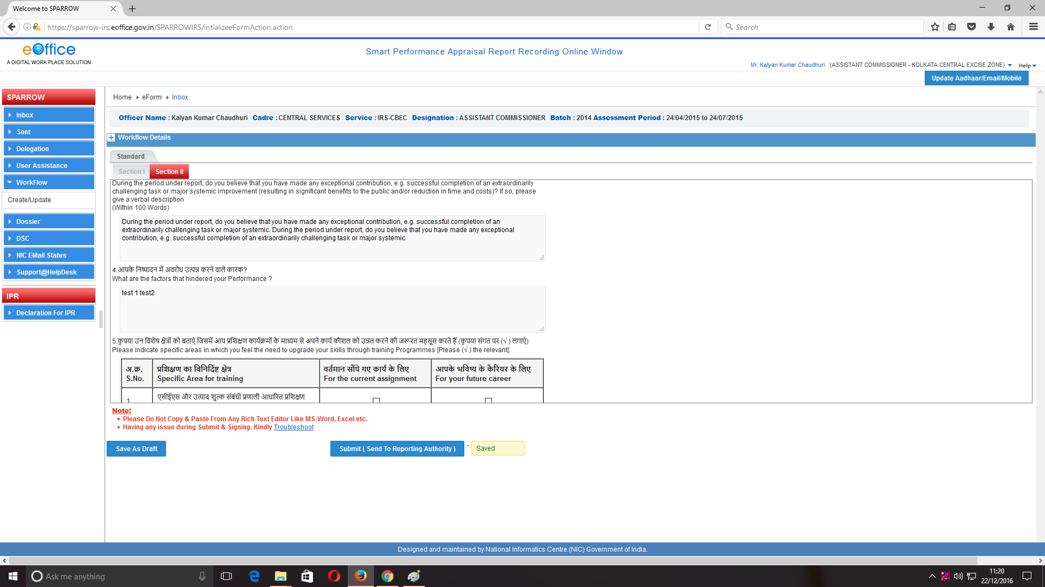
15. After this the officer needs to mention the specific areas of training as per his interests depending upon current assignment and future career progression. These details would be sent to NACEN, Faridabad to arrange trainings as per the interest of the officer.
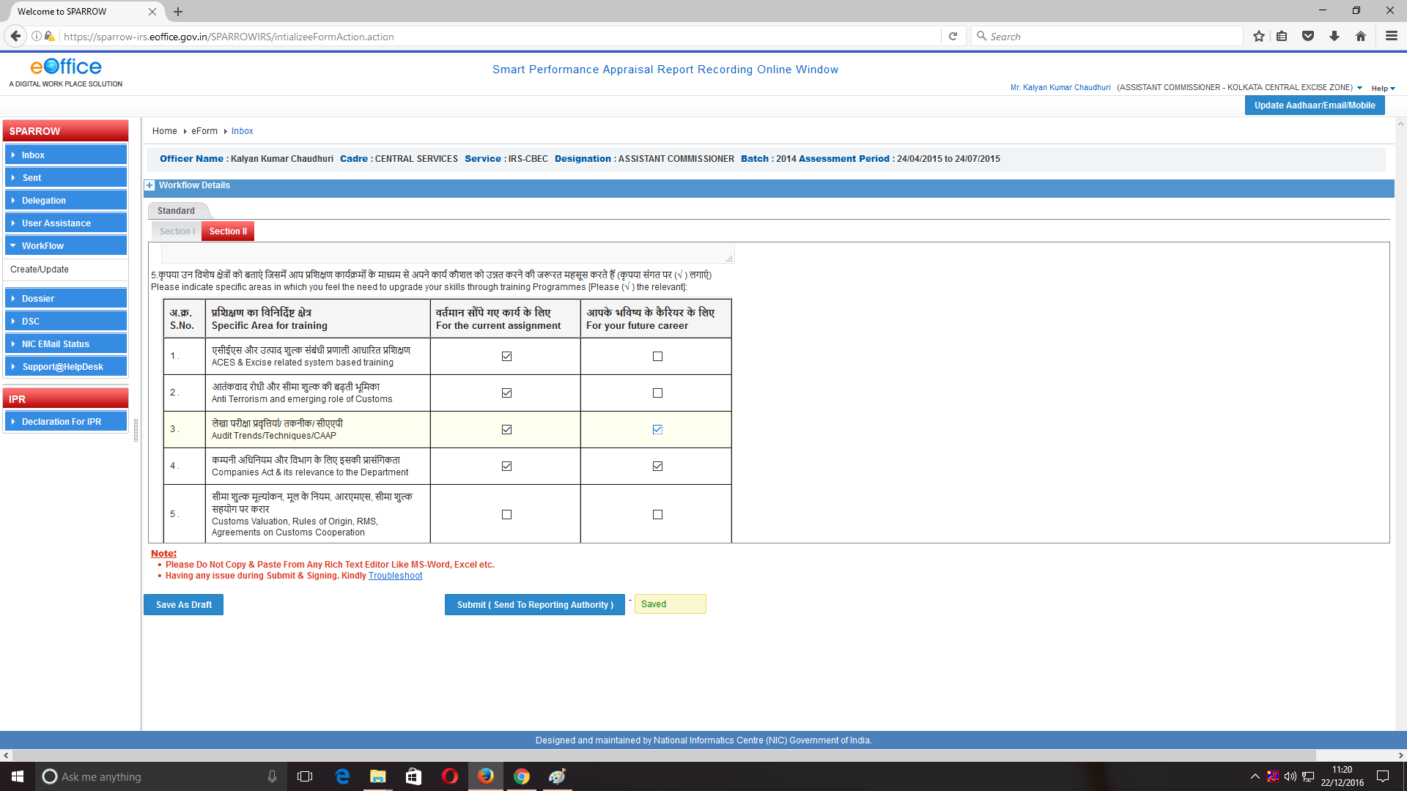

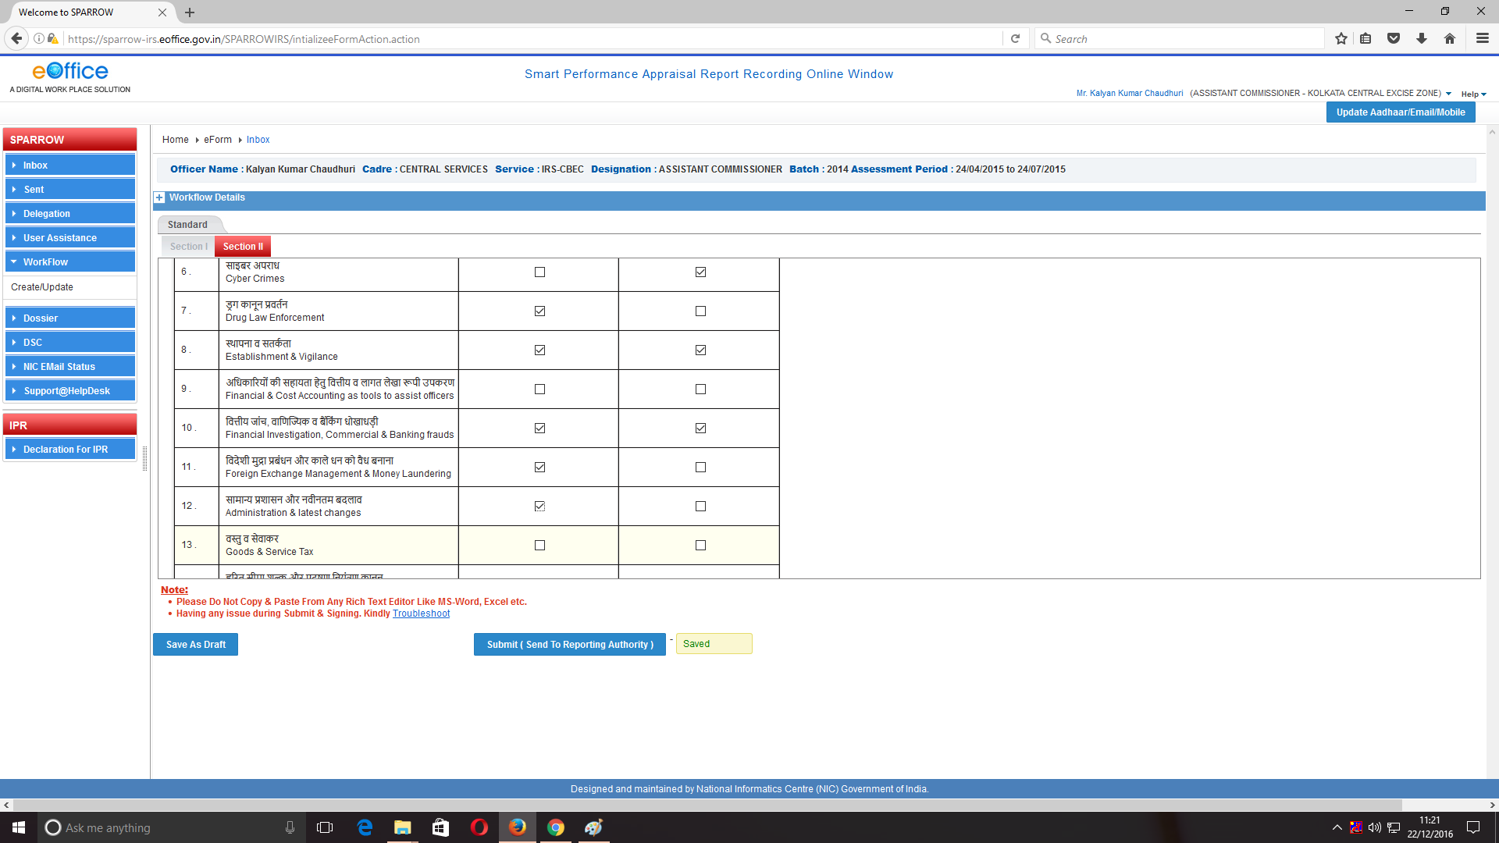
6. After filling the training requirements, the officer needs to choose Yes/No option pertaining to IPR returns, assets and liabilities declaration, medical examination date, setting work plan for subordinates etc.
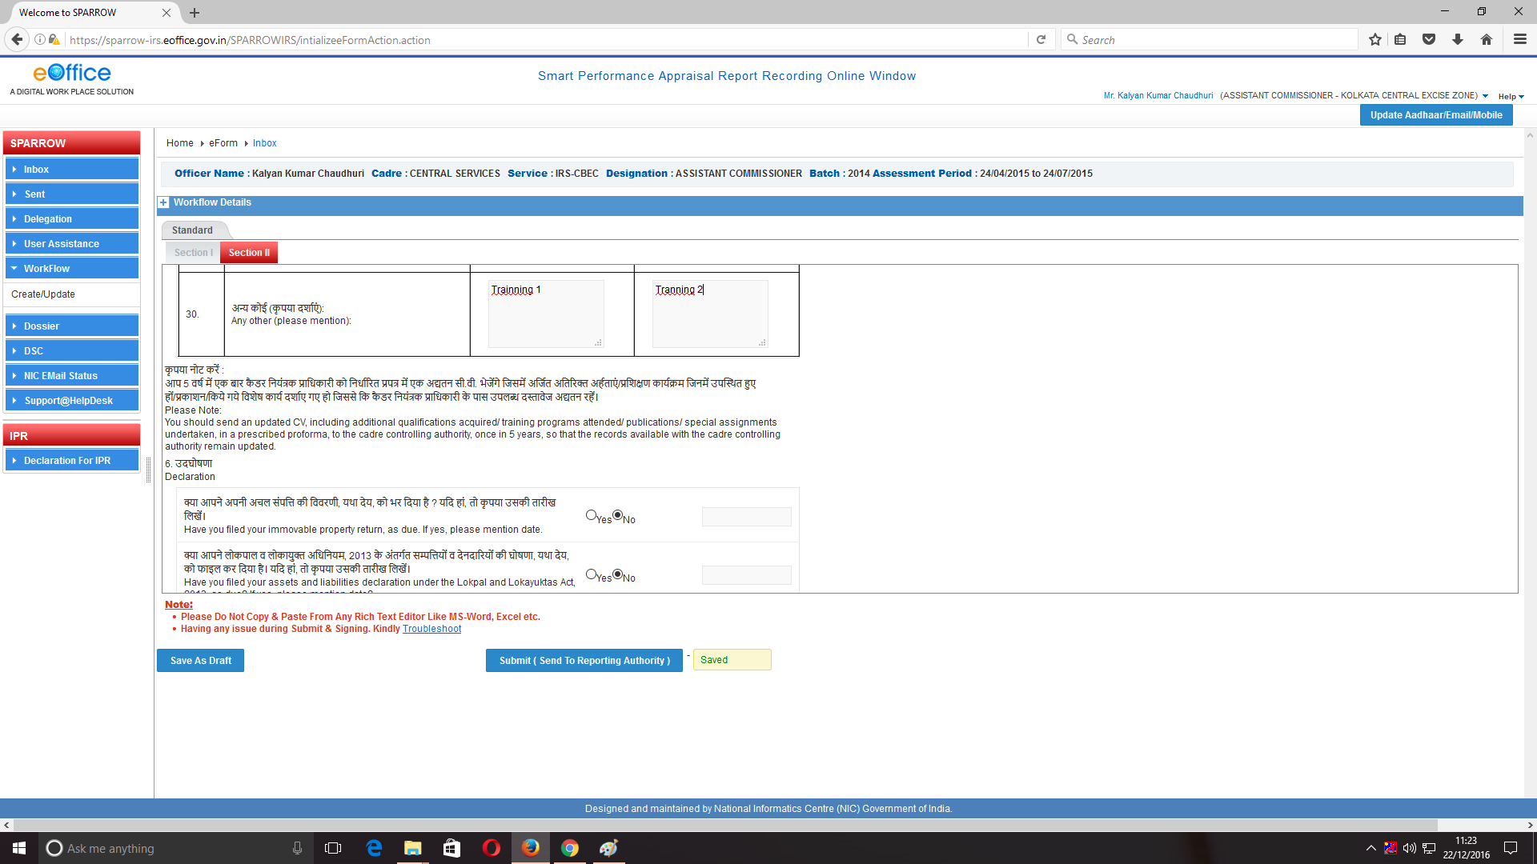
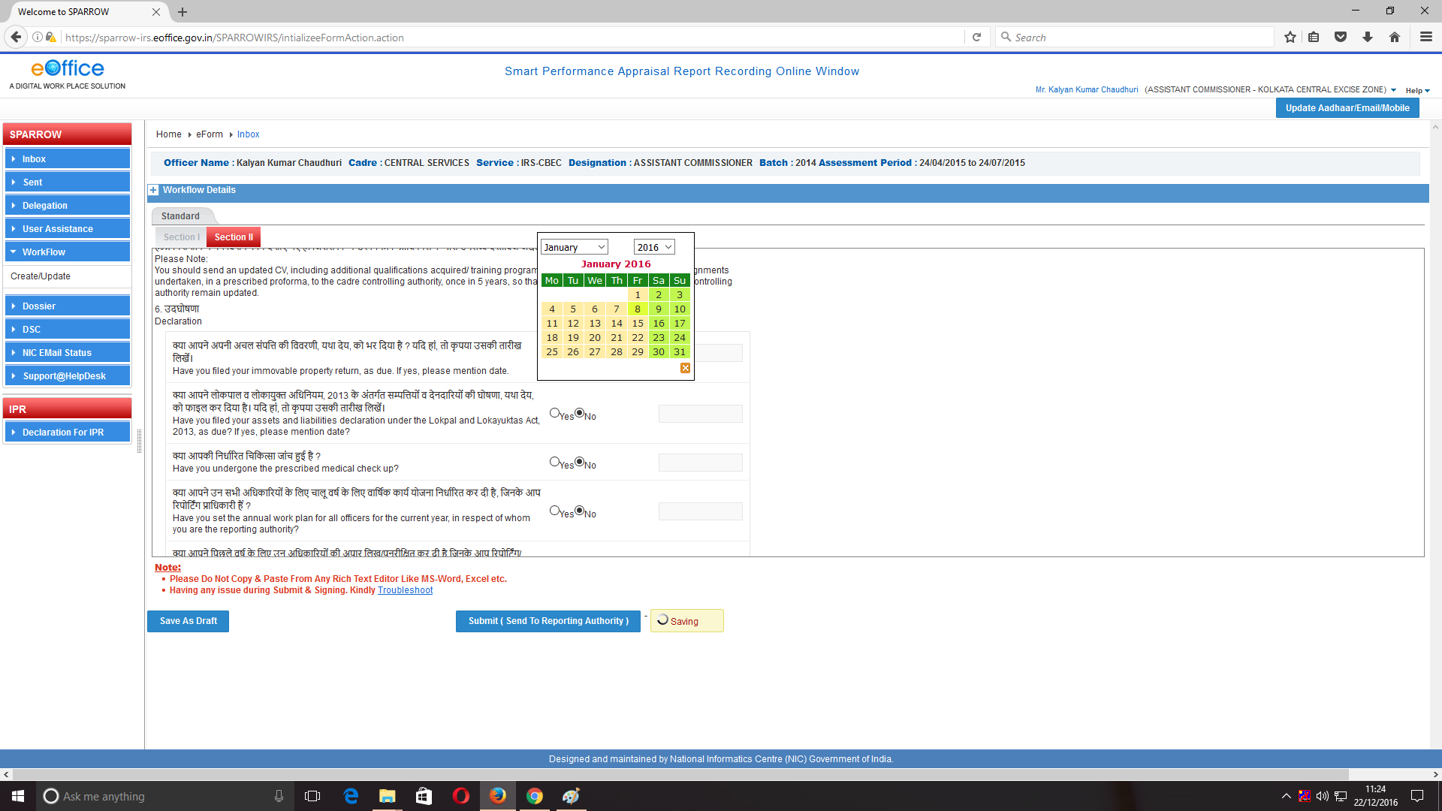

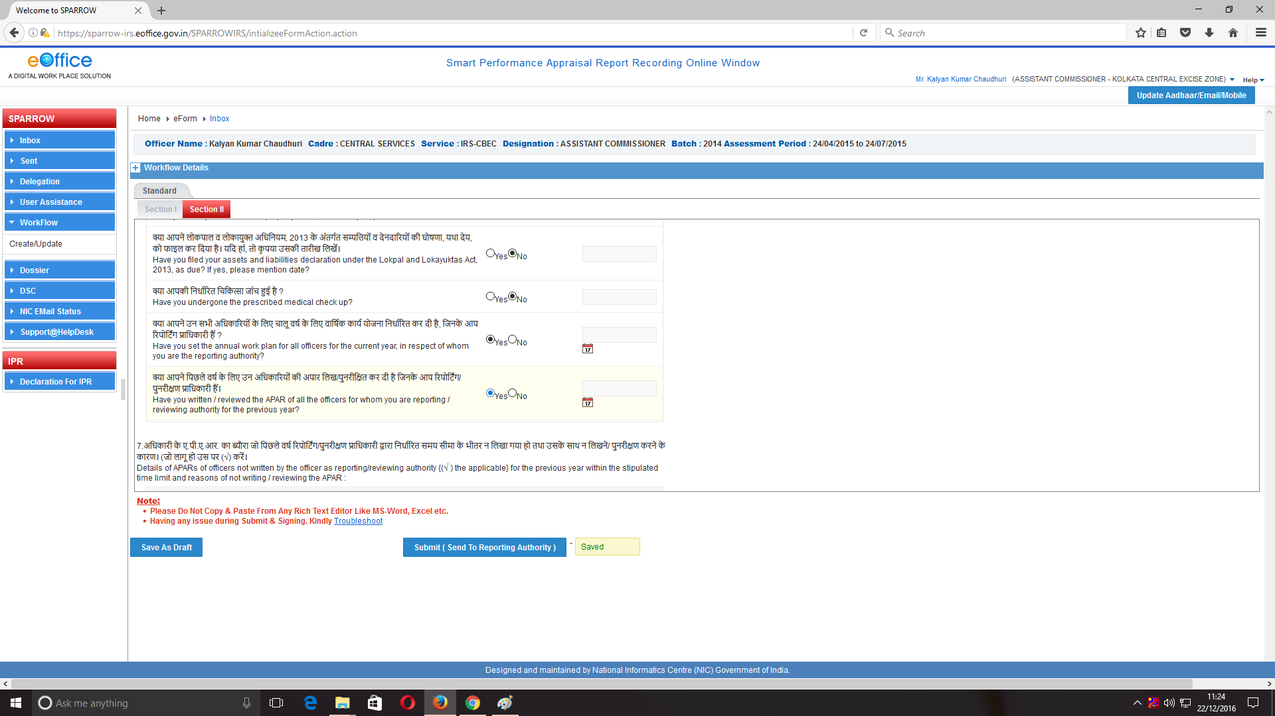
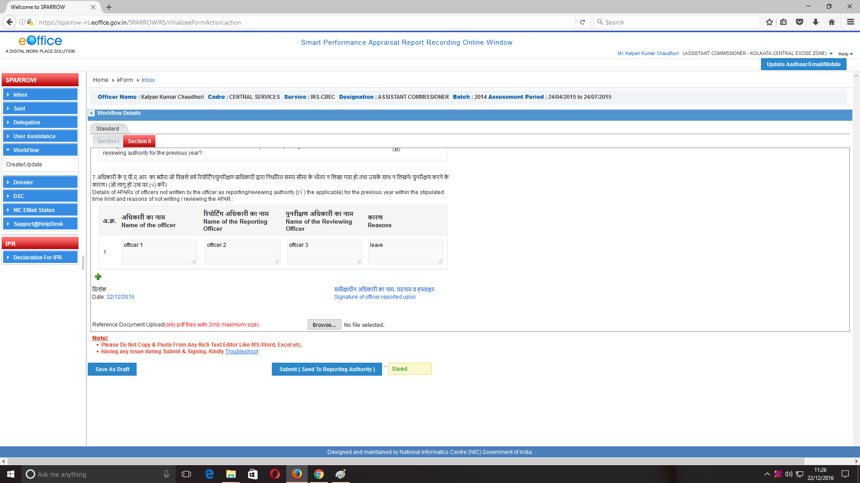

17. After filling all the details in Section–II, the officer can also upload any supporting documents in pdf format up to 3 mb by clicking Browse button.
18. The officer has an option to save the document and come back later to change/amend the same by clicking Save as Draft tab. Officers are also requested to keep on saving the document by clicking Save as Draft to avoid loss of data due to electricity failure or network connectivity issues.
19. Alternatively, the officer may send the PAR to Reporting officer after completing Section II of APAR for which the officer should click on Submit (Send to Reporting Authority). On clicking Submit button, a window asking OTP will appear in which you have to fill the OTP which will be received in your mobile linked with Adhaar card. After clicking this button a confirmation screen for submitting the Section II of APAR will appear with warning- “Once the form is submitted, data will not be changed. Are you sure you want to submit”.
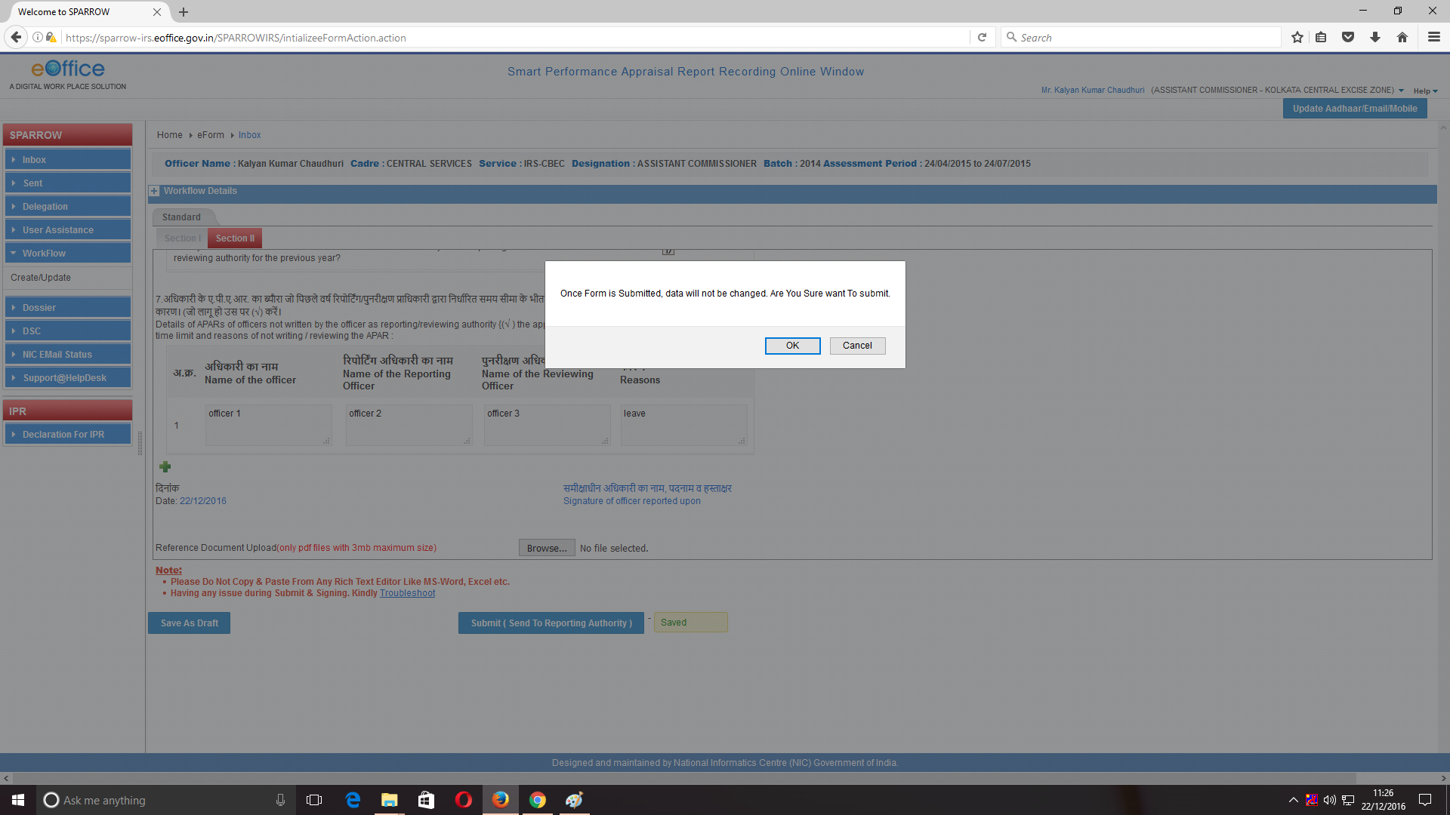

20. After pressing the OK button a message would pop up saying that the APAR has been sent to the Reporting Authority as shown in screen below. An email and SMS will also be sent to the Reporting Officer to this effect.

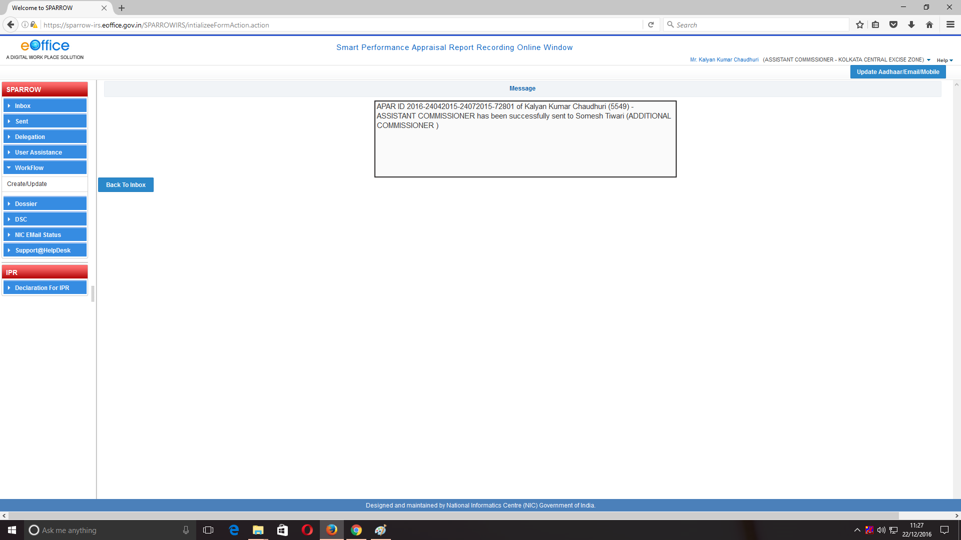

21. Now again the officer will click on Back to Inbox option to show the APARs of remaining period. The screen as shown below would appear. It contains the APAR-IDs for the remaining period i.e in present case for periods 25/07/2015 to 20/11/2015 and then from 21/11/2015 to 31/03/2016.
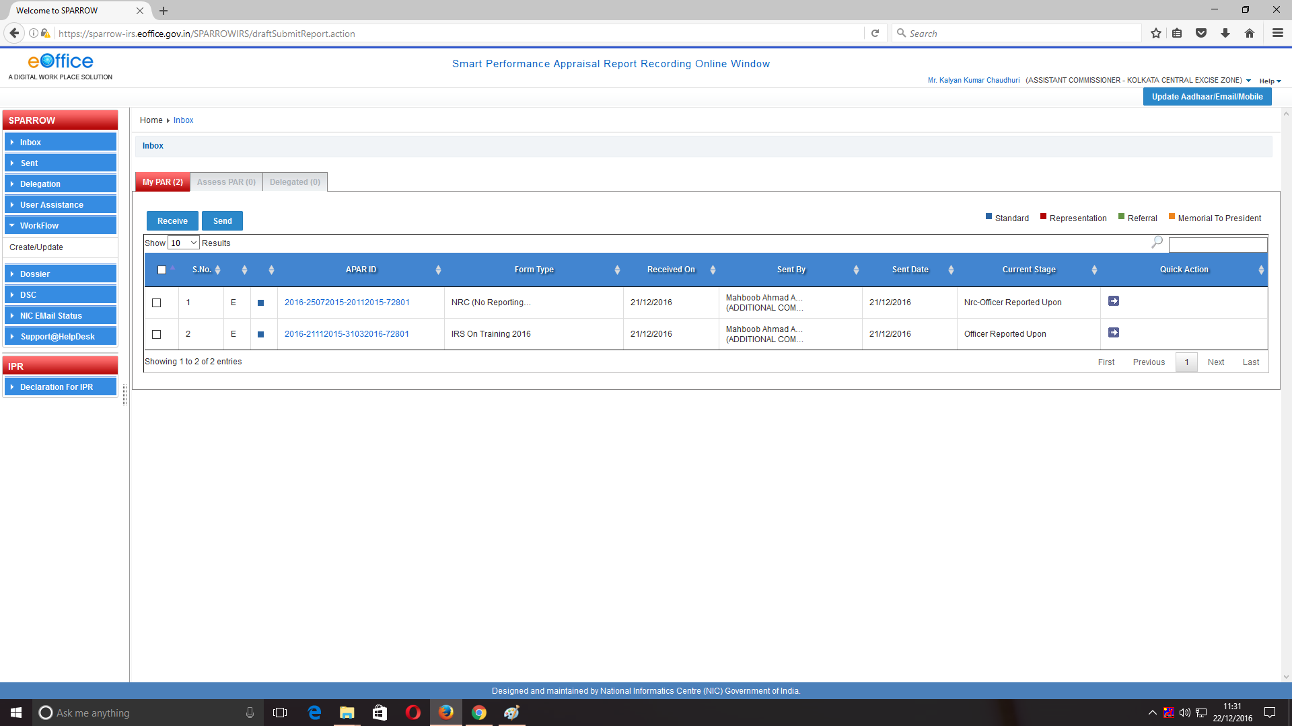
22. The officer just needs to click on blue arrow under Quick Action tab to send the APAR for issuance of NRC or click on the APAR-ID to open it. After clicking on arrow button APAR would be forwarded directly to Custodian for closing. If the officer clicks on the APAR-ID then the NRC would open as shown in the screen below-

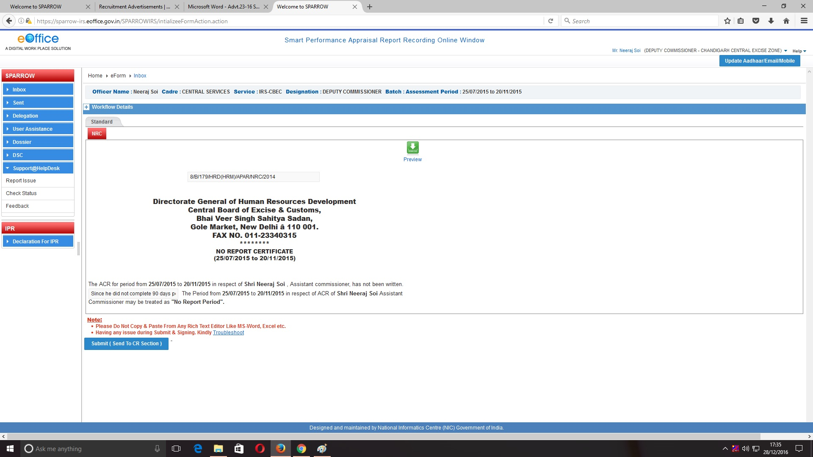
23. After going through his details, click on Submit (Send to CR Section) to send the APAR to the Custodian for closing. A confirmation message would pop-up-“Once form is submitted, data will not be changed. Are you sure want to submit.”

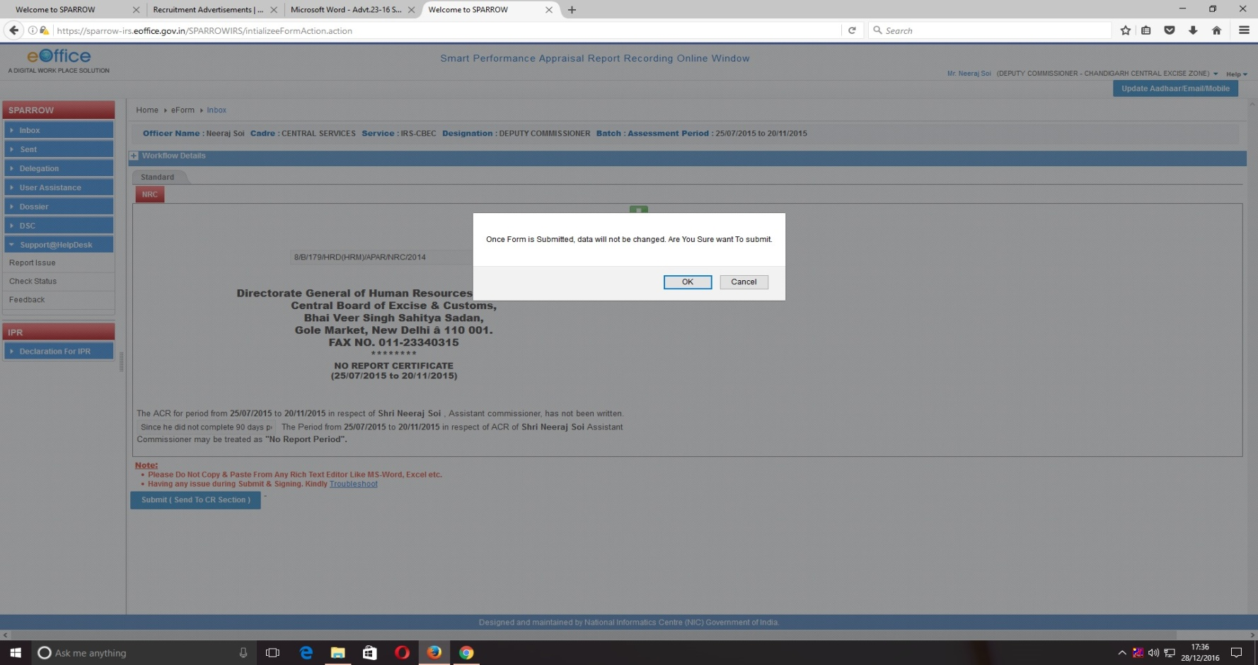
24. Click OK to submit the NRC. A confirmation screen will appear showing that the NRC has been successfully sent to the Custodian.
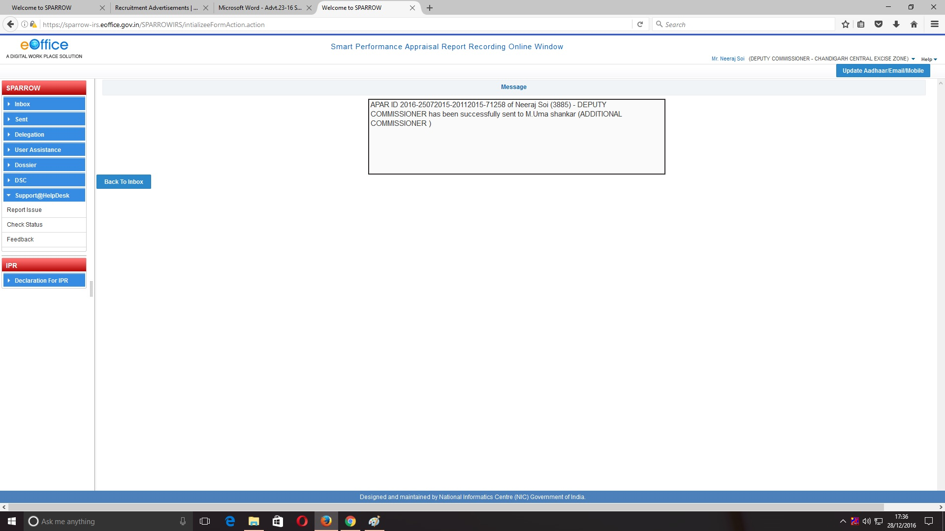
25. Now APAR-ID for remaining period only would appear. For example in the present case officer was on foreign assignment for the period 21/11/2015 to 31/03/2016 and therefore APAR-ID for this period would appear as shown below.

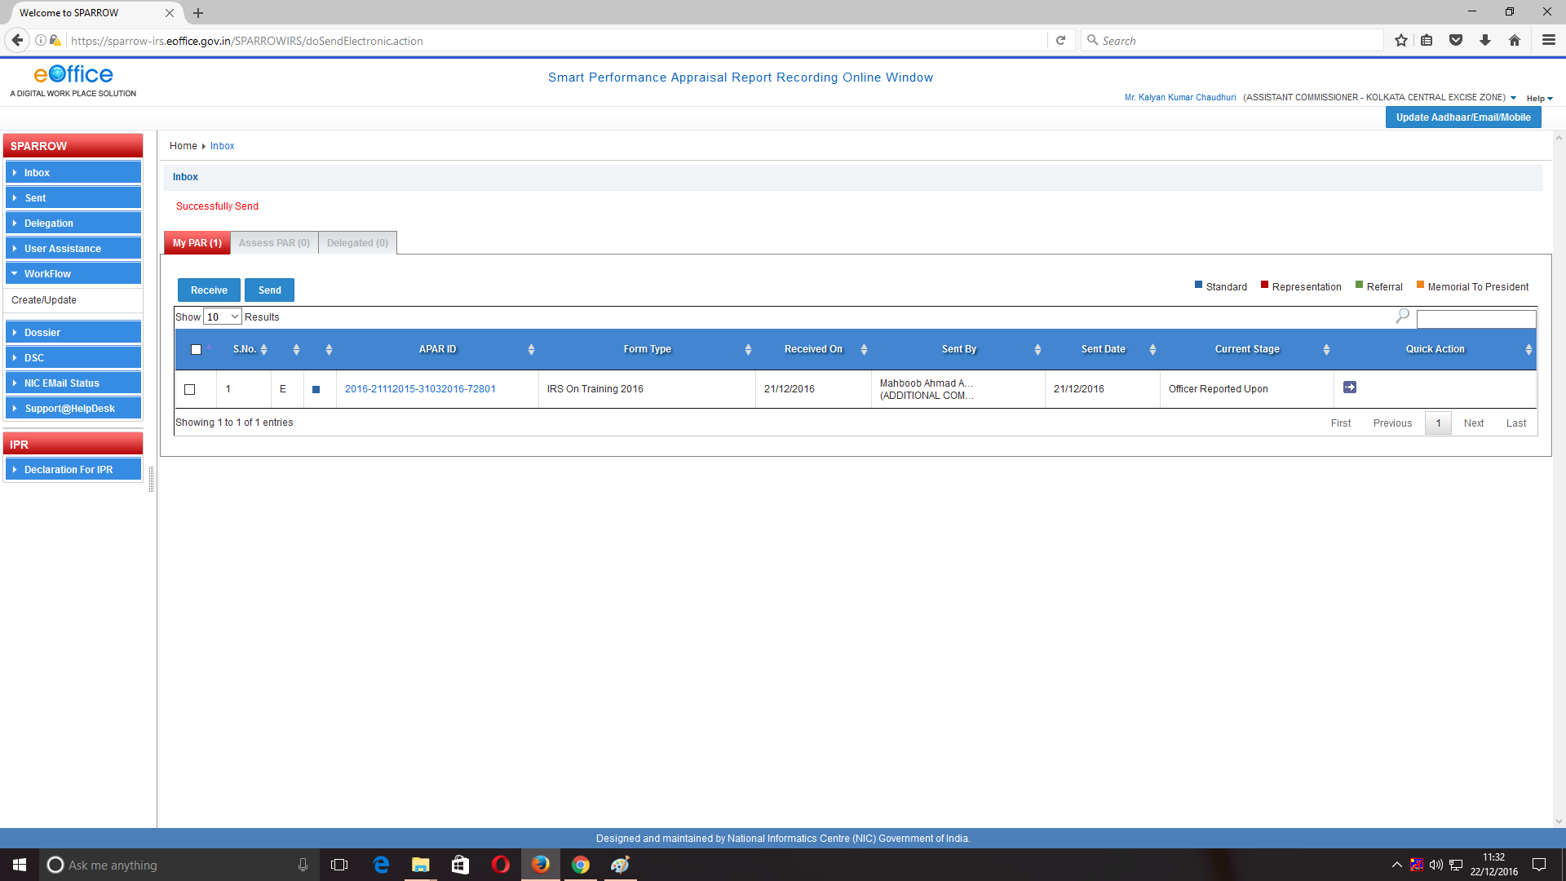
26. Again the officer would click on Blue colour arrow button to forward it to Custodian for closing. Alternatively the officer can also click on APAR-ID to open it. He can go through the same and then forward it to the Custodian for closing following the same procedure as mentioned in the NRC (Explained above. Point 22,23,24). After clicking the button, the next screen would appear as shown below.
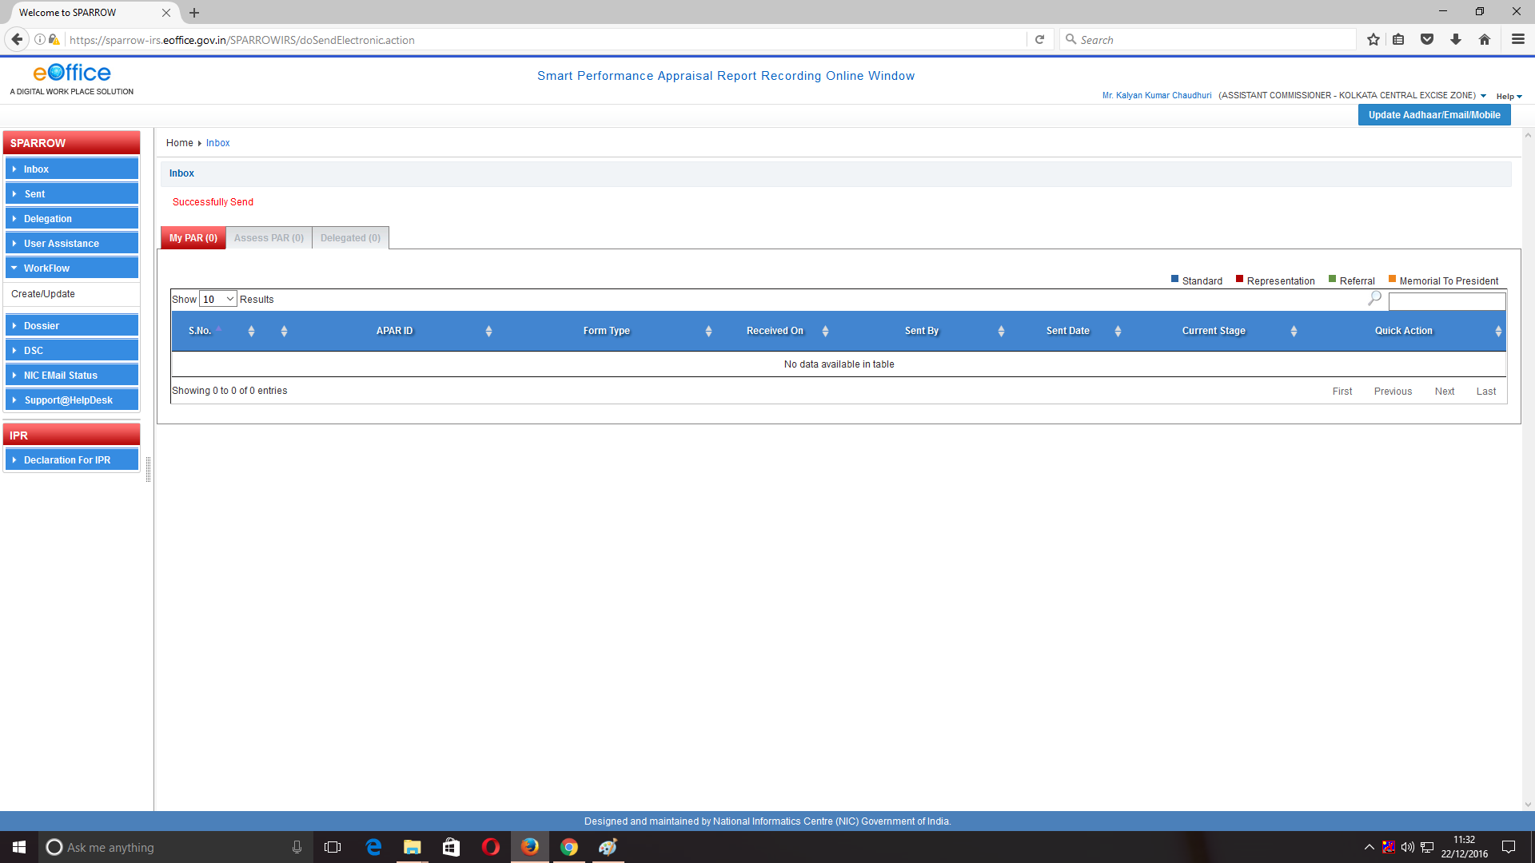 Acceptance of APAR or making representation by the Officer Reported Upon
27. Once Custodian discloses the completed APAR to the Officer Reported Upon, the APAR will be available in the My PAR tab and on clicking the Tab, following screen will appear.
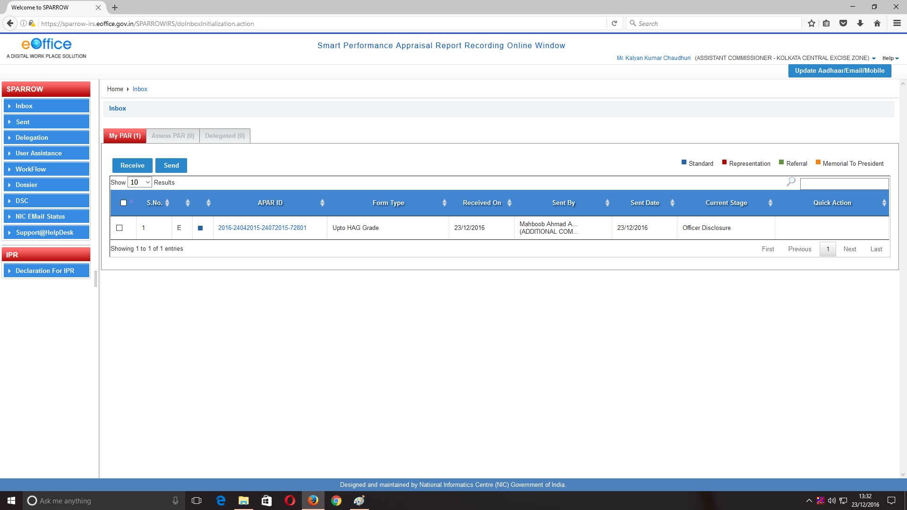
28. After clicking on APAR-ID, all four sections of APAR can seen by the Officer Reported Upon by clicking on different sections. The officer can also save this APAR by clicking on Preview Option as shown in the image in every section.

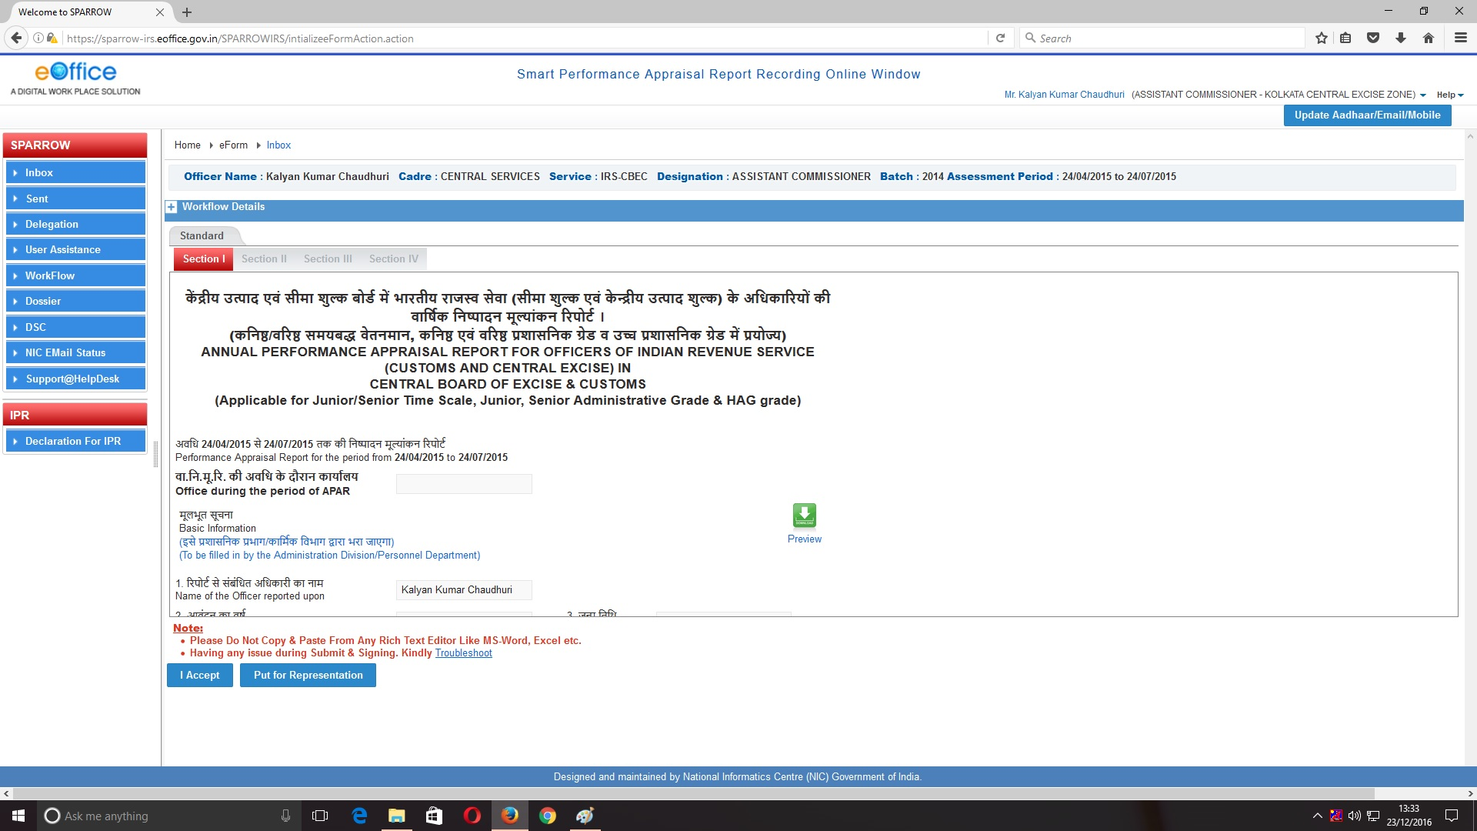

29. After clicking on Preview, the officer would have option to only open or SAVE the document. Click on SAVE File to make a copy in the computer.
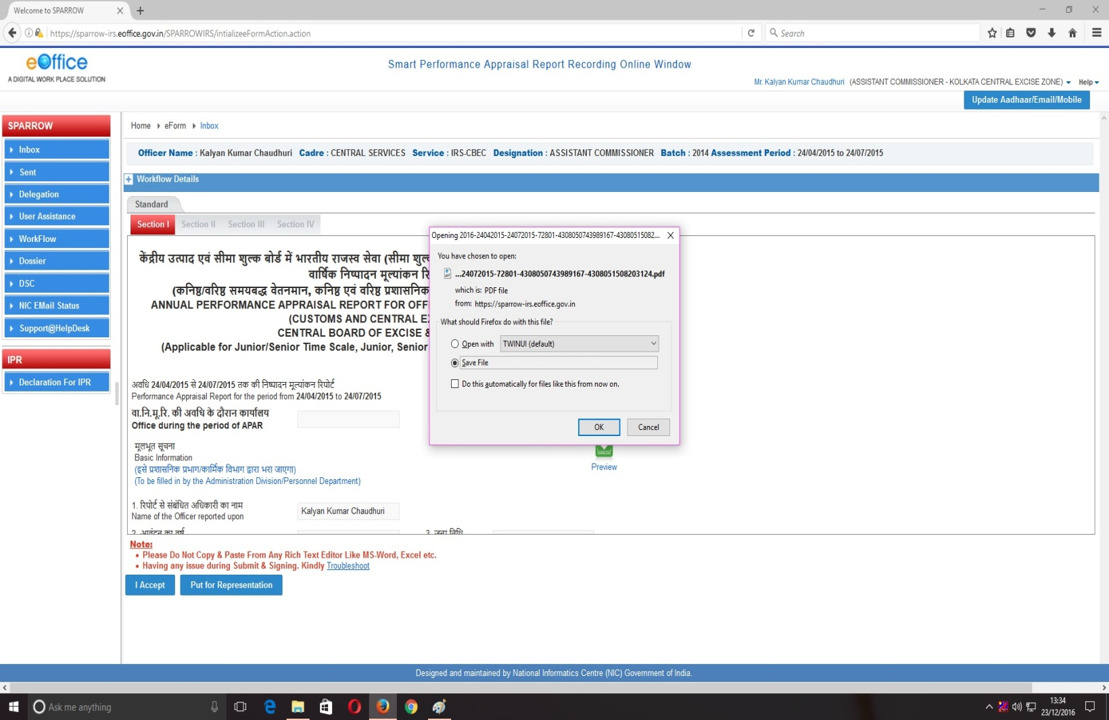

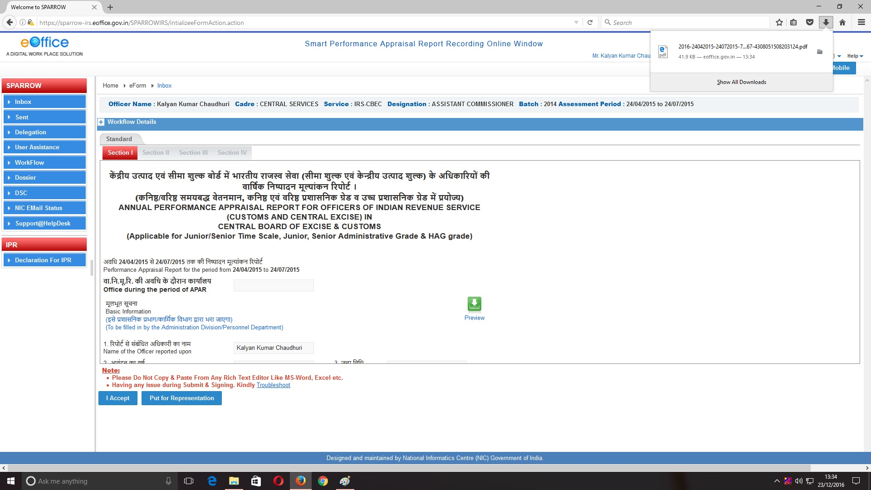
30. After viewing his Section III and Section IV the officer can either click on “I ACCEPT” the APAR or “PUT FOR REPRESENTATION”. If the officer clicks on I Accept Button, a confirmation message would pop up and APAR would be sent to the Custodian for closing.

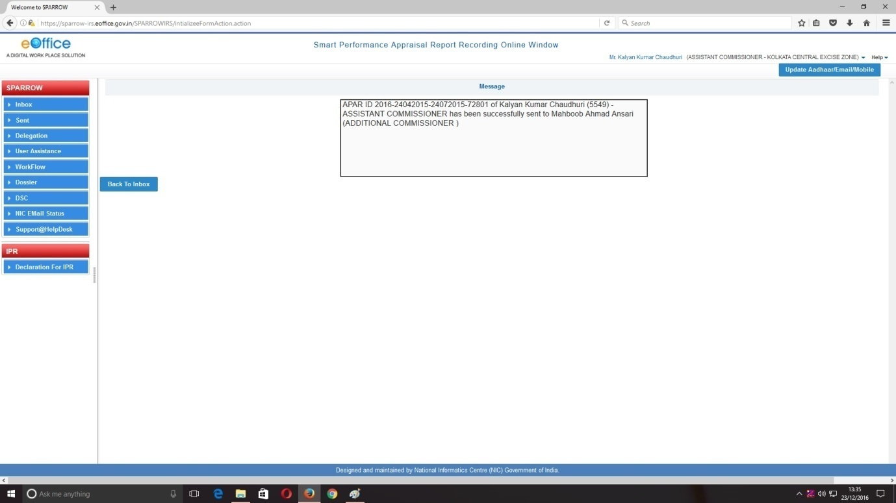

31. Further, If the officer clicks “PUT FOR REPRESENTATION”, the following screen would appear wherein the Officer Reported Upon has to mention the reasons for representation in the text box provided as shown in screen below. The officer can also click on Browse button to upload any reference document in support of his representation.

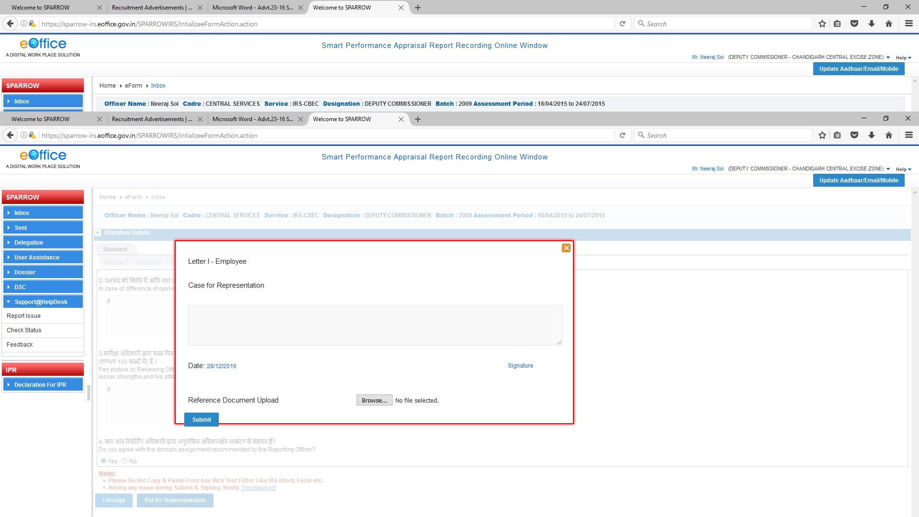

32. After mentioning the reasons and uploading documents, if any, the officer has to click Submit Button. On clicking Submit button, a window asking OTP will appear in which you have to fill the OTP which will be received in your mobile linked with Adhaar card. After clicking this button a confirmation screen for submitting the Section II of APAR will appear with warning- “Are you sure to put the case for representation.”
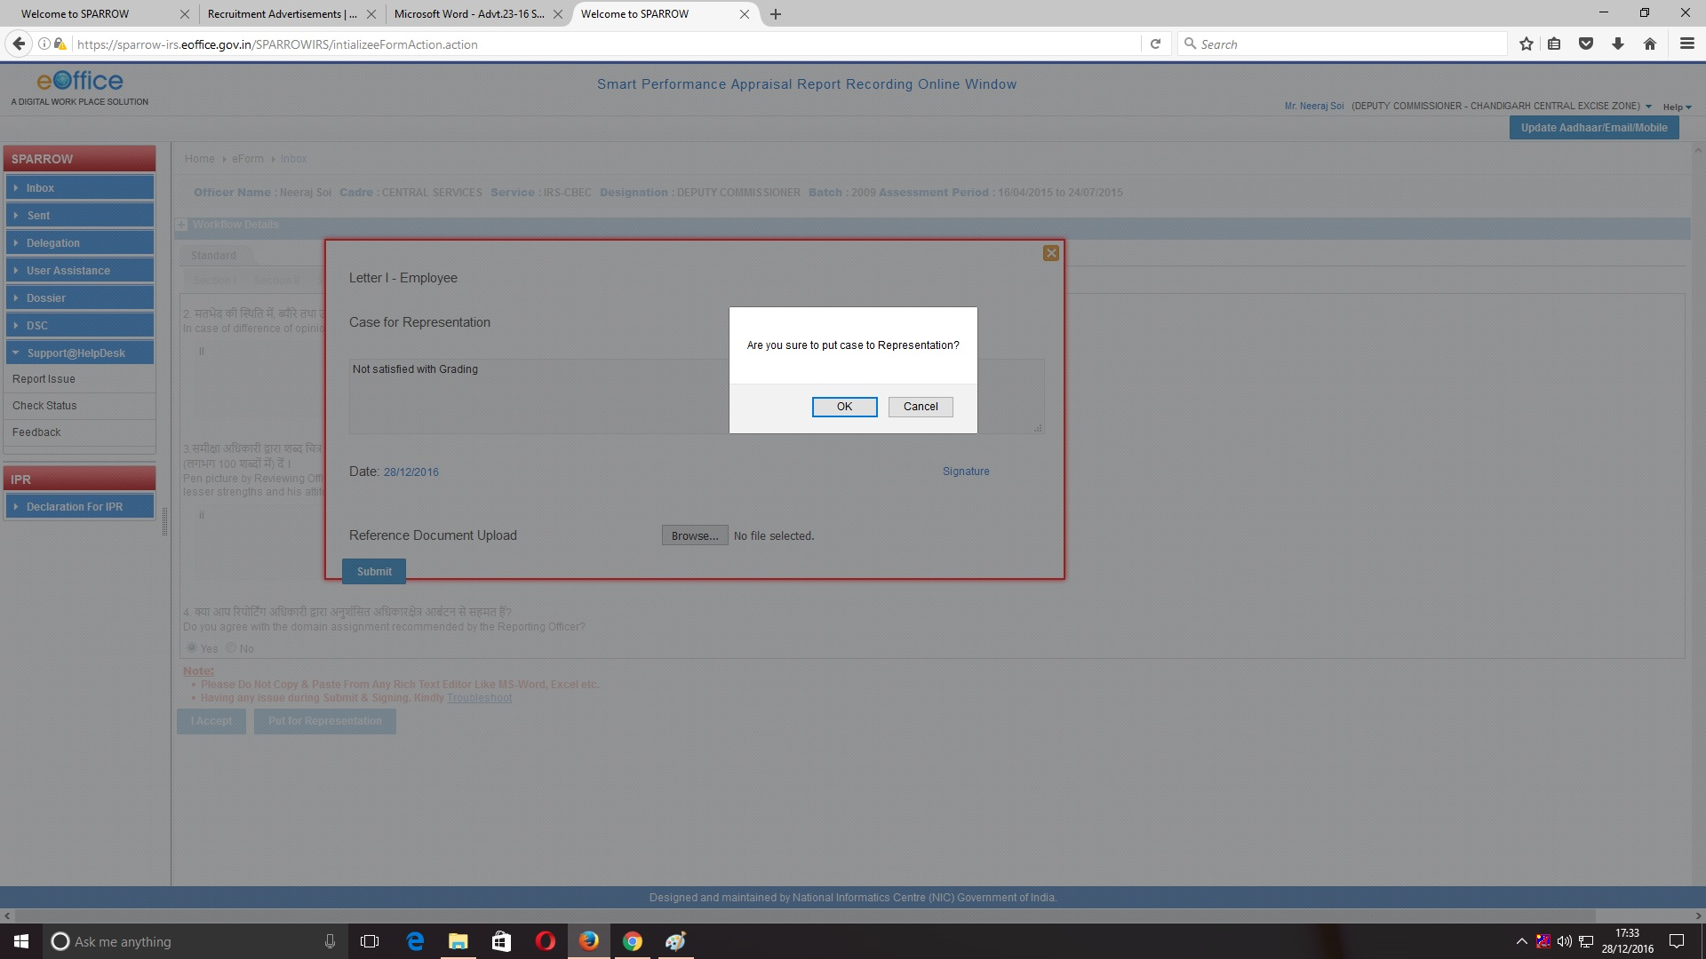

33. Click OK. A message would appear mentioning that the APAR has been successfully sent to the Custodian who will further Submit it to the Competent Authority (Referral Board) electronically for disposal of the representation.





