Step by step guide for the role of Custodian.
(Note: All the functions performed by the Custodian can also be performed by the Alternate Custodian, except the deletion of APAR)
Login
- Open the url https://sparrow-cbic.rcil.gov.in/

2. On opening the url, the "Login Screen of SPARROW Software" (given below) will open.

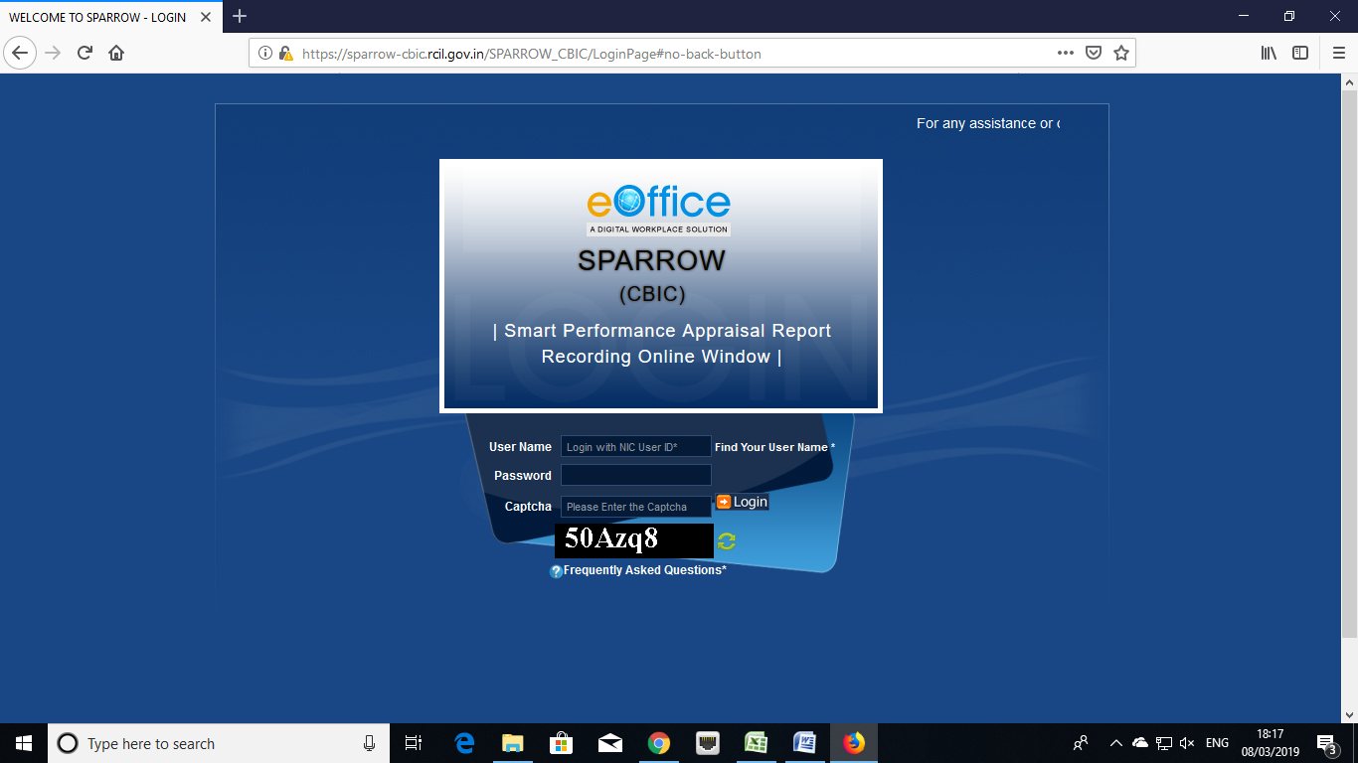

3. The "Smart Performance Appraisal Report Recording Online Window" screen will open up which is essentially a login screen for SPARROW. The screen will have three fields "Username", "Password" and "Captcha".
The username will be the NIC email id and only the name before "@" should be entered. For example if your NIC email is ashish.solanki@nic.in or ashish.solanki@gov.in, then, the user id will be ashish.solanki.
The password for the application will be same as your NIC email ID password.
Note: For practice environment, till software is launched, the default password for logging into the system is kept as "eoffice" for all the users. The following accounts can be used as the accounts of Custodians for the Training purposes:
- Shri Man Mohan Singh - manmohansing.g139301@gov.in
- Rajesh Mittal - rajeshmittal.g139301@gov.in
- Praveen Pathak - praveenpatha.g139201@gov.in
- Shri Deepak Verma - deepakverma.g139601@gov.in
- Manoj Kumar Sharma - manojkumarsh.g131102@gov.in
- AMAR RAI - amarkumarrai.g139401@gov.in
- Shri Jagdarshan Bist - jagdarshansi.g139401@gov.in
- Manish Agarwal - manishagrawa.g139001@gov.in
- PRAKASH RAWAT - prakashsingh.g139501@gov.in
- Shri Sanjay Mishra - sanjaymishra.g138601@gov.in

4. The Captcha as given in the box should be entered then click the "Login" button.
5. After logging in, the software would automatically move to next screen. By default, the SPARROW window will open up as shown in the next page.
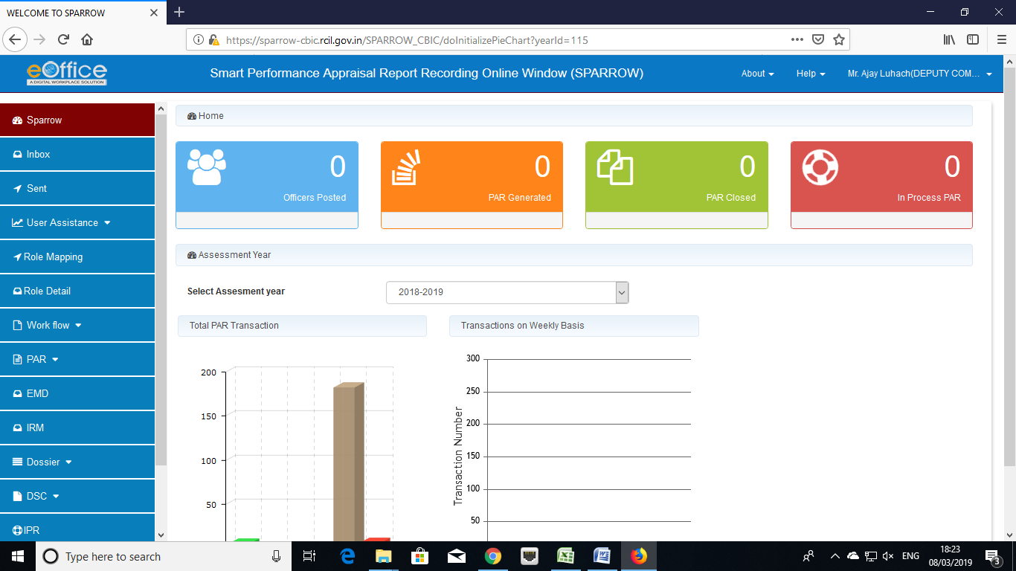
6. After successful login, the above window will open up. This page will have some tabs in the left side depending upon the role assigned to the officer. Above page is for the role of Custodian. These roles are allocated Super Custodian (Zonal Nodal Officer) and on logging in, different window will open up depending upon the role assigned to that user ID.
The basic function of the Custodian is to define the work flow. Accordingly, the Custodian has to click the tab "workflow" on the left hand side the screen and then click Create/ update link.
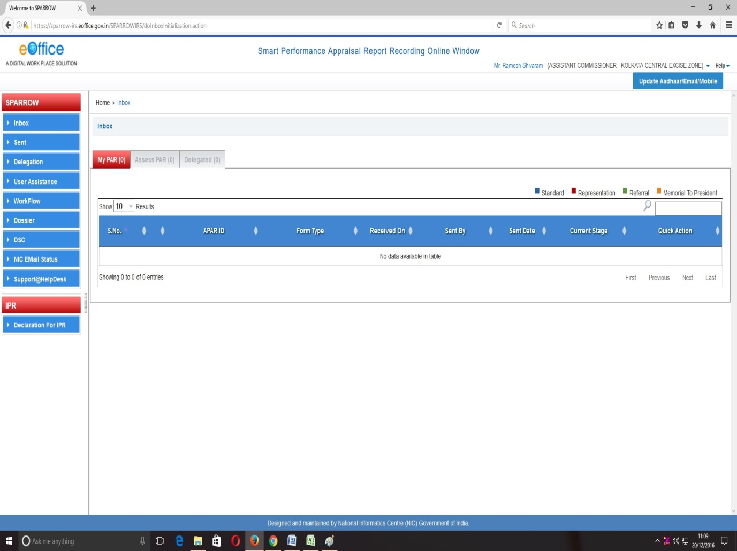
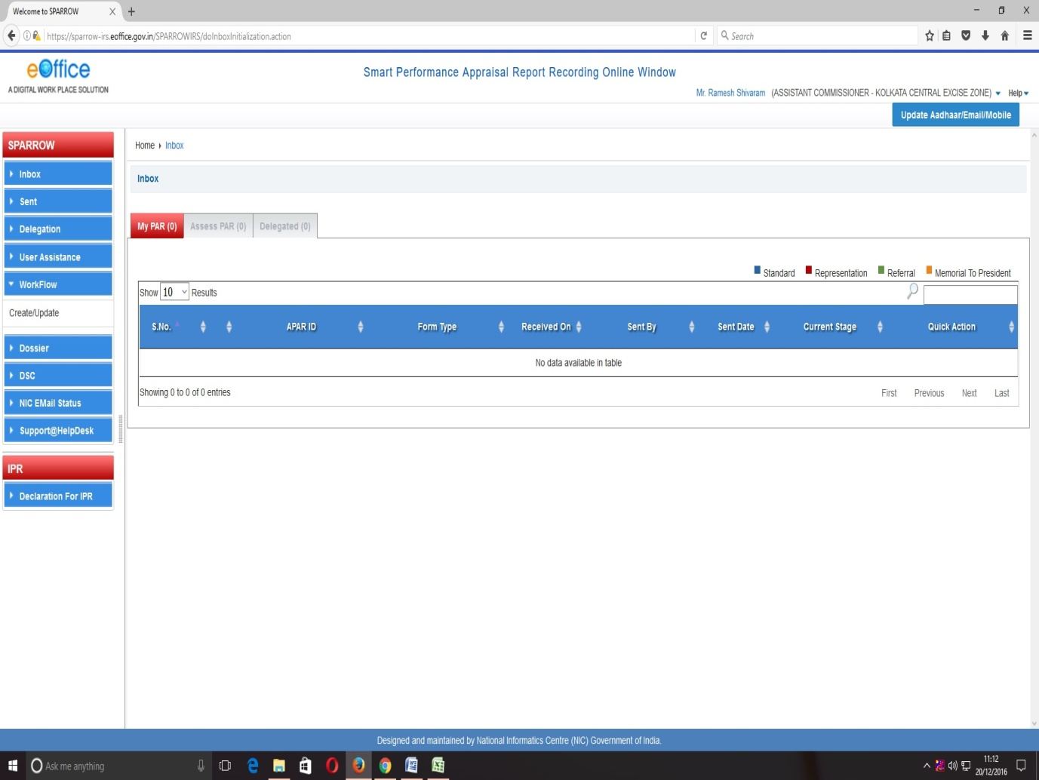
7. On clicking the Workflow, the Tab will extend and "Create/Update" link will be displayed. On clicking the "Create/Update" link (as shown in image above), the "Employee Search for Assessment - Workflow Creation" window will open up.
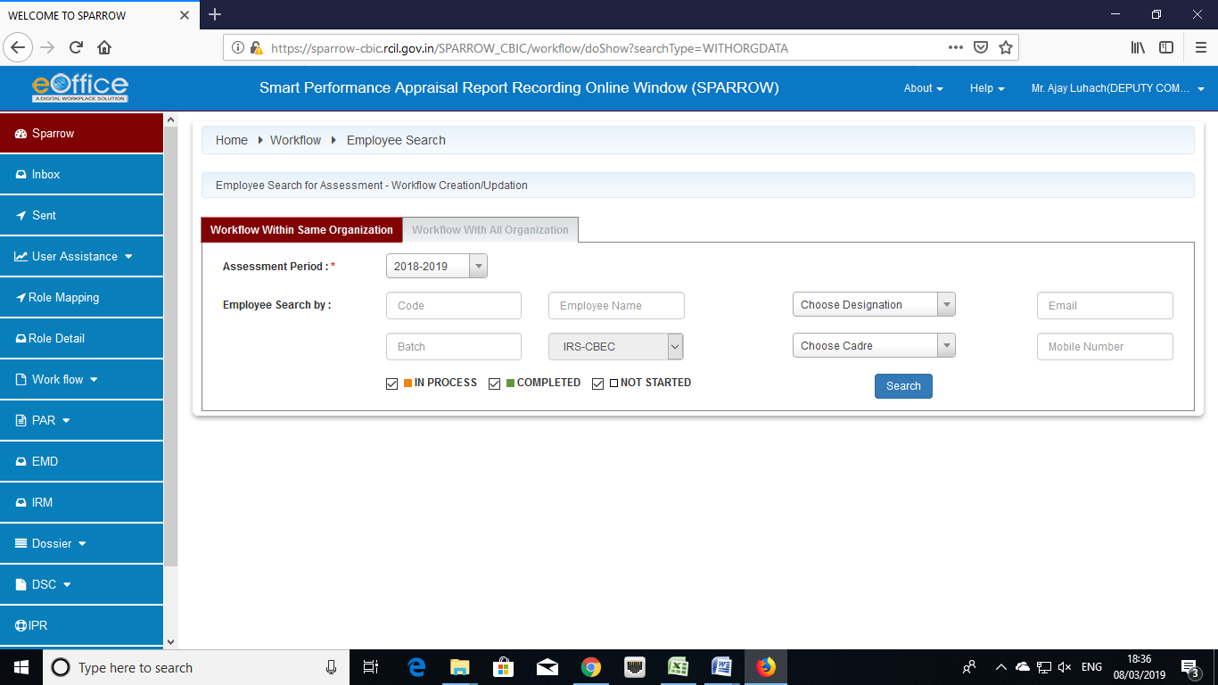
8. Workflow Creation" window will have two tabs which are "Workflow Within same Organisation" and "Workflow With All Organisation". Now depending upon whether the Custodian is creating workflow for the employee in same formation or in some different formation, he will choose "Workflow Within same Organisation" or "Workflow With All Organisation" respectively. It is advisable to select "Workflow With All Organisation".
Custodian should then select "Assessment Period" from the drop down menu provided.
Now the Custodian has to search the officer in respect of whom he wants to create work flow. Out of all the displayed option, the Custodian can search either by name or employee code. It is advisable to use the "Employee Code" of the officer for search as it is unique identification number for any officer
Once the “Employee Code” is entered & search button is pressed; the name of the officer whose workflow is to be created will be populated in a table below:
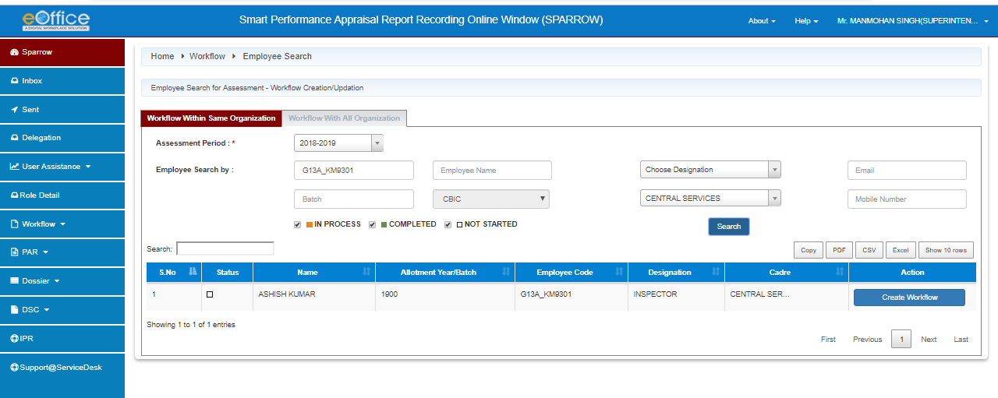
9. Three square boxes will also be displayed in the left side of the officer’s name. These square boxes will have a colour depending upon the status of workflow creation for the officer which is given as below.

In Process Completed Not Started

Custodian should click the Create Workflow Tab (In Blue Colour) which will populate the details of the Officer and a window will open for "Creation of Work Flow - Choosing Workflow Period” as given in the screen below.
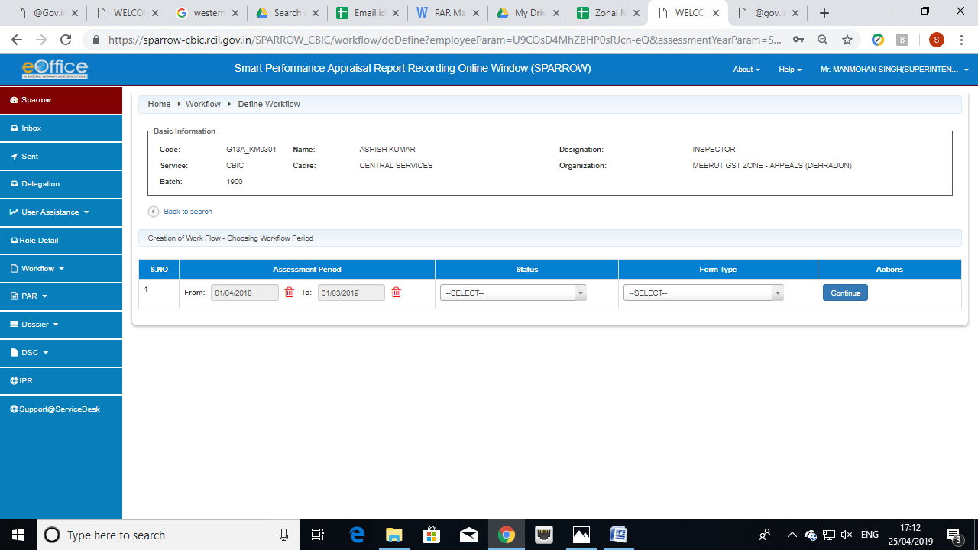
In this window, the "Assessment Period" has to be selected first which has to be done very carefully. The Assessment period has to be selected depending upon the dates during which the officer has worked under different Reporting and Reviewing officers during the financial year.
The APAR can be generated for period which is not less than 90 days. There may be periods where he has not worked under any Reporting and Reviewing officer for 90 days or more. In such cases, the form for NRC has to be selected by PAR Manager as in such cases NRC is to be issued. Hence, PAR Manager may be required to create more than one work flow during the year for any officer.
The dates for assessment period (from and to) are to be selected from the calendar as shown below.
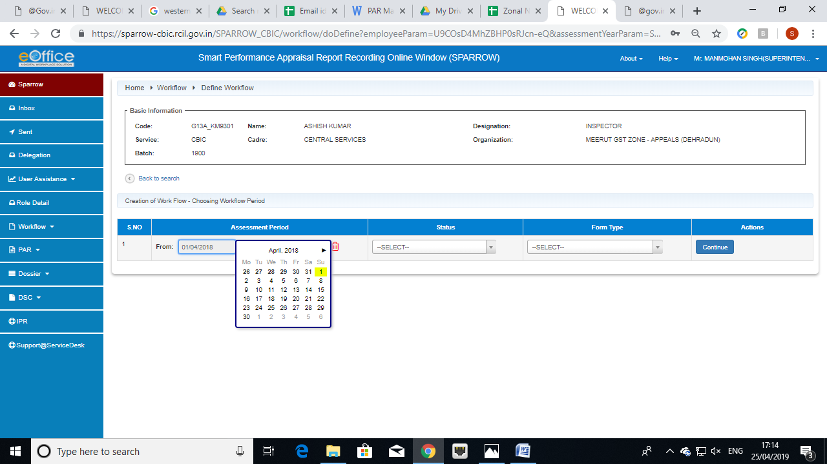
10. After selection of the assessment period, the Status has to be selected from the drop down menu out of the three options i.e. "WORKING", "NRC" and "FOREIGN ASSIGNMENT". Where ever the APAR is to generated, staus "WORKING" should be selected. Foreign Assignment is to be selected when the officer is on any Foreign Assignment with UN / WCO etc where the APAR is not written.
After selection of the Status, in case where the Status selected is Working, then the Form Type has to be selected from the drop down menu out of the two options depending on the present grade of the officer.
11. Let us now create work flow for an officer who has worked under one set of Reporting and Reviewing officers from 16th April to 24th July 2018 and he has not completed 90 days under any Reporting / Reviewing officer for middle period which is more than 90 days and he went for Foreign Assignment for remaining period with UN / WCO etc where the APAR is not written and only Foreign Assignment Note is to be placed in APAR folder as per DoP&T O.M. The work durations of this officer is tabulated below.

S.No. | From | To
1. | 16/04/2018 | 24/07/2018
2. | 25/07/2018 | 20/11/2018
3. | 21/11/2018 | 31/03/2019

12. The workflow details have to be filled in by the Custodian in the table below:
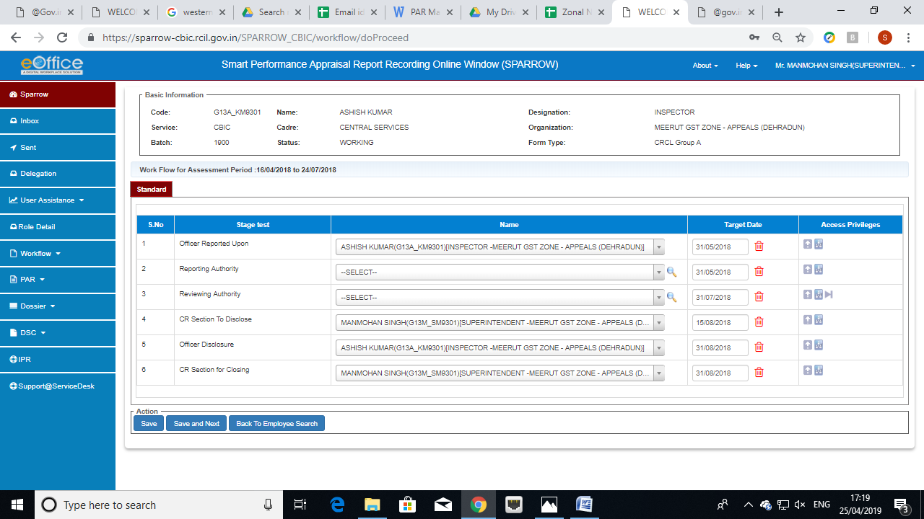

13. Till now, only workflow has been generated by Custodian but no PAR has been generated. Custodian can generate the PAR for which "PAR tab" should be clicked. On clicking it, the PAR tab will extend and 4 links will be displayed below PAR tab i.e. "Generation", "Update Section I", "Tracking" and "Force Forward".
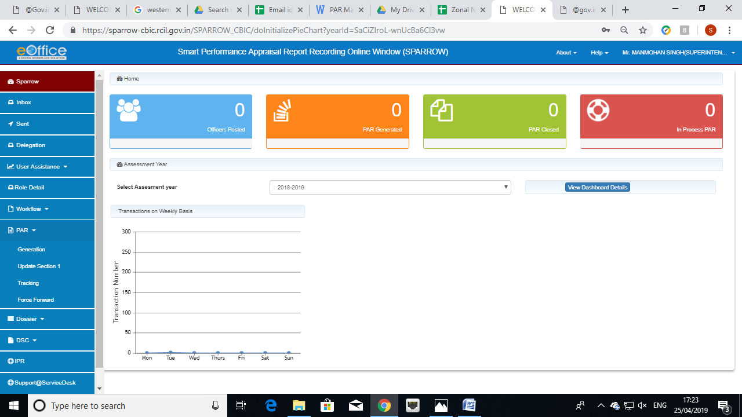
14. On clicking "Generation" link, the "APAR Generation" window will open up as shown below. In this window, he has to select the Assessment Period 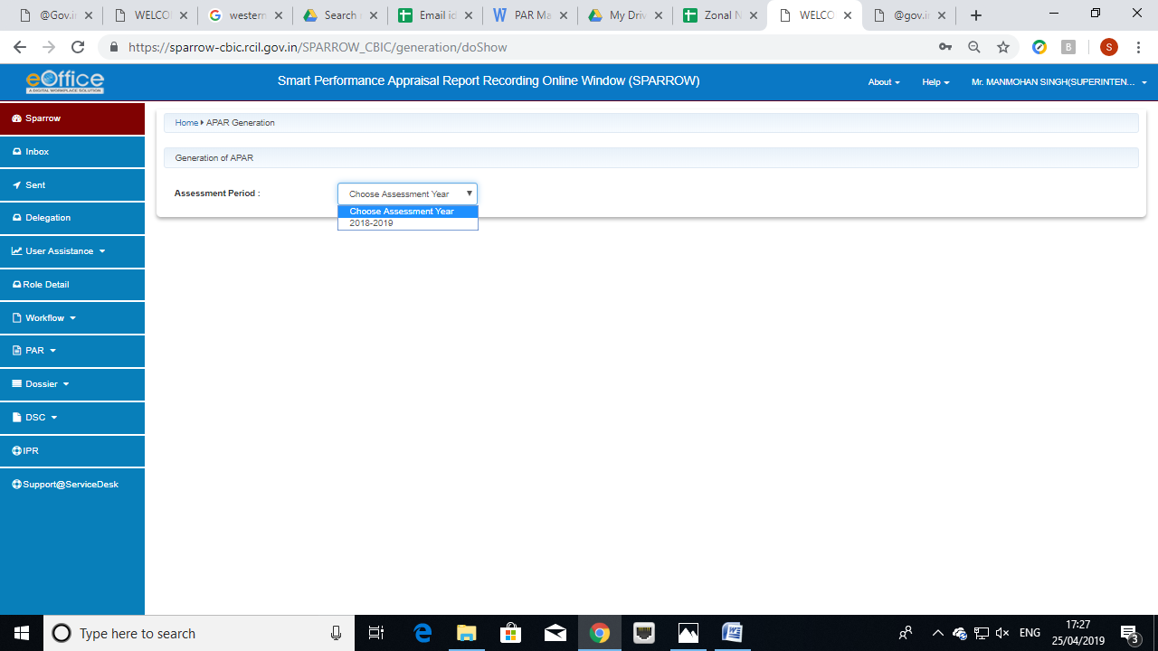
Then he can search employee by his/her Employee Code by filling the Employee code and clicking search button whereby all the PARs workflow created for that employee will be populated.
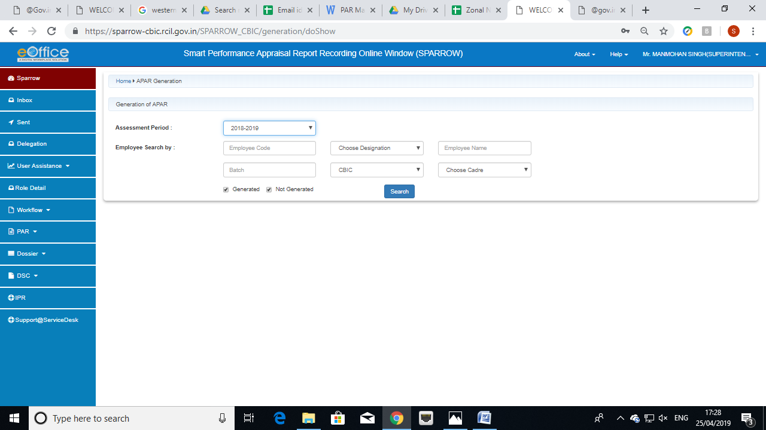

Alternatively, he can leave the Employee Code as blank and can only tick the "Not Generated" checkbox. In this case, the details of all the employees whose workflow has been created by Custodian but PARs are yet to be generated will be listed. The Custodian can select the work flow for any employee from the list for generation of APAR.
15. Let’s try to create APAR for an officer for whom 3 work flows have been created by the PAR Manager for any year based on the following work durations.
S.No. | From | To | Status
1. | 16/04/2018 | 24/07/2018 | Working
2. | 25/07/2018 | 20/11/2018 | NRC
3. | 21/11/2018 | 31/03/2019 | Foreign Assignment

16. For above work durations, the Custodian had already created three work flows. One for the period during which the officer has worked under one set of Reporting and Reviewing officers from 16th April to 24th July 2018. Second for the period where he has not completed 90 days under any Reporting / Reviewing officer but this period is more than 90 days and third for period during which he was on Foreign Assignment with UN / WCO where the APAR is not written and only Foreign Assignment Note is to be placed in APAR folder as per DoP&T O.M. These 3 workflow will be reflected as shown below in the Custodian screen for this officer.
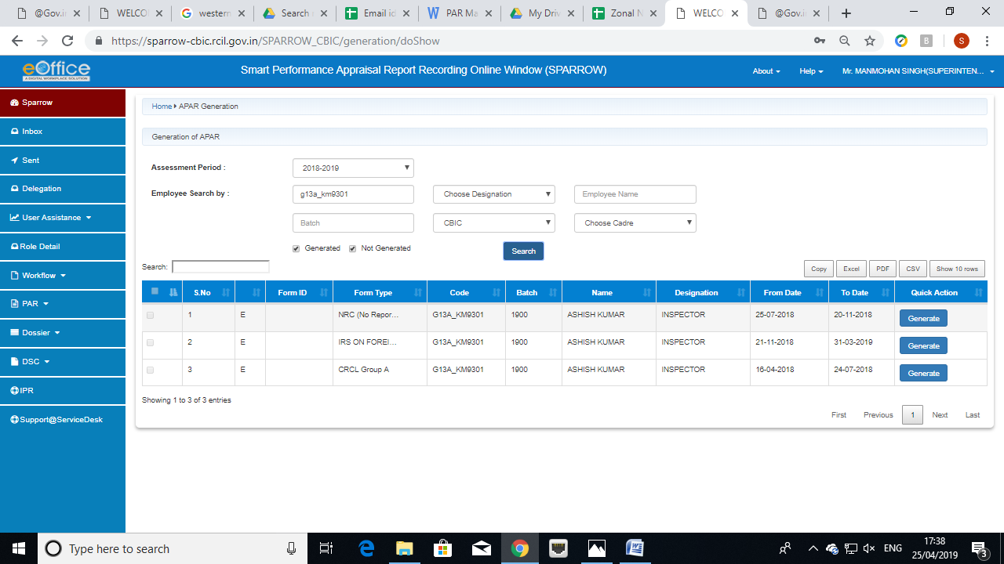
17. Custodian needs to be click Generate under the heading "Quick Action" for generating APAR. Now let us consider all the three cases one by one.
18. First we will generate the APAR for the period 16-04-2018 to 24-07-2018. The Custodian should click the Generate which is in the line of the Work Flow for the period 16-04-2018 to 24-07-2018 and the first page of the APAR i.e. Section-I of APAR will open up as shown below.

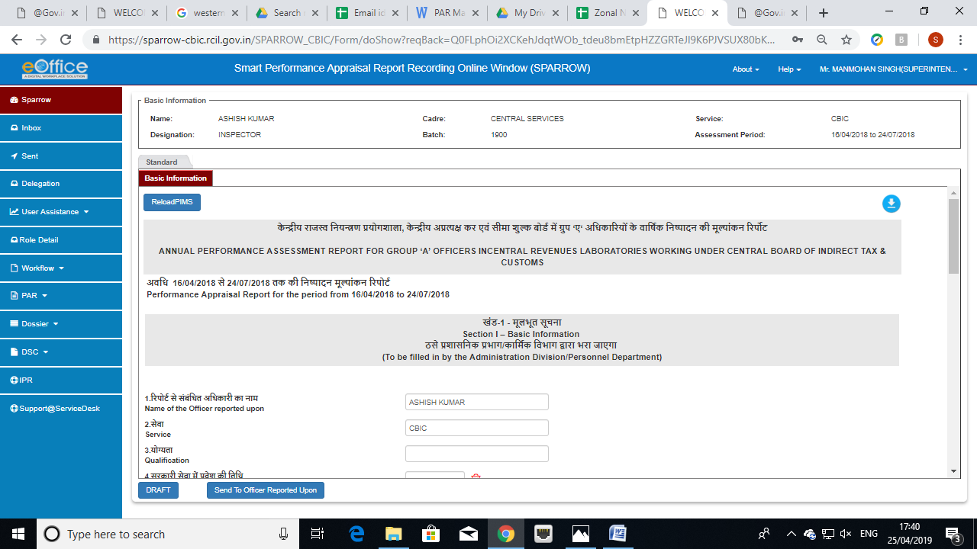

19. Certain fields like Name of the officer, Year of Allotment, Date of Birth, and Employee Code in the Section I of the APAR will be auto populated. If these values are incorrect the same can be changed/corrected by the Custodian.
20. Custodian should take extra care in filling the "Period Worked” under the Reporting and Reviewing officer (column no. 9) factually & correctly. The names of the Reporting Officer & Reviewing Officer along with the date field of "Period Worked" will be auto populated. The date fields will auto populate with same dates which are the initial and final dates of the period of work flow. The Custodian should however update these from and to dates for both Reporting and Reviewing officer with actual dates of supervision by these officers (which may last beyond the period under consideration) by clicking the calendar.
While updating these dates, if Custodian finds any mistake in creation of Work Flow, the Custodian can delete the work flow and can create a new work flow. This deletion of workflow is explained later in this manual.

21. In column no. 10, leave details are to be filled by selecting the dates from the calendar icon and entering the type of leave and remark as shown in screen below. For adding more leaves click on add “+” tab in green colour as shown in the screen below.
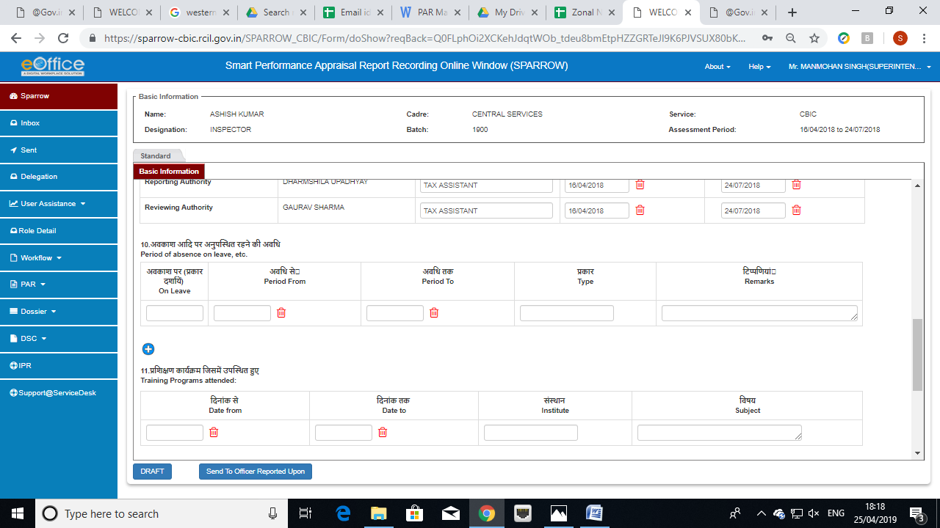

22. Column no. 11 consists of the Training details to be filled if the officer has attended any training during the period for which the APAR is being written. Training dates are to be selected from the calendar under “Date From” and “Date To”. Enter the Institution or Organisation where an officer has attended training and also the Subject in which the officer has been provided training.

23. Column no. 12 consists of Awards and Honours details. For adding more awards click on add “+” tab in green colour as shown in the screen below.

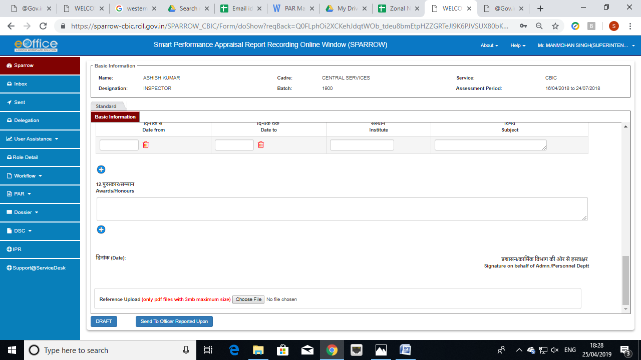

24. There are two options provided at the bottom, one as "Save as Draft" and "Send To Officer Reported Upon” as seen in the screen above. If the Custodian needs to save the Section-I of document for later reference he/she can click on "Save As Draft" or otherwise the document can be send to the Officer Reported Upon by clicking " Send To Officer Reported Upon ".

On clicking “Send To Officer Reported Upon” button, a window asking OTP will appear in which you have to fill the OTP which will be received in your mobile linked with Adhaar card. Once OTP is submitted, a confirmation window will pop up reading- "Once form is submitted, data will not be changed. Are you sure want to Submit". Click OK to submit the Section-I of APAR.

25. Once the PAR document is sent to the Officer reported upon, a confirmation message will be displayed as shown below and an email and sms alert will also be sent to the officer reported upon to this effect.

Deletion of Work flow:
Action required by Custodian when work flow created is not correct
26. In case, the Custodian finds that the work flow created is not correct and one or more work flow needs to be modified, he has the power to delete any work flow. The deletion can only be done before the generation of the APAR. Once the APAR is generated by Custodian, deletion is not possible.
27. For deletion, the custodian has to go to the "Workflow" menu of the SPARROW. On clicking the Workflow, the Tab will extend and "Create/Update" link will be displayed. On clicking the "Create/Update" link, the "Employee Search for Assessment - Workflow Creation" window will open up. Workflow Creation" window will have two tabs which are "Workflow Within same Organisation" and "Workflow With All Organisation"respectively. Now Custodian has to select "Workflow With All Organisation". Custodian should then select "Assessment Period" from the drop down menu provided. Once the "Assessment Period" is selected from the drop down menu; various search options will come on the screen as below.

28. Out of all the displayed option, the Custodian should fill the "Employee Code" of the officer who’s APAR he wants to delete.

29. The Name of the officer will be displayed.
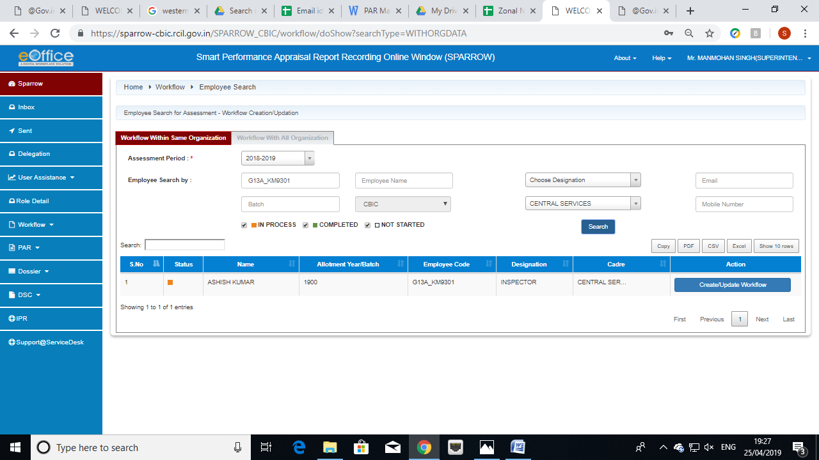
30. After clicking on Create/Update Workflow all the workflows created for the officer will be displayed as below:
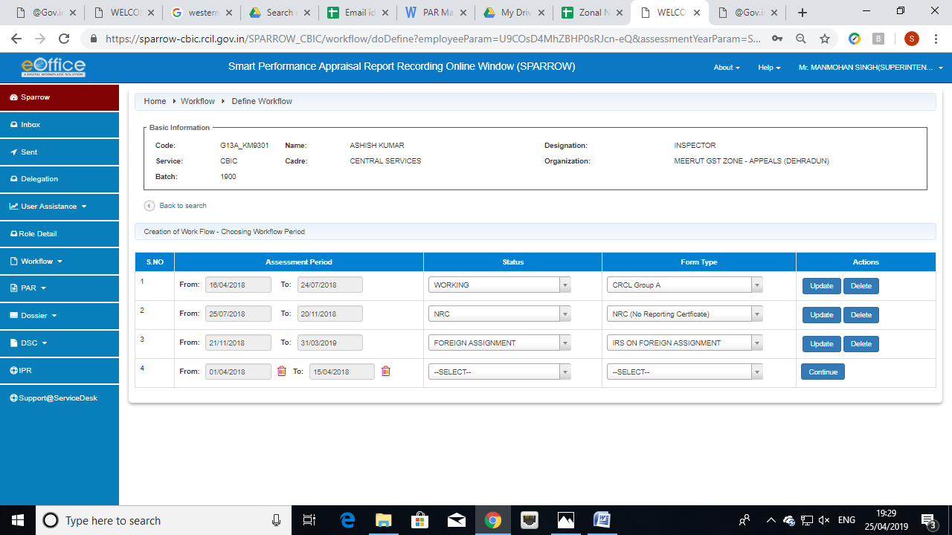

31. The workflow created will have two options Update and Delete as shown in the screen above. The Custodian can delete the wrong Workflow generated. On clicking the Delete button a message box will open up as shown in the screen below wherein the Reason for Deletion is to be filled up. Custodian can also attach any reference document if required.
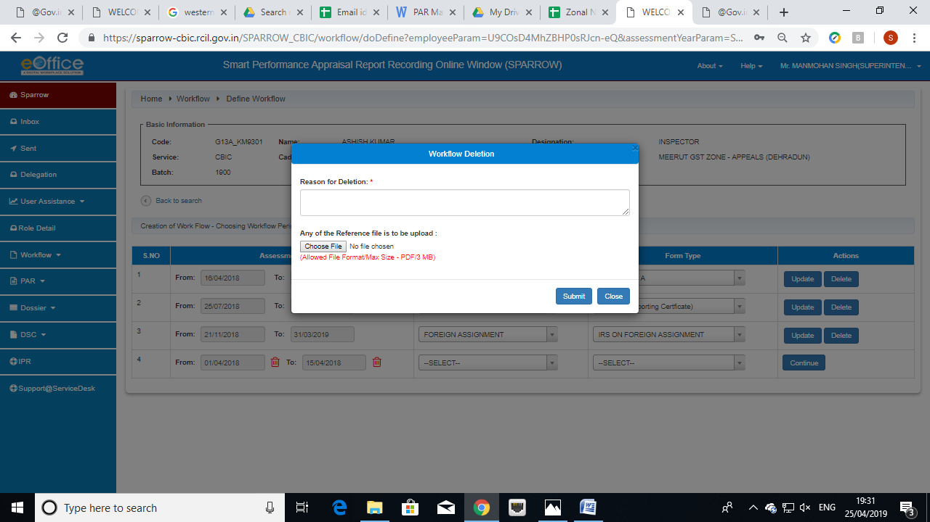

32. After writing the reason and uploading the document, Click Submit. The system will ask for confirmation before deletion. A confirmation message will pop up as shown below:

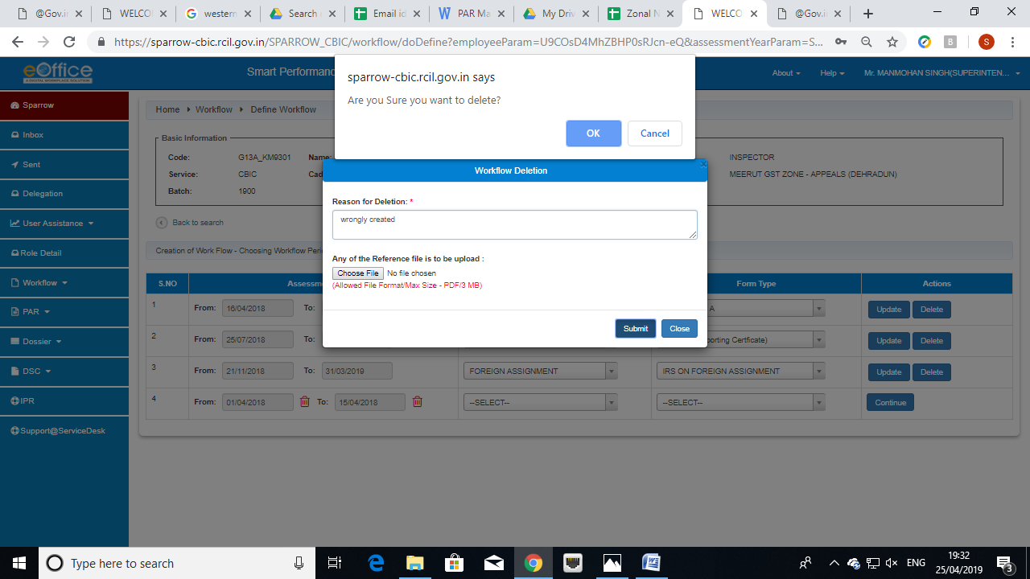

33. Once Ok is clicked, the said work flow will be deleted and the system will automatically propagate the remaining period for which the workflow is not yet to be created. The custodian can then generate the corrected workflow again.

Disclosing of APAR to the Officer Reported Upon
34. After the Reviewing officer assesses the APAR and submits it to the Custodian, the APAR is reflected in the Inbox Section of the Custodian. The Inbox section of the Custodian contains 5 tabs which are My PAR, Assess PAR, Delegated, Manual Process and Process as shown in the screen below.
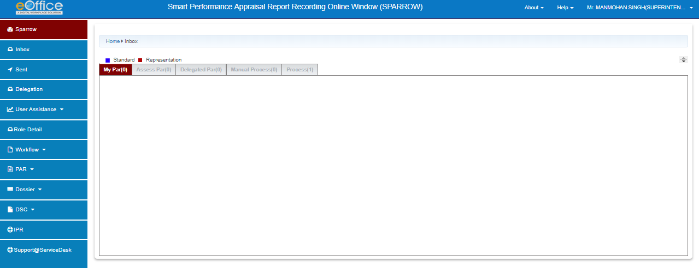

35. The APAR generated, NRC and Foreign Assignment will be shown in Process tab.
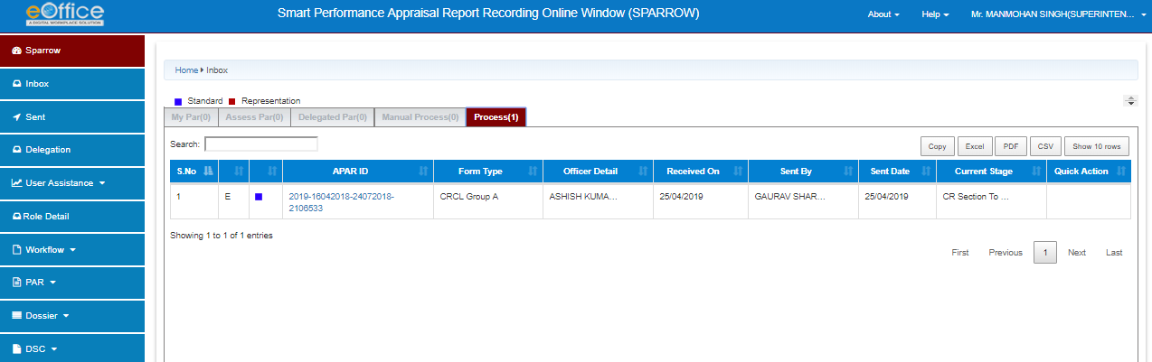
36. Clicking on the APAR ID the Disclose to Officer Section will be opened.
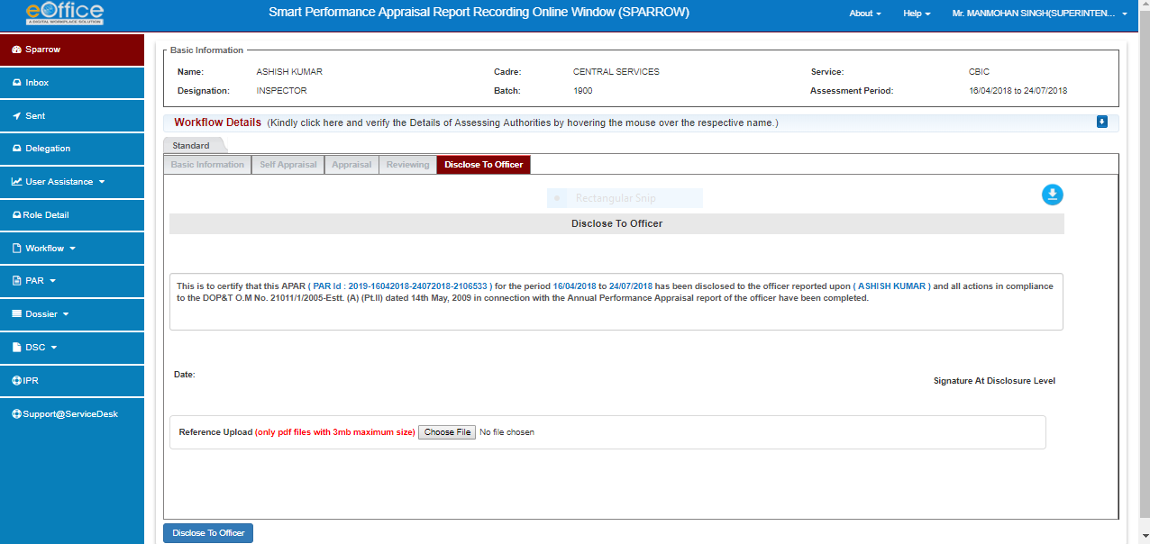
37. Clicking on the Disclose to Officer Button, the APAR will be sent to the Officer Reported Upon and the following message will appear:
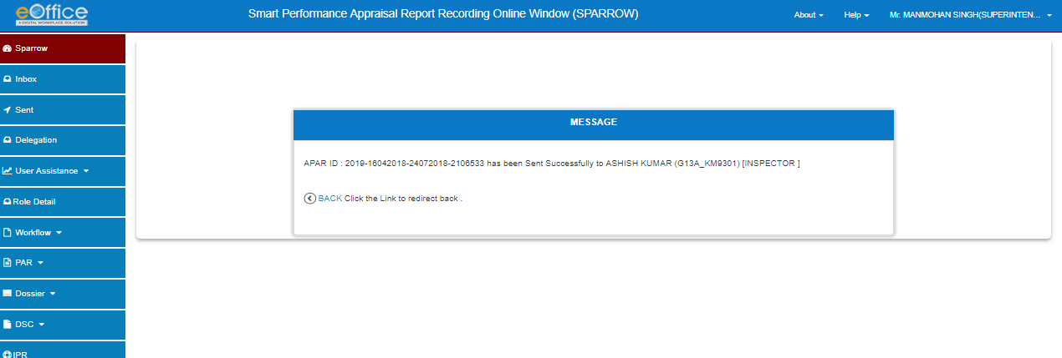
Closing of APAR generated.
38. Click Process tab in the Inbox and the following screen will appear.
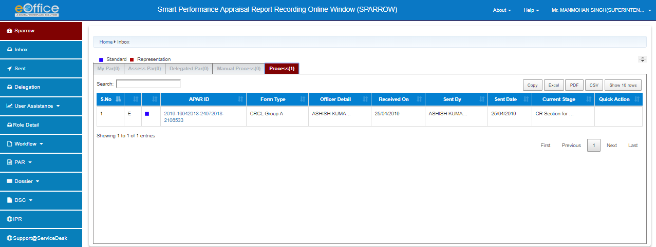
The APAR so generated for the period from 24-04-2018 to 24-07-2018 in case of the given example will appear here. The Current stage here will show CR section to Disclose.
39. The Custodian has to Click over the APAR id relating to the APAR generated and the following screen will appear.
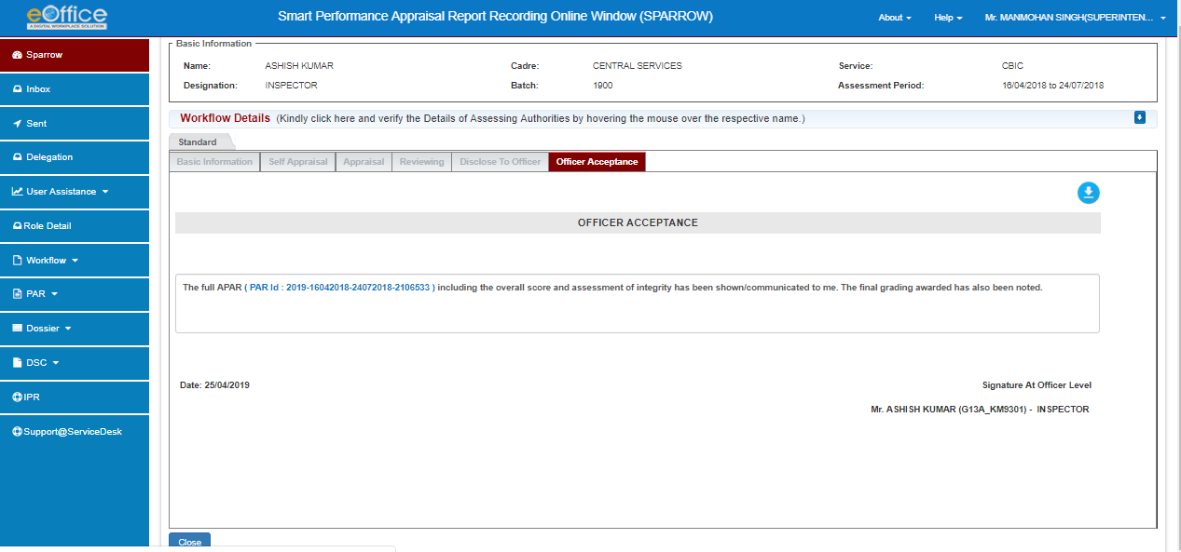

40. Click Close button to close the APAR and the following message will appear
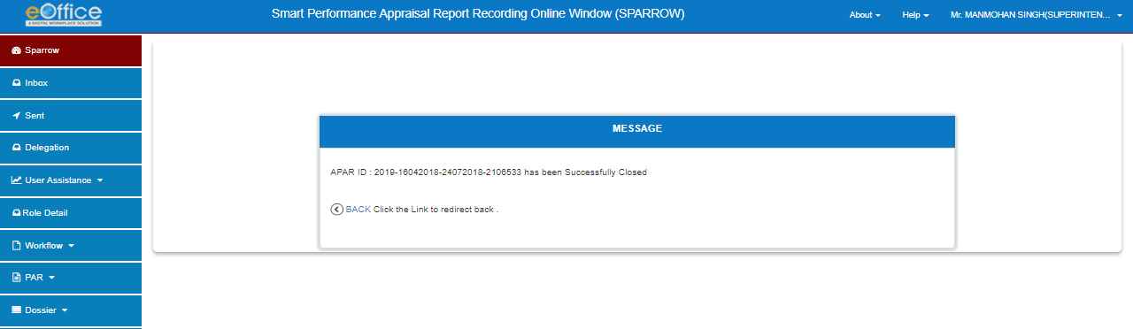
41. Now the generated APAR will go to the account of the Officer reporting Upon.

*******

