Step by step guide for “Officer Reported Upon”.

1. Open the url https://edgevpn.rcil.gov.in/ and log in with your details (kindly read the Help Manual for VPN).
2. The following window will appear: 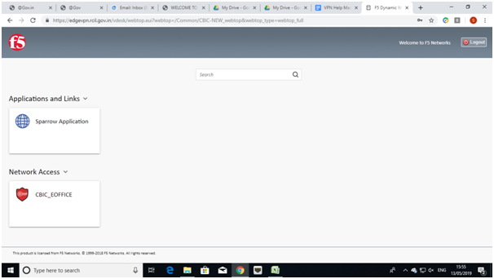
3. . Click on the SPARROW Application Tab and the following window will appear:
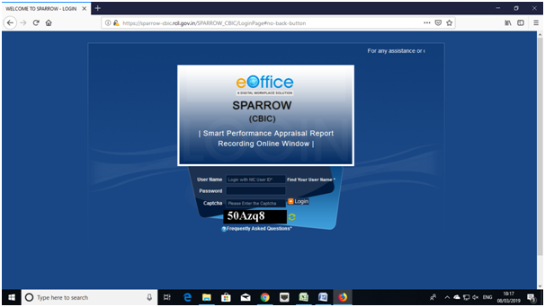

The "Smart Performance Appraisal Report Recording Online Window" screen will open up which is essentially a login screen for SPARROW. The screen will have three fields "Username", "Password" and "Captcha".
The username will be the NIC email id and only the name before "@" should be entered. For example if your NIC email is ashish.solanki@nic.in or ashish.solanki@gov.in, then, the user id will be ashish.solanki.
The password for the application will be same as your NIC email ID password.

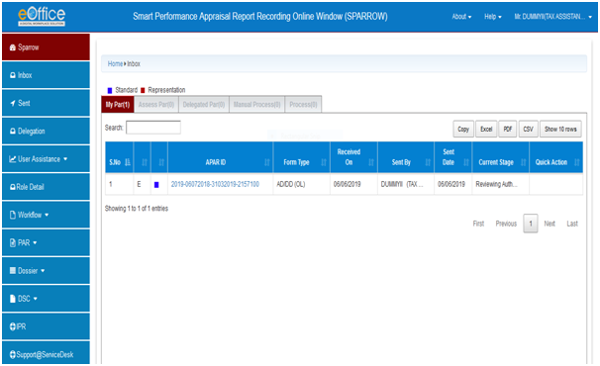

4. After successful login, the above window will open up. This page will have some tabs in the left side depending upon the role assigned to the officer. These roles are allocated centrally by DGHRD / NIC and on logging in, different window will open up depending upon the role assigned to that user ID.
Above page is for the Officer Reported Upon. In the inbox, on clicking the My Par Tab, all the PARs generated by the Custodian shall be listed with their corresponding APAR-IDs (shown in blue colour)
5. Now, the officer Reported upon will select his PAR by clicking the APAR-ID for the relevant period. This would open section-I of the APAR as filled and generated by the Custodian (shown in the screen shotbelow).

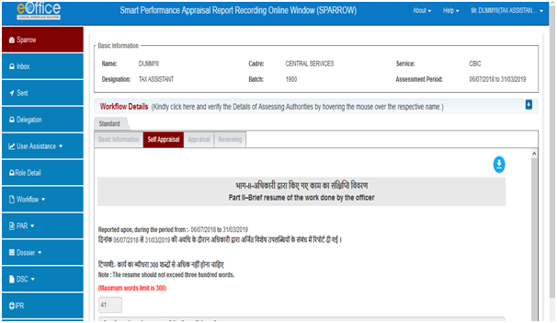
5. The Officer Reported Upon can check all his details filled in the Section-I which is name, Year of Allotment, Employee code, Date of Birth, work duration under Reporting and Reviewing Authority etc.
6. Further the officer has to check his leave details and trainings attended. These details would also be auto populated as they have been filled by Custodian.
7. Also the dates of filling the immovable property returns for year ending December, date of medical examination etc would be auto populated as they have been filled by Custodian.
8. If any information is found to be incorrect then he can submit error report to Custodian by clicking Submit Error Report tab. If all the information filled in is correct, the officer can click Section-II of APAR and fill Section-II of APAR.
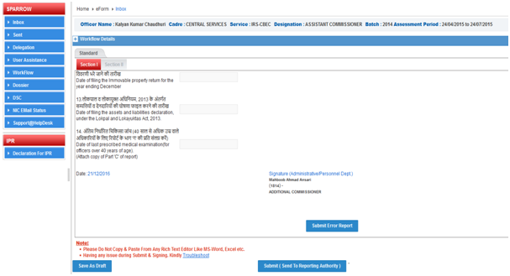

9. If he clicks Submit Error Report option following screen will open up which will have a text box. The officer can give the nature of errors / details which are to be corrected in the text box and click Submit button. This will send Section-I of the PAR to Custodian and thus allow Custodian to make requisite corrections to Section-I of the APAR.

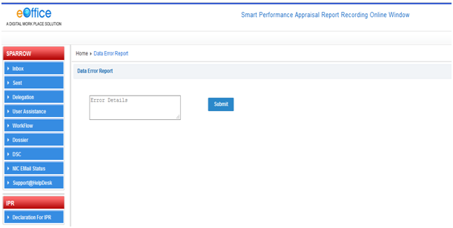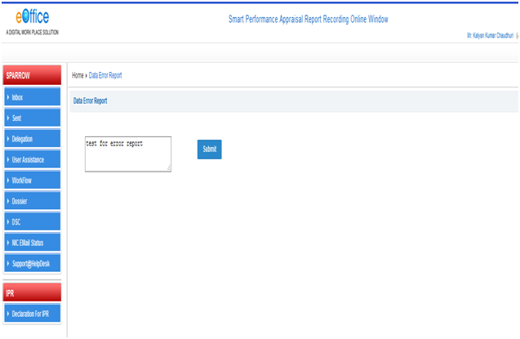

10. After clicking Submit a message would appear with text “Data Error Message is Reported Successfully” which means that the report has been sent to Custodian to make relevant changes.
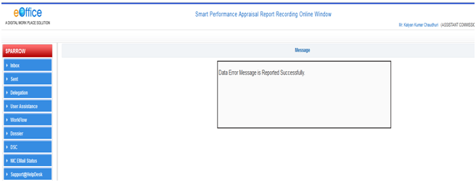

11. After sending the error report, the officer should go to Section-II of PAR and fill all his particulars for performance appraisal.

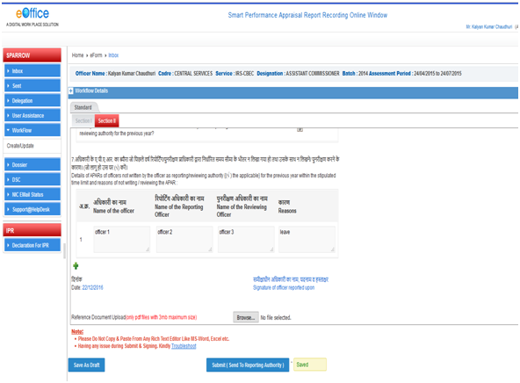

17. After filling all the details in Section–II, the officer can also upload any supporting documents in pdf format up to 3 mb by clicking Browse button.
18. The officer has an option to save the document and come back later to change/amend the same by clicking Save as Draft tab. Officers are also requested to keep on saving the document by clicking Save as Draft to avoid loss of data due to electricity failure or network connectivity issues.
19. Alternatively, the officer may send the PAR to Reporting officer after completing Section II of APAR for which the officer should click on Submit (Send to Reporting Authority). On clicking Submit button, a window asking OTP will appear in which you have to fill the OTP which will be received in your mobile linked with Adhaar card. After clicking this button a confirmation screen for submitting the Section II of APAR will appear with warning- “Once the form is submitted, data will not be changed. Are you sure you want to submit”.



