Help Manual/ Step by Step Guide for CBIC SPARROW Seva

The CBIC SPARROW Seva utility will have two components under two TABS: SPARROW-IRS and SPARROW-CBIC pre - loaded with employee database of the mapped officers. It will be accessible only to Custodians and Alternate Custodians through gov.in email id and only the custodian and Alternate Custodian will be able to login and submit any such Update Details/ Role Assignment/ Any other Issue requests.

- Step by step guide for Details Update.
(Note: Only the Custodian or Alternate Custodian of a formation can put up any request regarding any updation in SPARROW-IRS or SPARROW-CBIC)
- Open the url http://dghrdcbic.gov.in/sparrow_Seva/index.asp

- On opening the url, the "Login Screen of SPARROW SEVA" Utility (given below) will open.

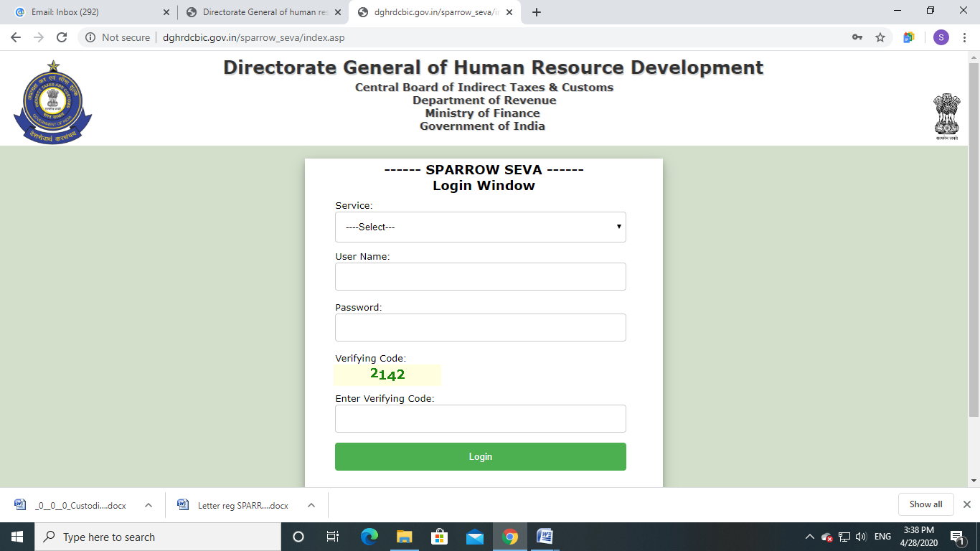

- The "SPARROW SEVA Login Window" screen will open up which is essentially a login screen for SPARROW SEVA. The screen will have four fields “Service” "Username", "Password" and "Verifying Code".
- In the “Service” option, IRS would be selected for Group ‘A’ IRS (C&CE) Officers, while CBIC would be selected for all Officers/ Staff covered under SPARROW-CBIC.
- The username will be the NIC email id. For example if your NIC email is abcd@nic.in or abcd@gov.in, then, the user id will be abcd@nic.in or abcd@gov.in. The initial password shall be Sparrow@123 and on first successful login the password will have to be changed mandatorily.
- The Verifying Code as given in the box should be entered then click the "Login" button.
- After logging in, the software would automatically move to next screen. By default, the window will open up as shown in the next page.
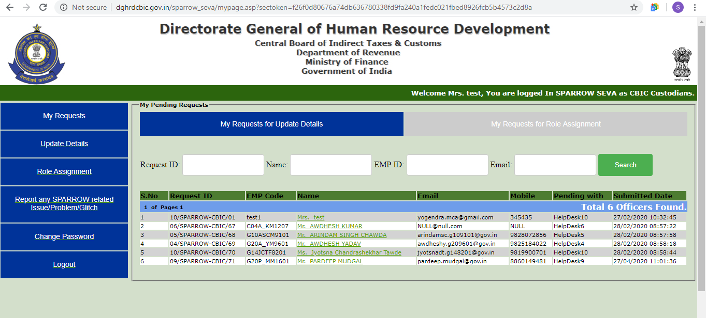
- After successful login, the above window will open up. This page will have some tabs in the left side.
- “My Requests” tab will show the status of all the previous requests made by the Custodian/ Alternate Custodian.
- To request for update of any details, click on the “Update Details” Tab on the left and the following window will appear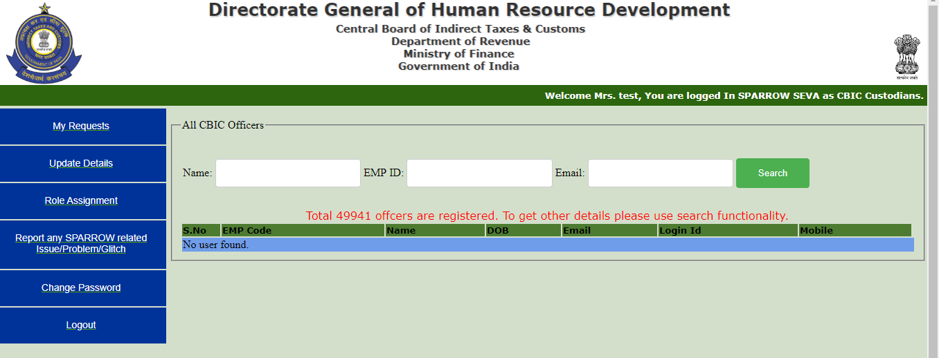
Search the employee by entering any of the details (Name, Emp ID, or e-mail) and click on “Search” and the following window with the details of the Officer will appear. 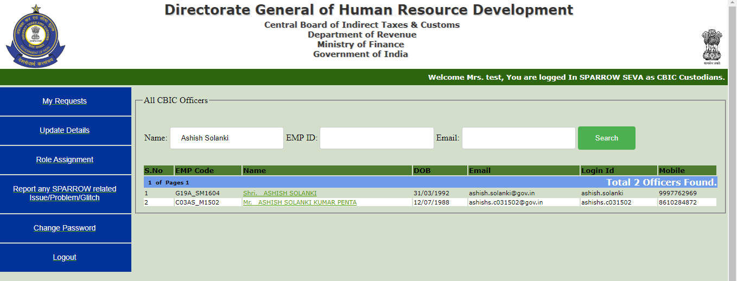
Click on the name of the concerned Officer and his details will appear in a window as shown below: 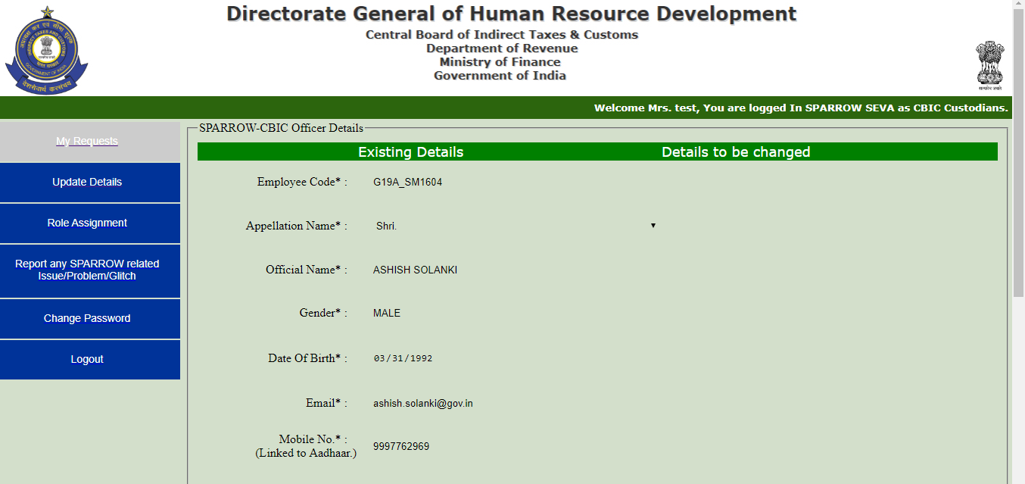
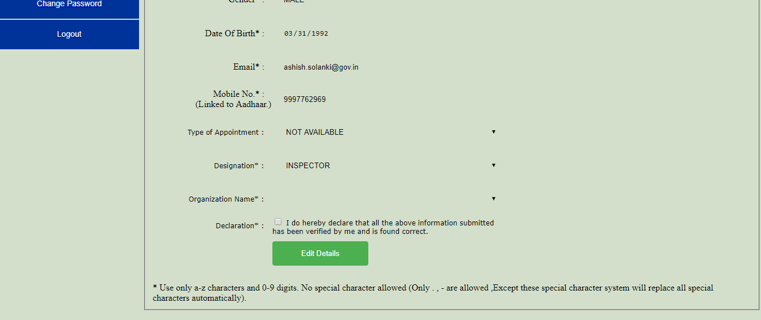
Let us consider that the Designation of the Officer taken in above example is to be updated as Superintendent in place of Inspector, then, click on the “Edit Details” Tab appearing in Green colour and the following window will appear: 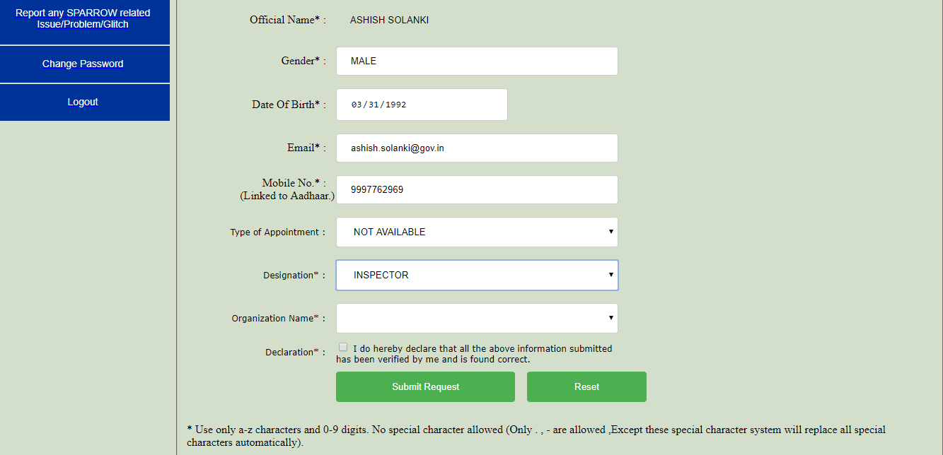
Fill in the required details, then click on the check box of the “Declaration” and then click on “Submit Request” button and the following Pop-up message will appear: 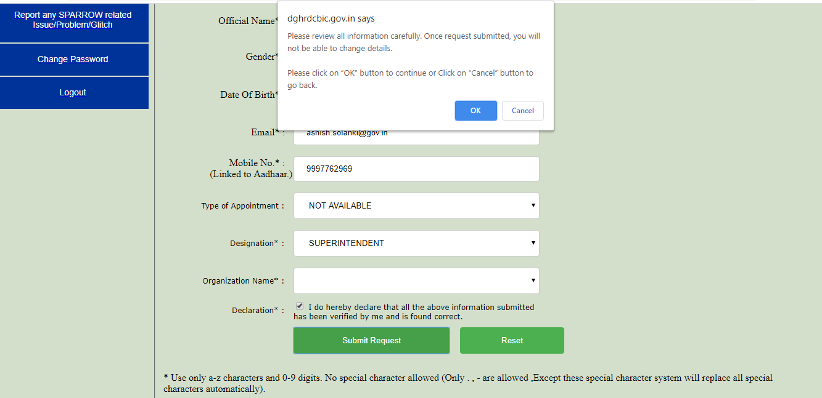
Click on “OK” Button and the following window will appear: 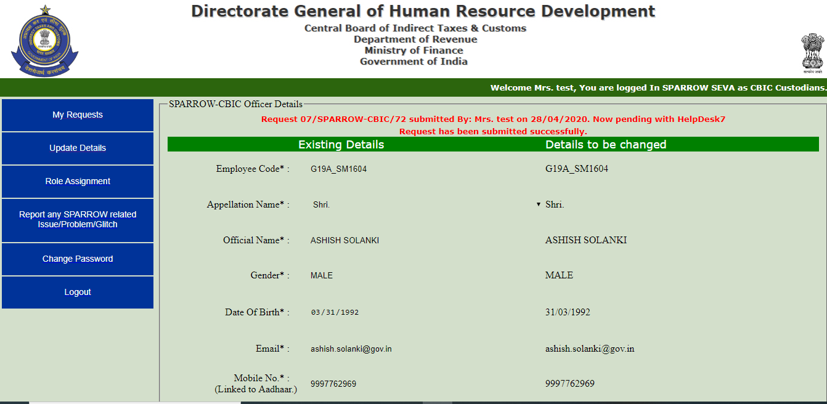
Message of Successful Submission along with the Request Number will appear at the top in Red Colour. Please note the request number for future reference.
Note: As far as possible, the requests relating to Update Details shall be completed within two working days from the date of submitting the request in “SPARROW Seva”.

- Step by step guide for Role Assignment.
(Note: Only the Custodian or Alternate Custodian of a formation can put up any request regarding Role Assignment/ Role Change in SPARROW-IRS or SPARROW-CBIC)
- Open the url http://dghrdcbic.gov.in/sparrow_Seva/index.asp

- On opening the url, the "Login Screen of SPARROW SEVA" Utility (given below) will open.



- The "SPARROW SEVA Login Window" screen will open up which is essentially a login screen for SPARROW SEVA. The screen will have four fields “Service” "Username", "Password" and "Verifying Code".
- In the “Service” option, IRS would be selected for Group ‘A’ IRS (C&CE) Officers, while CBIC would be selected for all Officers/ Staff covered under SPARROW-CBIC.
- The username will be the NIC email id. For example if your NIC email is abcd@nic.in or abcd@gov.in, then, the user id will be abcd@nic.in or abcd@gov.in. The initial password shall be Sparrow@123 and on first successful login the password will have to be changed mandatorily.
- The Verifying Code as given in the box should be entered then click the "Login" button.
- After logging in, the software would automatically move to next screen. By default, the window will open up as shown in the next page.

- After successful login, the above window will open up. This page will have some tabs in the left side.
- “My Requests” tab will show the status of all the previous requests made by the Custodian/ Alternate Custodian.

- To request for assigning the role of Custodian/ Alternate Custodian to a new Officer, click on the “Role Assignment” Tab on the left and the following window will appear


Search the employee by entering any of the details (Name, Emp ID, or e-mail) and click on “Search” and the following window with the details of the Officer will appear:


Click on the name of the concerned Officer and his details will appear in a window as shown below: 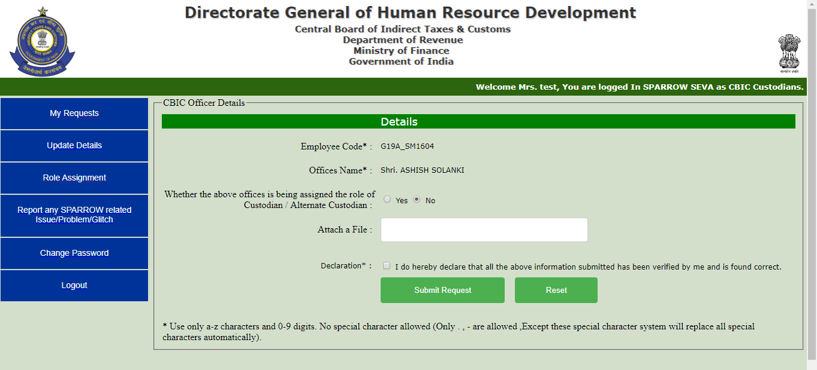

Click on the check box of “Yes” against “Whether the above Officer is being assigned the role of Custodian/ Alternate Custodian” and the following window will appear:
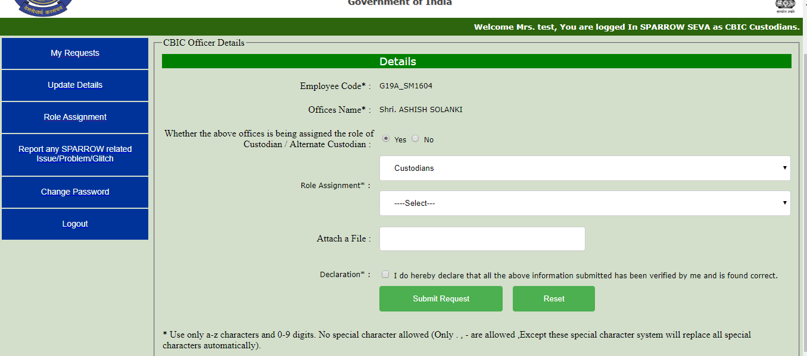

In the first drop down bar select the role to be given to the Officer from among “Super Custodian / Custodian/ Alternate Custodian”.
In the second drop down bar select the Organisation for which the role has to be assigned.
(For instance: Ashish Solanki is to be assigned the role of Custodian for DGHRD, then select Custodian in the first drop down bar and select DGHRD - Delhi in the second drop down bar)
Attach the Office Order to this effect, if any, and click on the check box of Declaration:
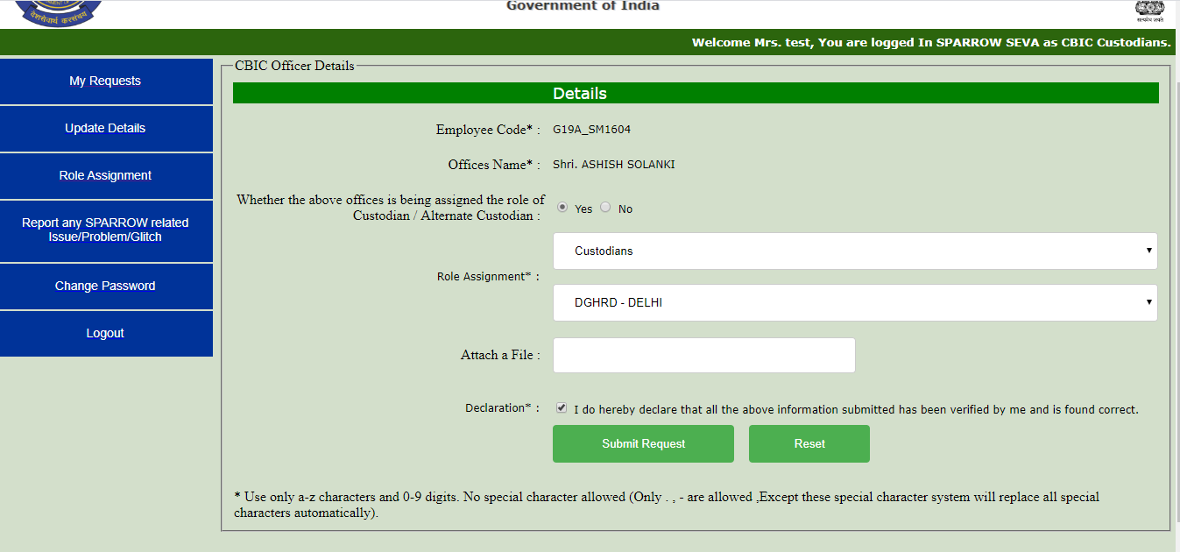

Then click on the “Submit Request” button and the following Pop up message will appear:
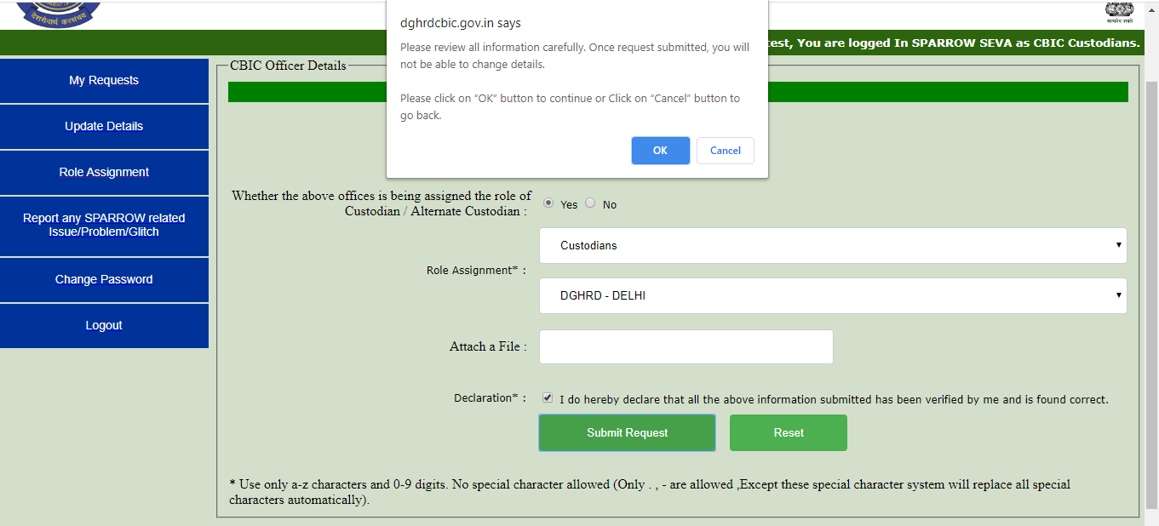

Click on “OK” Button and the following window will appear: 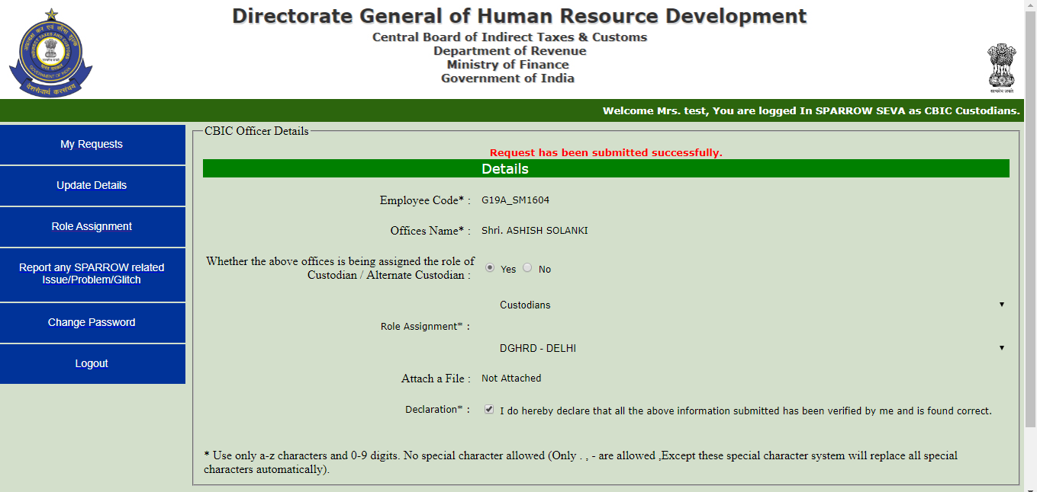

Message of Successful Submission appear at the top in Red Colour.
Note: As far as possible, the requests relating to Role Assignment/ Role Chnage shall be completed within two working days from the date of submitting the request in “SPARROW Seva”.

- Step by step guide for any Issue/Problem/Glitch related to SPARROW.
(Note: Only the Custodian or Alternate Custodian of a formation can put up any request regarding any issue/problem/glitch)
** For any issue/ problem/ glitch firstly go through all the Help manuals and FAQs regarding SPARROW-IRS and SPARROW-CBIC available on DGHRD Website and if the issue is not covered/resolved, then only report it here**
- Open the url http://dghrdcbic.gov.in/sparrow_Seva/index.asp

- On opening the url, the "Login Screen of SPARROW SEVA" Utility (given below) will open.



- The "SPARROW SEVA Login Window" screen will open up which is essentially a login screen for SPARROW SEVA. The screen will have four fields “Service” "Username", "Password" and "Verifying Code".
- In the “Service” option, IRS would be selected for Group ‘A’ IRS (C&CE) Officers, while CBIC would be selected for all Officers/ Staff covered under SPARROW-CBIC.
- The username will be the NIC email id. For example if your NIC email is abcd@nic.in or abcd@gov.in, then, the user id will be abcd@nic.in or abcd@gov.in. The initial password shall be Sparrow@123 and on first successful login the password will have to be changed mandatorily.
- The Verifying Code as given in the box should be entered then click the "Login" button.
- After logging in, the software would automatically move to next screen. By default, the window will open up as shown in the next page.

- After successful login, the above window will open up. This page will have some tabs in the left side.
- “My Requests” tab will show the status of all the previous requests made by the Custodian/ Alternate Custodian.
- To report any issue related to SPARROW click on the “Report Any SPARROW related Issue/Problem/Glitch” Tab on the left and the following window will appear:
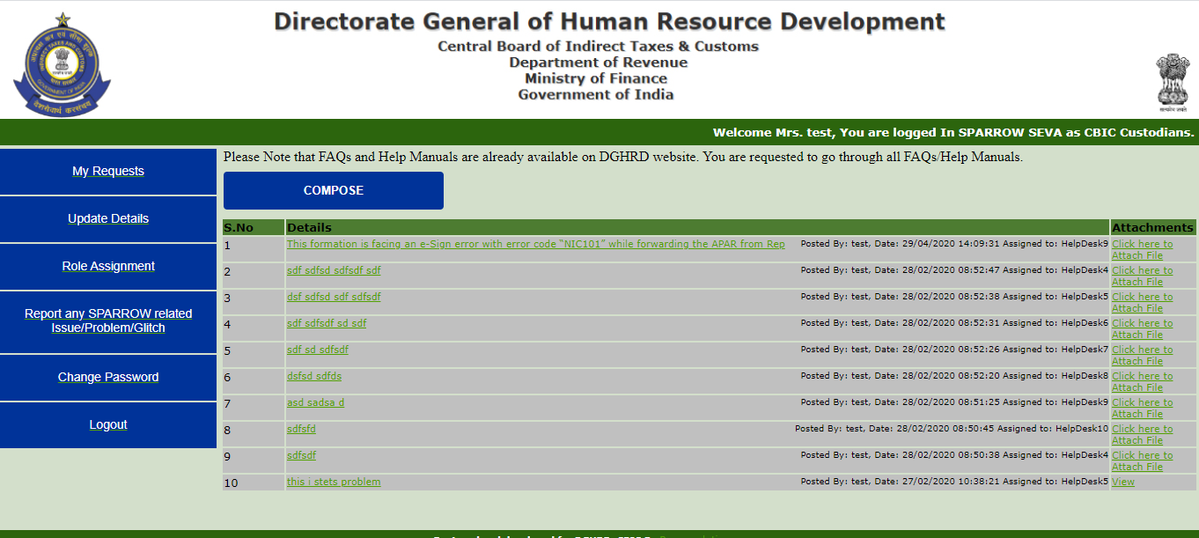

Then click on the “Compose” button and the following window will appear:
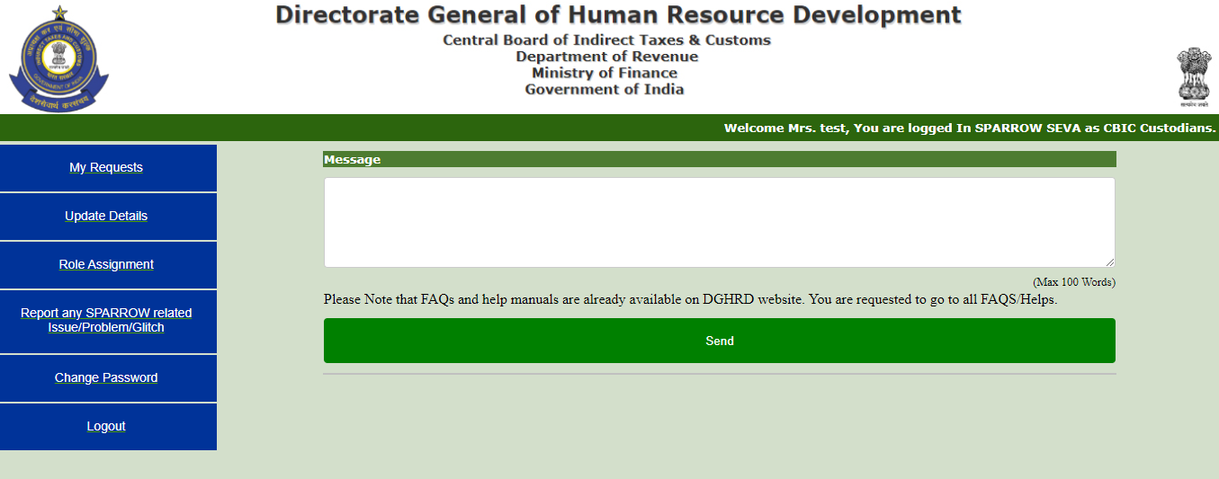

Write your issue in the message box in maximum 100 words. (For instance, there is a problem while doing e-Sign then write the message in maximum details possible in maximum 100 words like : This formation is facing an e-Sign error with error code “NIC101” while forwarding the APAR from Reporting Authority to Reviewing Authority Level. Kindly look into the matter ASAP.)
Then click on the “Send” and the following window will appear:
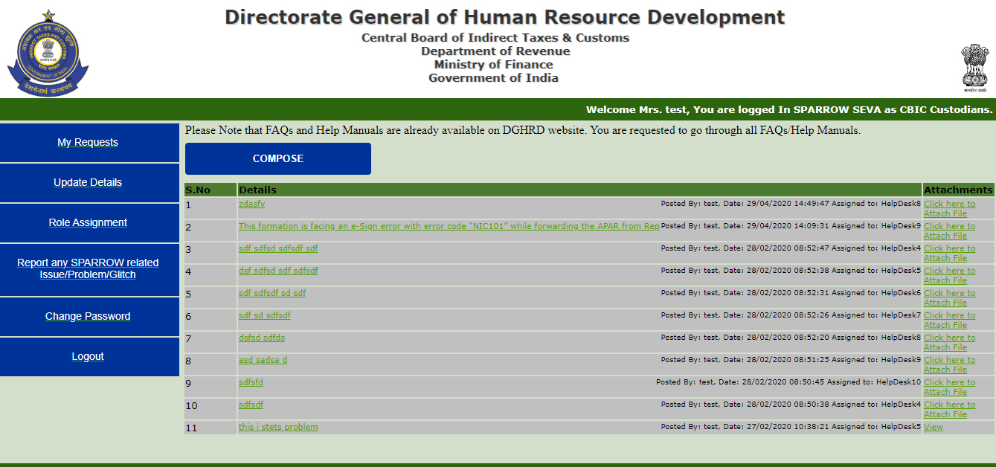

Now your request has been submitted.
Note: As far as possible, the requests relating to technical issues/ problems/ glitches shall be attempted to be resolved within two working days from the date of submitting the request in “SPARROW Seva” or a soon as possible.

