Help Manual for edge VPN Password reset
Any officer facing issue at login at Edge VPN portal, they may submit their edge vpn password reset request after login from someone else’s edge vpn account using VPN Password Request option as shown in the picture below.
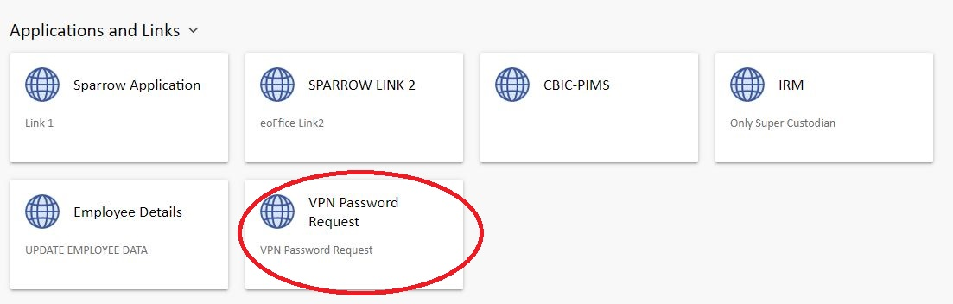
The officer’s details (who password is required to be reset) need to be mentioned after clicking on VPN Password Request option as shown in the picture below.
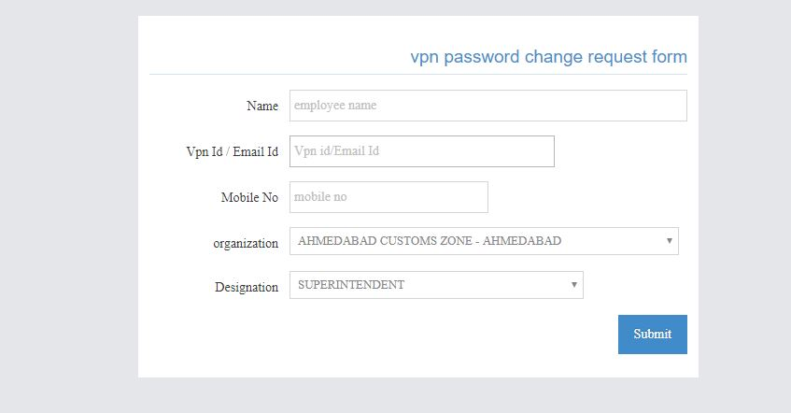
Once this request is submitted, the same will arise at DGHRD and a password will be provided on the respective Gov email id of the officer.

