Help Manual/ Step by Step Guide for Grading of PAR by the Reviewing Officer in case of PAR being Force Forwarded from Reporting Level

- Login into your SPARROW-CBIC account with your SPARROW Credentials, and the following window will open:

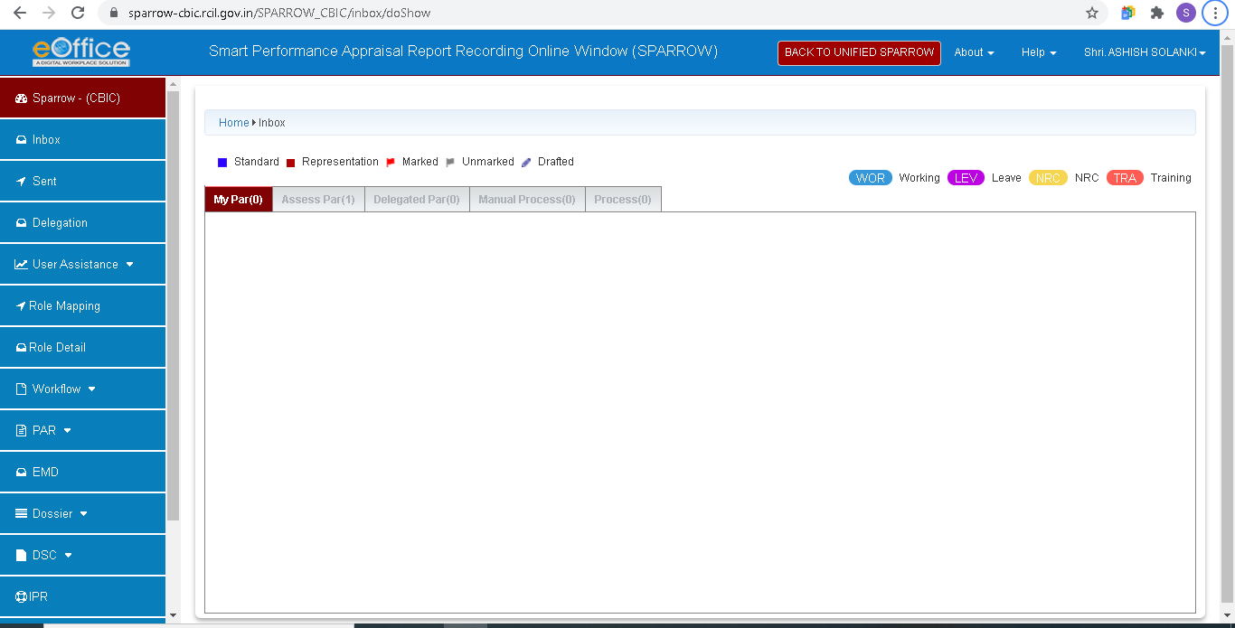

- Click on the “Assess Par” tab in the top panel and the following window will appear:

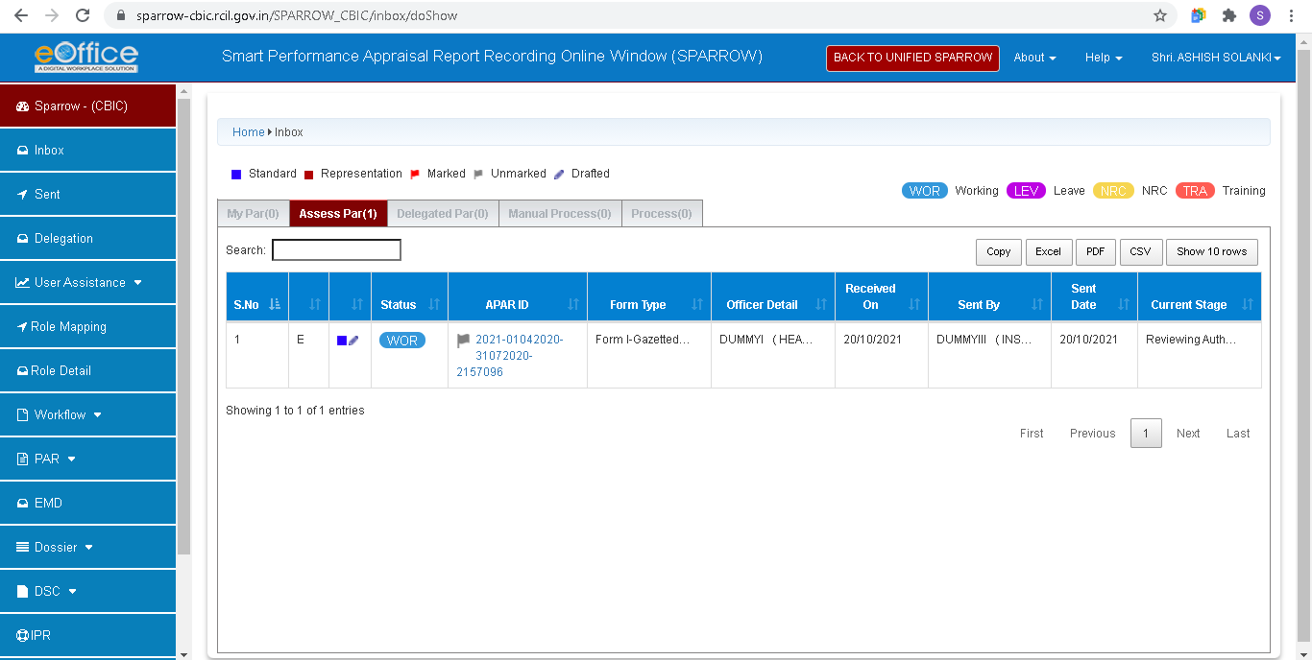

Click on the APAR ID of the PAR that you want to Review and the PAR will open and will appear as shown below:
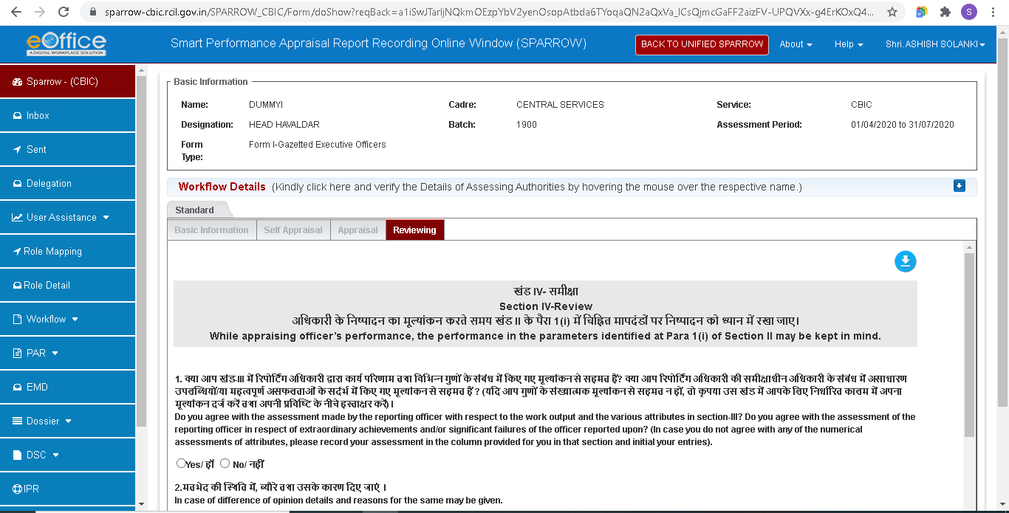

- Click on the “Appraisal” tab in the top panel (as shown in above screenshot) to view the Grading accorded by the Reporting Officer , it will appear as below:
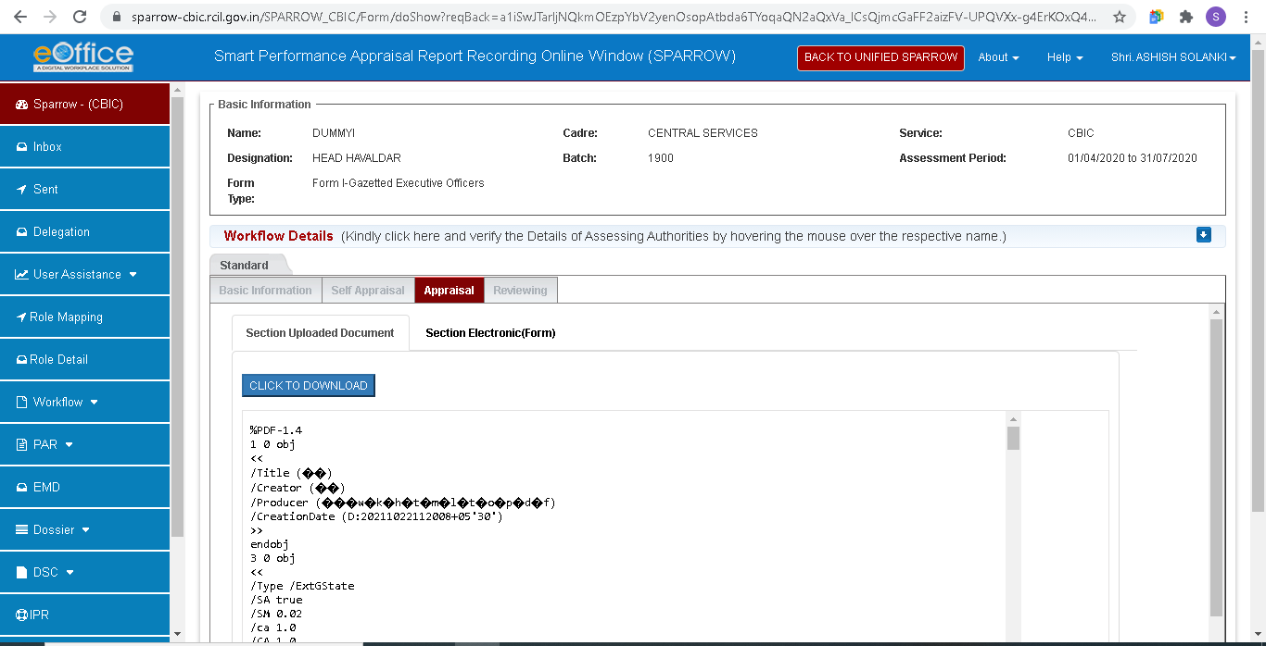

Click on the “Section Electronic (Form)” tab (as shown in above screenshot), just below the Appraisal tab and the PAR will appear as below:
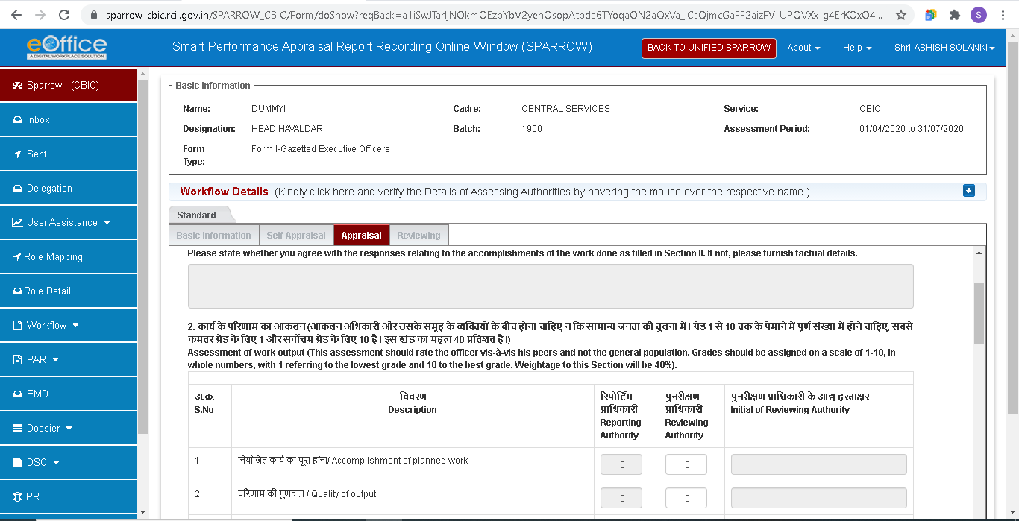

- Now, as per your assessment, award the Grades to the Officer under the Column of Reviewing Officer and then Click on the “Reviewing” tab in the top panel and there the Final Grades will be shown, as below:
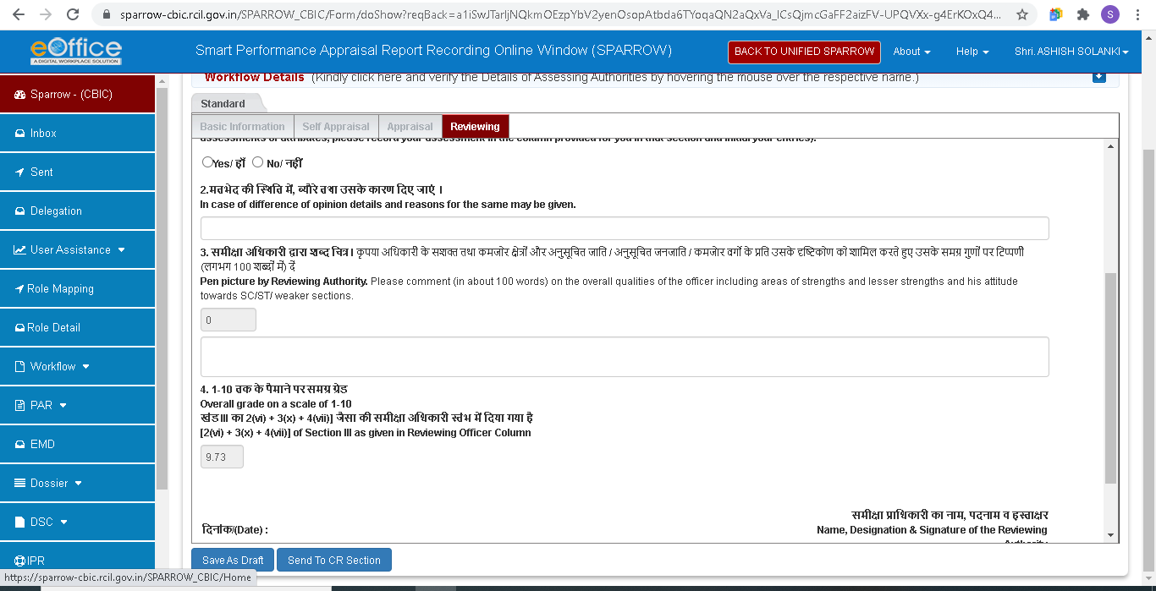

Now, in the Point No. 1, click on “No” and the reason in Point No. 2 will be, “The PAR was Force Forwarded from the level of Reporting Authority, hence, difference in Grades accorded.”
Then fill the Pen Picture of the Officer in Point no 3 and send the PAR to CR Section.

