augmentedRCBD

# Details

| Item | Details |
| --- | --- |
| Number of blocks | 6 |
| Number of treatments | 93 |
| Number of check treatments | 3 |
| Number of test treatments | 90 |
| Check treatments | C1, C2, C3 |
| Number of Traits | 5 |
| Traits | DFF, NPB, NSB, TW, SY |

# ANOVA, Treatment Adjusted

| **Source** | **Df** | **Mean.Sq** | | | | | | | | | |
| --- | --- | --- | --- | --- | --- | --- | --- | --- | --- | --- | --- |
| **DFF** | | **NPB** | | **NSB** | | **TW** | | **SY** | |
| Block (ignoring Treatments) | 5 | 22.79 | ** | 3.36 | ** | 40.83 | ** | 2.27 | ns | 34.27 | ** |
| Treatment (eliminating Blocks) | 92 | 20.86 | ** | 0.77 | ns | 7.53 | ns | 2.80 | ns | 19.06 | * |
| Treatment: Check | 2 | 189.56 | ** | 0.35 | ns | 6.51 | ns | 9.72 | * | 72.19 | ** |
| Treatment: Test and Test vs. Check | 90 | 17.12 | ** | 0.78 | ns | 7.56 | ns | 2.65 | ns | 17.88 | * |
| Residuals | 10 | 2.42 |  | 0.54 |  | 6.38 |  | 2.09 |  | 5.62 |  |

ns P > 0.05; * P <= 0.05; ** P <= 0.01

# ANOVA, Block Adjusted

| **Source** | **Df** | **Mean.Sq** | | | | | | | | | |
| --- | --- | --- | --- | --- | --- | --- | --- | --- | --- | --- | --- |
| **DFF** | | **NPB** | | **NSB** | | **TW** | | **SY** | |
| Treatment (ignoring Blocks) | 92 | 21.63 | ** | 0.93 | ns | 8.87 | ns | 2.87 | ns | 20.48 | * |
| Treatment: Check | 2 | 189.56 | ** | 0.35 | ns | 6.51 | ns | 9.72 | * | 72.19 | ** |
| Treatment: Test | 89 | 17.71 | ** | 0.93 | ns | 8.52 | ns | 2.61 | ns | 18.94 | * |
| Treatment: Test vs. Check | 1 | 34.76 | ** | 1.60 | ns | 44.95 | * | 12.45 | * | 54.53 | * |
| Block (eliminating Treatments) | 5 | 8.72 | * | 0.50 | ns | 16.20 | ns | 1.04 | ns | 8.14 | ns |
| Residuals | 10 | 2.42 |  | 0.54 |  | 6.38 |  | 2.09 |  | 5.62 |  |

ns P > 0.05; * P <= 0.05; ** P <= 0.01

# Standard Errors

| **Comparison** | **DFF** | **NPB** | **NSB** | **SY** | **TW** |
| --- | --- | --- | --- | --- | --- |
| A Test Treatment and a Control Treatment | 1.94 | 0.92 | 3.15 | 2.96 | 1.80 |
| Control Treatment Means | 0.90 | 0.42 | 1.46 | 1.37 | 0.83 |
| Two Test Treatments (Different Blocks) | 2.54 | 1.20 | 4.13 | 3.87 | 2.36 |
| Two Test Treatments (Same Block) | 2.20 | 1.04 | 3.57 | 3.35 | 2.05 |

# Critical Difference (5%)

| **Comparison** | **DFF** | **NPB** | **NSB** | **SY** | **TW** |
| --- | --- | --- | --- | --- | --- |
| A Test Treatment and a Control Treatment | 4.33 | 2.04 | 7.02 | 6.59 | 4.02 |
| Control Treatment Means | 2.00 | 0.94 | 3.25 | 3.05 | 1.86 |
| Two Test Treatments (Different Blocks) | 5.66 | 2.67 | 9.19 | 8.62 | 5.26 |
| Two Test Treatments (Same Block) | 4.90 | 2.31 | 7.96 | 7.47 | 4.56 |

# Coefficient of Variance

| **Trait** | **CV** |
| --- | --- |
| DFF | 1.63 |
| NPB | 12.86 |
| NSB | 28.90 |
| TW | 14.09 |
| SY | 29.92 |

# Overall Adjusted Mean

| **Trait** | **Overall.adjusted.mean** |
| --- | --- |
| DFF | 95.47 |
| NPB | 5.75 |
| NSB | 8.98 |
| TW | 10.38 |
| SY | 8.18 |

# Check Statistics

## DFF

| **Treatment** | **r** | **Means** | **SE** | **Min** | **Max** |
| --- | --- | --- | --- | --- | --- |
| C1 | 6 | 99.50 | 0.62 | 98.00 | 102.00 |
| C2 | 6 | 100.83 | 1.01 | 99.00 | 104.00 |
| C3 | 6 | 90.50 | 0.92 | 88.00 | 94.00 |

## NPB

| **Treatment** | **r** | **Means** | **SE** | **Min** | **Max** |
| --- | --- | --- | --- | --- | --- |
| C1 | 6 | 5.63 | 0.28 | 4.80 | 6.40 |
| C2 | 6 | 5.50 | 0.35 | 4.80 | 7.00 |
| C3 | 6 | 5.17 | 0.25 | 4.20 | 6.00 |

## NSB

| **Treatment** | **r** | **Means** | **SE** | **Min** | **Max** |
| --- | --- | --- | --- | --- | --- |
| C1 | 6 | 7.83 | 1.50 | 3.20 | 12.80 |
| C2 | 6 | 7.97 | 1.50 | 3.40 | 12.60 |
| C3 | 6 | 6.10 | 0.59 | 4.80 | 8.60 |

## TW

| **Treatment** | **r** | **Means** | **SE** | **Min** | **Max** |
| --- | --- | --- | --- | --- | --- |
| C1 | 6 | 10.82 | 0.29 | 9.74 | 11.57 |
| C2 | 6 | 9.40 | 0.54 | 7.03 | 10.94 |
| C3 | 6 | 8.28 | 0.70 | 4.91 | 9.70 |

## SY

| **Treatment** | **r** | **Means** | **SE** | **Min** | **Max** |
| --- | --- | --- | --- | --- | --- |
| C1 | 6 | 9.87 | 1.02 | 5.20 | 12.60 |
| C2 | 6 | 6.20 | 1.45 | 3.40 | 13.20 |
| C3 | 6 | 2.93 | 0.29 | 2.20 | 4.00 |

# Descriptive Statistics

| **Trait** | **Count** | **Mean** | **Std.Error** | **Std.Deviation** | **Min** | **Max** | **Skewness** | | **Kurtosis** | |
| --- | --- | --- | --- | --- | --- | --- | --- | --- | --- | --- |
| DFF | 93 | 95.47 | 0.48 | 4.59 | 74.94 | 103.94 | -1.37 | ** | 6.58 | ** |
| NPB | 93 | 5.75 | 0.09 | 0.91 | 3.63 | 7.83 | -0.10 | ns | 2.82 | ns |
| NSB | 93 | 8.98 | 0.33 | 3.16 | 0.97 | 16.23 | -0.05 | ns | 2.87 | ns |
| TW | 93 | 10.38 | 0.17 | 1.64 | 7.27 | 14.21 | 0.39 | ns | 2.53 | ns |
| SY | 93 | 8.18 | 0.48 | 4.59 | 0.80 | 24.40 | 1.00 | ** | 3.98 | ns |

ns P > 0.05; * P <= 0.05; ** P <= 0.01

# Frequency Distribution

## DFF

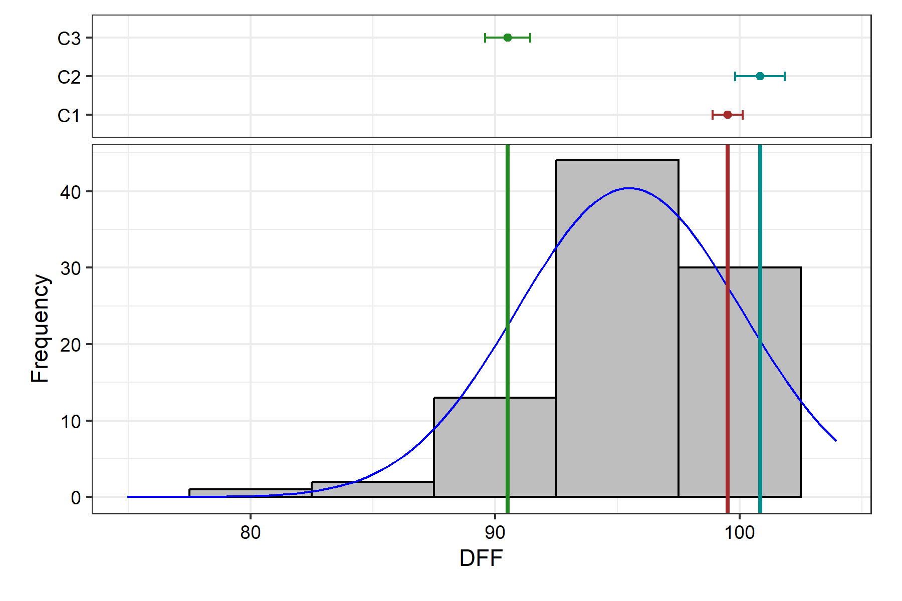

Removed 2 rows containing missing values or values outside the scale range (`geom_bar()`).

## NPB

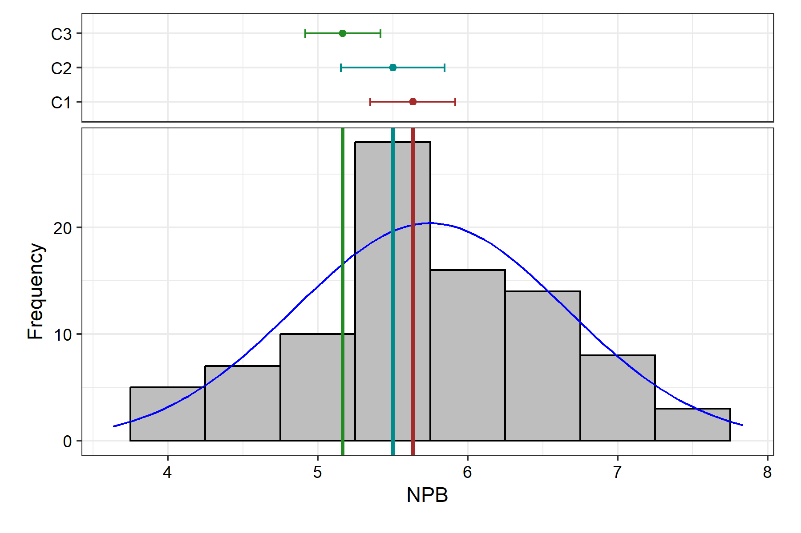

Removed 2 rows containing missing values or values outside the scale range (`geom_bar()`).

## NSB

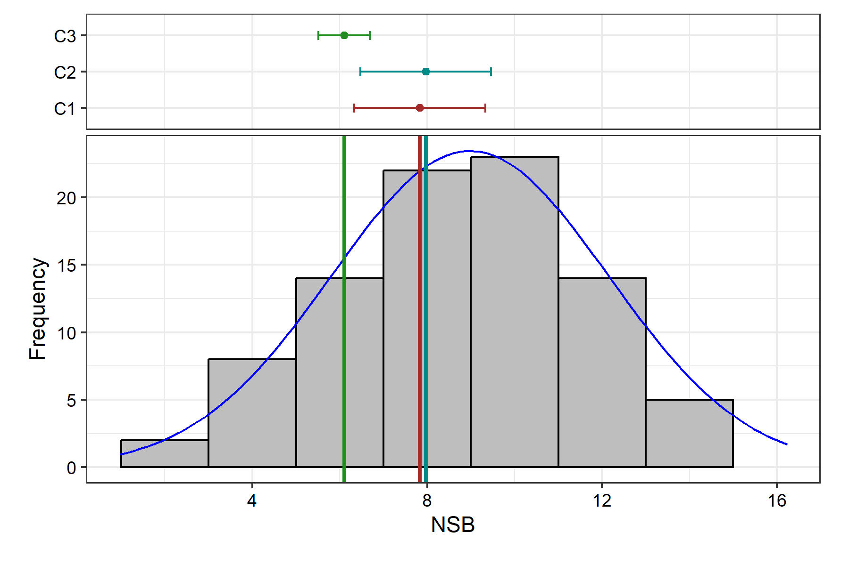

Removed 2 rows containing missing values or values outside the scale range (`geom_bar()`).

## TW

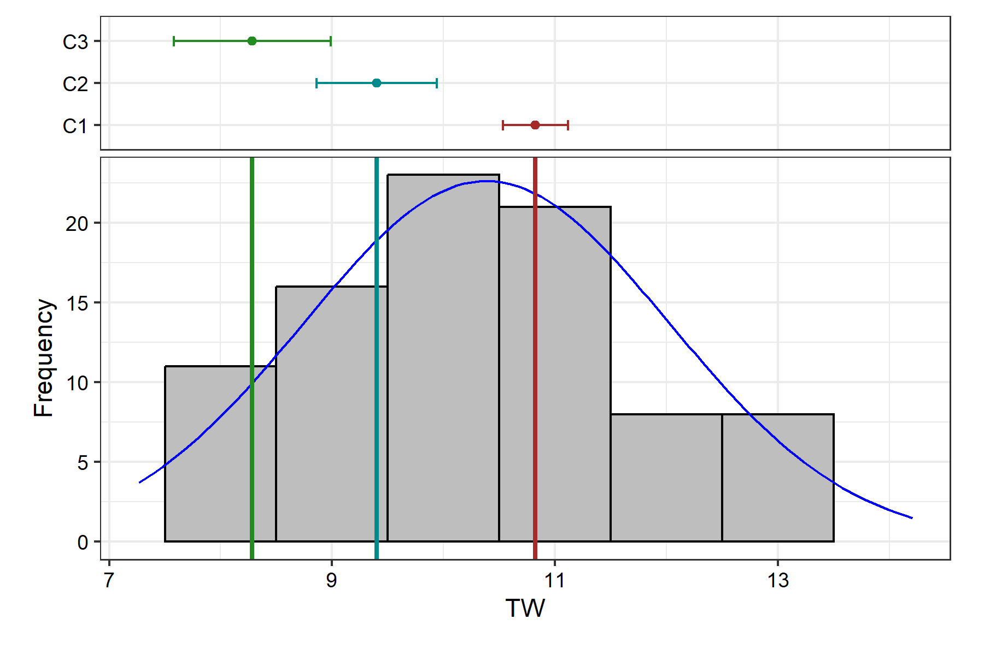

Removed 2 rows containing missing values or values outside the scale range (`geom_bar()`).

## SY

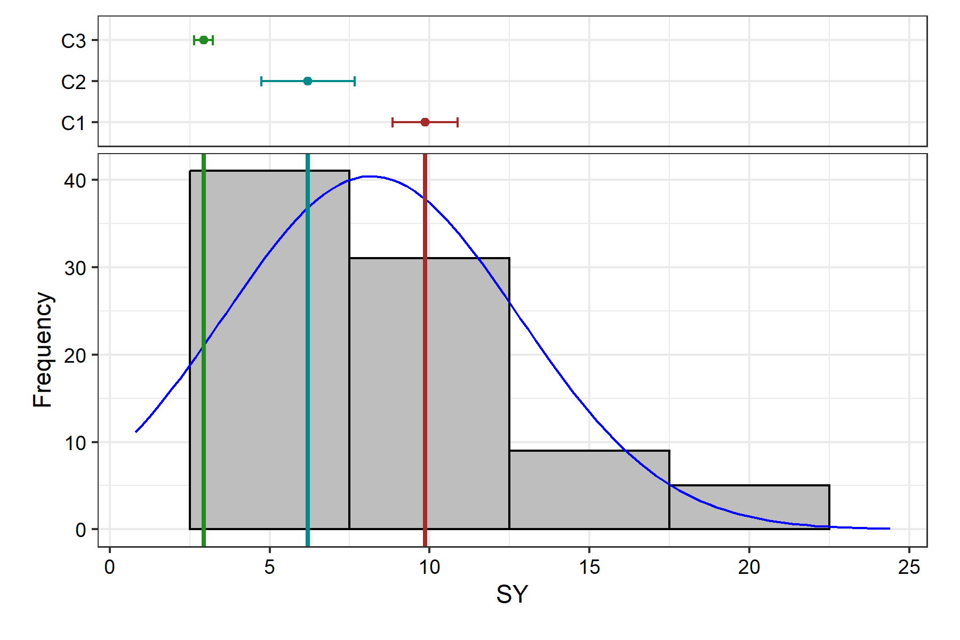

Removed 2 rows containing missing values or values outside the scale range (`geom_bar()`).

# Genetic Variability Analysis

| **Trait** | **Mean** | **PV** | **GV** | **EV** | **GCV** | **GCV.category** | **PCV** | **PCV.category** | **ECV** | **hBS** | **hBS.category** | **GA** | **GAM** | **GAM.category** |
| --- | --- | --- | --- | --- | --- | --- | --- | --- | --- | --- | --- | --- | --- | --- |
| DFF | 95.47 | 17.71 | 15.29 | 2.42 | 4.10 | Low | 4.41 | Low | 1.63 | 86.32 | High | 7.49 | 7.85 | Low |
| NPB † | 5.75 | 0.93 | 0.39 | 0.54 | 10.91 | Medium | 16.79 | Medium | 12.77 | 42.22 | Medium | 0.84 | 14.63 | Medium |
| NSB † | 8.98 | 8.52 | 2.14 | 6.38 | 16.29 | Medium | 32.52 | High | 28.15 | 25.07 | Low | 1.51 | 16.82 | Medium |
| TW  † | 10.38 | 2.61 | 0.52 | 2.09 | 6.92 | Low | 15.55 | Medium | 13.93 | 19.81 | Low | 0.66 | 6.36 | Low |
| SY | 8.18 | 18.94 | 13.32 | 5.62 | 44.63 | High | 53.21 | High | 28.98 | 70.34 | High | 6.31 | 77.21 | High |

† P-value for "Treatment: Test" is > 0.05. Genetic variability analysis may not be appropriate for this trait.

# Genetic Variablity Analysis Plots

## Phenotypic and Genotypic Coefficient of Variability

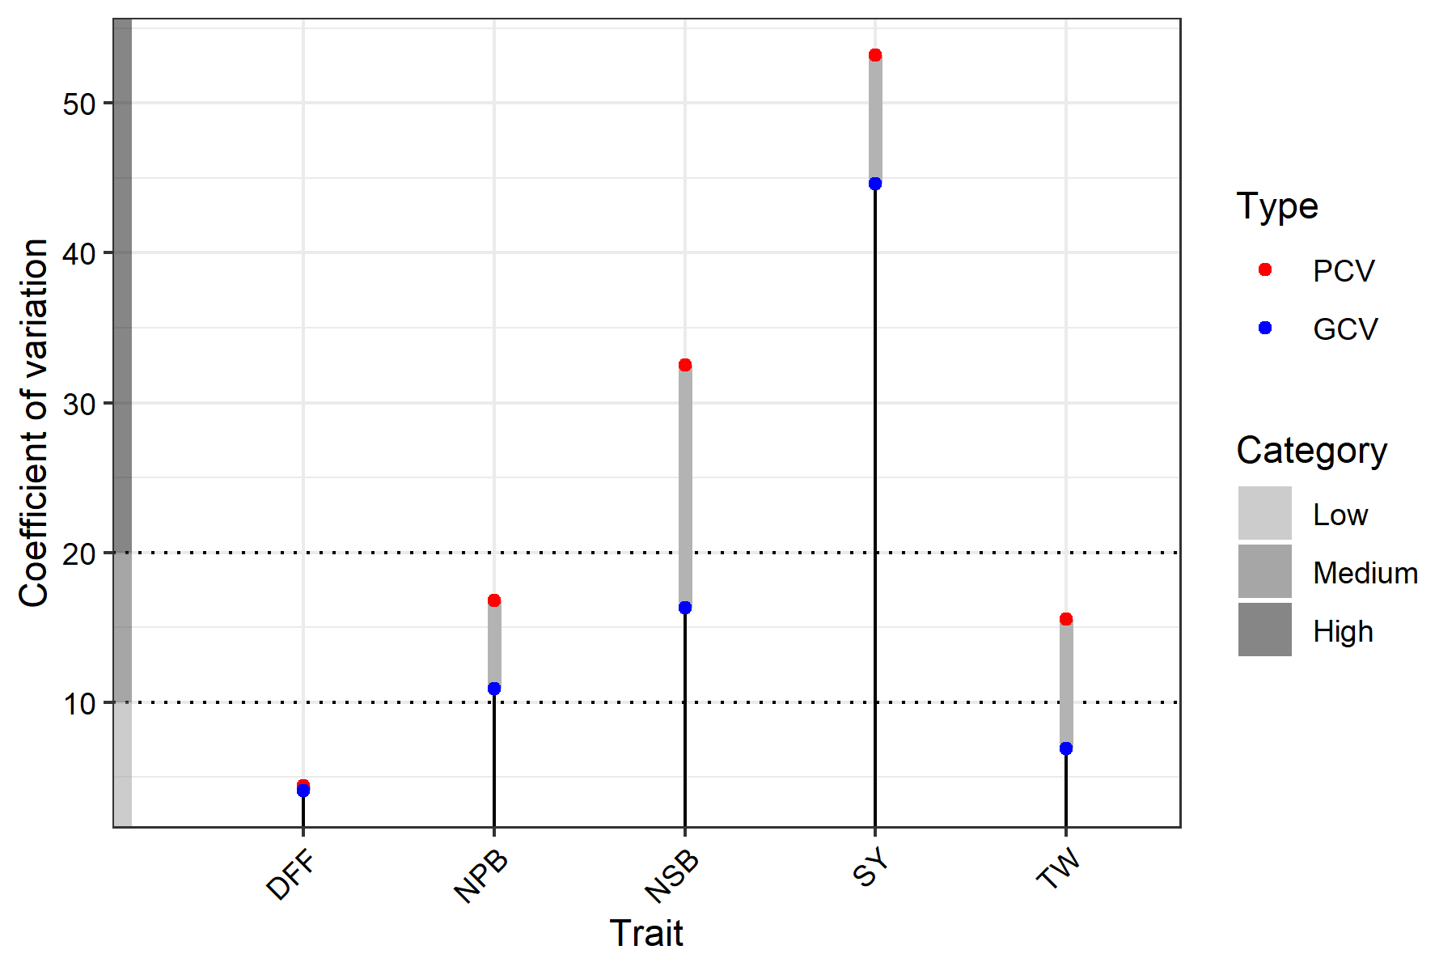

## Broad Sense Heritability

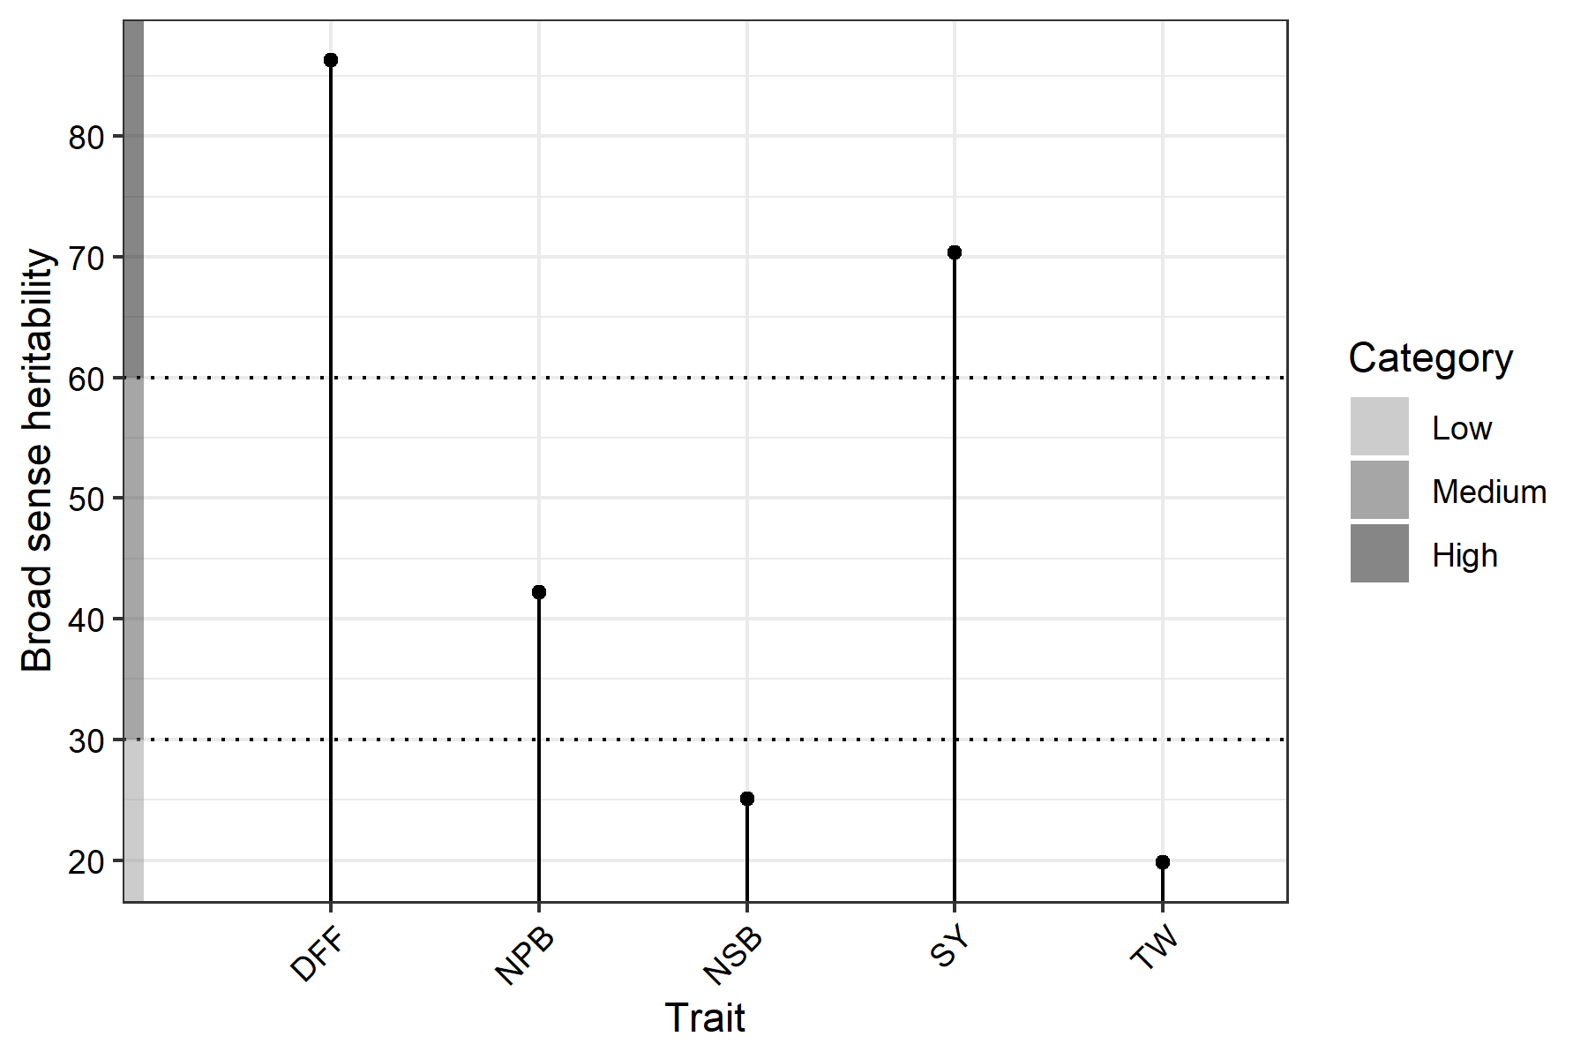

## Genetic Advance Over Mean

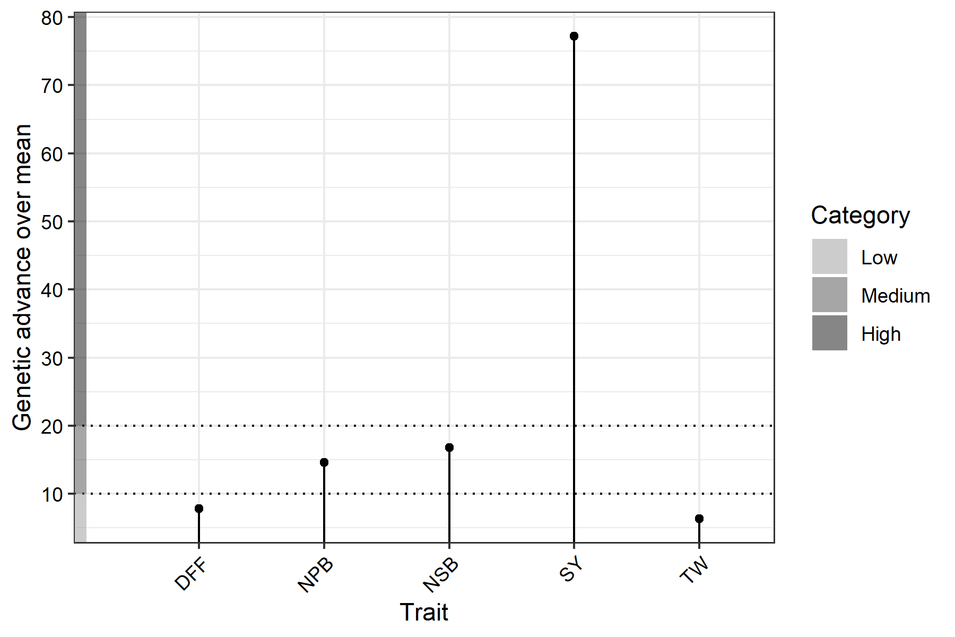

# Adjusted Means

| **Treatment** | **Block** | **DFF** | **NPB** | **NSB** | **SY** | **TW** |
| --- | --- | --- | --- | --- | --- | --- |
| C1 |  | 99.50 | 5.63 | 7.83 | 9.87 | 10.82 |
| C2 |  | 100.83 | 5.50 | 7.97 | 6.20 | 9.40 |
| C3 |  | 90.50 | 5.17 | 6.10 | 2.93 | 8.28 |
| V1 | 1 | 97.94 | 7.03 | 11.17 | 12.40 | 12.31 |
| V10 | 1 | 90.94 | 4.63 | 6.37 | 0.80 | 11.28 |
| V11 | 1 | 90.94 | 3.83 | 4.57 | 8.40 | 14.19 |
| V12 | 1 | 94.94 | 3.63 | 2.37 | 1.60 | 11.91 |
| V13 | 1 | 100.94 | 6.03 | 4.57 | 4.00 | 11.25 |
| V14 | 1 | 93.94 | 4.63 | 3.97 | 5.60 | 8.52 |
| V15 | 1 | 85.94 | 5.63 | 6.37 | 13.20 | 14.10 |
| V16 | 2 | 96.61 | 5.83 | 8.83 | 9.00 | 11.36 |
| V17 | 2 | 97.61 | 7.43 | 16.23 | 15.40 | 12.17 |
| V18 | 2 | 88.61 | 5.63 | 10.63 | 9.60 | 9.50 |
| V19 | 2 | 95.61 | 4.63 | 9.43 | 6.60 | 7.82 |
| V2 | 1 | 92.94 | 3.83 | 1.77 | 6.60 | 8.52 |
| V20 | 2 | 96.61 | 7.03 | 15.63 | 17.00 | 8.54 |
| V21 | 2 | 87.61 | 5.23 | 11.63 | 6.00 | 9.00 |
| V22 | 2 | 93.61 | 6.43 | 11.03 | 17.60 | 12.04 |
| V23 | 2 | 91.61 | 7.03 | 12.43 | 5.80 | 9.96 |
| V24 | 2 | 87.61 | 4.83 | 10.23 | 9.40 | 9.11 |
| V25 | 2 | 92.61 | 7.23 | 15.03 | 11.80 | 7.40 |
| V26 | 2 | 89.61 | 7.03 | 12.83 | 16.20 | 11.41 |
| V27 | 2 | 94.61 | 4.83 | 7.83 | 4.40 | 9.67 |
| V28 | 2 | 89.61 | 5.23 | 10.43 | 10.60 | 7.71 |
| V29 | 2 | 97.61 | 7.63 | 11.43 | 16.60 | 9.10 |
| V3 | 1 | 99.94 | 5.63 | 7.97 | 7.00 | 13.00 |
| V30 | 2 | 89.61 | 5.23 | 7.63 | 10.80 | 11.68 |
| V31 | 3 | 99.61 | 7.10 | 9.17 | 12.87 | 9.74 |
| V32 | 3 | 99.61 | 6.90 | 10.77 | 10.07 | 9.83 |
| V33 | 3 | 92.61 | 5.10 | 8.17 | 7.67 | 8.78 |
| V34 | 3 | 95.61 | 6.50 | 13.17 | 10.87 | 9.99 |
| V35 | 3 | 96.61 | 5.30 | 7.97 | 13.47 | 10.51 |
| V36 | 3 | 99.61 | 5.70 | 10.57 | 11.67 | 8.46 |
| V37 | 3 | 95.61 | 5.90 | 14.37 | 7.47 | 10.61 |
| V38 | 3 | 101.61 | 5.30 | 9.77 | 7.07 | 9.16 |
| V39 | 3 | 96.61 | 7.10 | 12.97 | 8.87 | 9.60 |
| V4 | 1 | 74.94 | 3.83 | 0.97 | 3.40 | 8.83 |
| V40 | 3 | 95.61 | 5.30 | 9.97 | 10.87 | 8.30 |
| V41 | 3 | 98.61 | 6.70 | 15.57 | 17.87 | 13.33 |
| V42 | 3 | 97.61 | 6.50 | 11.97 | 10.67 | 8.10 |
| V43 | 3 | 98.61 | 5.30 | 6.77 | 8.67 | 10.31 |
| V44 | 3 | 99.61 | 5.30 | 10.57 | 7.87 | 13.16 |
| V45 | 3 | 96.61 | 5.50 | 8.77 | 9.47 | 9.54 |
| V46 | 4 | 93.94 | 5.50 | 13.50 | 8.07 | 12.54 |
| V47 | 4 | 94.94 | 5.30 | 5.50 | 3.67 | 11.01 |
| V48 | 4 | 95.94 | 6.50 | 10.30 | 3.67 | 12.27 |
| V49 | 4 | 97.94 | 5.50 | 3.30 | 5.47 | 8.35 |
| V5 | 1 | 100.94 | 7.43 | 7.37 | 1.80 | 10.46 |
| V50 | 4 | 97.94 | 4.50 | 7.10 | 4.07 | 10.23 |
| V51 | 4 | 94.94 | 4.30 | 4.10 | 1.27 | 9.16 |
| V52 | 4 | 93.94 | 5.70 | 9.70 | 3.27 | 11.09 |
| V53 | 4 | 95.94 | 5.70 | 6.90 | 6.07 | 10.90 |
| V54 | 4 | 95.94 | 5.30 | 5.10 | 2.07 | 12.55 |
| V55 | 4 | 95.94 | 6.30 | 11.70 | 7.07 | 10.85 |
| V56 | 4 | 95.94 | 6.30 | 4.90 | 8.27 | 11.18 |
| V57 | 4 | 97.94 | 5.90 | 5.50 | 9.27 | 8.42 |
| V58 | 4 | 96.94 | 6.10 | 13.30 | 3.47 | 11.17 |
| V59 | 4 | 93.94 | 5.70 | 10.50 | 3.67 | 12.39 |
| V6 | 1 | 81.94 | 3.83 | 6.77 | 1.80 | 9.93 |
| V60 | 4 | 98.94 | 6.10 | 14.90 | 3.67 | 10.14 |
| V61 | 5 | 95.94 | 5.70 | 10.17 | 17.60 | 9.85 |
| V62 | 5 | 96.94 | 6.10 | 8.77 | 7.80 | 10.43 |
| V63 | 5 | 94.94 | 6.10 | 12.57 | 4.80 | 9.09 |
| V64 | 5 | 100.94 | 6.50 | 11.37 | 7.20 | 9.51 |
| V65 | 5 | 96.94 | 6.50 | 5.17 | 5.40 | 11.04 |
| V66 | 5 | 98.94 | 5.30 | 6.37 | 6.00 | 12.70 |
| V67 | 5 | 101.94 | 5.70 | 8.17 | 6.20 | 10.34 |
| V68 | 5 | 103.94 | 5.50 | 8.77 | 7.40 | 10.94 |
| V69 | 5 | 96.94 | 6.70 | 9.77 | 3.20 | 9.53 |
| V7 | 1 | 96.94 | 6.63 | 5.97 | 9.80 | 11.44 |
| V70 | 5 | 97.94 | 6.70 | 10.57 | 6.40 | 9.49 |
| V71 | 5 | 96.94 | 6.30 | 11.17 | 5.20 | 9.88 |
| V72 | 5 | 94.94 | 5.70 | 9.17 | 9.20 | 9.85 |
| V73 | 5 | 94.94 | 6.10 | 4.97 | 3.20 | 11.19 |
| V74 | 5 | 90.94 | 5.90 | 10.37 | 7.60 | 10.39 |
| V75 | 5 | 92.94 | 5.90 | 9.77 | 4.60 | 10.10 |
| V76 | 6 | 95.94 | 5.43 | 11.37 | 5.67 | 8.96 |
| V77 | 6 | 94.94 | 5.63 | 8.37 | 3.67 | 9.15 |
| V78 | 6 | 89.94 | 5.03 | 9.57 | 6.47 | 7.27 |
| V79 | 6 | 102.94 | 6.23 | 8.77 | 7.67 | 10.66 |
| V8 | 1 | 92.94 | 7.83 | 6.17 | 8.00 | 8.41 |
| V80 | 6 | 95.94 | 6.23 | 10.77 | 7.27 | 8.22 |
| V81 | 6 | 94.94 | 6.23 | 11.77 | 19.67 | 13.64 |
| V82 | 6 | 94.94 | 6.03 | 8.77 | 8.27 | 9.21 |
| V83 | 6 | 96.94 | 5.83 | 7.17 | 13.07 | 13.21 |
| V84 | 6 | 89.94 | 4.63 | 8.77 | 7.67 | 11.08 |
| V85 | 6 | 97.94 | 4.83 | 9.37 | 5.67 | 14.21 |
| V86 | 6 | 97.94 | 5.43 | 6.97 | 8.07 | 12.79 |
| V87 | 6 | 99.94 | 4.63 | 7.37 | 4.47 | 11.08 |
| V88 | 6 | 101.94 | 5.23 | 8.57 | 13.87 | 10.10 |
| V89 | 6 | 100.94 | 5.43 | 8.17 | 6.67 | 10.57 |
| V9 | 1 | 85.94 | 4.23 | 4.77 | 24.40 | 11.92 |
| V90 | 6 | 99.94 | 6.63 | 10.77 | 17.67 | 8.49 |

# Warnings

## Frequency Distribution

#### DFF

Removed 2 rows containing missing values or values outside the scale range (`geom_bar()`).

#### NPB

Removed 2 rows containing missing values or values outside the scale range (`geom_bar()`).

#### NSB

Removed 2 rows containing missing values or values outside the scale range (`geom_bar()`).

#### TW

Removed 2 rows containing missing values or values outside the scale range (`geom_bar()`).

#### SY

Removed 2 rows containing missing values or values outside the scale range (`geom_bar()`).

## Genetic Variablity Analysis

#### NPB

P-value for "Treatment: Test" is > 0.05. Genetic variability analysis may not be appropriate for this trait.

P-value for "Treatment: Test" is > 0.05. Genetic variability analysis may not be appropriate for this trait.

P-value for "Treatment: Test" is > 0.05. Genetic variability analysis may not be appropriate for this trait.

#### NSB

P-value for "Treatment: Test" is > 0.05. Genetic variability analysis may not be appropriate for this trait.

P-value for "Treatment: Test" is > 0.05. Genetic variability analysis may not be appropriate for this trait.

P-value for "Treatment: Test" is > 0.05. Genetic variability analysis may not be appropriate for this trait.

#### TW

P-value for "Treatment: Test" is > 0.05. Genetic variability analysis may not be appropriate for this trait.

P-value for "Treatment: Test" is > 0.05. Genetic variability analysis may not be appropriate for this trait.

P-value for "Treatment: Test" is > 0.05. Genetic variability analysis may not be appropriate for this trait.

# Citation Info

To cite the R package 'augmentedRCBD' in publications use:

Aravind, J., Mukesh Sankar, S., Wankhede, D. P., and Kaur, V. (2023).

augmentedRCBD: Analysis of Augmented Randomised Complete Block Designs. R package

version 0.1.7,

https://aravind-j.github.io/augmentedRCBD/https://cran.r-project.org/package=augmentedRCBD.

A BibTeX entry for LaTeX users is

@Manual{,

title = {augmentedRCBD: Analysis of Augmented Randomised Complete Block Designs},

author = {J. Aravind and S. {Mukesh Sankar} and Dhammaprakash Pandhari Wankhede and Vikender Kaur},

year = {2023},

note = {R package version 0.1.7 https://aravind-j.github.io/augmentedRCBD/ https://cran.r-project.org/package=augmentedRCBD},

}

This free and open-source software implements academic research by the authors and

co-workers. If you use it, please support the project by citing the package.