***ADS_PHASE 2***

***Future Sales Prediction***

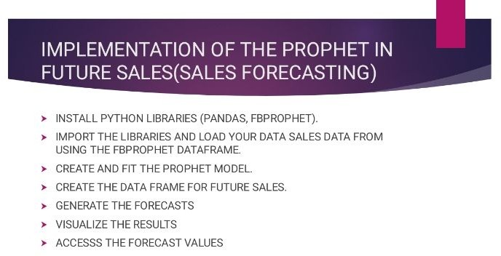



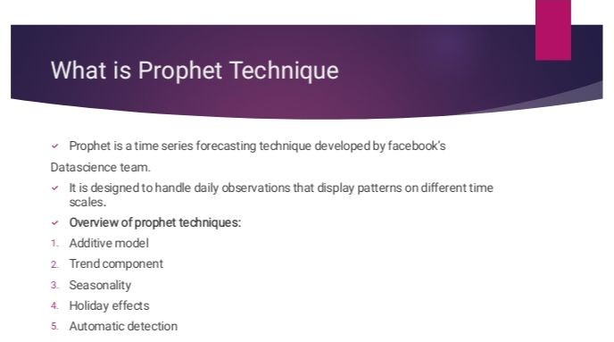

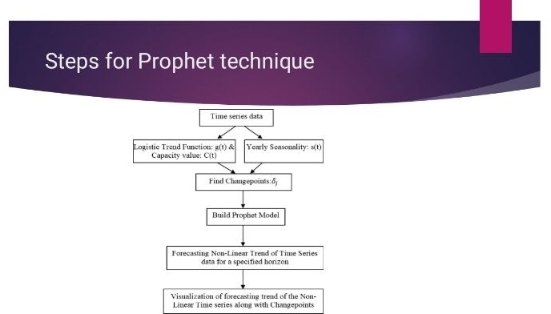

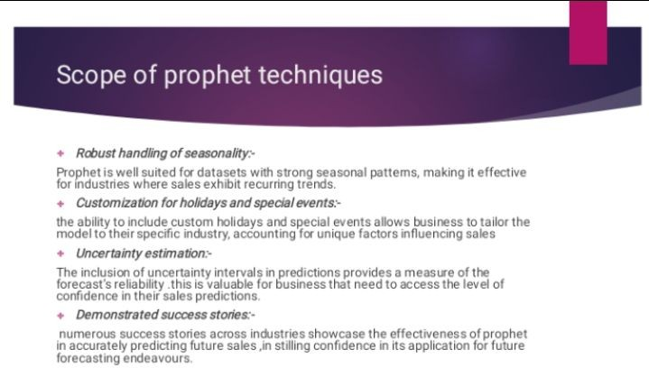



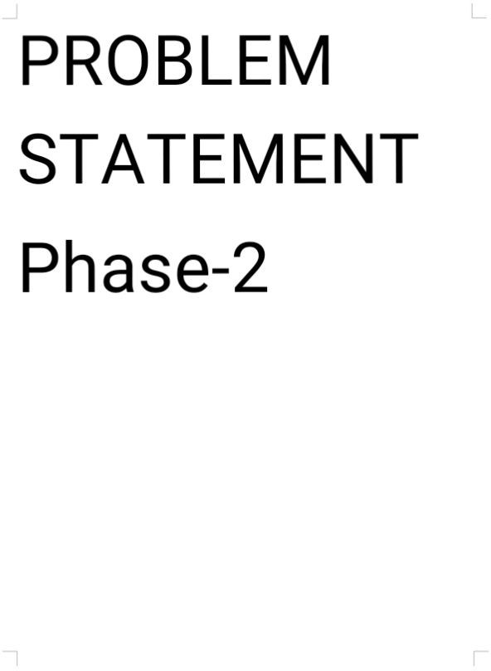

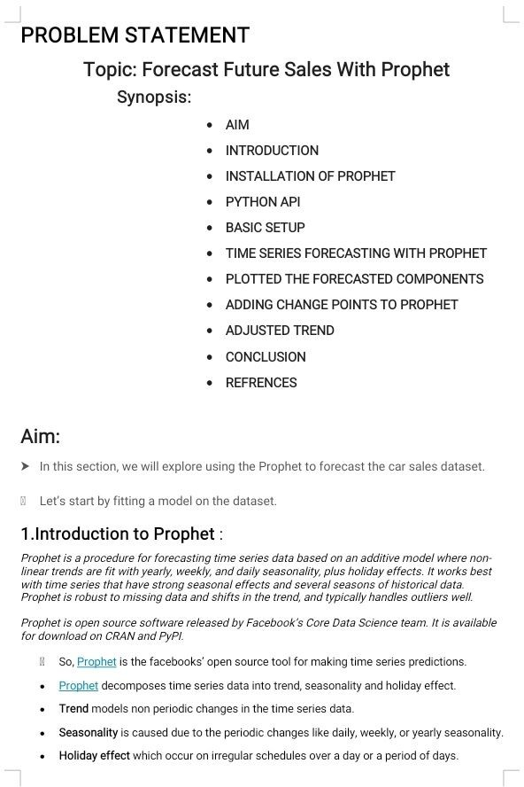

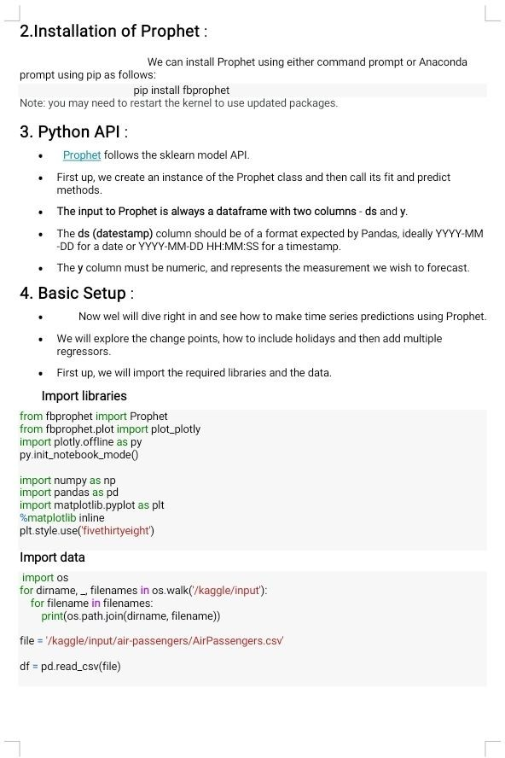

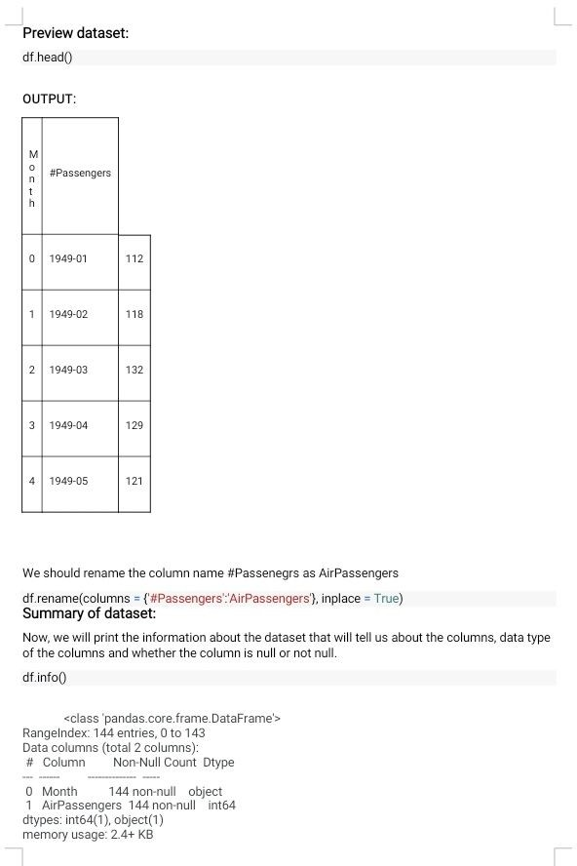

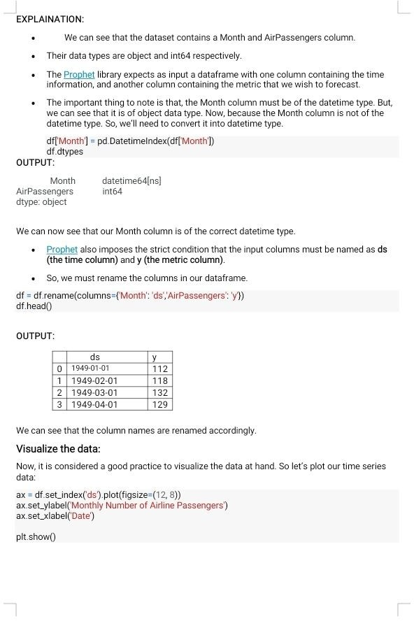

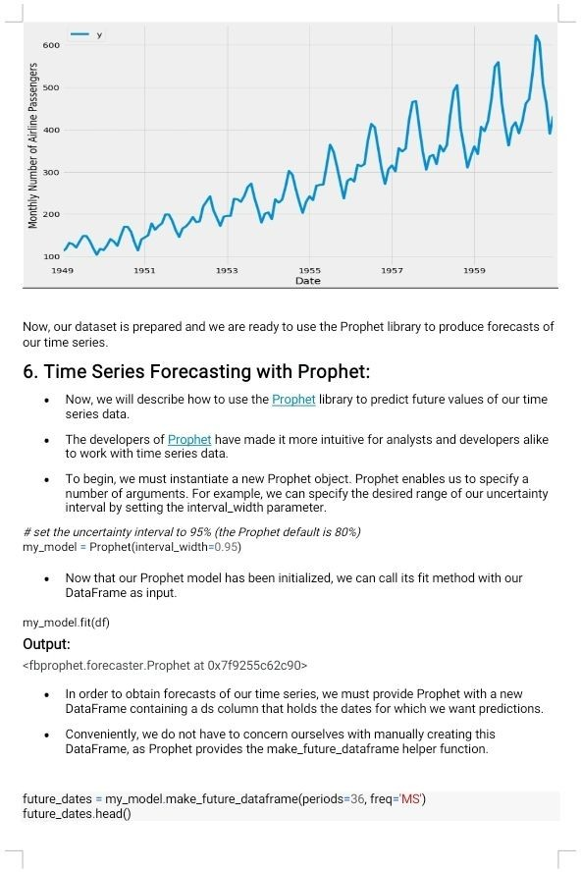

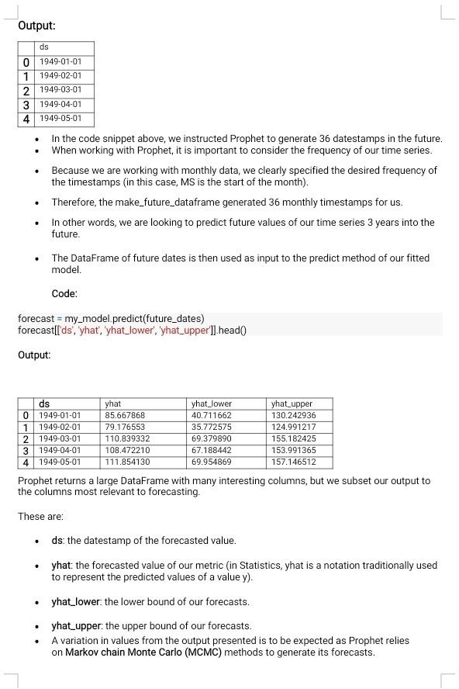

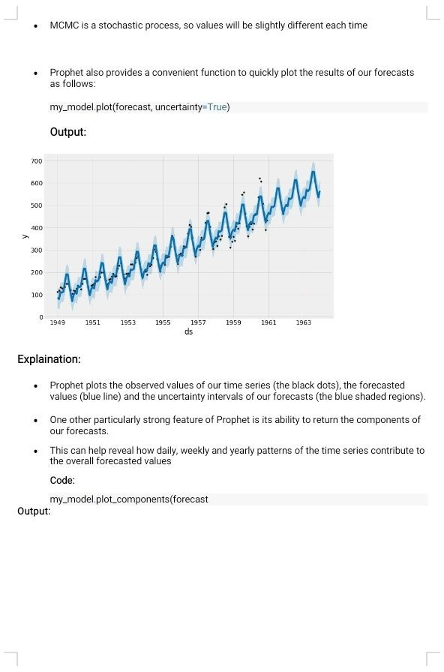

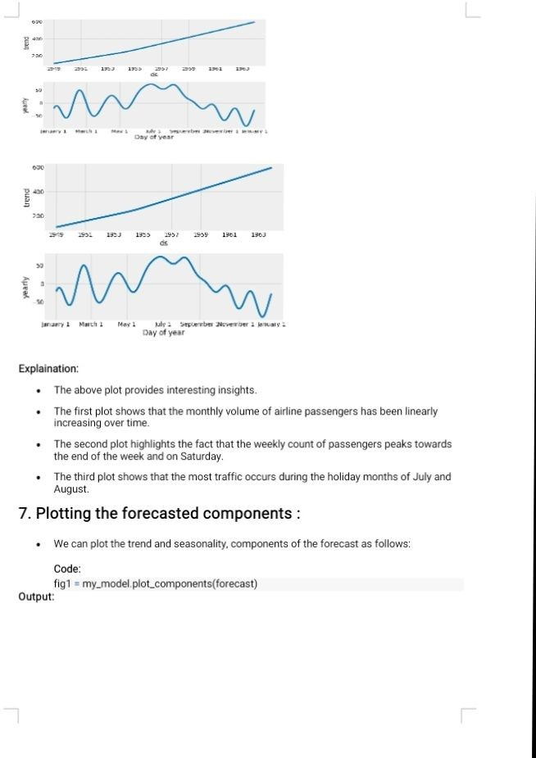

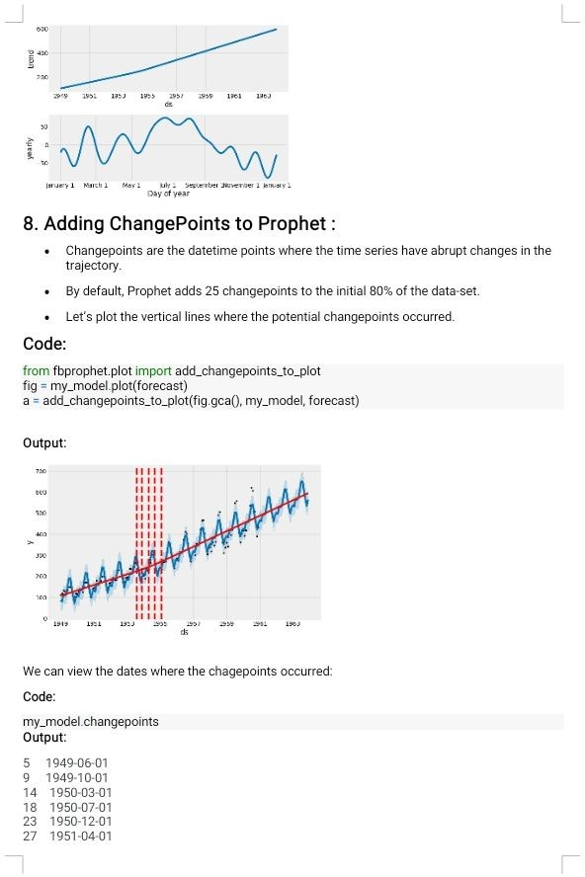

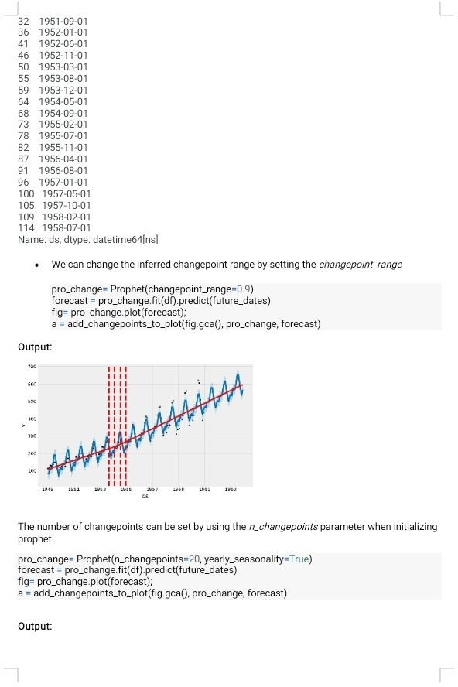

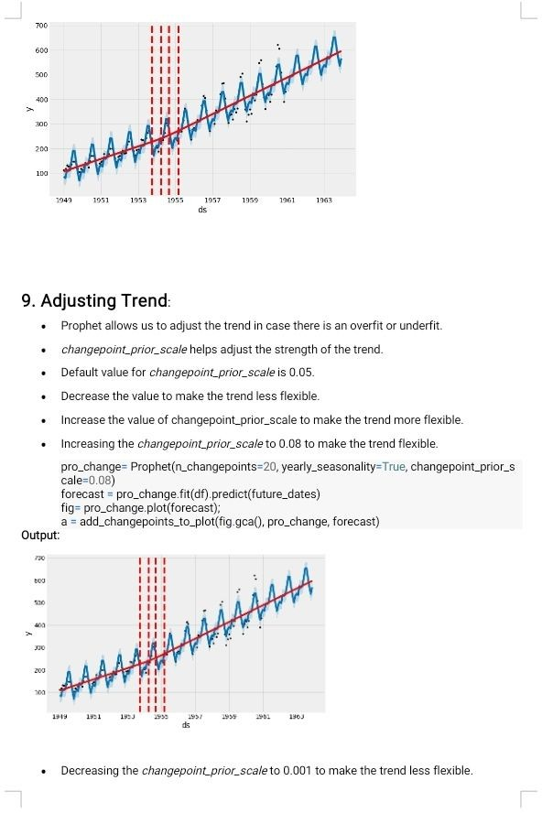

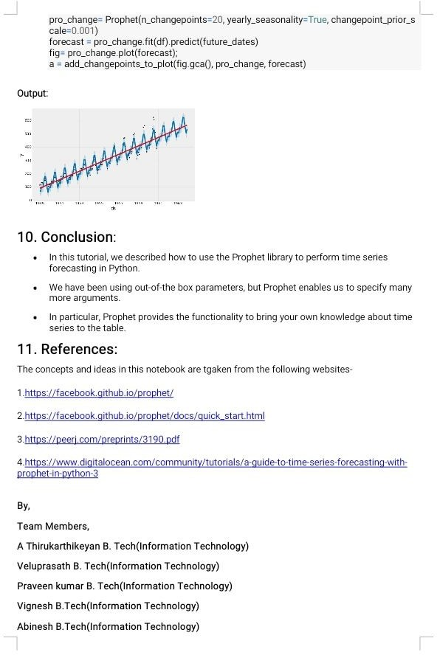



# check prophet version import fbprophet

#printversionnumber

print('Prophet %s' % fbprophet.version) ##

# load the car sales dataset from pandas import read_csv # load data

path = 'https://raw.githubusercontent.com/jbrownlee/Datasets/master/monthly-car-sales.csv' df = read_csv(path, header=0)

# summarize shape print(df.shape)

# show first few rows print(df.head())

##

# load and plot the car sales dataset from pandas import read_csv

from matplotlib import pyplot # load data

path = 'https://raw.githubusercontent.com/jbrownlee/Datasets/master/monthly-car-sales.csv' df = read_csv(path, header=0)

# plot the time series df.plot()pyplot.show()

...

# prepare expected column names df.columns = ['ds', 'y']

df['ds']=to_datetime(df['ds'])

# fit prophet model on the car sales dataset from pandas import read_csv

from pandas import to_datetime fromfbprophetimportProphet # load data

path = 'https://raw.githubusercontent.com/jbrownlee/Datasets/master/monthly-car-sales.csv' df = read_csv(path, header=0)

# prepare expected column names df.columns = ['ds', 'y']

df['ds']=to_datetime(df['ds']) # define the model

model = Prophet() # fit the model model.fit(df)

...

# define the period for which we want a prediction future = list()

foriinrange(1,13):

date='1968-%02d'%i future.append([date])

future = DataFrame(future) future.columns = ['ds']

future['ds']=to_datetime(future['ds'])

...

#summarizetheforecast

print(forecast[['ds','yhat','yhat_lower','yhat_upper']].head())

...

print(forecast[['ds', 'yhat', 'yhat_lower', 'yhat_upper']].head()) # plot forecast

model.plot(forecast) pyplot.show()

# make an in-sample forecast from pandas import read_csv from pandas import to_datetime from pandas import DataFrame from fbprophet import Prophet from matplotlib import pyplot

#loaddata

path = 'https://raw.githubusercontent.com/jbrownlee/Datasets/master/monthly-car-sales.csv' df = read_csv(path, header=0)

# prepare expected column names df.columns = ['ds', 'y']

df['ds']=to_datetime(df['ds']) # define the model

model = Prophet() # fit the model model.fit(df)

# define the period for which we want a prediction future = list()

foriinrange(1,13):

date='1968-%02d'%i future.append([date])

future = DataFrame(future) future.columns = ['ds']

future['ds']=to_datetime(future['ds']) # use the model to make a forecast forecast = model.predict(future)

#summarizetheforecast

print(forecast[['ds', 'yhat', 'yhat_lower', 'yhat_upper']].head()) # plot forecast

model.plot(forecast) pyplot.show()

...

# define the period for which we want a prediction future = list()

foriinrange(1,13):

date='1969-%02d'%i

future.append([date]) future = DataFrame(future) future.columns = ['ds']

future['ds']=to_datetime(future['ds'])

#makeanout-of-sampleforecast from pandas import read_csvfrom pandas import to_datetime from pandas import DataFrame from fbprophet import Prophet from matplotlib import pyplot

#loaddata

path = 'https://raw.githubusercontent.com/jbrownlee/Datasets/master/monthly-car-sales.csv' df = read_csv(path, header=0)

# prepare expected column names df.columns = ['ds', 'y']

df['ds']=to_datetime(df['ds']) # define the model

model = Prophet() # fit the model model.fit(df)

# define the period for which we want a prediction future = list()

foriinrange(1,13):

date='1969-%02d'%i future.append([date])

future = DataFrame(future) future.columns = ['ds']

future['ds']=to_datetime(future['ds']) # use the model to make a forecast forecast = model.predict(future)

#summarizetheforecast

print(forecast[['ds', 'yhat', 'yhat_lower', 'yhat_upper']].head()) # plot forecast

model.plot(forecast) pyplot.show()

...

# create test dataset, remove last 12 months train=df.drop(df.index[-12:])print(train.tail())

...

# calculate MAE between expected and predicted values for december y_true = df['y'][-12:].values

y_pred=forecast['yhat'].values

mae = mean_absolute_error(y_true, y_pred) print('MAE: %.3f' % mae)

...

# plot expected vs actual pyplot.plot(y_true, label='Actual') pyplot.plot(y_pred, label='Predicted') pyplot.legend()

pyplot.show()

# evaluate prophet time series forecasting model on hold out dataset from pandas import read_csv

from pandas import to_datetime from pandas import DataFrame from fbprophet import Prophet

from sklearn.metrics import mean_absolute_error from matplotlib import pyplot

#loaddata

path = 'https://raw.githubusercontent.com/jbrownlee/Datasets/master/monthly-car-sales.csv' df = read_csv(path, header=0)

# prepare expected column names df.columns = ['ds', 'y']

df['ds']=to_datetime(df['ds'])

# create test dataset, remove last 12 months train=df.drop(df.index[-12:])print(train.tail())

# define the model model = Prophet() # fit the model model.fit(train)

# define the period for which we want a prediction future = list()

foriinrange(1,13):

date='1968-%02d'%i future.append([date])

future = DataFrame(future) future.columns = ['ds']

future['ds']=to_datetime(future['ds']) # use the model to make a forecast forecast = model.predict(future)

# calculate MAE between expected and predicted values for december y_true = df['y'][-12:].values

y_pred=forecast['yhat'].values

mae = mean_absolute_error(y_true, y_pred) print('MAE: %.3f' % mae)

# plot expected vs actual pyplot.plot(y_true, label='Actual') pyplot.plot(y_pred, label='Predicted') pyplot.legend()

pyplot.show()

