Food Truck Help Documentation

***Release 0.1.***

**By Sudhakar Rao Avisa**

**May 13, 2023**

# USAGE

1. About Food Truck 3
2. Home Screen 4
3. Manage 5
4. New Food Truck 6
5. Rest End Points 7
6. README.md 9

**Food Truck Help Documentation, Release 0.1.**

**CHAPTER**

# ONE

**ABOUT FOOD TRUCK:**

Food trucks are a popular food service option, offering a wide variety of cuisines and menus to customers.

Food trucks are regulated by the state and local governments, with specific rules and regulations in

place to ensure food safety and compliance with health codes.

This app is an online directory that lists food trucks and its services. The directory allows users to search for

food trucks by location, cuisine, and availability.

**Food Truck Help Documentation Release 0.1.**

**CHAPTER**

# TWO

**HOME SCREEN:**

* Application landing page with default listed with Food Trucks.
* Search enabled to display like on Applicants or Facility Type or Food Items or Addresses or Status

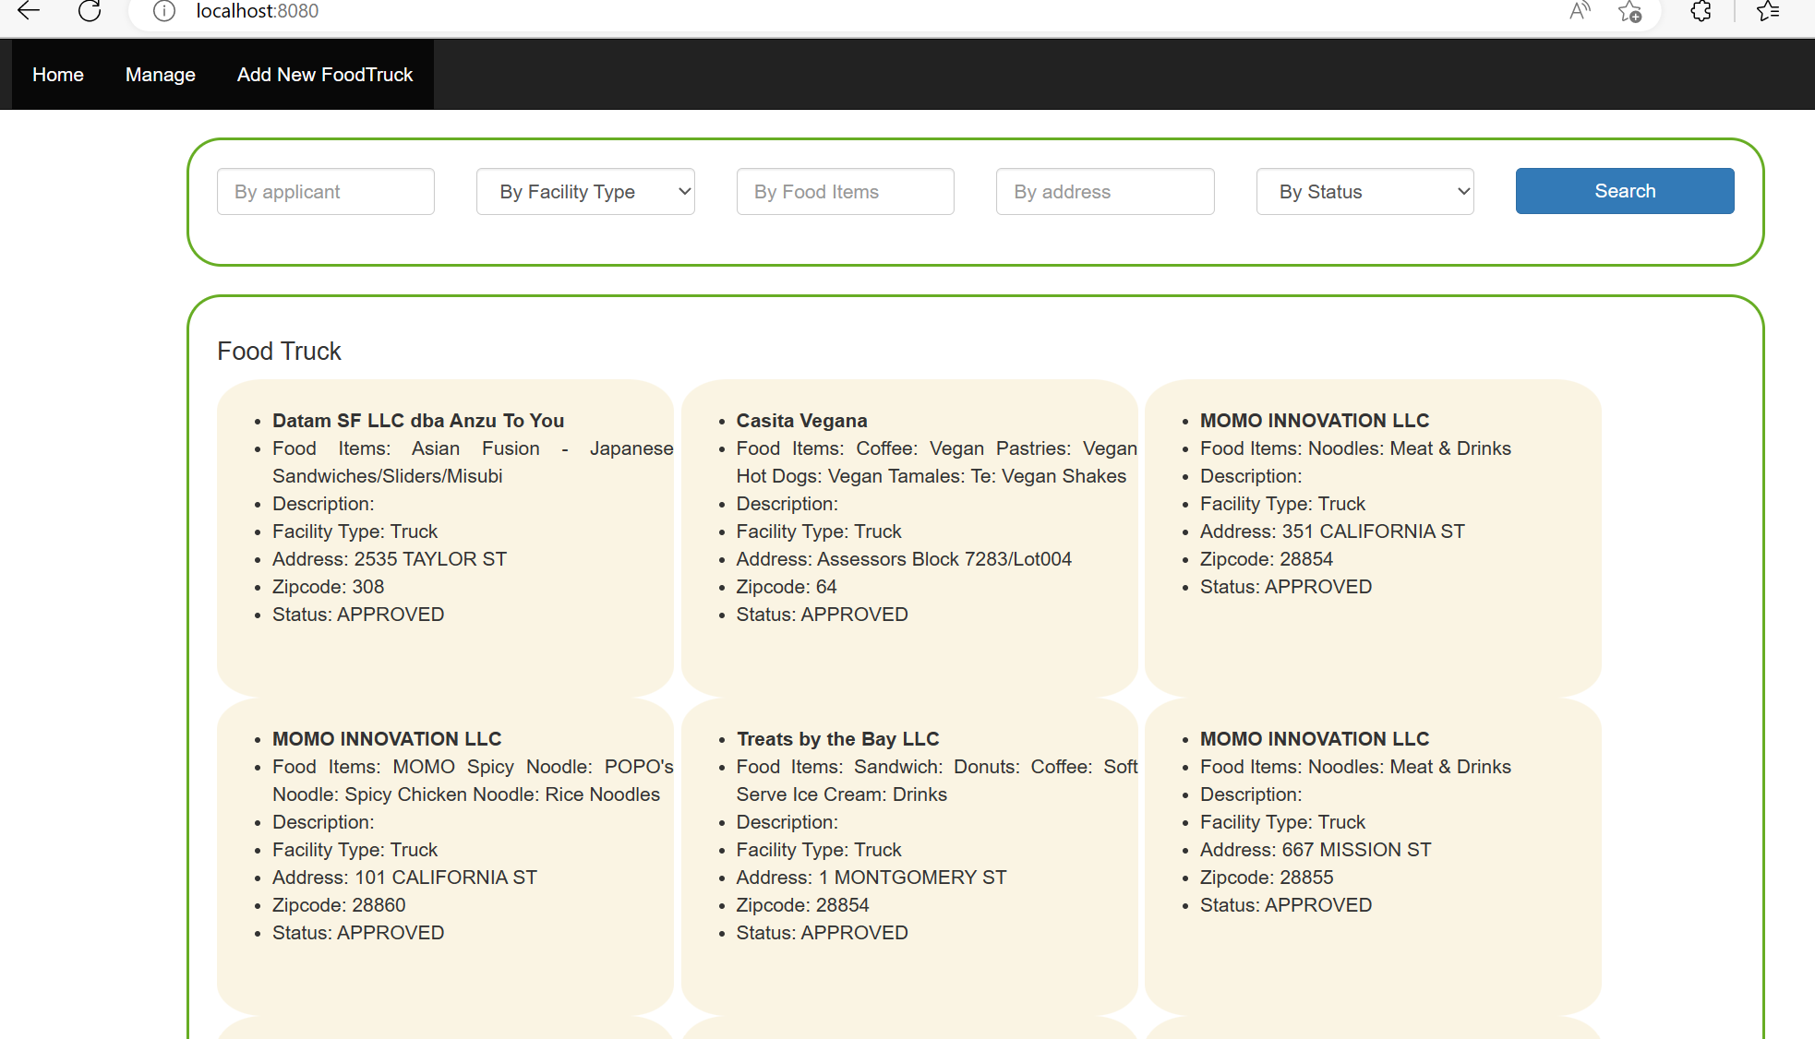

**Food Truck Help Documentation, Release 0.1.**

**CHAPTER**

# THREE

**MANAGE:**

* Tabular list of Food Trucks
* Click on Edit button to modify Food Truck Applicant, Food Items, Address
* Click on Delete to delete the Food Truck record.
* Search enabled to display like on Applicants or Facility Type or Food Items or Addresses or Status

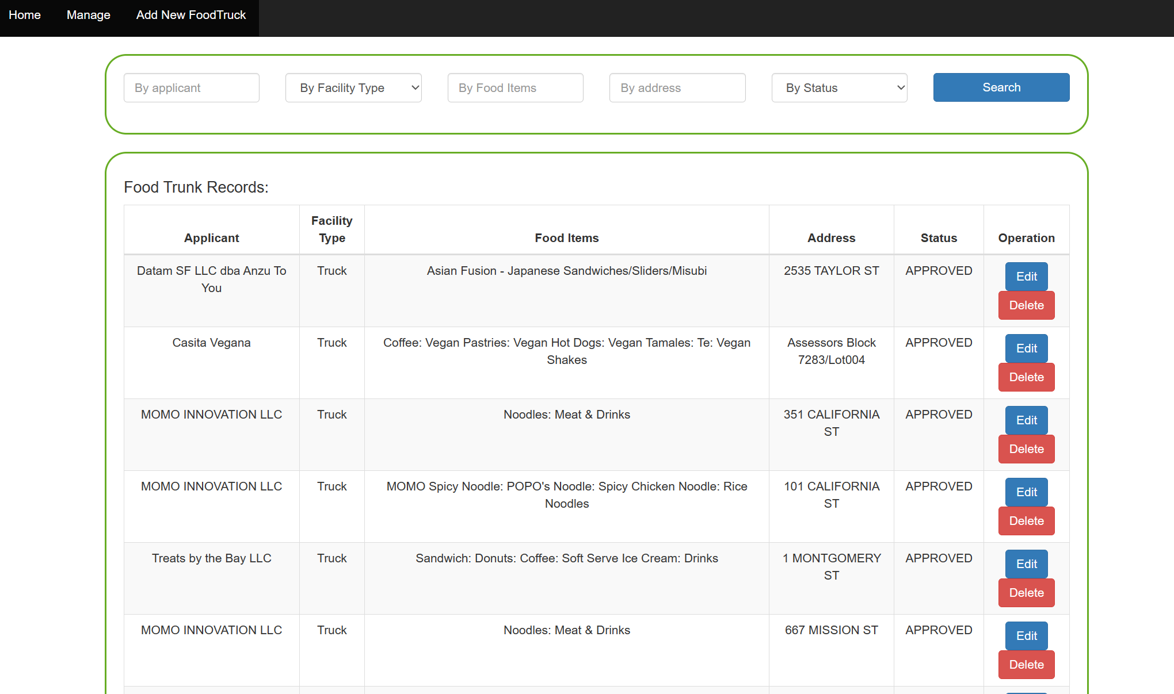

**Food Truck Help Documentation, Release 0.1.**

**CHAPTER**

# FOUR

**NEW FOOD TRUCK:**

* Click on “Add New FoodTruck” to create new Food Truck record
* Entry field for Applicant, Facility Type from the selection, Food Items, Address and Status from
* the selection lists.
* Click on Save Food Truck Information to save the record.

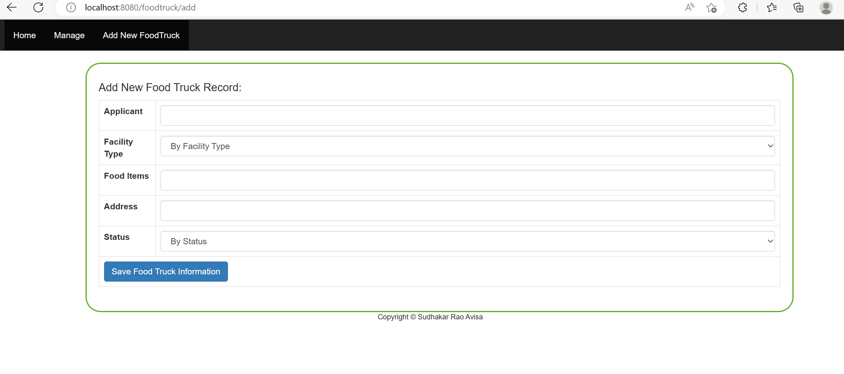

**Food Truck Help Documentation, Release 0.1.**

**CHAPTER**

# FIVE

**REST API END POINT:**

* <http://localhost:8080/api/v1/foodtruck/search>
* Headers:
  + Key: Content-Type
  + Value: application/json
* Method: POST
* Request Body:

{

        "address": "ST",

        "foodItems":"taco"

}

* Result will list Food Trucks based on the matched address text contains and food items text contains
* Curl command to run the REST API
  + curl -X POST http://localhost:8080/api/v1/foodtruck/search -H "Content-Type: application/json" -d '{"address": "ST", "foodItems":"taco" }'

**END POINT RESPONSE OUTPUT:**

[

    {

        "foodTruckId": 30,

        "locationId": 934719,

        "applicant": "\"Santana ESG, Inc.\"",

        "facilityType": "TRUCK",

        "cnn": 11542000,

        "locationDescription": **null**,

        "address": "1 SANSOME ST",

        "blocklot": "289003",

        "block": "289",

        "lot": "3",

        "permit": "17MFF-0122",

        "status": "EXPIRED",

        "foodItems": "Tacos: Burritos: Tortas: Quesadillas: Mexican Drinks: Aguas Frescas",

        "x": 6012406.465,

        "y": 2115874.016,

        "latitude": 37.79048515,

        "longitude": -122.4009404,

        "schedule": "http://bsm.sfdpw.org/PermitsTracker/reports/report.aspx?title=schedule&report=rptSchedule&params=permit=17MFF-0122&ExportPDF=1&Filename=17MFF-0122_schedule.pdf",

        "dayshours": "Mo-Fr:11AM-3PM",

        "noiSent": **null**,

        "approval": "2017-03-21",

        "received": 20170213,

        "priorPermit": 1,

        "expirationDate": "2018-07-15",

        "location": "\"(37.790485146128, -122.40094044068951)\"",

        "firePreventionDistricts": 4,

        "policeDistricts": 1,

        "supervisorDistricts": 10,

        "zipCodes": 28854,

        "neighborhoods_old": 6

    }

]

**Food Truck Help Documentation, Release 0.1.**

**CHAPTER**

# SIX

**README.md:**

Spring framework with a UI, API, and Database that can load it from CSV and display and do search for

Food Truck.

● Database used H2.

● Food Truck table will gets create and dump the data from the CSV file placed in the "resources" folder

and the file name is Mobile_Food_Facility_Permit.csv

● Application UI with a header, footer, index, manage page and search box etc.

● Application allows user to see the list of food truck and can do search and also manage it.

● Provided REST END Points to search the Food Trucks based on the Food Items and Address

curl -X POST http://localhost:8080/api/v1/foodtruck/search -H "Content-Type: application/json" -d '{"address": "ST", "foodItems":"taco" }'