Name:- Banait Nikita Sudhakar.

Roll No:- 05

Practical No:-8

Practical Name:- use git merge to mrge you changes to the primary branch.

____________________________________________________________________________________

Yash Banait@DESKTOP-4AUUNRJ MINGW64 ~/KBCNMU (branch2)

$ git merge main branch2

Already up to date.

Yash Banait@DESKTOP-4AUUNRJ MINGW64 ~/KBCNMU (branch2)

$ git branch --list

* branch2

main

Yash Banait@DESKTOP-4AUUNRJ MINGW64 ~/KBCNMU (branch2)

$ git checkout main

Switched to branch 'main'

Your branch is up to date with 'origin/main'.

Yash Banait@DESKTOP-4AUUNRJ MINGW64 ~/KBCNMU (main)

$ git checkout branch2

Switched to branch 'branch2'

Your branch is up to date with 'origin/branch2'.

Yash Banait@DESKTOP-4AUUNRJ MINGW64 ~/KBCNMU (main)

$ git pull https://github.com/NikitaSBanait/KBCNMU.git

remote: Enumerating objects: 1, done.

remote: Counting objects: 100% (1/1), done.

remote: Total 1 (delta 0), reused 0 (delta 0), pack-reused 0

Unpacking objects: 100% (1/1), 626 bytes | 156.00 KiB/s, done.

From https://github.com/NikitaSBanait/KBCNMU

* branch HEAD -> FETCH_HEAD

Updating ecde04c..a9e60ce

Fast-forward

**Before merge to local repository:-**

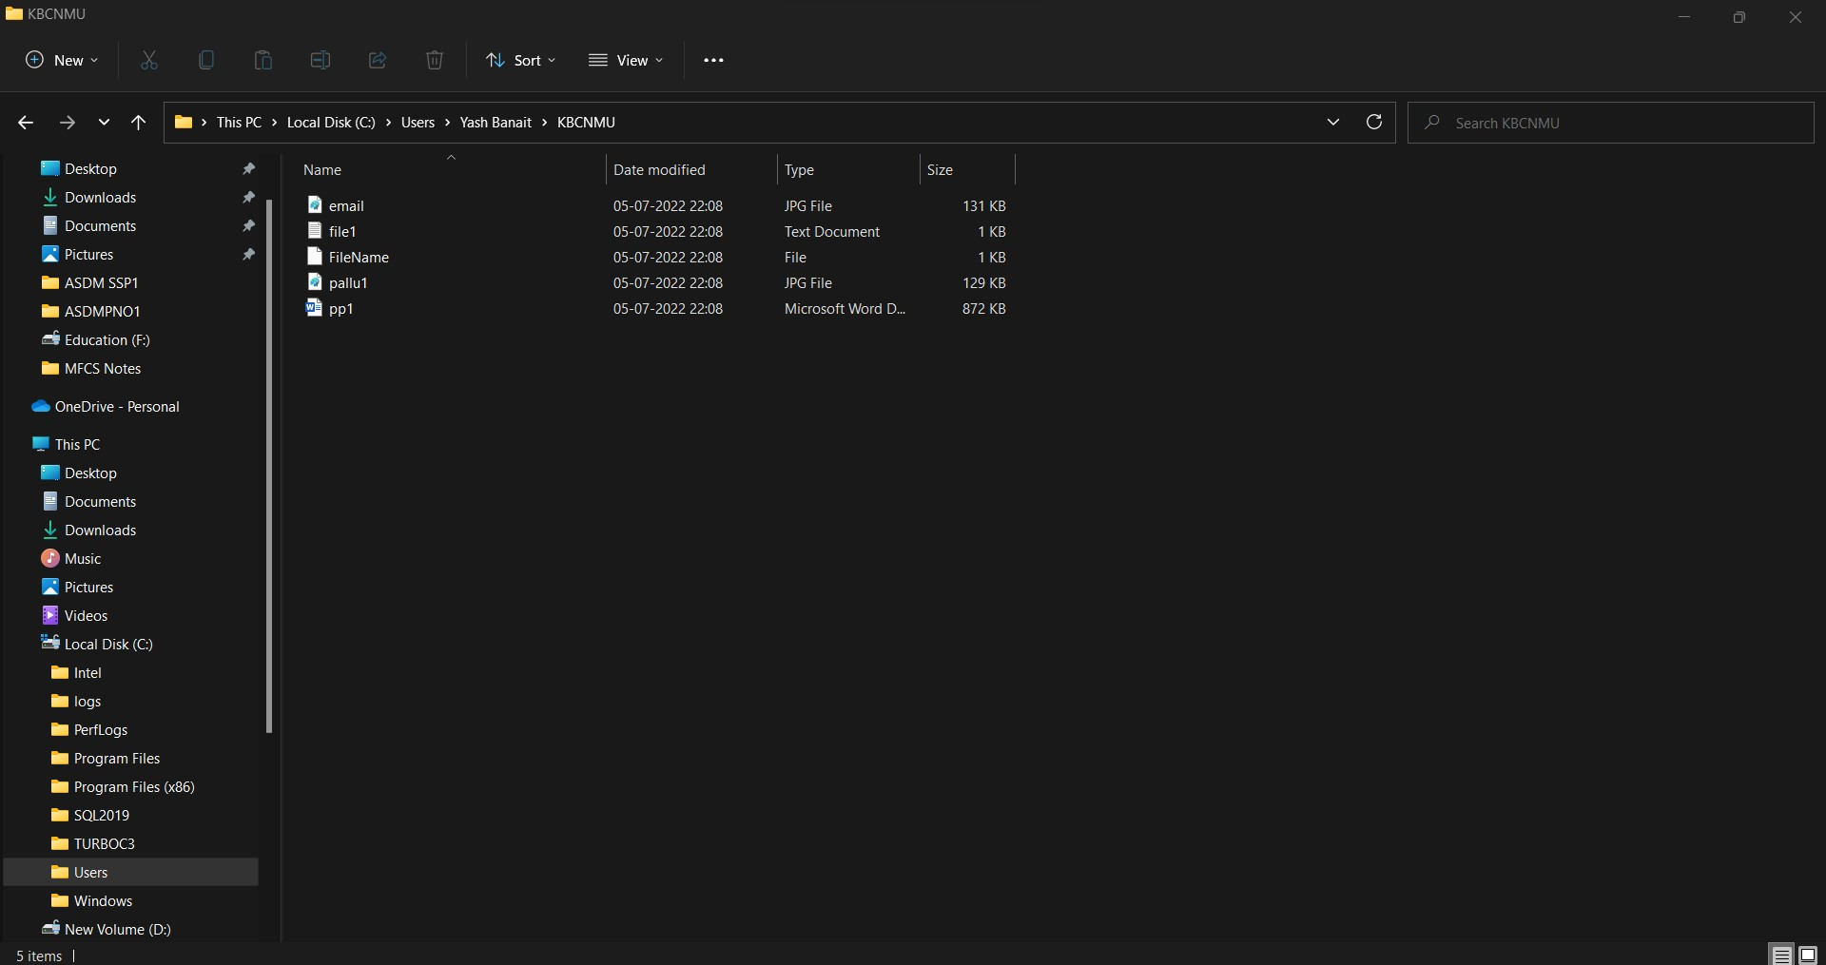

**After Merge to local repository:-**

