**Assignment – 1**

**Install Power BI Desktop and share the final screenshot of the report view page which appears when power desktop starts.**

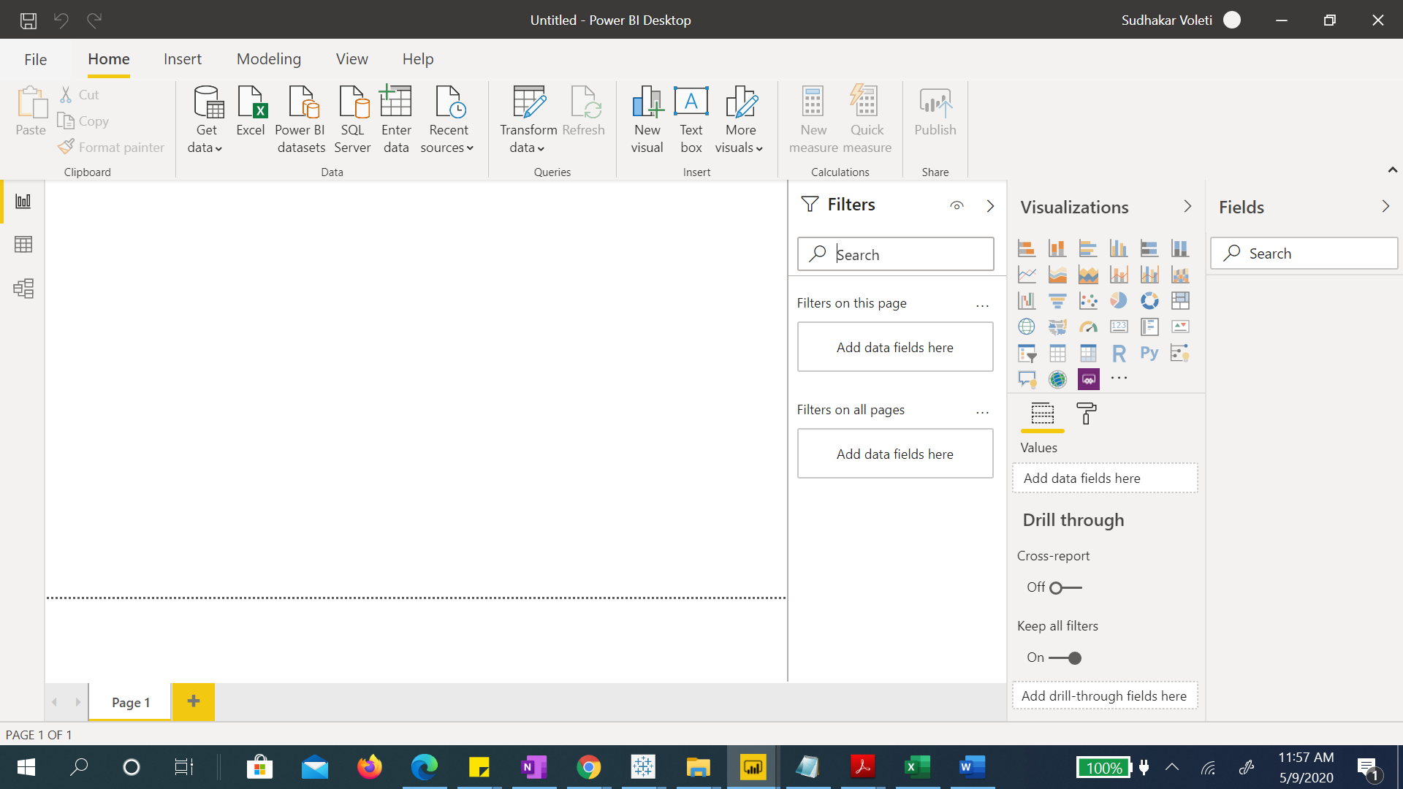

**Prepare a document and with the following screenshot**

* Report View

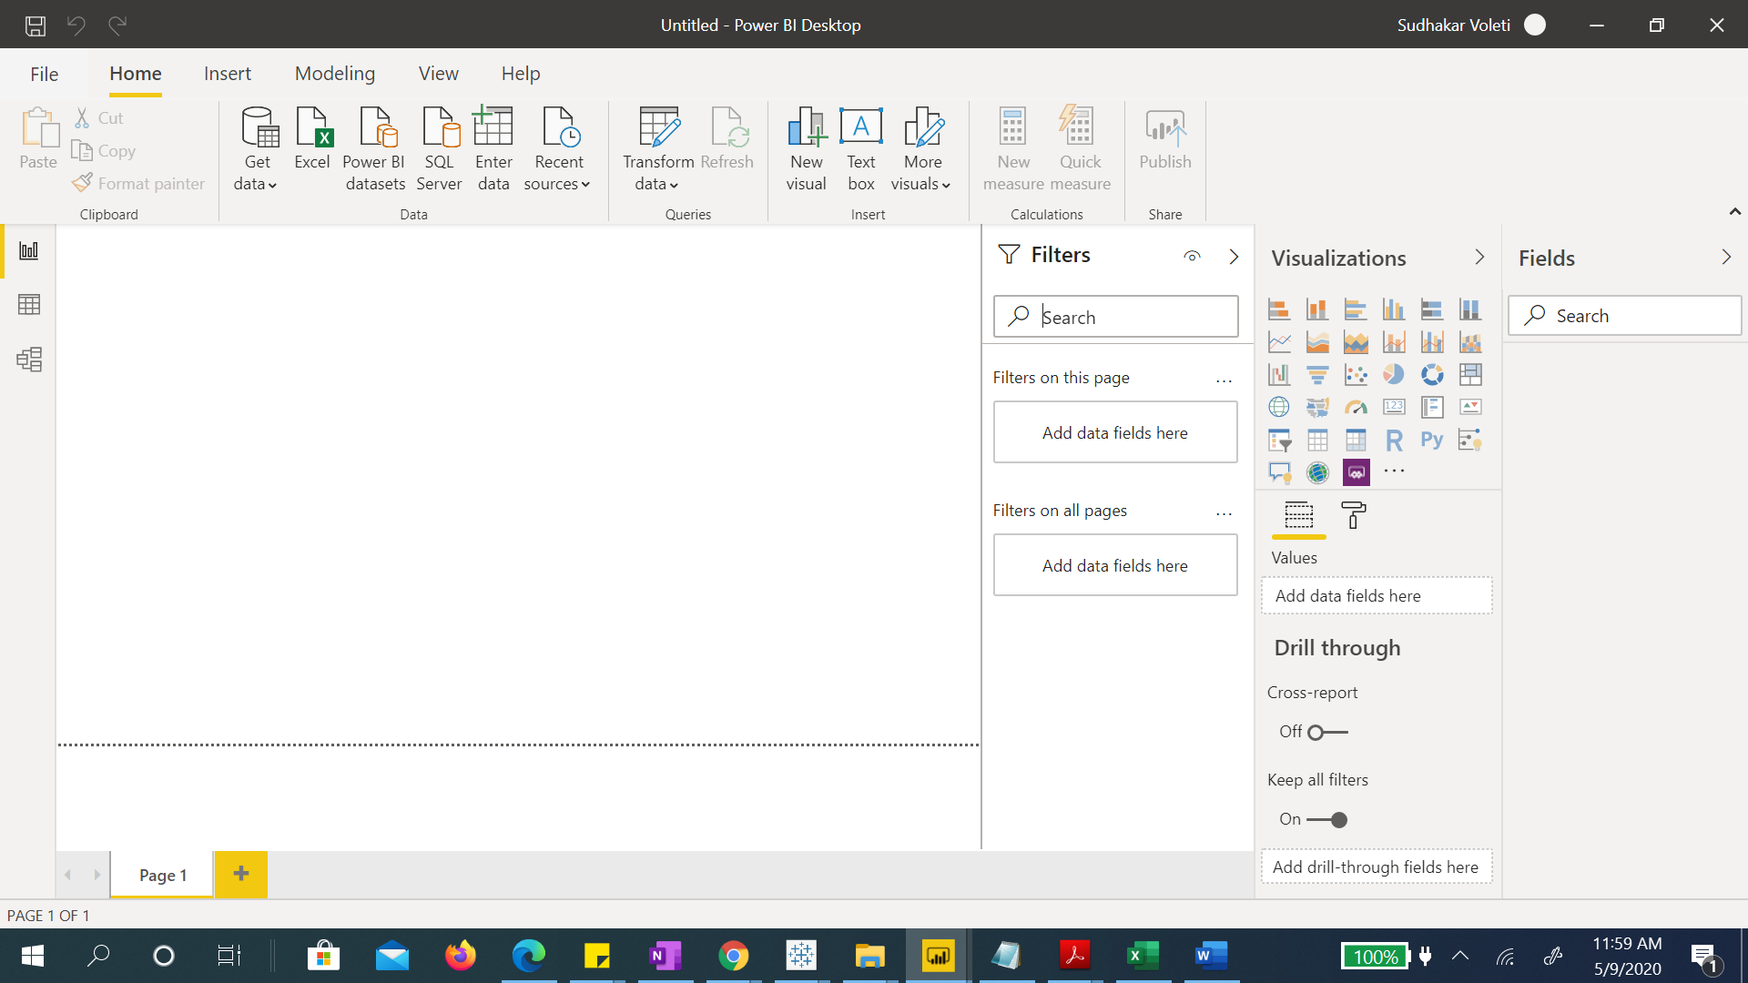

* Data View

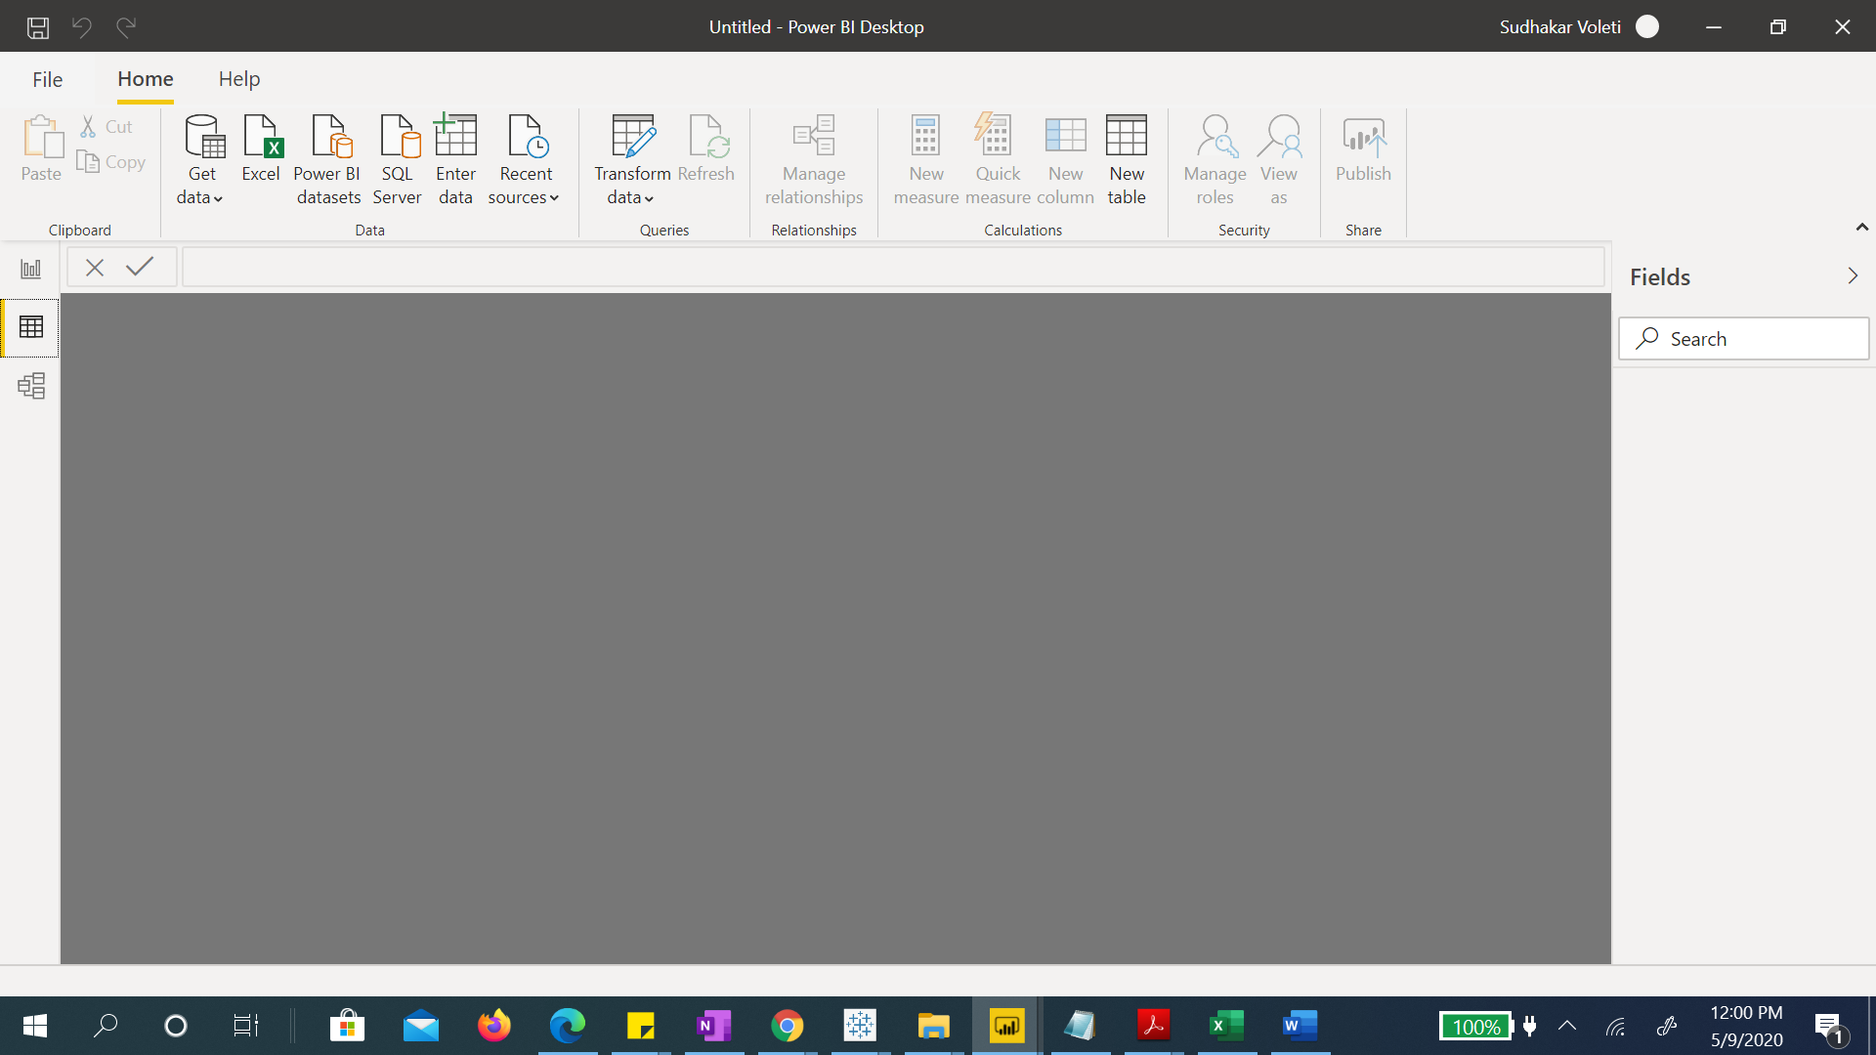

* Model View

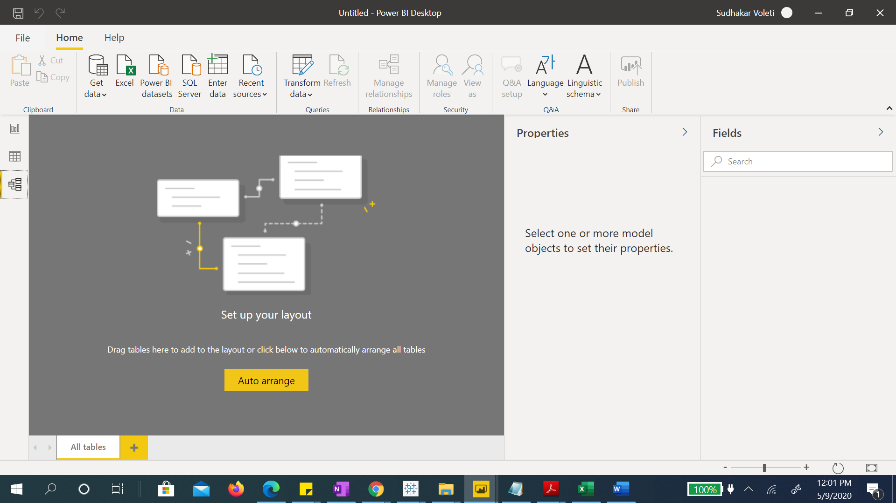

* Power Query Editor

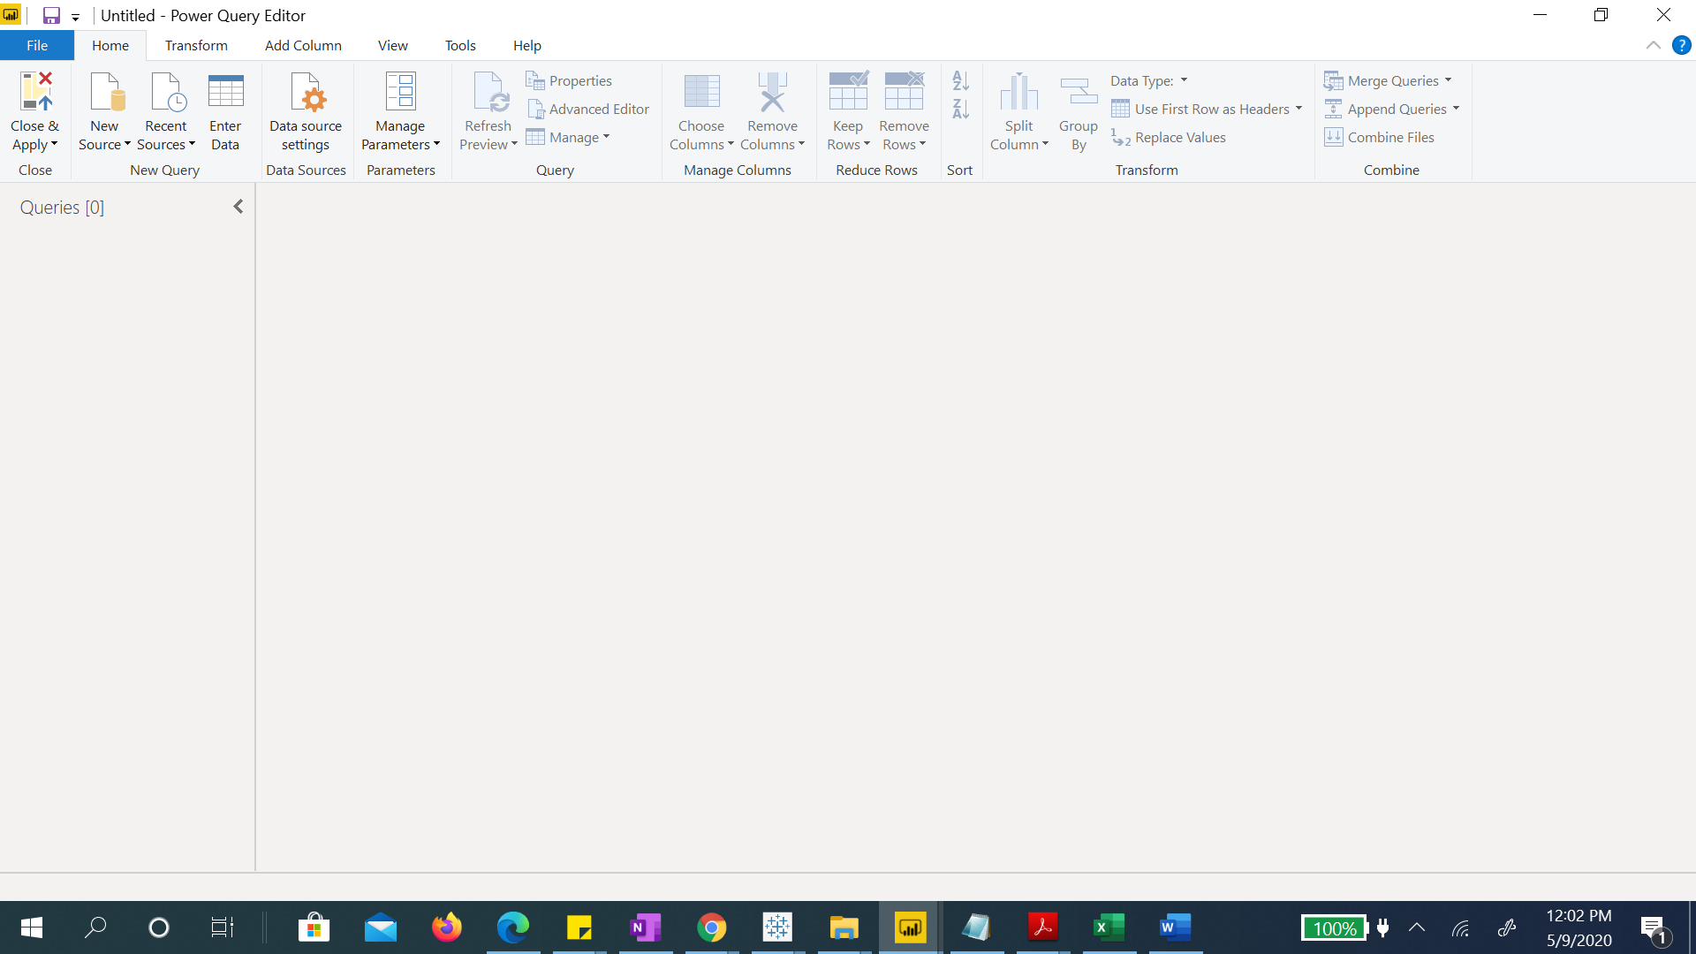

* Advance Editor

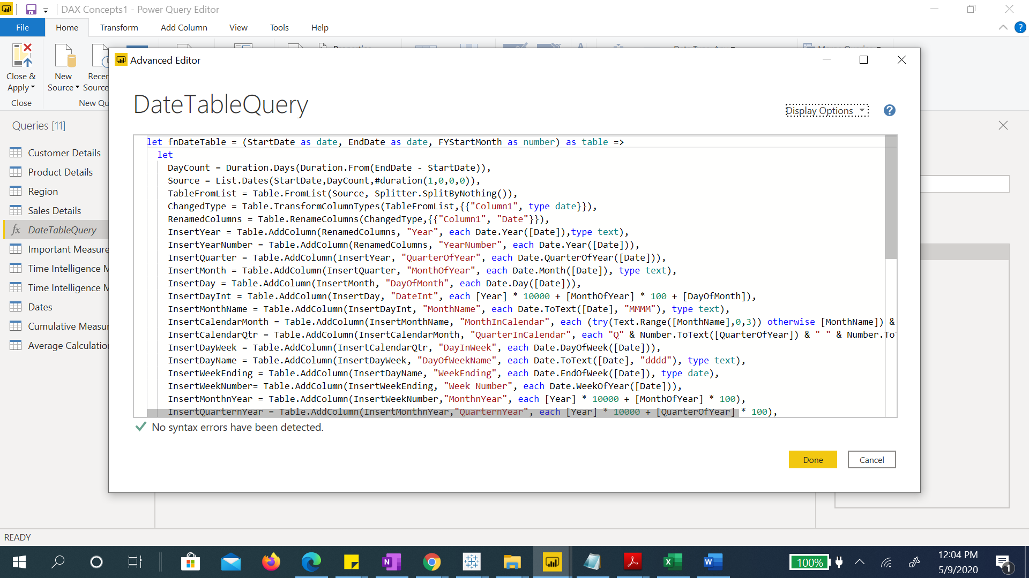

**Prepare a document with details of the following along with their price**

* Power BI Desktop

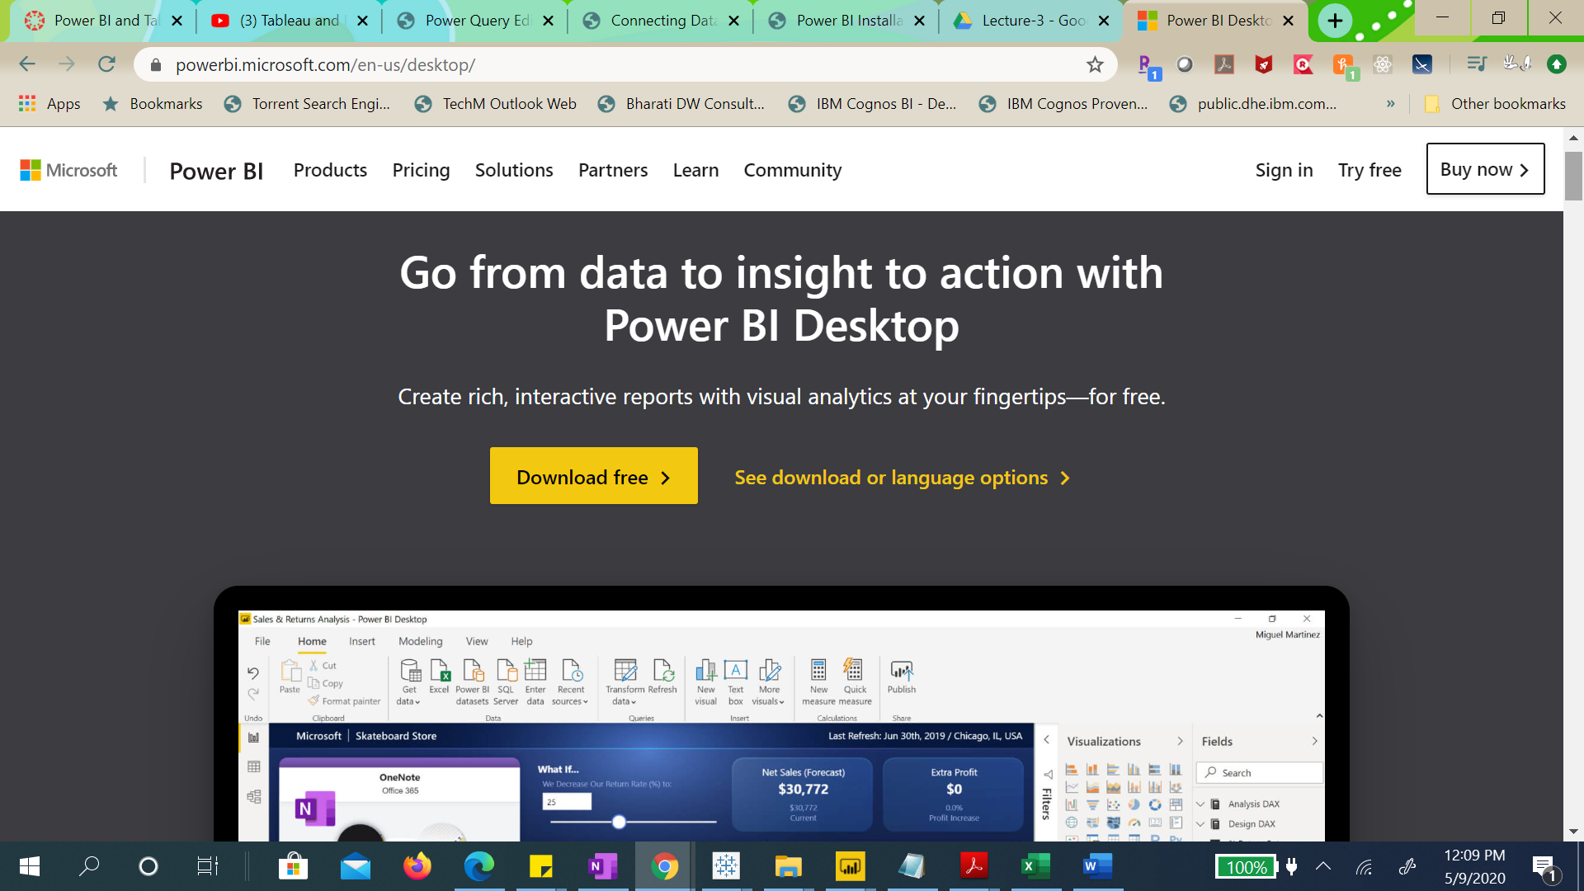

* Power BI Pro
* Power BI Premium

