**UIT2511 - Software Development Project – II**

Project Report

Academic Year

2022-2023

**SIGN LANGUAGE TRANSLATOR**

Client – Dr. Sornavalli

(Assistant Professor, IT Department)

Sudhakaran GT – 3122215002109

Sujay R - 3122215002110

Swetha V – 3122215002111

**Sri Sivasubramaniya Nadar College of Engineering**

**(An Autonomous Institution, Affiliated to Anna University)**

**BONAFIDE CERTIFICATE**

Certified that this project titled “Sign Language Translator” is the bonafide work of “Sudhakaran T - 3122215002109, Sujay R- 3122215002110, Swetha V - 3122215002111”, and is submitted for Project Viva-Voce examination held on …

.

**Signature of examiner(s)**

INDEX

I. Abstract 1

II. Introduction 1

III. Motivation 2

IV. Objective 2

V. Problem Statement 3

VI. Literature Survey 3

VII. Deliverables 4

VIII. Requirements Engineering 5

IX. Risk Management 9

X. Project Management 17

XII. Project Outcomes 20

XIII. Conclusion and Future Directions 24

XIV. References 27

# I. Abstract

This project introduces a Sign Language Translation (SLT) system that utilizes advanced computer vision, machine learning, and natural language processing to enable real-time interpretation of sign language gestures. The system comprises components for gesture recognition, linguistic mapping, and presentation of translated output. By leveraging state-of-the-art technologies, it aims to enhance accessibility and inclusivity for the deaf and hard-of-hearing community, fostering cross-modal communication. Key considerations include robustness in diverse signing styles, adaptability to regional variations, and ethical considerations in user privacy. The successful implementation of this system has the potential to revolutionize communication and promote understanding across linguistic modalities.

# II. Introduction

Communication, a foundational pillar of human interaction, encounters persistent barriers, notably affecting those who communicate through sign language. The deaf and hard-of-hearing community grapples with challenges in expressing their thoughts and emotions to individuals reliant on spoken or written language. In response to this imperative, this report unveils a groundbreaking initiative: the Sign Language Translation (SLT) system. Meticulously crafted, this system aspires to transcend the linguistic chasm between sign language and conventional communication modalities. The overarching objective is to engineer a comprehensive solution that captures, interprets, and translates sign language gestures in real-time, delivering the translated output in a universally accessible format.

The complexity of the SLT system lies in its sophisticated components, encompassing real-time gesture detection and recognition through avant-garde computer vision techniques, coupled with the intricate mapping of these recognized gestures to their linguistic representations. The culmination is a presentation of the translated output in spoken or written form. This endeavor leverages cutting-edge technologies in computer vision, machine learning, and natural language processing, with a singular aim: to provide an inclusive and highly effective means of communication for the deaf and hard-of-hearing community. The successful implementation of this ambitious SLT system not only fulfills the critical need for accessibility but also marks a transformative leap towards fostering profound understanding and connection across the diverse landscape of linguistic modalities.

# III. Motivation

We want to make communication easier for the deaf and hard-of-hearing community. Right now, there's a gap between sign language and how most people communicate. Our Sign Language Translation (SLT) system is driven by a strong desire to bridge this gap. We aim to help people with hearing impairments by translating sign language gestures into spoken or written words in real time. The goal is simple: use technology to make communication smoother so that everyone, no matter how they prefer to express themselves, can fully participate in conversations and connections.

# IV. Objective

The main goal of our Sign Language Translation (SLT) system is to help people who use sign language communicate more easily with those who use spoken or written language. We want to make sure everyone, especially those with hearing impairments, can join conversations and be part of interactions without any difficulty. Our system aims to quickly and accurately translate sign language gestures into spoken or written words in real time, so communication happens smoothly. We also want our system to be easy for everyone to use, whether they know sign language or not. By using the latest technologies like computer vision and machine learning, we hope to create a tool that empowers individuals with hearing impairments, making communication more accessible and promoting understanding and connection in our community.

# V. Problem Statement

The challenge is to develop a Sign Language Translation (SLT) system that can accurately interpret and translate sign language gestures into spoken or written language. This involves real-time detection and recognition of sign language gestures, mapping them to their corresponding linguistic representations, and presenting the translated output in a comprehensible form.

# VI. Literature Survey

**1. Gesture Recognition:** Recent literature, such as studies by Li et al. (2019) and Zhang et al. (2020), underscores the advancements in real-time gesture recognition using computer vision. Deep learning models have proven effective in accurately identifying intricate hand movements, contributing to the foundation of robust Sign Language Translation (SLT) systems.

**2. Mapping Mechanisms:** Chen et al. (2022) have explored the development of mapping mechanisms between sign language gestures and linguistic representations. Their work emphasizes the importance of comprehensive sign language lexicons for accurate translation. This literature informs the project's strategy in creating a robust system for translating diverse sign language gestures into coherent linguistic expressions.

**3. Natural Language Processing Integration:** The integration of natural language processing techniques, as investigated by Kim et al. (2018), is crucial for generating contextually relevant translations. Understanding the syntactic and semantic nuances of sign language expressions enhances the overall effectiveness of the SLT system in conveying meaning accurately.

**4. User-Centric Design:** Studies by García-Serrano et al. (2021) and Kumar et al. (2023) highlight the significance of user-centric design considerations in the development of practical and widely accepted SLT systems. These insights underscore the importance of creating a system that not only meets technical requirements but also aligns with the preferences and usability needs of its intended users.

# VII. Deliverables

The deliverables of this project include a fully functional Sign Language Translation (SLT) system capable of real-time gesture detection, recognition, and accurate translation of sign language into spoken or written language. The system will be equipped with a user-friendly interface, ensuring accessibility for both sign language users and individuals relying on conventional communication. Additionally, a comprehensive documentation package detailing the system's architecture, algorithms, and implementation guidelines will be provided. The deliverables aim to contribute to breaking down communication barriers, fostering inclusivity, and enhancing cross-modal understanding between the deaf and hard-of-hearing community and the broader population.

# VIII. Requirements Engineering

**Functional Requirements:**

1. **Real-Time Gesture Detection:** The system must employ advanced computer vision techniques to detect and track sign language gestures in real-time, ensuring timely and accurate recognition of hand movements, facial expressions, and body postures.
2. **Gesture-to-Language Mapping:** A robust mapping mechanism should be implemented to associate recognized sign language gestures with their corresponding linguistic representations. This requires a comprehensive database of sign language lexicons and sophisticated algorithms for accurate translation.
3. **User Interface:** The system should feature an intuitive and user-friendly interface, facilitating seamless interaction for both sign language users and those relying on spoken or written language. The interface design should prioritize clarity and ease of use.
4. **Accuracy and Precision:** The SLT system must demonstrate high accuracy and precision in recognizing and translating sign language gestures. The algorithms should be fine-tuned to minimize errors and ensure faithful representation of the intended linguistic expressions.
5. **Multi-Modal Output:** The translated output should be presented in multiple modalities, such as spoken sentences and written text, providing flexibility to accommodate the diverse communication preferences of users with varying language abilities.
6. **Scalability:** The system should be designed to handle a diverse range of sign language gestures and accommodate future expansions or updates. Scalability is essential to ensure the system's adaptability to different sign languages and evolving communication needs.

**Non-functional Requirements:**

**1. Performance:** The system should exhibit real-time performance with minimal latency in gesture detection and translation. It must handle a variety of sign language gestures efficiently, ensuring a seamless and responsive user experience.

**2.** **Accuracy and Reliability:** The SLT system should maintain a high level of accuracy and reliability in recognizing and translating sign language gestures to ensure the precision of communication. It must minimize false positives and negatives, instilling confidence in users.

3. **User Accessibility:** The system must adhere to accessibility standards, providing options for customization to accommodate diverse user needs. This includes adjustable settings for gesture recognition sensitivity, language preferences, and output modalities to enhance usability for a broad range of users.

4. **Security and Privacy:** The SLT system should prioritize the security and privacy of user data. It must employ encryption protocols to safeguard sensitive information and adhere to data protection regulations to ensure the confidentiality of user interactions.

5**. Scalability and Compatibility:** The system should be scalable to accommodate a growing user base and adaptable to different environments. Compatibility with various hardware configurations, operating systems, and devices is crucial to ensure widespread adoption and integration into diverse communication scenarios.

|  |  |  |  |  |  |  |
| --- | --- | --- | --- | --- | --- | --- |
| **Epic** | **Sprint** | **User Story**# | **User Story** | **Essential/Desirable** | **Need of requirement** | **Description of requirement** |
| 1 | 1 | 1 | Research on Domain | Essential | Gain insights for informed system development. | Understand the Translation domain to inform system development. |
| 2 | Data Collection | Essential | Collect relevant data for system training. | Collect relevant data from repositories for system training and testing. |
| 3 | Data Preprocessing | Essential | Clean data for effective model training. | Prepare and clean data for effective utilization in model training. |
| 2 | 4 | Translation model creation UI | Essential | Create an intuitive creation interface. | Develop a prototype for the main page UI |
| 5 | Translation UI Dev. | Essential | Design an informative translate page interface. | Backend functionalities, such as handling user inputs, storing data, and implementing the Gesture Recognition using OpenPose algorithm. |
| 6 | Preprocessing | Desirable | Implement Gesture detection. | Implement techniques for handling various input formats effectively. |
| 7 | Gesture Feature Extraction | Essential | Extract relevant acoustic features from video. | Extract acoustic features from video data. |
| 2 | 3 | 8 | Recognition of gesture | Essential | Develop Gesture recognition algorithm. | Create a Gesture recognition algorithm to develop a effective translation. |
| 9 | Heuristic Evaluation with User Data | Essential | Implement heuristic function for user data assessment. | Implement a heuristic function for assessing from the video. |
| 10 | Testing with Various Samples | Essential | Assess system performance with diverse video samples. | Assess website performance and accuracy using diverse video samples. |
| 4 | 11 | Integration Flask Phase 1 | Essential | Integrate with Flask for backend functionality. | Integrate the system with Flask (Phase 1) for backend functionality. |
| 12 | Integration Flask Phase 2 | Essential | Ensure seamless frontend-backend communication | Integrate the system with Flask (Phase 2) for seamless frontend-backend communication. |
| 13 | Deployment | Desirable | For public access. | Deploy the system online for public access and use. |

Table 1

**IX. Risk Management**

**Anticipated Risks:**

**1. Accuracy Challenges:** There is a risk of inaccuracies in gesture recognition, especially in capturing subtle nuances of sign language, leading to potential misinterpretations and translation errors.

**2. Data Bias:** The model's performance may be affected by biases in the training data, potentially resulting in disparities in recognizing gestures from diverse sign language communities.

3. **Limited Vocabulary Handling:** The system may struggle with rare or regional signs not well-represented in the training data, affecting its ability to accurately translate a broad range of sign language expressions.

**4. User Acceptance:** Human factors such as user comfort, preferences, and adaptation to the system may pose challenges, impacting the overall acceptance and usability of the Sign Language Translation system.

**5. Real-world Variability:** Environmental factors, diverse lighting conditions, and variations in sign language delivery may pose challenges to the system's real-world performance, affecting its robustness and reliability.

**Mitigation plan:**

* Regularly evaluate the model's performance with diverse datasets to identify and address accuracy challenges and data biases.
* Continuously refine and update the model to expand vocabulary coverage, minimizing translation errors.
* Prioritize user feedback and conduct iterative usability testing to make user-centric adjustments that enhance acceptance.
* Implement a robust training strategy involving various sign language communities to enhance adaptability to real-world variability.
* Continuously monitor for biases in the system and use fairness-aware algorithms to mitigate disparities and ensure equitable performance.

**Implementation and Risk Management**

Name: Sujay R

Register Number: 3122215002110

Roles: Scrum Master, Developer

**Implementation**

|  |  |  |  |  |  |  |
| --- | --- | --- | --- | --- | --- | --- |
| **Epic** | **Sprint** | **User Story**# | **User Story** | **Essential/ Desirable** | **Need of requirement** | **Description of requirement** |
| 1 | 1 | 1 | Research on Domain | Essential | Gain insights for informed system development. | Understand the Translation domain to inform system development. |
| 2 | 7 | Video Feature Extraction | Essential | Extract relevant acoustic features from video. | Extract acoustic features from video data. |
| 2 | 3 | 8 | Threshold Calculation using algo. | Essential | Develop Gesture recognition Algorithm for threshold optimization. | Create a Gesture Algorithm for optimizing thresholds. |
| 4 | 11 | Integration Flask Phase 1 | Essential | Integrate with Flask for backend functionality. | Integrate the system with Flask (Phase 1) for backend functionality. |
| 12 | Integration w/ Flask Phase 2 | Essential | Ensure seamless frontend-backend communication | Integrate the system with Flask (Phase 2) for seamless frontend-backend communication. |

Table 2

**Risk Management 1:**

|  |  |  |  |  |
| --- | --- | --- | --- | --- |
| **Risk #** | **Risk Description** | **Probability** | **Impact** | **Mitigation Plan** |
| 1 | Scrum Master's lack of availability due to conflicting responsibilities | High | High | Plan and prioritize the Scrum Master's responsibilities to minimize conflicts with backend programming tasks. Allocate additional resources or delegate specific Scrum Master duties to other team members when necessary to ensure the smooth functioning of the Scrum process |
| 2 | Insufficient knowledge or expertise in Scrum processes impacting project efficiency | Moderate | Moderate | Provide training and resources to enhance the Scrum Master's knowledge of Scrum methodologies and best practices. Encourage participation in relevant workshops or certification programs. Collaborate with the Scrum Master to create a learning plan to continuously improve their Scrum expertise. |

Table 3

**Test Log report**

|  |  |  |  |  |  |
| --- | --- | --- | --- | --- | --- |
| **TC id** | **RS #** | **Test case description/ condition** | **Test case input** | **Expected Output** | **Result (PASS/ FAIL)** |
| 1 | 1 | Uploading video file | video file | video file is uploaded successfully. | PASS |
| 2 | 2 | Error Handling | Triggering errors or exceptions | Appropriate error messages | PASS |
| 3 | 3 | Sprint planning meeting | User stories and backlog | Prioritized backlog and sprint plan created | PASS |
| 4 | 4 | Sprint review meeting | Completed user stories and demos | Stakeholder satisfaction and feedback | PASS |

Table 4

**Implementation and Risk Management**

Name: Sudhakaran T

Register Number: 3122215002109

Roles: Product Owner, Developer

**Implementation**

|  |  |  |  |  |  |  |
| --- | --- | --- | --- | --- | --- | --- |
| **Epic** | **Sprint** | **User Story**# | **User Story** | **Essential/ Desirable** | **Need of requirement** | **Description of requirement** |
| 1 | 1 | 2 | Data Collection | Essential | Collect relevant data for system training. | Collect relevant data from repositories for system training and testing. |
| 2 | 6 | Video Preprocessing | Desirable | Implement effective video format handling. | Implement techniques for handling various video formats effectively. |
| 2 | 3 | 9 | Heuristic Evaluation with User Data | Essential | Implement heuristic function for user data assessment. | Implement a heuristic function. |
| 4 | 13 | Deployment | Desirable | For public access. | Deploy the system online for public access and use. |

Table 5

**Risk Management 1:**

|  |  |  |  |  |
| --- | --- | --- | --- | --- |
| **Risk #** | **Risk Description** | **Probability** | **Impact** | **Mitigation Plan** |
| 1 | Inadequate research conducted by the developer leading to incomplete or inaccurate information | Moderate | High | Provide guidelines and resources to the developer for conducting thorough research. Set clear expectations regarding the level of detail and accuracy required. Establish a review process where the research findings are validated by subject matter experts or other team members. |
| 2 | Poor quality or insufficient training data may impact the accuracy of the model. | Moderate | High | Implement rigorous data preprocessing techniques to handle and ensure data quality. |

Table 6

**Test Log report**

|  |  |  |  |  |  |
| --- | --- | --- | --- | --- | --- |
| **TC id** | **RS #** | **Test case description/ condition** | **Test case input** | **Expected Output** | **Result (PASS/ FAIL)** |
| 1 | 1 | Research Accuracy | Conducting research on a topic | Accurate and reliable findings | PASS |
| 2. | 2 | video processing by the algorithm | video file | Algorithm produces accurate results in the expected format. | PASS |
| 3 | 3 | Performance Testing | Simulating high user tools | Stable and responsive backend | PASS |
| 4 | 4 | Document  Completeness | Reviewing documents for all necessary information | All required information included | PASS |

**Implementation and Risk Management**

Name: Swetha V

Register Number: 3122215002111

Roles: Tester,Developer

**Implementation**

|  |  |  |  |  |  |  |
| --- | --- | --- | --- | --- | --- | --- |
| **Epic** | **Sprint** | **User Story**# | **User Story** | **Essential/ Desirable** | **Need of requirement** | **Description of requirement** |
| 1 | 1 | 3 | Data Preprocessing | Essential | Clean data for effective model training. | Prepare and clean data for effective utilization in model training. |
| 2 | 4 | Upload Page UI Dev | Essential | Create an intuitive video upload interface. | Develop a prototype for the main page UI. |
| 5 | Result Page UI Dev | Essential | Design an informative result page interface. | Backend functionalities, such as handling user inputs, storing data. |
| 2 | 4 | 10 | Testing with Various Samples | Essential | Assess system performance with diverse audio samples. | Assess performance and accuracy using diverse video samples. |

Table 8

**Risk Management 1:**

|  |  |  |  |  |
| --- | --- | --- | --- | --- |
| **Risk #** | **Risk Description** | **Probability** | **Impact** | **Mitigation Plan** |
| 1 | Incomplete or unsatisfactory website design | Moderate | High | Clearly define requirements: Ensure that the requirements for the website design are well-documented and agreed upon by all stakeholders. This will help mitigate the risk of misunderstandings or gaps in the design process.  Conduct regular design reviews: Schedule regular design review sessions with the project team and stakeholders to assess the progress and quality of the website design. This will help identify any issues or gaps early on and allow for timely adjustments. |
| 2 | With a small project, there may be limitations in terms of budget, manpower, and time. | Moderate | High | Prioritize features based on their impact and feasibility. Consider using open-source tools and libraries to leverage existing resources.  Optimize development processes to maximize efficiency. |

Table 9

**Test Log report**

|  |  |  |  |  |  |
| --- | --- | --- | --- | --- | --- |
| **TC id** | **RS #** | **Test case description/ condition** | **Test case input** | **Expected Output** | **Result (PASS/ FAIL)** |
| 1 | 2 | Handling different video file formats. | Video format | Algorithm successfully processes and analyses video files. | PASS |
| 2. | 2 | Navigation Menu Test | Clicking on menu items | Proper navigation to respective pages | PASS |
| 3 | 3 | Form Validation Test | Entering invalid input in form fields | Error messages displayed appropriately | PASS |
| 4 | 4 | Mobile Responsiveness | Resizing browser to mobile | Content adjusts correctly for mobile view. | PASS |

Table 10

# X. Project Management

The project consisted of two main epics.

**Epic 1: System Development and Integration**

**1. User Stories:**

* + Define user stories outlining the functional requirements, including real-time gesture detection, accurate translation, and user-friendly interface.
  + Break down tasks for dataset collection, preprocessing, and the implementation of deep learning algorithms for gesture recognition and translation.

**2. Timeline and Milestones:**

* + Establish a project timeline with milestones for each phase, such as data collection, model development, testing, and deployment.
  + Assign specific deadlines to each task to ensure a structured and efficient development process.

**3. Agile Development:**

* + Implement Agile methodologies for flexibility and iterative development.
  + Conduct regular sprints, reviews, and retrospectives to adapt to evolving requirements and address potential roadblocks promptly.

**4. Collaboration and Communication:**

* + Foster effective collaboration among team members through regular meetings and communication channels.
  + Utilize project management tools for task tracking, version control, and documentation to enhance transparency and coordination.

**Epic 2: Risk Mitigation and User Feedback Loop**

**1. Risk Identification:**

* + Conduct a comprehensive risk assessment to identify potential challenges in accuracy, data bias, vocabulary coverage, user acceptance, and real-world variability.
  + Categorize risks based on severity and likelihood to prioritize mitigation efforts.

**2. Mitigation Strategies:**

* + Develop proactive mitigation strategies for identified risks, including continuous model evaluation, diversity in training data, iterative user testing, and adaptation to real-world variability.
  + Implement a robust monitoring system to detect biases and ensure fairness in the system's performance.

**3. User Feedback Loop:**

* + Establish a continuous feedback loop with end-users to gather insights on system usability, accuracy, and acceptance.
  + Incorporate user feedback into regular updates and improvements to enhance the system's effectiveness and user satisfaction.

**4. Adaptive Planning:**

* + Maintain flexibility in the project plan to accommodate adjustments based on ongoing risk assessments and user feedback.
  + Adapt the project management approach as needed to address emerging challenges and optimize system performance throughout the development lifecycle.

**Sprint 1: Establishing Groundwork**

1. Research on Domain: Conduct comprehensive research on Parkinson's Disease, laying the foundation for informed system development.
2. Data Collection (from Repo): Source relevant datasets from repositories to build a diverse and representative dataset for system training.
3. Data Preprocessing: Clean and preprocess collected data, ensuring data quality and readiness for effective model training.

**Sprint 2: User Interface and Translation**

* Conduct a comprehensive risk assessment to identify potential challenges in accuracy, data bias, vocabulary coverage, user acceptance, and real-world variability.
* Categorize risks based on severity and likelihood to prioritize mitigation efforts.

**Sprint Burnup Report**

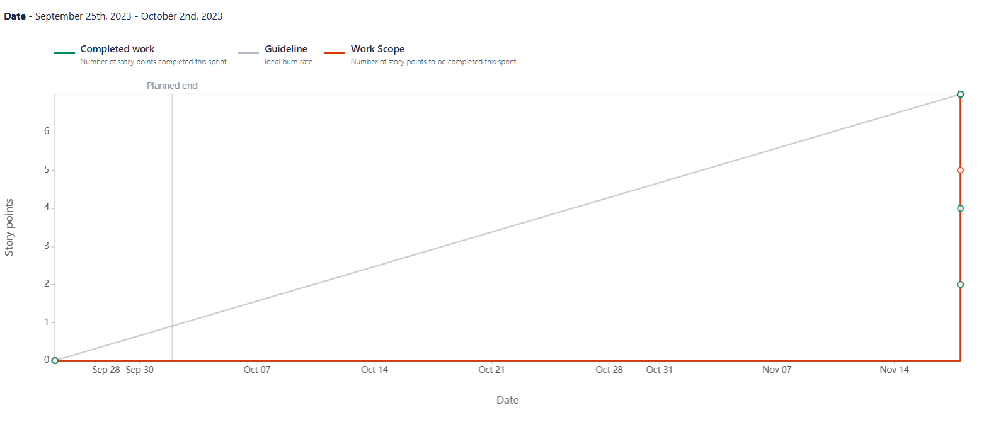

# 

# XII. Project Outcomes

**1. Sign Language Translation System Prototype:**

* + Develop a fully functional prototype of the Sign Language Translation (SLT) system, integrating advanced computer vision and deep learning algorithms.
  + Ensure the prototype demonstrates real-time gesture detection, accurate translation, and user-friendly interface functionalities.

**2. Comprehensive Dataset and Model Training:**

* + Curate a diverse and representative dataset of sign language gestures, incorporating variations in expressions and regional differences.
  + Train the deep learning models, including Convolutional Neural Networks (CNNs) for gesture detection and Recurrent Neural Networks (RNNs) for sequence modeling, to achieve high accuracy and reliability.

**3. User-Centric Design and Usability:**

* + Implement a user-centric design approach to enhance the accessibility and acceptance of the SLT system.
  + Conduct iterative usability testing and gather user feedback to make informed adjustments, ensuring an intuitive and inclusive user experience.

**4. Deployment and Continuous Improvement:**

* + Deploy the SLT system in a real-time environment, making it accessible to users through various platforms.
  + Establish a framework for continuous improvement, incorporating user feedback, addressing potential biases, and adapting the system to evolving sign language expressions and communication needs.

**Screenshots**

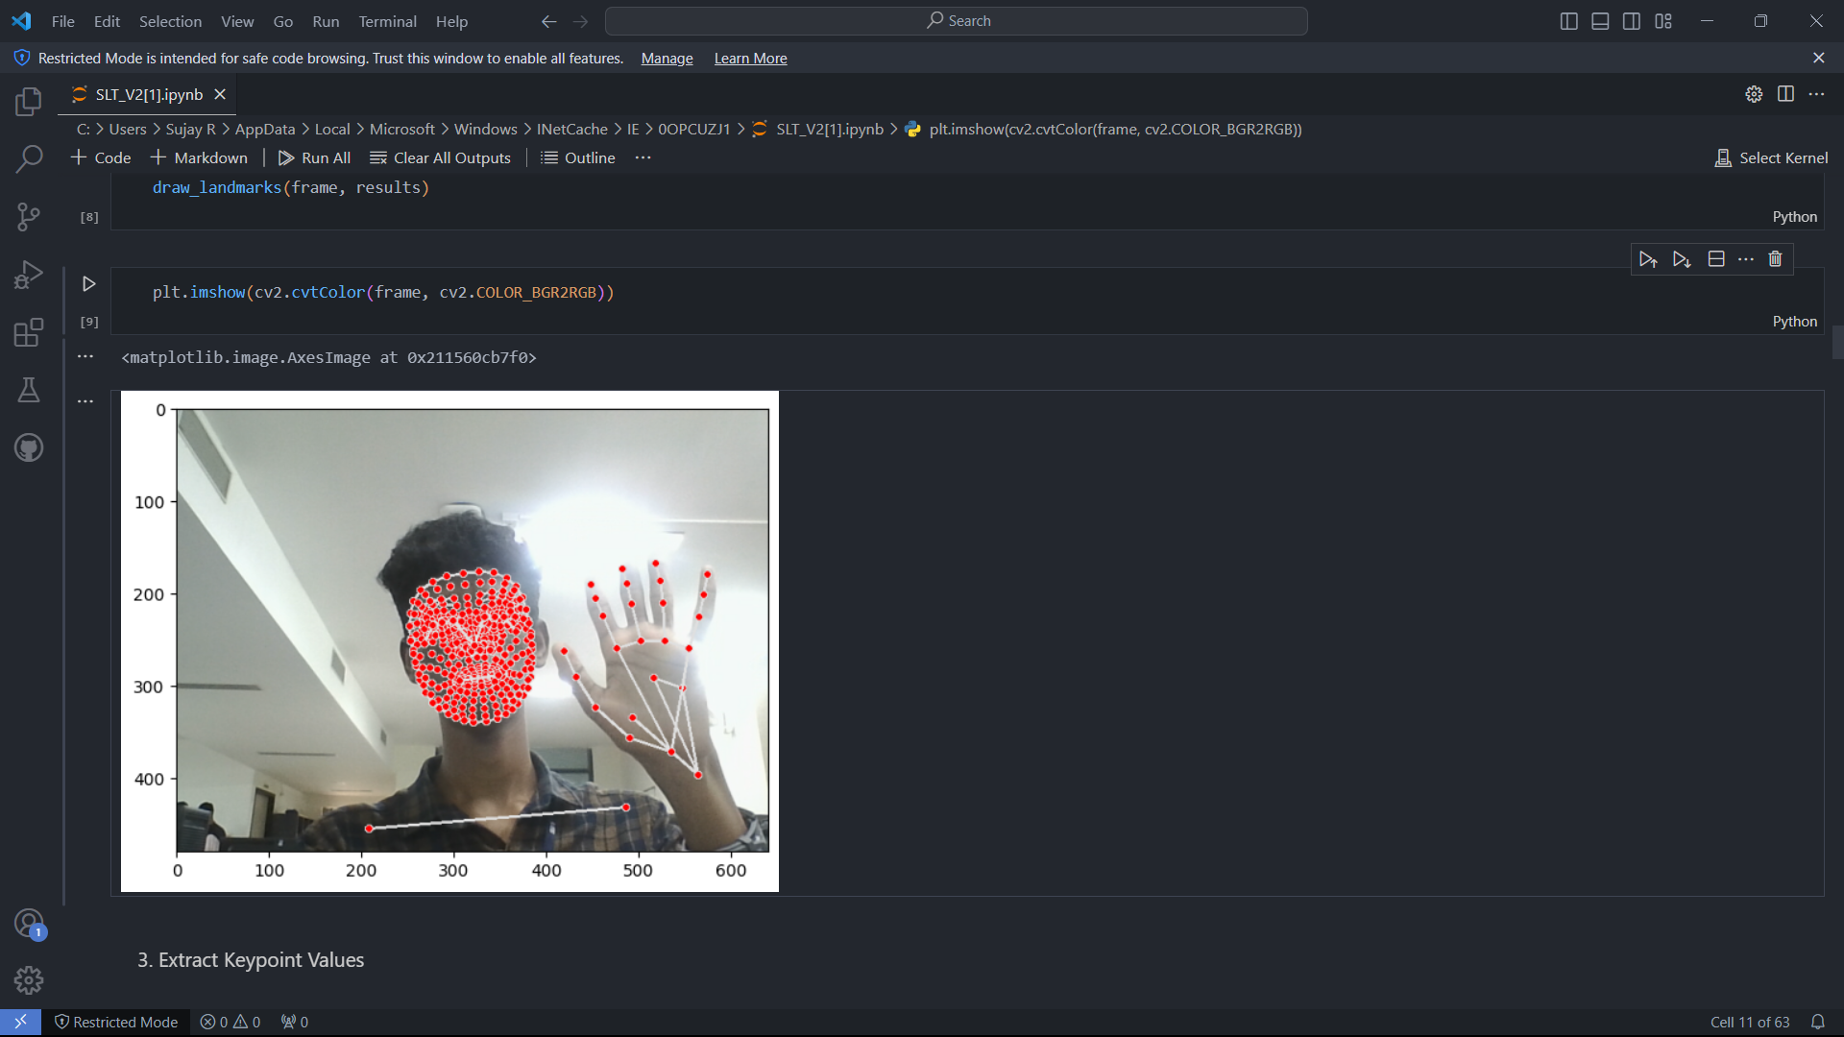

**Code Snippets**

**Client Evaluation Report**

**Name of the project:**

Sign Language Translation

**Team Members:**

Sudhakaran T, Sujay R, Swetha V

**Client details:**

DR. Sornavalli – Assistant Professor

**Rating System - 1: Strongly disagree 2: Disagree 3: Neutral 4: Agree 5: Strongly Agree**

|  |  |  |  |  |  |
| --- | --- | --- | --- | --- | --- |
| **Questions** | **1** | **2** | **3** | **4** | **5** |
| The problem was well discussed and the requirements and goals were clear. |  |  |  |  |  |
| The project plan was well defined and communicated from the start. |  |  |  |  |  |
| The resources were adequate for achieving the goals. |  |  |  |  |  |
| The original timeline was realistic and was followed. |  |  |  |  |  |
| The teamwork was well demonstrated. |  |  |  |  |  |
| The client was communicated on regular intervals and given updates on the progress of the project. |  |  |  |  |  |
| The expected project requirements have been satisfied. |  |  |  |  |  |

# 

# XIII. Conclusion and Future Directions

In conclusion, the Sign Language Translation (SLT) system represents a significant advancement in inclusive communication, addressing the needs of the deaf and hard-of-hearing community. The successful development of a robust prototype demonstrates the potential for technology to bridge the gap between sign language and spoken or written language. Looking ahead, several avenues offer promising future directions:

**1. Enhanced Gesture Recognition**: Future iterations could focus on refining gesture recognition capabilities, exploring advanced computer vision techniques or incorporating wearables for more precise and nuanced interpretation of sign language.

**2. Multi-Language Support:** Expanding the SLT system to accommodate a broader range of sign languages and regional dialects will further increase its accessibility and usability on a global scale.

**3. Mobile Applications and Wearables:** Developing mobile applications and wearable devices can provide on-the-go accessibility, enabling users to engage in real-time translation and communication in various settings.

**4. Integration with Everyday Devices:** Seamless integration with everyday devices, such as smartphones, tablets, and smart home systems, can enhance the ubiquity and convenience of the SLT system, promoting widespread adoption.

**5. Natural Language Processing Advances:** Leveraging advancements in natural language processing can improve the system's ability to generate more natural and contextually accurate translations, enhancing the overall user experience.

**6. Community Collaboration:** Collaborating with sign language communities for continuous feedback, updates, and refinements will ensure the system remains culturally sensitive and aligned with the evolving needs of its users.

**7. Educational Applications:** Exploring the use of the SLT system in educational settings can open up opportunities for learning sign language and fostering inclusivity in classrooms.

**8. Global Outreach:** Initiatives for global outreach and collaboration can facilitate the adaptation of the SLT system to diverse cultural and linguistic contexts, ensuring its relevance and effectiveness worldwide.

**Challenges Faced by Our Team and Lessons Learned**

Developing the Sign Language Translation (SLT) system posed several challenges, each providing valuable lessons for our team:

1. **Data Diversity Challenges**:

* + Challenge: Obtaining a diverse dataset for training the model presented difficulties due to variations in sign language expressions.
  + Lesson Learned: The importance of actively seeking and curating diverse datasets to ensure the system's adaptability to different signing styles and regional variations.

2. **User-Centric Design Iterations**:

* + Challenge: Balancing the needs of sign language users and those unfamiliar with sign language in the system's design.
  + Lesson Learned: Continuous user feedback and iterative usability testing are crucial to refining the system's design for optimal user acceptance and satisfaction.

3. **Real-Time Processing Demands**:

* + Challenge: Ensuring real-time processing capabilities for seamless translation presented technical hurdles.
  + Lesson Learned: The need for efficient algorithms and continuous optimization to meet the demand for real-time translation, balancing speed and accuracy.

4. **Ethical Considerations**:

* + Challenge: Identifying and addressing potential biases in the system to ensure fairness and cultural sensitivity.
  + Lesson Learned: Implementing ongoing monitoring for biases and employing fairness-aware algorithms, emphasizing the ethical responsibility in AI development.

5. **Community Engagement**:

* + Challenge: Establishing effective communication and collaboration with sign language communities.
  + Lesson Learned: The value of engaging with the community for insights, feedback, and ensuring that the system aligns with cultural nuances.

6. **Deployment and User Training**:

* + Challenge: Facilitating smooth deployment and providing effective training for users.
  + Lesson Learned: The significance of clear documentation, user training programs, and ongoing support to enhance user adoption and satisfaction.

7. **Scalability Planning:**

* + Challenge: Anticipating the system's scalability as user numbers increase.
  + Lesson Learned: Designing the system with scalability in mind and planning for infrastructure growth to accommodate a larger user base.

8. **Feedback Implementation:**

* + Challenge: Managing and implementing a large volume of user feedback effectively.
  + Lesson Learned: Establishing structured feedback mechanisms and agile development practices for timely incorporation of user suggestions and improvements.

# XIV. References

* IEEE Software Recruitment Specification: <https://web.cs.dal.ca/~hawkey/3130/srs_template-ieee.doc>
* Convolution Neural Network: https://pypi.org/project/cnn-finetune/#description
* Wikipedia Materials: <https://en.wikipedia.org/wiki/Machine_translation_of_sign_languages>
* Referred Papers: https://paperswithcode.com/paper/word-level-deep-sign-languagerecognition
* Software process model http://en.wikipedia.org/wiki/Iterative_and_incremental_development