**SQL PROJECT**

**DATA ANALYTICS PORTFOLIO WITH PYTHON**

**Basic Queries**

1. List all unique cities where customers are located.

Query –

select distinct customer_city from customers;

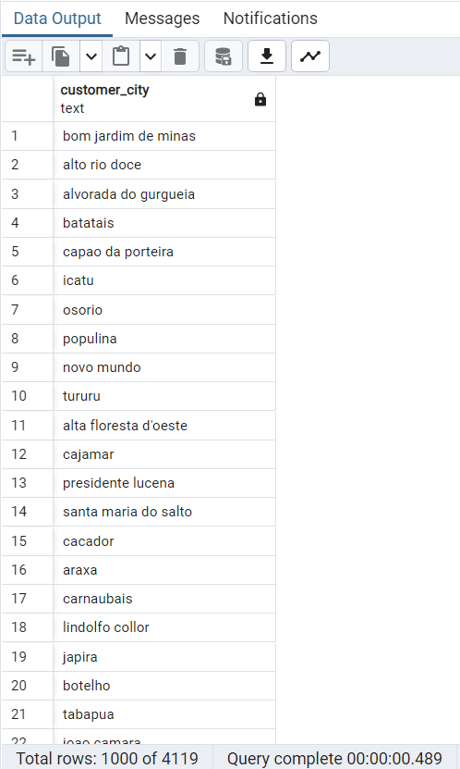

2. Count the number of orders placed in 2017.

Query –

Select count(*)

from orders

where order_purchase_timestamp between '2017-01-01' and '2017-12-31';

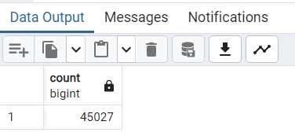

3. Find the total sales per category.

Query –

select products.product_category category,

sum(payments.payment_value) sales

from products join order_items

on products.product_id = order_items.product_id

join payments

on payments.order_id = order_items.order_id

group by category

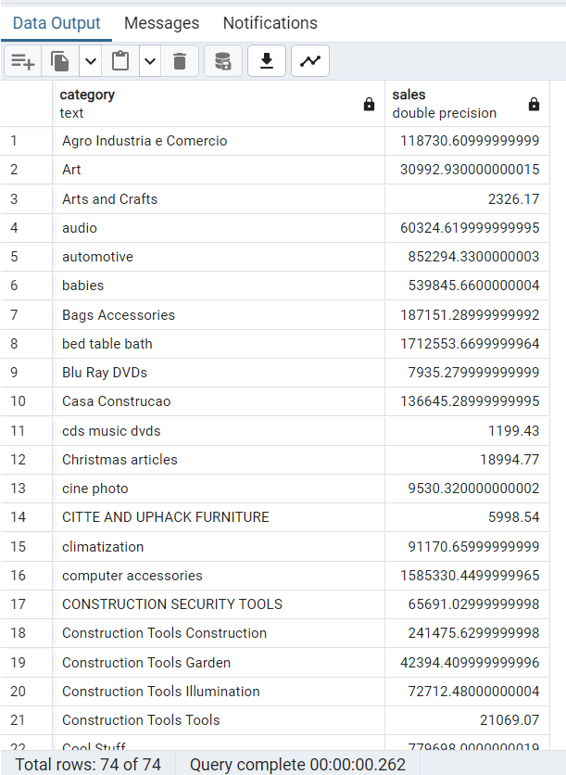

4. Calculate the percentage of orders that were paid in installments.

Query –

select (cast (sum(case when payment_installments >= 1 then 1 else 0 end) AS decimal) / count(*)) * 100 as percentage_with_installments from payments;

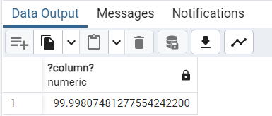

5. Count the number of customers from each state.

Query –

select customer_state , count(customer_id)

from customers group by customer_state

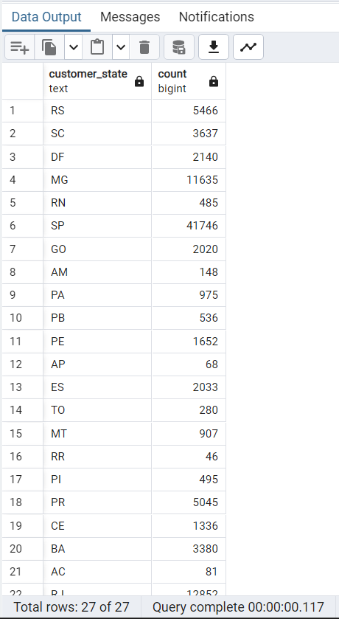

**Intermediate Queries**

1. Calculate the number of orders per month in 2018.

Query –

select to_char(order_purchase_timestamp::timestamp, 'Month') as months, count(order_id) as order_count

from orders

where extract(YEAR from order_purchase_timestamp::timestamp) = 2018

group by to_char(order_purchase_timestamp::timestamp, 'Month')

order by min(order_purchase_timestamp::timestamp);

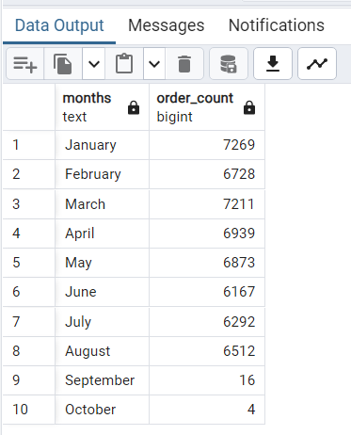

2. Find the average number of products per order, grouped by customer city.

Query –

with count_per_order as

(select orders.order_id, orders.customer_id, count(order_items.order_id) as oc

from orders join order_items

on orders.order_id = order_items.order_id

group by orders.order_id, orders.customer_id)

select customers.customer_city, round(avg(count_per_order.oc),2) average_orders

from customers join count_per_order

on customers.customer_id = count_per_order.customer_id

group by customers.customer_city order by average_orders desc;

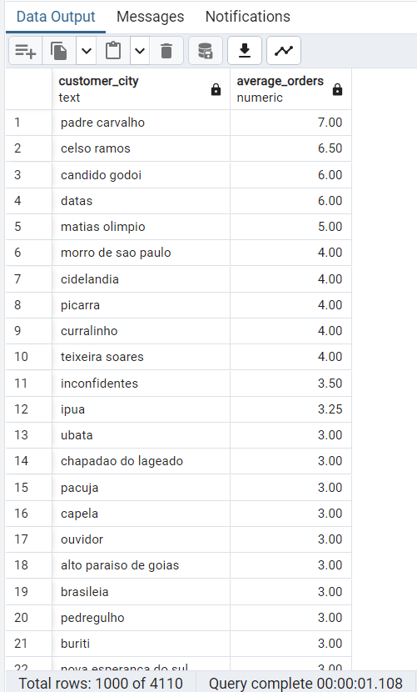

3. Calculate the percentage of total revenue contributed by each product category.

Query –

Select upper(products.product_category) AS category,

round(cast((sum(payments.payment_value) / (select sum(payment_value) from payments)) * 100 as numeric), 2) as sales_percentage

from products

join order_items on products.product_id = order_items.product_id

join payments on payments.order_id = order_items.order_id

group by category

order by sales_percentage desc;

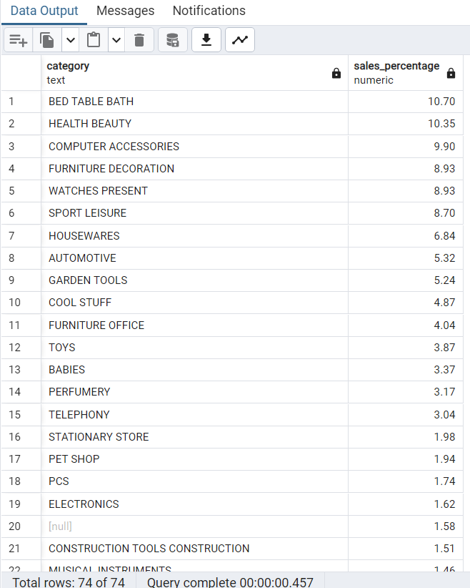

4. Identify the correlation between product price and the number of times a product has been purchased.

Query –

select products.product_category,

count(order_items.product_id) as product_count,

round(avg(order_items.price)::numeric, 2) as average_price

from products

join order_items on products.product_id = order_items.product_id

group by products.product_category;

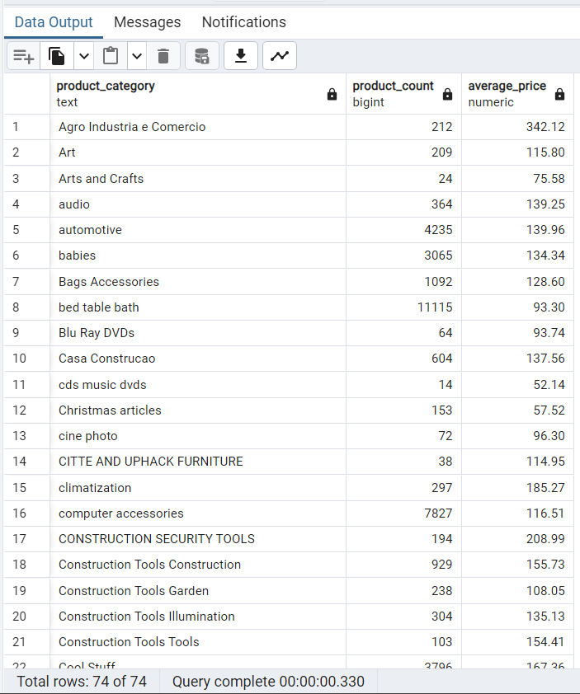

5. Calculate the total revenue generated by each seller, and rank them by revenue.

Query –

select *, dense_rank() over(order by revenue desc) as rn from

(select order_items.seller_id, sum(payments.payment_value)

revenue from order_items join payments

on order_items.order_id = payments.order_id

group by order_items.seller_id) as a

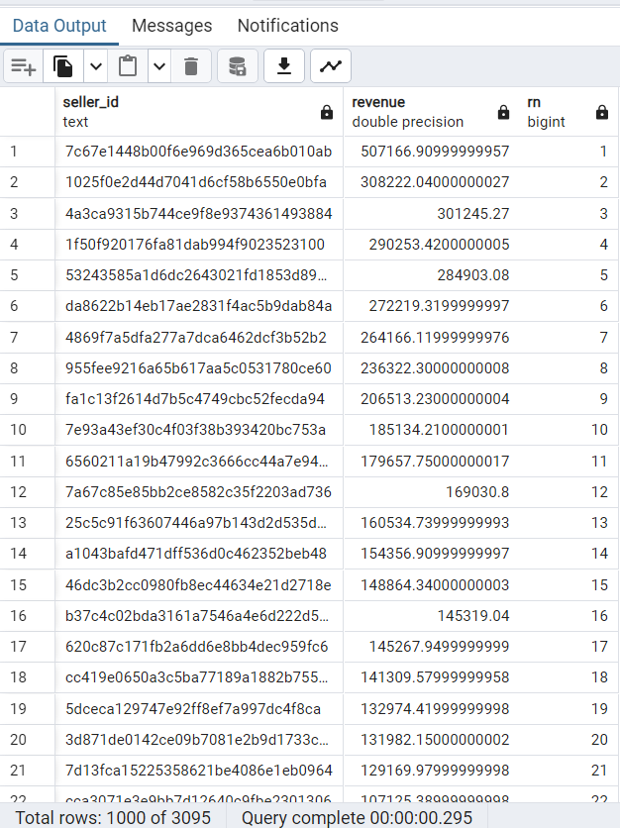

**Advanced Queries**

1. Calculate the moving average of order values for each customer over their order history.

Query –

select customer_id, order_purchase_timestamp, payment,

avg(payment) over(partition by customer_id order by order_purchase_timestamp

rows between 2 preceding and current row) as mov_avg

from

(select orders.customer_id, orders.order_purchase_timestamp,

payments.payment_value as payment

from payments join orders

on payments.order_id = orders.order_id) as a

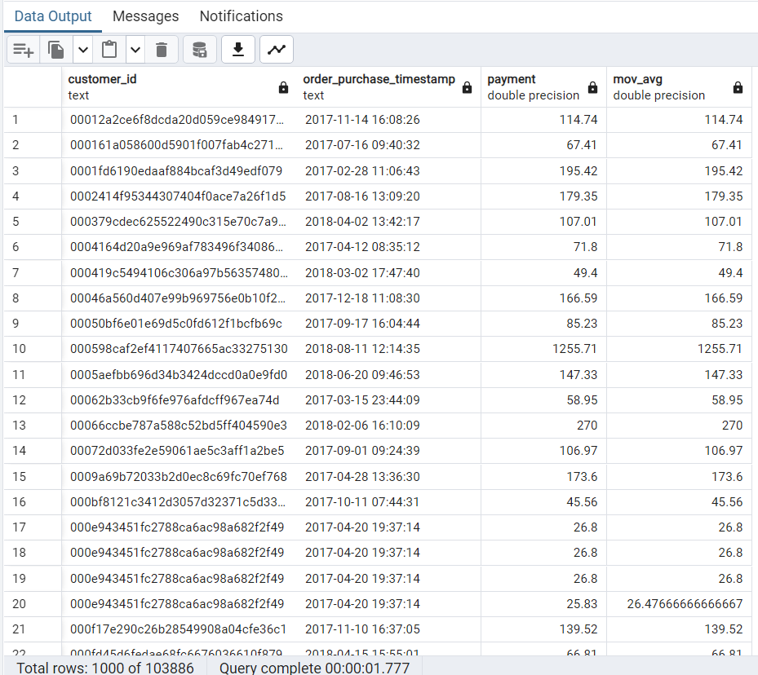

2. Calculate the cumulative sales per month for each year.

Query –

select years, months, payment,

sum(payment) over (order by years, months) as cumulative_sales

from (

select

extract(year from orders.order_purchase_timestamp::timestamp) as years,

extract(month from orders.order_purchase_timestamp::timestamp) as months,

round(sum(payments.payment_value)::numeric, 2) as payment

from orders

join payments on orders.order_id = payments.order_id

group by years, months

order by years, months) as a;

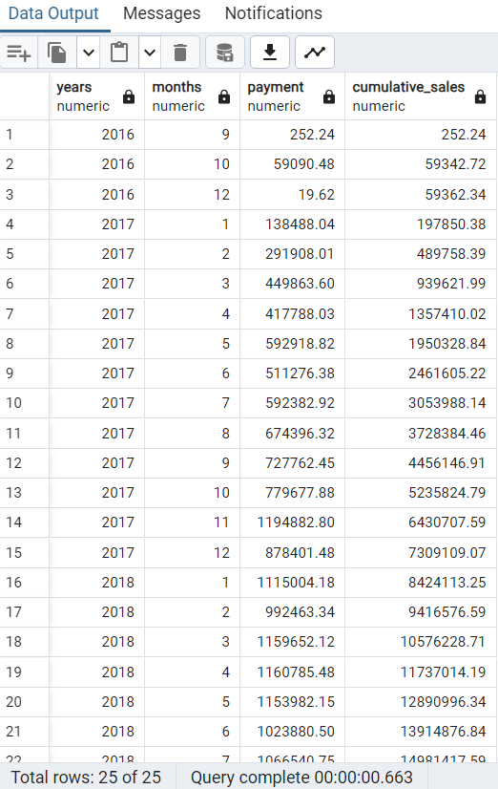

3. Calculate the year-over-year growth rate of total sales.

Query –

with a as (select

extract(year from orders.order_purchase_timestamp::timestamp) as years,

round(sum(payments.payment_value)::numeric, 2) as payment

from orders

join payments on orders.order_id = payments.order_id

group by years

order by year)

select years, ((payment - lag(payment, 1) over (order by years)) /

nullif(lag(payment, 1) over (order by years), 0)) * 100 as percentage_change

from a;

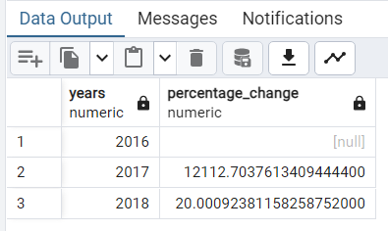

4. Calculate the retention rate of customers, defined as the percentage of customers who make another purchase within 6 months of their first purchase.

Query –

with a as (select

customers.customer_id,

min(orders.order_purchase_timestamp::timestamp) as first_order

from customers

join orders on customers.customer_id = orders.customer_id

group by customers.customer_id),

b as (select a.customer_id,

count(distinct orders.order_purchase_timestamp) as next_order

from a join orders on orders.customer_id = a.customer_id

where orders.order_purchase_timestamp::timestamp > a.first_order

and orders.order_purchase_timestamp::timestamp < a.first_order + interval '6 months'

group by a.customer_id)

select 100.0 * count(distinct a.customer_id) / nullif(count(distinct b.customer_id), 0) as percentage from a left join b on a.customer_id = b.customer_id;

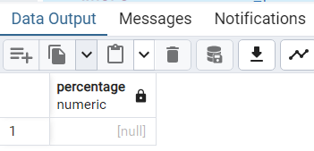

5. Identify the top 3 customers who spent the most money in each year.

Query –

select years, customer_id, payment, d_rank

from (select extract(year from orders.order_purchase_timestamp::timestamp) as years,

orders.customer_id, sum(payments.payment_value) as payment,

dense_rank() over (

partition by extract(year from orders.order_purchase_timestamp::timestamp)

order by sum(payments.payment_value) desc) as d_rank

from orders

join payments on payments.order_id = orders.order_id

group by extract(year from orders.order_purchase_timestamp::timestamp),

orders.customer_id) as a where d_rank <= 3;

