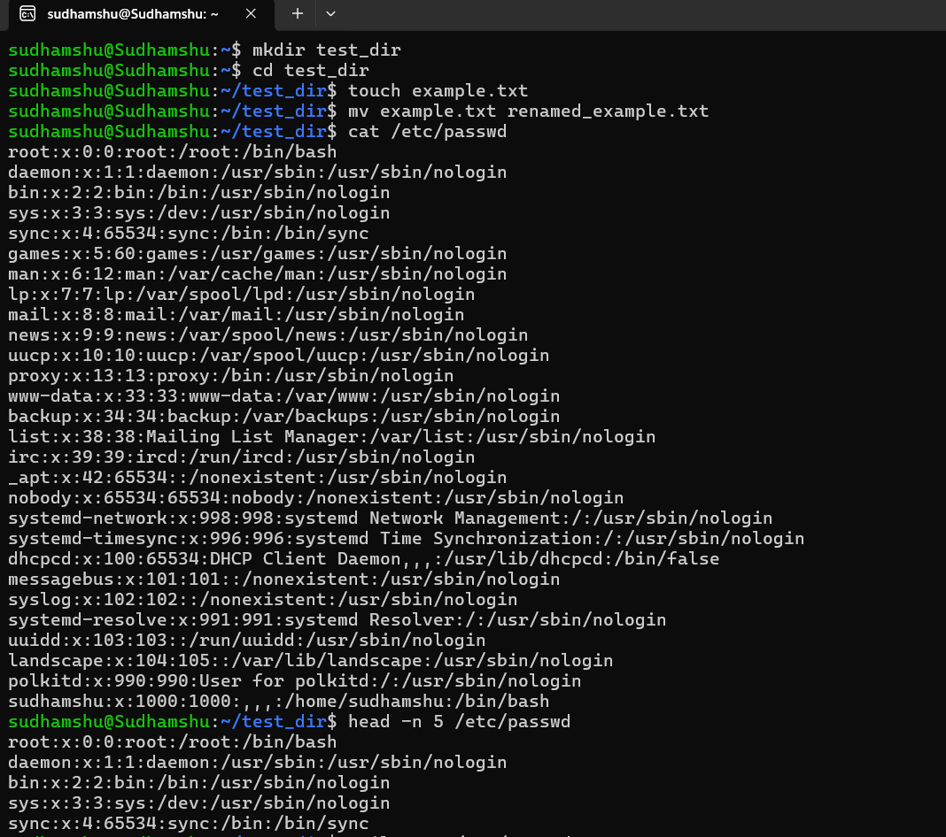
Mkdir – to create a directory
Cd – to change directory
Touch – to create an empty file
Cat – to display file contents on the terminal
Head -n 5 – displays first five lines of the file
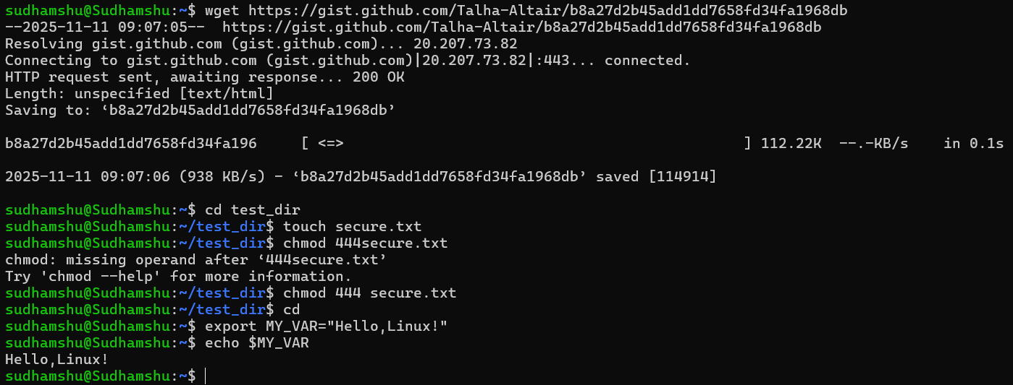
Wget – used to download data as files
Chmod 444 – used to change file permission to public
Export – exports the environment variables
Echo – prints any text
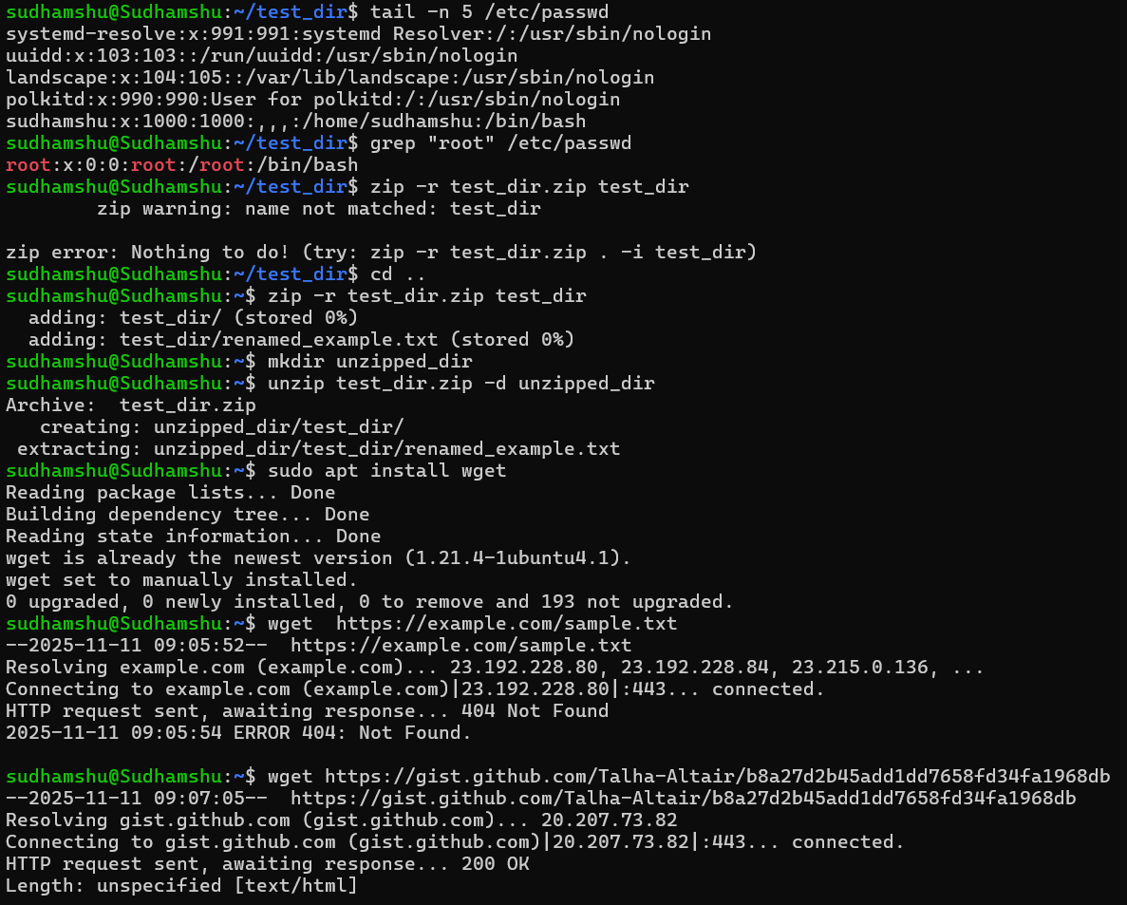
Tail -n 5 – used to display last five lines of the file
Grep – searches for a string within an output
Zip – used to compress or zip a file
Unzip – used to unzip a file

