**e-Yantra Ideas Competition - 2019**

**Title:**

**Autonomous Zea Mays Seeding and Monitoring Agribot using IoT**

**Abstract:**

The idea is to reduce the man power in seed sowing for the “Corn” vegetation. The first step is to find the nutrition level of the soil and analysing it using IoT. With these details the land is being modified according to soil nutrient level which is being required for the corn plantation. The robot is used to sow the seed in the land in the prescribed criteria. Later the field’s moisture and nutrient level is being monitored regularly. In case of any changes in the moisture and nutrient level, it can be resolved using IoT.

**Introduction/Motivation:**

Basic requirement of every human is food which is only provided by agriculture. Such agriculture should be encouraged by using technology. Still agriculture lacks due to unavailability of man power. Mostly, Farmers work in the field manually. To overcome these problem many new ideas has been developed and practiced but still not yet full filled. India is one of the top ten maize producing countries of the world with nearly 2-3% total production of the world. Many farmers depend on the cultivation of the corn. The idea we proposed is meant to help the farmers in the process of seed sowing and irrigation of the crops. The seed sowing process is the first and most important step towards the cultivation. Large amount of labour is required for this procedure. Due to the urbanisation the availability of the labour in rural areas is been a difficulty in recent times. Developing multifunctional machine which will be useful to reduce human and animal efforts at least for small scale farmers .There are different methods for seed sowing process to maintain row to row spacing, seed rate, seed to seed spacing & depth of seed.

**Literature Survey/Prior Artwork:**

The traditional method of seed sowing involves the use of animal in which the plough is being carried by the bulls and the farmers sow the seed behind the plough. The later developed ideas have the same principle the bulls have been replaced by the tractor and the farmer has been replaced by the heavy machineries. The previous versions of the seed sowing machines involve large machineries or which will involve a tractor. The problem associated with previous method is it requires skilled labour for its operation. This method of using the tractor and other machineries was very costly when compared to the manual way of seed sowing. The use of heavy machineries damages the soil nutrients. The prior works use diesel powered engines which pollute the environment in many ways. The use of these machines destroys the micro nutrient in the soil which provides many nutrients to the soil for the plant growth.

**Problem Statement:**

1. The lack of skilled labour in the rural regions has reduced the agricultural activities.

**Hardware requirements:**

1. Micro-Controller (Arduino-Mega)
2. Micro-Controller (Arduino-Uno)
3. 12V Mini-Solar Panel
4. Sharp Ultrasonic Sensor (GP2Y0A21)
5. Battery (12V Rechargeable)
6. Dc-Motors (Stepper Motor Torque 10Kg)
7. Motor Driver (L293D)
8. IR-Sensor
9. Wi-Fi Module ( ESP8266)
10. Humidity and Temperature Sensor (RHT03)
11. pH sensor
12. Relay Module
13. GSM Shield for Arduino

**Software requirements:**

1. Atmel Studio 7.0
2. Arduino IDE
3. Android Studio

**Implementation:**

The system includes three modules for its operation

1. Nutrient Monitoring Module
2. Motor Pump control Module
3. Seed Sowing Robot Module

**1. Nutrient Monitoring Module**

This module is set to be placed in the field itself where the crops are to be grown. The module consists of humidity and temperature sensor with pH sensor to monitor the cropland. The module takes the reading regularly with interval of uniform time period. The sensors are interfaced with the micro controller (Arduino Uno). The reading of the soil is now transferred into the cloud with the help of GSM module which is been interfaced with the micro-controller. The GSM shield provides the internet connectivity for the entire module so that the values that have been fetched by the sensors are being transferred into the cloud. This module is connected with the solar panel of voltage 1.5W and 12V. The required power to run the module is obtained from the solar panel itself. The following figure shows the block diagram of the module.

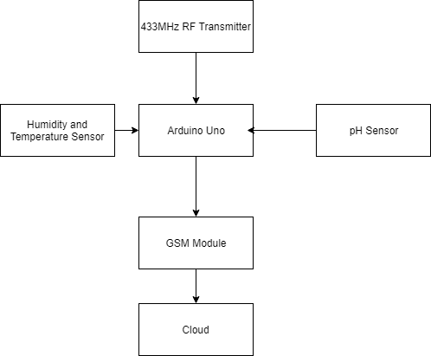

**Figure: 1**

**2. Motor Pump control Module**

This module is installed in the motor that has been connected with the drip irrigation pipe in the field. The module consists of micro controller (Arduino Uno), Wi-Fi Module and a relay module to control the motor to operate. The micro controller obtains the readings from the cloud using the GSM Module’s internet connection. The micro controller is programmed in such a way that the moisture level drops after a certain level than the relay module should be turned on and the motor starts to operate. The water is now being irrigated as per the requirement of the field. The drip irrigation is a very effective way to irrigate water. It serves two purposes that are it can irrigate water as well as be used for adding fertilizers to it. The corn crop needs urea for its growth. This can also be included in the same module itself. The amount of urea present in the soil can be found out by measuring the pH value. By analysing the pH value the module can identifies whether the soil requires urea or not. If the pH value decreases in the soil then there is a need for the urea. The module identifies this and mixes the urea with water and irrigates to the field. Thus again increasing the pH value to the need of the plant. The figure 2 shows the block diagram for the module.

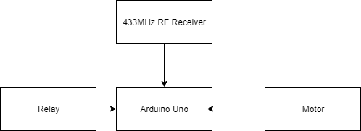

**Figure: 2**

**3. Seed Sowing Robot Module**

This is the module where the seed sowing takes place in the field. The corn seed must be placed at 1.5 to 2 inches depth and 4 to 6 inches apart with the row distance 30 to 36 inches apart. At each planting site there must minimum of 2-3 seeds to ensure that the plant will grow at least in any one of the seed. Initially the fence is to be added to the field to make sure that no rodents or any other pests enter the field. The fence should be added with the black board at the mentioned distance in the figure 3.

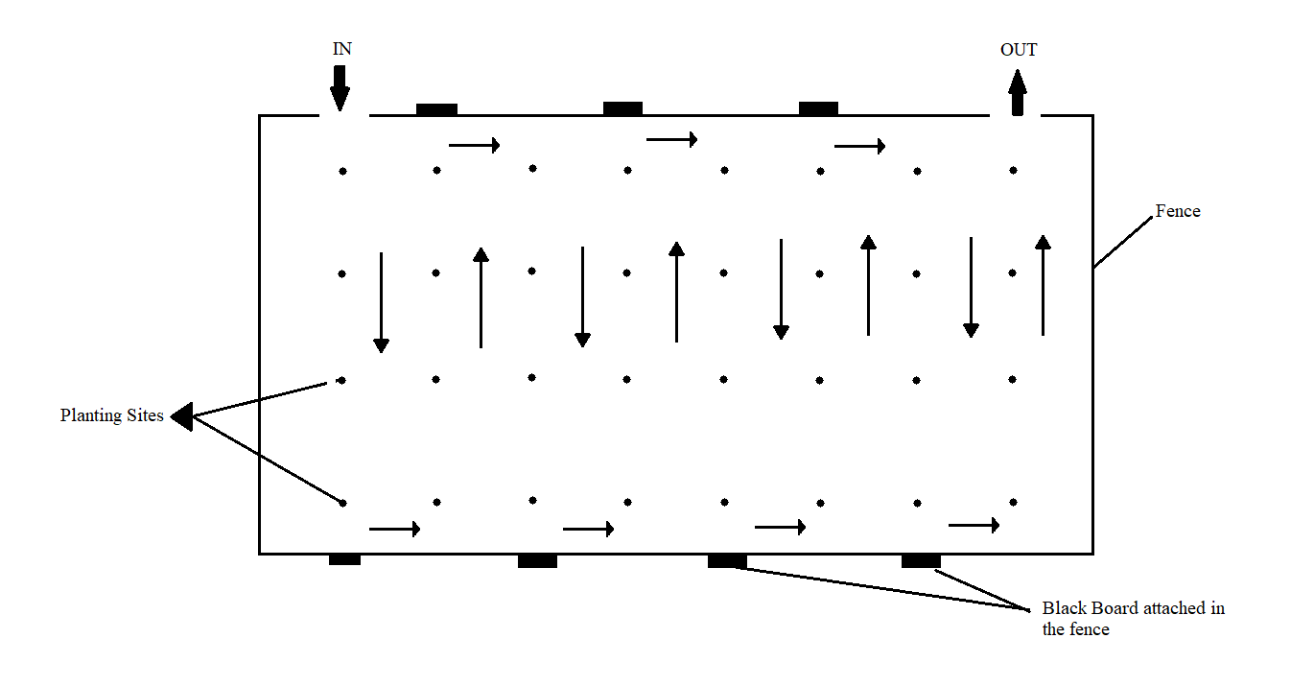**Figure: 3**

The robot is interfaced with IR sensor to detect the black board and turn. The robot sows the seeds at exact distance using positional encodes attached in the wheel. The mechanism used to sow the seed is to punch the seed inside the soil of distance about 1.5 inches. By using this method the seeds are accurately sown into the soil with equal distance. Once the robot detects the black board it turns to the next row for the sowing process. This is continued till all the seeds are sown in the field.

**Feasibility:**

The proposed idea is very useful for the farmers in India and also all over the world for those who cultivate corn maize. The basic operation of the idea is very simple and uses cost effective tools for its operation. Unlike the previous methods this system uses low weight machineries. It is designed in a way that it makes the robot very easy to operate. The modules used in the field uses humidity and temperature sensors along with pH sensor which does no leave back any toxic substances into the soil. The modules operate on solar energy and battery making them environment friendly. The method used to irrigate the field is “Drip Irrigation” which is a very effective way for irrigation. In many parts of the world this drip irrigation is used for watering the field. This consumes less amount of water as per the requirement of the plant. The way in which the fertilizers are distributed to the plant is also an effective way to reduce the fertilizer consumption. The installation of the modules is very easy and does not require much human attention for its maintenance purpose. Due to the cheaper cost, easy installation, maintenance and environmental friendly the project is hundred percent feasible in the real time scenario.

**References:**

[1] Green Growth Management by Using Arm Con-troller, B Yogesh Ramdas et al Int. Journal of En-gineering Research and

[1] Green Growth Management by Using Arm Con-troller, B Yogesh Ramdas et al Int. Journal of En-gineering Research and Applications ISSN : 2248-9622, Vol. 4, Issue 3( Version 1), March 2014, pp.360-363.

[2] D.S.Suresh, Jyothi Prakash K V, Rajendra C J, ”Automated Soil Testing Device”, ITSI Transac-tions on Electrical and Electronics Engineering (ITSI-TEEE) ISSN (PRINT): 2320 – 8945, Vol-ume - 1, Issue -5, 2013.

[3] Soil Testing in India”, Department of Agriculture & Co-operation, Ministry of Agriculture, Govern-ment of India, New Delhi, January, 2011.

[4] Sneha J. Bansod, Shubhadha Thakre, “Near Infra-red Spectroscopy based Soil Nitrogen measure-ment”, International Journal of Current Engineer-ing and Technology E-ISSN 2277 – 4106, P-ISSN 2347 – 5161.

Applications ISSN : 2248-9622, Vol. 4, Issue 3( Version 1), March 2014, pp.360-363.

[2] D.S.Suresh, Jyothi Prakash K V, Rajendra C J, ”Automated Soil Testing Device”, ITSI Transac-tions on Electrical and Electronics Engineering (ITSI-TEEE) ISSN (PRINT): 2320 – 8945, Vol-ume - 1, Issue -5, 2013.

[3] Soil Testing in India”, Department of Agriculture & Co-operation, Ministry of Agriculture, Govern-ment of India, New Delhi, January, 2011.

[4] Sneha J. Bansod, Shubhadha Thakre, “Near Infra-red Spectroscopy based Soil Nitrogen measure-ment”, International Journal of Current Engineer-ing and Technology E-ISSN 2277 – 4106, P-ISSN 2347 – 5161.