Membership Subscription/Renewal System
Process Flowchart

Overview
This flowchart illustrates the complete membership subscription and renewal process for the cooperative society system. The process handles member verification, payment history validation, membership year calculation, and payment gateway integration.

Process Flowchart
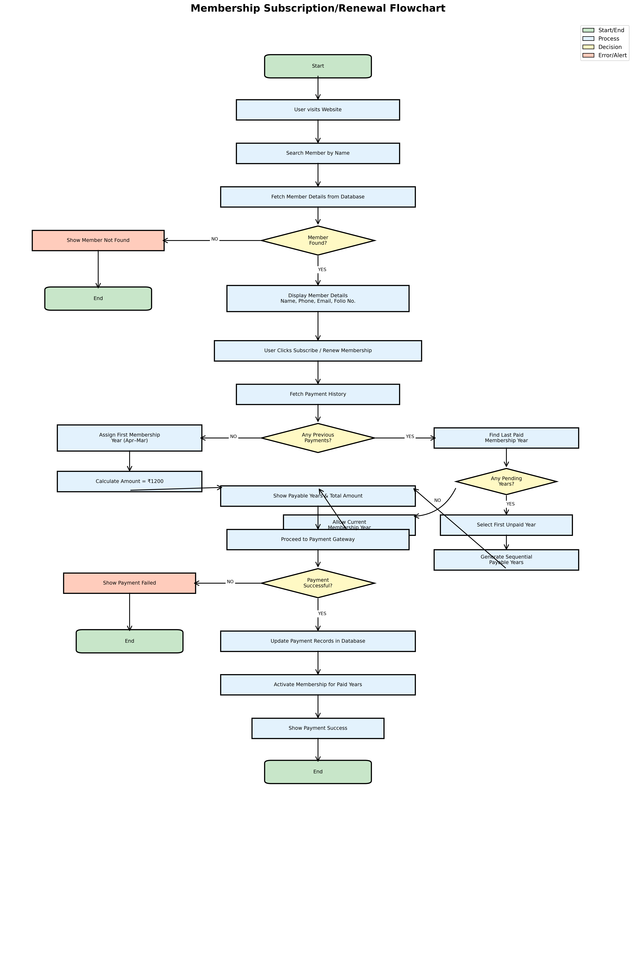

Process Description

1. Member Search & Verification
The process begins when a user visits the website and searches for a member by name. The system fetches member details from the database. If the member is not found, an error message is displayed and the process ends. If found, the system displays member details including Name, Phone, Email, and Folio Number.

2. Subscription/Renewal Initiation
When the user clicks the Subscribe/Renew Membership button, the system fetches the payment history to determine the appropriate membership years available for payment.

3. Membership Year Calculation
The system follows different paths based on payment history:
No Previous Payments: Assigns the first membership year (April–March) with an amount of ₹1,200.
Previous Payments Exist: Finds the last paid membership year and checks for pending years. If pending years exist, selects the first unpaid year and generates sequential payable years. If no pending years, allows payment for the current membership year.

4. Payment Processing
The system displays all payable years and the total amount. Upon proceeding to the payment gateway, if payment is successful, the system updates payment records in the database and activates membership for paid years. A success message is displayed. If payment fails, an error message is shown.

Key Features
Feature | Description
Member Verification | Validates member existence before proceeding with subscription
Payment History | Tracks and validates previous payments to ensure continuity
Sequential Payments | Ensures members pay for years in sequence, preventing gaps
Annual Cycle | Membership years run from April to March (financial year)
Payment Gateway | Secure online payment processing with success/failure handling
Membership Amount | ₹1,200 per year, calculated based on selected years

Technical Notes
Database Integration: The system integrates with the database to fetch member details, payment history, and update payment records.
Error Handling: Comprehensive error handling for member not found and payment failure scenarios.
Validation Logic: Ensures members can only pay for valid, sequential years to maintain data integrity.
Membership Activation: Automatically activates membership for paid years upon successful payment.
Membership Subscription System | Cooperative Society Management

