ALUMNI WEB APPLICATION
Network Portal
Software Requirements Specification (SRS)

Document Version: 1.0
Date: February 2026
Prepared by: Sunsys Technologies Pvt Ltd
Status: Draft

Confidential - Internal Use Only

Revision History
Version | Date | Description | Author
1.0 | February 2026 | Initial SRS document — baseline release | Sunsys Technologies Pvt Ltd

Table of Contents
Revision History 1
Table of Contents 1
1. Introduction 1
1.1 Purpose 1
1.2 Project Overview 1
1.3 Scope 1
1.4 Definitions, Acronyms and Abbreviations 1
1.5 References 1
2. Overall Description 1
2.1 Product Perspective 1
2.2 System Architecture 1
2.3 User Classes and Characteristics 1
2.4 Operating Environment 1
2.5 Assumptions and Dependencies 1
3. Functional Requirements 1
3.1 Authentication Module 1
3.1.1 Admin Login 1
3.1.2 Alumni Login 1
3.1.3 Forgot / Reset Password 1
3.2 Alumni Registration 1
3.3 Admin Dashboard 1
3.4 Alumni Management (Admin) 1
3.4.1 Add Alumni 1
3.4.2 Manage Alumni 1
3.4.3 Pending Approvals 1
3.5 Alumni Profile Management 1
3.6 Alumni Directory (Connect Page) 1
3.7 User Management (Admin) 1
4. Non-Functional Requirements 1
4.1 Performance 1
4.2 Security 1
4.3 Usability 1
4.4 Reliability 1
4.5 Maintainability 1
5. Flowchart 1
5.1 Flowchart Index 1
5.2 Flowchart 1 – Registration & Approval Flow 1
5.3 Flowchart 2 – Alumni Login Flow 1
5.4 Flowchart 3 – Forget & Reset Password Flow 1
5.5 Flowchart 4 – Admin Manage Alumni Flow 1
6. Data Requirements 1
6.1 Alumni Data Entity 1
6.2 Admin User Data Entity 1
7. Interface Requirements 1
7.1 User Interface 1
7.2 Software Interfaces 1
7.3 Communication Interfaces 1
8. Constraints and Limitations (v1.0) 1
9. Future Plans (Roadmap) 1
9.1 Version 2.0 — Communication & Engagement 1
9.1.1 Alumni Messaging System 1
9.1.2 Event Management Module 1
9.1.3 Announcements & News Feed 1
9.2 Version 2.1 — Professional Networking 1
9.2.1 Job Board 1
9.2.2 Mentorship Program 1
9.2.3 Enhanced Alumni Profiles 1
9.3 Version 2.2 — Analytics & Reporting 1
9.4 Version 3.0 — Platform Expansion 1
9.4.1 Multi-Institution Support 1
9.4.2 Mobile Application 1
9.4.3 Cloud Storage Integration 1
9.4.4 Social Login 1
9.5 Technical Infrastructure Improvements 1
10. Acceptance Criteria 1
11. Appendix 1
11.1 Technology Stack Summary 1
11.2 Document Sign-off 1

1. Introduction

1.1 Purpose
This Software Requirements Specification (SRS) document describes the functional and non-functional requirements for the Alumni Connect Network Portal. The document is intended for developers, project managers, QA engineers, and stakeholders involved in the design, development, testing, and maintenance of the system. This is Version 1.0, representing the initial baseline release of the platform.

1.2 Project Overview
Alumni Connect is a full-stack web application designed to help educational institutions manage, track, and connect with their alumni community. The system provides a structured platform for institutions to maintain alumni records, approve self-registrations, and allow alumni to network and explore each other's professional journeys.

1.3 Scope
The Alumni Connect portal covers the following functional areas:
- Admin Panel for managing alumni records, approvals, and platform statistics
- Alumni self-registration with institution approval workflow
- Alumni login and self-managed profile editing
- Public-facing alumni directory with search and filter capabilities
- Password management (forgot/reset password via email)
- Responsive web interface for desktop and mobile usage

1.4 Definitions, Acronyms and Abbreviations
Term | Definition
SRS | Software Requirements Specification
JWT | JSON Web Token — used for stateless authentication
API | Application Programming Interface
CRUD | Create, Read, Update, Delete — basic data operations
UI | User Interface
UX | User Experience
OTP | One-Time Password
REST | Representational State Transfer — architectural style for APIs
Multer | Node.js middleware for handling multipart/form-data (file uploads)

1.5 References
- React Documentation — https://react.dev
- Vite Documentation — https://vitejs.dev
- Node.js Documentation — https://nodejs.org
- Express.js Documentation — https://expressjs.com
- MySQL Documentation — https://dev.mysql.com/doc
- JSON Web Token RFC 7519

2. Overall Description

2.1 Product Perspective
Alumni Connect is a standalone web application developed using a modern MERN-style stack (React + Node.js + MySQL). It operates as a browser-based portal accessible on any device with an internet connection. The system is self-contained and does not depend on third-party alumni management software, although it may integrate with email services for password reset functionality.

2.2 System Architecture
The system follows a client-server architecture with a clear separation of concerns:
Layer | Technology | Role
Frontend (Client) | React + Vite + Tailwind CSS | Renders UI, handles routing and state
Backend (Server) | Node.js + Express.js | Processes business logic, REST API endpoints
Database | MySQL | Persistent storage for alumni and user data
Authentication | JWT (JSON Web Token) | Stateless session management
File Upload | Multer | Handles profile photo uploads
Email | Nodemailer / SMTP | Password reset email delivery

2.3 User Classes and Characteristics
User Role | Access Level | Primary Activities
Administrator | Full system control | Manage alumni records, approve registrations, view statistics, add/edit/delete alumni
Alumni (Registered) | Profile & directory access | Login, edit own profile, browse alumni directory
Public Visitor | Read-only public pages | View home page, register, request password reset

2.4 Operating Environment
- Browser: Modern browsers (Chrome, Firefox, Edge, Safari — latest two versions)
- Device: Desktop, tablet, and mobile (responsive design)
- Minimum screen width: 360px
- Backend: Node.js LTS version on any major operating system
- Database: MySQL 8.0+
- Hosting: cPanel or equivalent shared/VPS hosting

2.5 Assumptions and Dependencies
- SMTP credentials must be configured for password reset emails to function
- The institution assigns admin credentials; no public admin registration is available
- Profile photos are stored on the server filesystem
- MySQL database must be pre-configured with the required schema before deployment

3. Functional Requirements

3.1 Authentication Module

3.1.1 Admin Login
- The system shall allow admin users to login with a username and password
- A JWT token shall be issued on successful login
- Invalid credentials shall return an appropriate error message
- Admin sessions shall expire after a defined token lifetime

3.1.2 Alumni Login
- Alumni shall log in using their registered email and password
- Only approved alumni accounts shall be permitted to login
- A JWT token shall be issued to authenticated alumni

3.1.3 Forgot / Reset Password
- Alumni shall be able to request a password reset via their registered email
- The system shall send a time-limited reset token to the provided email address
- Alumni shall use the reset link to set a new password
- Used or expired reset tokens shall be invalidated after use

3.2 Alumni Registration
- Public users shall be able to self-register as alumni by providing personal and professional details
- Registration submissions shall be placed in a pending state awaiting admin approval
- Alumni shall receive a confirmation once approved
- Admin shall be able to approve or reject pending registrations

3.3 Admin Dashboard
- The dashboard shall display total alumni count
- The dashboard shall show alumni counts by employment status: Employed, Self-Employed, Studying, Pending
- Quick action links to Add Alumni, Manage Alumni, and Pending Approvals shall be available
- A Recent Alumni table shall show the latest records with name, designation, batch, status, and approval state

3.4 Alumni Management (Admin)

3.4.1 Add Alumni
- Admin shall be able to add alumni profiles directly without requiring self-registration
- Required fields include name, email, designation, batch year, employment status, and company
- Profile photo upload shall be supported

3.4.2 Manage Alumni
- Admin shall view a complete list of all alumni with search and filter capabilities
- Admin shall edit any alumni profile
- Admin shall delete alumni records with confirmation prompt

3.4.3 Pending Approvals
- Admin shall view all self-registered alumni awaiting approval
- Admin shall approve or reject each pending registration

3.5 Alumni Profile Management
- Authenticated alumni shall be able to view and edit their own profile
- Editable fields include profile photo, designation, company, employment status, bio, and contact details
- Changes shall be saved immediately to the database

3.6 Alumni Directory (Connect Page)
- All authenticated alumni shall be able to browse the alumni directory
- Alumni cards shall display profile photo, name, designation, company, batch year, and employment status
- The logged-in user's own card shall be highlighted with an 'Edit My Profile' button
- Filters shall allow alumni to search by name, batch year, employment status, and designation
- The directory shall show total alumni count

3.7 User Management (Admin)
- Admin shall be able to view and manage other admin user accounts
- Admin shall check username availability before creating new users
- Admin shall perform full CRUD operations on admin users

4. Non-Functional Requirements

4.1 Performance
- Page load time for main views shall not exceed 3 seconds on a standard broadband connection
- API response time for read operations shall be under 500ms under normal load
- The system shall support at least 100 concurrent users without degradation

4.2 Security
- All passwords shall be hashed using bcrypt before storage
- JWT tokens shall be signed with a secret key and validated on every protected API request
- Password reset tokens shall expire within 1 hour of generation
- File uploads shall be restricted to image types (JPEG, PNG, GIF, WebP)
- CORS policy shall be configured to allow only approved frontend origins

4.3 Usability
- The UI shall be responsive and functional on screen widths from 360px to 1920px
- Forms shall provide clear validation messages for required or invalid fields
- Navigation shall be consistent and intuitive across all user roles

4.4 Reliability
- The system shall have an uptime target of 99.5% per month
- Database connections shall include error handling and retry logic
- The backend shall log errors with sufficient detail for debugging

4.5 Maintainability
- Code shall follow a modular structure with clear separation between routes, middleware, and frontend pages
- Environment variables shall be used for all configuration (database credentials, SMTP, JWT secret)
- All sensitive information shall be excluded from version control via .env files

5. Flowchart
The following colour conventions are used across all flowcharts:

Start / End (Terminal)
Frontend — React + Vite (User Actions)
Backend — Node.js API (Processing)
Database — MySQL (Queries)
Email Service — Nodemailer
Decision Point
Error / Rejection

Arrows: Solid arrows show data flow direction. Red arrows indicate error paths.

5.1 Flowchart Index
- Flowchart 1 — Alumni Self-Registration, Admin Approval & Email Flow
- Flowchart 2 — Alumni Login Flow
- Flowchart 3 — Forgot & Reset Password Flow
- Flowchart 4 — Admin Manage Alumni Flow

5.2 Flowchart 1 — Registration & Approval Flow
This flowchart covers the complete journey from when a new alumni visits the registration page to when the admin approves or rejects their application, including email notifications at each stage.

Key Steps:
- Alumni visits the registration page and fills in their details
- The backend validates the data — checks for duplicate email and hashes the password
- A pending record is saved to the database and a notification email is sent to the admin
- Admin reviews the pending approval list and either approves or rejects the application
- An approval or rejection email is automatically sent to the alumni

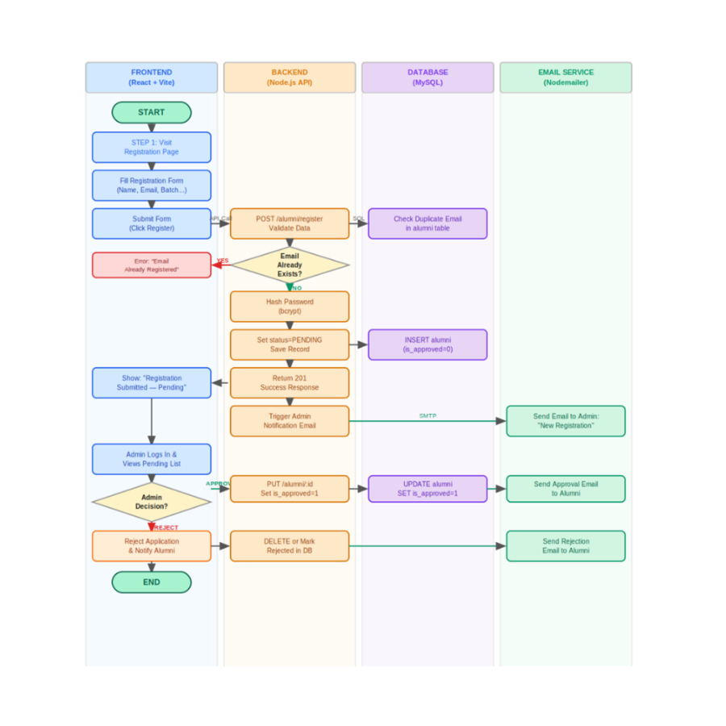

5.3 Flowchart 2 — Alumni Login Flow
This flowchart describes the authentication process for alumni users — from submitting their email and password to receiving a JWT token and accessing the alumni dashboard.

Key Steps:
- Alumni enters their email and password on the login page
- The backend looks up the alumni record by email
- The system checks if the account exists, is approved, and if the password matches
- On success, a JWT token is generated and returned to the frontend
- The frontend stores the JWT and redirects the alumni to their dashboard
- Errors at each validation step return meaningful messages to the user

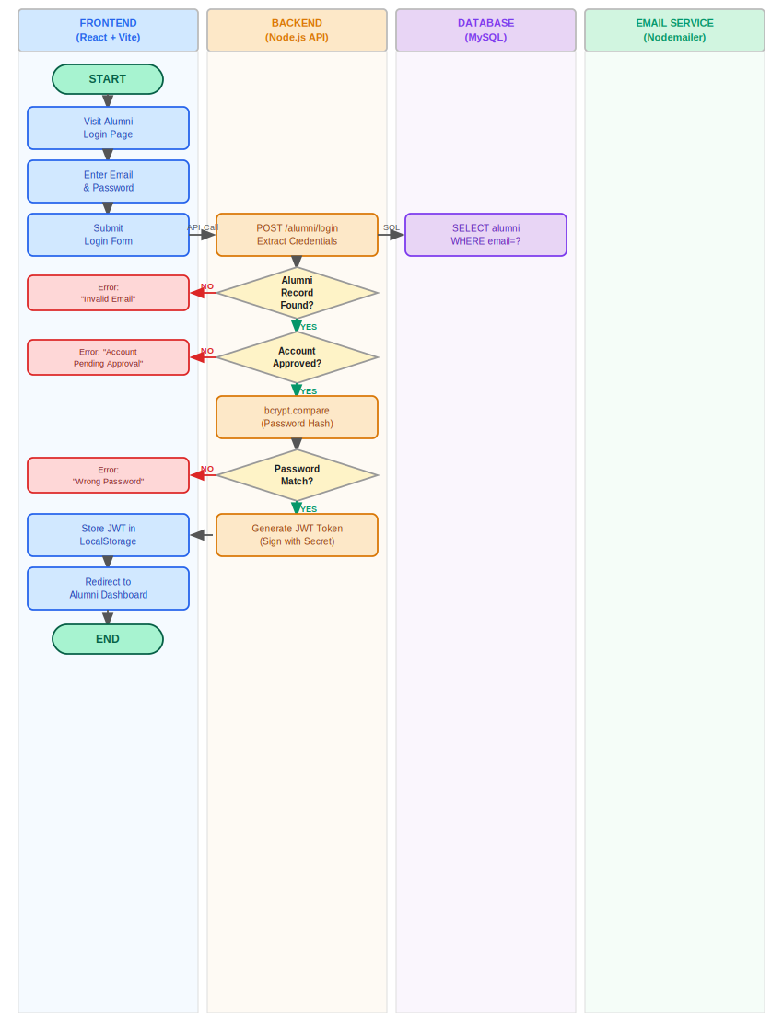

5.4 Flowchart 3 — Forgot & Reset Password Flow
This flowchart shows the full password reset cycle — from requesting a reset link via email to entering a new password using a time-limited secure token.

Key Steps:
- Alumni visits the Forgot Password page and submits their registered email
- The backend checks if the email exists in the database
- A secure reset token (with 1-hour expiry) is generated and saved to the database
- An email with the reset link is sent via Nodemailer
- Alumni clicks the link and enters a new password on the Reset Password page
- The backend validates the token expiry, hashes the new password, and clears the token
- Alumni is redirected to login with their new credentials

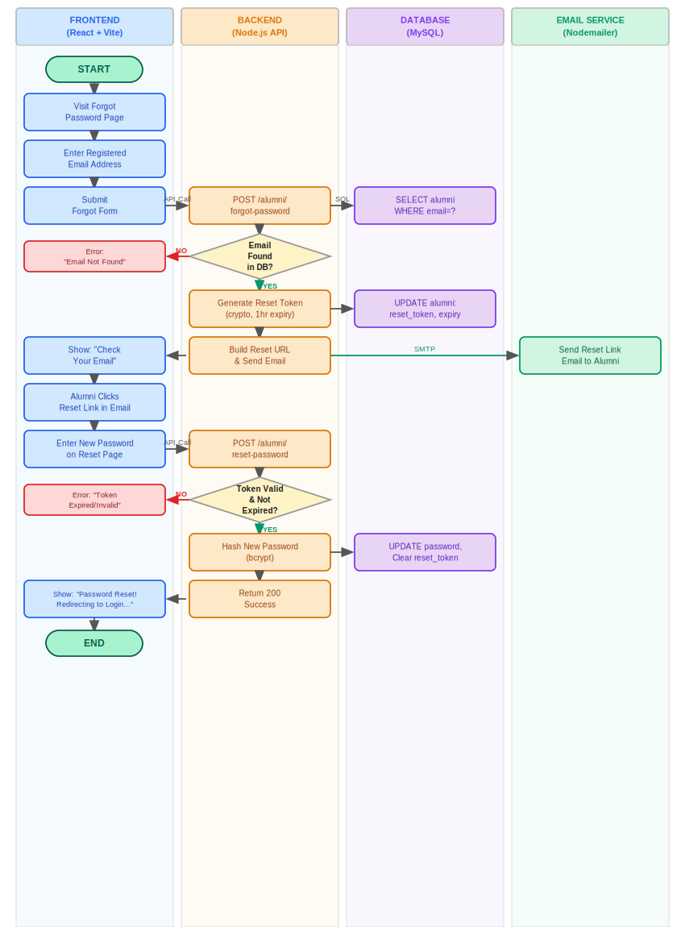

5.5 Flowchart 4 — Admin Manage Alumni Flow
This flowchart illustrates how the admin manages the alumni directory — including adding new records, editing profiles, deleting alumni, and searching/filtering the list. It also shows how the dashboard statistics are updated after each operation.

Key Steps:
- Admin logs in with a verified JWT and navigates to the Manage Alumni page
- The system loads all alumni records from the database via GET /alumni
- Admin can choose to Add, Edit, Delete, or Search alumni records
- ADD: Admin fills the form; data is POSTed and a new record is INSERTed into the database
- EDIT: Admin updates fields; a PUT request updates the alumni record
- DELETE: Admin confirms deletion; the record is permanently removed from the database
- SEARCH: Admin filters by name, batch, status; the backend queries with WHERE/LIKE conditions
- After any action, the alumni list is refreshed and dashboard statistics are updated

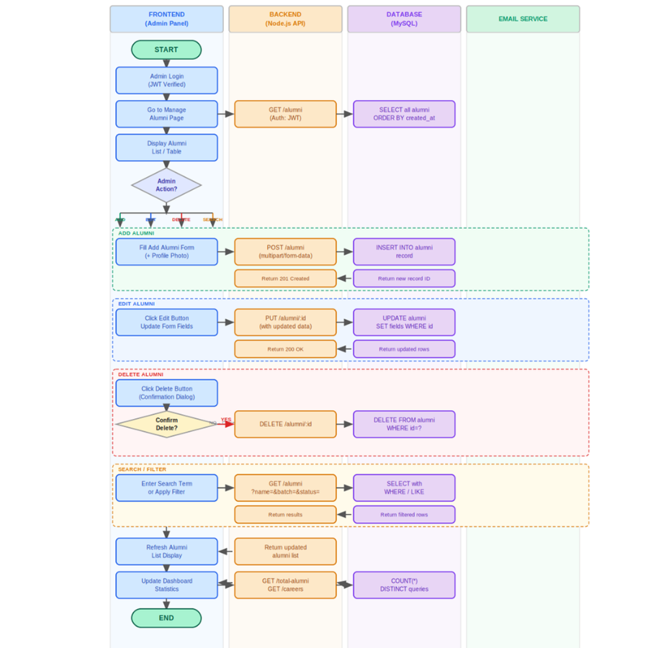

5. System Modules

5.1 Backend Module Structure
File / Folder | Purpose
routes/admin.js | Admin login, user management, alumni CRUD via admin
routes/alumni.js | Alumni login, registration, profile edit, forgot/reset password
routes/stats.js | Dashboard statistics (total alumni, career counts)
config/db.js | MySQL database connection configuration
middleware/auth.js | JWT token verification middleware
middleware/upload.js | Multer configuration for profile photo uploads
server.js | Express app entry point, route registration, CORS setup

5.2 Frontend Module Structure
File / Path | Purpose
pages/admin/AdminDashboard.jsx | Admin dashboard with statistics and quick actions
pages/admin/ManageAlumni.jsx | View, edit, and delete alumni records
pages/admin/AddAlumni.jsx | Form to add new alumni records
pages/admin/PendingApprovals.jsx | Review and approve pending self-registrations
pages/admin/ManageUsers.jsx | Manage administrator user accounts
pages/alumni/AlumniEditProfile.jsx | Alumni self-edit profile form
pages/public/Home.jsx | Landing page for public visitors
pages/public/Login.jsx | Admin login page
pages/public/UserLogin.jsx | Alumni login page
pages/public/UserRegistration.jsx | Alumni self-registration form
pages/public/ForgotPassword.jsx | Forgot password request form
pages/public/ResetPassword.jsx | Reset password form (via email token)
pages/user/ViewAlumni.jsx | Alumni directory / connect page
components/Navbar.jsx | Navigation bar component
components/AdminLayout.jsx | Admin panel layout wrapper

5.3 API Endpoint Summary
Method | Endpoint | Description | Auth
POST | /user/login | Admin login — returns JWT | None
GET | /users | List all admin users | Admin JWT
GET | /users/check-username/:username | Check username availability | Admin JWT
POST | /alumni/login | Alumni login — returns JWT | None
POST | /alumni/register | Alumni self-registration | None
GET | /alumni | Get all alumni | JWT
GET | /alumni/:id | Get specific alumni profile | JWT
PUT | /alumni/:id | Update alumni profile | JWT
DELETE | /alumni/:id | Delete alumni record | Admin JWT
PUT | /alumni/:id/approve | Approve or reject alumni | Admin JWT
POST | /alumni/forgot-password | Send password reset email | None
POST | /alumni/reset-password | Reset password via token | None
GET | /total-alumni | Total alumni count | Admin JWT
GET | /careers | Distinct designations count | Admin JWT

6. Data Requirements

6.1 Alumni Data Entity
Field | Type | Description
id | INT (PK) | Auto-increment primary key
name | VARCHAR(100) | Full name of the alumni
email | VARCHAR(150) | Unique email address
password | VARCHAR(255) | Bcrypt-hashed password
designation | VARCHAR(100) | Current job title/designation
company | VARCHAR(100) | Current employer
batch_year | YEAR | Year of graduation
employment_status | ENUM | Employed / Self-Employed / Studying / Unemployed
profile_photo | VARCHAR(255) | File path to uploaded profile photo
is_approved | BOOLEAN | Admin approval status
reset_token | VARCHAR(255) | Password reset token
reset_token_expiry | DATETIME | Expiry time of reset token
created_at | DATETIME | Record creation timestamp

6.2 Admin User Data Entity
Field | Type | Description
id | INT (PK) | Auto-increment primary key
username | VARCHAR(50) | Unique administrator username
password | VARCHAR(255) | Bcrypt-hashed password
role | VARCHAR(20) | User role (default: administrator)
created_at | DATETIME | Account creation timestamp

7. Interface Requirements

7.1 User Interface
- The frontend shall be built using React 18+ with Vite as the build tool
- Tailwind CSS shall be used for consistent and responsive styling
- The admin panel shall use Admin Layout as a consistent wrapper with sidebar navigation
- The alumni portal shall use a top navigation bar
- All forms shall include client-side validation before submission
- The alumni directory cards shall display profile photo, name, designation, company, batch, and status

7.2 Software Interfaces
- Frontend communicates with the backend via RESTful HTTP/HTTPS API calls
- Axios or Fetch API shall be used on the frontend for HTTP requests
- The backend shall connect to MySQL via mysql2 or sequelize ORM
- Email delivery shall use Nodemailer with SMTP configuration

7.3 Communication Interfaces
- All API communications shall use HTTPS in production
- JWT tokens shall be transmitted in HTTP Authorization headers (Bearer scheme)
- File uploads shall use multipart/form-data encoding

8. Constraints and Limitations (v1.0)
- No real-time features (live chat, notifications) are included in v1.0
- Alumni cannot message each other directly through the portal in v1.0
- No multi-institution support; the system serves a single institution
- Profile photos are stored on the server filesystem, not cloud storage
- No mobile native app is provided; the web app is mobile-responsive
- No automated email verification during alumni registration; approval is manual by admin

9. Future Plans (Roadmap)
The following features are planned for future versions of Alumni Connect. These are not part of the v1.0 release but represent the product roadmap based on institutional needs and user feedback.

9.1 Version 2.0 — Communication & Engagement

9.1.1 Alumni Messaging System
- Private messaging between alumni within the portal
- Message notifications via email or in-app alerts
- Conversation history and inbox management

9.1.2 Event Management Module
- Admin can create and publish alumni events (reunions, webinars, meetups)
- Alumni can register/RSVP for events through the portal
- Event calendar view with reminders

9.1.3 Announcements & News Feed
- Admin can post institutional announcements and news
- Alumni see a personalized feed on their dashboard

9.2 Version 2.1 — Professional Networking

9.2.1 Job Board
- Alumni and admin can post job openings
- Alumni can apply and track application status
- Email notifications for new job posts matching alumni profile

9.2.2 Mentorship Program
- Senior alumni can register as mentors
- Junior alumni can request mentorship and schedule sessions
- Mentorship tracking and feedback collection

9.2.3 Enhanced Alumni Profiles
- LinkedIn-style profile with skills, achievements, publications, and portfolio links
- Educational background section (multiple degrees)
- Endorsements and recommendations between alumni

9.3 Version 2.2 — Analytics & Reporting
- Admin dashboard with advanced analytics: employment trends, batch-wise statistics, career growth charts
- Exportable reports (PDF / Excel) for institutional accreditation and records
- Alumni engagement metrics (logins, profile updates, event participation)
- Visualized data with charts and graphs using Recharts or Chart.js

9.4 Version 3.0 — Platform Expansion

9.4.1 Multi-Institution Support
- Support for multiple educational institutions on a single platform (SaaS model)
- Institution-specific branding, domain, and admin panel
- Super-admin role to manage all institutions

9.4.2 Mobile Application
- React Native mobile app for Android and iOS
- Push notifications for messages, events, and announcements
- Camera integration for profile photo capture

9.4.3 Cloud Storage Integration
- Profile photos and documents stored on AWS S3 or Cloudinary
- Scalable file storage replacing local filesystem

9.4.4 Social Login
- Login with Google, LinkedIn, or Facebook OAuth
- Auto-populate alumni profile from LinkedIn data

9.5 Technical Infrastructure Improvements
- Migrate to cloud hosting (AWS, DigitalOcean, or Azure) for scalability
- Implement Redis caching for improved API response performance
- Add CI/CD pipeline with GitHub Actions for automated testing and deployment
- Email verification during registration (OTP or link-based)
- Two-factor authentication (2FA) for admin accounts
- API rate limiting and DDoS protection

10. Acceptance Criteria
Feature | Acceptance Criteria
Admin Login | Admin can login with valid credentials and is redirected to dashboard. Invalid credentials return error.
Alumni Registration | Registered alumni appear in Pending Approvals. Admin can approve or reject.
Alumni Login | Approved alumni can login. Pending/rejected alumni see appropriate message.
Forgot Password | Reset email is received within 2 minutes. Token expires after 1 hour.
Admin Dashboard | Correct counts displayed for Total, Employed, Self-Employed, Studying, and Pending.
Add Alumni | Admin-added alumni appear immediately in the directory after saving.
Edit Alumni | Changes saved by admin or alumni are reflected immediately on reload.
Delete Alumni | Deleted alumni are removed from the directory and cannot login.
Alumni Directory | All approved alumni are displayed. Filters function correctly.
Profile Photo Upload | Photo uploads succeed for JPEG/PNG files. Non-image files are rejected.
Responsive Design | All pages render correctly at 360px, 768px, 1024px, and 1920px widths.

11. Appendix

11.1 Technology Stack Summary
Category | Technology | Version
Frontend Framework | React | 18+
Frontend Build Tool | Vite | 5+
CSS Framework | Tailwind CSS | 3+
Backend Runtime | Node.js | LTS (20+)
Backend Framework | Express.js | 4+
Database | MySQL | 8.0+
ORM / DB Driver | mysql2 | Latest
Authentication | jsonwebtoken | Latest
Password Hashing | bcrypt | Latest
File Upload | Multer | Latest
Email | Nodemailer | Latest
HTTP Client (FE) | Axios / Fetch API | —

11.2 Document Sign-off
Role | Name | Date | Signature
Project Owner | Sunsys Technologoies
Lead Developer | Sudhanandhini S
QA Lead | Mahesh Kumar
Institution Representative

End of Document

