
Over the years, we have perfected the art of providing IT infrastructure solutions that incorporate the most suitable IT Solutions with best practices.
Pacer Automation Private Limited established in 1989 with a vision to provide professional IT infrastructure solutions & services to different verticals. Over the years, we have perfected the art of providing IT infrastructure solutions that incorporate the most suitable IT Solutions with best practices.
Backed by strong technical expertise, and seasoned practical experience, we deliver optimal performance, reliability, security, and access to IT infrastructure that delivers business value.
Our approach
We understand the complexity and challenges of deploying and scaling the ever-changing IT landscape. We help our customers starting from planning to execution to the realization of ROI.
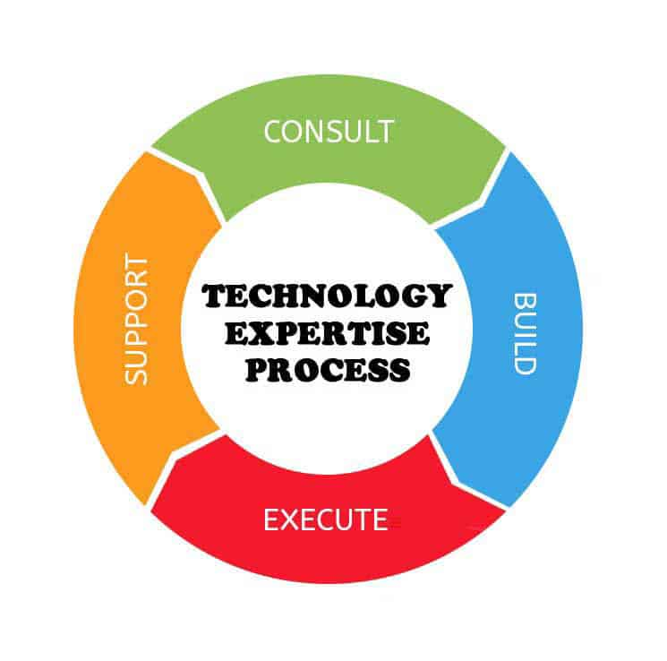
Team
Mrs. Madhu Singh
Managing Director
Ajith Dinakar
Director
Devaraj V
Director
Subrata Nag
General Manager Sales
Mahesh Rao
Service Delivery Manager
Sudarshan KS
Senior Technical Specialist

