PACER HOME
A Leading Simple, Agile, High-Performance, Scalable IT Infrastructure Solutions
Over the years, we have perfected the art of providing IT infrastructure solutions that incorporate the most suitable IT products with best practices.
Pacer Automation Private Limited was established in 1989 with a vision to provide professional IT infrastructure services to small, mid-cap, and large-cap clients.
More >
OUR OFFERING
We provide Technical expertise and practical advice required to deliver optimal performance,
reliability, security, and access to the IT infrastructure.

Infrastructure Management Services

Networking and Security Solutions

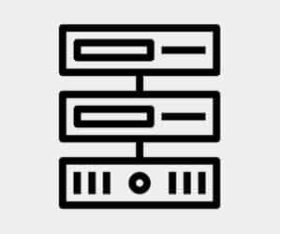Data Center Solutions

User Computing


Consulting Services

Cloud Solutions

Implementation And Migration Services

Infrastructure Management Services
Networking and Security Solutions
User Computing
Consulting Services
Cloud Solutions
Implementation And Migration Services
Channel Partners
[logo-showcase id=”4589″ title=”Logo”]

Learn more


