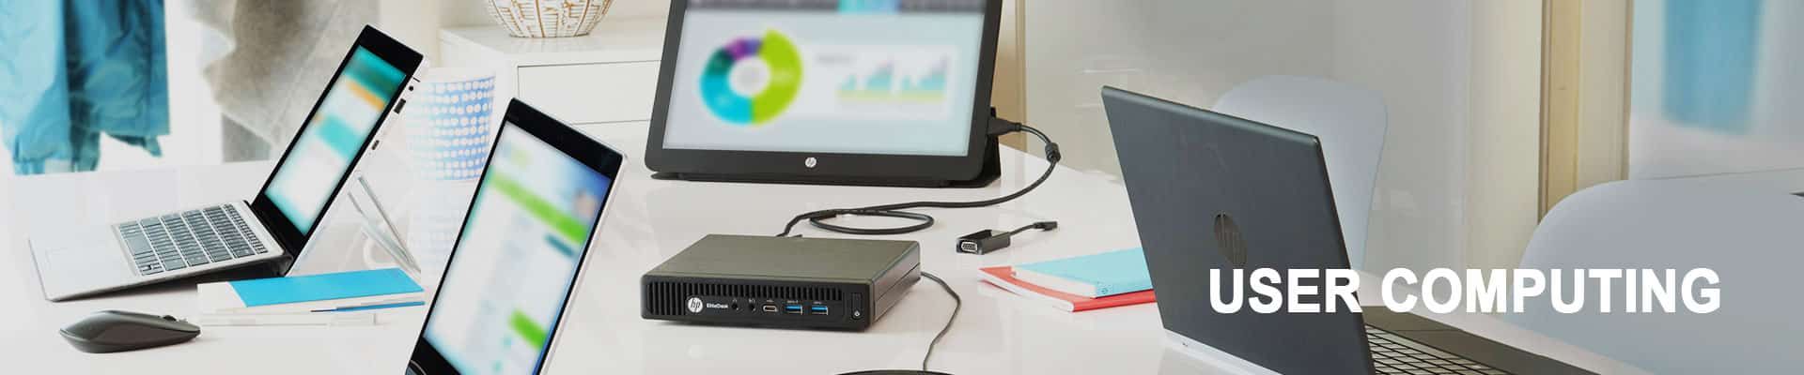
End users of an organization’s computing environment are the final recipients of the IT strategy and capabilities. It should be your endeavor to make the computing processes and interfaces as simple, standard, and streamlined as possible.
The end user computing experience should improve availability and service, and provide users with tools to succeed in the dynamic workplace of today.
Depending on your unique requirements and end-user needs, Pacer can design, build, and manage an efficient, collaborative and agile workplace. PACER uses well-defined frameworks, tools, and solution accelerators that make the transformation process easier.
We also leverage strong alliances with technology partners, such as Microsoft, Citrix, VMware, Cisco, and HP to be able to offer the best possible solutions.
We offer the following solutions and services:
Desktops, Laptops & Thin clients
High-end graphics workstations
Computer-aided engineering
Client Virtualization
Mobility
Client Management solutions
Application Management solutions

