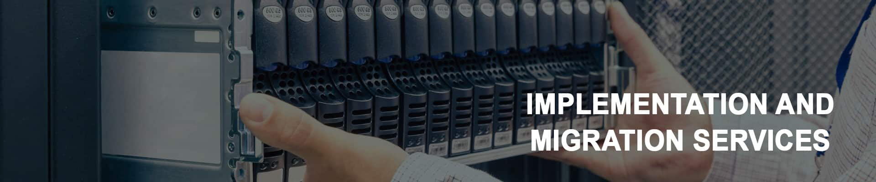
Acquiring right technology is one challenge and implementing the same with efficiency and to produce the desired out come in timely manner is another challenge. To effectively implement any IT Services, we require right expertise with experience and process with best practices.
Periodical changes in the IT infrastructure due to change in business requirements, change in technology, capacity scaling, performance improvement, improved service offering, relocation is common and necessary. These changes have to carried out with utmost care with minimal impact and downtime.
We at pacer understand this requirement thoroughly and we have built expertise over time with thorough process and practices to execute these activities with minimal impact and downtime.
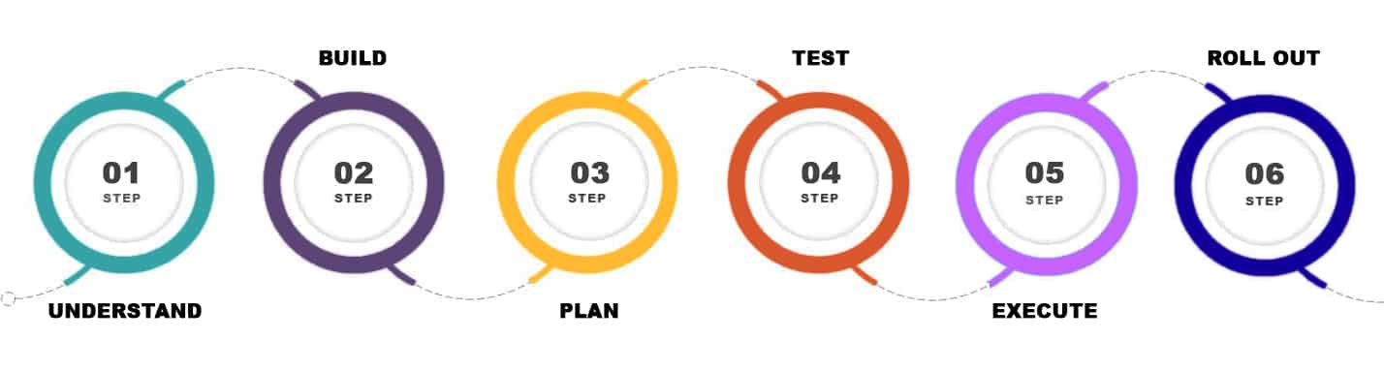
We offer various services like:-
OS and platform implementation [Windows Stack]
Networking and security stack
Enhanced and improved services rollout
Technology refresh
Version upgrades [Operating systems and Applications]
Datacenter relocation Services

