|  |  |  |
| --- | --- | --- |
| Project Title | : | Content Marketing Plan Template Based on HubSpot |
| NM Id | : | DDA9CBF432CA23B932244481FEA55216 |
| Industry Mentor(s) Name | : | Abdul Malic |

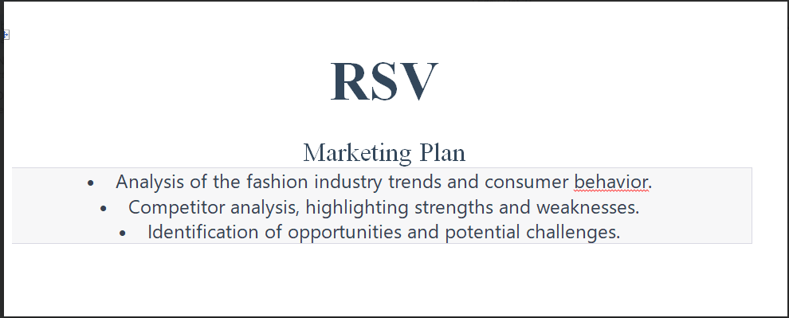

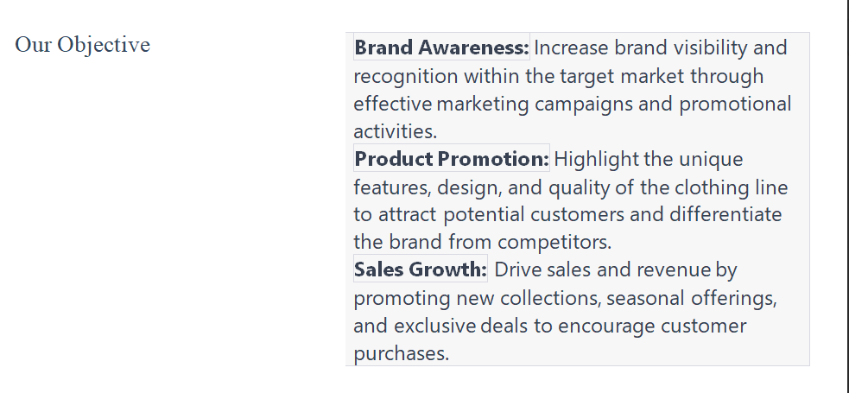

**Business Summary**

This milestone explains about Business Summary.

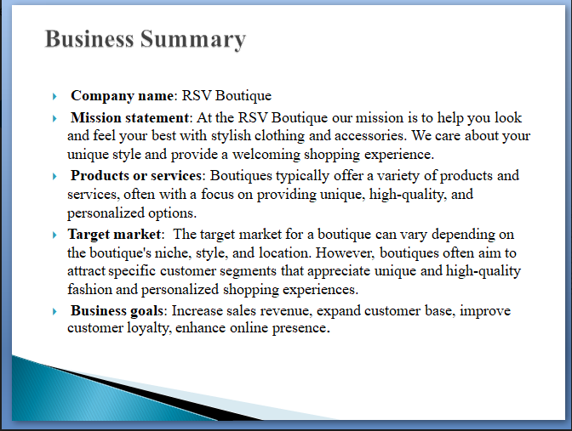

**Content Marketing Goals**

This milestone explains about content marketing goals.

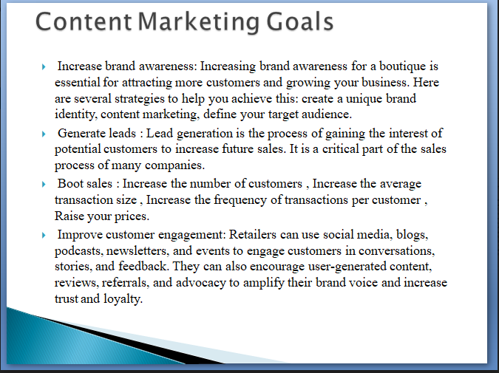

**Content Strategy**

This milestone explains about content strategy.

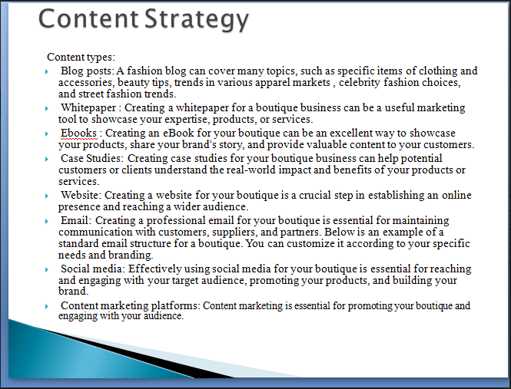

**Target Audience**

This milestone explains about target Audience.

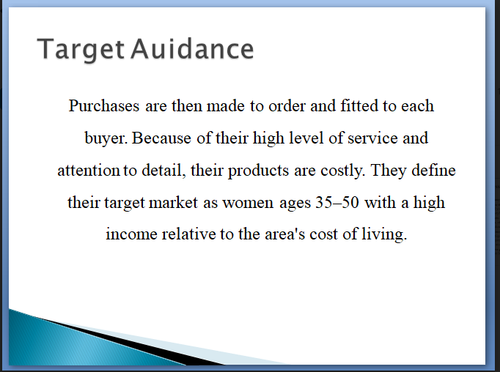

**Content Calendar**

This milestone explains about content calendar.

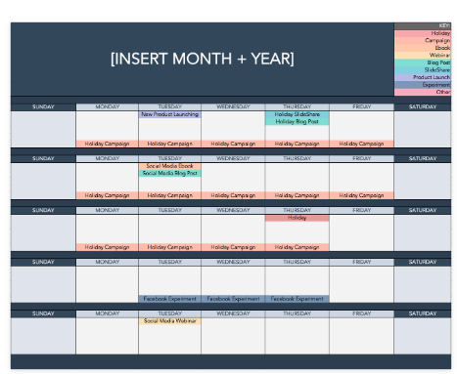

**Promotion Plan**

This milestone explains about promotion plan.

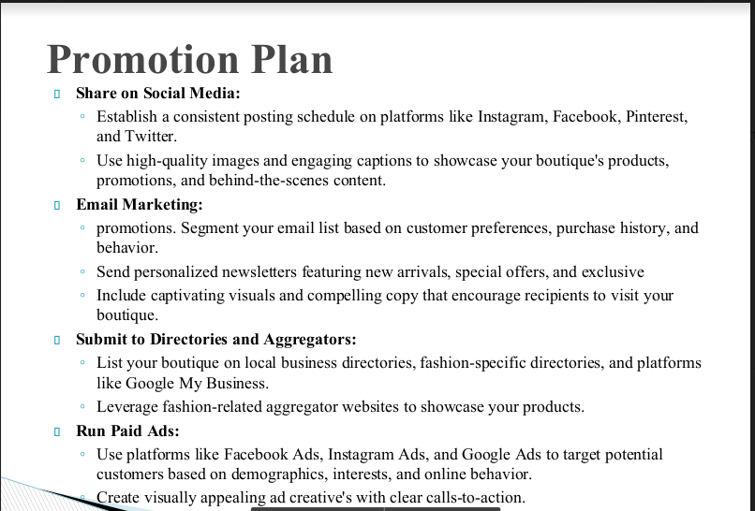

**Measurement Plan**

This milestone explains about measurement plan.

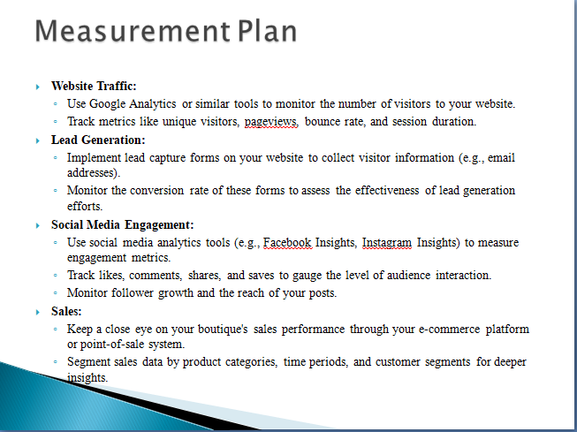

**Budget**

This milestone explains about budget.

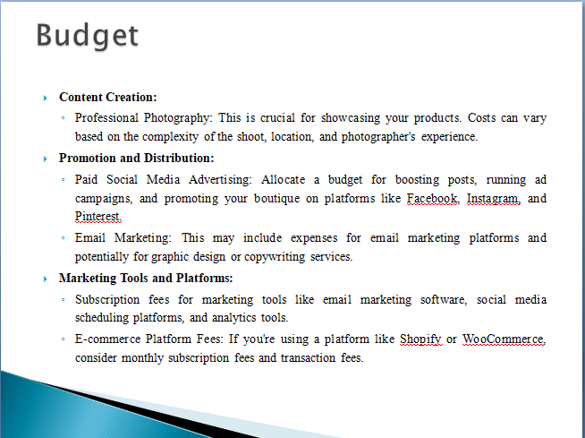

**Ideation Phase**

In this milestone you are expected to get started with the Ideation process.

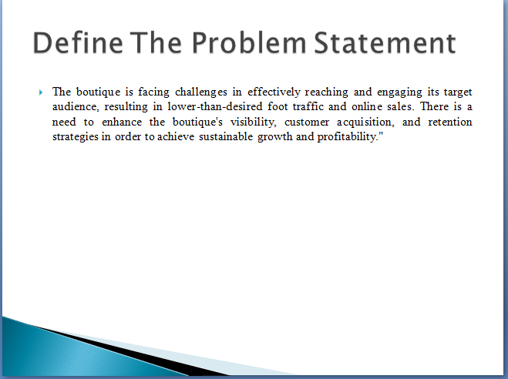

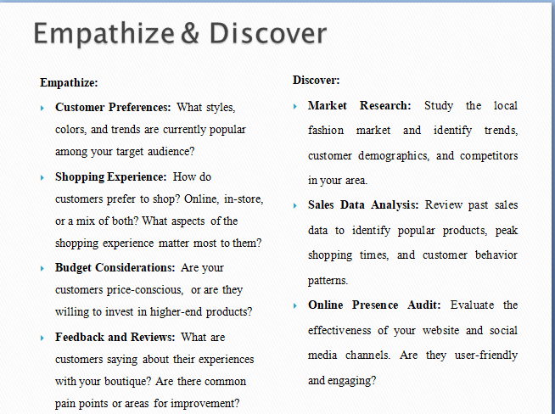

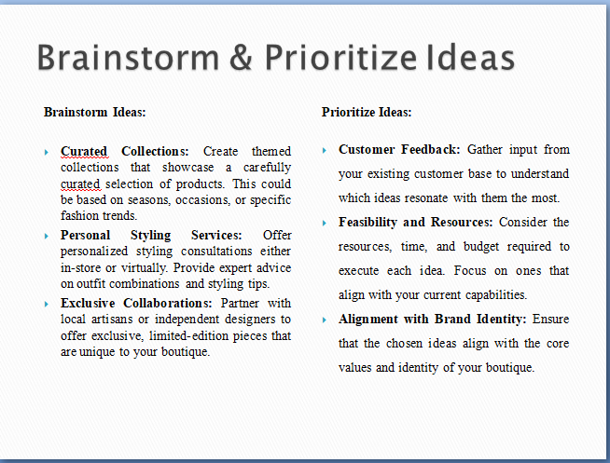

**Project Design Phase - Part 1**

From this milestone you will be starting the project design phase. You are expected to cover the activities given.

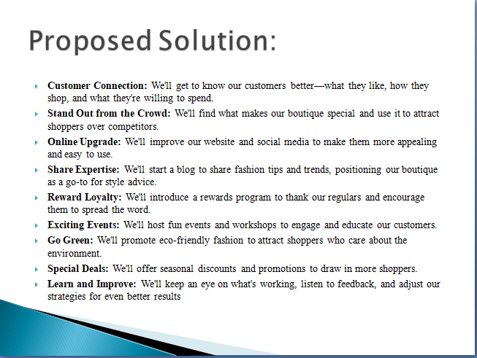

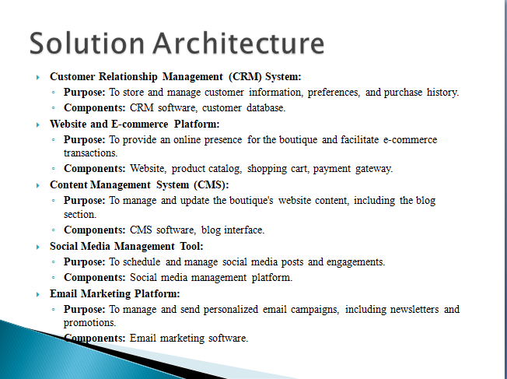

**Project Design Phase - Part 2**

From this milestone you will be continue working on the project design phase. You are expected to cover the activities given.

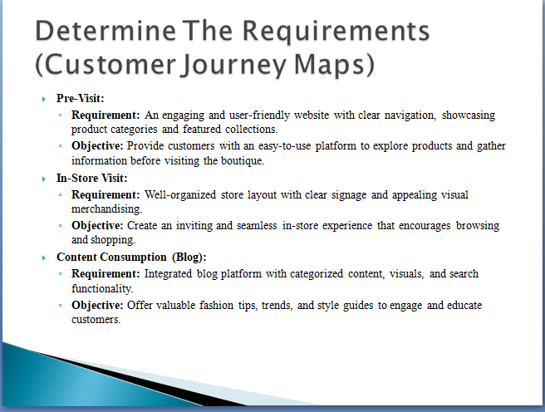

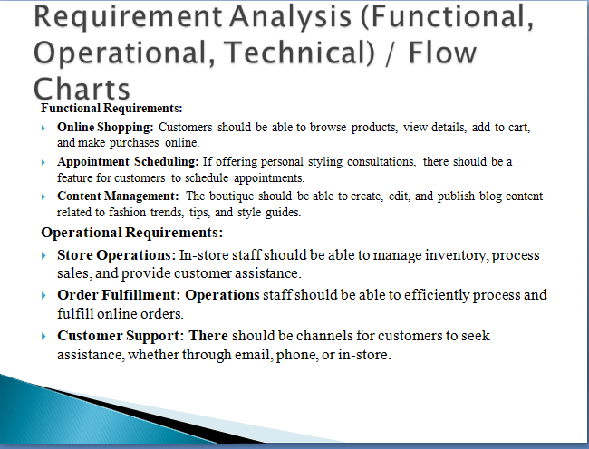

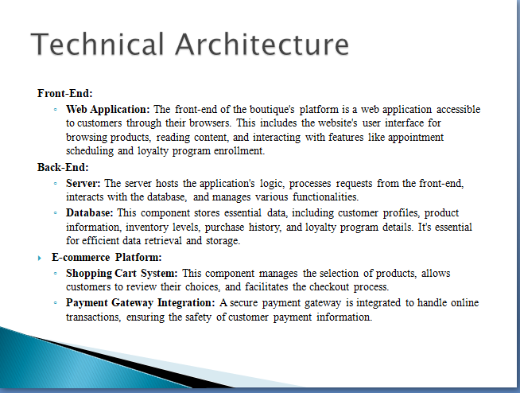

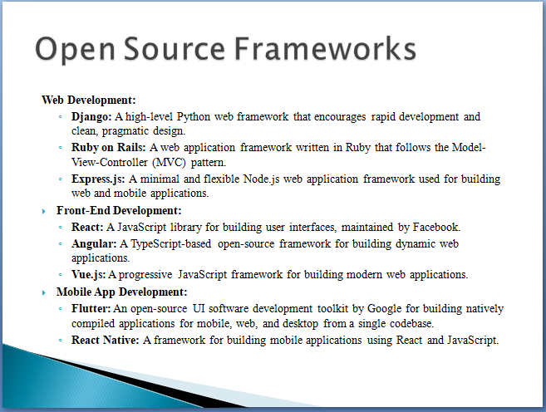

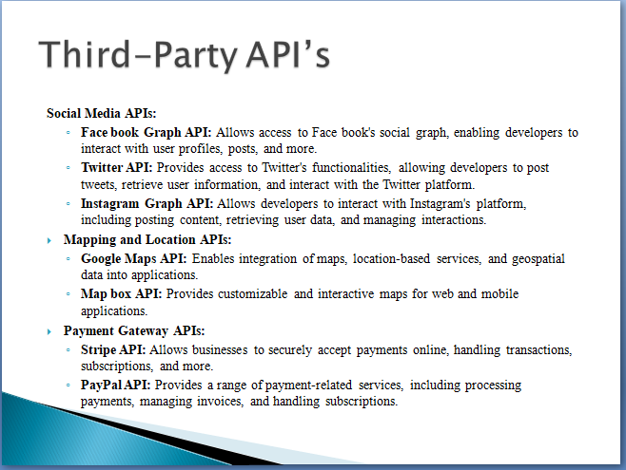

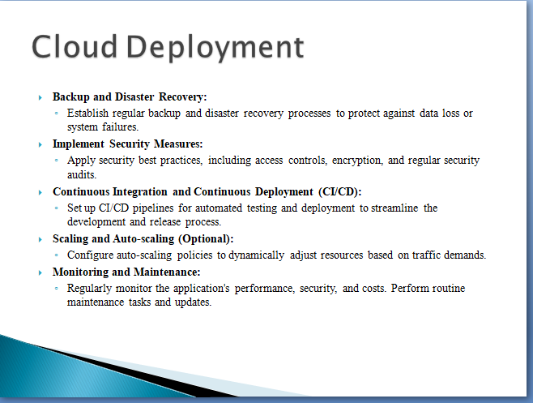

**Project Development Phase**

In this milestone you will start the project development and expected to perform the coding & solutioning, performance testing submit them.

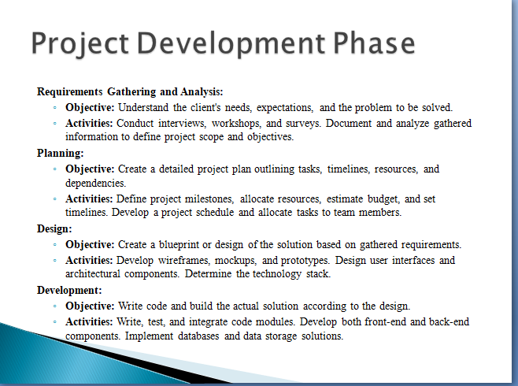

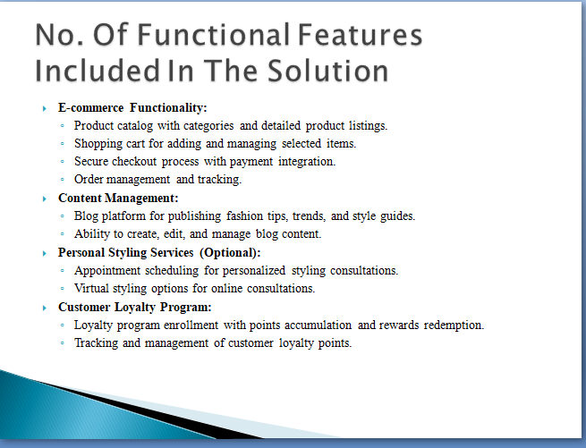

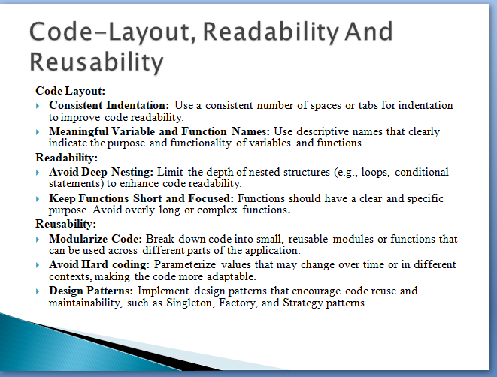

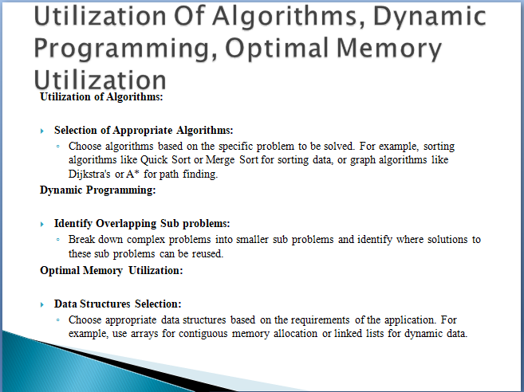

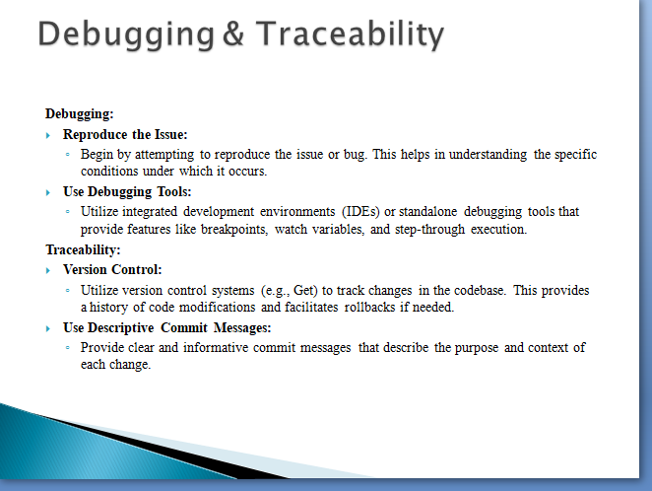

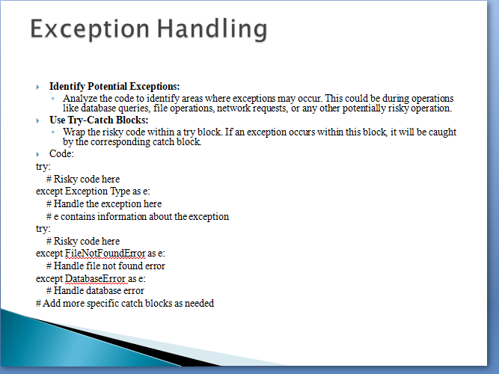

**Performance & Final Submission Phase**

In this milestone, you are expected to work on the activities mentioned.

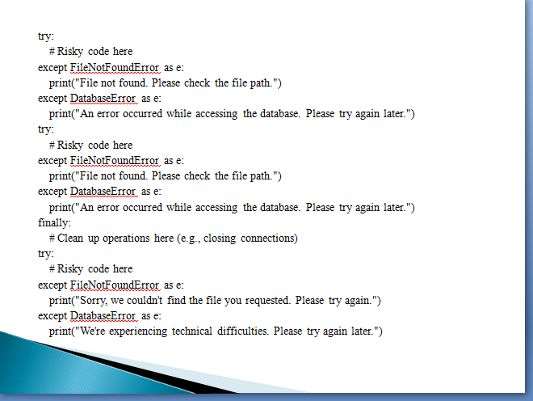

**Performance & Final Submission Phase**

In this milestone, you are expected to work on the activities mentioned.

