# Monitoring Depth of Anaesthesia by combining EEG and Body Vitals using Neural Nets

-Sudhanshu, Tanmai, and Siddharth

## Background

Anaesthesia is used to minimize pain during surgical procedures. Determining the state of patients administered with general anaesthesia is vital to the success of the surgery. It has been a common challenge in medicine. Monitoring anaesthesia goes both ways: preventing overdosage as well as under dosage. An overdose of general anaesthetic drugs such as Propofol, Thiopental Sodium, Etomidate, Ketamine, etc. (1) might lead to delayed recovery to awareness, and in extreme cases, to a coma. On the other hand, too light a dosage would lead to a mild awareness of the patient during a surgical procedure.

Therefore, continuous monitoring of anaesthesia is essential to the comfort and successful recovery of the patient in question. There have been a lot of studies for using either EEG data (2) or body vitals for the same. Some older studies (3) have used a combination of EEG and other physiological parameters, but little has been implemented using newer methods of spectral entropy and machine learning. We aim to introduce the idea of using the Hilbert Huang Entropy along with some other physiological and EEG parameters combined into a Neural Network to measure the Depth of anaesthesia (DoA) of patients.

## Analysis Methods

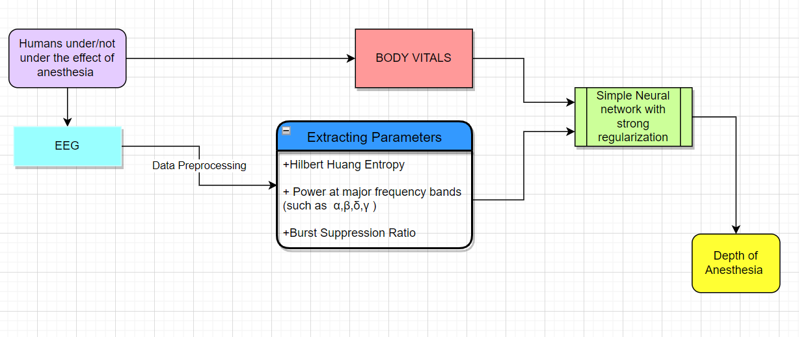

We use a novel approach combining both the EEG signals and body vitals to analyze the subject's Depth of Anaesthesia (DoA).

We pre-process the EEG data using simple notch filters to remove various artifacts like EOG, ECG, or line noise. After that, we calculate various parameters of interest to feed into the neural network. We calculate power at various frequency bands such as $α, β, δ, γ$ using power spectral analysis. We also find the Burst suppression Ratio as it an essential metric at deep anaesthetic levels $.^{\left[7\right]}$ We also calculate the HH entropy, a very accurate metric for detecting whether the subject is conscious or not $.^{\left[2\right]}$ We finally use a simple neural network to combine these parameters of interest into a single degree of anaesthesia.

## Data

We will use the University of Queensland Vital Signs Dataset(8), which contains a wide range of patient monitoring data and vital signs recorded during 32 surgical cases where patients underwent anesthesia at the Royal Adelaide Hospital. Monitoring data were recorded from 32 cases (25 general anaesthetics, three spinal anaesthetics, four sedations), ranging from 13 minutes to 5 hours (median 105 min). Most cases included data from the electrocardiograph, pulse oximeter, capnograph, non-invasive arterial blood pressure monitor, airway flow, and pressure monitor, and, in a few cases, the Y-piece spirometer, electroencephalogram monitor, and arterial blood pressure monitor.

References

1. V.K. Benzy, E.A. Jasmin, A Combined Wavelet and Neural Network Based Model for Classifying Depth of Anaesthesia, Procedia Computer Science, Volume 46, 2015, 1610-1617
2. Li X, Li D, Liang Z, Voss LJ, Sleigh JW. Analysis of Depth of anesthesia with Hilbert-Huang spectral entropy. Clin Neurophysiol. 2008 Nov;119(11):2465-75. doi: 10.1016/j.clinph.2008.08.006. Epub 2008 Sep 21. PMID: 18812265.
3. Liu, Quan et al. "Sample entropy analysis for the estimating depth of anaesthesia through human EEG signal at different levels of unconsciousness during surgeries." PeerJ vol. 6 e4817. 23 May. 2018, doi:10.7717/peerj.4817
4. Muammar Sadrawi, Shou-Zen Fan, Maysam F. Abbod, Kuo-Kuang Jen, Jiann-Shing Shieh, "Computational Depth of Anesthesia via Multiple Vital Signs Based on Artificial Neural Networks", BioMed Research International, vol. 2015, Article ID 536863, 13 pages, 2015. https://doi.org/10.1155/2015/536863
5. Rob J. Roy, Ashutosh Sharma, Depth of Anesthesia using Neural Networks, IFAC Proceedings Volumes, Volume 27, Issue 1, 1994, Pages 197-202
6. Bojan Musizza, Samo Ribaric 2, Monitoring the Depth of Anaesthesia, Sensors 2010, 10, 10896-10935
7. Nguyen-Ky, T., Wen, P. and Li, Y. (2014), Monitoring the Depth of anaesthesia using Hurst exponent and Bayesian methods. IET Signal Process., 8: 907-917.
8. Liu D, Görges M, Jenkins SA. University of Queensland vital signs dataset: development of an accessible repository of anesthesia patient monitoring data for research. Anesth Analg. 2012 Mar;114(3):584-9. doi: 10.1213/ANE.0b013e318241f7c0. Epub 2011 Dec 20. PMID: 22190558.