# MONITORING DEPTH OF ANAESTHESIA BY COMBINING EEG AND BODY VITALS USING NEURAL NETS

Specific Aims 1

Background and Significance 2

Research Design & Methods 3

Results 6

Expected Outcome and Pitfalls 8

References 9

Specific Aims

Anaesthesia is the medically induced numbness by treating intravenous or inhalational medications to a patient before a surgical operation. This prevents the patient from experiencing pain during the procedure. While local anaesthesia induces the absence of sensation in a particular body region, general anaesthesia is meant to induce a temporary coma. Anaesthetics are usually combined with pain-relievers and neuromuscular blockers.

Anaesthesia is marked by suppression in cardiorespiratory and thermoregulatory activity, and the patient requires external support for maintaining vital functions, particularly breathing1. This is accompanied by discernible changes in the brain behaviour, with a progressive decrease in the dominant frequency in the electroencephalogram (EEG) of the patient9. In the deeper stages of anaesthesia, the EEG witnesses nearly flat waves interspersed with sudden alpha and beta activity, called burst suppression1.

Depth of Anaesthesia (DoA) measures the degree of depression (or numbness) in the central nervous system and other body functions during treatment with anaesthetics. A century ago, the effect of anaesthesia in patients was determined by mere physical examination, often resulting in anaesthetic overdose2. While under dosage can put the patient in pain and the reflex responses of the body can interfere with the medical procedure, overdosage can ‘shut the body down’, which in extreme cases might be fatal. Today, keeping a check on DoA while administering anaesthetics is of utmost importance, and anaesthetists are trained well to prevent both under dosage and overdosage.

Quantifying anaesthetic effect in DoA is an active area of research, and several metrics have come up to make the monitoring more accurate. Bispectral index (BIS) is one of the several technologies used. While the company that developed BIS and manufactures BIS monitors has not revealed the exact details of the algorithm, it uses raw EEG data from the patient's scalp and processes it to provide a number between 0 to 100 (0 signifying EEG silence). A BIS value in the range of 40 to 60 is optimum for surgical procedures (as recommended by the manufacturer). The BIS value supplements the anaesthetist's physiology and response-to-stimulus-based assessment.

In the proposed study, we aim to develop a novel method of quantifying DoA by using body vitals and the raw EEG signal. We use the heart rate, breathing rate, and SpO­2 along with Hilbert-Huang entropy and power parameters from the processed EEG signal to construct a simple neural network. While some studies have used both body vitals and EEG signals to compute DoA3,4, not much has been done using the newer methods of spectral entropies and machine learning.

Our algorithm scores between 0 to 1, with a low score indicating a high depth of anaesthesia. The algorithm scored an accuracy of 79 % on test data against the BIS values.

Background and Significance

The earliest work we could find along the lines of what we are trying to achieve was done by Rob J Sharma and Ashuthosh Sharma (1994), who used autoregressive parameters from EEG and hemodynamic parameters – blood pressure and heart rate3. While the claimed accuracy was 85%, the study was performed on dogs with halothane as the anaesthetic. Halothane has long been abandoned because it has adverse side effects. Moreover, a study on dogs is very different from a human under anaesthesia undergoing a surgical procedure.

Benzy V.K. and E.A. Jasmin (2015) used the same dataset we used. They combined wavelet and neural network models to extract EEG features during anaesthesia and classify them according to DoA5. The wavelet coefficients for all EEG signals corresponding to the BIS range 0-20, 20- 40, 40-60, and 80-100 were extracted using discrete wavelet transform. They then used to an artificial neural network to classify the anaesthetic states as awake, light, deep, and very deep anaesthesia. The accuracy of the study was found to be 96.6% while categorizing. The accuracy might reduce quite a bit if absolute scores are analysed rather than sorting in categories.

We followed the usage of empirical mode decomposition (EMD) in Muammar Sadrawi et al. (2015) to purify the EEG signal4. While they also used hemodynamic parameters to feed into the neural network, they used Datex-Ohmeda M-Entropy. Xiaoli Li et al. (2008) proposed a new method based on Hilbert-Huang transform to calculate a spectral entropy value, called Hilbert-Huang spectral entropy6. They found that Hilbert-Huang spectral entropy exhibited excellent resistance to noise in the EEG signal; and decreased more linearly with increasing anaesthetic effect-site concentration, particularly around the loss of consciousness. The goodness of fit they reported is also slightly better than using M-entropy. This prompted us to make use of Hilbert-Huang entropy in our study.

Schwender et al. (1996) used delta ratio and spectral edge frequency 90 (SEF 90) in their study to monitor depth of anaesthesia7. Delta ratio is the ratio of power in 0-4 Hz to the power in 8-30 Hz. SEF 90 refers to the frequency in the 0-30 Hz below which 90% of the power in the range is located. They found the delta ratio to increase with the depth of anaesthesia and SEF 90 value to decrease. We also used these parameters and obtained similar results, consistent with the well-documented fact that dominant frequency falls with a higher depth of anaesthesia9.

Research Design & Methods

The code used in our proposal is found [here.](https://github.com/Sudhanshu-Sb2002/NSP-Grant-Proposal)

### Data

We've obtained our data from the University of Queensland Vital Signs Dataset, which contains a wide range of patient monitoring data and vital signs recorded during 32 surgical cases where patients underwent anaesthesia at the Royal Adelaide Hospital8. Monitoring data were recorded from 32 cases (25 general anaesthetics, three spinal anaesthetics, four sedations), ranging from 13 minutes to 5 hours (median 105 min). Most cases included data from the electrocardiograph, pulse oximeter, capnograph, non-invasive arterial blood pressure monitor, airway flow, and pressure monitor, and, in a few cases, the Y-piece spirometer, electroencephalogram monitor, and arterial blood pressure monitor.

The data relevant to us was of case 28, case 29, case 30 and case 31. They had EEG and body Vital recordings of patients sampled at a frequency of 100Hz

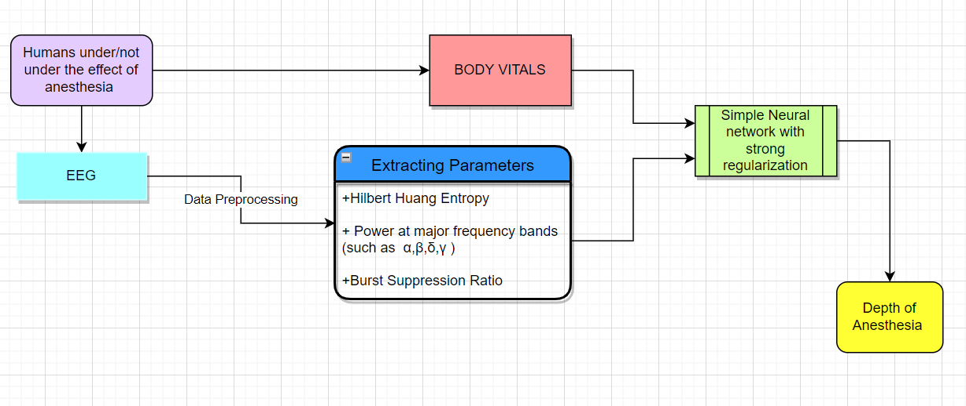

Our experiment can be broadly grouped into three components:

Filtering and Pre-processing

* Removal of NaN values and outlier points: The data that varies by more than 4 standard deviations has been removed. $\left|x-μ\right|≥4σ$
* Removal of 50Hz Line noise using spectral interpolation. We've proceeded to remove line noise at 50Hz using Spectral Interpolation. Spectral Interpolation is a technique derived from the Discrete Fourier Transform (DFT) filter. It involves transforming the signal from the time domain into the frequency domain by Discrete Fourier Transform, removing the line noise component and then interpolating the value at the interference by using the neighbouring frequencies. The signal is then transformed back into the time domain.   
  Spectral Interpolation has been compared to Notch (Butterworth), the DFT and CleanLine filters 10. It has been studied to hold advantage over the above-mentioned filters. DFT and CleanLine have been shown to produce spurious effects on the transformed EEG signal due to the wiping out of the entire frequency and don’t have a good performance on non-stationary line noise, whereas notch filters might cause unintended adverse filter effects that seriously change the signal and affect results12. Notch filters and Spectral Interpolation, apart from this drawback, have been shown to have almost the same performance.

Extraction of parameters

We divide our data into epochs of 20s, so that each parameter is computed over a 20s non-overlapping window. This also gives our model a sense of Real-Time analysis, since it is not using future data to make predictions. We compute the following parameters:

#### Entropies

Since the EEG Signal is a Non-linear and Dynamical system, it is perhaps appropriate to apply statsistical methods like entropies to find the DoI.  
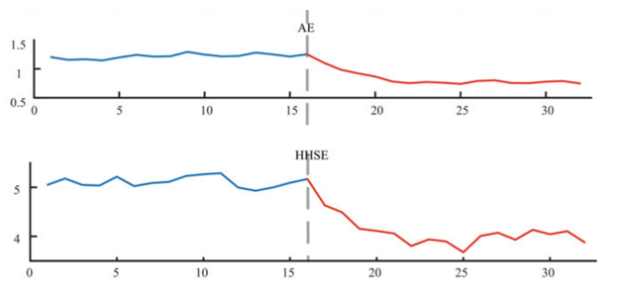We compute the Hilbert Huang Entropy and the approximate entropy of the signal. Both have been shown to be reliable metrics to predict the Anaesthetic states. [13] We consider both, because HHE is a spectral Entropy, while Approximate entropy works in the time domain.

Hilbert Huang Entropy finds basis functions (IMF’s) using Empirical Mode decomposition and then takes their Hilber transform to convert them into the frequency domain. It differs from other spectral estimates by having a more adaptive set of IMF’s to choose from, and therefore can represent more variable data accurately. While calculating the HHE, we drop the first IMF because it is the high frequency component and mostly consists of noise.

Naïve HHE has a mode mixing problem [Hilbert–Huang transform - Wikipedia](https://en.wikipedia.org/wiki/Hilbert%E2%80%93Huang_transform#Mode_mixing_problem) . Therefore , we calculate the ensemble HHE by adding white noise with SNR 25 and finding the average HHE of an ensemble of 11.

Approximate Entropy: ApEn measures the predictability of future amplitude values of the signal based on the information of previous amplitude values. It can be used to the finite length signal, and it belongs to nonlinear dynamics which describes the unpredictability or randomness of the signal .

*Both are computed at two frequency bands. State entropy (SE) is the entropy at the frequency band ranging from 0.8 to 32 Hz; Response entropy (RE) is calculated across the frequency band 0.8 to 47 Hz*

#### Power Spectral Analysis

We have used four parameters –  
  
 1) Absolute power in alpha band – With the increasing Depth of Anaesthesia, power in the alpha band (8 –13 Hz) is expected to decrease9.

2) Absolute power in delta band – Concomitant with the decrease in alpha power, power in delta (0 – 4 Hz) is expected to increase9.

3) Delta ratio – This was computed by taking the ratio of power in 0-4 Hz to the power in 8-30 Hz. With increasing delta power with DoA, the ratio of power in delta to higher frequencies is expected to go up7.

4) Spectral Edge Frequency 90 – SEF 90 refers to the frequency in the 0-30 Hz below which 90% of the power in the range is located. This was computed by integrating over the power spectrum in the range and interpolating to 0.9 times the total power. On the same lines as the previous arguments, SEF 90 is expected to decrease with increasing DoA. Schwender et al. (1996) reported the SEF 90 value to decrease to 12-14 Hz under surgical anaesthesia from 18-20 Hz baseline.

#### BSR Ratio

Burst suppression is an important phenomenon at deep levels of anaesthesia. It is characterised by relatively flat waves with sudden spikes in the alpha and beta bands. The Burst Suppression Ratio (BSR) is defined as the duration of the suppression period to the total duration of the signal. With increasing DoA, the BSR is expected to increase. BSR is one of the most reliable parameters for analysing EEG signals from anaesthesia11. We plan to proceed with calculating BSR and adding it as one of the attributes in the neural network to improve the performance of our algorithm.

### Neural Network

The training data includes various parameters obtained from EEG processing – two ensemble Hilbert Huang Entropies, two approximate entropies, the delta wave power, the alpha wave power, and the delta ratio. The body vitals passed to the network include the heart rate, the respiratory rate, and the oxygen saturation in the blood. . We have interpolated to replace the NaN values by taking the mean of the surrounding values.

To find the right combination of these parameters, we train a basic Neural Network with 21hidden layer. The Neural Network is (11 x 5 x 1), with L1 regularisation in the First Layer so that parameters that are particularly not useful are discarded.

To construct the desired neural network, PyTorch – an open-source machine learning framework whose library is available on python - has been utilised. The construction object of our class Net() has the following architecture:

* First Layer: Linear (in_features=11, out_features=5, bias=True). Nonlinearity: ReLU function
* Second Layer: Linear (in_features=5, out_features=1, bias=False) Nonlinearity: Signmoid

The neural network is trained against the BIS values. We have designed our parameters in such a way to give an output of DoA for every 20s.

Results

After pre-processing the correlation various parameters have with the BIS score are observed. Below are the most notable parameters among them:

|  |  |
| --- | --- |
|  |  |
|  |  |

These graphs were plotted only for patient 31. It is to be noted that for other patients the trends were sometimes very different.

*(Also note that even though Breathing rate has good correlation, it cannot capture smaller variations. In addition, breathing rate is a parameter that varies a lot in adverse conditions, therefore it is not completely reliable)*

All 11 Parameters were passed into the Neural Network. Below is the Corelation of the Score our Neural Network gives to the data vs the BIS score.

|  |  |
| --- | --- |
|  |  |
| The loss for the training data is 0.0074  The Training data Pearson correlation between BIS and our score is (0.754, 2.34e-193) | The loss for the training data is 0.0077  The Test data Pearson correlation between BIS and our score is (**0.786**, 3.32e-43) |

The Neural Network gives pretty good results. There is a correlation of 78.6% percent between our score and BIS on the testing data, which is comparable to the training data's correlation. Therefore, our Neural Network has not overfit the training data. There are still some anomalies because of the limited training data.

(Additional graphs can be found under the plots subsection of our GITHUB Repo).

Expected Outcome and Pitfalls

Upon processing and classification of our data, the expected output is the Degree of Anaesthesia (DoA) in the patient which ranges from zero to one. We do have good results, but below are some of the improvements that can be made to improve the accuracy the generalizability.

Data: The relevant data for our experiment was close to impervious. This is due to the specificity of the steps that we have taken in processing and pattern recognition. We have only been successful in obtaining datasets from only four people (case 28, case 29, case 30 and case 31) in a dataset of thirty-two people.

Another drawback in the data was that the EEG was recorded only after anaesthesia was administered, limiting the analysis of the effect of anaesthesia on EEG to only when it fades away and the person gains consciousness. Ideally, we would have normalised the body vitals with the trend we obtain before anaesthesia administration – this is because each person has a different resting rate of breathing, pulse etc. The absence of EEG recording before anaesthesia administration disables us from doing this.

Pre-processing: We have eliminated line noise and outliers, but we were not able to remove ECG signal noise from our EEG data. ECG noise can be removed by wavelet transform, Principal Component Analysis or Independent Component Analysis. IWCA – Independent Wavelet Component Analysis, is a preferred and updated method to remove ECG.

Processing: We've been successful in calculating Ensemble Hilbert-Huang Entropy and implementing power spectral analysis, but we have not yet calculated the proposed Burst Suppression ratio – a parameter that adds a significant amount of accuracy to our DoA calculation. BSR is one of the main components of systems like the BIS monitor.

Neural Network: A better model of a Neural Network would be a Recurrent Neural Network, as it would be closer to modelling a partial Auto-Regressive Model. Ideally, we should have passed more parameters for DoA estimation, like the coefficients of intrinsic mode function, Fourier series or wavelet transform for better pattern recognition by the neural network.   
The data set, owing to its extremely small size, was prone to be overfitted by our neural network, forcing us to use strong regularisation. Fortunately, it goes to mention that our neural network gave an accuracy of 79% despite limited data points.

In addition, the entire code must be modified so that it processes signal in real-time instead of taking processing the entire data at the end.

References

1) Brown EN, Lydic R, Schiff ND. General anaesthesia, sleep, and coma. *N Engl J Med*. 2010;363(27):2638-2650. doi:10.1056/NEJMra0808281

2) Siddiqui BA, Kim PY. Anaesthesia Stages. [Updated 2021 Mar 7]. In: StatPearls [Internet]. Treasure Island (FL): StatPearls Publishing; 2022 Jan

3) Rob J. Roy, Ashutosh Sharma, Depth of Anaesthesia using Neural Networks, IFAC Proceedings Volumes, Volume 27, Issue 1, 1994, Pages 197-202

4) Muammar Sadrawi, Shou-Zen Fan, Maysam F. Abbod, Kuo-Kuang Jen, Jiann-Shing Shieh, "Computational Depth of Anaesthesia via Multiple Vital Signs Based on Artificial Neural Networks", *BioMed Research International*, vol. 2015, Article ID 536863, 13 pages, 2015

5) V.K. Benzy, E.A. Jasmin, A Combined Wavelet and Neural Network Based Model for Classifying Depth of Anaesthesia, Procedia Computer Science, Volume 46, 2015, 1610-1617

6) Li X, Li D, Liang Z, Voss LJ, Sleigh JW. Analysis of depth of anaesthesia with Hilbert-Huang spectral entropy. Clin Neurophysiol. 2008 Nov;119(11):2465-75. doi: 10.1016/j.clinph.2008.08.006. Epub 2008 Sep 21. PMID: 18812265.

7) D Schwender, M Daunderer, S Mulzer, S Klasing, U Finsterer, K Peter. Spectral edge frequency of the electroencephalogram to monitor “depth” of anaesthesia with isoflurane or propofol, British Journal of Anaesthesia, Volume 77, Issue 2, 1996, Pages 179-184.

8) Liu D, Görges M, Jenkins SA. University of Queensland vital signs dataset: development of an accessible repository of anesthesia patient monitoring data for research. Anesth Analg. 2012 Mar;114(3):584-9. doi: 10.1213/ANE.0b013e318241f7c0. Epub 2011 Dec 20. PMID: 22190558

9) S. Hagihira, Changes in the electroencephalogram during anaesthesia and their physiological basis, BJA: British Journal of Anaesthesia, Volume 115, Issue suppl_1, July 2015, Pages i27–i31

10) Leske S, Dalal SS. Reducing power line noise in EEG and MEG data via spectrum interpolation. Neuroimage. 2019;189:763-776. doi:10.1016/j.neuroimage.2019.01.026

11) Musizza B, Ribaric S. Monitoring the depth of anaesthesia. Sensors (Basel). 2010;10(12):10896-10935. doi:10.3390/s101210896

12) Widmann A, Schröger E. Filter Effects and Filter Artifacts in the Analysis of Electrophysiological Data. Front Psychol. 2012;3:1–5. doi: 10.3389/fpsyg.2012.00233.

13) Li Hu, Zhiguo Zhang, EEG Signal Processing and Feature Extraction doi : https://doi.org/10.1007/978-981-13-9113-2

FieldTrip GitHub repository for ft_prepoc_dftfilter(),  
<https://github.com/fieldtrip/fieldtrip/blob/master/preproc/ft_preproc_dftfilter.m>

Our GitHub repository,   
<https://github.com/Sudhanshu-Sb2002/NSP-Grant-Proposal>