**Lab Assignment No: 01**

**Registration ID:- TUS3F171852**

|  |  |
| --- | --- |
| Roll. No. 75  Registration ID:- TUS3F171852 | Name: Sudhanshu Jena |
| Class: Comp-V | Batch: TE-C |
| Date of Experiment: 20/07/2020 | Date of Submission:24/09/2020 |
| Grade: | |

**B.1. Read the given questions and write appropriate commands in SQL.**

1. Display the names of ALL the tables in your Oracle account.   Display **all the records** from DEPARTMENTS table. Display all the records from the EMPLOYEES table.

**ANS : -** SELECT *FROM DEPARTMENTS;

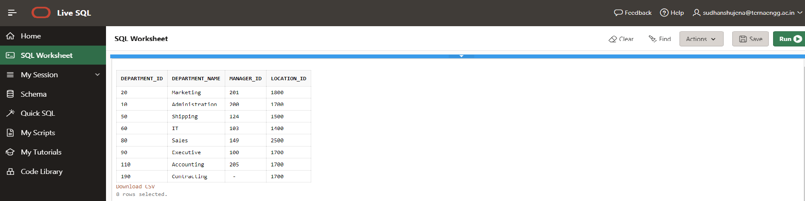

SELECT *FROM EMPLOYEES;

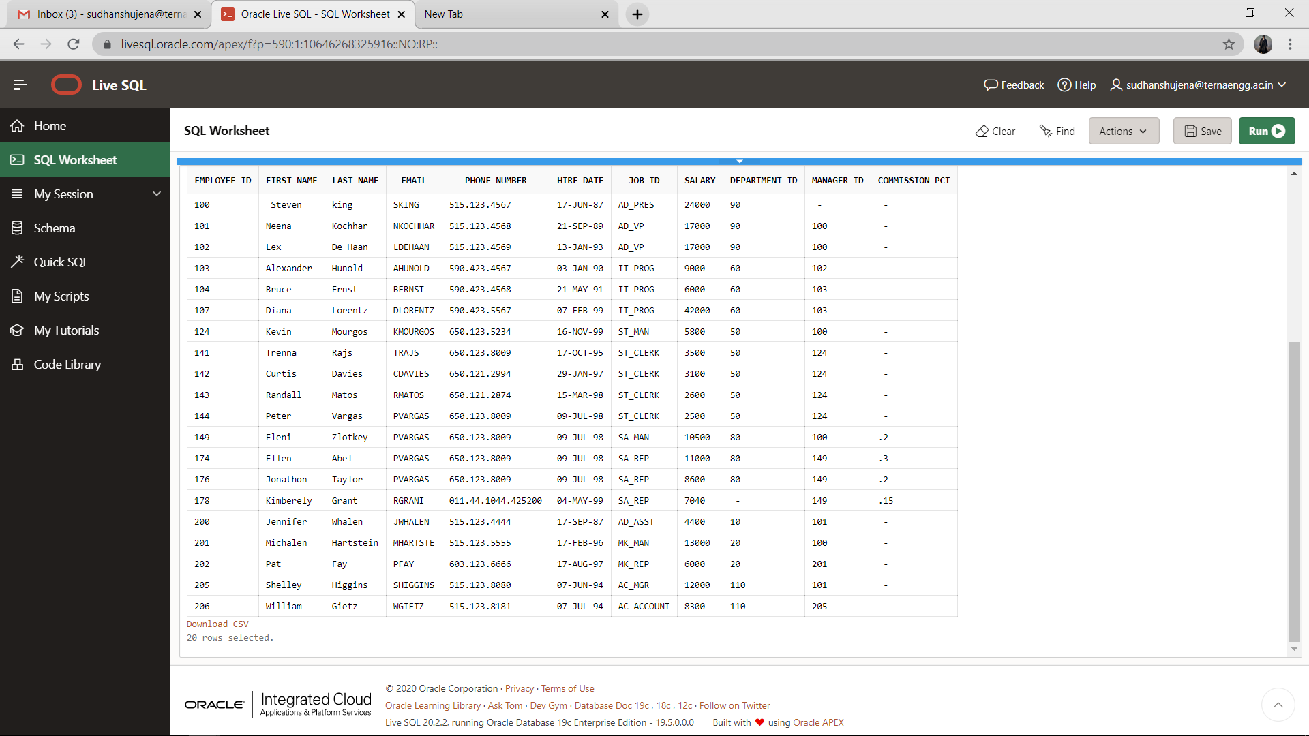

1. Create a query to display the last name, job_id, and employee id for each employee, with employee id appearing first.

**ANS : -** SELECT JOB_ID,LAST_NAME,EMPLOYEE_ID FROM EMPLOYEES;

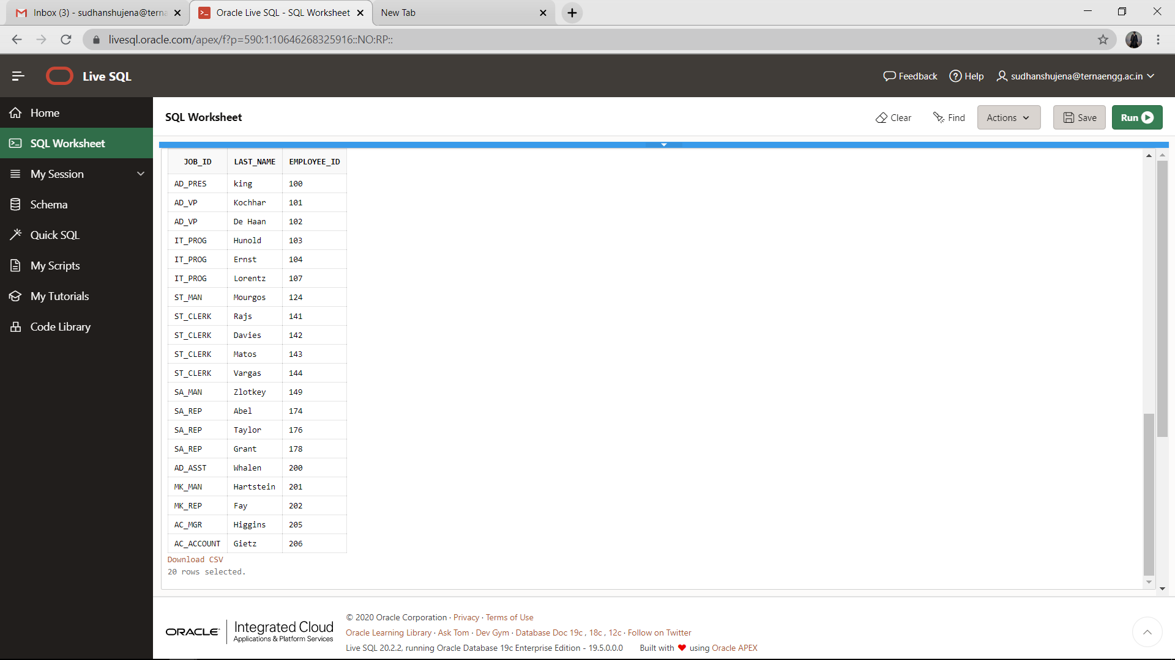

1. Create a query to display **distinct job_id** from the EMPLOYEES table.

**ANS:- select distinct job_id from employees;**

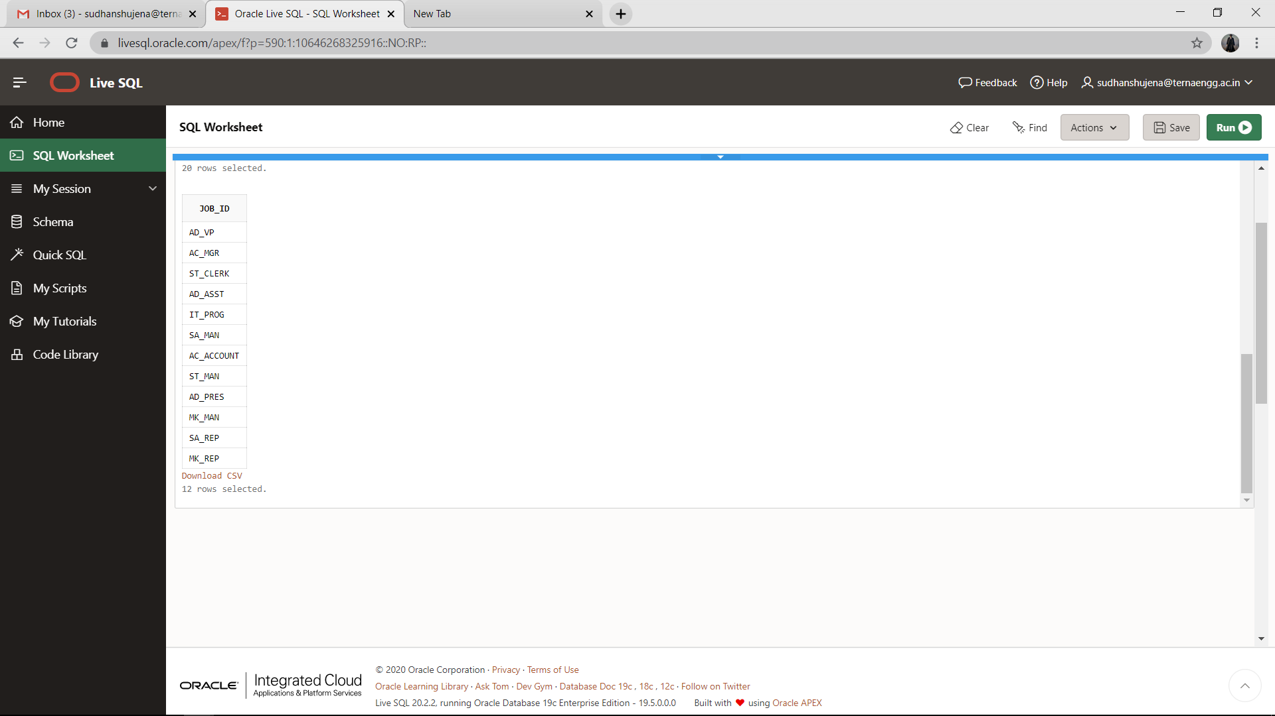

1. Create a query to display **distinct** department_id from EMPLOYEES table.

**ANS:- select distinct department_id from employees;**

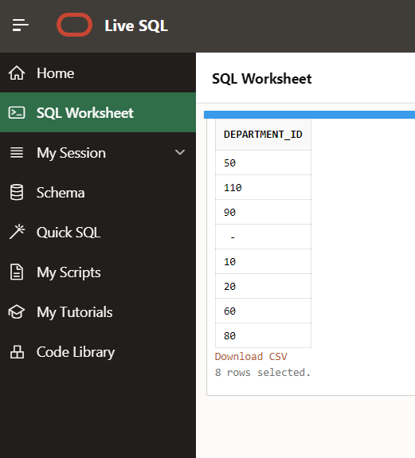

5.      There are four coding **errors** in this statement. Can you identify them?

                       SELECT   employee_id, last_name SAL x 12 ANNUAL SALARY

                       FROM   employees

**ANS:-**

* Comma is used between two attributes.
* In the end of the query semi-colon required.
* For multiplication operator multiplication sign ‘*’ is required instead of x.-
* Alias command is required.