# SOURCE CODE LINK:<https://drive.google.com/drive/folders/198zJruWsf_0X1GxNNZR6AUvZHuw9AUyc?usp=sharing>

# **ASSIGNMENT OF AWT**

# **ON**

# 



# **CODE STARTS HERE :**

<!DOCTYPE html>

<html lang="en">

<head>

  <meta charset="UTF-8">

  <meta name="viewport" content="width=device-width, initial-scale=1.0">

  <title>Inventory Management System</title>

  <!-- Bootstrap CSS -->

  <link href="https://stackpath.bootstrapcdn.com/bootstrap/4.5.2/css/bootstrap.min.css" rel="stylesheet">

  <!-- jQuery -->

  <script src="https://ajax.googleapis.com/ajax/libs/jquery/3.5.1/jquery.min.js"></script>

  <style>

    .product-list {

      margin-top: 30px;

    }

  </style>

</head>

<body>

<div class="container-fluid bg-light">

  <h1 class=" text-center p-3 bg-info">Inventory Management System</h1>

  <!-- Product List -->

  <div class="product-list">

    <h3 class="display">Product List</h3>

    <table class="table table-striped">

      <thead>

        <tr class="bg-dark text-white">

          <th>Product Name</th>

          <th>Description</th>

          <th>SKU</th>

          <th>Price</th>

          <th>Quantity</th>

        </tr>

      </thead>

      <tbody id="productList">

        <!-- Products will be dynamically added here -->

      </tbody>

    </table>

     <!-- Add Product Button -->

  <button type="button" class="btn btn-primary mt-3" data-toggle="modal" data-target="#addProductModal">Add Product</button>

  </div>

</div>

<!-- Add Product Modal -->

<div class="modal fade" id="addProductModal" tabindex="-1" role="dialog" aria-labelledby="addProductModalLabel" aria-hidden="true">

  <div class="modal-dialog" role="document">

    <div class="modal-content">

      <div class="modal-header">

        <h5 class="modal-title mark" id="addProductModalLabel" >Add Product</h5>

        <button type="button" class="close" data-dismiss="modal" aria-label="Close">

          <span aria-hidden="true">&times;</span>

        </button>

      </div>

      <div class="modal-body">

        <!-- Form to add a new product -->

        <form id="addProductForm" class="bg-light text-warning lead">

          <div class="form-group">

            <label for="productName">Product Name</label>

            <input type="text" class="form-control" id="productName" required>

          </div>

          <div class="form-group">

            <label for="productDescription">Description</label>

            <textarea class="form-control" id="productDescription" required></textarea>

          </div>

          <div class="form-group">

            <label for="productSKU">SKU</label>

            <input type="text" class="form-control" id="productSKU" required>

          </div>

          <div class="form-group">

            <label for="productPrice">Price</label>

            <input type="number" class="form-control" id="productPrice" required>

          </div>

          <div class="form-group">

            <label for="productQuantity">Quantity</label>

            <input type="number" class="form-control" id="productQuantity" required>

          </div>

        </form>

      </div>

      <div class="modal-footer">

        <button type="button" class="btn btn-secondary" data-dismiss="modal">Close</button>

        <button type="button" class="btn btn-primary" id="addProductBtn">Add Product</button>

      </div>

    </div>

  </div>

</div>

<!-- Bootstrap JS -->

<script src="https://stackpath.bootstrapcdn.com/bootstrap/4.5.2/js/bootstrap.min.js"></script>

<!-- Custom JavaScript -->

<script>

  $(document).ready(function(){

    $("#addProductBtn").click(function(){

      // Retrieve input values

      var productName = $("#productName").val();

      var productDescription = $("#productDescription").val();

      var productSKU = $("#productSKU").val();

      var productPrice = $("#productPrice").val();

      var productQuantity = $("#productQuantity").val();

      // Validate input values (e.g., check for empty fields)

      if(productName === "" || productDescription === "" || productSKU === "" || productPrice === "" || productQuantity === "") {

        alert("Please fill in all fields.");

        return;

      }

      // Check if product with the same SKU already exists

      var existingProduct = getProductBySKU(productSKU);

      if (existingProduct) {

        // If product already exists, update its quantity

        var newQuantity = parseInt(existingProduct.quantity) + parseInt(productQuantity);

        updateProductListItem(existingProduct.sku, newQuantity);

      } else {

        // If product doesn't exist, add it to the list

        var newProduct = {

          name: productName,

          description: productDescription,

          sku: productSKU,

          price: productPrice,

          quantity: productQuantity

        };

        addProductToList(newProduct);

      }

      // Clear the form fields

      $("#addProductForm")[0].reset();

      // Close the modal

      $("#addProductModal").modal("hide");

      // Check for low stock

      if (productQuantity < 10) {

        alert("Low stock alert for " + productName);

      }

    });

    // Function to add a new product to the list

    function addProductToList(product) {

      var productRow = `

        <tr id="product-${product.sku}">

          <td>${product.name}</td>

          <td>${product.description}</td>

          <td>${product.sku}</td>

          <td>$${product.price}</td>

          <td>${product.quantity}</td>

        </tr>

      `;

      $("#productList").append(productRow);

    }

    // Function to update the quantity of an existing product in the list

    function updateProductListItem(sku, newQuantity) {

      $("#product-" + sku + " td:last-child").text(newQuantity);

    }

    // Function to get a product by SKU

    function getProductBySKU(sku) {

      var products = $("tbody#productList tr");

      for (var i = 0; i < products.length; i++) {

        var productSKU = $(products[i]).attr("id").split("-")[1];

        if (productSKU === sku) {

          return {

            name: $(products[i]).find("td:eq(0)").text(),

            description: $(products[i]).find("td:eq(1)").text(),

            sku: sku,

            price: $(products[i]).find("td:eq(3)").text().substring(1),

            quantity: $(products[i]).find("td:eq(4)").text()

          };

        }

      }

      return null;

    }

    $("input").css("background-color", "cyan");

    $("textarea").css("background-color", "cyan");

  });

</script>

</body>

</html>

# **OUTPUT :**

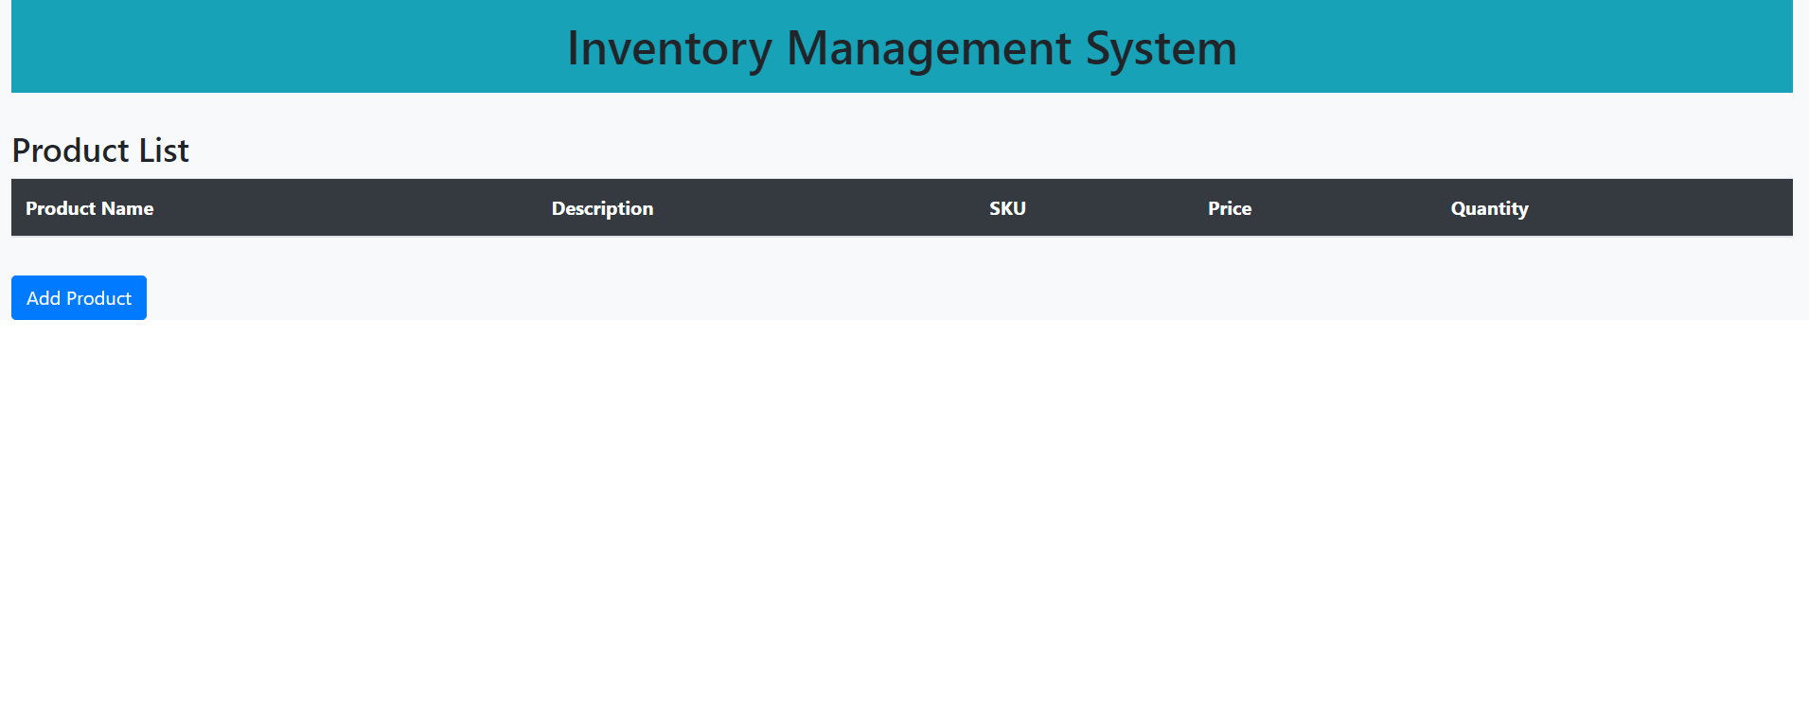

##### **AFTER CLICKING ON Add Product Button:**

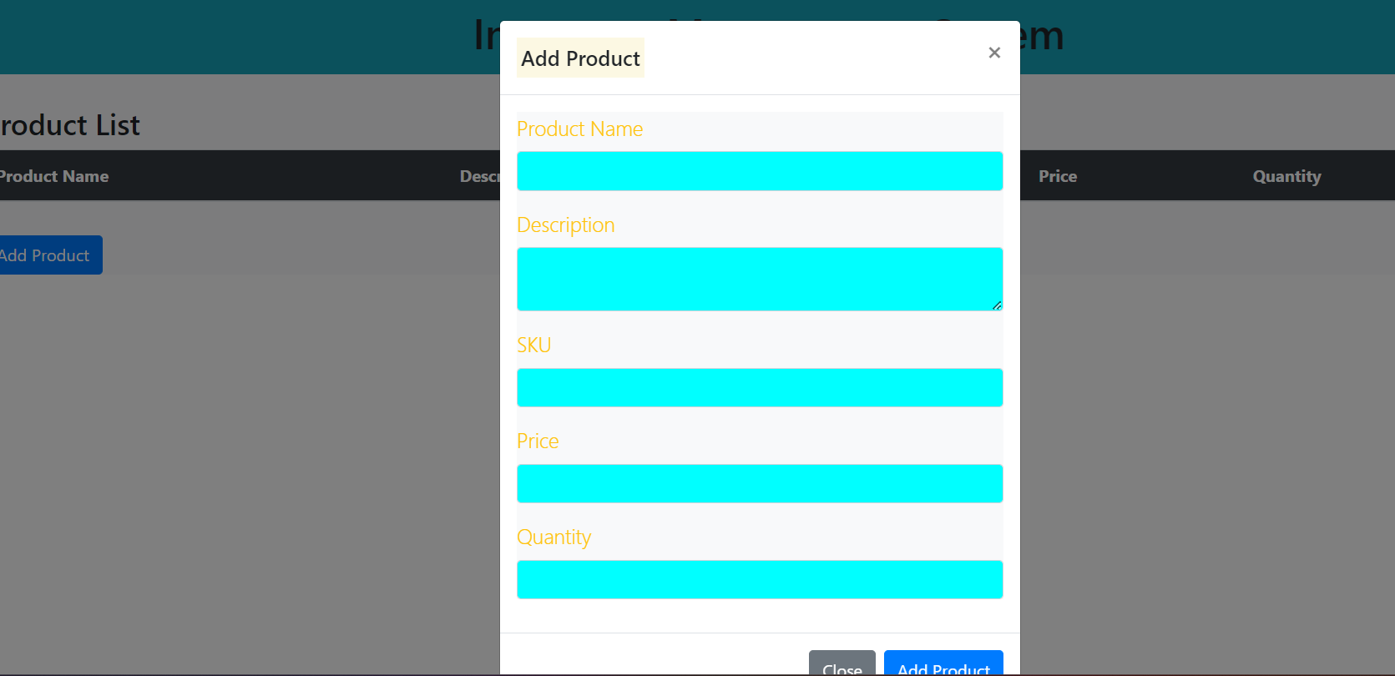

##### ALERT POP UP WHEN ANY FIELD IS EMPTY :

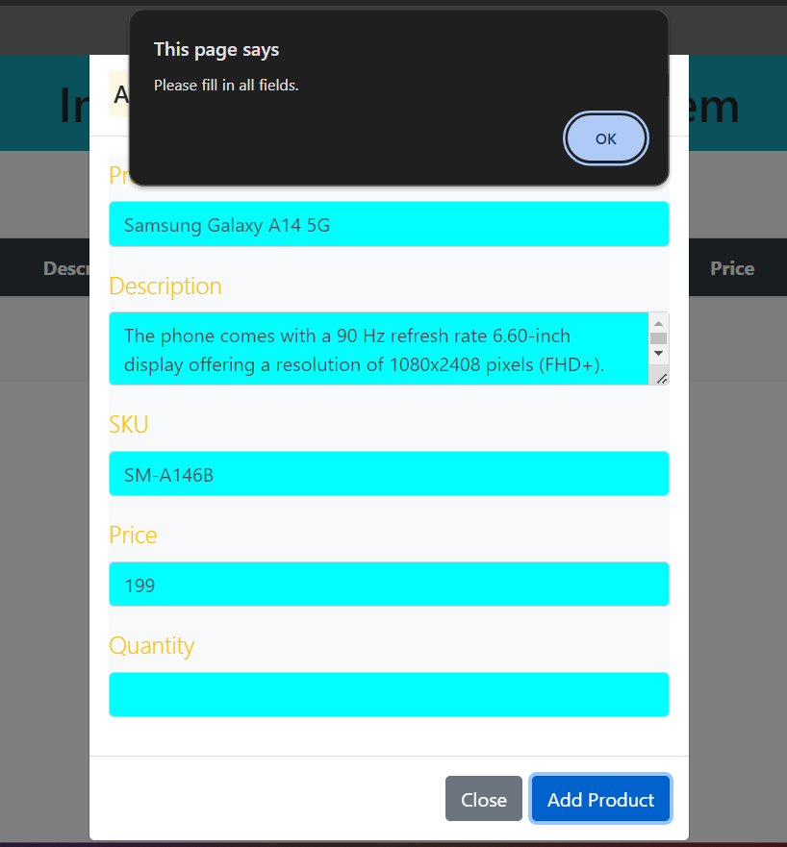

##### **ALERT WHEN NUMBER OF QUANTITY<10 :**

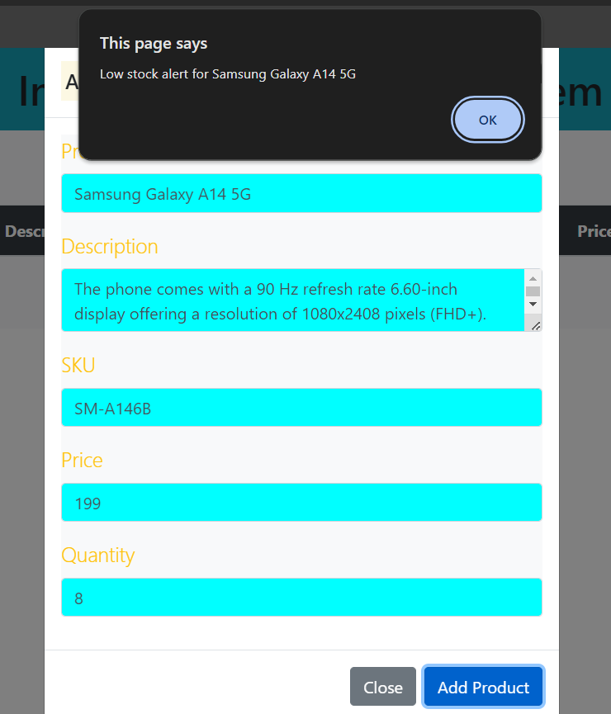

##### **AFTER ADDING PRODUCTS ON LIST :**

##### 

