SafarSetu: Design and Architecture of a Unified, Festival-Aware Multi-Modal Transport and Event-Logistics Platform for Regional Deployment in India
Sudhanshu Ranjan and Raunak Kumar
Department of Computer Applications (BCA – Data Science), Lovely Professional University, Phagwara, Punjab, India
Corresponding author email: [To be completed by the authors]
*ORCID: [To be completed by the authors]
Abstract—Ride-hailing and logistics technology in India is presently dominated by single-purpose applications that separately address urban passenger transport, goods movement, outstation travel, and wedding-related logistics, each requiring a distinct account and booking context. This fragmentation is particularly acute in Tier-2/3 regions such as Bihar, where mainstream platforms additionally provide limited support for regional dialects and assume continuous, unmetered connectivity to a commercial mapping provider. This paper presents SafarSetu, a prototype software system that unifies passenger ride-hailing, cargo transport, pilgrimage/outstation packages, and wedding-convoy booking under a single geofenced location-resolution, routing, and fare-computation pipeline. The system further introduces a festival-context orchestration engine that atomically reconfigures promotional content, an active dedicated service offer, and interface text across four languages — English, Hindi, Maithili, and Bhojpuri — from a single state transition; a dual-mode mapping subsystem that operates by default on keyless, open-data map rendering and routing services and transparently upgrades to a commercial provider when credentials are supplied; and an integrated wedding-services module, SafarShaadi, that couples multi-stop event transport with a vendor marketplace, budget tracker, guest manager, and ritual checklist inside a single event record. The paper details the system architecture, the shared booking pipeline, the fare-computation and geofencing algorithms, and the underlying data model, and situates the design against related work in ride-hailing dispatch, dynamic pricing, geofencing, low-resource regional-language technology, and Mobility-as-a-Service integration. As the system is at prototype stage, this paper reports its architecture, design rationale, and qualitative feature positioning rather than field-trial performance results, and it closes with a concrete evaluation roadmap — comprising backend implementation, controlled benchmarking, and a field pilot — identified as the primary direction for future work.
Index Terms—Ride-hailing systems, multi-modal transportation, Mobility-as-a-Service, geofencing, dynamic fare computation, low-resource language technology, regional software design, mobile application architecture, wedding-logistics platforms, festival-aware personalization.

I. INTRODUCTION
Ride-hailing and on-demand logistics applications have become a foundational part of urban mobility infrastructure worldwide, with platforms such as Uber, Ola, Lyft, and DiDi processing large volumes of dispatch and pricing decisions in real time [1], [2]. The engineering literature and industrial practice around these systems has matured considerably, encompassing large-scale order dispatch [2], reinforcement-learning-based vehicle repositioning and matching [3], [4], and electric-fleet-aware dispatching [5]. This body of work, however, is concentrated on high-density metropolitan deployments and on a single service category — typically point-to-point passenger transport.
India's Tier-2 and Tier-3 regions, including the state of Bihar, present a materially different deployment context. Transport demand in these regions spans not only ordinary passenger rides but also small-goods transport, seasonal pilgrimage travel, and — distinctively — wedding-related logistics, which in North Indian contexts typically involves multi-stop convoy transport (baraat) coordinated alongside vendor bookings for catering, decoration, and photography. At present, each of these needs is served, if at all, by a separate application or informal arrangement, with no shared account, fare logic, or vehicle inventory between them.
A second regional characteristic is linguistic diversity. Mainstream ride-hailing platforms typically support English and, at most, Hindi. Bihar, however, is home to large populations of speakers of Maithili and Bhojpuri — languages that remain classified as low-resource in the natural language processing literature despite tens of millions of first-language speakers each [6]–[8]. A third characteristic is variable network connectivity and cost-sensitivity, which makes continuous dependence on a metered commercial mapping application programming interface (API) a practical liability rather than a convenience.
This paper presents SafarSetu ("Bihar's Transport Bridge"), a prototype system designed around these three regional characteristics. Rather than treating passenger ride-hailing, cargo transport, pilgrimage travel, and wedding logistics as independent products, SafarSetu implements them as parameterized instances of a single shared booking pipeline — location resolution, geofence validation, mapping/route computation, fare computation, and dispatch — distinguished only by a substituted vehicle-and-rate table and, for wedding bookings, a multi-stop itinerary structure in place of a single pickup/drop pair. The system further incorporates a dual-mode mapping subsystem that defaults to keyless, open-data services and upgrades transparently to a commercial provider when configured; a festival-context orchestration engine that couples promotional, service, and localization state; and an integrated wedding-planning module, SafarShaadi, that extends transport booking into vendor marketplace, budget, guest, and ritual-checklist management within a single event record.
The contribution of this paper is a system and architecture contribution: it documents the design, data model, algorithms, and mathematical formulation underlying SafarSetu, evaluated against the current literature on ride-hailing dispatch, dynamic pricing, geofencing, low-resource regional language technology, and Mobility-as-a-Service (MaaS) integration. Because the implementation reviewed in this paper is a functional client-side prototype rather than a fielded, backend-complete production system, this paper does not report field performance metrics such as trip completion rate, driver utilization, or user-perceived latency under load; such an evaluation is identified explicitly as future work in Section XV, together with a concrete plan for obtaining it.
A. Research Objectives
The objectives of this work are: (i) to design a shared, geofenced booking pipeline capable of serving four heterogeneous transport service categories from a single codebase and account context; (ii) to design a mapping subsystem that does not require a paid commercial API key for baseline operation while remaining upgradable to one; (iii) to design a festival-context orchestration mechanism that couples promotional, service, and four-language localization state; and (iv) to design an integrated wedding-transport-and-vendor-marketplace module suited to North Indian wedding logistics.
B. Paper Organization
The remainder of this paper is organized as follows. Section II reviews related work in ride-hailing dispatch and pricing, geofencing, regional-language technology, and MaaS integration. Section III states the problem being addressed. Section IV analyzes the resulting research gap. Section V lists the paper's contributions. Section VI presents the system architecture. Section VII describes the proposed methodology and shared booking pipeline in detail. Section VIII presents the fare-computation and geofencing algorithms in pseudocode. Section IX develops the mathematical model underlying fare computation and geofence validation. Section X describes the implementation and experimental (development) setup. Section XI presents a qualitative, literature-grounded feature comparison in place of field performance results. Section XII discusses the findings, Section XIII discusses threats to validity, Section XIV concludes the paper, and Section XV outlines future work.
II. RELATED WORK
A. Ride-Hailing Dispatch and Matching
Large-scale ride-hailing dispatch has been extensively studied as a combinatorial matching and sequential decision problem. Xu et al. formulated large-scale order dispatch as a joint learning-and-planning problem and demonstrated substantial improvements over myopic matching baselines on industrial-scale data [2]. Guo and Xu applied deep reinforcement learning to vehicle dispatching in autonomous mobility-on-demand systems, framing dispatch as a sequential control problem over a spatial-temporal state [3]. Qin et al. provide an extended survey of reinforcement-learning approaches to ridesharing, covering matching, repositioning, and pricing as interconnected sub-problems [4]. Kullman et al. extend dynamic ride-hailing formulations to electric-vehicle fleets, incorporating charging constraints into the dispatch decision [5]. These works share a common assumption that is not satisfied by the SafarSetu design context: a single, homogeneous vehicle fleet serving a single service category (typically passenger rides) at metropolitan scale. SafarSetu instead addresses heterogeneous, low-volume, multi-category demand — passenger, cargo, pilgrimage, and wedding-convoy — within a single regional deployment, for which the literature offers comparatively little precedent.
B. Dynamic Pricing and Fare Computation
Yan et al. provide a practitioner-oriented survey of matching and dynamic-pricing ("surge") techniques in commercial ride-hailing platforms, characterizing dynamic pricing as a mechanism for balancing rider wait time, driver utilization, and platform revenue [1]. Subsequent work has examined the limitations of purely reactive dynamic pricing, including rider incentives to delay requests until a surge subsides [9], and has proposed privacy-preserving and reinforcement-learning-based pricing mechanisms as refinements [10]. SafarSetu's fare-computation engine (Section IX) adopts a simplified, transparent variant of this literature: an itemized base/distance/time decomposition with a threshold-triggered surge multiplier and an explicit, opt-in protection add-on, prioritizing fare transparency — a factor independently identified as a significant driver of user trust in the Indian ride-hailing market [11] — over revenue-maximizing dynamic-pricing sophistication.
C. Geofencing and Location-Based Service Boundaries
Geofencing — the use of a virtual geographic boundary to trigger or restrict application behavior — is a well-established technique in location-based services, with applications spanning marketing, asset tracking, and safety systems [12]. Deshmukh et al. survey geofencing algorithms and implementation approaches for mobile applications, characterizing the trade-offs between polygon-based and radius-based boundary tests [12]. SafarSetu applies geofencing not for marketing purposes but as a service-area integrity control, validating both pickup and drop coordinates against a configured operating boundary irrespective of which underlying mapping provider produced the coordinates (Section IX).
D. Open-Data Routing and Mapping Infrastructure
The Open Source Routing Machine (OSRM), introduced by Luxen and Vetter, demonstrated that contraction-hierarchy-based route computation over OpenStreetMap (OSM) data could achieve query latencies suitable for interactive, web-based routing applications without reliance on a commercial provider [13]. Subsequent tooling, such as the osrm interface package, has further lowered the barrier to integrating OSRM-based routing into applications and research pipelines [14]. SafarSetu's default mapping subsystem builds on this open-data routing lineage, combining Leaflet-based rendering with OSRM-compatible route geometry and Photon/Nominatim-style geocoding as a keyless baseline, with a detection-and-switch pathway to a commercial provider (Section VI).
E. Safety in Ride-Hailing, Particularly for Women Passengers
Passenger safety, and in particular the safety of women passengers and drivers, has emerged as a significant design and policy concern in ride-hailing research. Kushwaha et al. analyze safety and pricing transparency features across the Indian ride-hailing sector and describe the design of a gender-aware ride-matching prototype incorporating SOS alerts and ride tracking [11]. Torrao et al. conducted a mobility survey in India specifically examining women's perceptions of travel safety and the potential role of artificial intelligence in improving it, finding that security concerns are a dominant factor in women's mode choice and that a large majority of respondents value the availability of in-app emergency support [15]. These findings motivate SafarSetu's inclusion of a women's-safety mode linking driver-preference constraints with an emergency-dispatch pathway (Section VII).
F. Low-Resource Regional Language Technology
Maithili and Bhojpuri, alongside Magahi, are classified in the computational linguistics literature as low-resource languages of the Purvanchal region of India despite a combined first-language speaker base in the tens of millions [6]. Mundotiya et al. developed foundational linguistic resources, part-of-speech, and chunking baselines for these three languages, explicitly noting the scarcity of digital and annotated resources relative to their speaker populations [6]. Subsequent work has extended these resources to part-of-speech tagging [7] and named-entity recognition [8] specifically for Maithili and related languages. This literature substantiates the accessibility rationale for SafarSetu's inclusion of Maithili and Bhojpuri, alongside English and Hindi, as first-class interface languages (Section VI) — a scope broader than that typically offered by mainstream national ride-hailing platforms.
G. Mobility-as-a-Service (MaaS) Integration
Mobility-as-a-Service refers to the integration of multiple transport modes and providers behind a single trip-planning, booking, and payment interface [16]. Cisterna et al. provide a systematic review of MaaS demand-modeling literature, characterizing MaaS integration levels from basic information aggregation to advanced, tariff-integrated mobility packages [16]. Existing MaaS literature and deployments, however, are structured around integrating distinct public and private transport modes for a single trip-planning use case (e.g., combining transit, bike-share, and ride-hailing for one journey), rather than around integrating structurally distinct service categories — passenger transport, goods transport, event/pilgrimage packages, and a non-transport vendor marketplace — under a single application and account, which is the integration pattern SafarSetu implements.
H. Summary and Positioning
Table I summarizes the relationship between SafarSetu and the reviewed literature. The reviewed works individually address dispatch optimization, dynamic pricing, geofencing, open-data routing, ride-hailing safety, low-resource language technology, or MaaS integration, typically in isolation and at metropolitan or national scale. SafarSetu's contribution is architectural: it demonstrates how several of these individually studied concerns — geofenced dispatch, transparent fare computation, keyless-first mapping, regional-language accessibility, and safety — can be combined within a single, shared pipeline for a heterogeneous, regionally specific service catalogue, and extended into a novel, transport-plus-vendor-marketplace integration (SafarShaadi) not addressed in the reviewed MaaS or ride-hailing literature.
III. PROBLEM STATEMENT
Four concrete, interrelated technical problems motivate the SafarSetu design.
First, application fragmentation: a resident of a Bihar town requiring a passenger ride, a small-goods delivery, and a wedding-convoy booking within the same week must currently install and operate several unrelated applications, each with an independent registration, payment, and support flow, none of which share fare logic, vehicle inventory, or booking history.
Second, mapping-provider dependency: incumbent ride-hailing architectures are typically built around a single commercial mapping API. In a cost-sensitive regional deployment, this creates both a recurring operating expense proportional to request volume and a single point of failure in the event of key misconfiguration, quota exhaustion, or provider outage, with no documented architectural fallback in the reviewed dispatch literature [1]–[5].
Third, linguistic exclusion: the interface language coverage of mainstream platforms does not extend to Maithili or Bhojpuri, despite the substantial and specifically documented low-resource status of these languages relative to their speaker populations [6]–[8], creating an accessibility barrier for a significant share of the target user base.
Fourth, wedding-logistics coordination overhead: North Indian wedding-day transport (multi-venue baraat convoys) and wedding vendor booking (catering, decoration, photography) are presently coordinated manually by the user across unrelated services, with no shared budget, guest, or itinerary record linking the transport and vendor-marketplace aspects of the same event.
Existing academic and industrial ride-hailing systems, reviewed in Section II, address dispatch optimization, dynamic pricing, and — separately — MaaS-style mode integration, but do not address the combination of these four problems within a single regionally deployable, keyless-capable, multi-language architecture. This combination defines the design problem addressed by SafarSetu.
IV. RESEARCH GAP AND MOTIVATION FOR A UNIFIED DESIGN
Building on the positioning established in Section II, Table I identifies specific capability gaps between the reviewed literature/incumbent platforms and the design requirements established in Section III.
TABLE I
RESEARCH GAP: CAPABILITY COMPARISON
Capability | Ride-hailing dispatch/pricing lit. [1]–[5] | MaaS integration lit. [16] | SafarSetu
Multi-category dispatch (ride + cargo + pilgrimage + wedding) under one pipeline | Not addressed | Addresses multi-mode trip planning, not multi-category service integration | Yes — shared pipeline, Sec. VII
Keyless-default / fallback mapping architecture | Not addressed (assumes provider access) | Not addressed | Yes — dual-mode mapping, Sec. VI
Low-resource regional dialect UI (Maithili, Bhojpuri) | Not addressed | Not addressed | Yes — 4-locale framework, Sec. VI
Festival/seasonal service and content orchestration | Not addressed | Not addressed | Yes — orchestration engine, Sec. VI
Transport-plus-vendor-marketplace integration for events | Not addressed | Not addressed | Yes — SafarShaadi, Sec. VII
Transparent, itemized fare breakdown as a first-class UI element | Partially — pricing studied, transparency not emphasized [1] | Not addressed | Yes — Sec. IX
The novelty asserted in this paper is architectural and integrative rather than algorithmic: SafarSetu does not propose a new dispatch-optimization or pricing algorithm competitive with the reinforcement-learning-based methods surveyed in Section II-A–II-B; instead, it proposes a system architecture, described in Sections VI–IX, in which a shared pipeline, a provider-agnostic mapping abstraction, and a festival/language orchestration layer jointly cover a capability combination absent from the reviewed literature and from mainstream deployed platforms.
V. CONTRIBUTIONS
This paper makes the following contributions:
1) A shared, parameterized booking-pipeline architecture (Section VI, VII) in which passenger ride-hailing, cargo/tempo transport, pilgrimage/outstation packages, and multi-stop wedding-convoy booking are implemented as instances of one location-resolution/geofencing/mapping/fare/dispatch pipeline, distinguished only by a substituted vehicle-and-rate table and itinerary structure.
2) A dual-mode, provider-agnostic mapping subsystem design (Section VI) that operates by default on keyless, open-data services (Leaflet rendering, OSRM-compatible routing, Photon/Nominatim-style geocoding) and detects and transparently upgrades to a commercial mapping API when credentials are supplied, without altering downstream fare or geofencing logic.
3) A festival-context orchestration mechanism (Section VI) that couples promotional content, an active dedicated service offer, and four-language interface text (English, Hindi, Maithili, Bhojpuri) within a single application-state transition, together with the underlying four-locale rendering framework.
4) The design of SafarShaadi (Section VII), an integrated wedding-transport-and-vendor-marketplace module associating a multi-stop convoy itinerary, a filterable vendor marketplace, a live budget tracker, a guest manager, and a ritual checklist within a single event record, such that a vendor-booking action updates both the vendor-booking list and the cumulative-spend value against a user-defined budget.
5) A transparent, itemized fare-computation formulation and a provider-agnostic geofence validation procedure (Section VIII, IX), presented as pseudocode and as a closed-form mathematical model.
6) A literature-grounded qualitative feature comparison (Section XI) situating SafarSetu's design against the capabilities documented for related academic systems and commercially deployed platforms, together with an explicit, staged plan (Section XV) for obtaining field-validated quantitative results in future work.
VI. SYSTEM ARCHITECTURE
SafarSetu is implemented as a single-page client application (HTML5, CSS3, and JavaScript, bundled with Vite) structured around one shared application-state object and a set of cooperating modules, illustrated in Fig. 1. Screen transitions are handled by a central navigation function operating on this shared state rather than by a client-side routing library, and every feature subsystem — mapping, geofencing, fare computation, festival orchestration, and language rendering — reads from and writes to the same state object.
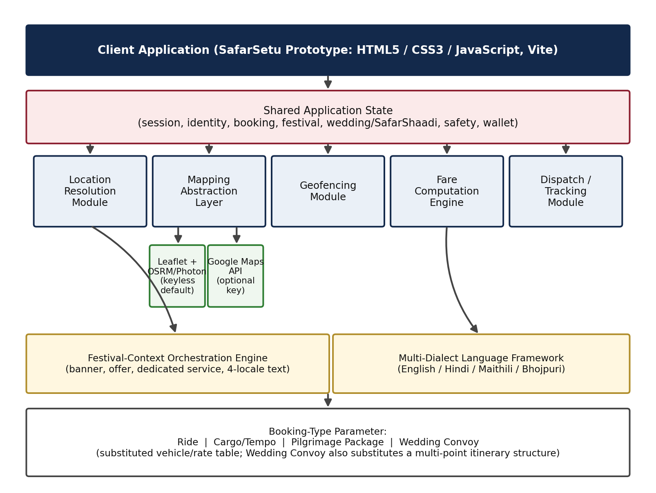
Fig. 1. SafarSetu system architecture. Five core modules operate on a shared application state; the mapping abstraction layer selects between a keyless default provider and an optional commercial provider; the festival and language engines act as cross-cutting layers over the booking pipeline.
A. Mapping Abstraction Layer
The mapping abstraction layer exposes a single interface — resolve pickup/drop coordinates, render a map, and compute route distance and duration — to the rest of the system. By default, this interface is backed by Leaflet for rendering, an OSRM-compatible service for route geometry (with a local great-circle-distance calculation as a secondary fallback when no route service is reachable), and a Photon/Nominatim-style service for place search and reverse geocoding, none of which require an API key. When an operator supplies a Google Maps API key through the application's configuration panel, the same interface is re-initialized against the Google Maps JavaScript API, Places Autocomplete, and Directions services. Because the geofencing module (Section IX) and the fare-computation engine (Section VIII, IX) consume only the coordinates, distance, and duration returned by this interface — not provider-specific data structures — neither module requires modification when the underlying provider changes.
B. Festival-Context Orchestration Engine
The festival-context orchestration engine maintains a set of predefined festival/seasonal states (for example, Chhath Puja, Durga Puja, wedding season, Eid, Gurpurab, and Christmas, alongside a neutral default). Each state is associated with a promotional banner configuration, a designated dedicated service or offer — for example, a free shuttle service to river ghats during Chhath Puja, or discounted decorated-vehicle pricing during wedding season — and parallel text content in each of the four supported languages. Selecting or automatically detecting an active state triggers a single state transition that updates all three associated elements together, rather than requiring independent configuration of the banner, the offer, and the localized text.
C. Multi-Dialect Language Framework
Interface text throughout the application is authored with parallel data attributes for English, Hindi, Maithili, and Bhojpuri. A single language-selection control causes all visible text, including dynamically generated festival banners, vendor listings, and system notifications, to re-render by resolving the active-language attribute at render time. This attribute-driven approach, rather than per-screen localized templates, is what allows festival and vendor content — which is generated dynamically rather than authored per-screen — to remain correctly localized without additional engineering for each new dynamic content type.
D. Shared Application State
The shared state object is organized into logical groups: session/UX state (current screen, active language, dark-mode and low-data flags, navigation history); identity state (user profile fields captured at registration); shared booking state (booking type, selected vehicle and fare, pickup/drop coordinates, route distance and duration); festival-engine state; wedding/SafarShaadi state (multi-stop itinerary, budget, spend, guest list, checklist, vendor bookings); safety state (women's-safety mode, trip-protection flag); and wallet/loyalty state (balance, loyalty-point total, active payment mode). This organization is what permits, for example, a festival mode selected on the home screen to immediately affect promotional content on the booking screen without a page transition or redundant state synchronization.
VII. PROPOSED METHODOLOGY
A. Shared Booking Pipeline
The central methodological contribution of this work is the design of a single booking pipeline, illustrated in Fig. 2, that is re-entered for all four supported booking types. The pipeline stages are: (1) booking-type selection, which sets a parameter determining the applicable vehicle/rate table and itinerary structure; (2) location resolution, in which pickup and, for non-wedding bookings, a single drop location (or, for wedding bookings, a sequence of named stops) are captured via autocomplete or map interaction; (3) geofence validation (Section IX); (4) mapping and route-geometry computation via the abstraction layer described in Section VI; (5) vehicle-class selection and itemized fare computation (Section VIII, IX); (6) dispatch simulation and live tracking; and (7) receipt generation and appending to booking history.
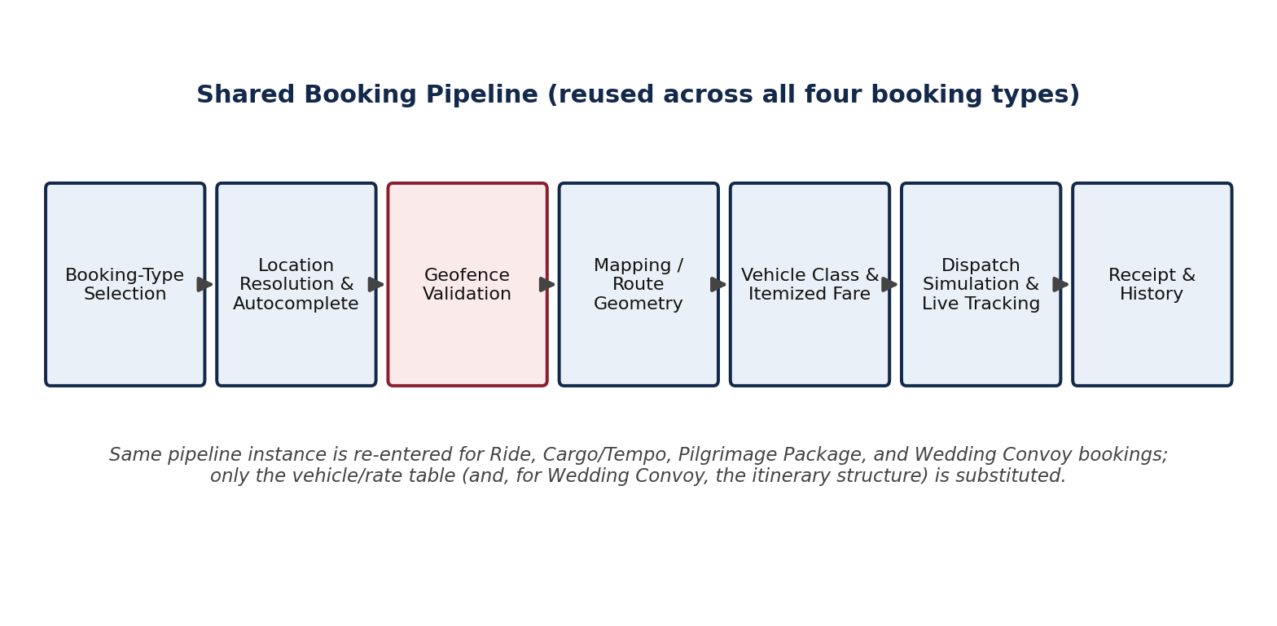
Fig. 2. Shared booking pipeline. The same seven-stage pipeline is re-entered for ride, cargo/tempo, pilgrimage-package, and wedding-convoy bookings; only the vehicle/rate table and, for wedding bookings, the itinerary structure are substituted.
Two booking types warrant specific note. Pilgrimage/outstation packages short-circuit stage (2) by pre-populating fixed pickup/drop coordinates and a fixed inclusive price associated with the selected package, then re-enter the pipeline at stage (3). Wedding-convoy bookings substitute a multi-stop itinerary structure (typically origin residence, ceremony venue, and reception venue) for the single pickup/drop pair used by the other three booking types, with stages (3)–(7) generalized to operate over the full stop sequence.
B. SafarShaadi: Integrated Wedding Transport and Vendor Marketplace
SafarShaadi extends the wedding-convoy booking type into a broader event-planning workflow, illustrated in Fig. 3. Entering the module for a given wedding creates an event record associated with the user account, comprising the multi-stop transport itinerary produced by the shared pipeline (Section VII-A), a filterable vendor marketplace (categories including catering, decoration, and photography, filterable by religion/caste preference captured during booking), a budget tracker holding a user-defined budget value and a cumulative-spend value, a guest manager (guest list with meal preference and RSVP status), and a ritual/task checklist (for example, Lagan, Godaan, Haldi, Matkor, and Jaimala milestones).
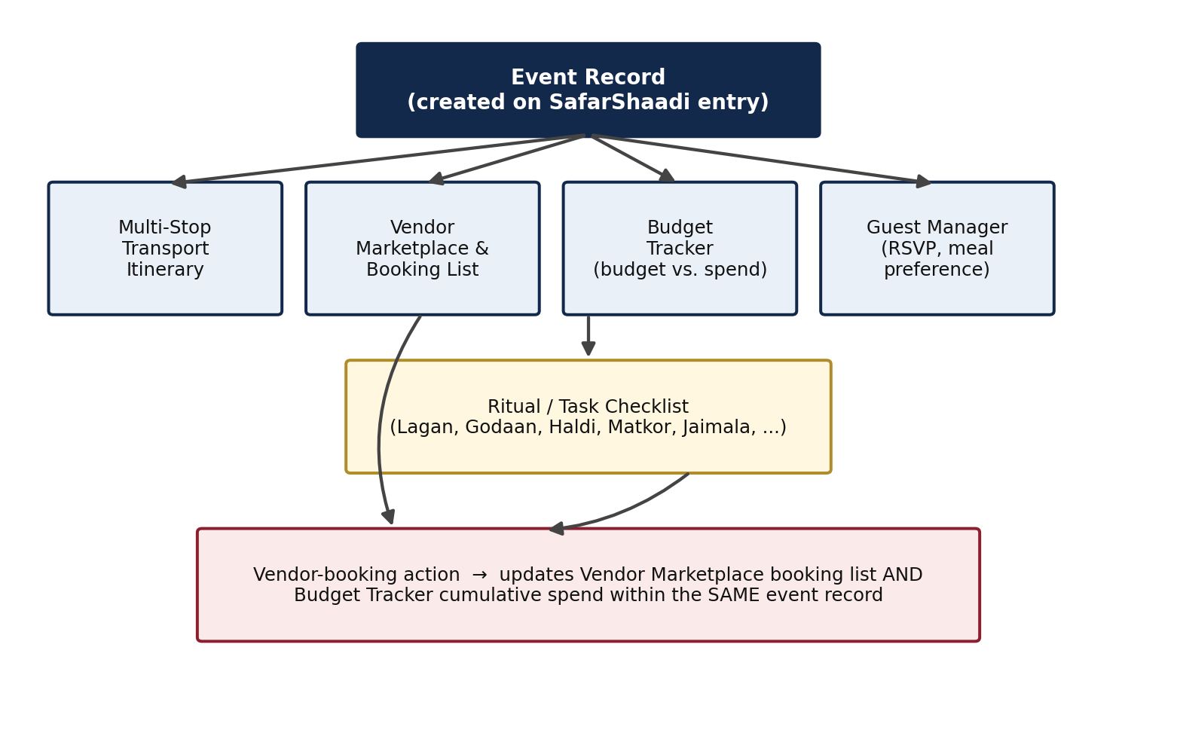
Fig. 3. SafarShaadi event-record data flow. A vendor-booking action updates both the vendor marketplace booking list and the budget tracker's cumulative-spend value within the same event record that holds the transport itinerary, guest list, and ritual checklist.
The methodologically significant property of this design is that a vendor-booking action — a user action taken within the marketplace component — updates two other components of the same event record (the vendor-booking list and the cumulative-spend value against the budget) without requiring the user to re-enter the transport-booking flow, and without the vendor-marketplace and budget-tracking functionality being implemented as separate applications or accounts, as they typically are in the incumbent-platform landscape reviewed in Section II.
C. Validation Strategy for the Present Study
Because this paper reports a system/architecture contribution rather than a field study, validation in the present work consists of (i) source-code-level verification that each described module and data flow is implemented as claimed, (ii) walkthrough-based confirmation that each of the seventeen distinct application screens (enumerated in the appendix-equivalent screen inventory omitted here for space) executes the described pipeline correctly across all four booking types, and (iii) the literature-grounded qualitative comparison presented in Section XI. Quantitative validation — controlled dispatch-latency benchmarking, load testing of a production backend, and a field user study — is scoped as future work (Section XV) and was not conducted for this prototype-stage submission.
VIII. ALGORITHM
A. Fare Computation Algorithm
Algorithm 1 presents the itemized fare-computation procedure applied to a selected vehicle class after route distance and duration have been resolved by the mapping abstraction layer. The procedure is common to all four booking types; only the base-fare and per-kilometre rate constants differ by vehicle class and booking type.
Algorithm 1: ComputeItemizedFare
Input: vehicleClass, distanceKm, durationMin,
protectionSelected (boolean)
Output: fareBreakdown

1 base <- BaseFare[vehicleClass]
2 distCharge <- distanceKm * PerKmRate[vehicleClass]
3 timeCharge <- durationMin * PerMinRate[vehicleClass]
4 subtotal <- base + distCharge + timeCharge
5 if bookingType = RIDE and distanceKm > SurgeThresh then
6 surgeMult <- CurrentSurgeMultiplier()
7 subtotal <- subtotal * surgeMult
8 else
9 surgeMult <- 1.0
10 protectionFee <- protectionSelected ? ProtFee : 0
11 taxable <- subtotal + protectionFee
12 tax <- taxable * GST_RATE
13 total <- taxable + tax
14 return {base, distCharge, timeCharge, surgeMult,
protectionFee, tax, total}
The procedure is re-evaluated on every change to vehicle class or protection selection prior to booking confirmation, so that the itemized breakdown displayed to the user (Section IX, eq. 1–3) always reflects the current selection.
B. Geofence Validation Algorithm
Algorithm 2 presents the geofence validation procedure applied to both the pickup and drop coordinates (or, for wedding-convoy bookings, to every stop in the itinerary) prior to allowing the booking pipeline to proceed to fare computation.
Algorithm 2: ValidateGeofence
Input: coordList = [(lat_1,lon_1), ..., (lat_n,lon_n)],
boundary = (latMin, latMax, lonMin, lonMax)
Output: isValid (boolean), violatingIndex

1 for i <- 1 to n do
2 (lat, lon) <- coordList[i]
3 if lat < boundary.latMin or lat > boundary.latMax
4 or lon < boundary.lonMin or lon > boundary.lonMax
5 then
6 return (false, i)
7 return (true, null)
This bounding-box test is deliberately provider-agnostic: coordList is populated identically regardless of whether the mapping abstraction layer (Section VI) is currently backed by the keyless default provider or by the optional commercial provider, so Algorithm 2 requires no modification when the mapping provider changes.
C. Time and Space Complexity
Algorithm 1 executes in O(1) time and space with respect to route complexity, since it operates on scalar distance and duration values rather than the full route geometry. Algorithm 2 executes in O(n) time and O(1) additional space with respect to the number of coordinates validated (n = 2 for standard ride/cargo/pilgrimage bookings; n equal to the number of stops for wedding-convoy bookings, typically 3–5). Route-geometry computation itself is delegated to the underlying provider: OSRM's contraction-hierarchy approach yields sub-second query latency in the general case [13], while the great-circle-distance fallback used when no route service is reachable executes in O(1) time via the haversine formula (Section IX, eq. 4).
D. Optimization Discussion
Because Algorithm 1 and Algorithm 2 are both low-complexity relative to network and route-computation latency, the dominant cost in the current prototype is the round-trip latency to the active mapping provider. The keyless default path (Leaflet/OSRM/Photon) and the commercial path (Google Maps) are architecturally interchangeable at this boundary (Section VI), so provider-level latency optimization — for example, response caching for frequently requested origin-destination pairs, or pre-computed distance matrices for fixed pilgrimage packages (Section VII-A) — is identified as a natural optimization target for the backend implementation scoped in Section XV, rather than as a change to Algorithm 1 or Algorithm 2 themselves.
IX. MATHEMATICAL MODEL
A. Notation
TABLE II
NOTATION USED IN THE FARE AND GEOFENCE MODEL
Symbol | Meaning
Fb, Fd, Ft | Base, per-km distance, and per-min time fare components
d, t | Route distance (km) and duration (min) for the trip
Cd, Ct | Per-km and per-min rate constants for the selected vehicle class
m | Surge multiplier, m ≥ 1
dth | Distance threshold above which surge is evaluated
p | Protection (insurance) flag, p ∈ {0,1}
Fp | Flat protection fee
r | GST tax rate
Ftot | Final itemized total fare
φ, λ | Latitude and longitude of a coordinate, in radians
R | Mean radius of the Earth (6371 km)
B. Fare Computation Model
The base, distance, and time fare components are computed as:
Fb = BaseFare(v), Fd = d · Cd(v), Ft = t · Ct(v) (1)
where v denotes the selected vehicle class, and m is a conditional surge multiplier, defined in equation (2b), applied only when the route distance exceeds a configured threshold for standard ride bookings. The pre-tax subtotal is:
S = (Fb + Fd + Ft) · m (2a)
m = M(d,t) if d > dth, else m = 1 (2b)
where M(d,t) is a demand-responsive surge function, consistent with the conditional surge-evaluation logic in Algorithm 1, line 5. The final itemized total is:
Ftot = (S + p·Fp) · (1 + r) (3)
Equations (1)–(3) correspond directly to lines 1–13 of Algorithm 1 and are re-evaluated whenever v or p changes.
C. Geofence Validation Model
A coordinate (φ, λ) is considered within the configured service-area boundary B = [φmin, φmax] × [λmin, λmax] if and only if:
φmin ≤ φ ≤ φmax ∧ λmin ≤ λ ≤ λmax (4)
A booking is admitted only if every coordinate in its associated coordinate set — {pickup, drop} for standard bookings, or the full stop sequence for wedding-convoy bookings — satisfies (4), corresponding to Algorithm 2.
D. Route Distance Fallback Model
When no network route-geometry service is reachable, route distance is approximated using the haversine great-circle distance between the pickup coordinate (φ1, λ1) and drop coordinate (φ2, λ2):
a = sin²(Δφ/2) + cos φ1 · cos φ2 · sin²(Δλ/2) (5)
d = 2R · atan2(√a, √(1−a)) (6)
where Δφ = φ2 − φ1 and Δλ = λ2 − λ1. This fallback value is substituted for the provider-computed distance in equation (1) when the mapping abstraction layer (Section VI) cannot reach a route-geometry service, preserving the fare-computation pipeline's availability under degraded connectivity.
E. Budget-Tracking Model (SafarShaadi)
For an event record with user-defined budget Bu and a set of committed vendor bookings {c1, ..., ck} with individual costs, the cumulative spend and remaining budget after the j-th vendor-booking action are:
Spend_j = Σ(i=1..j) c_i, Remaining_j = Bu − Spend_j (7)
Both Spend_j and Remaining_j are recomputed and re-rendered immediately upon each vendor-booking action, consistent with the cross-module update behavior described in Section VII-B.
X. IMPLEMENTATION AND EXPERIMENTAL SETUP
This section describes the actual development and build environment used to implement and inspect the prototype discussed in this paper. As noted in Section VII-C, no field or load-testing environment was used, since no such evaluation was conducted for this submission.
TABLE III
IMPLEMENTATION ENVIRONMENT
Component | Detail
Application language | JavaScript (ES6+), HTML5, CSS3
Build tool | Vite 5.x (development server and production bundler)
Package manifest | safarsetu-prototype, v1.0.0
Default map rendering | Leaflet.js 1.9.4
Default routing/geocoding | OSRM-compatible route geometry; Photon/Nominatim-style place search
Optional map provider | Google Maps JavaScript API (operator-supplied key)
Optional routing provider | OpenRouteService (operator-supplied key)
Deployment tooling | gh-pages (static hosting build/deploy scripts)
Typography | Inter (Latin script), Baloo 2 (Devanagari-compatible headings)
The prototype was reviewed via direct source-code inspection (index.html, index.js, index.css) and via a recorded on-screen walkthrough exercising all seventeen distinct application screens across all four booking types, the SafarShaadi module, the settings/safety screens, and the demonstration-only simulation controls (e.g., forced driver-match, simulated offline mode) that the presentation build exposes for evaluation purposes. No production backend, driver-side application, or payment-gateway integration exists at the time of writing; these are scoped as implementation targets in Section XV rather than components evaluated in this paper.
XI. QUALITATIVE EVALUATION AND FEATURE COMPARISON
Because SafarSetu has not yet undergone field deployment, this section reports a qualitative, literature-grounded feature comparison rather than field performance metrics (e.g., trip completion rate, matching latency, or user-satisfaction scores), consistent with the validation strategy stated in Section VII-C. Table IV compares the feature set described in Sections VI–VII against capabilities documented in the reviewed literature for (a) mainstream commercial ride-hailing architectures as characterized in the dispatch/pricing literature [1]–[5], and (b) the gender-aware ride-hailing prototype and safety-feature analysis reported for the Indian market by Kushwaha et al. [11].
TABLE IV
QUALITATIVE FEATURE COMPARISON (LITERATURE-GROUNDED)
Feature | Mainstream ride-hailing lit. [1]–[5] | India-focused safety study [11] | SafarSetu (this work)
Single-provider mapping dependency | Assumed | Not discussed | Avoided by design (Sec. VI)
Regional dialect UI beyond national language(s) | Not discussed | Not discussed | Present (4 locales, Sec. VI)
Cargo/goods booking in same session as passenger ride | Not discussed | Not discussed | Present (Sec. VII-A)
Wedding-convoy multi-stop booking | Not discussed | Not discussed | Present (Sec. VII-A)
Transport + vendor-marketplace integration for one event | Not discussed | Not discussed | Present — SafarShaadi (Sec. VII-B)
Women's-safety mode w/ emergency dispatch link | Not discussed | Present (SOS, tracking) [11] | Present (Sec. VII)
Itemized, pre-confirmation fare breakdown | Pricing studied; itemization not emphasized [1] | Fare transparency highlighted as valued [11] | Present (Sec. IX, eq. 1–3)
Festival/seasonal service reconfiguration | Not discussed | Not discussed | Present (Sec. VI)
This comparison should be read as a positioning exercise, not as a claim of superiority on any metric that would require field measurement (e.g., actual matching latency, actual driver availability, or actual user satisfaction) — none of which have been measured for SafarSetu at the time of writing. Where the literature reports a specific finding (for example, the safety-feature valuation reported in [11] and [15]), the corresponding SafarSetu capability is presented as architecturally responsive to that finding rather than as empirically validated against it.
XII. DISCUSSION
A. Interpretation
The design presented in Sections VI–IX indicates that it is architecturally feasible to serve four heterogeneous regional transport service categories from a single shared pipeline, provided that provider-specific details (mapping source, vehicle/rate table, itinerary structure) are isolated behind narrow interfaces consumed identically by the fare and geofencing modules. This is consistent with, though not a direct test of, general software-architecture principles of interface segregation; its specific contribution here is demonstrating the pattern in the under-studied context of regionally heterogeneous, low-resource-language, keyless-first transport dispatch.
B. Strengths
The principal strength of the design is its avoidance of a hard dependency on a commercial mapping API for baseline operation (Section VI), which directly addresses the cost-sensitivity and provider-outage risks identified in Section III without requiring a separate codebase or fallback mode to be maintained. A second strength is the explicit, itemized fare model (Section IX), which is directly responsive to the fare-transparency preference documented in the Indian ride-hailing literature [11]. A third strength is the SafarShaadi cross-module state design (Section VII-B), which is, to the authors' knowledge, not documented in the reviewed MaaS or ride-hailing literature (Section II).
C. Weaknesses and Practical Implications
The design's principal weakness, addressed directly in Section XIII, is that it has been evaluated only at the architecture and source-code level; no claims are made in this paper about production-scale dispatch latency, concurrent-user behavior, or real driver/vendor supply, all of which materially affect whether the shared-pipeline design would perform acceptably under real operating conditions. Practically, the design implies that a production implementation would need to add a backend dispatch service, a driver-side application, and a payment-gateway integration (Section X), none of which are addressed by the present client-side prototype.
D. Industrial and Research Implications
For industrial practice, the design suggests that regionally deployed transport platforms serving Tier-2/3 markets may benefit from architecting mapping-provider access as a replaceable abstraction from the outset, rather than retrofitting a fallback after a single-provider dependency is established. For research, the SafarShaadi transport-plus-marketplace integration pattern, and the festival-context orchestration mechanism, represent design patterns not previously documented in the MaaS literature reviewed in Section II-F and may be of independent interest for future MaaS integration-level taxonomies such as that of Cisterna et al. [16].
E. Unexpected Findings
During source-code review, the extent to which a single shared application-state object (Section VI-D) simplified cross-cutting features — in particular, the propagation of a festival-mode change into both promotional content and fare-relevant offers without additional integration code — was more complete than anticipated at the outset of this review, suggesting that the shared-state pattern may generalize further than the four booking types currently implemented (for example, to future service categories such as intercity freight or event catering delivery), a possibility noted further in Section XV.
XIII. THREATS TO VALIDITY
A. Internal Validity
The architectural claims in this paper (Sections VI–IX) are based on direct source-code inspection and walkthrough review by the authors rather than independent third-party code audit, which is a threat to the internal validity of the claim that the implementation matches the description. This threat is partially mitigated by cross-referencing the recorded product walkthrough against the source code for every described screen and booking type, but a formal code review or automated test suite was not available at the time of writing.
B. External Validity
Because no field deployment has occurred, no claim is made, or should be inferred, about how the design would perform under real user load, real driver/vendor supply constraints, or real network conditions in Bihar. The qualitative comparison in Section XI is grounded in literature describing other systems' documented capabilities, not in a head-to-head empirical comparison, and should not be read as evidence that SafarSetu outperforms the compared systems on any measured dimension.
C. Construct Validity
The "unified platform" and "keyless-first mapping" constructs central to this paper's contributions (Section V) are operationalized here as architectural properties verifiable by code inspection (e.g., shared pipeline reuse, absence of a required API key for baseline operation). Whether these architectural properties translate into the user-facing benefits motivated in Section III — reduced application-switching burden, lower operating cost, improved accessibility — would require a user study and cost analysis not conducted in this work.
D. Conclusion Validity
No statistical inference is drawn in this paper; all comparisons in Section XI are qualitative and literature-grounded. Consequently, conclusion-validity threats associated with statistical testing (e.g., sample size, effect size estimation) do not apply to the present work, but this also means the paper's claims should be read at the level of architectural feasibility and design rationale rather than as measured performance claims.
E. Bias and Mitigation
As the authors of this paper are also the developers of the reviewed prototype, a risk of favorable self-assessment bias exists, particularly in Section XI and Section XII-B. This is mitigated by explicitly scoping all quantitative and field-validation claims out of this paper (Section VII-C) and by stating comparisons in capability terms ("present/not discussed in the reviewed literature") rather than in performance-superiority terms wherever a fielded comparison was not conducted.
XIV. CONCLUSION
This paper presented SafarSetu, a prototype system architecture that unifies passenger ride-hailing, cargo transport, pilgrimage/outstation packages, and wedding-convoy booking under a single geofenced, shared booking pipeline, and that extends wedding-convoy booking into an integrated transport-plus-vendor-marketplace module, SafarShaadi. The design addresses four specific problems identified in the regional (Tier-2/3 Indian) deployment context — application fragmentation, mapping-provider dependency, regional-language exclusion, and wedding-logistics coordination overhead — through a dual-mode, provider-agnostic mapping abstraction, a festival-context orchestration engine coupling promotional, service, and four-language localization state, and a cross-module wedding-event data model. The system's fare-computation and geofence-validation logic were presented as pseudocode and as a closed-form mathematical model, and the design was positioned against related work in ride-hailing dispatch, dynamic pricing, geofencing, low-resource regional-language technology, and Mobility-as-a-Service integration.
As the reviewed implementation is a client-side prototype without a production backend or field deployment, this paper's contribution is architectural rather than empirical: it documents a design capable, on inspection, of the stated capabilities, and it does not report — and explicitly does not claim — field-validated performance results. The principal technical contribution is demonstrating that this specific combination of capabilities can be realized within a single shared codebase and account context, a combination not documented in the reviewed literature for any single system.
XV. FUTURE WORK
A. Backend Implementation and Scalability
The immediate next step is implementation of a production backend dispatch service, a driver-side application, and persistent, multi-user data storage, replacing the client-only prototype's local state. This would allow the shared-pipeline architecture described in Section VII to be evaluated under the multi-user, concurrent-request conditions that the dispatch literature reviewed in Section II-A addresses, including formal benchmarking of matching latency and throughput against the reinforcement-learning-based approaches surveyed in [3], [4].
B. Controlled Benchmarking
Prior to field deployment, controlled benchmarking of the mapping abstraction layer (Section VI-A) is planned, comparing request latency and route-quality metrics between the keyless default path and the commercial-provider path under representative Bihar road-network conditions, extending the evaluation methodology used for OSRM-based systems in prior open-routing literature [13], [14].
C. Field Pilot and User Study
A limited-scope field pilot, likely in Patna and one or two secondary towns, is planned as the primary mechanism for obtaining the field performance data explicitly not reported in this paper (Section VII-C, XIII-B), including trip-completion rate, driver/vendor supply adequacy, and — specifically motivated by the safety literature reviewed in Section II-E [11], [15] — a structured user study of the women's-safety mode's perceived and actual effect on ride uptake among women passengers.
D. Real-World Deployment and Commercialization
Deployment planning includes driver and vendor onboarding workflows, a payment-gateway integration (UPI, wallet, and cash reconciliation), and regulatory compliance review for cargo transport and passenger ride-hailing under applicable Indian state and central motor-vehicle aggregator regulations, which were outside the scope of the architectural review presented in this paper.
E. Emerging Technology Extensions
Longer-term extensions under consideration include demand-forecasting-driven pre-positioning of the festival-context orchestration engine (Section VI-B), informed by the reinforcement-learning-based repositioning literature [3], [4]; extension of the multi-dialect language framework (Section VI-C) to additional Purvanchal-region languages using the corpus and NER resources reported in [6]–[8]; and generalization of the shared booking pipeline (Section VII-A) to additional service categories such as intercity freight, consistent with the extensibility observation noted in Section XII-E.
ACKNOWLEDGMENT
The authors thank the reviewers of this manuscript for their time and constructive feedback. This work was carried out as part of the author's independent academic project development at Lovely Professional University, Phagwara, Punjab, India. [Additional acknowledgments — e.g., faculty supervision, institutional support, or funding — to be completed by the authors.]
REFERENCES
[1] C. Yan, H. Zhu, N. Korolko, and D. Woodard, "Dynamic pricing and matching in ride-hailing platforms," Naval Research Logistics, vol. 67, no. 8, pp. 705–724, 2020.
[2] Z. Xu et al., "Large-scale order dispatch in on-demand ride-hailing platforms: A learning and planning approach," in Proc. 24th ACM SIGKDD Int. Conf. Knowledge Discovery & Data Mining (KDD), 2018, pp. 905–913.
[3] G. Guo and Y. Xu, "A deep reinforcement learning approach to ride-sharing vehicle dispatching in autonomous mobility-on-demand systems," IEEE Intelligent Transportation Systems Magazine, vol. 14, no. 1, pp. 128–140, Jan. 2022.
[4] Z. T. Qin, H. Zhu, and J. Ye, "Reinforcement learning for ridesharing: An extended survey," Transportation Research Part C: Emerging Technologies, vol. 144, art. 103852, 2022.
[5] N. D. Kullman, M. Cousineau, J. C. Goodson, and J. E. Mendoza, "Dynamic ride-hailing with electric vehicles," Transportation Science, vol. 56, no. 3, pp. 775–794, May 2022.
[6] R. K. Mundotiya, M. K. Singh, R. Kapur, S. Mishra, and A. K. Singh, "Linguistic resources for Bhojpuri, Magahi, and Maithili: Statistics about them, their similarity estimates, and baselines for three applications," ACM Trans. Asian Low-Resource Lang. Inf. Process., vol. 20, no. 6, pp. 1–37, 2021.
[7] A. Priyadarshi and S. K. Saha, "Towards the first Maithili part of speech tagger: Resource creation and system development," Computer Speech & Language, vol. 62, art. 101054, 2020.
[8] A. Priyadarshi and S. K. Saha, "The first named entity recognizer in Maithili: Resource creation and system development," Journal of Intelligent & Fuzzy Systems, vol. 41, no. 1, pp. 1083–1095, 2021.
[9] "Pricing fast and slow: Limitations of dynamic pricing mechanisms in ride-hailing," Transportation Research Part C: Emerging Technologies, ScienceDirect, 2025.
[10] "Balancing privacy and revenue: A differentially private dynamic pricing algorithm for ride-hailing," Transportation Research Part C: Emerging Technologies, ScienceDirect, 2025.
[11] P. Kushwaha, N. Khare, P. Kumar, and R. R. Srivastava, "Safe rides, fair prices: A comprehensive analysis of India's ride-hailing sector," International Journal of Scientific Research in Computer Science and Engineering, vol. 13, no. 3, pp. 40–47, Jun. 2025.
[12] P. Deshmukh, A. Bhajibhakre, S. Gambhire, A. Channe, and N. Deshpande, "Survey of geofencing algorithms," International Journal of Computer Science, Engineering and Technology, vol. 3, no. 2, 2018.
[13] D. Luxen and C. Vetter, "Real-time routing with OpenStreetMap data," in Proc. 19th ACM SIGSPATIAL Int. Conf. Advances in Geographic Information Systems (GIS), 2011, pp. 513–516.
[14] T. Giraud, "osrm: Interface between R and the OpenStreetMap-based routing service OSRM," Journal of Open Source Software, vol. 7, no. 78, p. 4574, 2022.
[15] G. Torrao, A. Htait, and S. H. S. Wong, "Perceptions of women's safety in transient environments and the potential role of AI in enhancing safety: An inclusive mobility study in India," Sustainability, vol. 16, no. 19, art. 8631, 2024.
[16] C. Cisterna, N. Madani, C. Bandiera, F. Viti, and M. Cools, "MaaS modelling: A review of factors, customers' profiles, choices and business models," European Transport Research Review, vol. 15, no. 1, pp. 1–18, 2023.

