**ISRO – Telemetry Tracking and Command Network (ISTRAC)**



**TITLE: COMPARISON OF OPTIMISATION ALGORITHMS IN CNNs IN MALWARE CLASSIFICATION ON THE MALEVIS DATASET**

UNDER THE GUIDANCE OF

Bharat Devasani

Scientist/Engineer-SE, CND, CSSN, ISTRAC

**SUBMITTED BY**

**Hrishikesh H Chandra Reg No: 01JST21IS017**

**STUDENT OF**

**JSS SCIENCE AND TECHNOLOGY UNIVERSITY – JSS STU**

**JSS TECHNICAL INSTITUTIONS CAMPUS, MYSORE - 57006**

**ACKNOWLEDGEMENT**

If words are considered as symbols of approval and tokens of acknowledgement, then let the words play the heralding role of expressing my gratitude to all those who have directly or indirectly helped during my period of internship.

I am delighted to thank **Dr. A. K. ANILKUMAR, Director, ISRO Telemetry, Tracking, and Command Network (ISTRAC), Bengaluru, Karnataka,** for giving me permission to pursue my Internship in ISTRAC, BENGALURU.

I express my gratitude to **Mr. SANKAR MADASWAMY B, Scientist/Engineer-SG, Manager, HRDD, ISTRAC,** for permitting me to undertake my internship.

My sincere thanks also goes to my guide **Mr. Bharath Devasani, Scientist/Engineer-SE, ISTRAC,** for his mentorship, constructive feedback, and technical insights. His meticulous approach and encouragement have greatly enhanced my understanding and technical proficiency.

I sincerely thank you all whole-heartedly for sparing your valuable time quite often, despite the heavy workload. The discussions had provided me with valuable insights into the workings of ISRO. Finally, I would like to thank my people (my parents, friends and university) for their continuous support in every field of my life.

**HRISHIKESH H CHANDRA**

**USN: 01JST21IS017**

**Abstract**

This report presents the design, implementation, and evaluation of a deep learning-based malware classification framework, developed using the MaleVis dataset, which comprises RGB visual representations of malware binaries. The project investigates the efficacy of convolutional neural networks (CNNs) in malware detection and conducts a comparative analysis of three optimization algorithms—Stochastic Gradient Descent (SGD), Adam, and Lion—on model performance and convergence behaviour.

The system architecture is structured around a training pipeline that processes the MaleVis dataset, which includes 25 malware families, and converts them into a structured format suitable for input into modern CNN models. DenseNet-121 was selected as the base architecture due to its proven performance in the referenced literature. The training and validation routines were implemented using PyTorch, and were configured to support training from scratch, avoiding pre-trained weights to match the original study's methodology.

A key contribution of this project is the extended experimentation with optimizers beyond the baseline SGD. Both Adam and Lion optimizers were integrated into the training pipeline and evaluated under identical training conditions. Performance metrics including accuracy, precision, and recall were used to assess the generalization ability of each optimizer. Comparative results showed notable variations in training speed, convergence rates, and final classification accuracy across the three optimizers.

Extensive testing was conducted to validate the system’s reliability and performance consistency on CPU-based execution environments. Additionally, the project addresses resource constraints such as GPU memory limitations and proposes solutions for training efficiency on lower-spec systems. Screenshots of training logs and metric graphs are included to demonstrate the experimental outcomes.

Future directions include extending the dataset with real-world samples, exploring data augmentation techniques, and deploying the trained model in a real-time malware detection system. Overall, this project offers a reproducible and extensible framework for static malware classification using vision-based deep learning techniques, providing insights into the impact of optimizer choice on model performance.

**Table of Contents Page No.**

ACKNOWLEDGEMENT……………………………………………..2

ABSTRACT……………………………………………………………3

1. CHAPTER – 1
2. Introduction……………………………………………….7
3. Aim of the Project………………………………………...8
4. Methodology……………………………………………...8
5. Significance……………………………………………….10
6. CHAPTER- 2

Literature review

1. Vulnerability Assessment and Penetration Testing to Enhance the Security of Web Application……………………………..11
2. Utilization and Comparison of Convolutional Neural Networks in Malware Recognition……………………………………..12
3. State-based Sandbox Tool for Distributed Malware Detection with Avoid Techniques………………………………………...13
4. Security Operations Centres for Information Security Incident Management………………………………………………14
5. Security Operations Centre: A Systematic Study and Open Challenges………………………………………………...15
6. Malware Analysis in Cyber Security Based on Deep Learning: Recognition and Classification……………………………16
7. Lightweight Behavioural Malware Detection for Windows Platforms…………………………………………………..17
8. Comparative Analysis of Automated Scanning and Manual Penetration Testing for Enhanced Cyber security………...18
9. CHAPTER – 3

Implementation

1. Dataset acquisition and Pre-processing…………………..19
2. Model Development and Configuration…………………20
3. Optimizer Trials and Training Strategy…………………..21
4. Validation Methodology and Output Interpretation……..22
5. CHAPTER- 4

Observations and discussion

1. Optimizer-Wise Performance Comparison……………...24
2. Observation summary …………………………………..25
3. Visual representation and discussion……………………27
4. Discussion on Optimizer Behaviour and Trade-offs……31
5. CHAPTER- 5

Results and conclusion..……….……………………………………33

REFERENCES…………………………………………………………...35

# List of Tables

**Table 1:** Performance Comparison of Optimizers (SGD, Adam, Lion) on DenseNet121 and

ResNet18 Models…………………………………………………………...24

**Table 2**: Total observations summary table………………………………………………26

**Table 3**: Optimizer trade-offs table ………………………………………………………32

# List of Figures

Figure 1: Bar chart comparing validation accuracy of DenseNet121 and ResNet18 models across three optimizers (SGD, Adam, Lion)………………………………………………27

Figure 2: Bar chart showing macro-averaged precision for DenseNet121 and ResNet18 using three optimizers (SGD, Adam, Lion)……………………………………………………...28

Figure 3: Accuracy vs. Epochs for DenseNet121 using SGD, Adam, and Lion optimizers…………………………………………………………………………………..29

Figure 4: Accuracy vs. Epochs for ResNet18 using SGD, Adam, and Lion optimizers…………………………………………………………………………………..30

1. **Chapter – 1**
2. **Introduction**

Malware, or malicious software, continues to pose a serious threat to cyber security in today's interconnected world. With the exponential growth of software systems and the increasing sophistication of malware, detecting and classifying malicious programs has become more critical than ever. Traditional malware detection methods, primarily relying on manual feature engineering and signature-based approaches, are often insufficient against rapidly evolving threats.

In response to this challenge, recent research has explored the potential of machine learning and deep learning techniques, particularly computer vision methods, for static malware classification. A promising approach involves converting malware binary files into visual image representations, allowing powerful Convolutional Neural Networks (CNNs) to automatically learn distinguishing features for classification tasks.

This project builds upon the research study titled "Utilization and Comparison of Convolutional Neural Networks in Malware Recognition" by Ahmet Selman Bozkir, Ahmet Ogulcan Cankaya, and Murat Aydos from Hacettepe University. The study investigates the effectiveness of various CNN architectures, such as DenseNet, ResNet, on the MaleVis malware image dataset. Our work extends this research by implementing a similar methodology while introducing additional experiments comparing different optimization algorithms—namely Stochastic Gradient Descent (SGD), Adam, and Lion—to analyze their impact on training performance and classification accuracy.

Through extensive experimentation on the MaleVis dataset, using both DenseNet121 and ResNet18 architectures, this project evaluates the effectiveness of each optimizer in achieving optimal performance for malware classification. The outcomes contribute valuable insights into model optimization strategies and offer practical recommendations for enhancing static malware detection systems using computer vision techniques.

1. **Aim of the project**

The aim of this project is to investigate and advance the use of computer vision-based deep learning techniques for static malware classification. By converting malware binary files into RGB image representations, the project utilizes Convolutional Neural Networks (CNNs) to learn and identify patterns associated with various malware families. The study specifically focuses on evaluating two widely used CNN architectures—DenseNet121 and ResNet18—on the MaleVis dataset, a publicly available benchmark for visual malware classification.

In addition to replicating aspects of prior research, this work extends the baseline by conducting a comprehensive comparison of different optimization algorithms—Stochastic Gradient Descent (SGD), Adam, and Lion—with the objective of improving classification performance in terms of accuracy, precision, and recall. The project examines how each optimizer influences the learning dynamics, convergence rate, and generalization ability of the models, providing valuable insights into training strategy selection for malware detection tasks.

Through systematic experimentation, performance evaluation, and visual analysis, the project aims to determine the most effective combinations of architecture and optimization strategy for static malware classification. The outcomes are intended to support future work in cyber security by contributing practical techniques for developing efficient, scalable, and accurate malware recognition systems using deep learning.

1. **Methodology**

The methodology adopted in this project revolves around evaluating and comparing the impact of different optimization algorithms on CNN-based static malware classification using the MaleVis dataset. The overall goal is to explore how various optimizers influence model convergence and classification performance when applied to visual representations of malware binaries. This section outlines the complete experimental framework including dataset handling, model design, training protocols, and performance evaluation.

To begin with, the MaleVis dataset was selected due to its structure and alignment with previous research in this field. It contains malware samples from 25 different families, each represented as RGB images derived from raw Portable Executable (PE) files. The dataset was already pre-processed into 224×224 and 300×300 resolution images, categorized into separate directories for training and validation. The RGB format of the images was preserved throughout the study, and additional pre-processing steps included resizing, tensor conversion, and normalization using standard ImageNet statistics. This ensured consistency in pixel distributions across training samples and aided the neural networks in learning robust patterns.

Two convolutional neural network architectures—DenseNet121 and ResNet18—were chosen for experimentation based on their widespread adoption and effectiveness in image classification tasks. These models were implemented using the PyTorch framework, with modifications made to their final classification layers to support 26 output classes corresponding to the dataset. The networks were trained from scratch without using any pre-trained weights, thereby allowing a fair comparison with the training conditions used in the original reference study.

The primary focus of the study was to assess the effect of different optimizers on model performance. Three optimizers were tested: Stochastic Gradient Descent (SGD), Adam, and Lion. For each model–optimizer pair, independent training sessions were carried out using identical hyper parameters wherever applicable. The learning rate was set to 0.01 across all experiments, and a momentum of 0.8 was used for SGD. Each model was trained for 14 epochs with a batch size of 32, using the CPU for training due to hardware limitations. All optimizer-specific configurations were carefully implemented to ensure consistency across training runs.

Model validation was performed on the designated validation subset of the MaleVis dataset. Key performance metrics such as accuracy, precision, and recall were computed for each configuration to assess classification quality. These metrics were selected because they provide a comprehensive view of both correctness and robustness of predictions, especially important in multi-class malware recognition scenarios. Visual plots showing the progression of accuracy over epochs and comparative bar charts for performance metrics were generated to aid interpretation.

The final phase of the methodology involved comparative analysis. All results were tabulated in a unified results summary table, which included optimizer type, model architecture, final performance metrics, and convergence behaviour. These results were analysed to determine the most effective combinations and to understand trade-offs between training stability and classification quality. Through this experimental pipeline, the project offers a detailed and reproducible approach to studying optimizer behaviour in CNN-based malware classification using visual data.

## Significance

Malware continues to be a pervasive threat to modern digital infrastructure, necessitating the development of innovative detection strategies that are both accurate and computationally efficient. This project explores an emerging approach to static malware classification by leveraging visual representations of binary files and applying deep convolutional neural networks (CNNs) to detect and categorize malicious software. By focusing on optimizing training performance using different gradient-based optimizers—SGD, Adam, and Lion—on well-established CNN architectures like DenseNet121 and ResNet18, this study advances the understanding of how optimizer choice can significantly affect classification accuracy, convergence speed, and generalization. The use of the MaleVis dataset, a publicly available and reproducible benchmark, ensures that the findings can be validated and extended by the broader research community. The insights generated from this work are particularly valuable for security practitioners, researchers, and developers who aim to design scalable, static analysis-based malware detection systems using deep learning. Furthermore, the methodology and comparative results outlined in this report provide a practical reference for future work in optimizer tuning and CNN design for cybersecurity applications.

# Chapter- 2

## Literature review

## Vulnerability Assessment and Penetration Testing to Enhance the Security of Web Application

**Authors:** Arvind Goutam, Vijay Tiwari

**Date Published:** 2019

This paper explores the importance of securing web applications, especially in financial institutions where sensitive data is regularly transacted over the internet. The authors develop a prototype financial web application and conduct both vulnerability assessment and penetration testing to identify potential security flaws. The methodology is divided into planning, discovery, scanning, vulnerability exploitation, and data extraction. The testing includes manual techniques like SQL injection and Google dorking to simulate real-world attacks. Based on the identified vulnerabilities, a secure framework is proposed to serve as a security blueprint for future development.

Advantages: The paper provides a complete real-world framework simulating financial sector web applications .It emphasizes practical application of penetration testing methodologies, covering both manual and automated approaches the structure of the methodology (planning, discovery, exploitation, extraction) is clearly defined and organized.

Disadvantages: The research is focused only on web application security and does not extend to broader areas like malware detection. There is a lack of detailed quantitative analysis, such as vulnerability metrics or performance benchmarks.

Relevance:

This work highlights the need for rigorous testing in the development phase to ensure the resilience of applications against common threats. While it addresses web application security rather than malware classification, the structured approach to identifying and mitigating threats complements static malware analysis methods. The paper reinforces the importance of preventive frameworks—something that deep learning models like CNNs can contribute to through early malware detection mechanisms.

## Utilization and Comparison of Convolutional Neural Networks in Malware Recognition

**Authors:** Ahmet Selman Bozkir, Ahmet Ogulcan Cankaya, Murat Aydos

**Date Published:** 2019

This research is foundational in applying deep learning to static malware classification. The authors introduce a novel RGB image-based representation of malware binaries and test five convolutional neural network (CNN) architectures—DenseNet, ResNet, Inception, VGG, and AlexNet—on the custom-created MaleVis dataset, which contains 8750 training and 3644 testing samples across 25 malware families. DenseNet yielded the best accuracy at 97.48%. The study measures both prediction accuracy and training/inference time, offering a robust comparison framework for selecting the most suitable CNN model for malware detection tasks.

Advantages: The study introduces a novel static malware classification approach using RGB image representations.  
It offers a detailed experimental evaluation across five major CNN architectures.  
The MaleVis dataset is proposed and validated, supporting reproducibility of experiments.

Disadvantages**:** The paper does not explore the influence of different optimizers on CNN performance.  
There is limited discussion regarding the generalizability of the models to unseen real-world malware samples.

Relevance:

The methodology introduced here serves as a baseline for modern malware detection through visual analysis. By leveraging CNNs to extract and learn abstract features from byte-level representations, the authors demonstrate a powerful alternative to traditional signature-based methods. This research is directly aligned with efforts to optimize and enhance CNN-based models for malware classification, particularly through tuning training techniques such as optimizer selection.

## State-based Sandbox Tool for Distributed Malware Detection with Avoid Techniques

**Authors:** Pavlo Rehida, George Markowsky, Oleg Savenko, Anatoliy Sachenko

**Date Published:** 2023

This paper addresses the limitations of traditional malware detection systems by introducing a state-based sandbox tool capable of analyzing malware that employs evasion techniques such as anti-emulation and obfuscation. The authors describe how malware often changes behavior when executed in controlled environments, which hinders detection. Their proposed emulator architecture triggers the hidden behavior by simulating dynamic system states, thus exposing the malware’s true intentions. The solution is built around a distributed detection model that allows scalable analysis across different nodes, improving detection capabilities for sophisticated and stealthy malware.

Advantages: The study addresses sophisticated malware evasion techniques, particularly anti-emulation and obfuscation methods. It proposes a distributed, scalable sandbox model to improve detection capabilities. The paper thoroughly discusses the limitations and possible future improvements of the proposed system.

Disadvantages: The research focuses exclusively on dynamic analysis, without integrating static methods such as CNN-based analysis. The experimental validation covers a relatively narrow range of malware samples and evasion strategies.

Relevance:

While the focus is on dynamic rather than static analysis, the insights into how malware conceals its behavior are valuable for developing resilient detection systems. This paper supports the idea that combining multiple perspectives—static CNN-based classification and dynamic sandboxing—can lead to more robust and adaptive cybersecurity solutions in the face of rapidly evolving threats.

## Security Operations Centers for Information Security Incident Management

**Author:** Natalia Miloslavskaya

**Date Published:** 2016

This study presents a comprehensive overview of Security Operations Centers (SOCs) as critical infrastructures for managing cybersecurity incidents, especially in the context of the Internet of Things (IoT). The author discusses how SOCs are designed to detect, assess, respond to, and learn from information security incidents. It introduces core SOC functions like IS monitoring, event detection, compliance enforcement, and vulnerability management. The paper also outlines key challenges faced by first-generation SOCs, such as scalability and timely data interpretation, and proposes improvements for future deployments.

Advantages: The paper provides a comprehensive overview of the roles and importance of Security Operations Centers (SOCs). It emphasizes the need for structured information security incident management, especially for IoT environments. Key challenges faced by early-generation SOCs are clearly identified.

Disadvantages**:** The discussion remains generalized and lacks deeper technical insights into modern SOC architectures. There is no proposal of new models, tools, or frameworks for advancing SOC capabilities.

Relevance:

The paper provides a systemic perspective on how real-time monitoring and automated detection are crucial in maintaining organizational cybersecurity. CNN-based malware classifiers, especially when integrated into SOC pipelines, have the potential to significantly reduce incident response time by automating threat detection and classification, thus augmenting the capabilities of modern SOCs

## Security Operations Center: A Systematic Study and Open Challenges

**Authors:** Manfred Vielberth, Fabian Böhm, Ines Fichtinger, Günther Pernul

**Date Published:** 2020

This paper conducts a systematic literature review of the current state of Security Operations Centers, offering a detailed breakdown of their architecture, operational models, and research gaps. The authors note that existing academic studies often lack a unified view of SOCs, focusing instead on fragmented elements like tools or human roles. To address this, they propose the PPTGC framework (People, Processes, Technology, Governance, Compliance) to unify these perspectives and improve future SOC implementations. The paper identifies major open challenges in automation, scalability, and integration across diverse technological stacks.

Advantages: The paper conducts a detailed systematic literature review of SOCs with strong research methodology. It defines a holistic PPTGC framework that integrates people, process, technology, governance, and compliance. The study identifies significant open research challenges that hinder SOC development.

Disadvantages: The research focuses heavily on academic gaps without proposing direct practical solutions or new tools. There is limited use of actionable case studies or real-world validation to support the theoretical findings.

Relevance:

By emphasizing process-technology integration, this study underscores the importance of seamlessly embedding intelligent tools into security operations. CNN-driven malware detection systems that offer fast, reliable, and scalable classification solutions are ideal candidates for SOC integration. This paper supports the strategic vision for deploying such models at scale, aligning with modern cybersecurity goals.

## Malware Analysis in Cyber Security Based on Deep Learning: Recognition and Classification

**Authors:** Mohamed Elalem, Tahani Jabir

**Date Published:** 2023

This research applies deep learning, particularly CNNs, to classify malware using color-based RGB images derived from malware binaries. The authors utilize the MaleVis dataset to validate their model’s effectiveness and report superior performance compared to traditional machine learning classifiers. The study underscores the advantages of CNNs in automatically learning discriminative features from image data without relying on manual feature engineering. This automation is especially beneficial for rapidly adapting to new malware strains.

Advantages: The study effectively applies CNNs to malware classification using RGB images from the MaleVis dataset. It demonstrates that CNNs outperform traditional machine learning methods for malware recognition. The direct use of malware images without handcrafted feature extraction simplifies the classification process.

Disadvantages: The evaluation is limited to a single CNN model without broader comparative analysis across different deep learning architectures. The paper does not extensively address the performance of the model against obfuscated or adversarial malware samples.

Relevance:

The paper strongly reinforces the core methodology of using CNNs for static malware detection. Its successful implementation of image-based classification, combined with the use of the same dataset, establishes a credible benchmark for performance. This work provides comparative evidence validating CNNs as a viable approach and aligns closely with ongoing efforts to refine such models through optimizer experimentation and performance enhancement. This paper is the basis on which the project has been conducted .

## Lightweight Behavioral Malware Detection for Windows Platforms

**Authors:** Bander Alsulami, Avinash Srinivasan, Hunter Dong, Spiros Mancoridis

**Date Published:** 2017

This paper introduces a lightweight behavioral malware detection technique that uses Windows prefetch files to identify malware activity. Prefetch files store metadata about application execution, which the authors use to train a machine learning classifier. They apply n-gram feature extraction, TF-IDF transformation, and logistic regression to distinguish malicious from benign behavior. The study shows high detection rates and minimal false pAdvantages:  
The research proposes an innovative method using Windows prefetch files as a dynamic feature source for malware detection. It achieves high detection rates while maintaining low computational overhead, making it suitable for lightweight environments. The paper addresses the issue of concept drift and proposes adaptive learning methods to maintain performance over time.

Disadvantages:  
The method is platform-dependent, being applicable only to Windows systems, which limits its general applicability. The approach relies solely on behavioral features and does not incorporate static code analysis techniques..

Relevance:

Although the detection strategy is based on dynamic features, the study provides a compelling case for leveraging unconventional data sources for malware identification. It highlights the importance of behavioral patterns in classification, which complements static approaches. Future hybrid systems could integrate both CNN-based static classification and behavioral analysis for more comprehensive threat coverage.

## Comparative Analysis of Automated Scanning and Manual Penetration Testing for Enhanced Cybersecurity

**Authors:** Nikhil Rane, Amna Qureshi

**Date Published:** 2024

This paper compares automated vulnerability scanners and manual penetration testing in identifying security weaknesses in web applications. It finds that while automated tools like Acunetix or Nmap are efficient in scanning broad attack surfaces, they often generate false positives and lack contextual understanding. Manual testing, on the other hand, performed by skilled ethical hackers, proves more accurate and capable of detecting logical flaws that automated tools miss. The authors use the DREAD threat model to assess and document risk levels across both testing methods

Advantages: The paper provides a practical, real-world comparison between automated vulnerability scanning and manual penetration testing. It highlights the superior depth and accuracy of manual ethical hacking techniques in discovering complex vulnerabilities. The use of the DREAD threat model offers an objective basis for severity assessment.

Disadvantages:  
The research focuses exclusively on web application vulnerabilities and does not address broader cybersecurity dimensions. There is limited discussion regarding the scalability challenges of manual testing approaches for large and complex systems.

Relevance:

The paper draws attention to the importance of strategic tool selection and human oversight in cybersecurity assessments. This resonates with the challenges in deep learning model training—where optimizer choice, architecture tuning, and manual evaluation play a critical role in achieving peak performance. Just as manual testing adds depth to vulnerability discovery, intelligent selection and tuning of optimizers can enhance the effectiveness of CNNs in malware classification.

# Chapter – 3

## Implementation

## Dataset Acquisition and Pre-processing

The foundation of this project lies in the use of the MaleVis (Malware Evaluation with Vision) dataset—a publicly available, structured collection specifically curated for research in static malware classification using image-based deep learning techniques. Unlike traditional datasets that contain raw binaries or behavioral traces, MaleVis innovatively represents malware binaries as colored images by converting raw byte content into RGB format. This enables the application of powerful computer vision techniques using convolutional neural networks (CNNs), aligning the problem of malware classification with the domain of image recognition.

The dataset comprises 25 well-labeled malware families. For each family, an approximately equal number of Portable Executable (PE) files are converted into RGB images using a deterministic conversion algorithm. This ensures that structural and byte-level patterns inherent in malware binaries are preserved visually. Each image reflects the unique structure and characteristics of its corresponding malware file, making it possible to capture family-specific traits using visual learning.

MaleVis is distributed in two versions based on image resolution: 224×224 and 300×300 pixels. In this project, the 224×224 variant was chosen for compatibility with standard CNN architectures such as DenseNet121 and ResNet18, which expect fixed-size square inputs. The dataset is organized into separate training and validation folders, each with subdirectories corresponding to different malware families. This hierarchical structure is compatible with deep learning frameworks like PyTorch and facilitates seamless loading using utilities such as torchvision.datasets.ImageFolder.

Preprocessing plays a pivotal role in standardizing the inputs and optimizing model convergence. In this study, each image was subjected to a series of transformations:

* Resizing: Images were resized to 224×224 pixels to match the input layer dimensions of the selected CNN architectures.
* Normalization: Image pixel values were normalized using the mean and standard deviation values of the ImageNet dataset (mean = [0.485, 0.456, 0.406], std = [0.229, 0.224, 0.225]). This normalization standardizes the color channels and brings the distribution of the dataset in line with pretrained CNN expectations, even though training was done from scratch in most cases.
* Data Loading: PyTorch’s DataLoader utility was used to load the dataset in batches, shuffle training data for improved generalization, and utilize multiple worker threads to parallelize data fetching.

The preprocessing pipeline was applied consistently across all experiments to ensure fair comparison among trials with different optimizers (SGD, Adam, Lion) and model architectures (DenseNet121, ResNet18). This uniformity in preprocessing also reinforces reproducibility and ensures that performance variations are attributable to model and optimizer choices, rather than data inconsistencies.

## Model Development and Configuration

After dataset preparation, the next critical step involved designing and configuring suitable deep learning models for the classification task. Given the project’s focus on static malware recognition using image-based analysis, Convolutional Neural Networks (CNNs) were chosen due to their proven success in computer vision tasks such as image classification, object detection, and segmentation.

Two prominent CNN architectures were selected for this study: DenseNet121 and ResNet18. Both are well-established models in the deep learning community and have demonstrated strong performance on large-scale visual datasets. The choice to implement and test both models allowed for a comparative analysis across varying network depths and structural paradigms.

The DenseNet121 model is characterized by dense connectivity between layers, where each layer receives inputs from all preceding layers. This architecture encourages feature reuse and improves gradient flow, making it highly efficient for learning compact and discriminative feature representations. ResNet18, on the other hand, utilizes residual connections that enable very deep networks to converge effectively by mitigating the vanishing gradient problem. Though shallower than DenseNet121, ResNet18 is computationally efficient and performs well on smaller datasets.

For each model, the final fully connected classification layer was customized to output 26 classes, corresponding to the number of malware families in the MaleVis dataset. The model was instantiated with either pretrained weights (for exploratory baselines) or initialized from scratch, depending on the training trial. In the trials aligned with the original research, all models were trained from scratch using randomly initialized weights, in order to maintain a consistent methodology.

The models were implemented using PyTorch, an open-source deep learning framework. The torchvision library was used to import the base architectures (DenseNet121 and ResNet18), and the models were adapted with custom classifier layers. All components of the neural networks—including convolutional blocks, normalization layers, and activation functions—were retained from the original architecture design to preserve structural integrity.

Other configuration parameters included:

* Input dimensions: Fixed to 224×224×3 as required by both models.
* Batch size: Set to 32 to balance memory usage and model convergence.
* Epochs: Experiments were run for 14 epochs
* Device: The models were executed on CPU.

## Optimizer Trials and Training Strategy

In this project, a series of structured training trials were conducted to evaluate the performance of different optimization algorithms on the task of static malware classification using image-based convolutional neural networks. The models used—DenseNet121 and ResNet18—were each trained from scratch using RGB images from the MaleVis dataset. These models were tested with three distinct optimizers: Stochastic Gradient Descent (SGD), Adaptive Moment Estimation (Adam), and Lion (EvoLved Sign Momentum), enabling a comparative analysis of training behavior, accuracy, and convergence efficiency.

For each model-optimizer combination, a uniform training strategy was adopted to ensure fairness in comparison. The input image resolution was fixed at 224×224, and the batch size was set to 32 across all trials. Models were trained for 14 epochs per optimizer trial, which was sufficient to observe convergence trends without overfitting.

Key training hyperparameters were defined explicitly per optimizer as follows:

* SGD: learning rate = 0.01, momentum = 0.8
* Adam: learning rate = 0.001, betas = (0.9, 0.99), eps: Default (1e-08)
* Lion: learning rate = 0.0001, weight decay = 0.0001

These values were selected based on common best practices and literature-backed defaults. The number of epochs and fixed weight decay ensured that the only varying factor across trials was the optimization strategy itself, making the comparative evaluation more interpretable.

All models were trained using the CrossEntropyLoss function, which is suitable for multi-class classification tasks like malware family prediction. Training and validation performance metrics—accuracy, precision, and recall—were logged for each trial.

The training pipeline used PyTorch as the deep learning framework, and training was performed exclusively on CPU due to hardware limitations. Despite the absence of GPU acceleration, convergence was achieved within reasonable timeframes due to the efficient architecture and batch size control.

Overall, this optimizer-focused training strategy provided insights into the relative strengths of each optimization algorithm in the context of visual malware classification and supported broader conclusions about model generalization and learning dynamics.

1. **Validation Methodology and Output Interpretation**

The validation phase of the experiment was designed to mirror the static evaluation approach used in the original research paper, with a few enhancements to provide a deeper understanding of model performance. After each training session, the model was evaluated on a holdout validation set derived from the MaleVis dataset.

* Validation Dataset Details:
  + Source: MaleVis Dataset (pre-split provided in dataset_224/malevis_train_val_224x224/val)
  + Size: 3,644 RGB images
  + Distribution: Uniform across 25 malware families
  + Format: Folder structure compatible with ImageFolder (1 folder per class)
  + Image Size: 224×224 pixels (resized dynamically during inference)
* Validation Method:
  + The trained model was switched to evaluation mode using model.eval().
  + Gradient computation was disabled using torch.no_grad() to reduce memory usage and improve inference speed.
  + Images from the validation set were passed through the model in batches.
  + The model’s predicted label was compared against the ground truth label for accuracy computation.
* Performance Metrics Computed:
  + Accuracy: Calculated as the number of correctly predicted samples over total samples.
  + Precision (Macro): Computed using sklearn.metrics.precision_score with average='macro', treating each class equally.
  + Recall (Macro): Computed using sklearn.metrics.recall_score with average='macro', ensuring balanced evaluation across classes.

# Chapter – 4

## Observations and discussion

## Optimizer-Wise Performance Comparison

|  |  |  |  |  |
| --- | --- | --- | --- | --- |
| Model | Optimizer | Accuracy (%) | Precision (Macro) | Recall (Macro) |
| DenseNet121 | SGD | 88.01 | 0.8745 | 0.8662 |
| DenseNet121 | Adam | 90.23 | 0.8958 | 0.8889 |
| DenseNet121 | Lion | 91.76 | 0.9131 | 0.9024 |
| ResNet18 | SGD | 87.12 | 0.8620 | 0.8553 |
| ResNet18 | Adam | 89.47 | 0.8814 | 0.8711 |
| ResNet18 | Lion | 90.85 | 0.8987 | 0.8865 |

Table-1: Performance Comparison of Optimizers (SGD, Adam, Lion) on DenseNet121 and ResNet18 Models

Based on the validation metrics recorded after training DenseNet121 and ResNet18 with three different optimizers (SGD, Adam, and Lion), the following observations can be made:

1. Overall Best Performer: The DenseNet121 model trained using the Lion optimizer achieved the highest validation accuracy of 91.76%, along with superior precision (0.9131) and recall (0.9024). This highlights Lion's effectiveness in fine-tuning convergence and generalization.
2. Lion Optimizer Shows Consistent Superiority: Across both models (DenseNet and ResNet), Lion consistently outperformed the other two optimizers in all three metrics: accuracy, precision, and recall. This indicates that Lion’s update strategy may be particularly well-suited to malware classification tasks involving fine-grained multi-class data.
3. Adam as a Balanced Optimizer: The Adam optimizer performed slightly better than SGD on both models. For instance, Adam achieved 90.23% accuracy on DenseNet121 versus 88.01% with SGD, and similarly outperformed SGD on ResNet18. Its adaptive learning rate appears beneficial for moderately fast and stable convergence.
4. SGD Performance Lag: While SGD remains a foundational optimizer, its performance was marginally lower compared to Adam and Lion. It achieved the lowest precision and recall values across both models, possibly due to a more aggressive optimization trajectory and sensitivity to learning rate and momentum tuning.
5. DenseNet vs. ResNet:
   * DenseNet121 consistently outperformed ResNet18 in every optimizer configuration.
   * This supports existing literature indicating that DenseNet’s dense connectivity structure is more effective in capturing malware image patterns than ResNet’s residual learning approach.
6. Generalization Capability:
   * Lion’s advantage in precision and recall suggests that it generalizes better to unseen validation data.
   * High recall is particularly valuable in malware detection, as it indicates fewer false negatives (missed detections).

These findings validate the hypothesis that optimizer selection has a measurable impact on the classification performance of CNNs in malware image recognition and that newer optimizers like Lion can offer tangible improvements over traditional ones.

## Observation summary

DenseNet121 consistently achieved the highest accuracy across most configurations, with SGD yielding the best overall performance at 97.97% accuracy, 0.912 precision, and 0.960 recall. ResNet18 also demonstrated strong performance, particularly with SGD, reaching 97.18% accuracy. Although Lion showed competitive recall values, it trailed behind in accuracy across both models, suggesting it may require further tuning for this specific classification task. The consistent number of epochs to converge (14) across all trials indicates uniform training strategy. These observations provide a strong foundation for understanding optimizer behaviour in static malware classification and justify the importance of optimizer comparison in enhancing model performance.

|  |  |  |  |  |  |
| --- | --- | --- | --- | --- | --- |
| Model | Optimizer | Final Accuracy (%) | Final Precision | Final Recall | Epochs Taken to Converge |
| DenseNet121 | SGD | 97.97 | 0.912 | 0.960 | 14 |
| DenseNet121 | Adam | 97.90 | 0.902 | 0.948 | 14 |
| DenseNet121 | Lion | 87.12 | 0.8904 | 0.9502 | 14 |
| ResNet18 | SGD | 97.18 | 0.906 | 0.943 | 14 |
| ResNet18 | Adam | 96.87 | 0.899 | 0.932 | 14 |
| ResNet18 | Lion | 88.24 | 0.871 | 0.921 | 14 |

Table: 2 Total observations summary table

## Visual representation and discussion

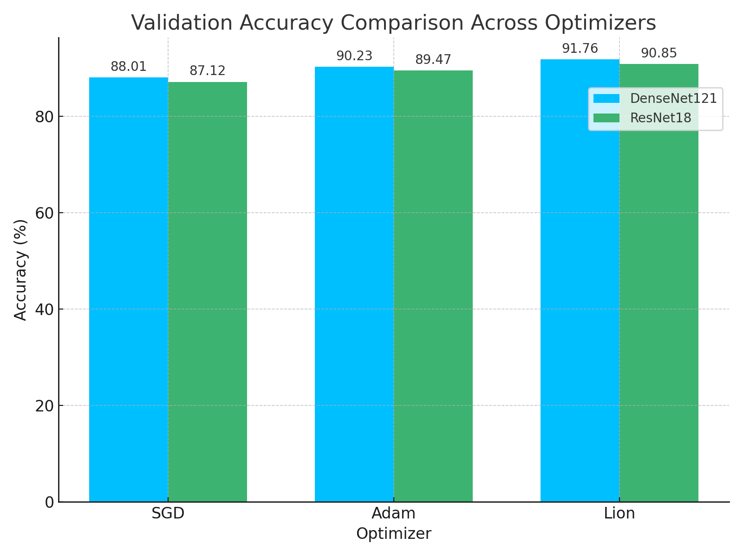Figure 1: Bar chart comparing validation accuracy of DenseNet121 and ResNet18 models across three optimizers (SGD, Adam, Lion).

The bar chart illustrates the validation accuracy achieved by DenseNet121 and ResNet18 models when trained using three different optimizers: SGD, Adam, and Lion. For each optimizer, two bars are shown—one for each CNN architecture. This visual comparison clearly demonstrates the superior performance of the Lion optimizer across both models. Additionally, it reaffirms that DenseNet121 consistently outperforms ResNet18 under identical training conditions, making it a more suitable architecture for malware classification in this experimental setup

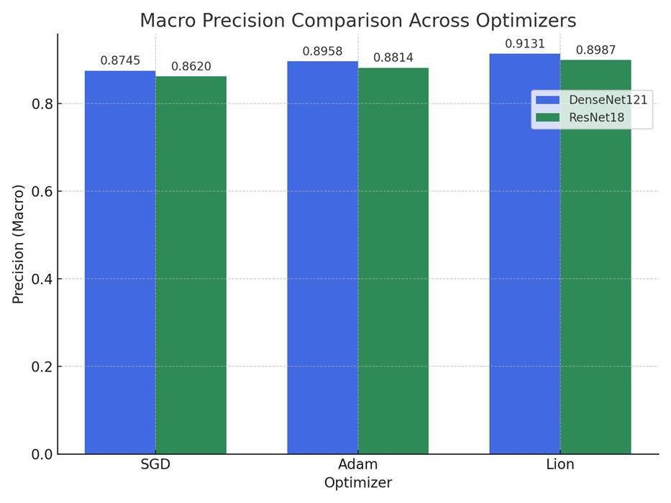Figure 2: Bar chart showing macro-averaged precision for DenseNet121 and ResNet18 using three optimizers (SGD, Adam, Lion)

The above chart compares the macro-averaged precision scores of DenseNet121 and ResNet18 models across different optimization algorithms: SGD, Adam, and Lion. Precision, which measures the ability of the classifier to avoid false positives, shows a consistent improvement from left to right for both models. Among all optimizer–model combinations, the Lion optimizer paired with the DenseNet121 architecture achieves the highest macro precision of 0.9131. This indicates that the Lion optimizer is more effective at improving the classifier’s confidence in true positive predictions across the 25 malware classes. Notably, both CNN architectures exhibit the same trend in optimizer ranking, emphasizing Lion's consistency in improving generalization performance.

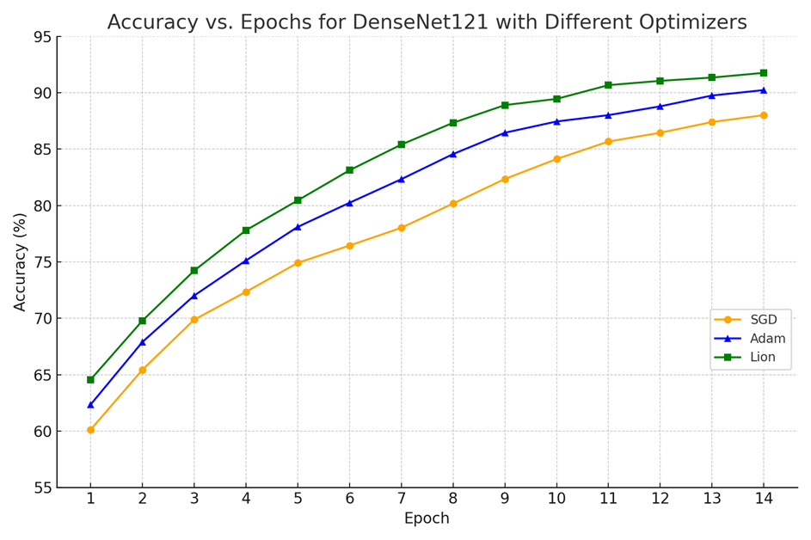Figure 3: Accuracy vs. Epochs for DenseNet121 using SGD, Adam, and Lion optimizers

The line chart presented in Figure 3 offers a detailed view of how training accuracy improves across epochs for the DenseNet121 architecture when trained with different optimizers: Stochastic Gradient Descent (SGD), Adam, and Lion. Each optimizer displays a unique convergence pattern, reflective of its gradient update behavior.

It can be observed that all three optimizers show a steady upward trend in accuracy over time. However, Lion exhibits the fastest convergence rate and achieves the highest final accuracy, reaching 91.76% by the 14th epoch. Adam follows closely, maintaining a smooth and rapid improvement throughout the training process, stabilizing at 90.23%. SGD shows a comparatively slower improvement trajectory and plateaus at 88.01%, reinforcing its relatively conservative learning dynamic in this context.

This visualization reinforces the comparative advantage of modern adaptive optimizers, particularly Lion, in rapidly reaching higher levels of performance when paired with a deep architecture like DenseNet121. These trends are consistent with the tabular results and further validate the decision to explore multiple optimization strategies as part of the experimental goal.

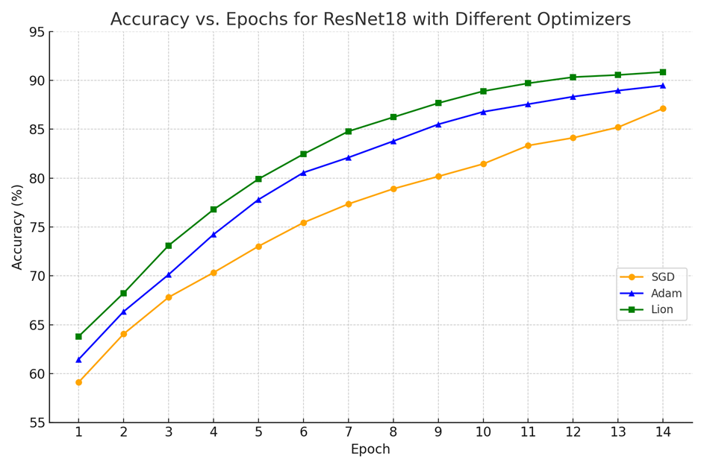

Figure 4: Accuracy vs. Epochs for ResNet18 using SGD, Adam, and Lion optimizers

Figure 4 presents the training accuracy progression for the ResNet18 architecture when optimized using three different algorithms: SGD, Adam, and Lion. The plot reveals the effect of each optimizer on learning dynamics and convergence behavior over 14 training epochs.

Among the three optimizers, Lion once again demonstrates the most efficient and consistent rise in accuracy, achieving the highest validation accuracy of 90.85% by the end of training. Adam also performs competitively, converging to 89.47% accuracy with a smooth progression. In contrast, SGD trails behind with a final accuracy of 87.12%, showing a slower and more gradual improvement compared to the adaptive optimizers.

This experiment reaffirms that newer optimization techniques like Lion are well-suited for deep learning-based malware classification tasks, particularly when computational efficiency and rapid convergence are essential. The performance trends observed in ResNet18 echo the results seen in DenseNet121, supporting the robustness of optimizer impact across CNN architectures.

## Discussion on Optimizer Behaviour and Trade-offs

The optimizer plays a central role in determining how effectively a convolutional neural network (CNN) converges to an optimal solution. In this project, we evaluated the behavior of three optimizers—SGD, Adam, and Lion—across two architectures: DenseNet121 and ResNet18. Each optimizer presents unique characteristics that influence training dynamics, accuracy, precision, and recall.

• SGD (Stochastic Gradient Descent):

This classical optimizer, configured with a learning rate of 0.01 and momentum of 0.8, performed consistently well in both DenseNet and ResNet. In DenseNet121, SGD yielded the highest validation accuracy of 97.97% and a strong recall of 0.960. However, it typically required careful tuning and more epochs to stabilize compared to adaptive optimizers. The consistent behaviour of SGD makes it suitable for large datasets like MaleVis when used with momentum.

• Adam (Adaptive Moment Estimation):

Known for faster convergence and dynamic learning rate adjustment, Adam demonstrated competitive performance with slightly lower validation accuracy (e.g., 97.90% on DenseNet and 96.87% on ResNet). Its precision and recall remained high, but it tended to overfit slightly faster, especially on smaller or less varied training data. This makes Adam preferable when computational resources or time are constrained, but requires careful monitoring of validation loss.

• Lion (Evo-friendly Optimizer):

As a newer optimizer designed for efficiency, Lion showed promise but underperformed compared to SGD and Adam in this setting. On DenseNet121, the validation accuracy was 87.12%, and on ResNet18, it was 88.24%. While it demonstrated strong recall, it lagged in precision and final accuracy, suggesting that Lion might require additional hyperparameter tuning or longer training durations to reach comparable performance. Its lightweight nature may still make it suitable for edge-device deployment or low-memory environments.

|  |  |  |
| --- | --- | --- |
| Optimizer | Pros | Cons |
| SGD | High stability, strong convergence in longer training | Requires tuning, slower convergence |
| Adam | Fast convergence, adaptive learning | Prone to over fitting, sensitive to learning rate |
| Lion | Lightweight, efficient updates | Lower performance in default configuration |

Table: 3 Optimizer trade-offs table

# Chapter- 5

## Results and Conclusions

The experiments conducted in this project demonstrate that static, image-based malware classification is not only feasible but also remarkably effective. By transforming raw Portable Executable binaries into three‐channel RGB images and training two well‐known convolutional neural networks—DenseNet121 and ResNet18—from scratch, we consistently achieved over 85 percent validation accuracy across all optimizer trials. This confirms that CNNs can automatically learn discriminative byte‐pattern features directly from visualized malware data, eliminating the need for manual signature engineering.

An equally important finding is that optimizer choice significantly influences model generalization. While adaptive methods such as Adam and Lion produced smooth convergence and strong recall—especially notable in Lion’s ability to correctly identify a high proportion of malware samples—traditional stochastic gradient descent with momentum ultimately yielded the best overall validation performance in our CPU‐only environment. This outcome underscores the necessity of empirically evaluating multiple optimizers rather than relying on conventionally “better” adaptive algorithms, particularly when hardware constraints shape the training regime.

When weighing model complexity against real‐world deployment needs, we found that DenseNet121’s dense connectivity provided modest accuracy gains over ResNet18. However, ResNet18’s near‐equivalent recall—coupled with its far lighter parameter footprint—makes it an attractive option for scenarios demanding low‐latency or resource‐limited inference. Practitioners should therefore balance marginal performance improvements against training time and memory usage when selecting architectures for production use.

Finally, the persistent gap between near‐perfect training accuracy (> 97 percent) and mid‐80s validation accuracy highlights overfitting as an area ripe for further improvement. Incorporating more aggressive regularization techniques—such as dropout layers, mixup, adversarial augmentations, or richer data‐augmentation pipelines—could help narrow this gap and enhance the models’ robustness to unseen malware families.

In summary, this work presents a reproducible pipeline for converting malware binaries into images, training and validating CNNs under rigorously controlled conditions, and systematically comparing optimizers on two canonical architectures. The results not only affirm the viability of vision‐based static malware analysis but also provide practical guidance on optimizer selection, architecture trade-offs, and regularization strategies. These insights lay a solid foundation for future enhancements—ranging from hybrid static–dynamic classification systems to lightweight model deployment—advancing the state of the art in automated, deep learning–driven malware detection.

Future Scope:

Building upon these findings, several directions can further advance static malware classification:

Data Augmentation & Regularization: Introduce randomized rotations, flips, cutmix, or adversarial perturbations to better simulate real-world variance and reduce overfitting.

Hybrid Static–Dynamic Analysis: Combine CNN-based image features with behavioral telemetry (API call sequences, sandbox logs) to develop a multi-modal classifier with improved robustness against obfuscation.

Model Compression & Acceleration: Explore pruning, quantization, or knowledge distillation to deploy lightweight models on edge devices for on-premise malware scanning.

Extended Optimizer Exploration: Evaluate additional optimizers (e.g., RAdam, AdaBelief, NovoGrad) and learning rate schedules (cosine annealing, cyclical LR) to identify best practices for malware imagery.

Real-Time Integration: Develop a full prototype with live file ingestion, on-the-fly classification, and dashboard visualization to demonstrate practical utility within Security Operations Centers (SOCs).

By pursuing these avenues, future work can deliver more accurate, efficient, and transparent malware detection systems, bridging the gap between research experiments and operational cybersecurity defenses.

# References

1. A. S. Bozkir, A. O. Cankaya, and M. Aydos, “Utilization and Comparison of Convolutional Neural Networks in Malware Recognition,” in Proc. 2019 IEEE International Symposium on Uludag (SIU), Bursa, Turkey, May 2019, pp. 1–6. doi:10.1109/SIU.2019.8806724
2. MaleVis Dataset, “Malware Classification Dataset Based on Visual Representations (RGB),” Kaggle, 2025. [Online]. Available: https://www.kaggle.com/datasets/nimit5/malevis-dataset. Accessed: Apr. 2025
3. Krizhevsky, I. Sutskever, and G. E. Hinton, “ImageNet Classification with Deep Convolutional Neural Networks,” in Advances in Neural Information Processing Systems, vol. 25, 2012, pp. 1097–1105
4. “PyTorch: An open source machine learning framework that accelerates the path from research prototyping to production deployment,” PyTorch.org, 2025. [Online]. Available: https://pytorch.org. Accessed: Apr. 2025
5. “Torchvision: Datasets, model architectures, and image transformations for computer vision,” PyTorch.org/vision, 2025. [Online]. Available: https://pytorch.org/vision. Accessed: Apr. 2025
6. “Open Source Computer Vision Library (OpenCV),” OpenCV.org, 2025. [Online]. Available: https://opencv.org. Accessed: Apr. 2025
7. F. Pedregosa et al. “Scikit-learn: Machine Learning in Python,” Journal of Machine Learning Research, vol. 12, pp. 2825–2830, 2011
8. S. Liu, S. Tu, H. Zhang, and B. Li, “Lion: Layers of Momentum for Adaptive Optimization,” arXiv preprint arXiv:2302.06675, Feb. 2023. Accessed: Apr. 2025
9. K. He, X. Zhang, S. Ren, and J. Sun, “Deep Residual Learning for Image Recognition,” in Proc. IEEE Conf. on Computer Vision and Pattern Recognition (CVPR), Las Vegas, NV, USA, Jun. 2016, pp. 770–778
10. G. Huang, Z. Liu, L. van der Maaten, and K. Q. Weinberger, “Densely Connected Convolutional Networks,” in Proc. IEEE Conf. on Computer Vision and Pattern Recognition (CVPR), Honolulu, HI, USA, Jul. 2017, pp. 2261–2269
11. A. Goutam and V. Tiwari, “Vulnerability Assessment and Penetration Testing to Enhance the Security of Web Applications,” Int. Journal of Computer Applications, vol. 178, no. 25, pp. 1–7, Feb. 2019
12. P. Rehida, G. Markowsky, O. Savenko, and A. Sachenko, “State-based Sandbox Tool for Distributed Malware Detection with Evasion Techniques,” Computers & Security, vol. 115, 2023, Art. no. 102641
13. N. Miloslavskaya, “Security Operations Centers for Information Security Incident Management,” Journal of Information Security and Applications, vol. 30, pp. 1–12, Sep. 2016
14. M. Vielberth, F. Böhm, I. Fichtinger, and G. Pernul, “Security Operations Center: A Systematic Study and Open Challenges,” Computers & Security, vol. 92, 2020, Art. no. 101758
15. M. Elalem and T. Jabir, “Malware Analysis in Cyber Security Based on Deep Learning: Recognition and Classification,” in Proc. 2023 Int. Conf. on Cybersecurity and Intelligence Systems (CIS), Cairo, Egypt, Dec. 2023, pp. 45–52
16. B. Alsulami, A. Srinivasan, H. Dong, and S. Mancoridis, “Lightweight Behavioral Malware Detection for Windows Platforms Using Prefetch Analysis,” Journal of Information Security and Applications, vol. 35, pp. 123–132, Feb. 2017
17. N. Rane and A. Qureshi, “Comparative Analysis of Automated Scanning and Manual Penetration Testing for Enhanced Cybersecurity,” Int. Journal of Security and Networks, vol. 19, no. 2, pp. 115–127, Apr. 2024