H1B-B CASE STUDY
1 a) Is the number of petitions with Data Engineer job title increasing over time?
b) Find top 5 job titles who are having highest growth in applications.

2 a) Which part of the US has the most Data Engineer jobs for each year?
b) find top 5 locations in the US who have got certified visa for each year.

3)Which industry has the most number of Data Scientist positions?

4)Which top 5 employers file the most petitions each year?

5) Find the most popular top 10 job positions for H1B visa applications for each year?

6) Find the percentage and the count of each case status on total applications for each year. Create a graph depicting the pattern of All the cases over the period of time.

7) Create a bar graph to depict the number of applications for each year

8) Find the average Prevailing Wage for each Job for each Year (take part time and full time separate)

9) Which are top ten employers who have the highest success rate in petitions?

10) Which are the top 10 job positions which have the highest success rate in petitions?

11) Export result for question no 10 to MySql database.

HIVE

1.Which industry has the most number of Data Scientist positions?

select soc_name, count(soc_name) as name from hb where job_title="DATA SCIENTIST" group by soc_name order by name desc limit 1;

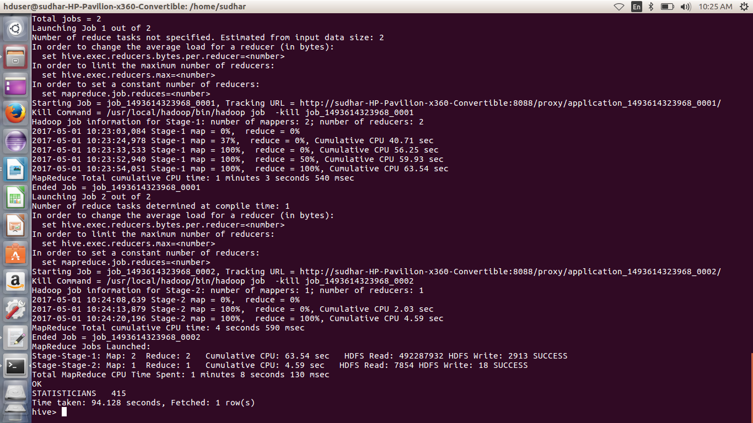

2.Which are top ten employers who have the highest success rate in petitions?

select ROUND(((count(s_no)/t.tot)*100),2) as ctn,employer_name from h1b_pro,(select count(s_no) as tot from h1b_pro)t where case_status ='CERTIFIED' or case_status= 'CERTIFIED-WITHDRAWN' group by employer_name,t.tot order by ctn desc limit 10;
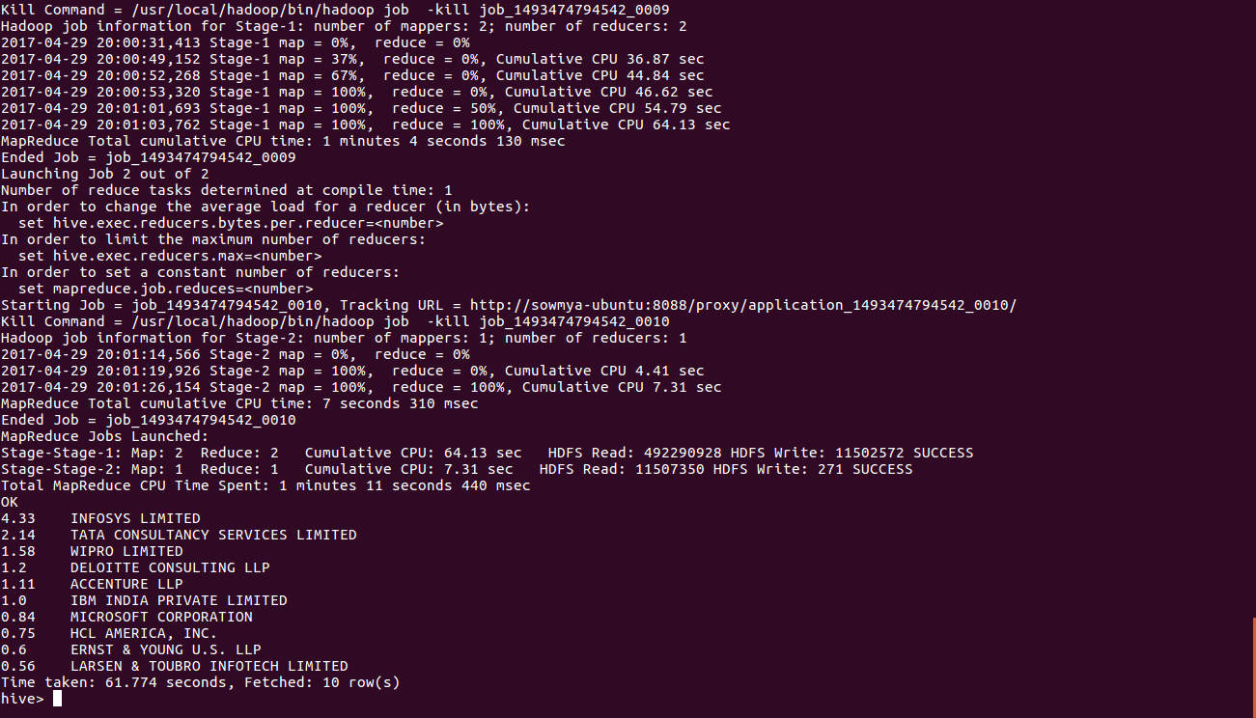

3. Find the average Prevailing Wage for each Job for each Year (take part time and full time separate)

selectROUND((AVG(prevailing_wage)),2), job_title,year,full_time_position from hb where full_time_position!='NULL' group by full_time_position,job_title,year order by full_time_position desc;

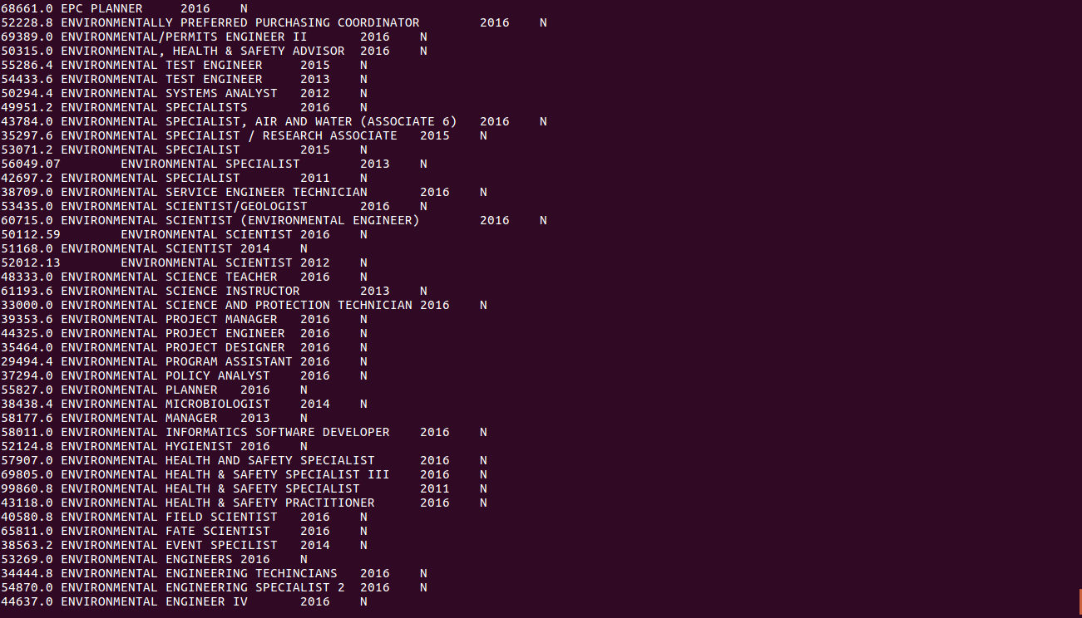

4.Which are the top 10 job positions which have the highest success rate in petitions?

select ROUND(((count(s_no)/t.tot)*100),2) as headcount,job_title from hb,(select count(s_no) as tot from hb)t where case_status ='CERTIFIED' or case_status= 'CERTIFIED-WITHDRAWN' group by job_title,t.tot order by headcount desc limit 10;

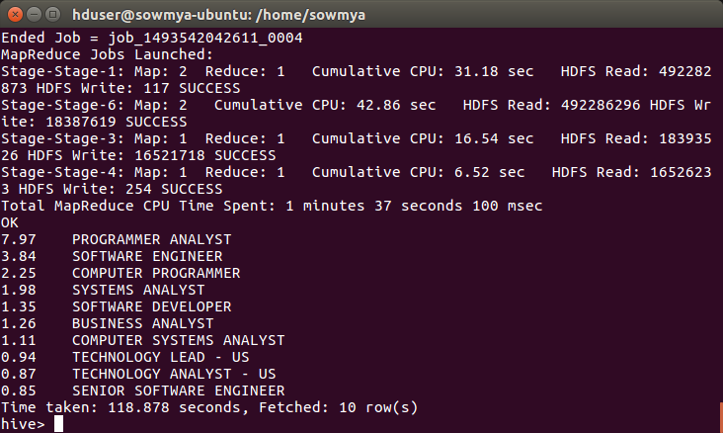

PIG

1.Which top 5 employers file the most petitions each year?

gp= group hb by (year, employer_name);
cp= foreach gp generate group as year, COUNT(hb) as headcount;
op= order cp by $1 desc;
lp= limit op 5;

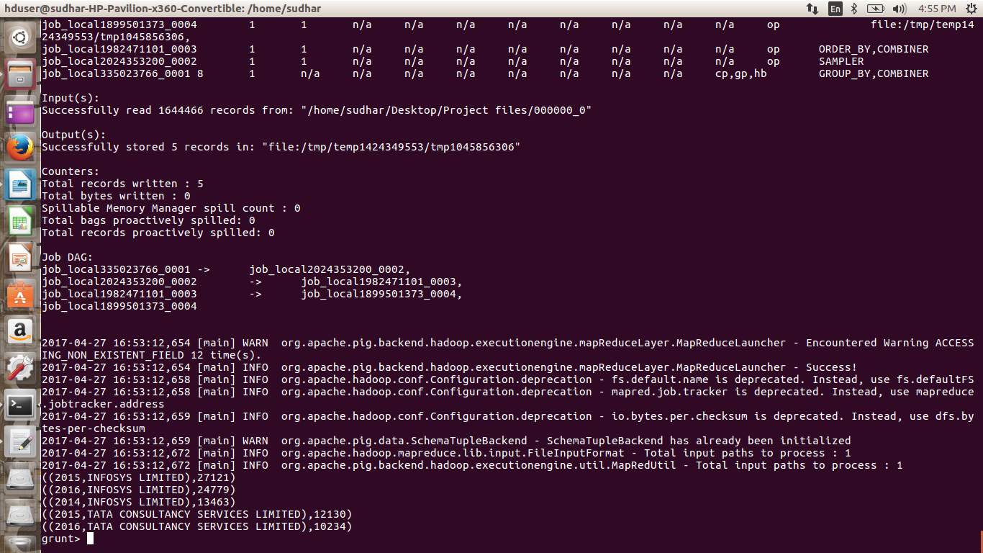

2.Create a bar graph to depict the number of applications for each year

ga= group hb by (year, case_status);
ca= foreach ga generate group as year, COUNT(hb) as headcount;
oa= order ca by $1 desc;
la= limit oa 10;
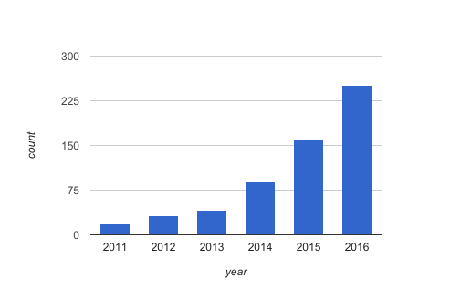

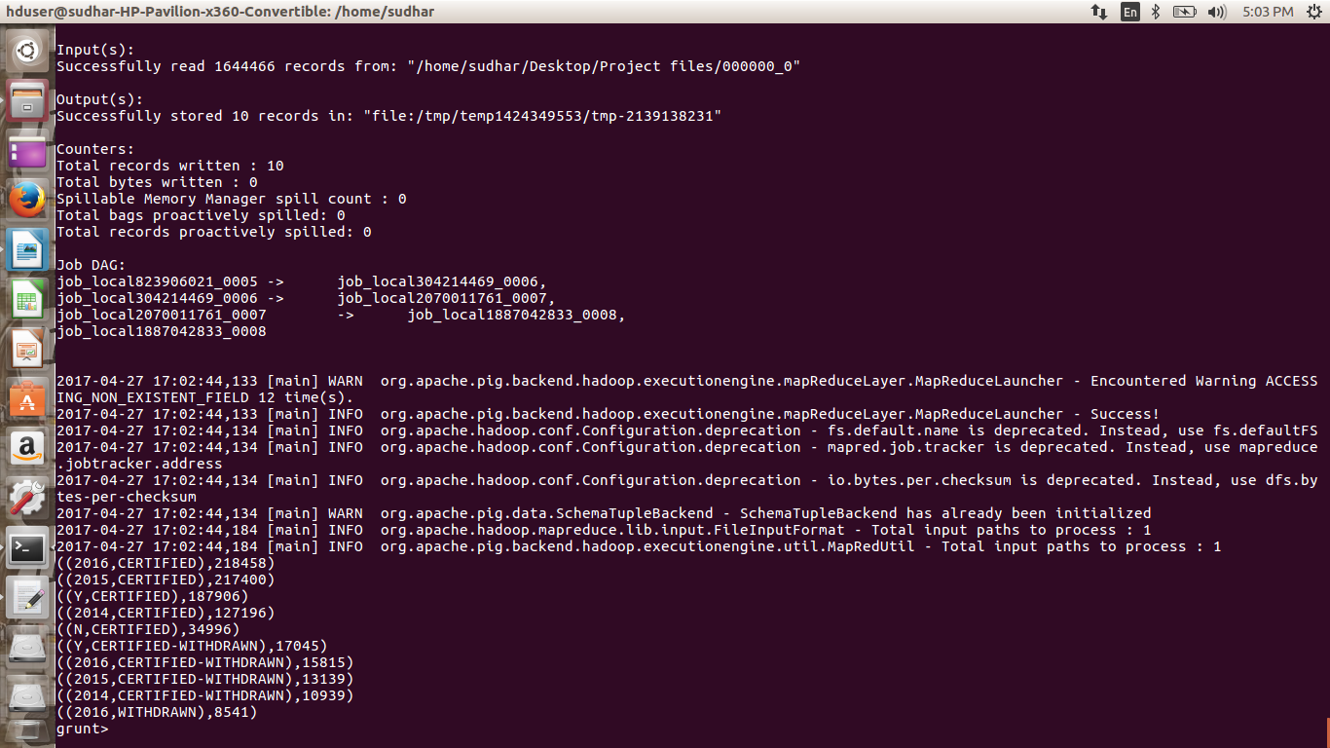

3.Find top 5 job titles who are having highest growth in applications.

gb= group hb by(job_title, case_status);
cb= foreach gb generate group as job_title, COUNT(hb) as headcount;
oc= order cb by $1 desc;
lc= limit oc 10;

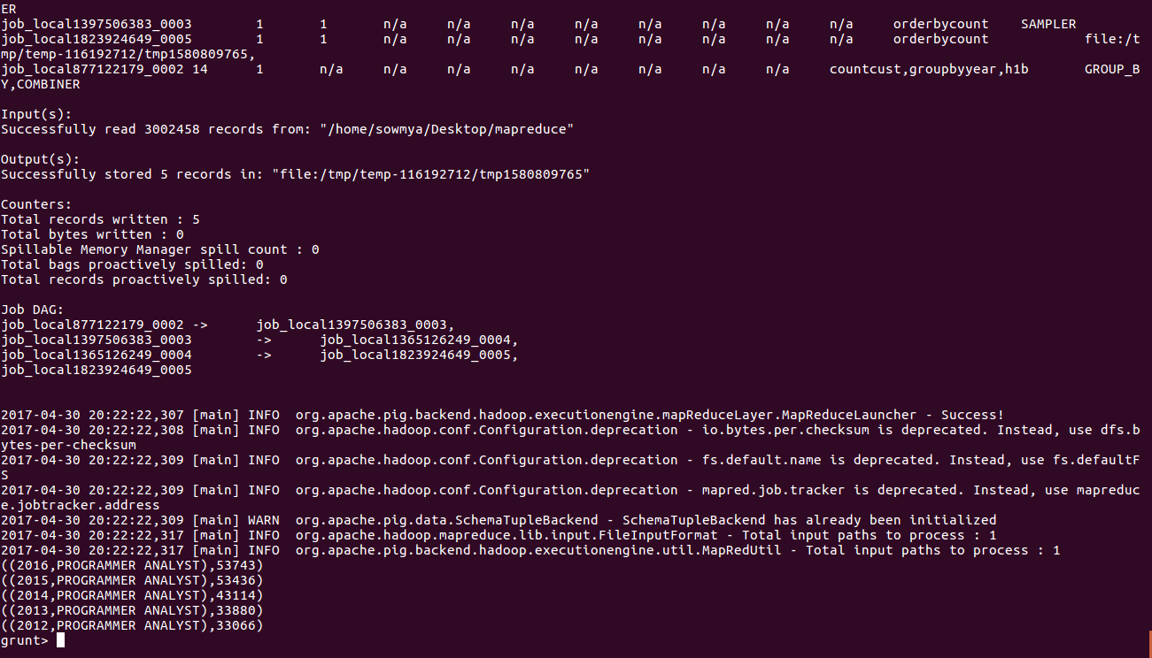

4.Find the percentage and the count of each case status on total applications for each year. Create a graph depicting the pattern of All the cases over the period of time.

gs= group a by (year,case_status);
cs= foreach gs generate group as year, COUNT(hb) as headcount;
group_all= group cs all;
sum_all= foreach group_all generate SUM(cs.$1) as total;
perc= foreach group_all generate ((cs.headcount)/3002458*100);
perc= foreach groupbytype generate cs.headcount/sum_all.total;
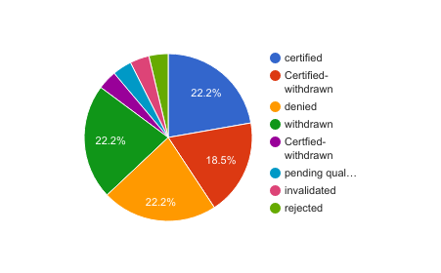

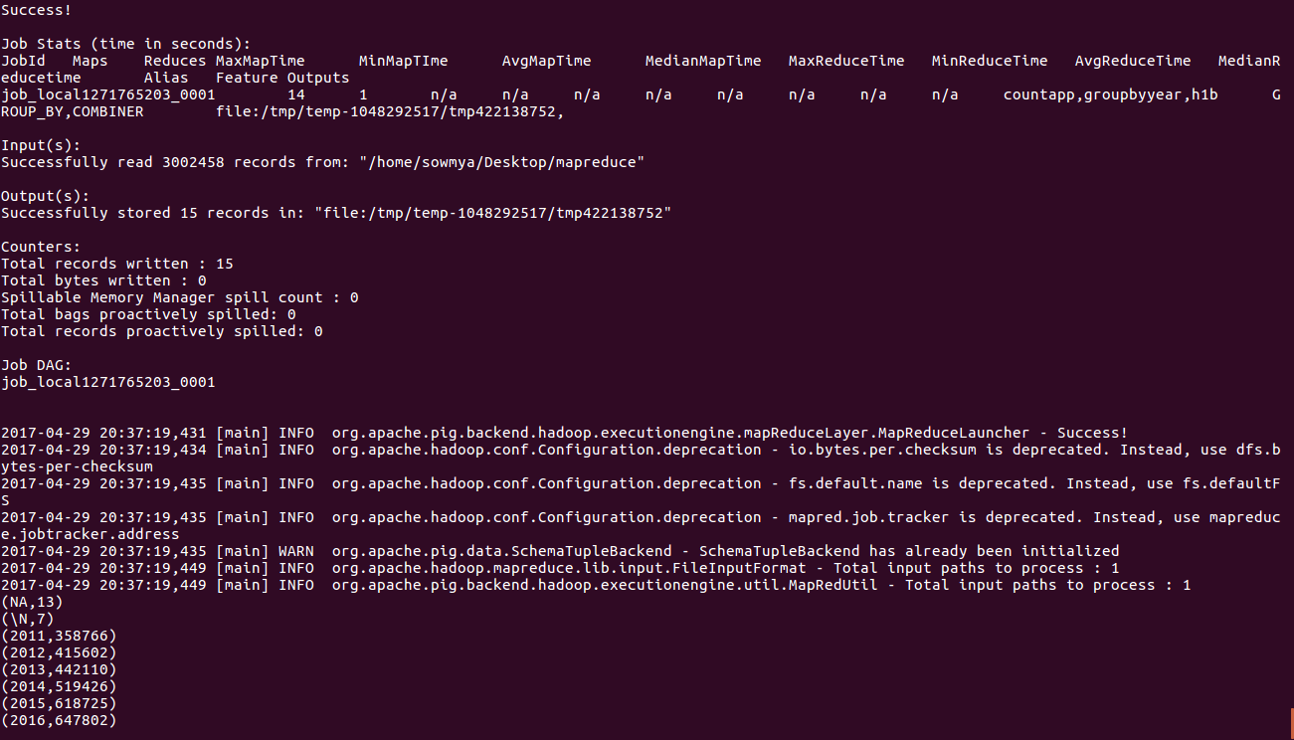

MAPREDUCE

1.Find the most popular top 10 job positions for H1B visa applications for each year?

import java.io.IOException;
import java.util.TreeMap;
import org.apache.hadoop.conf.Configuration;
import org.apache.hadoop.fs.Path;
import org.apache.hadoop.io.LongWritable;
import org.apache.hadoop.io.NullWritable;
import org.apache.hadoop.io.Text;
import org.apache.hadoop.mapreduce.Job;
import org.apache.hadoop.mapreduce.Mapper;
import org.apache.hadoop.mapreduce.Reducer;
import org.apache.hadoop.mapreduce.lib.input.FileInputFormat;
import org.apache.hadoop.mapreduce.lib.output.FileOutputFormat;

public class top10positions
public static class Top10Mapper extends Mapper<LongWritable, Text, Text, Text> {
public void map(LongWritable key, Text value, Context context) throws IOException, InterruptedException {

try {
String[] str = value.toString().split("\t");
String position= str[4];
int year= Integer.parseInt(str[7]);
String status= str[1];
String myyear= String.format("%d", year);
String myvalue= position + ',' + myyear;
context.write(new Text(myvalue),new Text(status));

}
catch(Exception e)
{
System.out.println(e.getMessage());
}
}
}

public static class Top10Reducer extends
Reducer<Text, Text, NullWritable, Text> {
private TreeMap<Long, Text> repToRecordMap = new TreeMap<Long, Text>();
public void reduce(Text key, Iterable<Text> values,
Context context) throws IOException, InterruptedException {
long count=0;
String myvalue= "";
String mycount= "";
for (Text val : values) {
//String[] token= key.toString().split(",");
count++;
}
myvalue= key.toString();
mycount= String.format("%d", count);
myvalue= myvalue + ',' + mycount;
repToRecordMap.put(new Long(mycount), new Text(myvalue));
if (repToRecordMap.size() > 10) {
repToRecordMap.remove(repToRecordMap.firstKey());
}
}

protected void cleanup(Context context) throws IOException,
InterruptedException {
for (Text t : repToRecordMap.descendingMap().values()) {
// Output our five records to the file system with a null key
context.write(NullWritable.get(), t);
}
}
}
public static void main(String[] args) throws Exception {

Configuration conf = new Configuration();
Job job = Job.getInstance(conf, "Top 10 positions");
job.setJarByClass(top10positions.class);
job.setMapperClass(Top10Mapper.class);
job.setReducerClass(Top10Reducer.class);
job.setMapOutputKeyClass(Text.class);
job.setMapOutputValueClass(Text.class);
job.setOutputKeyClass(NullWritable.class);
job.setOutputValueClass(Text.class);
FileInputFormat.addInputPath(job, new Path(args[0]));
FileOutputFormat.setOutputPath(job, new Path(args[1]));
System.exit(job.waitForCompletion(true) ? 0 : 1);
}
}

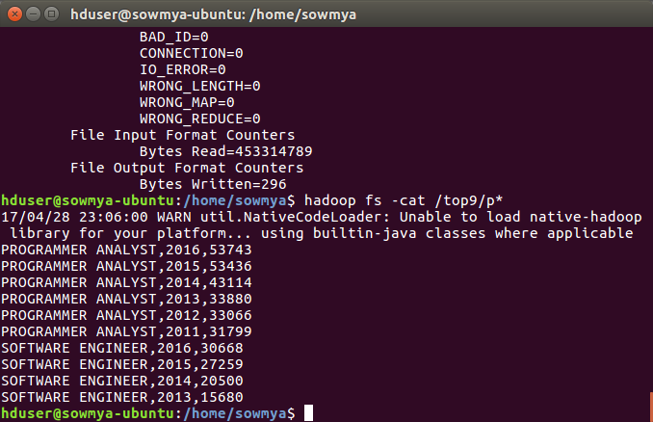

2.Is the number of petitions with Data Engineer job title increasing over time?

import java.io.IOException;
import org.apache.hadoop.conf.Configuration;
import org.apache.hadoop.fs.Path;
import org.apache.hadoop.io.IntWritable;
import org.apache.hadoop.io.LongWritable;
import org.apache.hadoop.io.Text;
import org.apache.hadoop.mapreduce.Job;
import org.apache.hadoop.mapreduce.Mapper;
import org.apache.hadoop.mapreduce.Reducer;
import org.apache.hadoop.mapreduce.lib.input.FileInputFormat;
import org.apache.hadoop.mapreduce.lib.output.FileOutputFormat;

public class one {
public static class datamap extends Mapper<LongWritable,Text,Text,IntWritable> {

public void map(LongWritable key,Text value,Context context)throws IOException,InterruptedException {
String[] word = value.toString().split("\t");
String word1 = word[4] +','+ word[7];
if(word[4].contains("DATA ENGINEER")) {

context.write(new Text(word1), new IntWritable(1));
}
}
}
public static class datared extends Reducer<Text,IntWritable,Text,IntWritable> {

public void reduce(Text key,Iterable<IntWritable> values,Context context)throws IOException,InterruptedException {

int count=0;

for (IntWritable i :values)
{
count++;
}
context.write(key,new IntWritable(count));
}
}
public static void main(String args[]) throws IOException, ClassNotFoundException, InterruptedException{
Configuration conf= new Configuration();
Job job=Job.getInstance(conf, "");
job.setJarByClass(one.class);
job.setMapperClass(datamap.class);
job.setReducerClass(datared.class);
job.setNumReduceTasks(1);
job.setMapOutputKeyClass(Text.class);
job.setMapOutputValueClass(IntWritable.class);
FileInputFormat.addInputPath(job,new Path(args[0]));
FileOutputFormat.setOutputPath(job,new Path(args[1]));
System.exit(job.waitForCompletion(true) ? 0 :1);

}

}

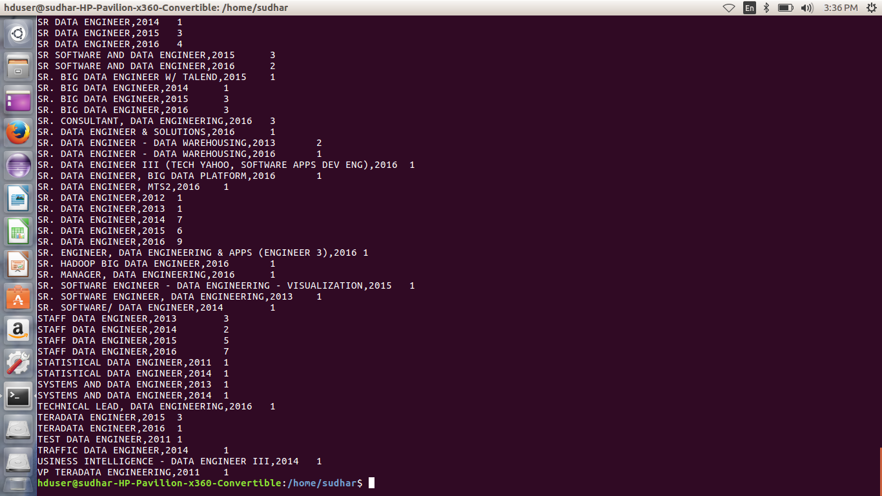

3.Which part of the US has the most Data Engineer jobs for each year?

import java.io.IOException;
import java.util.TreeMap;

import org.apache.hadoop.conf.Configuration;
import org.apache.hadoop.fs.Path;
import org.apache.hadoop.io.IntWritable;
import org.apache.hadoop.io.LongWritable;
import org.apache.hadoop.io.NullWritable;
import org.apache.hadoop.io.Text;
import org.apache.hadoop.mapreduce.Job;
import org.apache.hadoop.mapreduce.Mapper;
import org.apache.hadoop.mapreduce.Reducer;
import org.apache.hadoop.mapreduce.lib.input.FileInputFormat;
import org.apache.hadoop.mapreduce.lib.output.FileOutputFormat;

public class two {

public static class datamap extends Mapper<LongWritable,Text,Text,IntWritable>
{

public void map(LongWritable key,Text value,Context context)throws IOException,InterruptedException {
String[] word = value.toString().split("\t");
String word1 = word[4]+','+ word[7];
if(word[4].contains("DATA ENGINEER"))
{

context.write(new Text(word1), new IntWritable(1));
}
}
}
public static class datared extends Reducer<Text,IntWritable,NullWritable,Text>
{
private TreeMap<Integer,Text> repToRecordMap= new TreeMap<Integer,Text>();
public void reduce(Text key, Iterable<IntWritable> values, Context context)throws IOException, InterruptedException
{
int count=0;
String myvalue= "";
for(IntWritable val:values)
{
count++;
}
myvalue= key.toString();
String mycount= String.format("%d", count);
myvalue= myvalue + ',' + mycount;
repToRecordMap.put(new Integer(mycount), new Text(myvalue));
if(repToRecordMap.size() >10)
{
repToRecordMap.remove(repToRecordMap.firstKey());
}

}
protected void cleanup(Context context) throws IOException, InterruptedException
{
for(Text t: repToRecordMap.values())
{
context.write(NullWritable.get(), t);
}
}
}

public static void main(String args[]) throws IOException, ClassNotFoundException, InterruptedException{
Configuration conf = new Configuration();
Job job = Job.getInstance(conf, "data count");
job.setJarByClass(two.class);
job.setMapperClass(datamap.class);
job.setReducerClass(datared.class);
job.setNumReduceTasks(1);
job.setMapOutputKeyClass(Text.class);
job.setMapOutputValueClass(IntWritable.class);
FileInputFormat.addInputPath(job, new Path(args[0]));
FileOutputFormat.setOutputPath(job, new Path(args[1]));
System.exit(job.waitForCompletion(true) ? 0 :1);

}
}

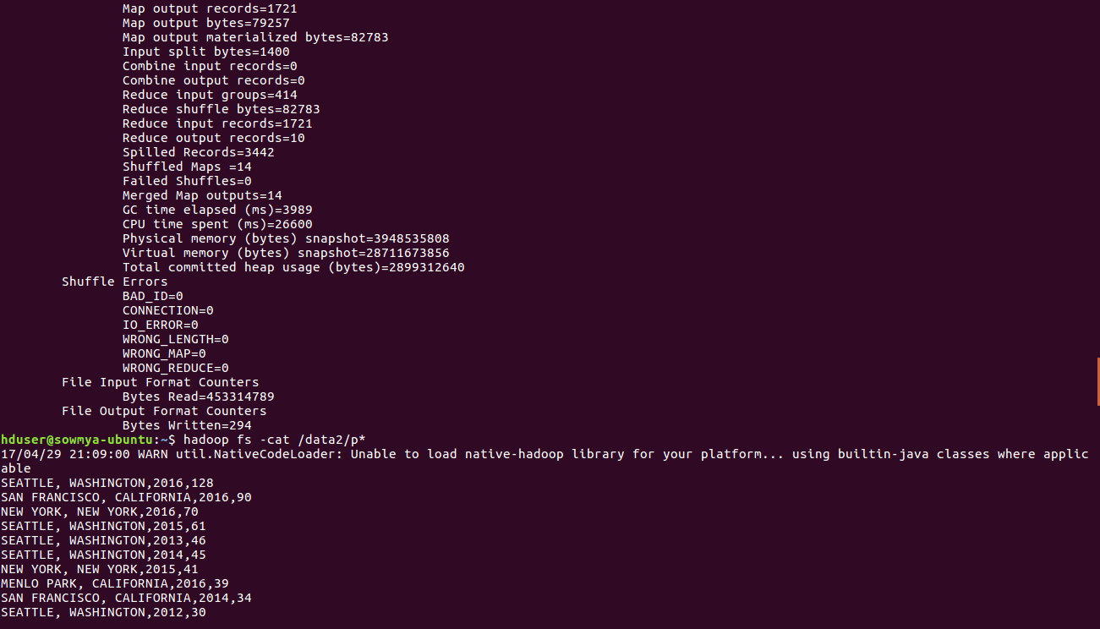

4.Find top 5 locations in the US who have got certified visa for each year.

import java.io.IOException;
import java.util.TreeMap;
import org.apache.hadoop.conf.Configuration;
import org.apache.hadoop.fs.Path;
import org.apache.hadoop.io.LongWritable;
import org.apache.hadoop.io.NullWritable;
import org.apache.hadoop.io.Text;
import org.apache.hadoop.mapreduce.Job;
import org.apache.hadoop.mapreduce.Mapper;
import org.apache.hadoop.mapreduce.Reducer;
import org.apache.hadoop.mapreduce.lib.input.FileInputFormat;
import org.apache.hadoop.mapreduce.lib.output.FileOutputFormat;

public class certifiedvisa {
public static class Top5Mapper extends Mapper<LongWritable, Text, Text, Text> {
public void map(LongWritable key, Text value, Context context
) throws IOException, InterruptedException {

try {
String[] str = value.toString().split("\t");
String worksite= str[8];
int year= Integer.parseInt(str[7]);
String status= str[1];
String myyear= String.format("%d", year);
if(str[1].contains("CERTIFIED"))
{
String myvalue= worksite + ',' + myyear;
context.write(new Text(myvalue),new Text(status));

}
}
catch(Exception e)
{
System.out.println(e.getMessage());
}
}
}

public static class Top5Reducer extends
Reducer<Text, Text, NullWritable, Text> {
private TreeMap<Long, Text> repToRecordMap = new TreeMap<Long, Text>();

public void reduce(Text key, Iterable<Text> values,Context context) throws IOException, InterruptedException {
long count=0;
String myvalue= "";
String mycount= "";
for (Text val : values) {
//String[] token= key.toString().split(",");
count++;
}
myvalue= key.toString();
mycount= String.format("%d", count);
myvalue= myvalue + ',' + mycount;
repToRecordMap.put(new Long(mycount), new Text(myvalue));
if (repToRecordMap.size() > 5) {
repToRecordMap.remove(repToRecordMap.firstKey());
}
}

protected void cleanup(Context context) throws IOException,
InterruptedException {
for (Text t : repToRecordMap.descendingMap().values()) {
// Output our five records to the file system with a null key
context.write(NullWritable.get(), t);
}
}
}
public static void main(String[] args) throws Exception {

Configuration conf = new Configuration();
Job job = Job.getInstance(conf, "Top 10 positions");
job.setJarByClass(certifiedvisa.class);
job.setMapperClass(Top5Mapper.class);
job.setReducerClass(Top5Reducer.class);
job.setMapOutputKeyClass(Text.class);
job.setMapOutputValueClass(Text.class);
job.setOutputKeyClass(NullWritable.class);
job.setOutputValueClass(Text.class);
FileInputFormat.addInputPath(job, new Path(args[0]));
FileOutputFormat.setOutputPath(job, new Path(args[1]));
System.exit(job.waitForCompletion(true) ? 0 : 1);
}
}

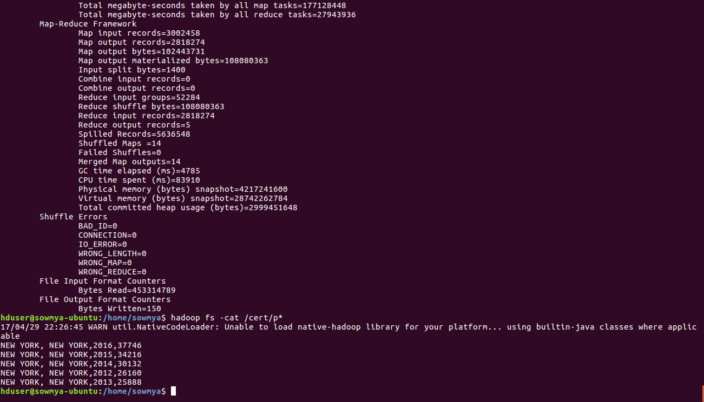

SQOOP

1.Export result for question no 10 to MySql database.

10.Which are the top 10 job positions which have the highest success rate in petitions?

create table hb(success_rate FLOAT NOT NULL, position VARCHAR(40) NOT NULL,status VARCHAR(40) NOT NULL,PRIMARY KEY(success_rate));

sqoop export --connect jdbc:mysql://localhost/app --username root -P --table hb --update-mode allowinsert --update-key success_rate --export-dir /user/visa.txt --input-fields-terminated-by ',';

