Game Design Document

Fill up the following document

1. Write the title of your project.

Rapid Survival

1. What is the goal of the game?

Kill all the zombies

1. Write a brief story of your game.

The people is infected by a dangerous virus which turned people into zombies. The player was the only one to survive the infection. He have to kill the zombies on his way and find the cure for it.

1. Which are the playing characters of this game?

* Playing characters are the ones who respond to the user based on the input from the user.
* Cars, monkeys, dinos, wizards, etc., are the playing characters in the game.

|  |  |  |
| --- | --- | --- |
| Number | Character Name | What can this character do? |
| 1 | Player | Kill zombies |
| 2 | Zombies | Bite the Player |
| 3 |  |  |
| 4 |  |  |
| 5 |  |  |
| 6 |  |  |
| 7 |  |  |
| 8 |  |  |

1. Which are the Non-Playing Characters of this game?

* Non-Playing characters are the ones that don't have an action or behavior when the user interacts with the game.
* Hurdles, stones, bananas, coins, etc., are non-playing characters in the game.

|  |  |  |
| --- | --- | --- |
| Number | Character Name | What can this character do? |
| 1 | Trees | Do nothing |
| 2 | Mountains | Do nothing |
| 3 | Sky | Do nothing |
| 4 | Ground | Holds all PC and NPC |
| 5 |  |  |
| 6 |  |  |
| 7 |  |  |
| 8 |  |  |

Draw your imagination of this game. What does this game look like?

* Draw the game either on your computer or on paper.
* Add images of the game scenes to show each of the playing and non-playing characters at least once.

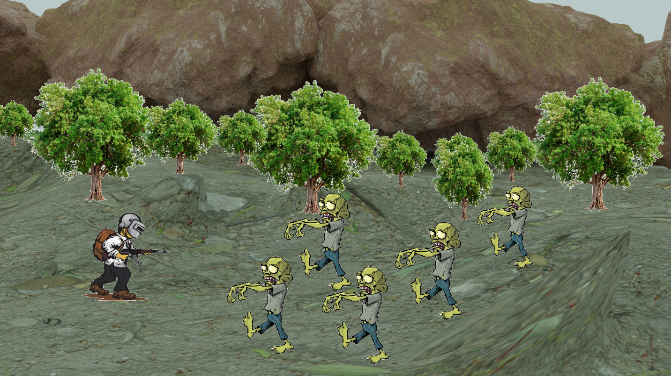

How do you plan to make your game engaging?

The number of zombies spawn will be increased fastly. The player speed gets slowly decreased by the last wave(5th wave).