My Django Learning Material
11/17/25 - After 5 PM
Logout - 6.14 PM
What is Django?
Python based Backend web framework
Both has soc but in different ways
MVC Concept | Purpose | Django Term | Notes
Model (M) | Handles data, DB layer | Model | Same meaning in both.
View (V) | UI / Presentation | Template | In Django, Templates handle the UI, not the “View” class.
Controller (C) | Coordinates logic, routing, flow | View | Django “Views” act like controllers (they contain the logic).

Why Django over others?
1.Fast Configuration
2.Predefined components (Login, sessions)
3.Security and Scalability

SetUp
Differs for OS
Python and Pip
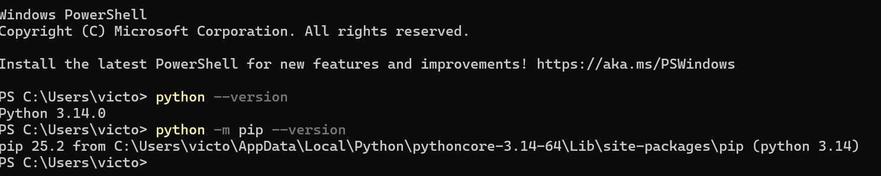Virtual environment wrapper called test
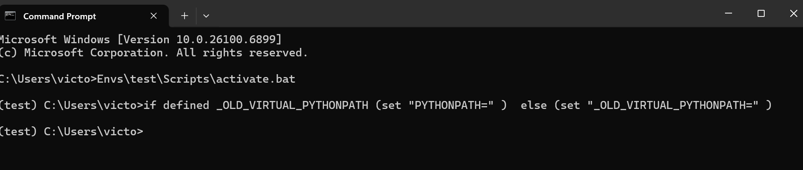After you create a virtual environment (your test wrapper), you install Django inside that environment. To avoid issues like version conflicts dependencies issues etc..

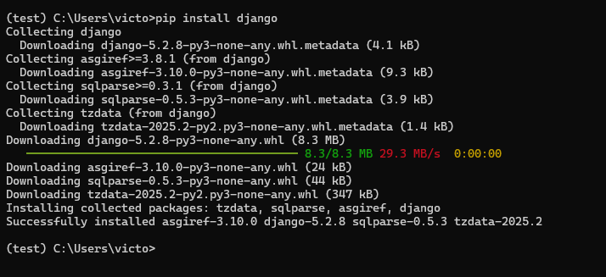
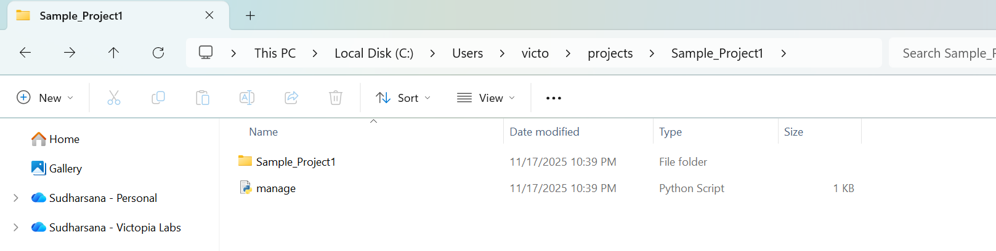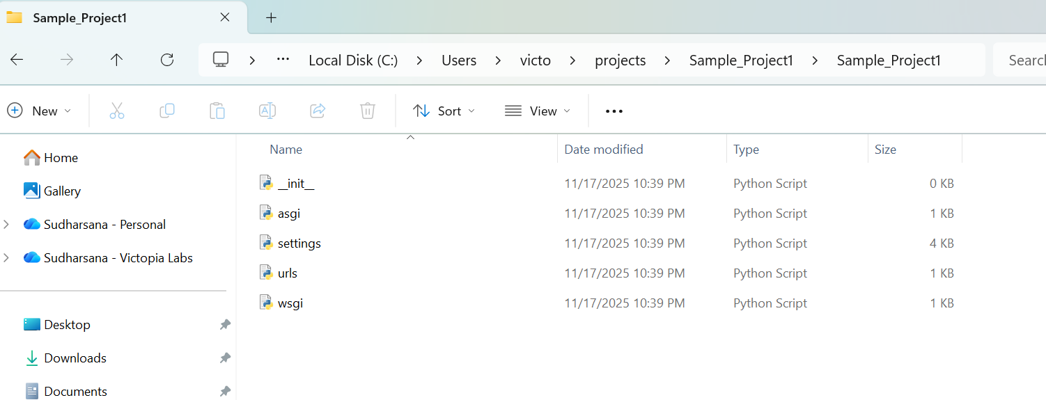
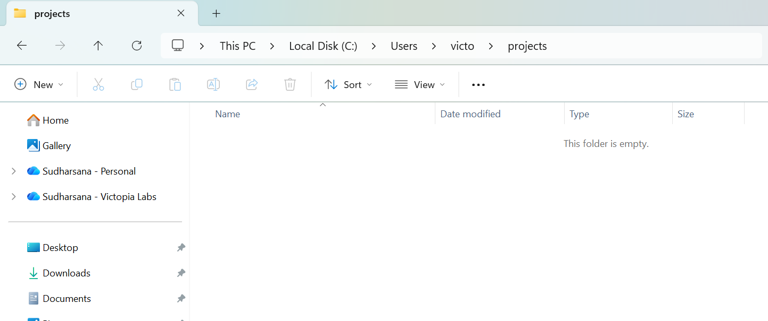
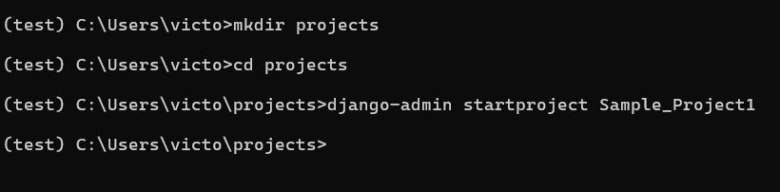

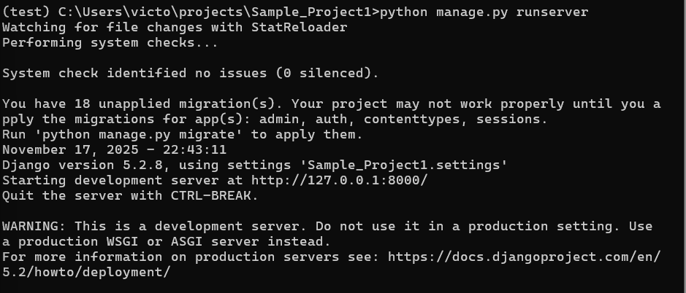
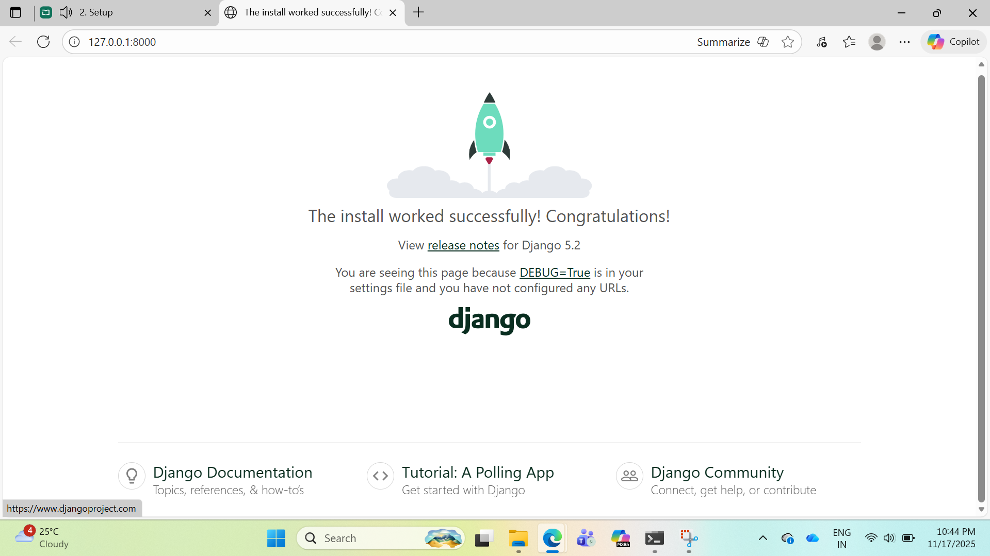

1. What is the Django setup?
To start a Django project you must install and verify:

(1) Python
- Django is a Python framework, so Python ≥ 3.4 is required.
- Verify installed version:
python --version

(2) pip
- Python’s package manager (used to install Django).
- Verify:
pip --version

(3) Virtual Environment (Important!)
Instead of installing Django system-wide, you create an isolated environment per project.
Install virtualenv + wrapper:
pip install virtualenv virtualenvwrapper-win
Create env:
mkvirtualenv test
Activate env (Windows):
workon test

(4) Install Django inside the environment
pip install django
Verify Django:
django-admin --version

2. Why is a test environment (virtual environment) always needed?

Reasons:
- Project isolation:
Each project may need different Django versions.
Example: Project A → Django 4.0,
Project B → Django 3.2
- Protect the system:
You do not pollute your system with global packages.
- Reproducibility:
Other developers can recreate your env using requirements.txt.
- Safety:
System Python stays untouched.
No dependency conflicts.
This is considered standard practice in Python development.

3. Why is manage.py created when you create a project?
When you run:
django-admin startproject projectname
Django generates:
- /projectname/
  - manage.py
  - projectname/ (inner folder containing settings and config files)

Purpose of manage.py:
- It is the central command-line utility for your Django project.
- Used to:
  - run server
  - run migrations
  - create apps
  - manage databases
  - execute admin commands
Example:
python manage.py runserver
manage.py automatically loads your project settings so Django knows how to run.

4. What do these files mean?
(Inside the project folder)

__init__.py
- Makes the directory a Python package.
- Required so Python can import this folder.
- Usually empty.

settings.py
The central configuration file for the entire project.
Contains:
- Installed apps
- Database config
- Security keys
- Templates & static files
- Middleware
- Debug mode
- Allowed hosts
You will constantly update this file.

urls.py
Think of this as the routing table for your project.
- Maps URLs → views (code that runs)
- Example:
path('home/', home_view)
This file controls how your website responds to different URLs.

asgi.py
- Entry point for ASGI servers (Asynchronous Server Gateway Interface).
- Needed for:
  - WebSockets
  - Async Django views
  - Modern async servers like Uvicorn/Daphne
Used mainly in production setups enabling async.

wsgi.py
- Traditional Python web server standard.
- Used for production deployments.
- Handles synchronous requests.

5. How to run the Django development server?
Go inside your project folder and run:
python manage.py runserver
Default address:
http://127.0.0.1:8000/
To change the port:
python manage.py runserver 8080
To allow all network interfaces (for testing on same LAN):
python manage.py runserver 0.0.0.0:8000

Setup Process
- Install Python
- Install pip
- Create virtual environment
- Install Django
- Start a new project
- Run development server

Key Files
File | Meaning
manage.py | Project command-line controller
settings.py | All configurations
urls.py | Routing rules
wsgi.py | Production server entry (sync)
asgi.py | Production server entry (async)
__init__.py | Required for Python package

Why Virtual Environment?
- Prevents version conflicts
- Keeps dependencies separate
- Safer, cleaner, reproducible

Run server command
python manage.py runserver

Static HTML
- Fixed content.
- Browser receives exactly what’s written in the file.
- No server-side logic, no database calls.
- Example: about.html with hardcoded text.

Dynamic HTML
- Generated at request time by server-side code.
- Content can change based on data, user, permissions, time, etc.
- Template + backend logic → rendered HTML.

Is Django dynamic?
Yes. Django is a server-side web framework that produces dynamic HTML.

Login Time : 9.00 AM
9.30-10.30 AM
Create a project:
You must create and activate a virtual environment before you install Django or run the project.
python -m venv venv
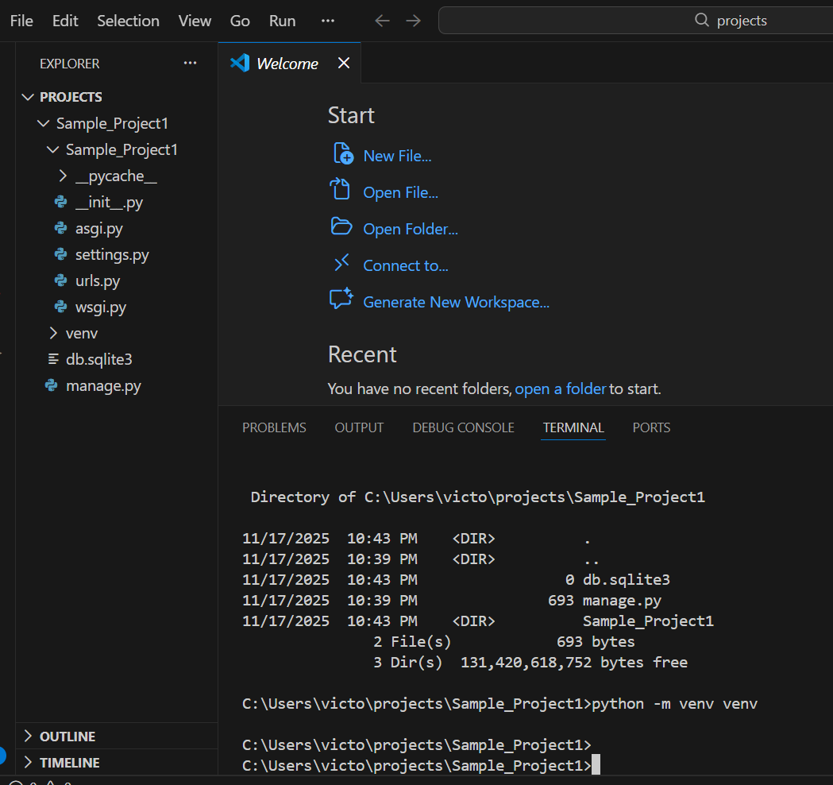
Activate the env:
C:\Users\victo\projects\Sample_Project1>venv\Scripts\activate
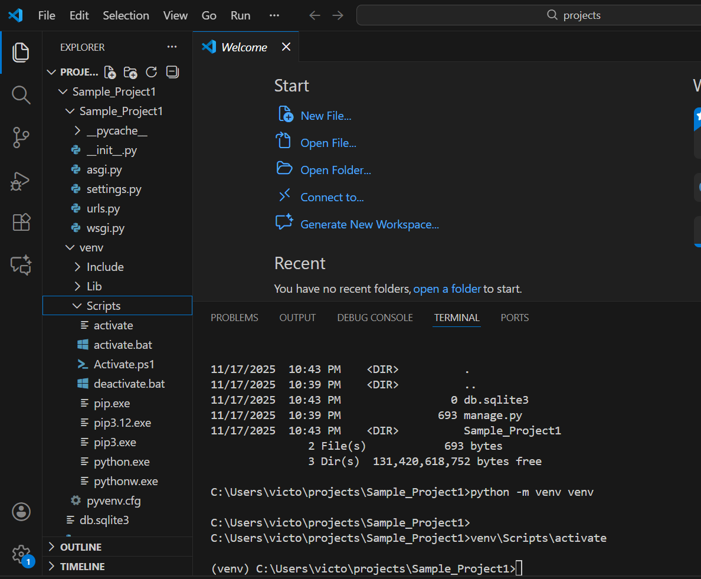

Install Django inside venv:
pip install django

Run Server:
python manage.py runserver

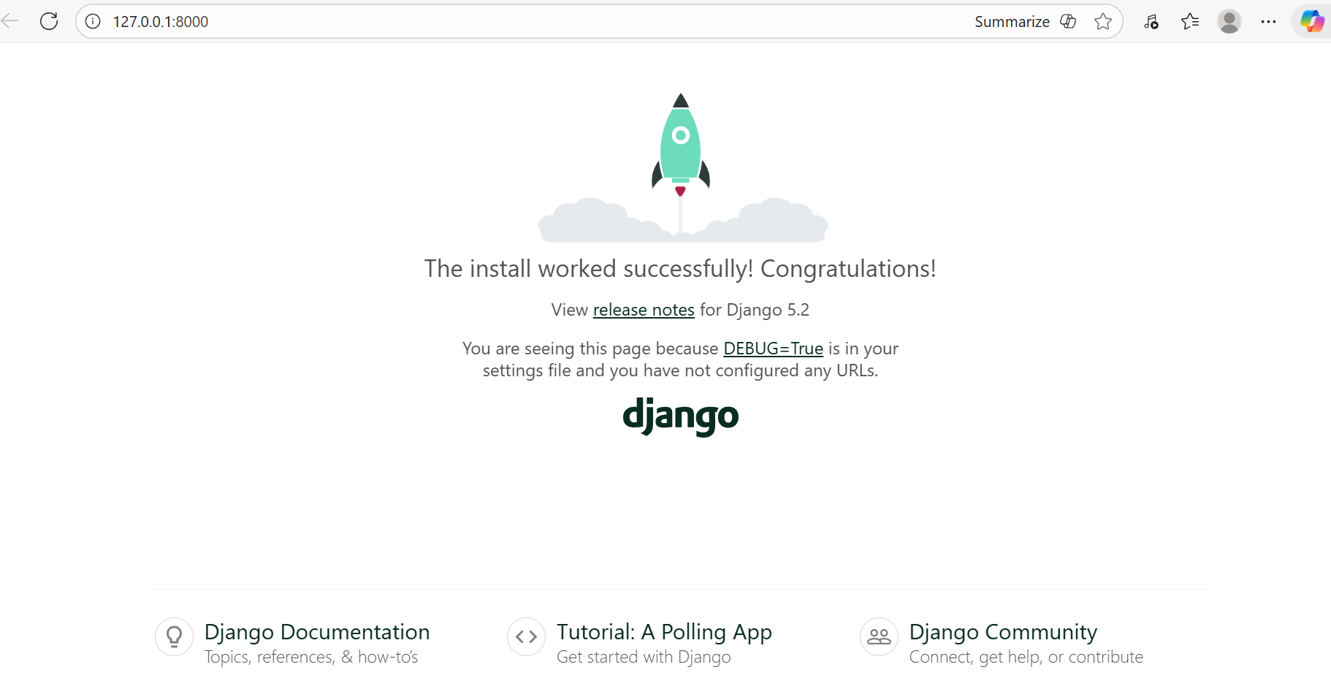

To migrate the 18 unapplied errors:
python manage.py migrate
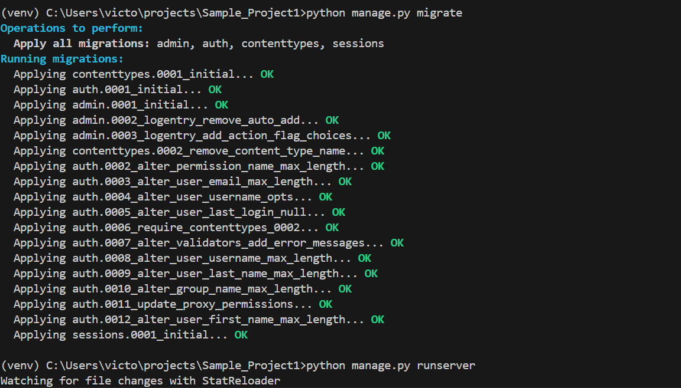

This is needed for:
You're now ready to:
- add apps
- create models
- build views and URLs
- work with templates
- connect to external DB
- scale as needed

Create a app called Home:
python manage.py startapp home

Register the app in settings.py:
Tell Django that this new home app exists
Here I have added the home app
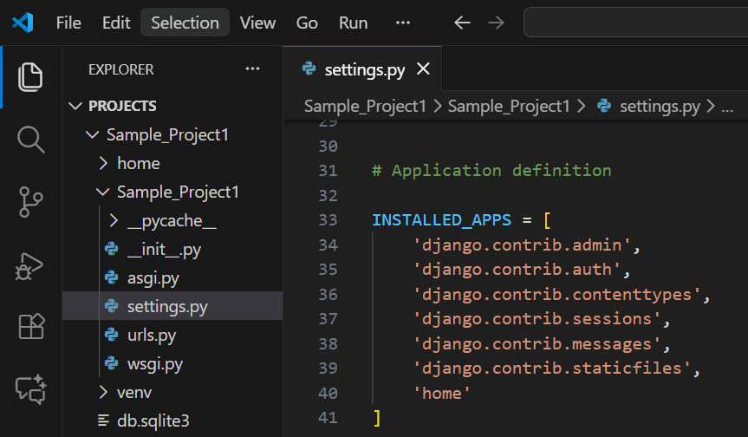

10.30 – 11.30 AM
1.Create a simple view (home_view)
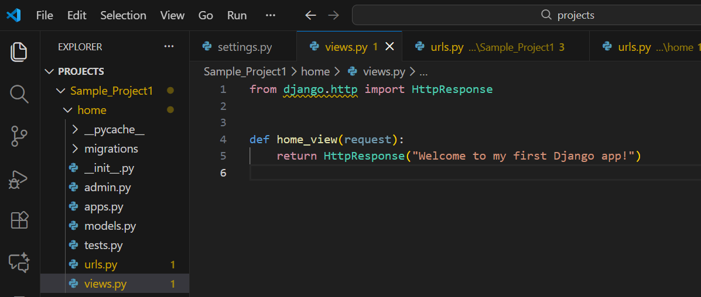
This tells Python:
HttpResponse is what you use to send text (or HTML) back to a browser.
def home_view(request):
- defined function named home_view.
- Django calls this function whenever someone visits a URL connected to it.
- The request parameter contains information about the visitor (browser, headers, URL, etc.)
Return HttResponse()
This creates an HttpResponse object with the text and retur to the browser
2. Create home/urls.py (App level urls)
from django.urls import path
from .views import home_view

urlpatterns = [
path("", home_view, name="home"),
]

1. urlpatterns
This list is Django’s routing map. Every incoming HTTP request must match one of the patterns inside it. If there’s no match, Django returns a 404.
This urlpatterns has predefined convertor and matching mechanism
Eg: Regex
If not matched it returns 404 error

2. path("", home_view, name="home")
This line declares:
- "" → the root URL (e.g., /)
- home_view → the function that should run when a user visits /
- name="home" → a stable identifier so you can reference this route in templates, redirects, and reverse lookups (e.g., reverse("home"))
3. Why this file is needed at all
Django uses a hierarchical URL resolution system:
- The project’s main urls.py includes app-level URLs.
- Each app declares its own route definitions.
- Django resolves URLs top-down until it finds a match.
Without defining urlpatterns in each app:
- Django can’t route requests to your views.
- Your view functions become unreachable.

3. Hook home URLs into the main project (Sample_Project 1)
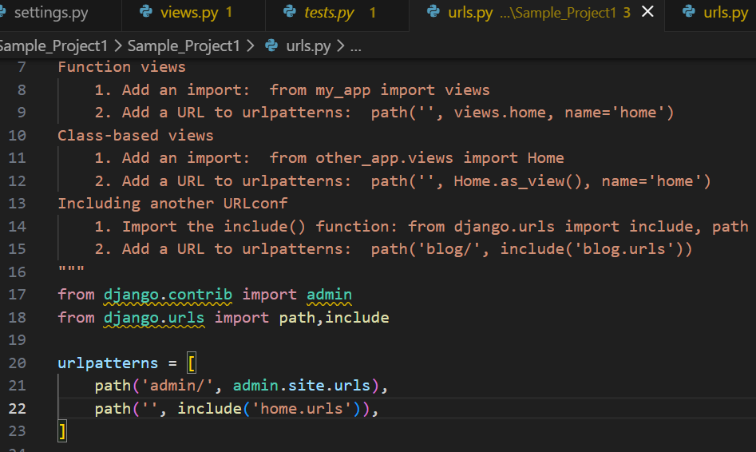
Use include
path('', include('home.urls')), ‘’ empty string is root url
include() When the URL matches this prefix, switch to another urls.py file and continue routing there

Means:
- If the user goes to /
- Look inside home/urls.py next

urlpatterns = [ ... ] python list Django uses as its routing table

Home page
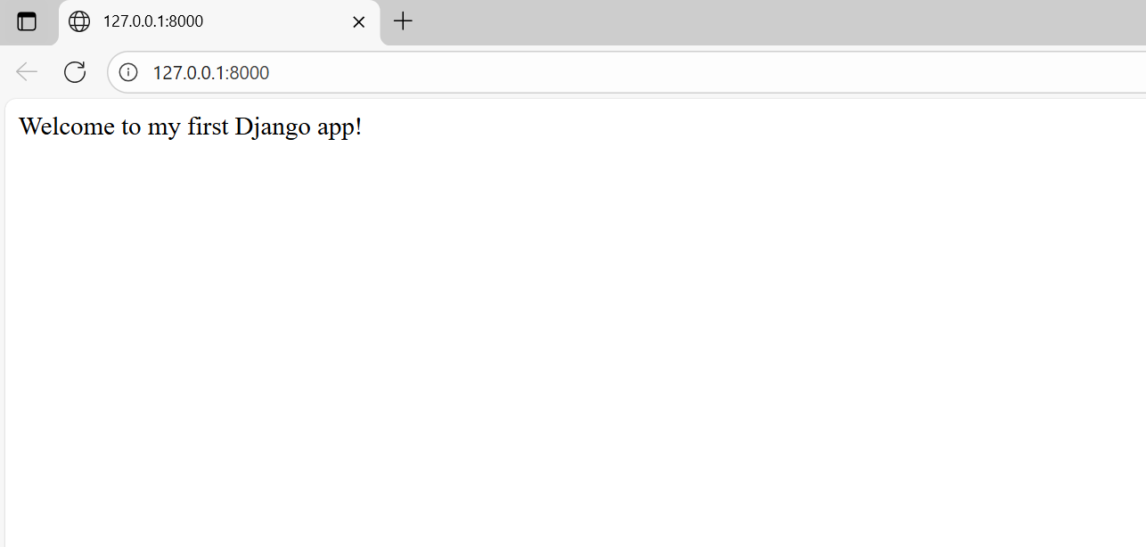
Now I am trying to create another url for another page
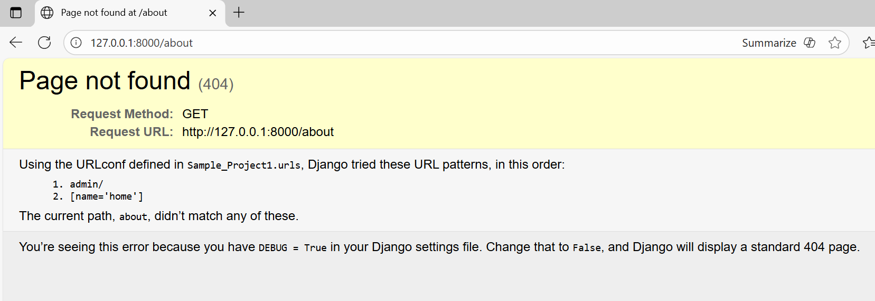
Reason I don’t add the about_view in the urls.py of the home app
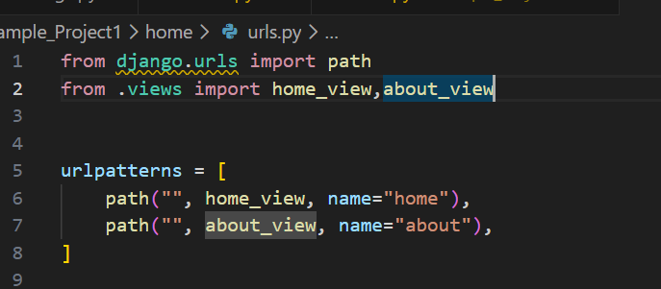
Make sure u add the path and import the same to avoid that
After that create the name “” about inside it so that it checks for it
Django considers about/ and about in url differently make sure the path matches
Hence it worked

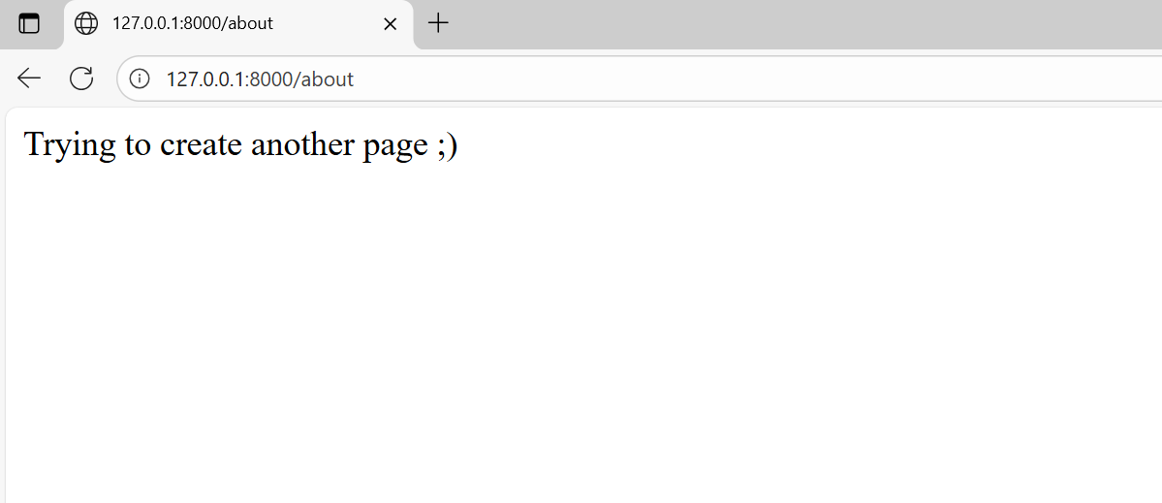
All these are ok
now we can give tags inside the httpresponse itself
We will get the output but considering large applications this is not possible
and this can only providestatic print statement that we are giving in the code
Hence we want DTL
Understanding DTL:

Django’s template language (DTL) is the system Django uses to dynamically generate HTML (or any text output) by combining static markup with data passed from your views.

In settings.py
import os
'DIRS': [os.path.join(BASE_DIR,'templates')],

Views.py
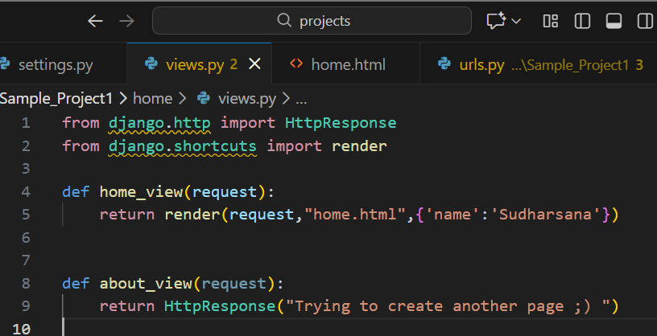
Home.html:
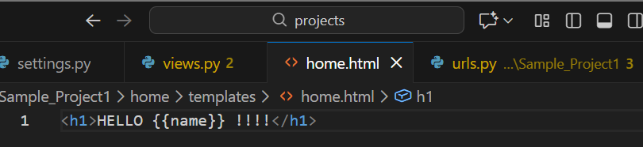
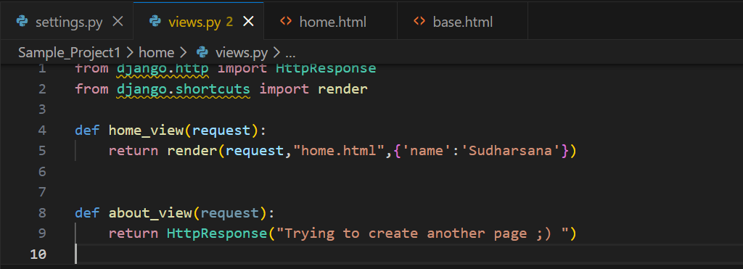
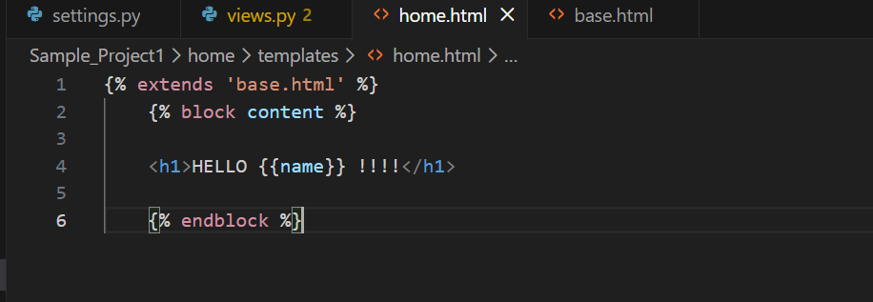
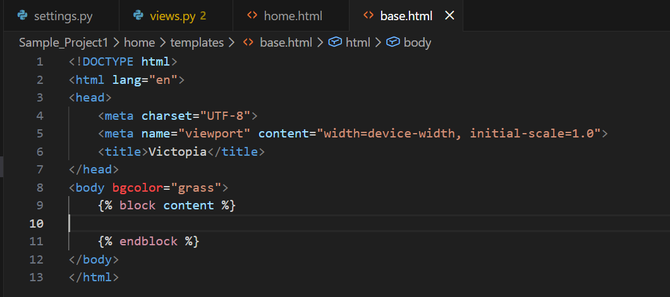

Output:
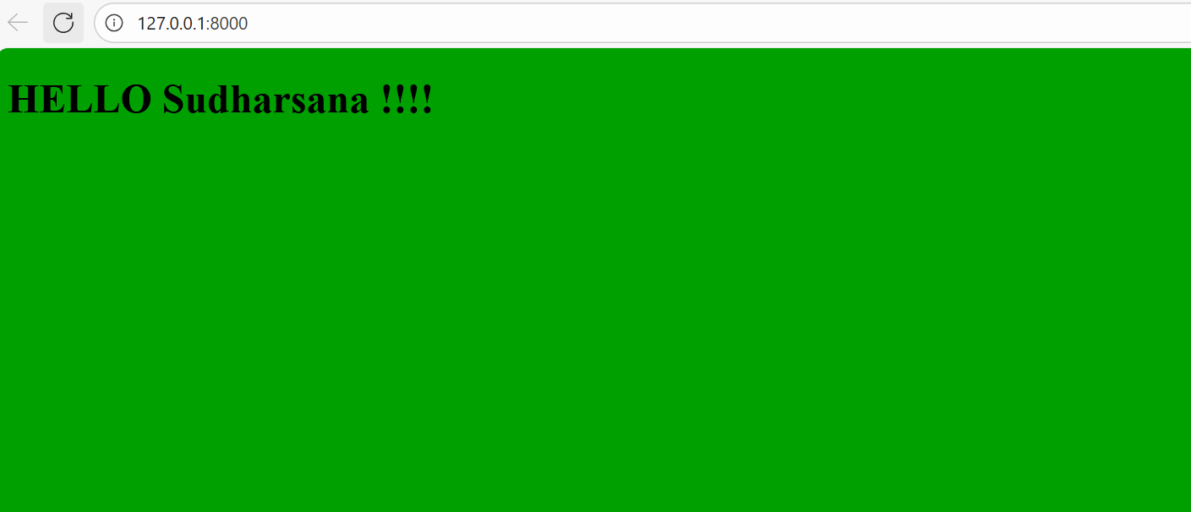
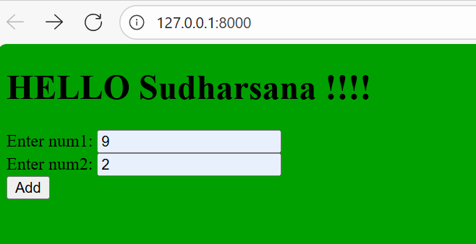
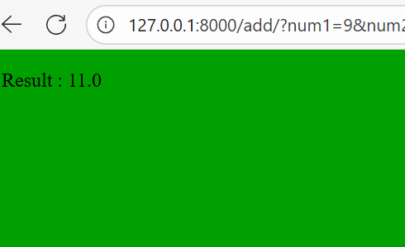
MVT
- Model
- View
- Template
Work Flow
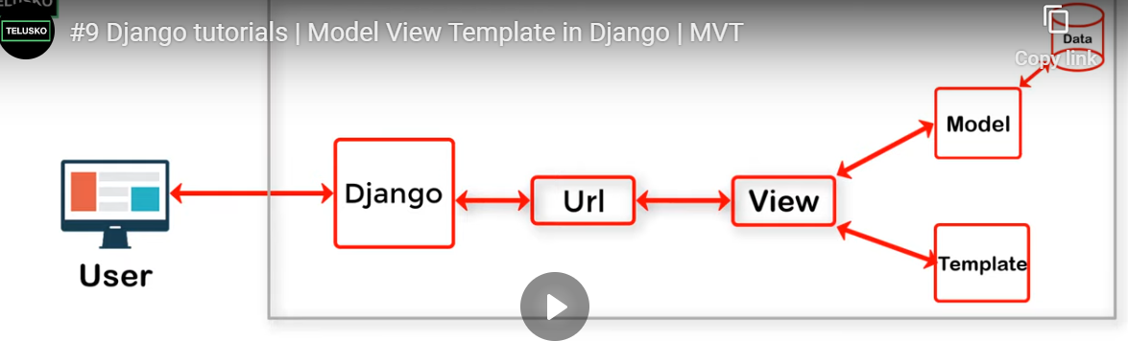

Comparison
1.CRUD
Feature | Hibernate / Spring Data JPA | Django ORM
Create | save(entity) | Model.objects.create()
Read (all) | findAll() | Model.objects.all()
Read (one) | findById(id) | Model.objects.get(id=...)
Update | save(entity) | obj.save()
Delete | delete(entity) | obj.delete()
Delete by ID | deleteById(id) | Model.objects.filter(id=id).delete()

2.Relationship
Relationship | Hibernate | Django
One-to-One | @OneToOne | OneToOneField
One-to-Many | @OneToMany | ForeignKey
Many-to-Many | @ManyToMany | ManyToManyField
Cascade | cascade = CascadeType.ALL | on_delete=models.CASCADE

3.Aggregation
Aggregation | Hibernate | Django
Count | count() | count()
Sum | SUM() (JPQL) | aggregate(Sum("field"))
Avg | AVG() (JPQL) | aggregate(Avg("field"))
Min | MIN() | aggregate(Min("field"))
Max | MAX() | aggregate(Max("field"))
Group By | JPQL | values().annotate()

19/11/25
Login Time : 8.57 AM
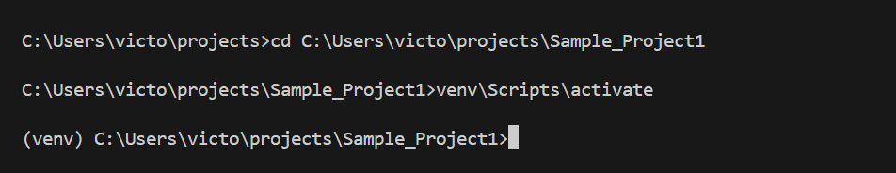
ORM
It lets you to work with the database using python and not SQL (no need of raw sql)
It does:
Convery python code SQL
SQL Results Python Objects
Handles CRUD
user = User.objects.create(username="victor", email="victor@example.com")
It creates the tble by itself using migration after defining the model using python
Step 1 Create a model
class Product(models.Model):
name = models.CharField(max_length=255)
price = models.IntegerField()
Step 2 Run the migration
python manage.py makemigrations
python manage.py migrate
Result Creates the table automatically
appname_modelname
here it is product and suppose if your app is shop
eg: shop_product

Migrations manage your entire database structure — not just table creation.
They keep:
- Your models
- Your database schema
Perfectly in sync.

What Django Migrations Actually Do
Migrations manage ALL changes to your database schema, including:
✔ 1. Create tables
CREATE TABLE app_model (...);
✔ 2. Add new fields (columns)
ALTER TABLE app_model ADD COLUMN age INT;
✔ 3. Rename fields
ALTER TABLE app_model RENAME COLUMN old_name TO new_name;
✔ 4. Remove fields
ALTER TABLE app_model DROP COLUMN old_column;
✔ 5. Change field types
Example: Integer → Char
ALTER TABLE app_model ALTER COLUMN age TYPE VARCHAR(10);
✔ 6. Add indexes
CREATE INDEX idx_name ON app_model (username);
✔ 7. Add unique constraints
ALTER TABLE app_model ADD CONSTRAINT unique_email UNIQUE(email);
✔ 8. Add foreign keys (relationships)
ALTER TABLE shop_order
ADD CONSTRAINT fk_user FOREIGN KEY(user_id) REFERENCES auth_user(id);
✔ 9. Create many-to-many intermediate tables
app_model_rel_table
✔ 10. Rename tables
ALTER TABLE old_table RENAME TO new_table;
✔ 11. Modify default values
Django updates constraints or triggers as needed.
✔ 12. Run custom Python code
Useful for data migrations, e.g.:
- Copying data
- Populating initial rows
- Moving data between columns
- Cleaning up inconsistent records
Example migration:
def forward(apps, schema_editor):
User = apps.get_model("auth", "User")
for user in User.objects.all():
user.is_active = True
user.save()

🚀 In short:
Migrations manage your entire database structure — not just table creation.
They keep:
- Your models
- Your database schema
Perfectly in sync.

✔ Summary Table
Migration Action | Purpose
Create table | New model added
Drop table | Model removed
Add field | Column added
Remove field | Column removed
Rename field/table | Schema rename
Change field type | Modify column
Add indexes | Performance tuning
Add constraints | Data integrity
Add relationships | ForeignKey, M2M
Run custom code | Data transformation

Model:
A model is the full data layer abstraction in Django — structure plus behavior
It does:
1.Defines table structure
2.Each model automatically gets

Hands ON:
Update Settings.py
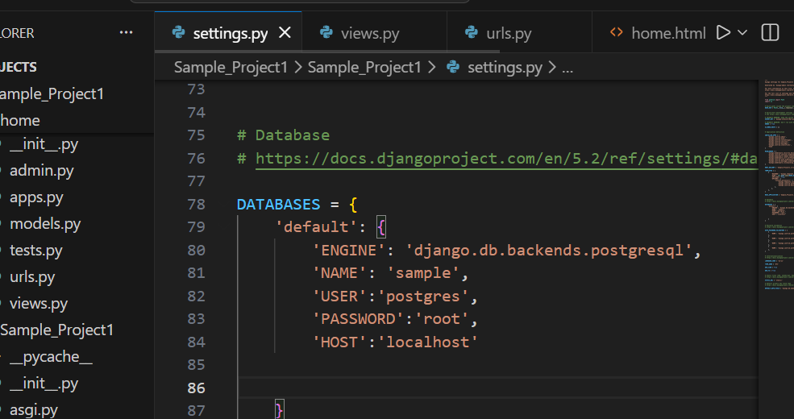
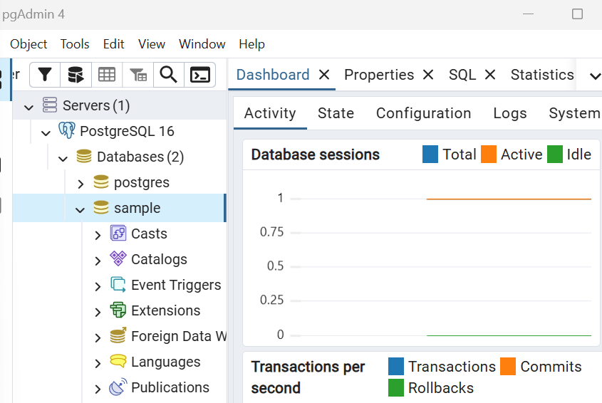
To connect we need a connector:
Psycopg – Popular PostgreSQL Database Adapter for python
Cmd used pip install psycopg2
Django Model Fields: (Refer Django documentation)
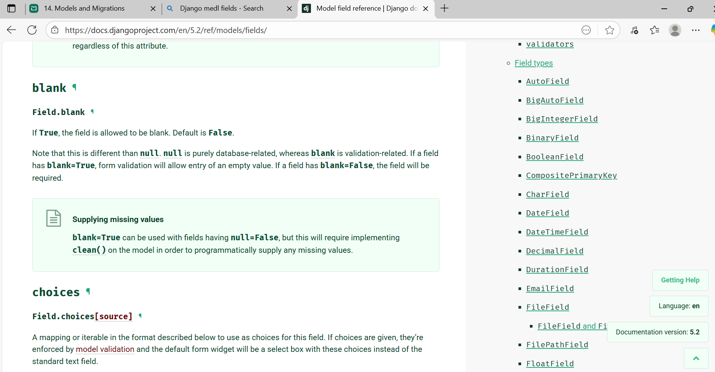

Django Item | Becomes in Database
Model Class Name | Used to generate table name
Field Names (variables) | Become column names
Model Instance | Becomes a row

Model class name : Student
Database name (generated) : Sample_student
Field name : name,age,etc..
Model Instance:
student = Student(
name="John Doe",
age=21,
email="john@example.com"
)
student.save()

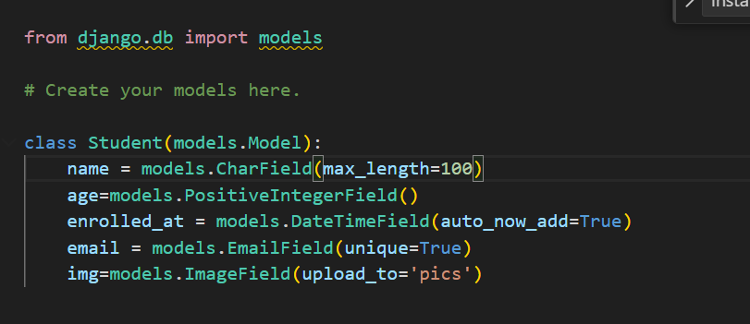

Making migration:
Make sure the app is in installed apps []
Cmd used:
Python manage.py makemigrations
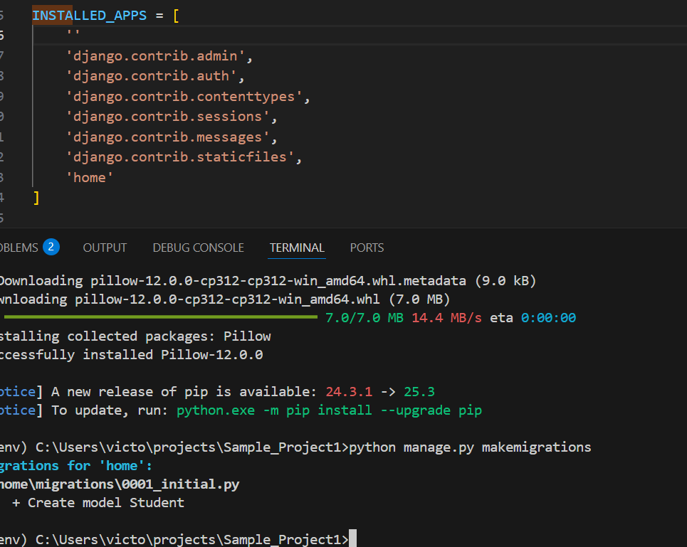

After running this cmd we can see 0001_initial.py file created
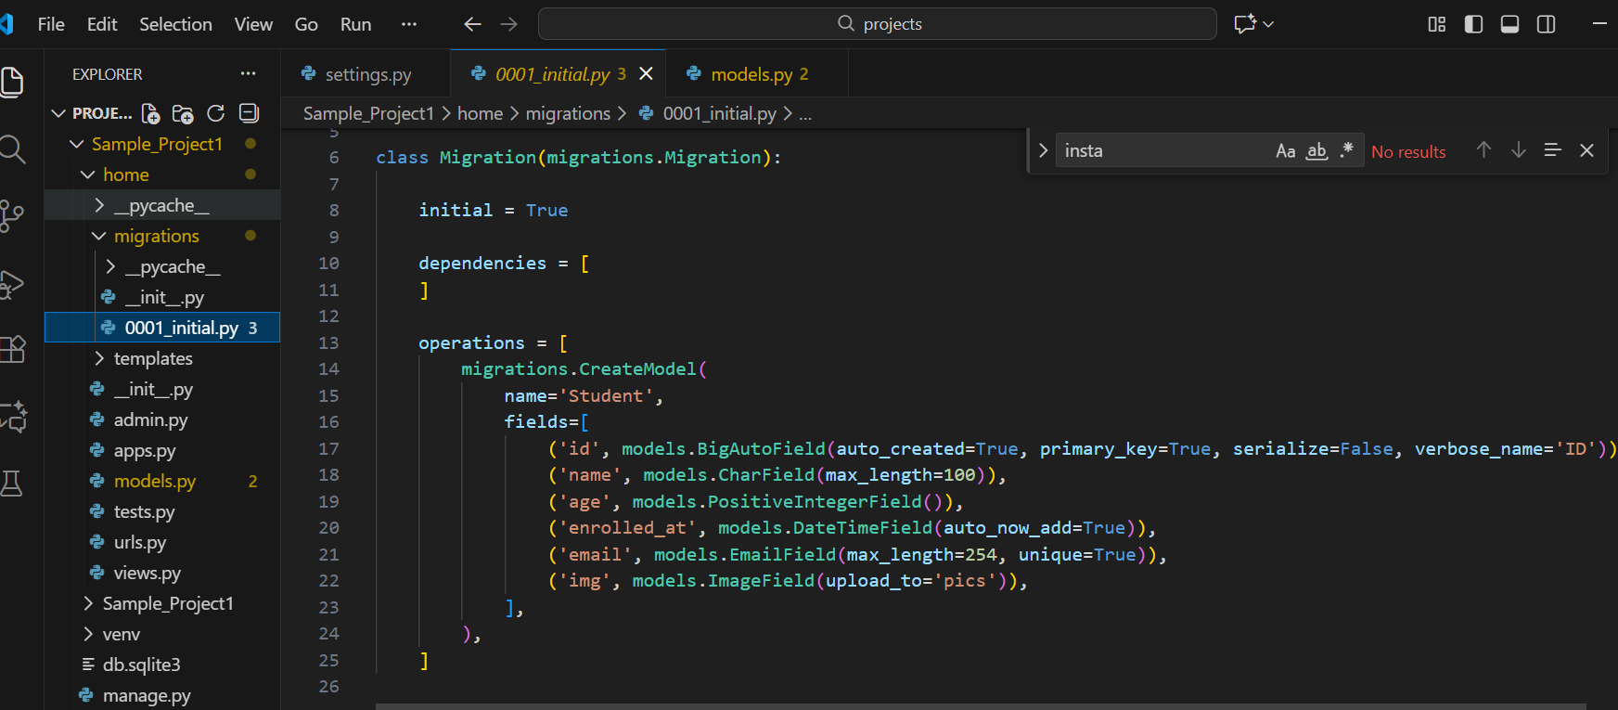
Now to actually migrate
Step 1
python manage.py sqlmigrate home 0001
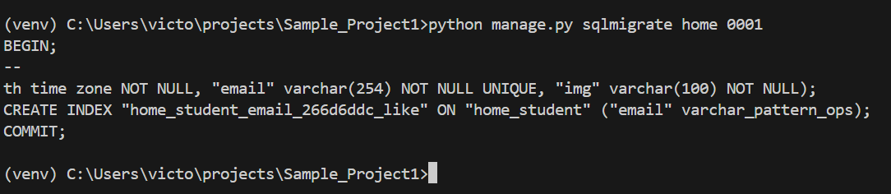
You can see the sql query automatically created we don’t have to write sql query
Step 2
Python manage.py migrate
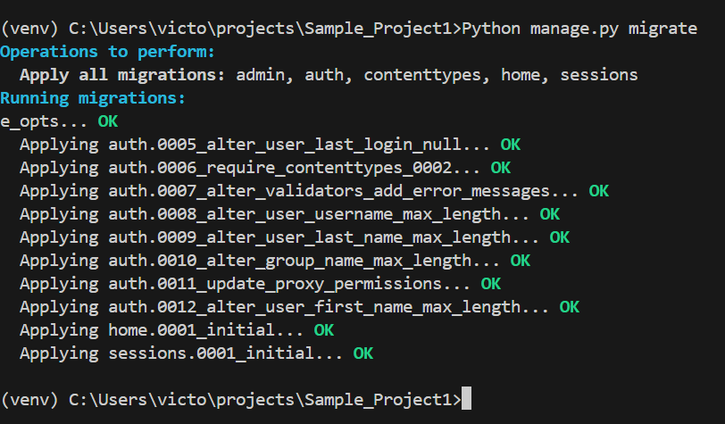

After this
Check pgadmin
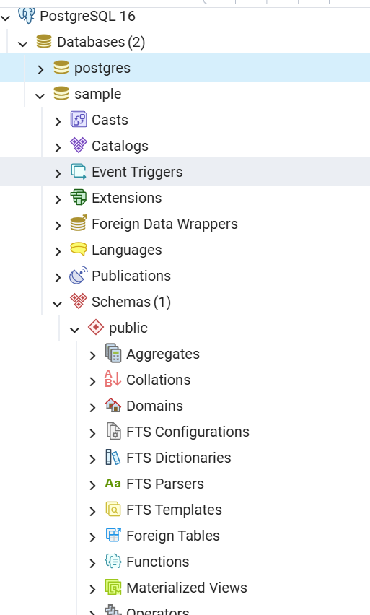
Here we can see the tables.
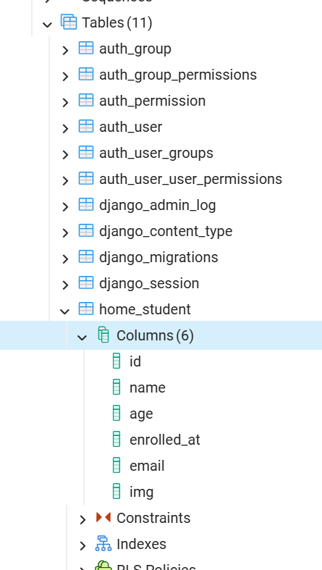
Hence classes are created as tables
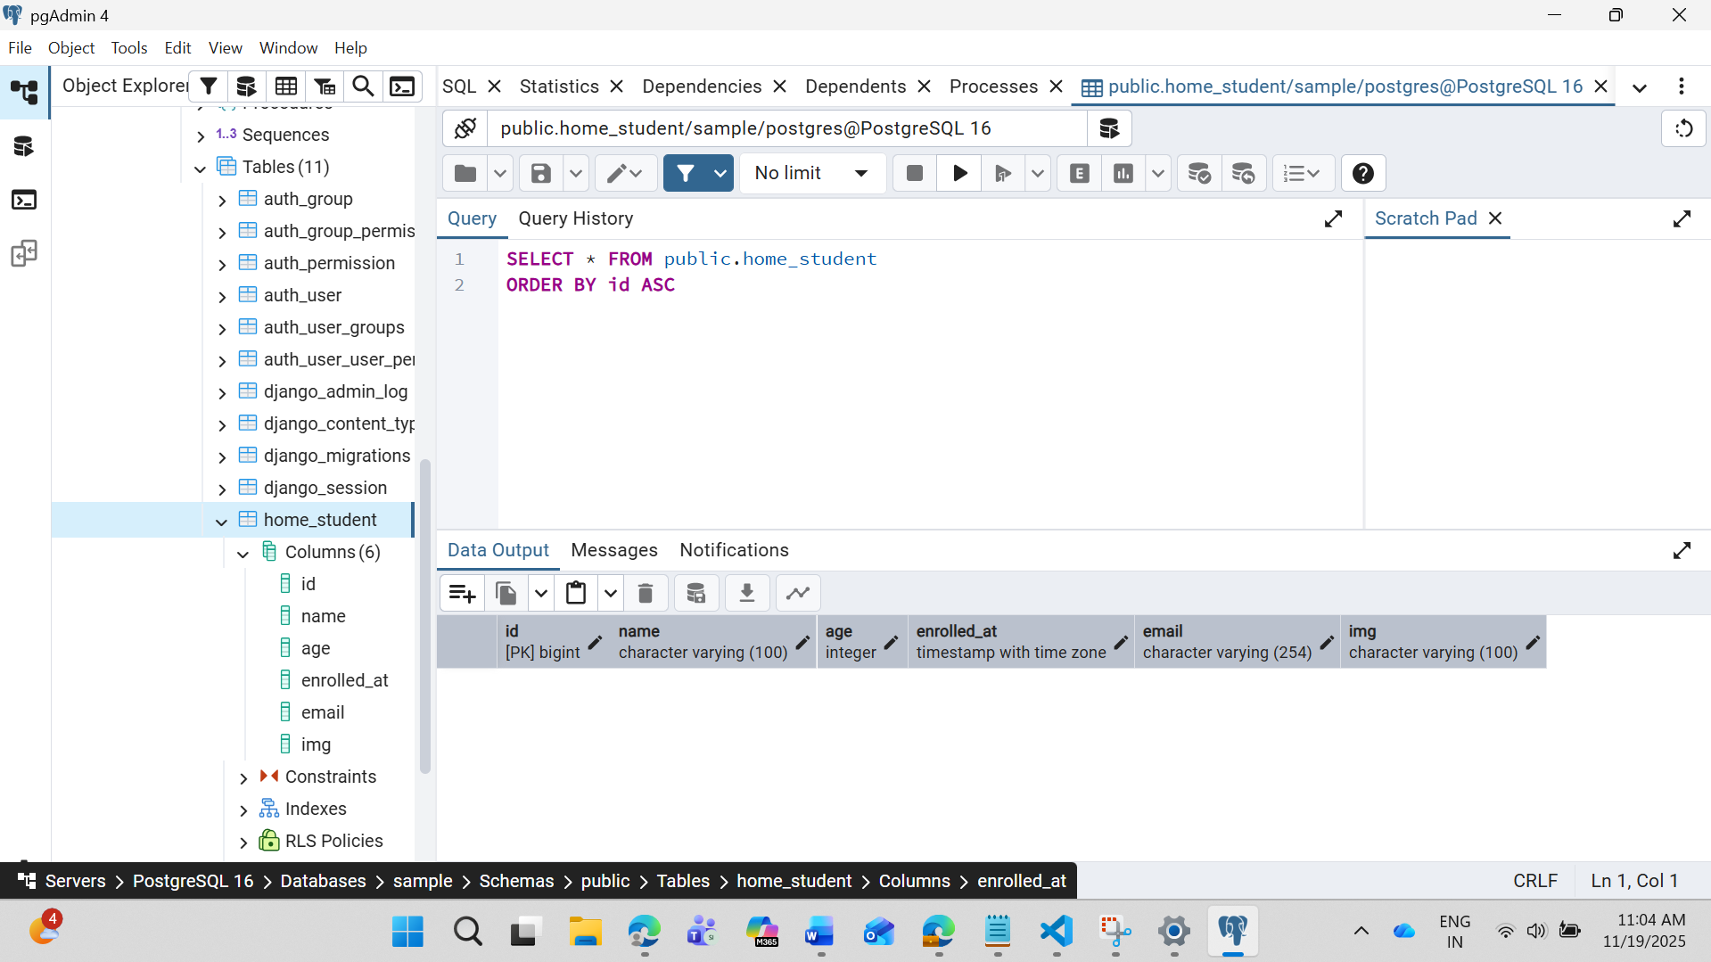
Now if I miss out anything / made mistake while creating a model then use Re-Migration/make changes by manually writing query in pgadmin
Re-Migration
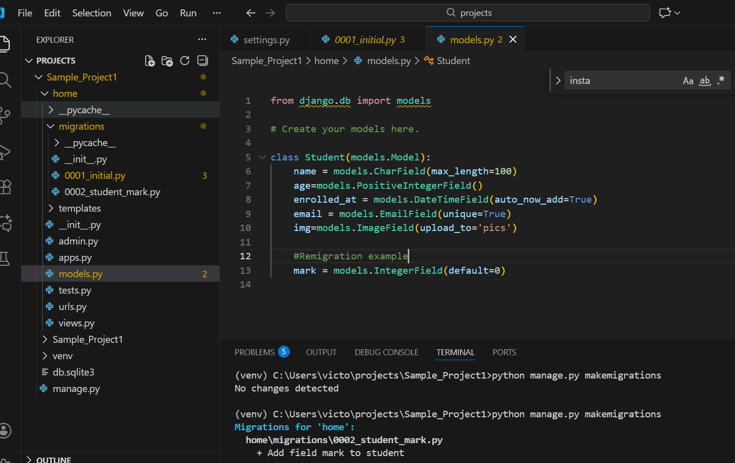
Same way add a command in models.py then procesd with the same command
save the changes and run and we could see another file that has been generated
“0002_student_mark.py”
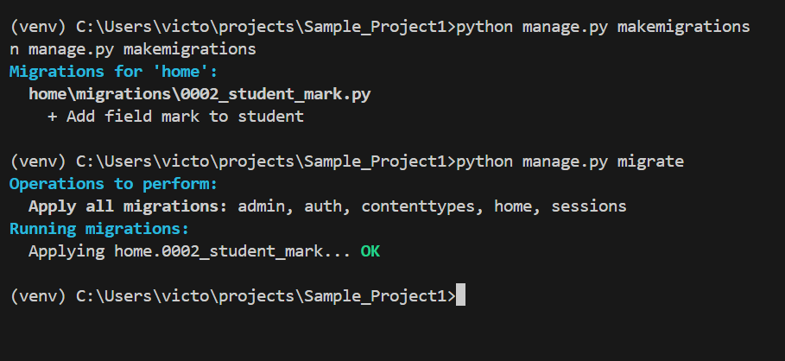
Now migrate this and check in Pg admin
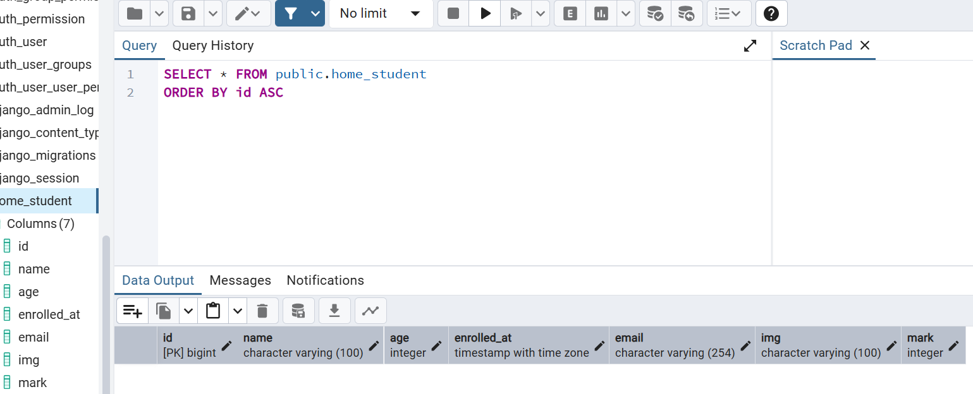

Admin Panel
By default we could see
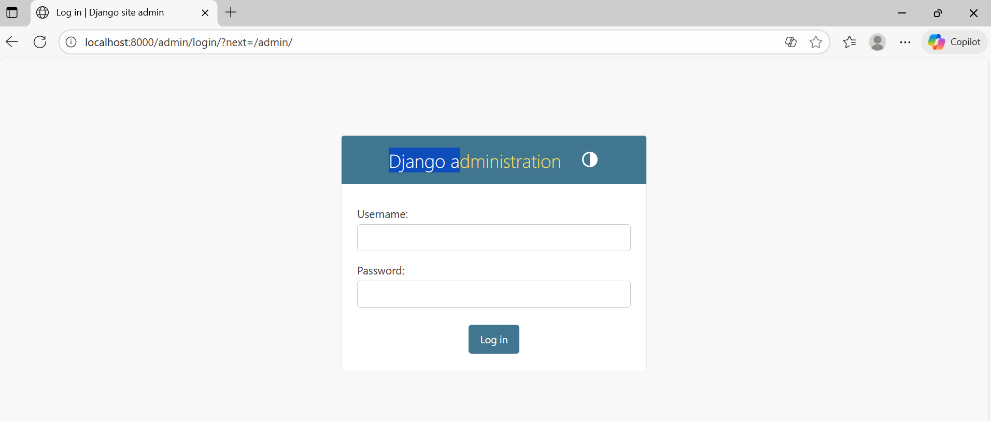
Now use the cmd:
createsuperuser to create one for login
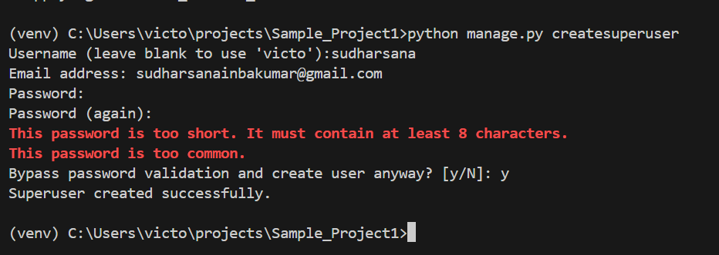

I have used password : root
Always use a stronger one this is only for demo

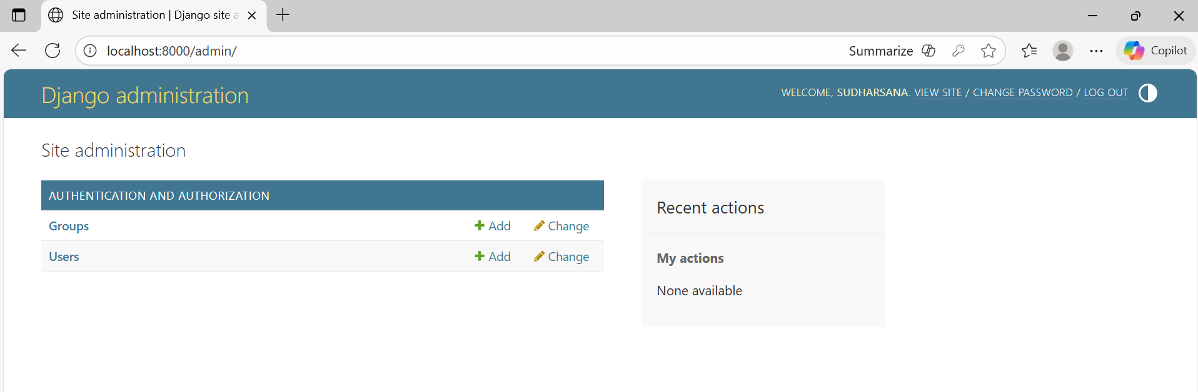
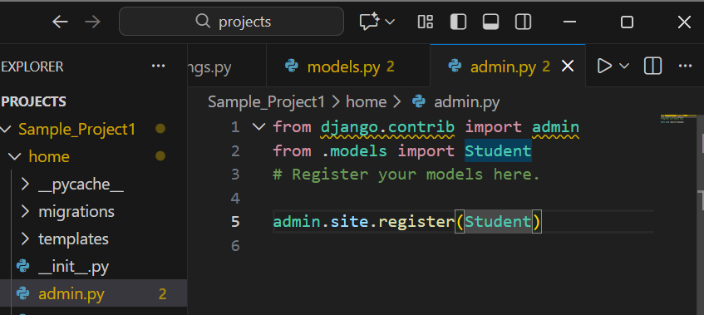
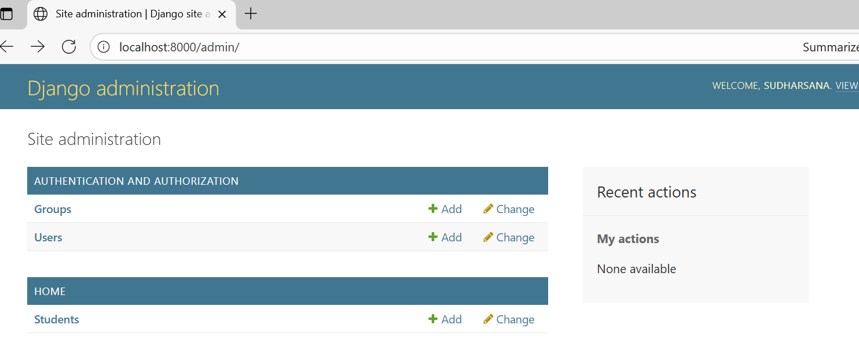

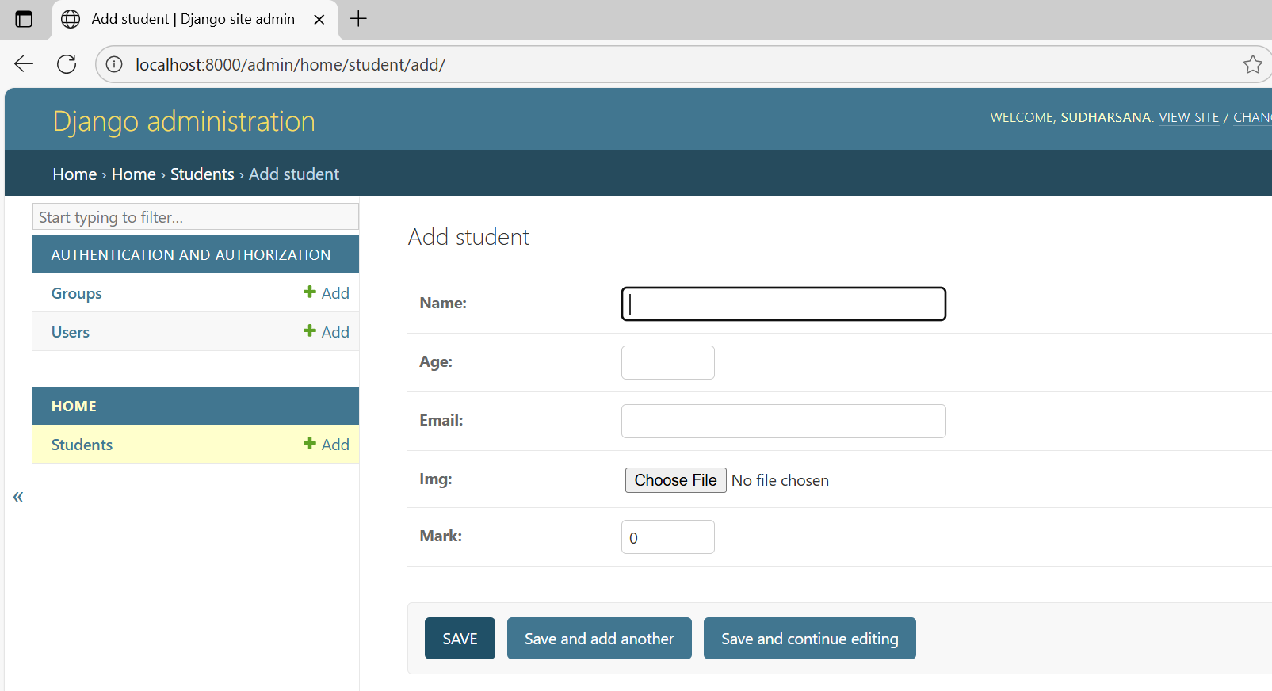
Add and Fetch Data from Database
Make changes in
1.Settings.py
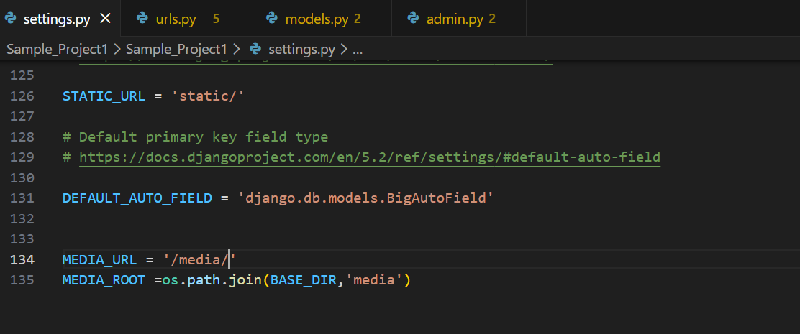
2.Urls.py
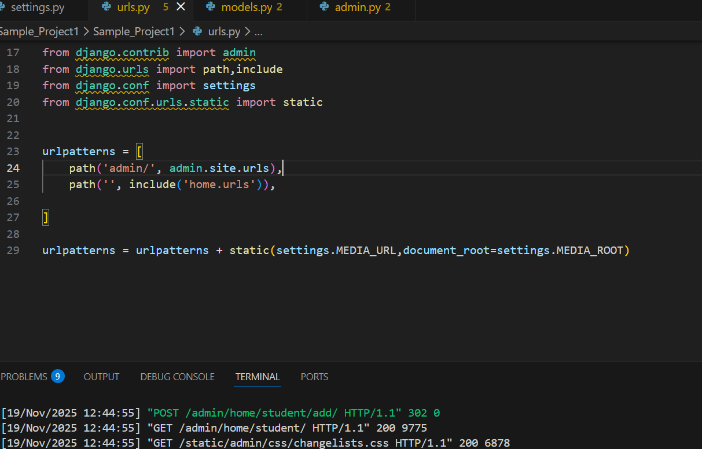
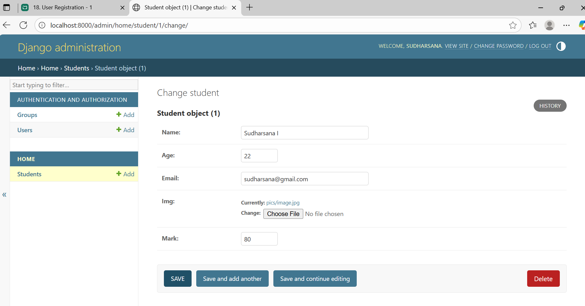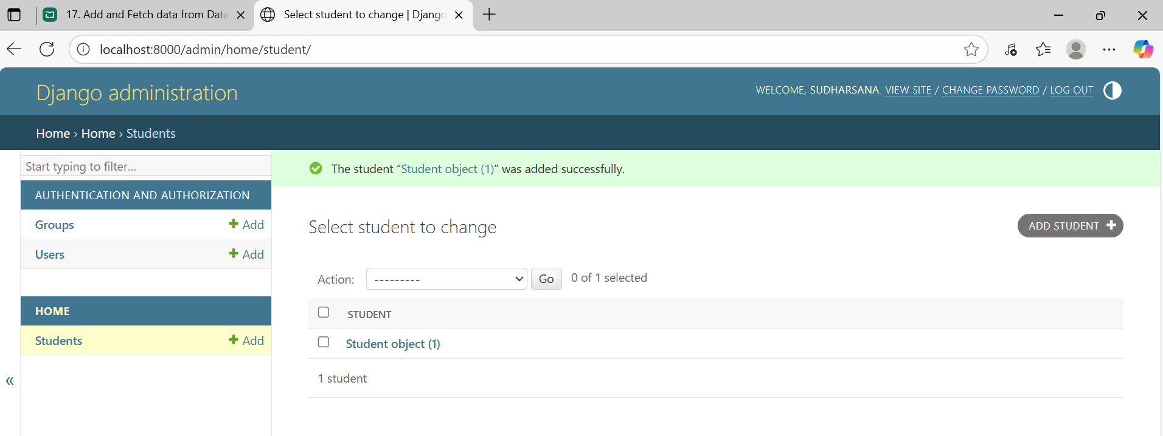
Refresh to reflect changes
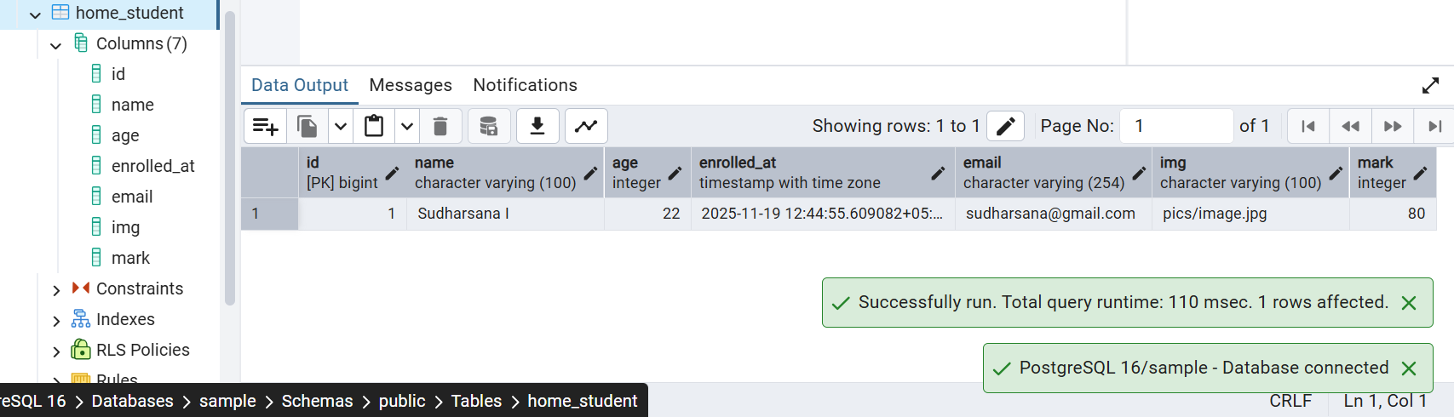

User Registration
1.Define URL
Created a sub app called accounts
Inside accounts>urls
urlpatterns = [
path("register/", views.register, name="register"),
]
So this will make page ready to view on:
http://localhost:8000/accounts/register/
2. Registration View Logic
Your view handles:
- GET request: shows the registration form
- POST request: validates data and creates a new user
accounts/views.py
3. Registration Form Template
Register.html
4. Template Folder Setup
Place this register.html in valide “Templates” folder (Create the templates folder)
5.Add the sub app accounts
Add inside the installed app in settings.py
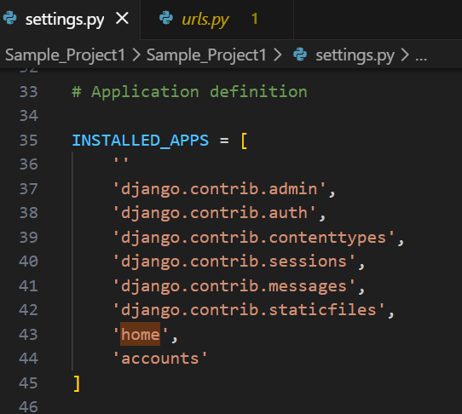
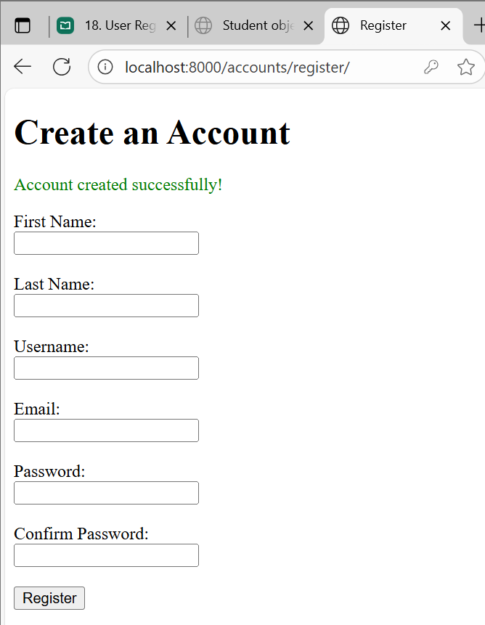

Output
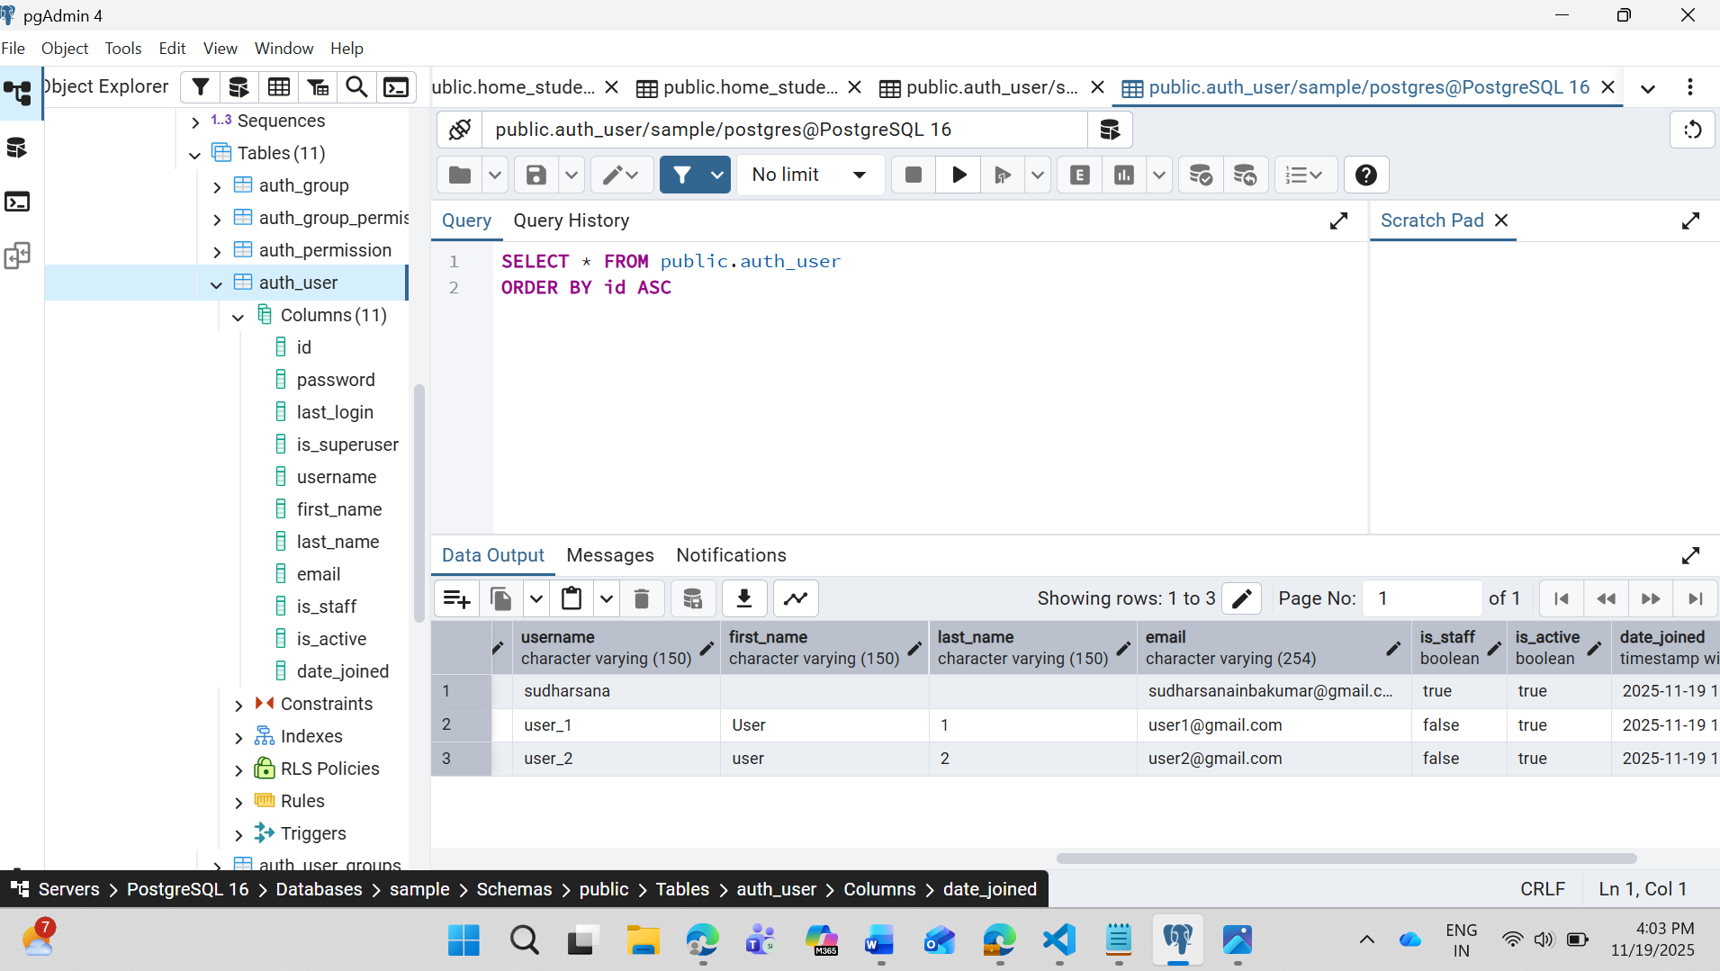

Passing Messages
from django.contrib import messages

messages.error(request, msg)
messages.success(request, msg)
messages.warning(request, msg)
messages.info(request, msg)
Also Jinja can be used {{ }}

Eg: messages.error(request, "All fields are required.")
Only Django error messages passing is powerful

Login Creation
1.Create the login Url
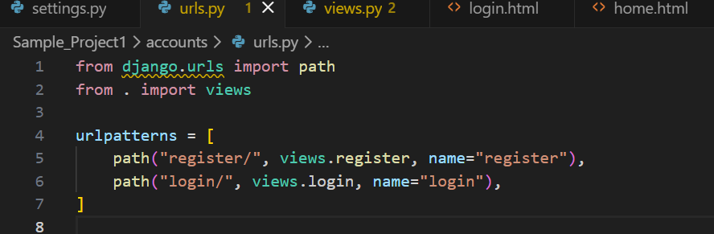
2.Create the login View
Inside accounts/views.py add this:
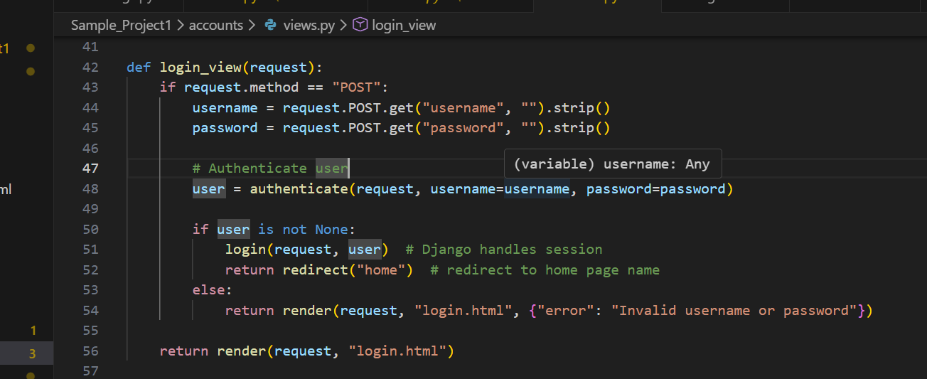

3.Create Login.html
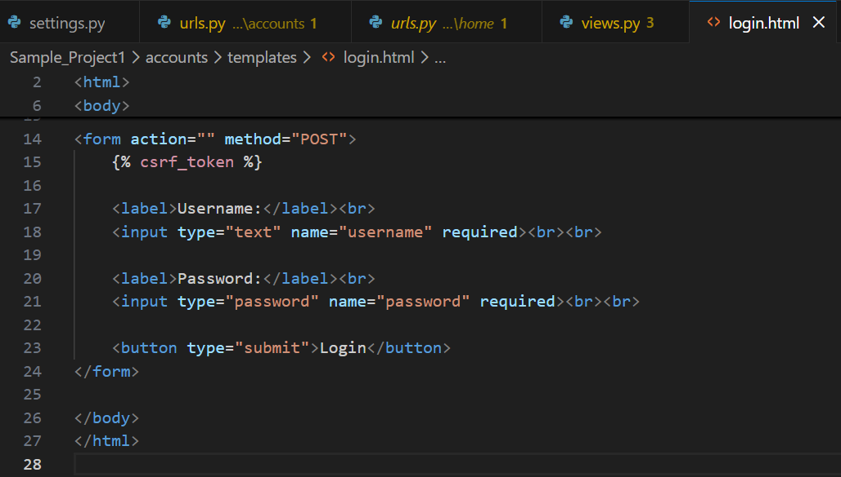
Output:
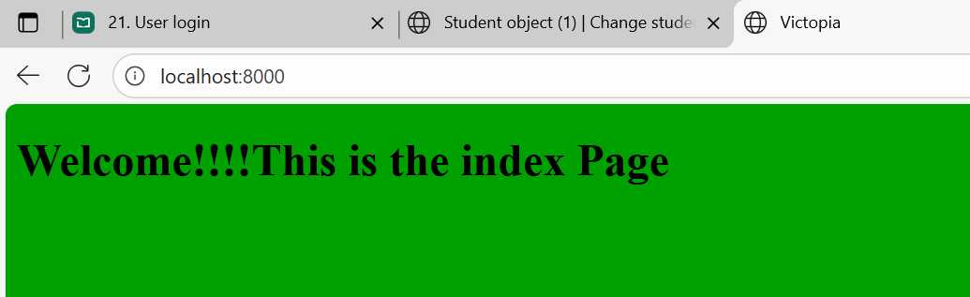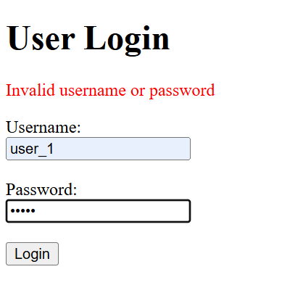

Logout:
1.Create URL
2.Define view
3.Add logout form action home.html
