BITSCRAPE
Architecture Diagram & Reference
v0.1.0 · June 2026 · MIT License
async-first · pluggable · Python 3.11+
github.com/Sudharsansm/Bitscrape

About Bitscrape
Bitscrape is a modern, production-grade asynchronous web scraping framework for Python 3.11+. It is built around Python's native asyncio event loop, giving it high concurrency with low overhead. The architecture is intentionally layered — each concern (scheduling, downloading, parsing, validation, storage) lives in its own module and communicates through well-defined interfaces.
The diagram on the following page shows the full request-to-item flow, from the entry points (CLI / API) down through the engine, scheduler, downloader, middleware stack, spider callbacks, item pipeline, and feed exporters.

Architecture Diagram
The diagram below shows every layer of the framework — from the three entry points at the top, through the Engine, Scheduler, Downloader, Middleware, Spider, and Item Pipeline, down to the Feed Exporters at the bottom. Optional integrations (Redis, PostgreSQL, LangGraph, uvloop) are shown in dashed boxes. The numbered flow at the bottom traces a single request from start to exported item.

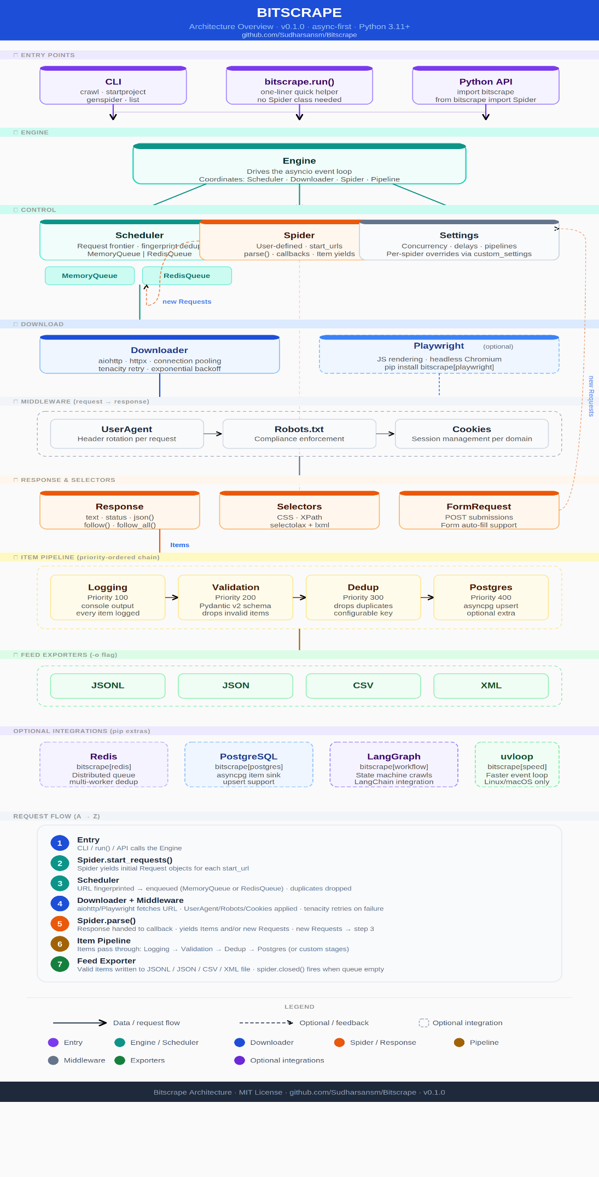

Layer-by-Layer Reference
The table below maps every layer visible in the diagram to the code module that implements it, along with its primary responsibility. Layers are colour-coded to match the diagram

Layer | Component | Responsibility
Entry | CLI | Click-based command interface: crawl, startproject, genspider, list
Entry | bitscrape.run() | One-liner helper — scrape a URL without writing a Spider class
Entry | Python API | Direct import: from bitscrape import Spider, Item
Engine | Engine | Drives the asyncio event loop; coordinates all subsystems in one place
Control | Scheduler | Manages the request frontier; deduplicates URLs by SHA-1 fingerprint
Control | MemoryQueue | Default in-process FIFO queue; stores pending Requests in RAM
Control | RedisQueue | Redis-backed queue enabling distributed multi-worker crawling
Control | Spider | User-defined; declares start_urls and parse() callback; yields Items and Requests
Control | Settings | Central config: concurrency, download delay, pipeline order, user-agent, etc.
Download | Downloader | Sends async HTTP via aiohttp/httpx; connection pooling; tenacity retry with backoff
Download | Playwright | Optional browser engine for JS-rendered pages (pip install bitscrape[playwright])
Middleware | UserAgent | Rotates User-Agent header on every outgoing request from a configurable list
Middleware | Robots.txt | Fetches robots.txt per domain and blocks disallowed paths
Middleware | Cookies | Maintains per-domain cookie sessions across multiple requests
Response | Response | Wraps HTTP response; exposes .text, .status, .json(), .css(), .xpath(), .follow()
Response | Selectors | CSS (.css()) and XPath (.xpath()) query interface via selectolax + lxml
Response | FormRequest | Request subclass for POST submissions and HTML form auto-filling
Pipeline | LoggingPipeline | Logs every yielded item to stdout (priority 100)
Pipeline | ValidationPipeline | Runs Pydantic v2 schema validation; drops items that fail (priority 200)
Pipeline | DedupPipeline | Drops duplicate items by a configurable key field (priority 300)
Pipeline | PostgresPipeline | Upserts items into PostgreSQL via asyncpg (priority 400, optional)
Export | JSONL Exporter | Streams items as newline-delimited JSON — best for large datasets
Export | JSON Exporter | Writes a pretty-printed JSON array on spider close
Export | CSV Exporter | Writes flat items as comma-separated values
Export | XML Exporter | Wraps items as XML elements
Optional | Redis | pip install bitscrape[redis] — RedisQueue + distributed fingerprint store
Optional | PostgreSQL | pip install bitscrape[postgres] — asyncpg item sink in PostgresPipeline
Optional | LangGraph | pip install bitscrape[workflow] — state machine workflow orchestration
Optional | Playwright | pip install bitscrape[playwright] — headless Chromium browser rendering
Optional | uvloop | pip install bitscrape[speed] — faster event loop on Linux/macOS (not Windows)

Request → Item Data Flow
This table traces a single URL from the moment it enters the framework to the moment its data is written to a file. Steps 2–4 repeat for every new URL the spider discovers.

# | Stage | What happens
1 | Entry | User runs bitscrape crawl spider.py -o out.jsonl (or calls bitscrape.run() / imports the Python API). The Engine is initialised and the event loop starts.
2 | Spider.start_requests() | Spider yields a Request object for each URL in start_urls. Custom start_requests() can add headers, cookies, or meta.
3 | Scheduler | Each Request URL is SHA-1 fingerprinted. If already seen → dropped. Otherwise enqueued in MemoryQueue (default) or RedisQueue (distributed mode).
4 | Downloader + Middleware | Engine pulls the next Request from the Scheduler. Middleware applies: UserAgent rotates headers, Robots.txt checks the path, Cookies attaches session data. aiohttp (or Playwright) makes the async HTTP call. On failure, tenacity retries with exponential backoff.
5 | Spider.parse() | The Response is handed to the spider's parse() callback. The spider yields: Items (→ pipeline, step 6) and/or new Requests (→ Scheduler, back to step 3). FormRequests follow the same path as Requests.
6 | Item Pipeline | Each Item passes through the ordered pipeline chain: Logging (console output) → Validation (Pydantic v2 schema check, drops invalid) → Dedup (drops duplicates by key) → Postgres (optional DB upsert). Custom pipeline stages plug in at any priority.
7 | Feed Exporter | Valid Items are written to the output file in the chosen format (JSONL / JSON / CSV / XML). When the Scheduler queue empties and all downloads finish, the Engine calls spider.closed() and prints a stats summary.

Optional Extras
Bitscrape uses pip extras to keep the base install lightweight (under 15 MB). Install only what your project needs:

Install command | Provides | Use case
pip install bitscrape | Core framework | Static pages · CSV/JSON export · CLI · all built-in pipelines
bitscrape[playwright] | Playwright + Chromium | JavaScript-rendered pages · SPAs · pages requiring login
bitscrape[redis] | redis-py client | Distributed multi-worker crawling · shared dedup store
bitscrape[postgres] | asyncpg driver | Write items directly to a PostgreSQL table
bitscrape[workflow] | LangGraph + LangChain | State machine–driven crawls with conditional branching
bitscrape[speed] | uvloop | Faster asyncio event loop on Linux and macOS (not Windows)
bitscrape[full] | All extras bundled | Everything in one install for production deployments
bitscrape[dev] | pytest · mypy · ruff · cov | Development and CI toolchain for contributors

Key Design Decisions

1 — Async-first with native asyncio
Every I/O operation is non-blocking. The Engine drives a single asyncio event loop, allowing hundreds of concurrent requests without OS threads. This eliminates GIL contention, keeps memory usage predictable, and integrates natively with aiohttp, asyncpg, and any other async library.

2 — Pydantic v2 for type-safe Items
Item subclasses extend pydantic.BaseModel. This provides: automatic field validation, type coercion, clear error messages on bad data, and free JSON serialisation. Validation happens at the pipeline stage so bad data is caught early and reported — not silently written to disk.

3 — Pluggable middleware and pipelines
Middleware (request/response hooks) and pipelines (item processing stages) are ordered lists of classes. You add a new stage by: (a) creating a class with process_request() or process_item(), and (b) adding it to DOWNLOADER_MIDDLEWARES or ITEM_PIPELINES in settings with a numeric priority. Zero changes to the framework core.

4 — Optional extras keep installs lean
Playwright, Redis, asyncpg, LangGraph, and uvloop are all opt-in. A basic crawl with pip install bitscrape is under 15 MB and has no native binary dependencies. This matters for CI pipelines, serverless functions, and Docker images where cold-start time and layer size are constraints.

5 — PEP 561 typed package
The package ships a py.typed marker file. mypy and Pyright treat all public APIs as fully typed. Spider, Item, Response, and all pipeline classes have complete annotations. This means IDE autocompletion works out of the box and static analysis catches type errors in spider code before runtime.

Quick Reference

Install
pip install bitscrape # core only
pip install bitscrape[full] # all extras
pip install bitscrape[playwright] # JS rendering
uv add bitscrape # using uv

Run a spider
bitscrape crawl my_spider.py -o output.jsonl
bitscrape crawl my_spider.py -o output.csv --loglevel DEBUG

Minimal spider
from bitscrape import Spider, Item

class ArticleItem(Item):
title: str
url: str
price: float | None = None

class MySpider(Spider):
name = 'myspider'
start_urls = ['https://example.com']

def parse(self, response):
for card in response.css('div.card'):
yield ArticleItem(
title = card.css('h2::text').get(),
url = card.css('a::attr(href)').get(),
price = card.css('.price::text').get(),
)
# follow pagination
if nxt := response.css('a.next::attr(href)').get():
yield response.follow(nxt, self.parse)

CLI commands
bitscrape crawl spider.py -o out.jsonl # run spider
bitscrape startproject myproject # scaffold project
bitscrape genspider quotes https://site # generate template
bitscrape list # list all spiders

Bitscrape Architecture Document · MIT License · github.com/Sudharsansm/Bitscrape

