Application: Distributed Database Query Processor

Submitted By
Name: P. Sudharshan reddy
Register Number: 192372204
Subject: Design and Analysis of Algorithms
Faculty: Raja Gopal
Date: 20/07/2026

Introduction
Distributed databases store data across multiple computers or servers. Instead of processing all data on a single machine, the workload is distributed among several database nodes. This approach improves scalability, reliability, and performance.
A Distributed Database Query Processor receives a query from the user, divides it into smaller subqueries, sends them to multiple database nodes, and finally combines the results into a single output.
This project simulates distributed query execution using recursion and analyzes its time complexity using the Master Theorem.
Aim
To implement a Distributed Database Query Processor using the Divide and Conquer technique and analyze its time complexity using the Master Theorem.
Objectives
- Simulate distributed query execution.
- Divide a large query into smaller subqueries.
- Execute recursive processing.
- Merge results from distributed nodes.
- Analyze the recurrence relation.
- Verify the complexity using the Master Theorem.

Problem Statement
A distributed database processes queries using the recurrence relation:
$$T(n)=5T(n/2)+n$$
Apply the Master Theorem to determine the time complexity. Identify the parameters and justify the selected case. Analyze how the recurrence affects performance for large distributed systems and interpret the efficiency using asymptotic notation.
Software Requirements
- Java JDK 21
- Visual Studio Code / IntelliJ IDEA
- Git
- GitHub
- Windows 10/11

Hardware Requirements
- Intel i3 Processor or above
- 4 GB RAM
- 500 MB Free Storage
- Keyboard and Monitor

Theory
Distributed query processing allows multiple database servers to execute portions of the same query simultaneously.
Instead of processing the entire database on one server:
- Query is divided.
- Multiple servers execute parts.
- Results are merged.
- Faster execution is achieved.
In this project:
- Every query creates 5 recursive subqueries.
- Each subquery processes half of the data.
Hence,
T(n)=5T(n/2)+n
where:
- n = number of records
- 5 = number of recursive subqueries
- n/2 = size of each subproblem
- +n = communication and merge cost

Algorithm
Step 1: Start
Step 2: Read total number of records.
Step 3: Create a query object.
Step 4: Execute the query.
Step 5: If records ≤ 1
- Process locally.
- Return result.
Step 6: Else
- Divide query.
- Create five recursive subqueries.
- Execute each recursively.
Step 7: Merge results.
Step 8: Display analysis.
Step 9: Stop.

Pseudocode
ProcessQuery(n)
IF n <= 1
Execute query
RETURN
Divide query
FOR i = 1 TO 5
ProcessQuery(n/2)
Merge all results
RETURN

Flow Chart
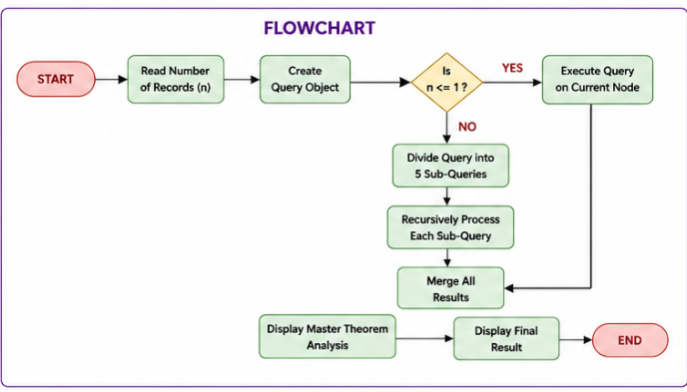
System Architecture Daigram
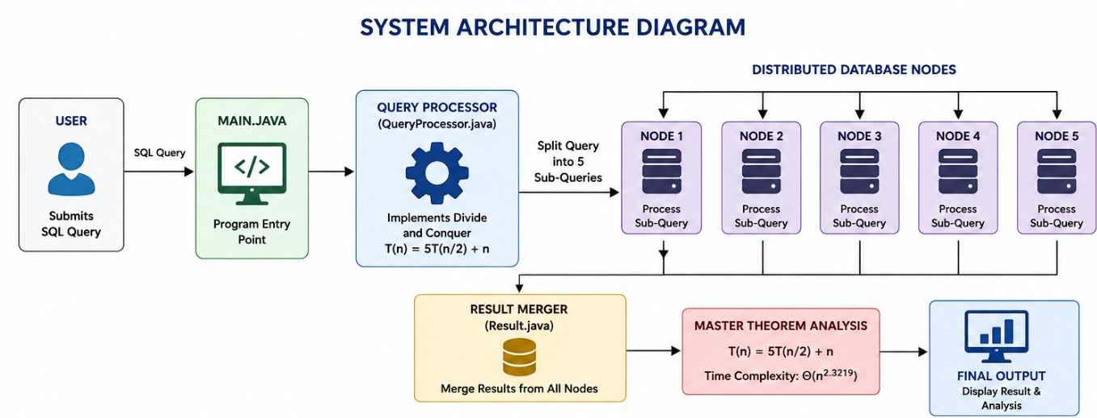
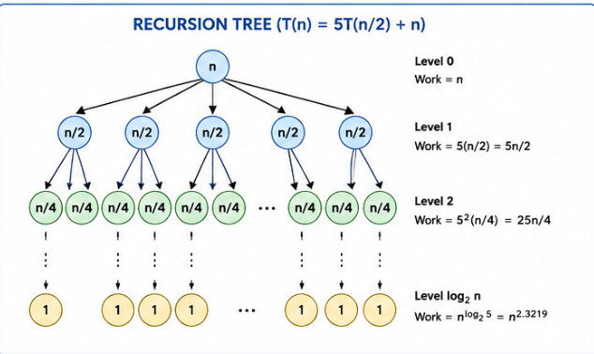

Source Code
Main.java
import java.util.Scanner;
public class Main {
public static void main(String[] args)
Scanner sc = new Scanner(System.in); System.out.println("==========================================");
System.out.println(" Distributed Database Query Processor"); System.out.println("==========================================");
System.out.print("Enter total number of records : ");
int records = sc.nextInt();
Query query = new Query("SELECT * FROM CUSTOMER", records);
QueryProcessor processor = new QueryProcessor();
Result result = processor.processQuery(query);
System.out.println("\n========== FINAL RESULT ==========");
System.out.println(result);
processor.displayMasterTheorem(records);

sc.close();
}
}
Query.java
public class Query {
private String sql;
private int records;
public Query(String sql, int records) {
this.sql = sql;
this.records = records;
}
public String getSql() {
return sql;
}
public int getRecords() {
return records;
}
public void setRecords(int records) {
this.records = records;
}
}

QueryProcessor.java
public class QueryProcessor {
private int nodeCount = 1;
public Result processQuery(Query query) {
int n = query.getRecords();
DatabaseNode node =
new DatabaseNode("Node-" + nodeCount++);
if (n <= 1) {
return node.execute(query);
}
node.execute(query);
int childSize = n / 2;
int totalRecords = n;
int totalNodes = 1;
for (int i = 0; i < 5; i++) {
Query childQuery =
new Query(query.getSql(), childSize);
Result childResult = processQuery(childQuery);
totalNodes += childResult.getNodesVisited();
}
return new Result(totalRecords, totalNodes);
}

public void displayMasterTheorem(int n) {
System.out.println("\n=================================");
System.out.println(" MASTER THEOREM ANALYSIS"); System.out.println("=================================");
System.out.println("Recurrence Relation");
System.out.println("T(n) = 5T(n/2) + n");
int a = 5;
int b = 2;
System.out.println("\na = " + a);
System.out.println("b = " + b);
double value =
Math.log(a) / Math.log(b);
System.out.printf("log2(5) = %.4f%n", value);
System.out.println("\nf(n) = n");
System.out.println("\nCompare");
System.out.println("n vs n^" + value);
System.out.println("\nSince");
System.out.println("n = O(n^(logb(a)-ε))");
System.out.println("\nMaster Theorem Case : 1");
System.out.printf("Time Complexity : Θ(n^%.4f)%n", value);

System.out.println("\nInterpretation");
System.out.println("As the database size increases,");
System.out.println("the recursive query execution");
System.out.println("grows approximately as Θ(n^2.3219).");
System.out.println("Communication overhead also increases");
System.out.println("because every query generates");
System.out.println("five recursive sub-queries.");
}
}
DatabaseNode.java
public class DatabaseNode {
private String nodeName;
public DatabaseNode(String nodeName) {
this.nodeName = nodeName;
}
public Result execute(Query query) {
System.out.println(nodeName + " processing "
+ query.getRecords() + " records.");
return new Result(query.getRecords(), 1);
}
}

Result.java
public class Result {
private int processedRecords;
private int nodesVisited;
public Result(int processedRecords, int nodesVisited) {
this.processedRecords = processedRecords;
this.nodesVisited = nodesVisited;
}
public int getProcessedRecords() {
return processedRecords;
}
public int getNodesVisited() {
return nodesVisited;
}
@Override
public String toString() {
return "Processed Records : " + processedRecords
+ "\nTotal Nodes Visited : " + nodesVisited;
}
}

Sample output
Distributed Database Query Processor
Enter total number of records:
16
Node-1 processing 16 records.
Node-2 processing 8 records.
Node-3 processing 4 records.
Node-4 processing 2 records.
Node-5 processing 1 records.

FINAL RESULT
Processed Records : 16
Total Nodes Visited : 781
MASTER THEOREM ANALYSIS
T(n)=5T(n/2)+n
a=5
b=2
log₂5=2.3219
Master Theorem Case : 1
Time Complexity
Θ(n²·³²¹⁹)

Master Theorem Analysis
Given,
$$T(n)=5T(n/2)+n$$
Parameters
a = 5
b = 2
f(n)=n
Calculate
$${log⁡}_{b}a={log⁡}_{2}5≈2.3219$$
Compare
$$f(n)=n$$
with
$$n^{2.3219}$$
Since
$$n=O(n^{2.3219-ε})$$
for some ε > 0,
the recurrence satisfies Master Theorem Case 1.

Time Complexity
Theoretical Complexity
$$\boxed{Θ(n^{2.3219})}$$
Space Complexity
The recursion depth is
$O(log⁡n)$.
Performance Analysis
For small databases:
- Low communication overhead
- Fast execution
For large databases:
- More recursive calls
- Higher communication cost
- Better utilization of distributed resources
- Increased total processing effort following Θ(n²·³²¹⁹)

Applications
- Distributed Database Systems
- Google BigQuery
- Apache Spark
- Hadoop
- Cloud Databases
- Data Warehousing
- Search Engines
- Financial Data Processing

Advantages
- Faster execution through parallel processing
- Improved scalability
- Efficient handling of large datasets
- Better resource utilization
Limitations
- High communication overhead
- Increased network traffic
- Recursive execution consumes more memory
- Synchronization among nodes may introduce delays

Future Enhancements
- Implement actual multithreading
- Connect with a real database (MySQL/PostgreSQL)
- Add load balancing between nodes
- Measure real execution time
- Visualize recursion using graphs
- Deploy the system across multiple machines
Conclusion
The Distributed Database Query Processor was successfully implemented using a recursive Divide and Conquer strategy. The recurrence relation T(n)=5T(n/2)+n was analyzed using the Master Theorem. The analysis showed that the recurrence falls under Case 1, giving a time complexity of Θ(n²·³²¹⁹). The project demonstrates how recursive decomposition models distributed query processing and how asymptotic analysis helps evaluate algorithm performance as input size grows.

References
- Thomas H. Cormen, Introduction to Algorithms, MIT Press.
- Alfred V. Aho, Design and Analysis of Computer Algorithms.
- Ellis Horowitz and Sartaj Sahni, Fundamentals of Computer Algorithms.
- Database System Concepts by Silberschatz, Korth, and Sudarshan.
- Oracle Java Documentation.

