Q64. Application: Online Billing System
Analysis of the Recurrence Relation T(n) = T(n-1) + 1 using the Substitution Method
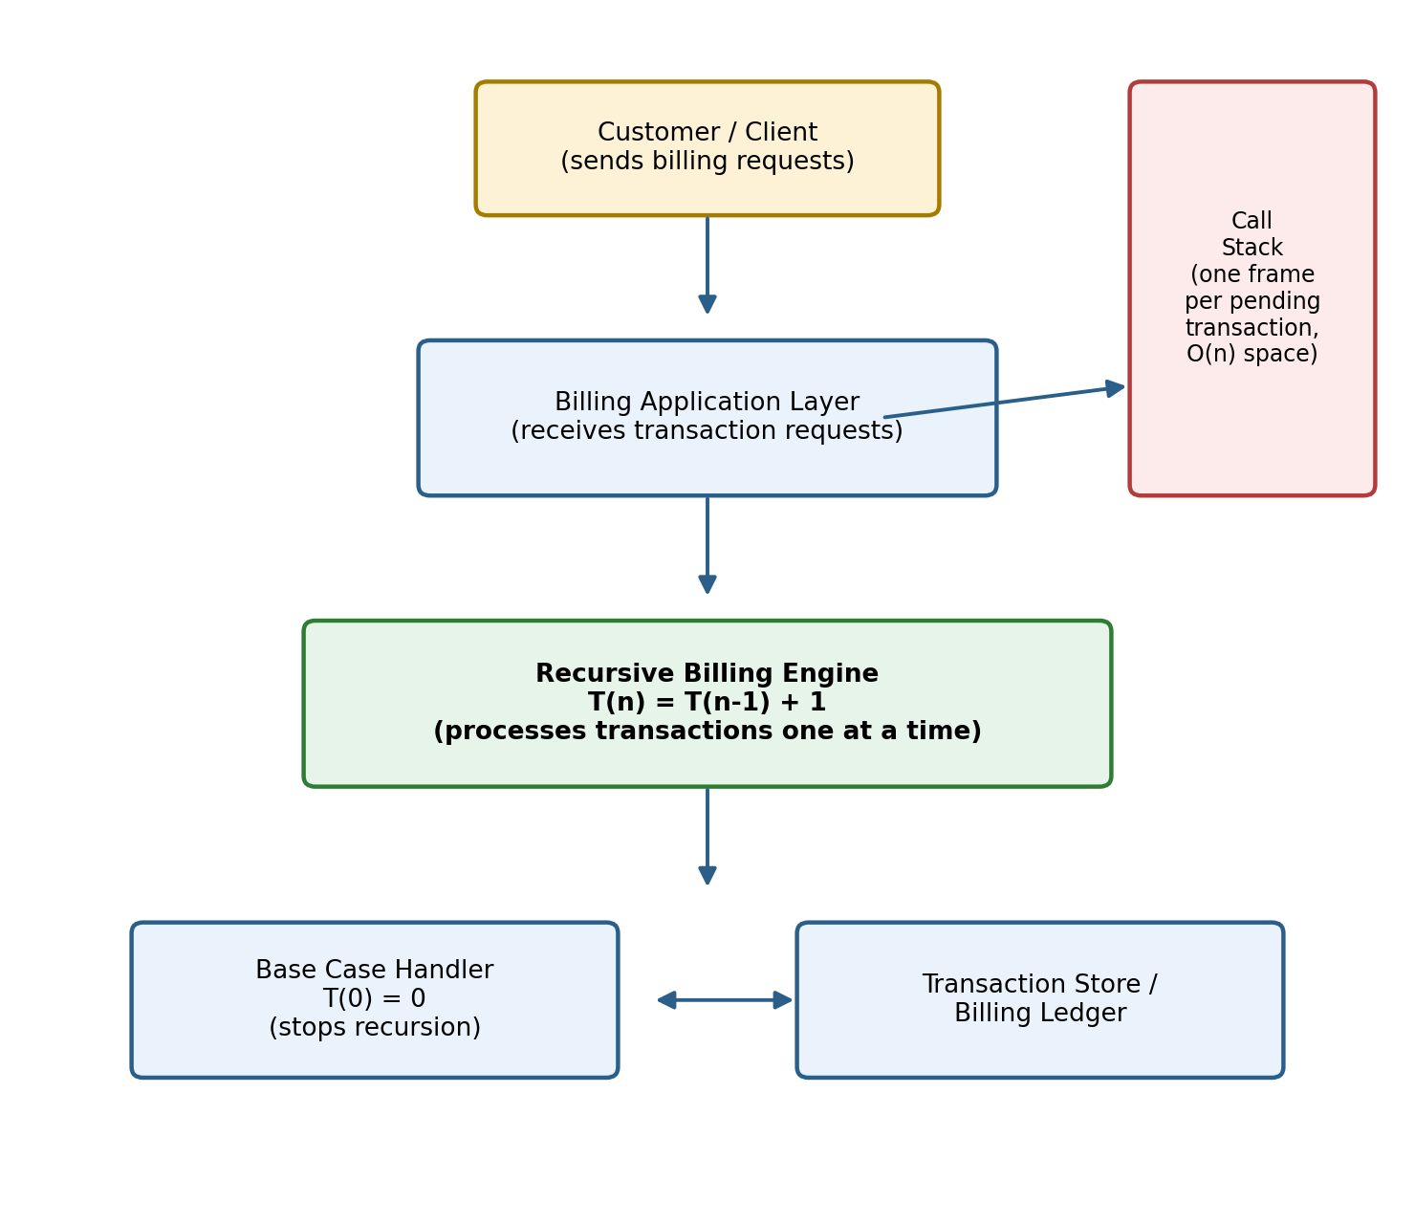
Fig. 0 — High-level view of the recursive online billing system

1. Introduction
Modern online billing systems must process a series of customer transactions reliably and in order — for example, applying charges, tax, or usage units one at a time until every pending transaction has been billed. A natural way to model such repetitive, self-similar work is a recurrence relation, where the cost of solving a problem of size n is expressed in terms of the cost of solving a smaller instance of the same problem. This report studies the simplest possible recursive billing model, governed by the recurrence T(n) = T(n-1) + 1, and uses it to demonstrate how recurrence relations are defined, expanded, and solved.

2. Aim
To recall the definition of a recurrence relation, explain how the recurrence T(n) = T(n-1) + 1 expands step by step, solve it using the substitution method to obtain its closed-form time complexity, and determine the space complexity of the corresponding recursive process — applied in the context of an online billing system.

3. Objectives
- To understand what a recurrence relation is and why it is used to analyse recursive algorithms.
- To model the transaction-processing behaviour of a billing system as a recurrence relation.
- To expand the recurrence T(n) = T(n-1) + 1 through successive substitution.
- To derive a closed-form solution and express the resulting time complexity in Big-O notation.
- To analyse the space complexity contributed by the recursive call stack.
- To implement the recurrence as working C source code and verify the output.

4. Problem Statement
An online billing system receives n pending transactions that must be processed one at a time. Processing a single transaction — validating it, computing the charge, and recording it to the ledger — takes a constant amount of time, independent of n. After a transaction is processed, the system must still process the remaining (n-1) transactions before billing is considered complete. The problem is to express the total processing cost T(n) as a recurrence relation, solve it to find the overall time complexity, and analyse how much memory the recursive implementation consumes.

5. Theory of Recurrence Relation

5.1 Definition
A recurrence relation is an equation that defines a function in terms of its own value(s) on smaller inputs, together with one or more base cases that stop the recursion. In algorithm analysis, T(n) usually denotes the running time of an algorithm on an input of size n, and the recurrence expresses T(n) in terms of T(n-1), T(n-2), T(n/2), and so on, plus the extra work performed at the current level. Recurrence relations are the natural analytical tool for recursive algorithms because each recursive call itself contributes one term to the equation.

5.2 The recurrence for this problem
For the online billing system described above, the recurrence is:
T(n) = T(n-1) + 1 for n > 0
T(0) = 0 (base case: no transactions left)
Here, the "+1" represents the constant amount of work done to bill one transaction at the current call, and T(n-1) represents the cost of recursively billing the remaining transactions.

5.3 How the recurrence expands
Expanding the recurrence one level at a time shows the same pattern repeating, with the argument decreasing by 1 and a constant "+1" being added at each level:
T(n) = T(n-1) + 1
= [T(n-2) + 1] + 1 = T(n-2) + 2
= [T(n-3) + 1] + 2 = T(n-3) + 3
= [T(n-4) + 1] + 3 = T(n-4) + 4
... ...
= T(n-k) + k (after k successive expansions)
The recursion keeps unfolding until the argument reaches the base case, i.e. n - k = 0, which happens when k = n.

6. Algorithm
- Step 1: Start with n transactions to be billed.
- Step 2: If n = 0, no transactions remain — return 0 (base case).
- Step 3: Otherwise, bill 1 transaction (constant-time work).
- Step 4: Recursively call the billing function on the remaining (n-1) transactions.
- Step 5: Add 1 (the transaction billed at this level) to the result returned by Step 4.
- Step 6: Return the accumulated count to the caller.
- Step 7: Repeat Steps 2–6 until all transactions are billed and the recursion unwinds back to the top level.

7. Pseudocode
FUNCTION billTransactions(n):
IF n == 0 THEN
RETURN 0 // Base case: T(0) = 0
END IF

process one transaction // constant work: +1
remaining = billTransactions(n-1) // recursive call: T(n-1)
RETURN remaining + 1 // T(n) = T(n-1) + 1
END FUNCTION

8. Flowchart
The flowchart below traces one recursive call of the billing function:
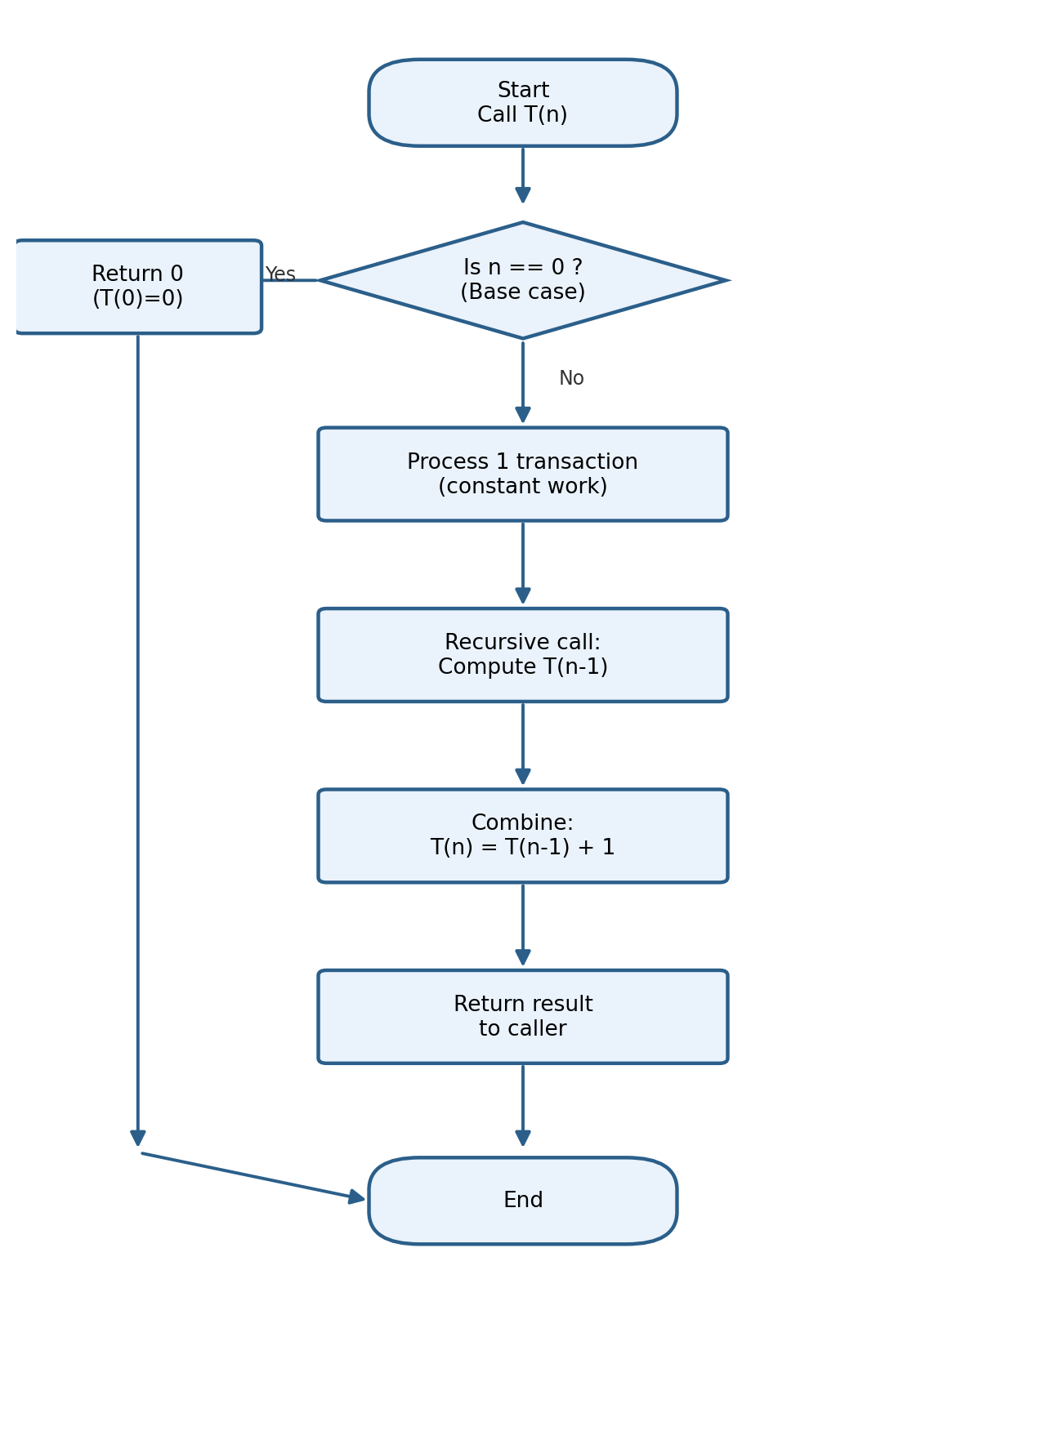
Fig. 1 — Flowchart of the recursive billing function

9. Architecture Diagram
The diagram below places the recurrence in the context of a complete online billing system, showing how a client request flows down to the recursive billing engine, the base-case handler, and the transaction ledger, while the call stack grows in proportion to the number of pending transactions.

Fig. 2 — Architecture of the online billing system

10. Source Code Explanation
The accompanying C program (billing_system.c) implements the recurrence directly:
- billTransactions(n) is the recursive function that models T(n).
- The base case "if (n == 0) return 0;" implements T(0) = 0 and stops the recursion.
- The printf() statement represents the constant amount of work done to bill one transaction — this is the "+1" term.
- The line "int remaining = billTransactions(n - 1);" is the recursive call corresponding to T(n-1).
- The statement "return remaining + 1;" combines the recursive result with the current level's work, exactly matching T(n) = T(n-1) + 1.
- main() reads n from the user, invokes billTransactions(n), and prints the total number of transactions billed along with the derived complexities.

11. Output
Sample run of the program for n = 5 pending transactions:
=== Online Billing System ===
Enter number of transactions to process: 5
Processing transaction #5 ... billed successfully.
Processing transaction #4 ... billed successfully.
Processing transaction #3 ... billed successfully.
Processing transaction #2 ... billed successfully.
Processing transaction #1 ... billed successfully.

Total transactions billed: 5
Recurrence used : T(n) = T(n-1) + 1
Time complexity : O(n)
Space complexity : O(n) (recursion call stack)

12. Substitution Method Analysis
The substitution (or iterative expansion) method solves a recurrence by repeatedly substituting the recurrence into itself, spotting the resulting pattern, and then verifying it. Applying it to T(n) = T(n-1) + 1:
Expansion step | Resulting expression
1 substitution | T(n) = T(n-1) + 1
2 substitutions | T(n) = T(n-2) + 2
3 substitutions | T(n) = T(n-3) + 3
k substitutions | T(n) = T(n-k) + k

The pattern T(n) = T(n-k) + k holds after k expansions. The recursion terminates at the base case, which occurs when n - k = 0, i.e. k = n. Substituting k = n:
T(n) = T(n-n) + n
= T(0) + n
= 0 + n (since T(0) = 0)
= n
Verification (proof by induction): Assume T(n-1) = n-1 (inductive hypothesis). Then T(n) = T(n-1) + 1 = (n-1) + 1 = n, which matches the closed-form solution. The base case T(0) = 0 also satisfies T(n) = n. Hence T(n) = n for all n ≥ 0, confirmed by substitution.

13. Time Complexity
Since T(n) = n exactly, the running time grows linearly with the number of transactions. In asymptotic (Big-O) notation:
Time Complexity = O(n)
This matches intuition: each of the n transactions requires exactly one constant-time unit of work (billing that transaction), and there is exactly one recursive call per transaction, so the total work is directly proportional to n.

14. Space Complexity
Unlike time complexity, which counts total operations, space complexity for a recursive process counts the maximum depth of the call stack at any point in execution, since each pending (not-yet-returned) recursive call occupies its own stack frame.
billTransactions(n) calls billTransactions(n-1) before it can return, which calls billTransactions(n-2), and so on, down to billTransactions(0). All n+1 calls (from n down to 0) are simultaneously active on the call stack at the deepest point of the recursion, each holding its own local variables and return address. Therefore:
Space Complexity = O(n) (linear recursion depth, one stack frame per call)
This is in contrast to an equivalent iterative implementation (a simple for-loop), which would achieve the same O(n) time complexity but only O(1) auxiliary space, since it does not need a growing call stack.

15. Applications
- Sequential processing of pending invoices or transactions in a billing/payment gateway.
- Counting or summing items in a linked list, queue, or transaction log recursively.
- Any "process-one-then-recurse-on-the-rest" pattern, such as recursive traversal of an order list.
- Teaching example for introducing recurrence relations and the substitution method in algorithm courses.

16. Advantages
- The recursive formulation directly mirrors the natural, self-similar structure of the problem, making the code easy to reason about.
- The recurrence is simple to expand and solve, giving a clean, exact closed-form solution T(n) = n.
- Recursive code is often shorter and closer to the mathematical definition than an equivalent iterative version.

17. Limitations
- O(n) space usage from the call stack makes this approach unsuitable for billing a very large number of transactions, risking stack overflow.
- Function-call overhead (stack frame setup/teardown) makes the recursive version slower in practice than an equivalent O(1)-space iterative loop, despite identical asymptotic time complexity.
- The linear recurrence does not take advantage of any parallelism, since each call strictly depends on the previous one completing first.

18. Future Enhancements
- Convert the recursive solution to an iterative loop or use tail-call optimisation to reduce space complexity to O(1).
- Batch transactions and process them in parallel where the billing order does not matter, reducing wall-clock time.
- Add persistent logging/checkpointing so that a partially completed billing run can resume after a failure without restarting from n.
- Extend the model to a weighted recurrence (e.g. T(n) = T(n-1) + c) to represent transactions with variable processing cost.

19. Conclusion
The recurrence T(n) = T(n-1) + 1 provides a clear, minimal model of a recursive online billing system that processes one transaction per call. Expanding the recurrence and applying the substitution method shows that T(n) = n exactly, giving a time complexity of O(n). Because each of the n recursive calls remains active on the stack until the base case is reached, the process also requires O(n) auxiliary space. These results illustrate, in a very direct way, how the structure of a recurrence relation determines both the time and space behaviour of a recursive algorithm.

20. References
- Cormen, T. H., Leiserson, C. E., Rivest, R. L., & Stein, C. — Introduction to Algorithms (3rd ed.), Chapter 4: Divide-and-Conquer / Recurrences, MIT Press.
- Sedgewick, R., & Wayne, K. — Algorithms (4th ed.), Addison-Wesley — Sections on recursion and analysis of algorithms.
- Horowitz, E., Sahni, S., & Rajasekaran, S. — Fundamentals of Computer Algorithms, Universities Press — Recurrence relations and substitution method.
- GeeksforGeeks — "Methods to Solve Recurrence Relations" (educational reference for the substitution method).

