Sudharshank

192111101

**COMPUTER NETWORKS**

23.WLAN Using Cisco Packet Tracer

step1:-first take WLAN controller

step2:-link that WLAN with server and router then connect all with switch like laptop , tablet

step3:-connect that pc with the switch and the switch to router and router to server

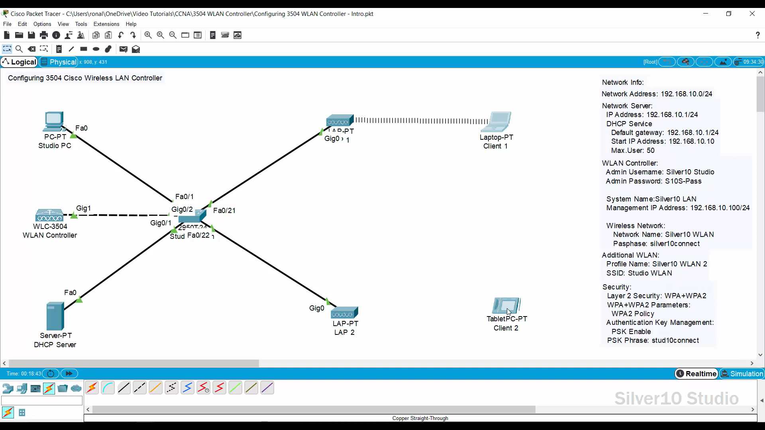

step4:- after connection check the IP address of the all pc in the config

step5:- if command send correctly you got successfull other wise recheck the connections

Step6:- Then the WLAN Using Cisco Packet Tracer is succesfully simulated in packest tracer .

