Modbus Communication using LPC1769 and ARM Embedded Linux

Contents

List of Figures 3
List of Tables 3
1. Objective 4
2. Introduction 4
2.1 MODBUS 4
2.2 MODBUS frame description 5
2.3 The Two Serial Transmission Modes 5
2.3.1 ASCII Mode 5
2.3.2 RTU Mode 6
2.4 Master / Slaves State Diagrams 6
2.4.1 Master state diagram 6
2.4.2 Slave state diagram 7
3. Test Environment Setup 8
3.1 Test case table 10
4. Observations 11
5. References 13

List of Figures

Figure 1 Master–Slave Query–Response Cycle ([1]) 4
Figure 2 MODBUS Protocol Data Unit ([2]) 5
Figure 3 MODBUS frame over Serial Line ([2]) 5
Figure 4 ASCII Message Frame ([1]) 5
Figure 5 RTU Message Frame ([1]) 6
Figure 6 Master state diagram ([2]) 6
Figure 7 Slave state diagram ([2]) 7
Figure 8 System setup for scenario 1 8
Figure 9 System setup for scenario 2 9
Figure 10 System setup for scenario 3 9
Figure 10 Modbus Master 11
Figure 11 Modbus Master (TX PDU) 12
Figure 12 Modbus Master - slave response (RX PDU) 12

List of Tables

Table 1 Test case table 10

Objective

To test Modbus communication on LPC1769 acting as a Modbus slave.

For master 3 scenarios are used.

- PC (QModBus utility based on libmodbus) acting as a Modbus Master. (Please refer this link for more details: http://qmodbus.sourceforge.net/)
- ARM11- S3C6410X (Master developed using libmodbus) acting as a Modbus Master
- NVIDIA Jetson TK1 powered by Tegra K1 SoC (Master developed using libmodbus) acting as a Modbus Master

Master and slave communicates over the serial port. Our Implementation uses RS485 physical interface.

Introduction

MODBUS
- Modbus is a serial communication protocol.
- Controllers communicate using a master–slave technique, in which only one device (the master) can initiate transactions (called ‘queries’). The other devices (the slaves) respond by supplying the requested data to the master, or by taking the action requested in the query.
- The master can address individual slaves, or can initiate a broadcast message to all slaves. Slaves return a message (called a ‘response’) to queries that are addressed to them individually. Responses are not returned to broadcast queries from the master.
- At the physical level, MODBUS over Serial Line systems may use different physical interfaces (RS485, RS232).

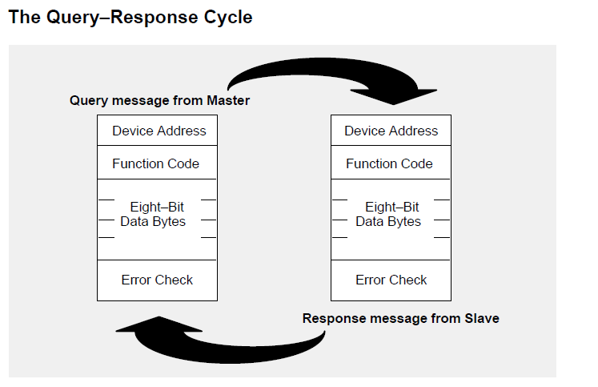
Figure 1 Master–Slave Query–Response Cycle ([1])

MODBUS frame description

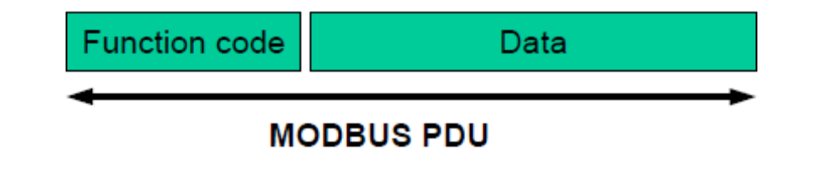
Figure 2 MODBUS Protocol Data Unit ([2])

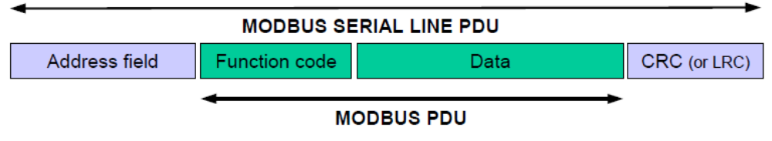
Figure 3 MODBUS frame over Serial Line ([2])
- On MODBUS Serial Line, the Address field only contains the slave address, the valid slave nodes addresses are in the range of 0 – 247 decimal.
- The function code indicates to the server what kind of action to perform. The function code can be followed by a data field that contains request and response parameters.
- Error checking field is the result of a "Redundancy Checking" calculation that is performed on the message contents. Two kinds of calculation methods are used depending on the transmission mode that is being used (RTU or ASCII).

The Two Serial Transmission Modes

2.3.1 ASCII Mode
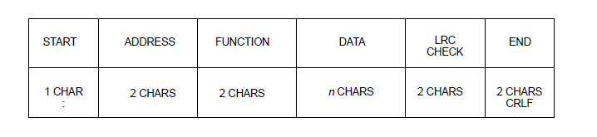
Figure 4 ASCII Message Frame ([1])

2.3.2 RTU Mode
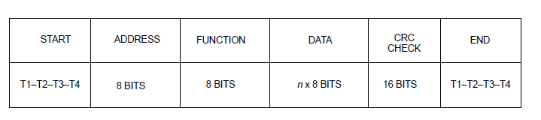
Figure 5 RTU Message Frame ([1])

Master / Slaves State Diagrams

2.4.1 Master state diagram

Request sent in
broadcast mode
/ turnaround delay is started
Idle
End of error processing
End of reply processing
Waiting
turnaround delay

turnaround delay expiration
request sent to a
slave
/ response time- out is started
Processing
reply
Frame error
Reply reception [Expected slave]
/ response time-out is stopped
Reply reception
[Unexpected slave]
Waiting
for reply
response time-out expiration
Processing
error

Figure 6 Master state diagram ([2])

- State "Idle" = no pending request. This is the initial state after power-up. A request can only be sent in "Idle" state. After sending a request, the Master leaves the "Idle" state, and cannot send a second request at the same time
- When a unicast request is sent to a slave, the master goes into "Waiting for reply" state, and a “Response Time-out” is started. It prevents the Master from staying indefinitely in "Waiting for reply" state. Value of the Response time-out is application dependent.
- When a reply is received, the Master checks the reply before starting the data processing. The checking may result in an error, for example a reply from an unexpected slave, or an error in the received frame. In case of a reply received from an unexpected slave, the Response time-out is kept running. In case of an error detected on the frame, a retry may be performed.
- If no reply is received, the Response time-out expires, and an error is generated. Then the Master goes into "Idle" state, enabling a retry of the request. The maximum number of retries depends on the master set-up.
- When a broadcast request is sent on the serial bus, no response is returned from the slaves. Nevertheless, a delay is respected by the Master in order to allow any slave to process the current request before sending a new one. This delay is called "Turnaround delay". Therefore, the master goes into "Waiting Turnaround delay" state before going back in "idle" state and before being able to send another request.
- In unicast the Response time out must be set long enough for any slave to process the request and return the response, in broadcast the Turnaround delay must be long enough for any slave to process only the request and be able to receive a new one. Therefore, the Turnaround delay should be shorter than the Response time-out. Typically, the Response time-out is from 1s to several second at 9600 bps; and the Turnaround delay is from 100ms to 200ms.

2.4.2 Slave state diagram


Idle
error reply sent
normal reply sent
Formatting
normal reply
reception of a
request
(from the master)
end of processing [unicast mode]
end of processing
[broadcast mode]
check OK
Checking
request
Processing
required action error while processing
error in request data
Formatting
error reply
error in frame
checking, or frame not addressed to this slave
Figure 7 Slave state diagram ([2])

- State "Idle" = no pending request. This is the initial state after power-up.
- When a request is received, the slave checks the packet before performing the action requested in the packet. Different errors may occur: format error in the request, invalid action, … In case of error, a reply must be sent to the master.
- Once the required action has been completed, a unicast message requires that a reply must be formatted and sent to the master.
- If the slave detects an error in the received frame, no respond is returned to the master.
- MODBUS diagnostics counters are defined and should be managed by any slave in order to provide diagnostic information. These counters can be get using the Diagnostic MODBUS function

Test Environment Setup

- We have used LPC1769 (Cortex-M3 microcontroller) as our platform for Modbus slave. Modbus slave firmware implemented on LPC1769 responds to standard queries.

- On LPC1769, RXD2(P0.11) and TXD2(P0.10) pins are used for this purpose. On the master side we have tested with 2 different scenarios as mentioned below.

- As mentioned earlier our implementation uses RS485 physical interface, we have used MAX485 driver to convert standard TTL RX/TX signals to RS485 signals.

.

Scenario 1: PC (QModBus utility) acting as a Modbus Master.

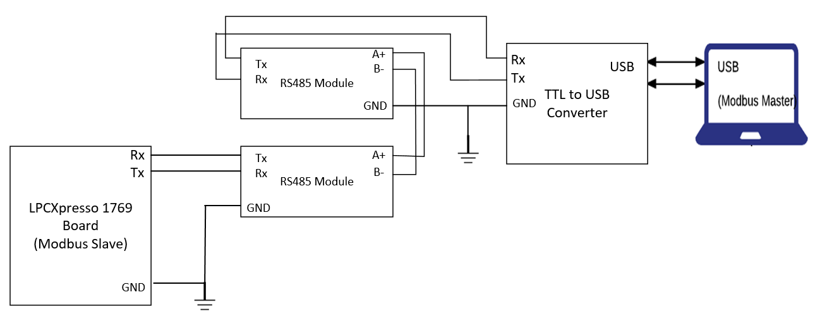
Figure 8 System setup for scenario 1

- In this scenario QModBus utility based on libmodbus is used as Modbus Master

- LPC1769 (Modbus slave) is connected to PC via RS485 driver pair

- TTL to USB converter is used at PC End to convert the RX/TX signal to appropriate USB signals

Scenario 2: ARM11 (Master developed using libmodbus) acting as a Modbus Master
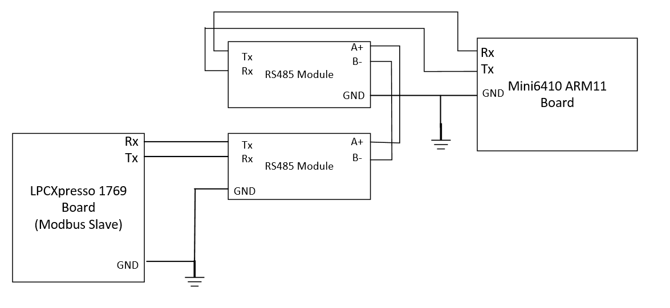
Figure 9 System setup for scenario 2
- In this scenario Mini6410 ARM11(S3C6410X) board is used as Modbus Master

- Application developed using libmodbus runs on ARM11 board

- LPC1769 (Modbus slave) is connected to ARM11 board via RS485 driver pair

Scenario 3: NVIDIA Jetson TK1 (Master developed using libmodbus) acting as a Modbus Master, refer figure 10.
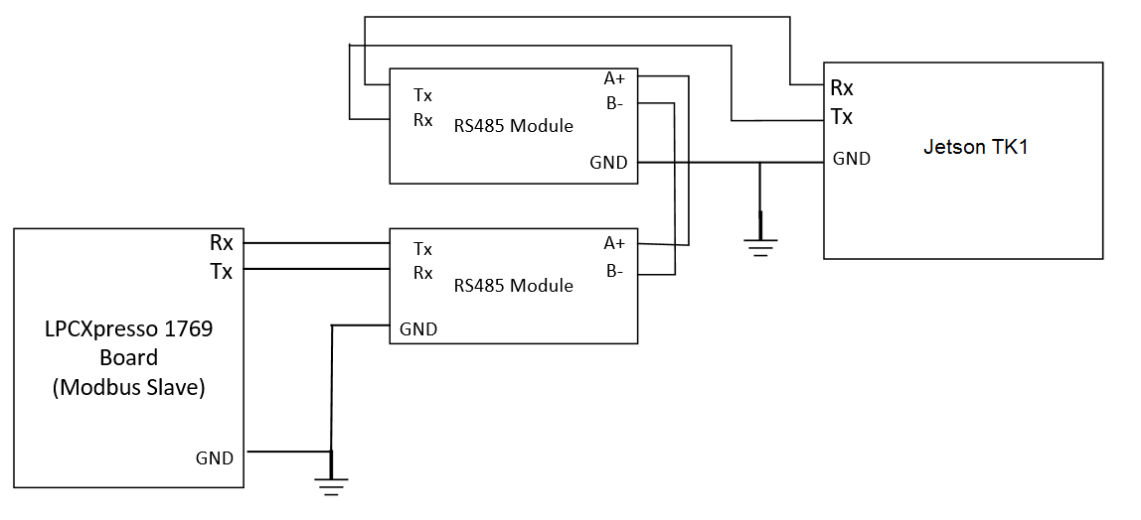
Figure 10 System setup for scenario 3
- In this scenario Mini6410 ARM11(S3C6410X) board is used as Modbus Master

- Application developed using libmodbus runs on ARM11 board

- LPC1769 (Modbus slave) is connected to ARM11 board via RS485 driver pair

- On Jetson TK1 board following pins from connector J3A2 are used

Pin 65 -- UART2_RXD
Pin 68 -- UART2_TXD

Test case table

No | Test case Description | Expected Output | Actual Output | Test Result
1 | In this test, PC (QModBus master) is used to send commands to LPC1769(Modbus slave)  Command Format:  Slave Address: 0x0A  Function Code: 0x01(Read Coil Status)  Command Packet Format:  0x0A|0x01|0x00|0x00|0x00|0x08|0x3C|0xB7 | Slave should respond with coil status of the required number of coils.  Response Packet Format:  0xAF is coil status of 8 coils  1 bit per coil  0x0A|0x01|0x01|0xAF|0x13|0xD0 | Output received:  0x0A|0x01|0x01|0xAF|0x13|0xD0 | Pass
2 | In this test, Modbus master application developed using libmodbus is used to send commands to LPC1769(Modbus slave)  Command Format:  Slave Address: 0x0A  Function Code: 0x01(Read Coil Status)  Command Packet Format:  0x0A|0x01|0x00|0x00|0x00|0x08|0x3C|0xB7 | Slave should respond with coil status of the required number of coils.  Response Packet Format:  0xAF is coil status of 8 coils  1 bit per coil  0x0A|0x01|0x01|0xAF|0x13|0xD0 | Output received:  0x0A|0x01|0x01|0xAF|0x13|0xD0 | Pass
Table 1 Test case table
Note: Please refer RTU Mode for Packet Format

Observations

- Following figures show output of the test for different scenarios
- We send commands (queries) from Modbus master to LPC1769(Modbus Slave) and slave responds with particular response
- Figure 10 shows the Modbus Master setting
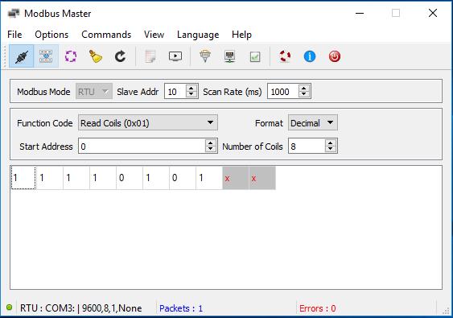
Figure 11 Modbus Master

- Following figure shows TX PDU
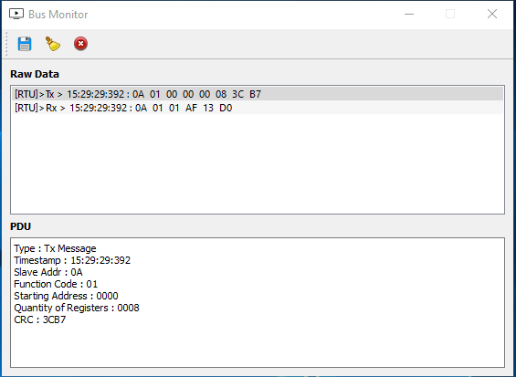
Figure 12 Modbus Master (TX PDU)
- Following figure (Figure 12) shows RX PDU

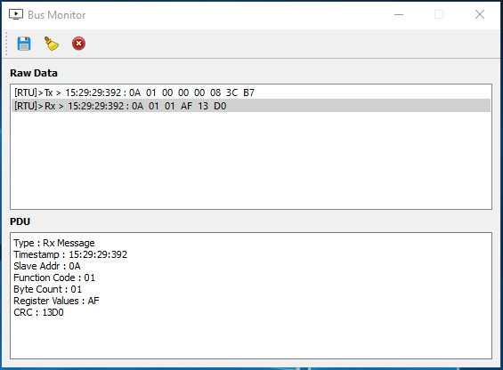
Figure 13 Modbus Master - slave response (RX PDU)

References

- Modicon Modbus Protocol Reference Guide, PI–MBUS–300 Rev. J
- MODBUS over Serial Line Specification and Implementation Guide, v1.02

